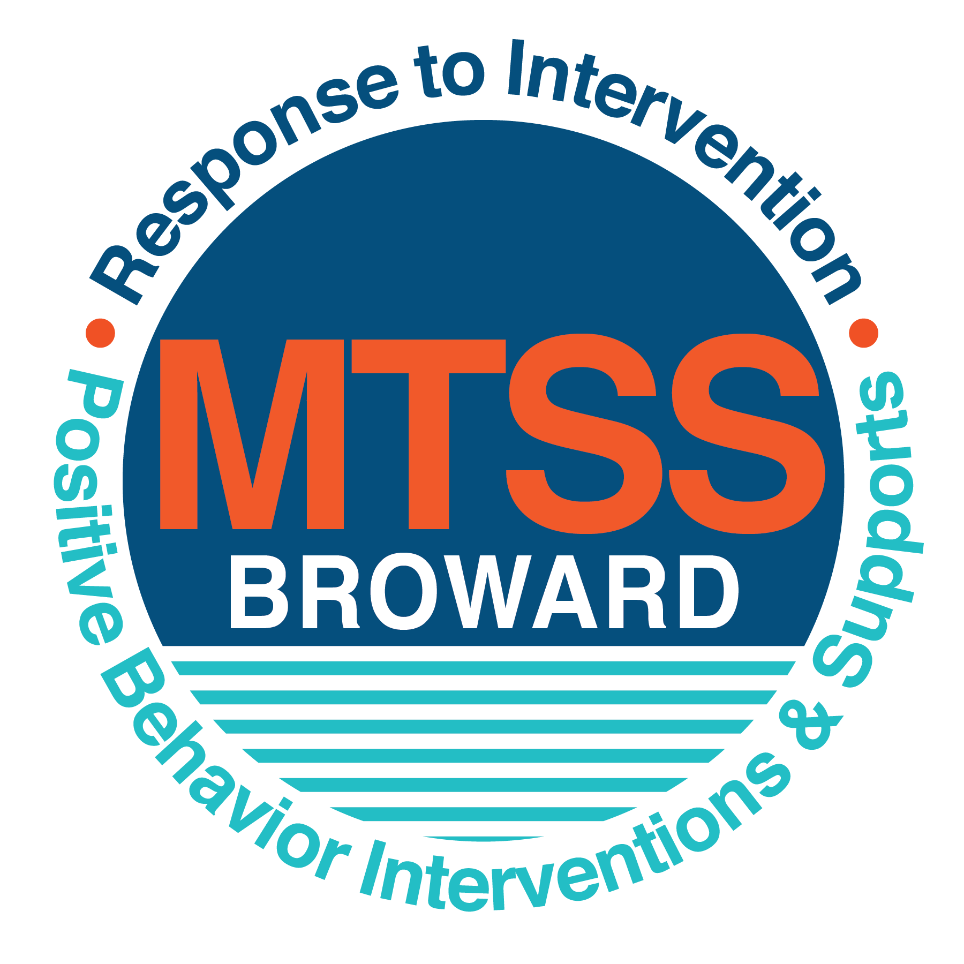
\
School-wide Positive Behavior Plan (SPBP)
Broward County Public Schools
To be implemented in SY 2019/20

School Name: | Thurgood Marshall Elementary
School Number: | 3291
SPBP Contact Name: | Delphia Kaigler
Direct Phone Number: | 754-322-7000

CRITICAL ELEMENT # 1: Active Team with Administrative Participation

1A. Current (SY 2018/19) SPBP team members:
Full Name | Position
Angie Moodilyar-Jones | 1. Administration
Joel McCray | 2. BTU Representative
Delphia Kaigler | 3. SPBP Point of Contact
Fany Avil | 4. Parent/Community Representation
Floyd Nickle | 5. Behavior Specialist
Geranda Odom | 6. Intermediate Represenative
Debbie Darby | 7. Primary Representative
Atensia Earp | 8. Social Worker
Trisha Wolfe | 9. ESE Specialist
Yanick Prince | 10. Community Liasion

1B. Schedule of quarterly SPBP Team Meeting dates for next 2019/20 school year:
Meeting Date | Meeting Time | Content of meetings:
8/21/2019 | 7:30 AM | 1. Progress of Action Steps indicated in Implementation Plan in #9  2. Collect & analyze fidelity of staff implementation data in #10A  3. Collect & analyze student outcome data in #10B
10/30/2019 | 3:30 PM
1/8/2020 | 8:30 AM
3/11/2020 | 3:30 PM

CRITICAL ELEMENT # 2: Faculty & Stakeholder Commitment:

2A. Action Steps completed this year (SY 2018/19) that increased faculty and stakeholder knowledge of the new SPBP:

Action Steps: | Date  (Between Jan 15 and  April 30, 2019) | Details  (Sign-in sheets in SPBP Binder)
Presented the new SPBP (for SY 2019/20) to staff | 3/5/2019 | # of participants = 35
Held a faculty vote on the new SPBP  (for SY 2019/20) | 3/11/2019 | # of participants = 100%  % approved =
Presented the new SPBP (for SY 2019/20) to stakeholders (parents and community) | 3/14/2019 | # of participants = 12

2B. Action Steps to be completed next year (SY 2019/20) to increase faculty and stakeholder knowledge of the new SPBP:

Action Steps: | Date  (SY 2019-20) | Content  (Sign-in sheets in SPBP Binder)
Provide professional development on the 2019/20 SPBP for all staff | Prior to students’ 1st day:  8/9/2019 | The team will present the updates in the SPBP for the 19/20 school year. All stakeholders will be provided with access to the SPBP. Feedback will be collected for future team meetings.
Present the 2019/20 SPBP to stakeholders  (parents and community) | Prior to Oct 1st, 2019  9/12/2019
Present the behavior data to all staff quarterly | 1. 10/15/2019 | The team will present:  - the team’s progress in the Implementation Plan in # 9.  - the fidelity of staff implementation data in #10A.  - the student outcome data in #10B.
 | 2. 1/14/2020
 | 3. 3/17/2020
 | 4. 4/14/2020

CRITICAL ELEMENT # 3: School-wide Expectations

3A. Top five behavior incidents data YTD as listed in BASIS 3.0
Top 5 Behavior Incidents
- Disobedience/insubordination
- Unruly/Disruptive behavior
- Defiance of authority/habitual
- Battery
- Minor/altercation/conference

3B. School-wide expectations are 3 – 5 positive characteristics (not behaviors) that counteract the demonstration of the top school-wide misbehaviors above. ALL people on campus model these expectations.
School-wide Expectations
- Be Safe
- Be Respectful
- Be Responsible
4.
5.

3C. At least one lesson plan for each school-wide expectation above is distributed to teachers during pre-planning SY 2019/20 and maintained in the SPBP Binder.
Dates the school-wide expectations lesson plans are taught:
 | Date(s) | Time: | Location(s):
August | Aug. 8-9 | 8:15- 8:45 AM | Classroom
January | Jan. 7-10 | 8:15-8:45 AM | Classroom
After Spring Break | Apr. 1-2 | 8:15-8:45 AM | Classroom

CRITICAL ELEMENT #4: Location-based Rules

4A. Top three school-wide locations for Behavior Events YTD.
Top 3 Locations, not including Classroom:
School Location | # Incidents
1. Athletic Field | 8
2. Playground | 6
3.Hallway | 10

4B. Expectations and Rules Chart for common areas of school campus: (next page)

Expectations and Rules Chart |  |  |  | To be completed by classroom teachers
School-wide EXPECTATIONS | Cafeteria | Hallway | Athletic Field | Classroom Rules
Be Safe | Walk in cafeteria quietly and in a straight line. | Walk with safe arms during transition | Use PE equipment properly at all times. Enter and exit the PE area in a straight line and quietly.
Be Respectful | Pick up trash from table and floors before dumping your tray. Voice levels at a level 1. | Walk on the right side of the hallways while transitioning. Voice levels at a level 0. | Listen to follow all directions of PE coaches.
Be Responsible | Make sure to get everything you need before sitting down to eat. | Always walk in the hallways and with another student | Place all equpiment back in appropriate place when done.

4C. At least one Rules lesson plan for each specific location is distributed to teachers during pre-planning SY 2019/20 and maintained in the SPBP Binder.

Dates the Locations’ Rules lesson plans are taught
 | Date(s) | Time: | Location(s):
August | Aug. 8-9 | 8:15-8:45 AM | Classroom
January | Jan. 7-10 | 8:15- 8:45AM | Classroom
After Spring Break | Apr. 1-2 | 8:15-8:45 AM | Classroom

CRITICAL ELEMENT # 5: Reward and Recognition Programs

5. The reward system is focused on one School-wide Expectation OR specific location at a time.
Expectation or Location: ___Cafeteria__________________

4 Step Problem Solving Process | Plan Details
1. Problem Identification: Use your behavior data to identify one school-wide problem.  What problem did you identify? (use numerical data) | Data used:  The data used was collected from the Behavior Dashboard on BASIS to determine the problem below. Currently there are 9 referrals documented in BASIS from the cafeteria.  Problem Identification Statement:  The identified problem is students are not following one of the school-wide expectations of being safe.
2. Problem Analysis: Why do you think this problem is occurring?  What is your goal? (use a SMART goal statement with numerical data) | Hypothesis:  The problem is occurring because many students are getting out of their seats/ tables to talk to other students. Many of them come into cafeteria running or horse playing which causes incidents to occur. Some also forget things like condiments and/or go to restroom without asking.  Goal Statement:  By April 2020, the number of referrals given in the cafeteria will be reduced by 20% as evident of data taken from BASIS.
3. Intervention Design: Describe how you will implement a positive reward program to decrease this problem. | Type of System: Point system  Description of System: (≥ 5 sentences)  Classes will receive points in 4 categories daily (Entering the cafeteria, noise level, cleanliness, and exiting the cafeteria). Each class will receive a clipboard and bring to cafeteria everyday. Paras will be assigned to a grade level and give points to classes that deserve them. At the end of each week, the class with the most points will receive a reward.
4. Evaluation:  A. Implementation fidelity | - How will you monitor the fidelity (consistency and effectiveness) of the staff’s implementation of the reward program? (2-3 sentences)  The point system will be implemented the first week of school and monitored on a monthly basis by administration. Classes that consistently receive all their points for appropriate cafeteria behavior will be recognized with something special.
B. Student outcome monitoring | - How will you know if the reward program is positively impacting students? What measurable data will you use to determine “success”? (2-3 sentences)  We will know if the reward program is positively impacting students if the number of referrals decrease and remain low over a few months. Each month the data from BASIS will be reviewed and shared with teachers to reinforce the program where needed.

CRITICAL ELEMENT #6: Effective Discipline Procedures

Student Behavior Discipline Flow Chart
Observe problem behavior behaviorBehavior
Intervene and redirect
Office Managed Misbehaviors
Staff Managed Misbehaviors
Redirect student behavior and review rules and procedures

Call to notify office of a
crisis/safety issue
No
Yes

Is behavior Office Managed?
(if unsure, check below)

Specific Examples of  6 Staff Managed  Misbehaviors: | Specific Examples of  6 Office Managed  Misbehaviors:
Screaming and Yelling  Disruptive behavior  Fighting  Making Noise  Talking out of turn  Out of area consistently | Disobedience Insubordination  Disruptive Play  Defiance of authority  Fight (minor altercation)  Battery
Conference with administration

Model appropriate behavior student behavior/expectations

Administration applies appropriate consequences based on discipline matrix

Parent Conference

Enter into BASIS and contact parent

Implement interventions if behavior continues

CRITICAL ELEMENT # 7: Classroom Management Systems

7A. In SY 2019/20, ALL teachers implement an evidence-based Tier 1 classroom management system:
Evidence-based system: | Evidence of training:
☒ CHAMPS | 20% of teachers currently holding valid CHAMPS certificate:
☐ PBIS Classroom Management  http://www.fl-pda.org/independent/ | % of teachers currently holding completion certificate:
☐ Other: Click here to enter name of system. | Training evidence: Click here to enter evidence  % of teachers currently trained:

7B. The administration reviews and analyzes the fidelity of staff implementation of Tier 1 classroom management systems across teachers using:
☒ CHAMPs 7 Up Checklist
☐ Basic FIVE (Classroom Management Screening)
☐ PBIS Classroom Assistance Tool (CAT)
☐ Other (specify):
☐ Classroom management screening is not conducted across teachers to determine appropriate professional
development. (Next year, assessment of classroom management implementation fidelity will be scored).

7C. School year 2018/19 percentage of classroom referrals:
Total number of discipline referrals from classrooms: | 271
Total number of other school-wide discipline referrals: | 49
% of referrals in the classroom: | 85%
Do more than 40% of your referrals come from the classroom? | ☒ Yes ☐ No
If >40% of discipline referrals come from the classroom, it suggests Tier 1 classroom management implementation may need to be strengthened school-wide.
If “Yes”, school-wide classroom management professional development will be conducted in 2019-20:
CHAMPS Brainsharks - Individual If “Other”, indicated system here: Click here to enter text.

CRITICAL ELEMENT # 8: Data Collection and Analysis

8A. Core Effectiveness:
TOTAL Population: | 440 | % of Total Population | Core Effectiveness
# Referrals: | # of Students:
0 - 1 referrals | 61 | 87% | Are your 0 – 1 referrals > 80%? | ☒Yes ☐No
2 - 5 referrals  (at risk students) | 37 | 8% | Are your 2 - 5 referrals <15%? | ☒Yes ☐No
> 5 referrals  (high risk students) | 21 | 5% | Are your >5 referrals <5%? | ☐Yes ☒No

8B. Core Effectiveness Action Steps:
If all 3 are “Yes”, your core is effective. Is your core behavior curriculum effective? | ☐Yes ☒No
Answer either (a) or (b):
(a) If you answered “Yes”, although your core is effective, what steps does your school leadership team take for early identification of at risk and high-risk students?
(b) If you answered “NO”, indicate the supports and interventions your school leadership team will implement at the beginning of the next school year to improve core strength:
Core Effectiveness Action Steps: (3-4 steps)
1. The leadership team will use data from 2018-2019 school year to identify possible at-risk students to implement early intervention strategies specified by the Behavior Specialist.
2. Each leadership team member will be given a group of “high or at-risk” students to mentor and monitor behavior on a regular basis.
3. Targeted students will receive positive incentives in order to promote desired appropriate behavior.

8C. Disproportionality within racial subgroups:
Subgroups | (PctPop - Green)  % of students | (PctRef - Blue)  % of referrals | Difference in referral composition | Positive value suggests disproportionality  (Is the value positive?)
Black | 92% | 96% | 1 | ☐Yes ☒No
Hispanic/Latin | 5% | 3% | 0 | ☒Yes ☐No
White | 2% | 0% | 0 | ☒Yes ☐No

8D. Disproportionality Action Steps:
If all three are “No”, disproportionality is not indicated. Are all 3 “No”? | ☐Yes ☒No
Answer either (a) or (b):
(a) If you answered “Yes”, although your data indicates equity, what plan does your school leadership team implement for early identification of any disproportionality issues
(b) If you answered “No”, indicate the support plan and interventions your school leadership team will implement at the beginning of next year to improve sub group disproportionality
Disproportionality Action Steps: (3-4 steps)
1. Implement School-wide Positive Behavior Plan with 100% fidelity school-wide.
2. Identify and track students weekly with more than 5 referrals.
3. Provide a support person for each grade level to assist with the implementation of the SPBP.
4. The team will provide support for students that have difficulty staying on a positive behavior path.

Critical Elements # 9: SPBP Implementation Planning
RED Font = Action Steps for all schools in Broward County
GREY Font = Best Practices for all schools in Broward County
TEAL Font = Resources available at https://browardcountyschools.sharepoint.com/sites/DPI6Strands/strand6/SitePages/SPBP.aspx
SPBP Team Implementation Action Plan 2019 - 2020
Month | Action Steps  ☒ check off Action Step when completed
Current | ☒ Create a SPBP binder or portfolio to retain (for 2 years) hard copies of: your SPBPs, Action Plans, staff PBIS  professional development attendance, stakeholder training attendance, quarterly meeting agendas, quarterly staff  behavior presentations, voting attendance and outcome, Expectations lesson plans and Rules lesson plans
Pre-Planning  2019 | ☐ Print up your SPBP Review and school score from OSPA  ☐ Provide SPBP presentation to all staff during Pre-Planning  ☐ Disseminate the current SPBP (hard copy or electronically) to all staff and stakeholders  ☐ Market and post school-wide Expectations and location-specific Rules  ☐ Identify your district RtI Instructional Facilitator  (Contact tyyne.hogan@browardschools.com for more information, if you are unsure)  ☐ Confirm 1st team meeting date and time
August  1st meeting | ☐ Ensure schedule of quarterly meeting dates for entire year as indicated in the SPBP  ☐ Review Implementation plan; check off completed Action Steps  ☐ Determine any needed team training, such as these Brainsharks: 4 Step Problem Solving Process series, PBIS 10  Critical Elements, Data Collection, Big 5 Data, PBIS 101, etc. (All found in Sharepoint site)  ☐ Review previous year’s behavior data. (Use ‘Agenda’ Form and ‘Data Collection Template’ in Sharepoint site)  ☐ Utilize the 4 Step Problem Solving Process to initiate a Reward System for all students  ☐ Review previous year’s SPBP and feedback form; make necessary modifications  ☐ Verify and implement teaching schedule for Expectations and Rules behavior lesson plans  ☐ Present implementation data, behavior data, team activities and SPBP progress to entire staff
September | ☐ Provide SPBP stakeholder presentation prior to October 1  ☐ Check for staff and teacher understanding of PBIS - provide “PBIS 101” Brainshark as a resource  Brainshark available at: http://www.brainshark.com/browardschools/PBIS101  ☐ Ensure the Discipline Flow Chart is distributed to all staff and is being used as written
October  2nd meeting | ☐ Review Implementation plan; check off completed Action Steps  ☐ Ensure instructional staff know how to (and are, as needed) enter Tier 1 Supplemental Strategies  for behavior in BASIS  ☐ Review previous quarter’s behavior data. (Use ‘Agenda’ and ‘Data Collection Template’ in Sharepoint site)  ☐ Present implementation data, behavior data, team activities, and SPBP progress to entire staff  ☐ Ensure all teachers are using an evidence-based classroom management plan, such as CHAMPS  ☐ Ensure Core Effectiveness Action Steps are being implemented as written
November | ☐ Team to develop new and/or improved lesson plans as indicated by behavior data.  ☐ Ensure that the Disproportionality Action Steps are being implemented as written
January  2020  3rd meeting  Prepare for SY 2020/21 SPBP | ☐ Review Implementation plan; check off completed Action Steps  ☐ Staff to re-teach Expectations and Rules after winter break  ☐ Principal signs in and watches the new “SPBP for Principals” Brainshark: Due January 30th  ☐ Present implementation data, behavior data, team activities, and SPBP progress to entire staff  ☐ Choose team members and dates to work on, complete, and submit the new SPBP  ☐ Teams watch the new “SPBP Team Overview” Brainshark and refers to district resources and supports  (Brainsharks and Additional items in Sharepoint site. Webinars and in-person lab information in Team Brainshark)
February | ☐ Ensure progress towards completion of SPBP  ☐ Check on recently hired staff for PBIS understanding - provide “PBIS 101” Brainshark resource  ☐ Provide the SPBP Surveymonkey link to all staff (optional)
March  4th meeting | ☐ Ensure progress towards completion and submission of SPBP  ☐ Review Implementation plan; check off completed Action Steps  ☐ Staff to re-teach Expectations and Rules after from spring break  ☐ Provide stakeholders/parent presentation on new SPBP for next year  ☐ Provide staff presentation and faculty vote on new SPBP for next year  ☐ Present implementation data, behavior data, team activities, and SPBP progress to entire staff
April | ☐ Submit your SPBP in OSPA by April 30th every year. Use this new SPBP in the next school year  ☐ Continue implementing your current SPBP through the end of the current school year

CRITICAL ELEMENT # 10: Evaluation

10A. Staff implement the School-wide Positive Behavior Plan effectively:
“Are staff implementing the SPBP with fidelity? How do you know?”
STAFF Implementation Monitoring
Action Step | Create an observable and measurable SMART goal to determine “successful”  staff implementation of action step
School-wide expectations and location-specific rules are posted across campus | By August 9, 2019, the school-wide expectations will be posted 100% throughout the school.
Expectations and Rules lesson plans are being taught as written and when indicated | By the beginning of each quarter, all lesson plans expected to be taught will be disseminated to 100% of the staff.
The Discipline flow chart is being used by all staff as written | By September 2019, the discipline consequences and flow chart will be used by the staff with 100% fidelity.
A reward system is being implemented for all students | By August 2019, the reward system will be 100% in effect throughout the school.

10B. The SPBP is successful in positively impacting students:
“If staff are implementing the SPBP consistently and effectively, did it positively impact the students? How do you know?”
STUDENT Outcome Monitoring
Student Outcome Data | Create an observable and measurable SMART goal to determine  “successful” student outcomes
Behavior Incident data  (See critical element #3A) | By October 2019, the number of referrals written for disobedience/insubordination will reduce by 20% as evident of data taken from BASIS.
Top 3 event locations data  (See critical element #4A) | By October 2019, the number of referrals given in the top 3 event locations identified will decrease by 50% as evident of data taken from BASIS.
Core effectiveness data  (See critical element #8A) | By September 2019, the school’s core effectiveness will increase by 20% as evident of data collected through walkthroughs coducted by administration.
Classroom referrals data  (See critical element #7C) | By October 2019, the number of classroom referrals will decrease by 50% as evident of data taken from BASIS.

