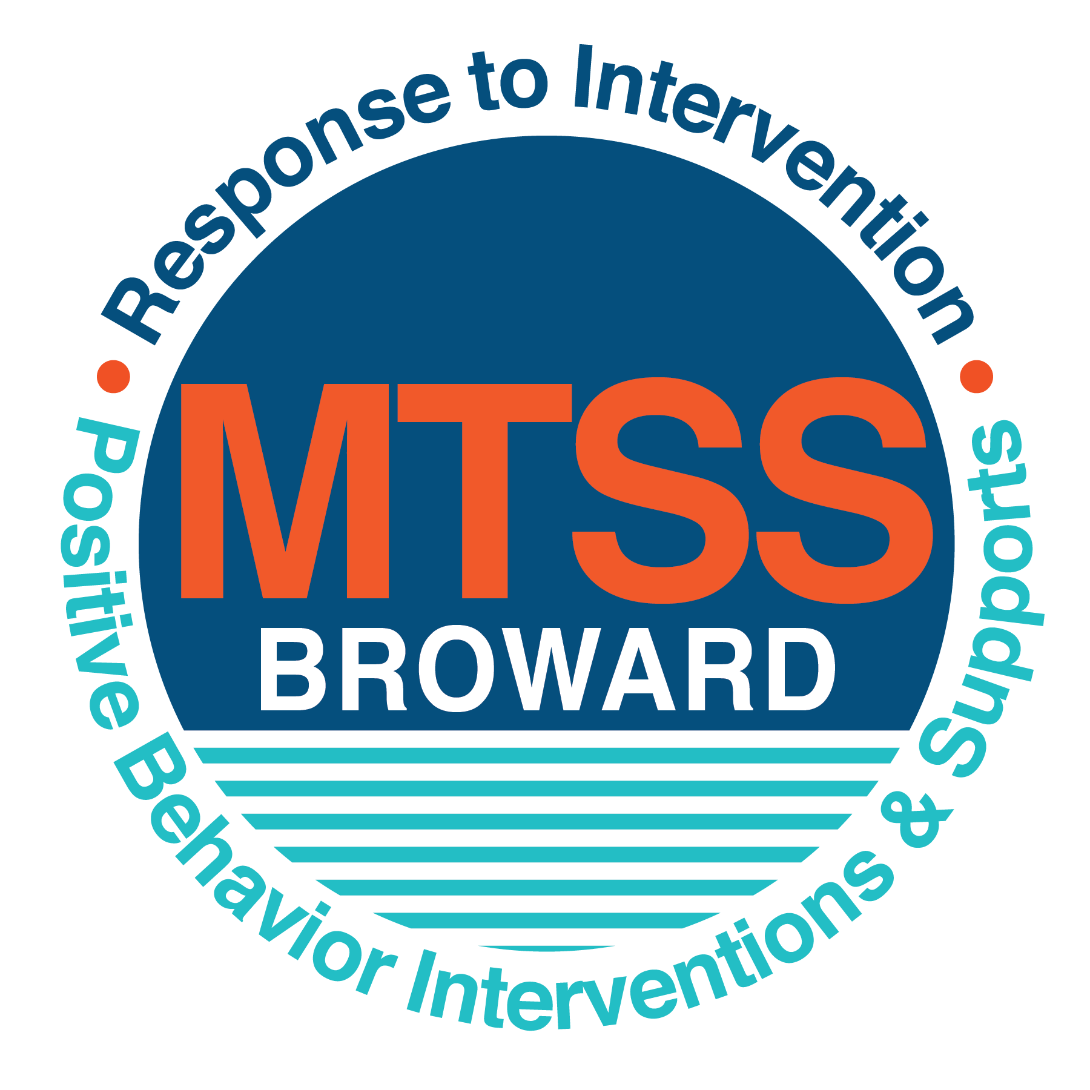
School-wide Positive Behavior Plan (SPBP)
Broward County Public Schools
To be implemented in SY 2019/20

School Name: | PINEWOOD ELEMENTARY
School Number: | 2811
SPBP Contact Name: | KICIA DANIEL (PRINCIPAL)/ DARLENE MILNER (ASSISTANT PRINCIPAL)
Direct Phone Number: | 754-322-7950

CRITICAL ELEMENT # 1: Active Team with Administrative Participation

1A. Current (SY 2018/19) SPBP team members:
Full Name | Position
Kicia Daniel | Administration
Darlene Milner | Administration
Donna Spellman | School Counselor/Point of Contact
Latoya Flournoy | Parent/Community Representation
Amy Norcutt | SAC Chair/ Instructional- Teacher
Brenda Seleznow | Instructional- Teacher (Primary PreK)
Angela Smith | Content Area Representation/ Math
Yolanda Butler | Content Area Representation/ Literacy
Germaine Odom | Content Area Representation/ Science
Hernrika Amos | Instructional- Teacher (Intermediate)

1B. Schedule of quarterly SPBP Team Meeting dates for next 2019/20 school year:
Meeting Date | Meeting Time | Content of meetings:
10/17/2019 | 2:10-3:00PM | 1. Progress of Action Steps indicated in Implementation Plan in #9  2. Collect & analyze fidelity of staff implementation data in #10A  3. Collect & analyze student outcome data in #10B
1/9/2020 | 2:10-3:00PM
3/19/2020 | 2:10-3:00PM
5/21/2020 | 2:10-3:00PM

CRITICAL ELEMENT # 2: Faculty & Stakeholder Commitment:

2A. Action Steps completed this year (SY 2018/19) that increased faculty and stakeholder knowledge of the new SPBP:

Action Steps: | Date  (Between Jan 15 and  April 30, 2019) | Details  (Sign-in sheets in SPBP Binder)
Presented the new SPBP (for SY 2019/20) to staff | 8/9/2019 | # of participants =
Held a faculty vote on the new SPBP  (for SY 2019/20) | 8/9/2019 | # of participants =  % approved =
Presented the new SPBP (for SY 2019/20) to stakeholders (parents and community) | 9/26/2019 | # of participants =

2B. Action Steps to be completed next year (SY 2019/20) to increase faculty and stakeholder knowledge of the new SPBP:

Action Steps: | Date  (SY 2019-20) | Content  (Sign-in sheets in SPBP Binder)
Provide professional development on the 2019/20 SPBP for all staff | Prior to students’ 1st day:  8/9/2019 | The team will present the updates in the SPBP for the 19/20 school year. All stakeholders will be provided with access to the SPBP. Feedback will be collected for future team meetings.
Present the 2019/20 SPBP to stakeholders  (parents and community) | Prior to Oct 1st, 2019  9/26/2019
Present the behavior data to all staff quarterly | 1. 10/18/2019 | The team will present:  - the team’s progress in the Implementation Plan in # 9.  - the fidelity of staff implementation data in #10A.  - the student outcome data in #10B.
 | 2. 1/16/2020
 | 3. 3/20/2020
 | 4. 5/28/2020

CRITICAL ELEMENT # 3: School-wide Expectations

3A. Top five behavior incidents data YTD as listed in BASIS 3.0
Top 5 Behavior Incidents
1. Disobedience/Insubordination- 64
2. Unruly/Disruptive- 54
3. Insulting/Profane/Obscene Language- 18
4. Battery- 16
5. Defiance of Authority- Habitual- 10

3B. School-wide expectations are 3 – 5 positive characteristics (not behaviors) that counteract the demonstration of the top school-wide misbehaviors above. ALL people on campus model these expectations.
School-wide Expectations
Responsibilty (Be Responsible for your School Success)
Ownership (Take Ownership for your Actions)
Awesome Attitude (Display a Positive Attitude)
Respect (Show Respect for Staff, Students and Others)

3C. At least one lesson plan for each school-wide expectation above is distributed to teachers during pre-planning SY 2019/20 and maintained in the SPBP Binder.
Dates the school-wide expectations lesson plans are taught:
 | Date(s) | Time: | Location(s):
August | August 14-20, 2019 | 8:00-8:25AM | All PreK-5th Grade Classrooms
January | January 7-10, 2020 | 8:00-8:25AM | All PreK-5th Grade Classrooms
After Spring Break | March 30-April 3, 2020 | 8:00-8:25AM | All PreK-5th Grade Classrooms

CRITICAL ELEMENT #4: Location-based Rules

4A. Top three school-wide locations for Behavior Events YTD.
Top 3 Locations, not including Classroom:
School Location | # Incidents
1. Cafeteria | 31
2. School Grounds (Drop-off/Dismissal) | 18
3. Hallway | 11

4B. Expectations and Rules Chart for common areas of school campus: (next page)

Pinewood  Panthers  Expectations | 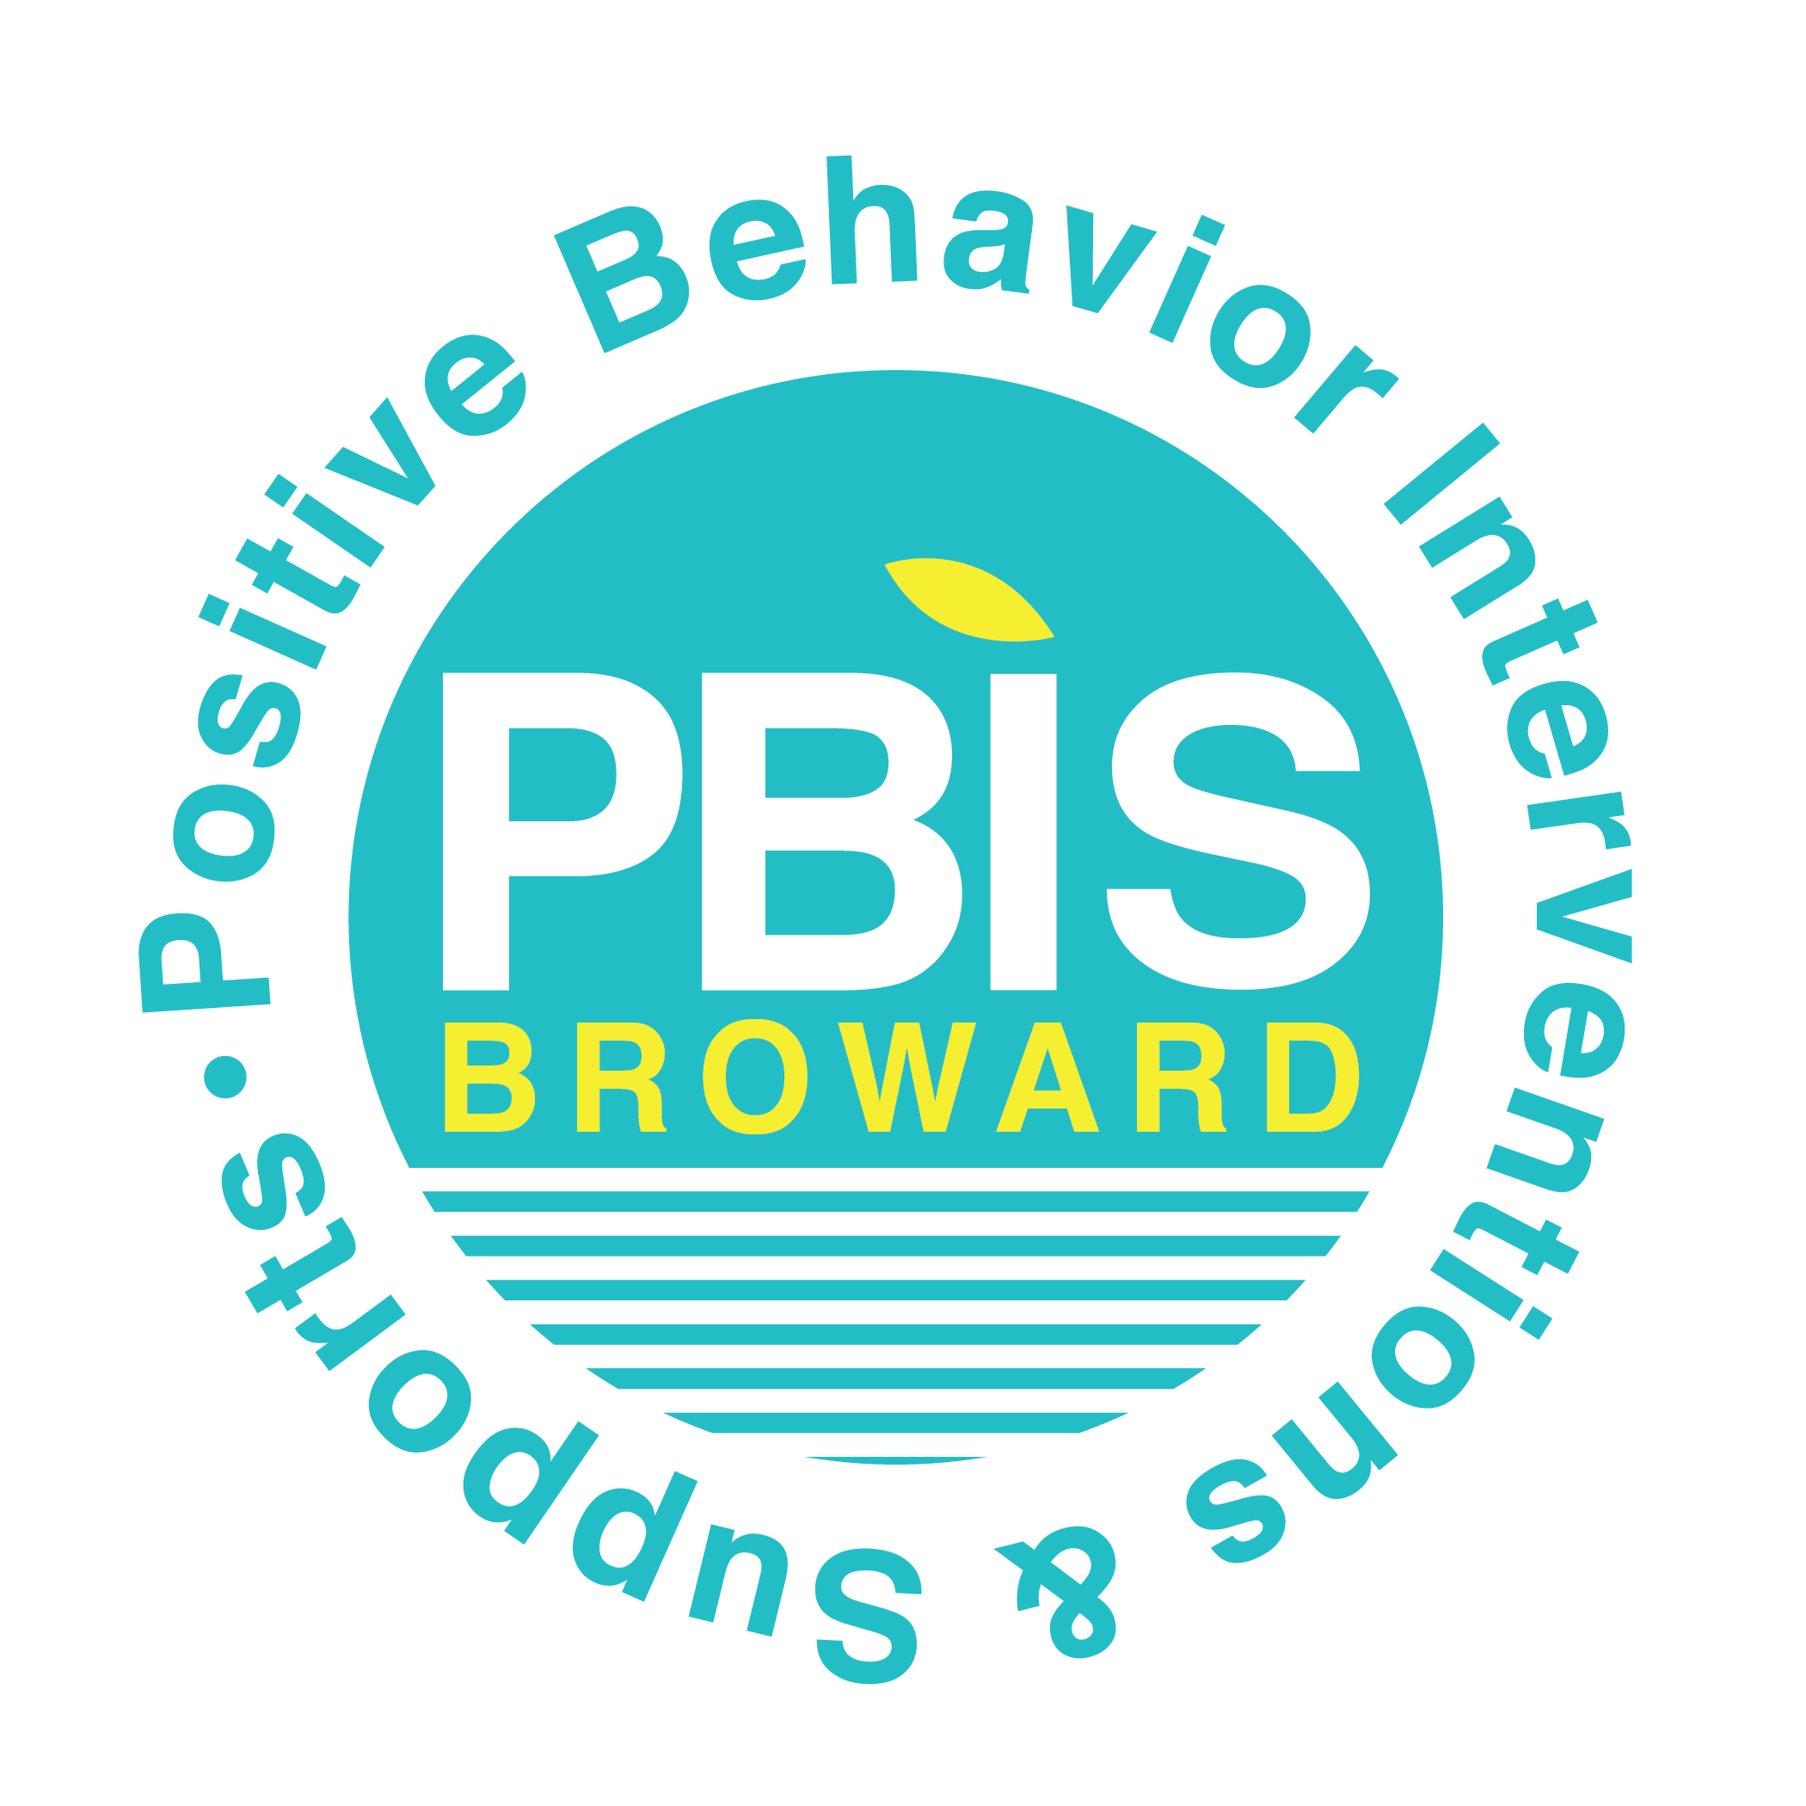  Cafeteria  Rules | School Grounds  AM Arrival/PM Dismissal  Rules | Hallway  Rules | Classroom  Rules
Responsibility | - Use a CHAMPs voice Level 2  - Eat only the food that belongs to you | - Use a CHAMPs voice level 0  - Read a book to yourself | - Use a CHAMPs voice level 0  - Panther walk on the right side of the hallway
Ownership | - Clean up all trash and food left on the table and floor | - Remain in your waiting area until the first bell rings | - Walk directly to your destination
Awesome Attitude | - Use kind words and speak in a positive tone to adults and classmates | - Follow all adult directions the first time given | - Follow all adult directions the first time given
Respect | - Keep hands, feet, and food to yourself | - Keep hands, feet, and objects to yourself | - Keep hands and feet to yourself

Pinewood Elementary School
School-Wide Expectations/Rules Matrix

4C. At least one Rules lesson plan for each specific location is distributed to teachers during pre-planning SY 2019/20 and maintained in the SPBP Binder.

Dates the Locations’ Rules lesson plans are taught
 | Date(s) | Time: |  | Location(s):
August | August 14-20, 2019 |  | 8:00-8:25AM | All PreK-5th Grade Classrooms
January | January 7-10, 2020 |  | 8:00-8:25AM | All PreK-5th Grade Classrooms
After Spring Break | March 30-April 3, 2020 |  | 8:00-8:25AM | All PreK-5th Grade Classrooms

CRITICAL ELEMENT # 5: Reward and Recognition Programs

5. The reward system is focused on one School-wide Expectation OR specific location at a time.
Expectation or Location: Respect (ROAR Expectation)

4 Step Problem Solving Process | Plan Details
1. Problem Identification: Use your behavior data to identify one school-wide problem.  What problem did you identify? (use numerical data) | Data used: Behavior incidents- Disobedience/Insubordination are the highest amount of office discipline referrals; 33% of total incidents.  Problem Identification Statement: Students are receiving the highest amount of office discipline referrals for disobedient/insubordinate behavior. Students receiving disobedience/insubordination ODRs are not showing respect to adults which one of the RORA school-wide expectations.
2. Problem Analysis: Why do you think this problem is occurring?  What is your goal? (use a SMART goal statement with numerical data) | Hypothesis: Students who receive ODRs for disobedience/insubordination are not exhibiting respect, one of our school-wide expectations. If students are taught and motivated to demonstrate respect, then the percentage of disobedience/insubordination referrals will be reduced.  Goal Statement: By April 2020, the percentage of disobedience/insubordination referrals in all school settings will decrease by 10% from a baseline of 33%.
3. Intervention Design: Describe how you will implement a positive reward program to decrease this problem. | Type of System: Token system  Description of System: Students who use ROAR actions will receive a Panther Buck and HERO points from a staff member. (Responsibility, Ownership, Awesome Attitude and Respect). Students can earn bucks from the classroom teacher, cafeteria supervisor and hallway monitors. Students can cash in panther bucks at the school store on a bi-weekly basis for prizes. PBIS team and PTA monitor the fidelity of implementation by teachers and provide support to teachers who are not utilizing the reward system or teaching behavioral expectations.
4. Evaluation:  A. Implementation fidelity | - How will you monitor the fidelity (consistency and effectiveness) of the staff’s implementation of the reward program? (2-3 sentences)  Ms. Milner will review PBIS store inventory and Panther Buck usage data to ensure all students have opportunity to earn Panther Bucks points in every class. Teachers who have difficulty utilizing the school-wide reward system will receive support from the PBIS team.
B. Student outcome monitoring | - How will you know if the reward program is positively impacting students? What measurable data will you use to determine “success”? (2-3 sentences)  Using the “Daily Activity” report in HERO, students who earn enough HERO “Panther Bucks” points in the month cash tickets in for prizes at the Panther Buck store open every two weeks. Students who have not earned HERO Panther Bucks points during the month will be supported through response to intervention.

CRITICAL ELEMENT #6: Effective Discipline Procedures
Pinewood Elementary School
Discipline Flow Chart
Observe and identify problem behavior
Teacher/Staff vs. Administration
Managed Managed
- Out of assigned area
- Inappropriate language
- Tardiness
- Calling/blurting out
- Teasing
- Inattentive Behavior
- Invading personal space
- Lying/giving false information
- Minor disruption
- Minor aggression-grabbing items
- Pushing past someone
- Rough play
- Disrespectful tone
- Not completing homework
- Dress Code
- Cheating
- Profanity tow

- Aggressive physical contact
- Bullying/Harassment
- Fighting
- Property destruction
- Weapons
- Leaving school property
- Pattern of aggressive/profane language
- Credible threats
- Major/chronic destruction
- Major/chronic refusal to follow school rules
- Theft
- Racial/Ethnic discrimination
- Inappropriate use of internet
- Direct refusal of authority

Administration managed

Teacher managed
Redirect student
Verbal Warning
2nd Step: Same Behavior Reteach Expectation/Rule
Use Tier 1 Behavior Strategies (proximity, positive specific praise, non-verbal gesures/cues

Reteach Expectations/Rules Use Classroom Management System (CHAMPs), Provide Choices, Loss of Privilege, Reflection Sheet
Submit Referral/Contact Guidance/Administration for next action steps

Referring Teacher/Staff Member completes discipline referral and contacts parent
Administrative action/Administrative Consequence
Contact Parent
Continue to Reteach Expectations/ Rules

Administration follows up teacher/staff member

Student Behavior Management Process
Consistently Teach and Re-Teach
School-Wide Rules/Expectations

Is the behavior Teacher or Administration managed?
YES
Notice and reward correct behaviors
NO
Crisis Incident is when a student is in immediate danger of harming him/herself or another student. Call office for removal of student.
Did the behavior change?

Tier 1
Behavior Strategies must be entered into BASIS

CRITICAL ELEMENT # 7: Classroom Management Systems

7A. In SY 2019/20, ALL teachers implement an evidence-based Tier 1 classroom management system:
Evidence-based system: | Evidence of training:
☒ CHAMPS | % of teachers currently holding valid CHAMPS certificate: 100%
☐ PBIS Classroom Management  http://www.fl-pda.org/independent/ | % of teachers currently holding completion certificate:
☐ Other: Click here to enter name of system. | Training evidence: Click here to enter evidence  % of teachers currently trained:

7B. The administration reviews and analyzes the fidelity of staff implementation of Tier 1 classroom management systems across teachers using:
☒ CHAMPs 7 Up Checklist
☐ Basic FIVE (Classroom Management Screening)
☐ PBIS Classroom Assistance Tool (CAT)
☐ Other (specify):
☐ Classroom management screening is not conducted across teachers to determine appropriate professional
development. (Next year, assessment of classroom management implementation fidelity will be scored).

7C. School year 2018/19 percentage of classroom referrals:
Total number of discipline referrals from classrooms: | 111
Total number of other school-wide discipline referrals: | 93
% of referrals in the classroom: | 54%
Do more than 40% of your referrals come from the classroom? | ☒ Yes ☐ No
If >40% of discipline referrals come from the classroom, it suggests Tier 1 classroom management implementation may need to be strengthened school-wide.
If “Yes”, school-wide classroom management professional development will be conducted in 2019-20:
CHAMPS Brainsharks - Individual If “Other”, indicated system here: Click here to enter text.

CRITICAL ELEMENT # 8: Data Collection and Analysis

8A. Core Effectiveness:
TOTAL Population: | 609 | % of Total Population | Core Effectiveness
# Referrals: | # of Students:
0 - 1 referrals |  | 92% | Are your 0 – 1 referrals > 80%? | ☒Yes ☐No
2 - 5 referrals  (at risk students) | 39 | 6% | Are your 2 - 5 referrals <15%? | ☒Yes ☐No
> 5 referrals  (high risk students) | 12 | 2% | Are your >5 referrals <5%? | ☒Yes ☐No

8B. Core Effectiveness Action Steps:
If all 3 are “Yes”, your core is effective. Is your core behavior curriculum effective? | ☒Yes ☐No
Answer either (a) or (b):
(a) If you answered “Yes”, although your core is effective, what steps does your school leadership team take for early identification of at risk and high-risk students?
(b) If you answered “NO”, indicate the supports and interventions your school leadership team will implement at the beginning of the next school year to improve core strength:
Core Effectiveness Action Steps: (3-4 steps)
Pinewood ES uses the Panther Buck and HERO system to track positive behavior for students in all school settings (classroom, cafeteria, hallways, playground). Students who earn “Panther Bucks” will receive a reward at the Panther Store. In addition, the Collaborative Problem-Solving Team (CPST) will meet to put behavioral support plans into place for students who receive multiple office discipline referrals. Coaches will work with those teachers to make sure the PBIP is in place and implemented with fidelity. CPST will progress monitor and adjust the behavior support plans as needed to reinforce expectations and teach replacement positive behavior.

8C. Disproportionality within racial subgroups:
Subgroups | (PctPop - Green)  % of students | (PctRef - Blue)  % of referrals | Difference in referral composition | Positive value suggests disproportionality  (Is the value positive?)
Black | 78 | 85 | 7 | ☒Yes ☐No
Hispanic/Latin | 13 | 13 | 0 | ☐Yes ☒No
White | 4 | 0 | -4 | ☐Yes ☒No

8D. Disproportionality Action Steps:
If all three are “No”, disproportionality is not indicated. Are all 3 “No”? | ☐Yes ☒No
Answer either (a) or (b):
(a) If you answered “Yes”, although your data indicates equity, what plan does your school leadership team implement for early identification of any disproportionality issues
(b) If you answered “No”, indicate the support plan and interventions your school leadership team will implement at the beginning of next year to improve sub group disproportionality
Disproportionality Action Steps: (3-4 steps)
Data indicate disproportionality among black subgroup of students receiving a higher percentage of office discipline referrals than percentage of population. The Collaborative Problem-Solving Team (CPST) will share data with teachers and support teachers with implementing effective Tier 1 classroom management practices such as PAX Good Behavior Game (K-2) and CHAMPS (K-5). The CPST will also support teachers with using culturally responsive teaching practices in the classroom to reduce the disproportionality among these students.

Critical Elements # 9: SPBP Implementation Planning
RED Font = Action Steps for all schools in Broward County
GREY Font = Best Practices for all schools in Broward County
TEAL Font = Resources available at https://browardcountyschools.sharepoint.com/sites/DPI6Strands/strand6/SitePages/SPBP.aspx
SPBP Team Implementation Action Plan 2019 - 2020
Month | Action Steps  ☒ check off Action Step when completed
Current | ☐ Create a SPBP binder or portfolio to retain (for 2 years) hard copies of: your SPBPs, Action Plans, staff PBIS  professional development attendance, stakeholder training attendance, quarterly meeting agendas, quarterly staff  behavior presentations, voting attendance and outcome, Expectations lesson plans and Rules lesson plans
Pre-Planning  2019 | ☐ Print up your SPBP Review and school score from OSPA  ☐ Provide SPBP presentation to all staff during Pre-Planning  ☐ Disseminate the current SPBP (hard copy or electronically) to all staff and stakeholders  ☐ Market and post school-wide Expectations and location-specific Rules  ☐ Identify your district RtI Instructional Facilitator  (Contact tyyne.hogan@browardschools.com for more information, if you are unsure)  ☐ Confirm 1st team meeting date and time
August  1st meeting | ☐ Ensure schedule of quarterly meeting dates for entire year as indicated in the SPBP  ☐ Review Implementation plan; check off completed Action Steps  ☐ Determine any needed team training, such as these Brainsharks: 4 Step Problem Solving Process series, PBIS 10  Critical Elements, Data Collection, Big 5 Data, PBIS 101, etc. (All found in Sharepoint site)  ☐ Review previous year’s behavior data. (Use ‘Agenda’ Form and ‘Data Collection Template’ in Sharepoint site)  ☐ Utilize the 4 Step Problem Solving Process to initiate a Reward System for all students  ☐ Review previous year’s SPBP and feedback form; make necessary modifications  ☐ Verify and implement teaching schedule for Expectations and Rules behavior lesson plans  ☐ Present implementation data, behavior data, team activities and SPBP progress to entire staff
September | ☐ Provide SPBP stakeholder presentation prior to October 1  ☐ Check for staff and teacher understanding of PBIS - provide “PBIS 101” Brainshark as a resource  Brainshark available at: http://www.brainshark.com/browardschools/PBIS101  ☐ Ensure the Discipline Flow Chart is distributed to all staff and is being used as written
October  2nd meeting | ☐ Review Implementation plan; check off completed Action Steps  ☐ Ensure instructional staff know how to (and are, as needed) enter Tier 1 Supplemental Strategies  for behavior in BASIS  ☐ Review previous quarter’s behavior data. (Use ‘Agenda’ and ‘Data Collection Template’ in Sharepoint site)  ☐ Present implementation data, behavior data, team activities, and SPBP progress to entire staff  ☐ Ensure all teachers are using an evidence-based classroom management plan, such as CHAMPS  ☐ Ensure Core Effectiveness Action Steps are being implemented as written
November | ☐ Team to develop new and/or improved lesson plans as indicated by behavior data.  ☐ Ensure that the Disproportionality Action Steps are being implemented as written
January  2020  3rd meeting  Prepare for SY 2020/21 SPBP | ☐ Review Implementation plan; check off completed Action Steps  ☐ Staff to re-teach Expectations and Rules after winter break  ☐ Principal signs in and watches the new “SPBP for Principals” Brainshark: Due January 30th  ☐ Present implementation data, behavior data, team activities, and SPBP progress to entire staff  ☐ Choose team members and dates to work on, complete, and submit the new SPBP  ☐ Teams watch the new “SPBP Team Overview” Brainshark and refers to district resources and supports  (Brainsharks and Additional items in Sharepoint site. Webinars and in-person lab information in Team Brainshark)
February | ☐ Ensure progress towards completion of SPBP  ☐ Check on recently hired staff for PBIS understanding - provide “PBIS 101” Brainshark resource  ☐ Provide the SPBP Surveymonkey link to all staff (optional)
March  4th meeting | ☐ Ensure progress towards completion and submission of SPBP  ☐ Review Implementation plan; check off completed Action Steps  ☐ Staff to re-teach Expectations and Rules after from spring break  ☐ Provide stakeholders/parent presentation on new SPBP for next year  ☐ Provide staff presentation and faculty vote on new SPBP for next year  ☐ Present implementation data, behavior data, team activities, and SPBP progress to entire staff
April | ☐ Submit your SPBP in OSPA by April 30th every year. Use this new SPBP in the next school year  ☐ Continue implementing your current SPBP through the end of the current school year

CRITICAL ELEMENT # 10: Evaluation

10A. Staff implement the School-wide Positive Behavior Plan effectively:
“Are staff implementing the SPBP with fidelity? How do you know?”
STAFF Implementation Monitoring
Action Step | Create an observable and measurable SMART goal to determine “successful”  staff implementation of action step
School-wide expectations and location-specific rules are posted across campus | By April 2020, expectation/rules posters will be displayed in 100% of classrooms and rule posters will be displayed in the top three locations: hallway, cafeteria and playground.  By April 2020, 90% of teachers and students interviewed will be able to recall ROAR expectations.
Expectations and Rules lesson plans are being taught as written and when indicated | By April 2020, 95% of teachers will teach behavior lesson plans as observed through classroom walkthroughs during the specified dates/times.
The Discipline flow chart is being used by all staff as written | Each quarter Pinewood will have 20% less ODRs in the 2018-19 SY than the 2017-18 school year.
A reward system is being implemented for all students | By April 2020, 90% of teachers will use the Panther Buck system to track students who demonstrate ROAR expectations. CPST will monitor teacher usage data monthly and provide support as needed.

10B. The SPBP is successful in positively impacting students:
“If staff are implementing the SPBP consistently and effectively, did it positively impact the students? How do you know?”
STUDENT Outcome Monitoring
Student Outcome Data | Create an observable and measurable SMART goal to determine  “successful” student outcomes
Behavior Incident data  (See critical element #3A) | By June 2020, Pinewood will decrease the percentage of behavior incidents in 2019-20 by 10% as compared to the 2018-19 school year.
Top 3 event locations data  (See critical element #4A) | By June 2020, the percentage of behavior incidents occurring the top three locations: cafeteria, hallway and arrival/dismissal will decrease by 10% as compared to the 2018-19 school year.
Core effectiveness data  (See critical element #8A) | By June 2020, 90% or more of students will receive 0-1 office discipline referral during the 2018-19 school year as compared to the 2018-19 school year.
Classroom referrals data  (See critical element #7C) | By June 2020, office discipline referral incidents in the classroom will decrease by 15% as compared to the 2018-19 school year.

