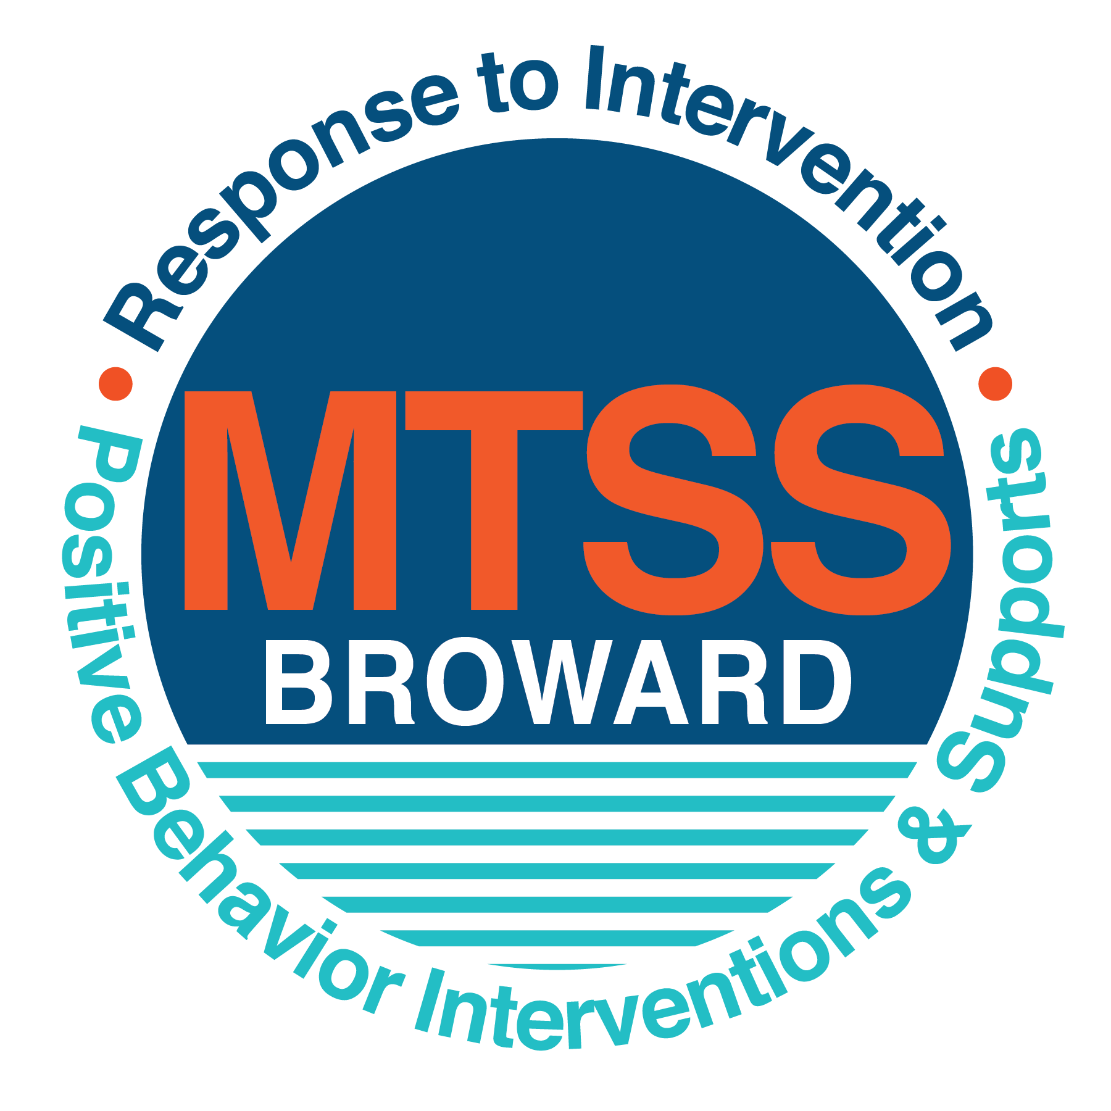
School-wide Positive Behavior Plan (SPBP)
Broward County Public Schools
To be implemented in SY 2019/20

School Name: | Ramblewood Elementary
School Number: | 2721
SPBP Contact Name: | Gregory Charlotin
Direct Phone Number: | 954-448-2708

CRITICAL ELEMENT # 1: Active Team with Administrative Participation

1A. Current (SY 2018/19) SPBP team members:
Full Name | Position
Maria E. Perez | 1. Administration
Alvaro Picado | 2. BTU Representative
Gregory Charlotin | 3. SPBP Point of Contact
Christina Stewart | 4. Parent/Community Representation
Diana Berrieum | 5. Guidance Counselor
Audrey Fay | 6. Literacy Coach
Kathy Kinsley | 7. E.S.E. Specialist
Nicole Schuler | 8. Gr. 1 Teacher - Primary
Adina Lapaglia | 9. Gr. 5 Teacher - Intermediate
Karen Wheeler | 10. Media Specialist - Specials

1B. Schedule of quarterly SPBP Team Meeting dates for next 2019/20 school year:
Meeting Date | Meeting Time | Content of meetings:
10/23/2019 | 2:15 p.m. | 1. Progress of Action Steps indicated in Implementation Plan in #9  2. Collect & analyze fidelity of staff implementation data in #10A  3. Collect & analyze student outcome data in #10B
12/18/2019 | 2:15 p.m.
3/25/2020 | 2:15 p.m.
5/29/2020 | 2:15 p.m.

CRITICAL ELEMENT # 2: Faculty & Stakeholder Commitment:

2A. Action Steps completed this year (SY 2018/19) that increased faculty and stakeholder knowledge of the new SPBP:

Action Steps: | Date  (Between Jan 15 and  April 30, 2019) | Details  (Sign-in sheets in SPBP Binder)
Presented the new SPBP (for SY 2019/20) to staff | 4/24/2019 | # of participants = 77
Held a faculty vote on the new SPBP  (for SY 2019/20) | 3/27/2019 | # of participants = 88%  % approved =
Presented the new SPBP (for SY 2019/20) to stakeholders (parents and community) | 4/17/2019 | # of participants = 15

2B. Action Steps to be completed next year (SY 2019/20) to increase faculty and stakeholder knowledge of the new SPBP:

Action Steps: | Date  (SY 2019-20) | Content  (Sign-in sheets in SPBP Binder)
Provide professional development on the 2019/20 SPBP for all staff | Prior to students’ 1st day:  8/8/2019 | The team will present the updates in the SPBP for the 19/20 school year. All stakeholders will be provided with access to the SPBP. Feedback will be collected for future team meetings.
Present the 2019/20 SPBP to stakeholders  (parents and community) | Prior to Oct 1st, 2019  9/18/2019
Present the behavior data to all staff quarterly | 1. 10/23/2019 | The team will present:  - the team’s progress in the Implementation Plan in # 9.  - the fidelity of staff implementation data in #10A.  - the student outcome data in #10B.
 | 2. 12/18/2019
 | 3. 3/25/2020
 | 4. 5/27/2020

CRITICAL ELEMENT # 3: School-wide Expectations

3A. Top five behavior incidents data YTD as listed in BASIS 3.0
Top 5 Behavior Incidents
- Unruly/Disruptive Behavior
- Disobedience/Insubordination
- Battery
- Disruptive/Unruly Play
- Assault Threat (Non-Criminal)

3B. School-wide expectations are 3 – 5 positive characteristics (not behaviors) that counteract the demonstration of the top school-wide misbehaviors above. ALL people on campus model these expectations.
School-wide Expectations
- Be Respectful
- Be Responsible
- Be Kind
- Be Positive
- Be safe

3C. At least one lesson plan for each school-wide expectation above is distributed to teachers during pre-planning SY 2019/20 and maintained in the SPBP Binder.
Dates the school-wide expectations lesson plans are taught:
 | Date(s) | Time: | Location(s):
August | Week of August 14 | 8:15-9:15 a.m. | Classrooms
January | Week of January 6 | 8:15-9:15 a.m. | Classrooms
After Spring Break | Week of April 6 | 8:15-9:15 a.m. | Classrooms

CRITICAL ELEMENT #4: Location-based Rules

4A. Top three school-wide locations for Behavior Events YTD.
Top 3 Locations, not including Classroom:
School Location | # Incidents
1. Cafeteria | 7
2. Hallways | 7
3. Playground | 2

4B. Expectations and Rules Chart for common areas of school campus: (next page)

Expectations and Rules Chart |  |  |  | To be completed by classroom teachers
School-wide EXPECTATIONS | Cafeteria Rules | Hallway Rules | Playground Rules | Classroom Rules
Be Respectful | Follow adult directions. Use table manners | Walk quietly so others can continue to learn | Line up with the adult calls. Follow adult directions | Follow adult directions the first time a directive is given
Be Responsible | Stay in seat. Raise hand when you need something. Pick up after yourself. | Walk on the right side and in single file | Collect equipment when lining up. | Complete all assignments. Take responsibility for own actions.
Be Kind | Say please/thank you. Use kind words when speaking to others. | Yield to passing classes | Use kind words. Take turns/ share equipment. | Use kind words with students and adults. Help others when needed.
Be Positive | Show respect to all adults monitoring the cafeteria | Show respect to all adults monitoring the hallways | Show respect to all adults monitoring the playground | Show respect to all adults and students
Be Safe | Remain seated until an adult says other wise | Walk quietly in a single file | Follow playground rules | Follow classroom rules and procedures.

4C. At least one Rules lesson plan for each specific location is distributed to teachers during pre-planning SY 2019/20 and maintained in the SPBP Binder.

Dates the Locations’ Rules lesson plans are taught
 | Date(s) | Time: | Location(s):
August | Week of August 14 | 8:15-9:15 am. | Classrooms
January | Week of January 6 | 8:15-9:15 a.m. | Classrooms
After Spring Break | Week of April 6 | 8:15-9:15 | Classrooms

CRITICAL ELEMENT # 5: Reward and Recognition Programs

5. The reward system is focused on one School-wide Expectation OR specific location at a time.
Expectation or Location: ________Be Respectful__________________________

4 Step Problem Solving Process | Plan Details
1. Problem Identification: Use your behavior data to identify one school-wide problem.  What problem did you identify? (use numerical data) | Data used: Basis 3.0 Discipline Referrals  Problem Identification Statement: 50% of the referrals are coded to Unruly Disruptive behavior, which directly tied to students lack of respect.
2. Problem Analysis: Why do you think this problem is occurring?  What is your goal? (use a SMART goal statement with numerical data) | Hypothesis: If School-wide Positive Behavior Plan is put in place, incidents of behavior in high incident areas will decrease.  Goal Statement: Behaviors codded to Unruly Disruptive Behaviors will decrease by 50%.
3. Intervention Design: Describe how you will implement a positive reward program to decrease this problem. | Type of System: Lottery  Description of System: The program that we will implement is called the “Caught Being Good”. Students “Caught Being Good” are given a ticket in which they can enter a raffle to win prizes. Student raffle winners are announced weekly on the morning announcements, therefore providing positive reinforcement.
4. Evaluation:  A. Implementation fidelity | - How will you monitor the fidelity (consistency and effectiveness) of the staff’s implementation of the reward program? Administration and Guidance Counselor will be responsible for tracking assigned grade level(s) to ensure fidelity of the program. Non-compliant teachers will be reminded of the procedures.
B. Student outcome monitoring | - How will you know if the reward program is positively impacting students? What measurable data will you use to determine “success”? The program is positively impacting students if there is decrease in incidents and behaviors as documented in BASIS 3.0 discipline referrals

CRITICAL ELEMENT #6: Effective Discipline Procedures

Student Behavior Discipline Flow Chart
Observe problem behavior behaviorBehavior
Intervene and redirect
Office Managed Misbehaviors
Staff Managed Misbehaviors
Call to notify office of
referral written in DMS
No
Yes

Implement an initial consequence
Is behavior Office Managed?
(if unsure, check below)

Behavior is corrected
Behavior is not corrected Implement Discipline
Management System
Reinforce/reward student
Issue referral to Guidance or If behavior is a crisis, follow
Administration crisis protocol

Specific Examples of  6 Staff Managed  Misbehaviors: | Specific Examples of  6 Office Managed  Misbehaviors:
- Talking out of turn  - Chasing/ Horse play  - Making distracting noises  - Not walking quietly in line  - Not completing classwork/homework  - Running in building/ on walkways | - Disobedience/Insubordination  - Disruptive/Unruly Play  - Defiance of authority  - Battery  - Assault/Threat  - Repetitive staff managed  misbehaviors

CRITICAL ELEMENT # 7: Classroom Management Systems

7A. In SY 2019/20, ALL teachers implement an evidence-based Tier 1 classroom management system:
Evidence-based system: | Evidence of training:
☒ CHAMPS | 25% of teachers currently holding valid CHAMPS certificate:
☒ PBIS Classroom Management  http://www.fl-pda.org/independent/ | 100% of teachers currently holding completion certificate:
☐ Other: Click here to enter name of system. | Training evidence: Click here to enter evidence  % of teachers currently trained:

7B. The administration reviews and analyzes the fidelity of staff implementation of Tier 1 classroom management systems across teachers using:
☐ CHAMPs 7 Up Checklist
☐ Basic FIVE (Classroom Management Screening)
☒ PBIS Classroom Assistance Tool (CAT)
☒ Other (specify):Marzano Domain 1, Design Question 5,6,7,8,9
☐ Classroom management screening is not conducted across teachers to determine appropriate professional
development. (Next year, assessment of classroom management implementation fidelity will be scored).

7C. School year 2018/19 percentage of classroom referrals:
Total number of discipline referrals from classrooms: | 46
Total number of other school-wide discipline referrals: | 22
% of referrals in the classroom: | 68%
Do more than 40% of your referrals come from the classroom? | ☒ Yes ☐ No
If >40% of discipline referrals come from the classroom, it suggests Tier 1 classroom management implementation may need to be strengthened school-wide.
If “Yes”, school-wide classroom management professional development will be conducted in 2019-20:
PBIS online course If “Other”, indicated system here: Click here to enter text.

CRITICAL ELEMENT # 8: Data Collection and Analysis

8A. Core Effectiveness:
TOTAL Population: | 870 | % of Total Population | Core Effectiveness
# Referrals: 68 | # of Students:
0 - 1 referrals | 36 | 4% | Are your 0 – 1 referrals > 80%? | ☒Yes ☐No
2 - 5 referrals  (at risk students) | 10 | 1% | Are your 2 - 5 referrals <15%? | ☒Yes ☐No
> 5 referrals  (high risk students) | 2 | .02% | Are your >5 referrals <5%? | ☒Yes ☐No

8B. Core Effectiveness Action Steps:
If all 3 are “Yes”, your core is effective. Is your core behavior curriculum effective? | ☒Yes ☐No
Answer either (a) or (b):
(a) If you answered “Yes”, although your core is effective, what steps does your school leadership team take for early identification of at risk and high-risk students?
(b) If you answered “NO”, indicate the supports and interventions your school leadership team will implement at the beginning of the next school year to improve core strength:
Core Effectiveness Action Steps: (3-4 steps)
- Tier I strategies will be implemented in all classrooms.
- All at risk or high risk students will be referred to on campus groups led by the Guidance Counselor.
- They will also be referred to outside counseling agencies with parents’ consent. All teachers are required to have a discipline plan, which includes grade level team planning.
- Students with repeated behavioral actions will be referred to the Comprehensive Problem Solving Team (CPST) and placed on behavioral RtI.

8C. Disproportionality within racial subgroups:
Subgroups | (PctPop - Green)  % of students | (PctRef - Blue)  % of referrals | Difference in referral composition | Positive value suggests disproportionality  (Is the value positive?)
Black | 31 | 55 | 14 | ☒Yes ☐No
Hispanic/Latin | 36 | 14 | -12 | ☐Yes ☒No
White | 27 | 25 | -2 | ☒Yes ☒No

8D. Disproportionality Action Steps:
If all three are “No”, disproportionality is not indicated. Are all 3 “No”? | ☐Yes ☒No
Answer either (a) or (b):
(a) If you answered “Yes”, although your data indicates equity, what plan does your school leadership team implement for early identification of any disproportionality issues
(b) If you answered “No”, indicate the support plan and interventions your school leadership team will implement at the beginning of next year to improve sub group disproportionality
Disproportionality Action Steps: (3-4 steps)
- Disproportionality Plan: Tier I strategies will be implemented in all classrooms.
- All at risk or high risk students in all subgroups will be referred to on campus groups led by the Guidance Counselor.
- They will also be referred to outside counseling agencies with parents’ consent. All teachers are required to have a discipline plan, which includes grade level team planning.
- Students with repeated behavioral actions will be referred to the Comprehensive Problem Solving Team (CPST) and placed on behavioral RtI.

Critical Elements # 9: SPBP Implementation Planning
RED Font = Action Steps for all schools in Broward County
GREY Font = Best Practices for all schools in Broward County
TEAL Font = Resources available at https://browardcountyschools.sharepoint.com/sites/DPI6Strands/strand6/SitePages/SPBP.aspx
SPBP Team Implementation Action Plan 2019 - 2020
Month | Action Steps  ☒ check off Action Step when completed
Current | ☐ Create a SPBP binder or portfolio to retain (for 2 years) hard copies of: your SPBPs, Action Plans, staff PBIS  professional development attendance, stakeholder training attendance, quarterly meeting agendas, quarterly staff  behavior presentations, voting attendance and outcome, Expectations lesson plans and Rules lesson plans
Pre-Planning  2019 | ☐ Print up your SPBP Review and school score from OSPA  ☐ Provide SPBP presentation to all staff during Pre-Planning  ☐ Disseminate the current SPBP (hard copy or electronically) to all staff and stakeholders  ☐ Market and post school-wide Expectations and location-specific Rules  ☐ Identify your district RtI Instructional Facilitator  (Contact tyyne.hogan@browardschools.com for more information, if you are unsure)  ☐ Confirm 1st team meeting date and time
August  1st meeting | ☐ Ensure schedule of quarterly meeting dates for entire year as indicated in the SPBP  ☐ Review Implementation plan; check off completed Action Steps  ☐ Determine any needed team training, such as these Brainsharks: 4 Step Problem Solving Process series, PBIS 10  Critical Elements, Data Collection, Big 5 Data, PBIS 101, etc. (All found in Sharepoint site)  ☐ Review previous year’s behavior data. (Use ‘Agenda’ Form and ‘Data Collection Template’ in Sharepoint site)  ☐ Utilize the 4 Step Problem Solving Process to initiate a Reward System for all students  ☐ Review previous year’s SPBP and feedback form; make necessary modifications  ☐ Verify and implement teaching schedule for Expectations and Rules behavior lesson plans  ☐ Present implementation data, behavior data, team activities and SPBP progress to entire staff
September | ☐ Provide SPBP stakeholder presentation prior to October 1  ☐ Check for staff and teacher understanding of PBIS - provide “PBIS 101” Brainshark as a resource  Brainshark available at: http://www.brainshark.com/browardschools/PBIS101  ☐ Ensure the Discipline Flow Chart is distributed to all staff and is being used as written
October  2nd meeting | ☐ Review Implementation plan; check off completed Action Steps  ☐ Ensure instructional staff know how to (and are, as needed) enter Tier 1 Supplemental Strategies  for behavior in BASIS  ☐ Review previous quarter’s behavior data. (Use ‘Agenda’ and ‘Data Collection Template’ in Sharepoint site)  ☐ Present implementation data, behavior data, team activities, and SPBP progress to entire staff  ☐ Ensure all teachers are using an evidence-based classroom management plan, such as CHAMPS  ☐ Ensure Core Effectiveness Action Steps are being implemented as written
November | ☐ Team to develop new and/or improved lesson plans as indicated by behavior data.  ☐ Ensure that the Disproportionality Action Steps are being implemented as written
January  2020  3rd meeting  Prepare for SY 2020/21 SPBP | ☐ Review Implementation plan; check off completed Action Steps  ☐ Staff to re-teach Expectations and Rules after winter break  ☐ Principal signs in and watches the new “SPBP for Principals” Brainshark: Due January 30th  ☐ Present implementation data, behavior data, team activities, and SPBP progress to entire staff  ☐ Choose team members and dates to work on, complete, and submit the new SPBP  ☐ Teams watch the new “SPBP Team Overview” Brainshark and refers to district resources and supports  (Brainsharks and Additional items in Sharepoint site. Webinars and in-person lab information in Team Brainshark)
February | ☐ Ensure progress towards completion of SPBP  ☐ Check on recently hired staff for PBIS understanding - provide “PBIS 101” Brainshark resource  ☐ Provide the SPBP Surveymonkey link to all staff (optional)
March  4th meeting | ☐ Ensure progress towards completion and submission of SPBP  ☐ Review Implementation plan; check off completed Action Steps  ☐ Staff to re-teach Expectations and Rules after from spring break  ☐ Provide stakeholders/parent presentation on new SPBP for next year  ☐ Provide staff presentation and faculty vote on new SPBP for next year  ☐ Present implementation data, behavior data, team activities, and SPBP progress to entire staff
April | ☐ Submit your SPBP in OSPA by April 30th every year. Use this new SPBP in the next school year  ☐ Continue implementing your current SPBP through the end of the current school year

CRITICAL ELEMENT # 10: Evaluation

10A. Staff implement the School-wide Positive Behavior Plan effectively:
“Are staff implementing the SPBP with fidelity? How do you know?”
STAFF Implementation Monitoring
Action Step | Create an observable and measurable SMART goal to determine “successful”  staff implementation of action step
School-wide expectations and location-specific rules are posted across campus | All hallways, classrooms, and cafeteria will have expectations and rules posted.
Expectations and Rules lesson plans are being taught as written and when indicated | Amount, type, and location of referrals issued will be analyzed to measure frequency.
The Discipline flow chart is being used by all staff as written | Walkthroughs will be conducted to monitor that all staff follow the discipline consequences and flow chart.
A reward system is being implemented for all students | Students will enter raffle in which prizes will be given for positive behavior.

10B. The SPBP is successful in positively impacting students:
“If staff are implementing the SPBP consistently and effectively, did it positively impact the students? How do you know?”
STUDENT Outcome Monitoring
Student Outcome Data | Create an observable and measurable SMART goal to determine  “successful” student outcomes
Behavior Incident data  (See critical element #3A) | The incident report found in BASIS 3.0 is analyzed to determine if the number of student referrals have increased or decreased
Top 3 event locations data  (See critical element #4A) | Analyze referrals in top 3 areas to determine if referrals are increasing or decreasing in areas on a monthly basis
Core effectiveness data  (See critical element #8A) | Core effectiveness data will be analyzed during CPST meeting to determine if we need to readjust plan
Classroom referrals data  (See critical element #7C) | Walkthroughs will be conducted to observe the effectiveness of teachers’ management skills

