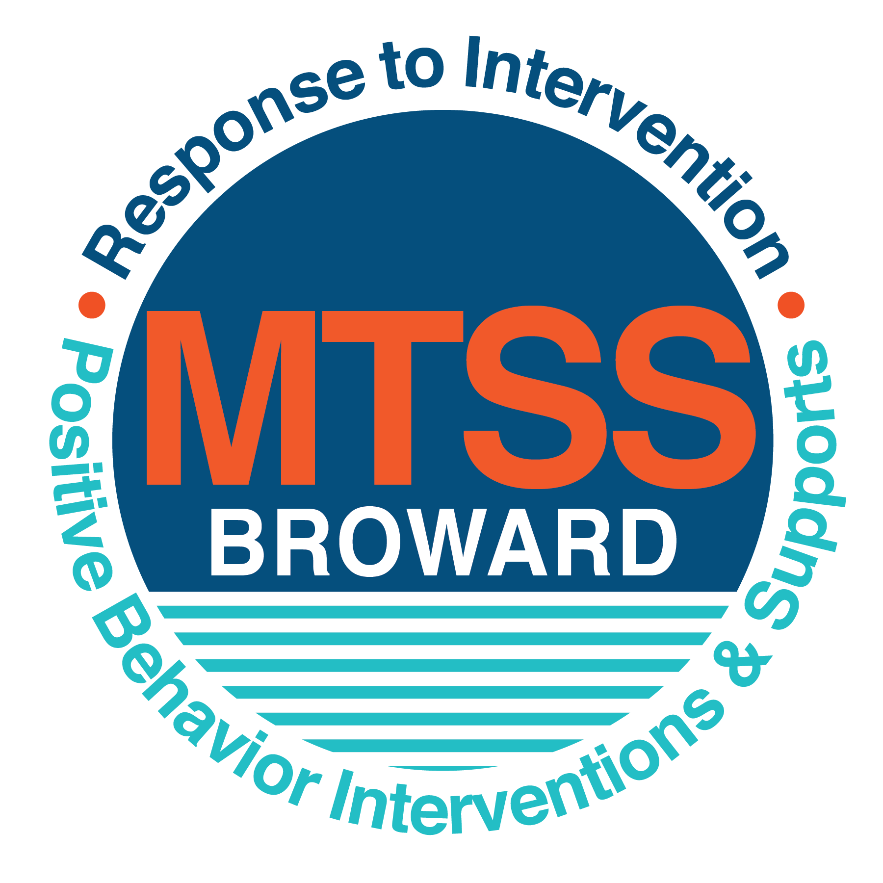**School-wide Positive Behavior Plan (SPBP)**

Broward County Public Schools

To be implemented in SY 2018/19

**Elements have changed in the SPBP.**

Before completing, go to[**http://www.browardprevention.org/mtssrti/rtib/ →**](http://www.browardprevention.org/mtssrti/rtib/%20→)*School-wide Positive Behavior Plan* for:

* **A NEW Brainshark for Principals. ACTION: Log in with your p # and watch the Brainshark before Jan 30th.**
* **A NEW Overview Brainshark for Teams. ACTION: Log in with school name and watch the Brainshark.**
* A NEW mini Brainshark Series for teams. These Brainsharks are divided into the 10 Critical Elements of PBIS. They will

show you “how to” write a comprehensive SPBP (and receive a high score!)

* A Rating Rubric to ensure teams will correctly complete the SPBP and develop a meaningful plan.

To provide consistency across the District, *only plans entered on the current district template will be accepted*.

**ACTION: Download, complete and upload the SPBP into your School Improvement Plan before May 1, 2018:**

|  |  |
| --- | --- |
| **School Name:** | Morrow Elementary School |
| **School Number:** | 2691 |
| **SPBP Contact Name:** | Chris Brightman |
| **Direct Phone Number:** | (754) 322-7158 |

|  |
| --- |
| **CRITICAL ELEMENT # 1: Active Team with Administrative Participation** |

**1A.** List your current (SY 2017/18) team members (6 - 10 team members). **Must include an instructional representative from EACH grade/content area.** *Each name on this list verifies attendance in ongoing team meetings and participation in developing this SPBP. Each member is responsible for representing major stakeholders and sharing the SPBP content and updates with their respective group.*

|  |  |  |
| --- | --- | --- |
| **Full Name** | **Position** | **Who or what grade level does this member represent?** |
| Dr. Laurel Crowle | Principal | Administration |
| Chris Brightman | SPBP Point of Contact / AP | Administration |
| Camille Plummer | Parent/Community Representation | SAC |
| Kim Reneau | BTU Representative | BTU and 2nd Grade |
| My D Nguyen | School Counselor | Support Staff |
| Jean Villus | ELL Coordinator | ELL |
| Tamilla Eldridge Mason | Literacy Coach | Support Staff and 5th Grade |
| Maria Betro | ESE Support Facilitator | ESE |
| Alisha Caesar | Early Head Start Teacher | Head Start |
| Christine Campbell | Intensive Pre-K Teacher | Pre-K |
| Michael Thomas | Kindergarten Teacher | Kindergarten |
| Dana Dowe | Reading Intensive Teacher | 1st Grade |
| Jennifer Gagne | 3rd Grade Teacher | 3rd Grade |
| Wynta Tiller | 4th Grade Teacher | 4th Grade |

**1B**. Schedule and document your quarterly team meeting dates for *next* 2018/19 school year:

|  |  |  |  |
| --- | --- | --- | --- |
| **Meeting Date** | **Meeting Time** | **Name & title of person responsible to facilitate meeting** | **Content of meetings:** |
| 8/8/2018 | 2:15 – 3:00 | Chris Brightman/Assistant Principal | 1. Create and disseminate updated  Expectations and Rules lesson  plans (#3 and #4)  2. Review progress of  Implementation Action Plan (#9)  3. Collect & analyze implementation  data (#10A)  4. Collect & analyze student  outcome data (#10B) |
| 10/18/2018 | 2:15 – 3:00 | Chris Brightman/Assistant Principal |
| 1/7/2019 | 2:15 – 3:00 | Chris Brightman/Assistant Principal |
| 3/21/2019 | 2:15 – 3:00 | Chris Brightman/Assistant Principal |

|  |
| --- |
| **CRITICAL ELEMENT # 2: Faculty & Stakeholder Commitment:** |

**2A**. Action Steps completed **this year** (SY 2017/18) that increased faculty and stakeholder understanding and knowledge of your *new* (2018/19) SPBP:

|  |  |  |  |
| --- | --- | --- | --- |
| **Action Steps:** | **Date**  *(Between Jan 15 –*  *April 30, 2018)* | **Details**  *(retain attendance sheets at school)* | **Person responsible to collect and retain attendance sheets:** |
| Presented the *new* SPBP (for SY 2018/19) to staff | 4/17/2018 | # of participants = 50 | Chris Brightman |
| Held a *faculty* vote on the new SPBP  (for SY 2018/19) | 4/24/2018 | % approved = 100% | Chris Brightman |
| Presented the *new* SPBP (for SY 2018/19) to stakeholders (parents and community) | 4/13/18: Shared draft to gather input.  5/17/18: Will present staff approved plan. | # of participants = 18 | Chris Brightman |

**2B.** Action Steps to be completed **next year** (SY 2018/19) to increase faculty and stakeholder understanding and knowledge of your SPBP:

|  |  |  |  |
| --- | --- | --- | --- |
| **Action Steps:** | **Date(s)**  *(NEXT YEAR)* | **Content**  *(retain attendance sheets at school)* | **Person responsible to collect and retain attendance sheets:** |
| Provide a professional development on the 2018/19SPBP for all staff | Prior to students’ 1st day:  8/8/2018 | The team will present the updates in the SPBP for the 18/19 school year. All stakeholders will be provided with access to the SPBP. Feedback will be collected for future team meetings. | Chris Brightman |
| Present the 2018/19SPBP to stakeholders (parents and community) | Prior to Oct 1st, 2018  9/14/2018 |
| Present behavior data to staff  *Quarterly: minimum of 4 each year* | 1. 10/18/2018 | The team will present the implementation data in 10A. Include:  • the “marketing” (teaching and posting) of expectations and rules  • lesson plan implementation  • discipline procedures  • reward system implementation  The team will present the student outcome data in 10B. Include:  • top 3 event locations  • type of behavior incidents  • core effectiveness data  • classroom referral data, as well as analysis of this data. | Chris Brightman |
| 2. 1/7/2019 |
| 3. 3/21/2019 |
| 4. 5/9/2019 |

|  |
| --- |
| **CRITICAL ELEMENT # 3: School-wide Expectations** |

**3A.** List the **top 10 behavior incidents** data YTD from BASIS 3.0 Behavior Dashboard:

|  |  |
| --- | --- |
| **Top 10 Behavior Incidents**  *(put N/A in any blank spaces)* | |
| 1. SB: Disruptive (Unruly) Behavior | 6. FS: Fire – Starting a Fire on Campus |
| 2. O1: Disobedience/Insubordination | 7. 22: Battery |
| 3. ZW: Defiance of Authority - Habitual | 8. ZX: Profanity towards Staff Member |
| 4. ZN: Assault/Threat (Low Level) | 9. Z9: Bus Violation (Level 3) |
| 5. ZI: Fight (Minor) Altercation | 10. Z8: Bus Violation (Level 2) |

**3B.** Based on the behavior incidents in 3A, develop 3 – 5 **positive characteristics** *(not behaviors)* that would counteract the demonstration of these misbehaviors. These positive characteristics become your school-wide expectations.

|  |
| --- |
| **School-wide Expectations** |
| 1. Be respectful to others |
| 1. Be responsible for your actions |
| 1. Be Safe at All Times |
|  |
|  |

**3C.** Research indicates that discipline referrals increase after long holidays and during testing times. Plan to teach your expectations at least 3 times throughout the year (and anytime the expected behaviors are not being demonstrated).

**ACTION:** Create at least one lesson plan for **each** school-wide expectation above and distribute to teachers during pre-planning 2018-19. Develop additional lesson plans you will use throughout the year to re-teach and reinforce your school-wide expectations. *You do not need to submit your lesson plans with the SPBP. Retain all behavior lesson plans at the school; make sure these lesson plans are available for guests and stakeholders.*

|  |  |  |  |
| --- | --- | --- | --- |
| **When will school-wide expectations lesson plans be taught?** | | | |
|  | Date(s) | Time: | |
| August | August 15 - 22, 2018 | 8:00 – 8:30 | |
| January | January 8 – 11, 2019 | 8:00 – 8:30 | |
| 4th Quarter | April 1 – 5, 2019 | 8:00 – 8:30 | |
|  | | | |
| Who will be responsible for teaching the lesson plans? | | | Classroom Teachers |
| Where will the lesson plan instruction occur? | | | In the classrooms |
| Who is responsible for retaining, organizing and distributing all lesson plans? | | | Chris Brightman |

|  |
| --- |
| **CRITICAL ELEMENT #4: Location-based Rules** |

**4A.** List the **top 3 locations** for behavior Events YTD from BASIS 3.0 Behavior Dashboard**.** ***Do not use “classroom”***

|  |  |
| --- | --- |
| **Top 3 Locations** | |
| School Location | # Incidents |
| 1. Hallway | 13 |
| 1. Cafeteria | 5 |
| 1. Playground | 3 |

**4B.** Create an Expectations/Rules Matrix from your 3-5 school-wide expectations and your top 3 event locations. Develop a positively stated, observable, and measurable rule that correlates with every expectation to create a maximum of 5 rules under each location**.**

|  |  |  |  |  |
| --- | --- | --- | --- | --- |
| **Expectations and Rules Matrix** | | | | |
| **School-wide EXPECTATIONS** | *Copy and paste expectations from* ***3C****.* | **IDENTIFIED LOCATIONS**  *Copy and paste locations from* ***4A.*** | | |
| Hallway | Cafeteria | Playground |
| **Rules** | **Rules** | **Rules** |
| Expectation #1: Be respectful to others | I will use a Zero conversation level. | I will keep my food wrappings, straws, and other items on my tray. I will raise my hand if I need help. | I will use kind words when speaking to others. I will take turns and share playground equipment with others. |
| Expectation #2: Be responsible for your actions | I will stay on the gray line. I will stay behind the person in front of me. | I will remain at my assigned seat. I will use a level one voice. | I will use all playground equipment as it is intended to be used. |
| Expectation #3: Be Safe at All Times | I will walk on the right side of the hallway. I will keep my hands and feet to myself. | I will walk at all times when in the cafeteria. | I will line up using CHAMPS protocol. I will keep my hands and feet to myself. |
|  |  |  |  |
|  |  |  |  |

**4C**. Research indicates that discipline referrals increase after long holidays and during testing times. Plan to teach your location-specific rules at least 3 times throughout the year (and anytime the expected behaviors are not being demonstrated).

**ACTION:** Create at least one lesson plan for **each** location above and distribute to teachers during pre-planning 2018-19. Develop additional lesson plans you will use throughout the year to re-teach and reinforce your location-specific rules.

*You do not need to submit your lesson plans with the SPBP. Retain all behavior lesson plans at the school; make sure these lesson plans are available for guests and stakeholders.*

|  |  |  |  |
| --- | --- | --- | --- |
| **When will location-specific rules lesson plans be taught?** | | | |
|  | Date(s) | Time: | |
| August | August 15 - 22, 2018 | Prior to lining up, during playground time, and during cafeteria time. | |
| January | January 8 – 11, 2019 | Prior to lining up, during playground time, and during cafeteria time. | |
| 4th Quarter | April 1 – 5, 2019 | Prior to lining up, during playground time, and during cafeteria time. | |
|  | | | |
| Who will be responsible for teaching the lesson plans? | | | Classroom Teachers and Cafeteria Support Staff |
| Where will the lesson plan instruction occur? | | | In classrooms, on playground, and in cafeteria |
| Who is responsible for retaining, organizing and distributing all lesson plans? | | | Chris Brightman |

|  |
| --- |
| **CRITICAL ELEMENT # 5: Reward and Recognition Programs** |

Although you will post, teach, review, practice and reinforce all school-wide expectations and location-specific rules, **choose 1 expectation OR 1 event location** you will target for a specific reward program for students. Based on the data that led to this expectation or location, create a reward plan using the 4 Step Problem Solving Process:

Expectation or Location: Cafeteria

|  |  |
| --- | --- |
| **4 Step Problem Solving Process** | **Plan** |
| **1. Problem Identification:** Use your behavior data to identify a school-wide problem.  What problem did you identify? *(use numerical data)* | **Data used:** Office Discipline Referral data from Behavior Dashboard.    **Problem Identification:** The second highest number of referrals comes from the cafeteria. |
| **2**. **Problem Analysis:** Why do you think this problem is occurring?  What is your goal? *(use a SMART goal statement with numerical data)* | **Hypothesis:** Students need more frequent reteaching and reminders of cafeteria rules.  **Goal Statement:** By June 2019, we will reduce the number of referral incidents that occur in the cafeteria by 50%, as evidenced by the BASIS Behavior Dashboard. |
| **3. Intervention Design:**  Describehow you will implement a positive reward program to decrease this problem. | **Type of System: Point system**  **Description of System:** A chart with students’ names will be placed at each table daily to monitor positive behavior. All charts will be replaced every two weeks. Students will receive treats at the end of the two-week period if they have received less than 4 initials. We will notify students of the treat they are working towards every two weeks. Treats will consist of cotton candy, snow cones, and popcorn. If a student fails to follow cafeteria procedures, staff members will place his/her initial by that student’s name in the appropriate box. If a student receives more than two initials in one week, a staff member will meet with him or her to review cafeteria rules. All charts will be reviewed every two weeks and teachers will receive prize tickets for those students who have earned the treats. |
| **4. Evaluation:**  A. Implementation fidelity | 1. How do you monitor the fidelity (consistency and effectiveness) of the **staff’s** implementation of the reward program? We will monitor the fidelity of the program based on the behavior charts collected for each class and the number of prize tickets given out every two weeks. Depending on the number of initials being given and the number of students receiving the biweekly reward, we will be able to monitor consistency and effectiveness. |
| B. Student outcome monitoring | 1. How will you know if the reward program is positively impacting **students**? What measurable data will you use to determine “success”? One way we will know is through our monitoring of the behavior charts for each class and the number of prize tickets given biweekly. We will also use referral data from the Behavior Dashboard to monitor whether or not incidents are occurring in the cafeteria. |

|  |
| --- |
| **CRITICAL ELEMENT #6 Effective Discipline Procedures** |

**6A. Staff Managed Misbehaviors:** List the top 6 *most common* school-wide misbehaviors **staff are expected to manage.**

Write a short, objective, and measurable definition for each.

|  |  |
| --- | --- |
| **Staff Managed Misbehaviors** | |
| Misbehavior | “Looks Like” - *provide a description with example(s)* |
| 1. Refusing to follow teacher directions | Refusing to move to a small group, use a computer program, or start an assignment when asked. |
| 1. Distracting themselves or others | Talking to or tapping on the desk of a student trying to work. |
| 1. Arguing with the adult in charge | Going against what the teacher is saying verbally. |
| 1. Using profanity | Using profane language while speaking to the teacher or other classmates |
| 1. Throwing any object in their area | Throwing items in their direct area, not resulting in an injury to others. |
| 1. Placing hands, feet, or objects on others | Coming in contact with another student with their hand, foot, or item such as a pencil. |

**6B. Staff Managed Consequences**: Create a consequencemenu **OR** a consequence hierarchy for staff to use when students exhibit the above misbehaviors. Provide a minimum of **5** consequences.

|  |  |
| --- | --- |
| Is this a menu or hierarchy system? | Menu Hierarchy |
| Give a verbal warning | |
| Earn fewer Hero points for the day | |
| Inform parent with documentation | |
| Have student move to another area of the room | |
| Participate in reteaching of classroom rules/expectations | |
| Parent Conference | |
| Loss of classroom privilege | |

**6C. Administration Managed Misbehaviors**:

(a) Define the first 3 behaviors by providing examples that clearly identify the point at which the misbehavior warrants an Office Discipline Referral (ODR).

(b) List two additional common school-wide misbehaviors that will result in an ODR. Provide concrete examples.

(c) Determine staff tolerance level for repetitive misbehaviors (the point at which the number of staff-managed misbehaviors becomes an ODR).

|  |  |
| --- | --- |
| **Office Discipline Referrals (ODRs)** | |
| Behavior | “Looks Like” - *provide a description with example(s)* |
| 1. Disobedience/Insubordination | Failure to obey a reasonable or repeated instruction or request from a member of the school staff. Example: School staff has exhausted all classroom level progressive consequences and/or interventions for student. |
| 2. Disruptive/Unruly Play | Unruly play that interferes or disrupts the learning environment. |
| 3. Defiance of authority | Disobedience/insubordination resulting in four or more separate Disobedience/Insubordination referrals, or the deliberate refusal to physically attend the In-School-Suspension Program as assigned or failure to comply with the In-School-Suspension Program rules and requirements resulting in dismissal from the Program. |
| 4. Assault/Threat (Low Level) | A threat that poses minimal risk to the victim and/or public safety. |
| 5. Fight (Minor) Altercation | Mutual participation of two or more persons in a physical encounter/altercation that results in no injury. |
| 6. Repetitive staff managed  misbehaviors | More than misbehaviors inwarrants an office referral.  hour  one  3    *e.g., 3 half hour*  *2 one period* |

**6D. School-wide Discipline Flow Chart:**

(a) Review the sample discipline flow charts in “Additional Items” located on browardprevention.org

(b) Copy or customize a flow chart to graphically represent the discipline process at **your** school.

(c) Paste the flow chart here**OR** complete the flow chart below.

See next page.

Observe Problem Behavior

Re-direct behavior.

Give verbal warning.

**Morrow Elementary Behavior Flow Chart**

Student conference

with administration.

Reflection/ re-teach/

rehearse behavior.

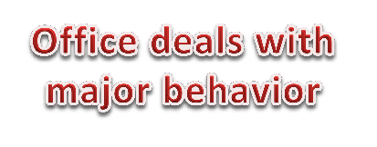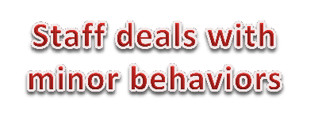

Is the behavior a minor or major offense?

|  |  |
| --- | --- |
| **Minor Problem**  **Behaviors** | **Major Problem**  **Behaviors** |
| Refusing to follow teacher directions | Disobedience/ Insubordination |
| Distracting self or others | Disruptive/ Unruly Play |
| Arguing with adult in charge | Defiance of authority |
| Using profanity | Assault/Threat (Low Level) |
| Throwing objects | Fight (Minor) Altercation |
| Placing hands, feet or objects on others | Repetitive staff managed misbehaviors |

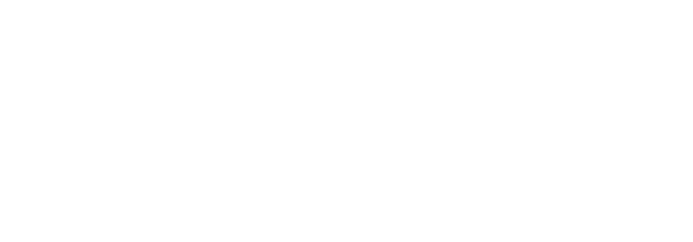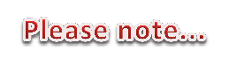

Re-teach appropriate

behavior to meet expectations.

Consequences will be

given with progressive discipline.

Use alternate redirect

options:

Pull aside and discuss behavior, review expectations, etc.

Communication with

teacher.

Parent contact is made.

If consequence is given,

document on ABC form.

* Everyday starts with a clean slate.
* Fill out discipline referral when student doesn't respond to redirection, pre-correction, or verbal warning.

If behavior continues,

refer to major offense.

* Take concrete action to correct behavior (i.e. individual

practice, removal from activity, seat change, etc.)

* Behaviors are defined on back of this page.

Document incident on ABC form to be

entered in DMS.

|  |  |
| --- | --- |
| Morrow Elementary Behavior Definitions | |
| **Minor Problem**  **Behaviors** | **Looks Like** |
| Refusing to follow teacher directions | Refusing to move to a small group, use a computer program, or start an assignment when asked. |
| Distracting themselves or others | Talking to or tapping on the desk of a student trying to work. |
| Arguing with the adult in charge | Going against what the teacher is saying verbally. |
| Using profanity | Using profane language while speaking to the teacher or other classmates |
| Throwing any object in their area | Throwing items in their direct area, not resulting in an injury to others. |
| Placing hands, feet, or objects on other | Coming in contact with another student with their hand, foot, or item such as a pencil. |
| **Major Problem**  **Behaviors** | **Looks Like** |
| Disobedience/ Insubordination | Failure to obey a reasonable or repeated instruction or request from a member of the school staff. Example: School staff has exhausted all classroom level progressive consequences and/or interventions for student. |
| Disruptive/Unruly Play | Failure to obey a reasonable or repeated instruction or request from a member of the school staff. Example: School staff has exhausted all classroom level progressive consequences and/or interventions for student. |
| Defiance of authority | Disobedience/insubordination resulting in four or more separate Disobedience/Insubordination referrals, or the deliberate refusal to physically attend the In-School-Suspension Program as assigned or failure to comply with the In-School-Suspension Program rules and requirements resulting in dismissal from the Program. |
| Assault/Threat (Low Level) | A threat that poses minimal risk to the victim and/or public safety. |
| Fight (Minor) Altercation | Mutual participation of two or more persons in a physical encounter/altercation that results in no injury. |
| Repetitive staff managed misbehaviors | More than 3 misbehaviors in 1 hour warrants an office referral. |

|  |
| --- |
| **CRITICAL ELEMENT # 7 : Classroom Management Systems** |

**7A.** ALL teachers implement an effective Tier 1 classroom management system:

|  |  |
| --- | --- |
| Which **evidence-based** classroom management system is supported by your school’s administration and is expected to be implemented school-wide?  *(Class Dojo, LEAPs, HERO, Cloud 9, etc. are tools,* ***not*** *classroom systems)* | CHAMPs* (12 hour Face to Face Trainings scheduled)  PBIS Classroom Management  Administration does not expect an evidence-based classroom management system to be implemented by teachers this year  (*your school will need to adopt one next year)*  Other *(complete below)* |
| If other, name the **evidence-based classroom management system:** | NA |
| *CHAMPs is the district-supported, evidence-based universal classroom management system for all teachers. Would your Principal like to be contacted to learn about CHAMPs professional development? | Yes  No |

**7B.** Fidelity of **staff** implementation of school-wide classroom management systems

|  |
| --- |
| What data collection tool does your school leadership team use to monitor and evaluate your teacher’s classroom management skills? *(Measure* ***staff skills****, not student outcomes)* |
| CHAMPs 7 Up Checklist |
| CHAMPs Classroom Check Up (CCU) |
| PBIS Classroom Assistance Tool (CAT) |
| PBIS Walkthrough |
| Marzano’s Domain 1, Design Questions 5, 6, 7, 8, 9 |
| Fidelity of staff classroom management implementation is not monitored to determine training needs this year *(you will need to adopt a tool and plan next year)* |
| Other *(specify):* |
| Explain how this data is collected and analyzed by your school leadership team as a **universal screening** *across teachers* to determine the need for classroom management training: |
| Fidelity of Implementation Plan: By utilizing Marzano’s observation tool, administration will be able to evaluate the fidelity of staff implementation of our school-wide classroom management system. During walkthroughs, informal, and formal observations, administration will collect and analyze data in Domain 1 on how teachers are implementing CHAMPS and other components from our SPBP. Depending on what the Marzano data shows, plans will be put in place for professional development to ensure all teachers are effectively utilizing our school-wide classroom management system. |

**7C. Percentage of Classroom Referrals:**

(a) Review your classroom data YTD (“Events by Location”) in BASIS 3.0 Behavior Dashboard.

(b) Complete the yellow highlighted cells first.

(c) Auto-calculate the % of referrals in the classroom by clicking on “!Zero Divide” in the next cell and pressing “Fn + F9” together.

|  |  |
| --- | --- |
| Total number of discipline referrals **from classrooms**: | 118 |
| Total number of **school-wide** discipline referrals: | 150 |
| % of referrals in the classroom: | 79% |
| Do more than 40% of your referrals come from the classroom? | Yes  No |

***If >40% of discipline referrals come from the classroom, it suggests Tier 1 classroom management implementation may need to be strengthened school-wide.***

|  |
| --- |
| **CRITICAL ELEMENT # 8: Data Collection and Analysis** |

**8A. Determine your School-wide Core Effectiveness YTD** from the BASIS Behavior Dashboard in the “Referrals per Student” chart.

(a) Complete the yellow highlighted cells first.

(b) Auto-calculate the “% of Total Population” by clicking on each “!Zero Divide” in the cells and pressing “Fn + F9”.

(c) Determine if the core is effective in all three areas

|  |  |  |  |  |
| --- | --- | --- | --- | --- |
| TOTAL Population: | 546 |  |  | |
| # Referrals |  | **% of Total Population** | Core Effectiveness | |
| 0 - 1 referral |  | 94% | Are your 0 – 1 referrals > 80%? | Yes No |
| 2 - 5 referrals  (at risk students) | 21 | 4% | Are your 2 - 5 referrals <15%? | Yes No |
| > 5 referrals  (high risk students) | 11 | 2% | Are your >5 referrals <5%? | Yes No |

**8B. Core Effectiveness Plan:**

|  |  |
| --- | --- |
| If all 3 are “**Yes**”, your core is effective. Is your core behavior curriculum effective? | Yes No |
| Answer **either** (a) or (b):  (a) If you answered “**Yes**”, although your core is effective, what plan does your school leadership team implement for early identification of at risk and high risk students?  (b) If you answered “**NO”**, indicate the supports and interventions your school leadership team will implement at the beginning of the next school year to improve core strength: | |
| Core Effectiveness Plan: In order to identify any at risk students, our school leadership team will closely monitor the BASIS Behavior Dashboard. Any student with two or more referrals will be put into RtI in order for our CPS Team to ensure that strategies are in place and also a Tier 2 behavior intervention plan if necessary. If a student is not showing improvement with the Tier 2 intervention, the team will consider doing a Functional Behavior Assessment (FBA). Based on the assessment, a Positive Behavior Intervention Plan (PBIP) will be created and monitored to ensure that the behavior is corrected. | |

**8C. Disproportionality: Determine if there are any issues within subgroups** from BASIS 3.0 Behavior Dashboard in the “Referrals by Demographics” chart.

(a) Complete the yellow highlighted cells first.

(b) Auto-calculate the difference by clicking on each “0” in the next cell and pressing “Fn + F9”.

|  |  |  |  |  |
| --- | --- | --- | --- | --- |
| Subgroups | (PctPop - Green)  % **of students** | (PctRef - Blue)  **% of referrals** | Difference in referral composition | Positive value suggests disproportionality  (Is the value positive?) |
| Black | 77 | 87 | 10 | Yes No |
| Hispanic/Latin | 13 | 8 | -5 | Yes No |
| White | 8 | 4 | -4 | Yes No |

**8D. Disproportionality Plan:** If any values are positive, the percentage of referrals contributed to that subgroup is higher than expected, given that subgroups’ percentage in the student population.

|  |  |
| --- | --- |
| If all 3 are “**No**”, disproportionality is not indicated. Are all 3 “No”? | Yes No |
| Answer **either** (a) or (b):  (a) If you answered “**Yes**”, although your data indicates equity, what plan does your school leadership team implement for early identification of any disproportionality issues  (b) If you answered “**No**”, indicate the support plan and interventions your school leadership team will implement at the beginning of next year to improve sub group disproportionality | |
| Disproportionality Plan: In order to improve sub group disproportionality, our leadership team will be monitoring the BASIS Behavior Dashboard quarterly to ensure our data is showing equity. Our faculty has received the Culturally Responsive Teaching training and we are making sure these strategies are being implemented throughout the school. We are also beginning Sanford Harmony, which is a social-emotional teaching program that empowers students to communicate, embrace diversity, and resolve conflict. This program will be incorporated into lesson plans and monitored throughout the year. Lastly, our staff will be receiving professional development from the District on Mindfulness. This teaches strategies for teachers to use in their classrooms that is proven to reduce behavior incidents and improve social-emotional wellbeing. | |

|  |
| --- |
| **Critical Elements # 9: SPBP Implementation Planning** |

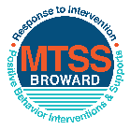This form provides a timeline to complete best practices and required actions. This timeline should drive team actions and accountability. As you implement your SPBP *NEXT* year, check off **completed items** and indicate the accountable person. (Complete only the yellow highlighted area at this time). Next year, you will upload this completed plan within your SPBP.

Required actions for all schools in Broward County

Best Practices for all schools in Broward County

**Resources**

|  |  |  |
| --- | --- | --- |
| **SPBP Team Implementation Action Plan 2018 - 2019** | | |
| **Month** | **Action Step**  *check when Action completed* | **Completed:**  Person Responsible  Name & Title |
| **Current** | **This Action Plan has been saved to use *next year* during quarterly meetings** | **Chris Brightman, Assistant Principal** |
| **Current** | **Create a SPBP binder or portfolio to retain (for 2 years) hard copies of: your SPBPs, Action Plans, staff PBIS professional development attendance, stakeholder training attendance, quarterly meeting agendas, quarterly staff behavior presentations, voting attendance and outcome, Expectation lesson plans and Rules lesson plans** | **Chris Brightman, Assistant Principal** |
| **Pre Planning**  **2018** | Print up your SPBP Review and school score from OSPA  Provide SPBP presentation to all staff during Pre Planning  Disseminate the current SPBP (hard copy or electronically) to all staff and stakeholders  Market and post school-wide Expectations and location-specific Rules (posters, PSAs, etc.)  Identify your RtI Instructional Facilitator provided by the district  (Contact [tyyne.hogan@browardschools.com](mailto:tyyne.hogan@browardschools.com) for more information, if you are unsure)  Confirm 1st team meeting date and time | Click here to enter NAME & title. |
| **August**  **1st meeting** | Ensure schedule of quarterly meeting dates for entire year as indicated in the SPBP  Determine any needed team training, such as the 4 Step PSP Brainshark Series, 10 Critical  Elements Brainsharks, Data Collection, Effective CPST Teams, PBIS 101, etc.  Trainings available at: <http://www.browardprevention.org/mtssrti/training-modules/>  Review previous year’s behavior data. (Use ‘Agenda’ and ‘Data Collection Template’)  Forms available at: <http://www.browardprevention.org/mtssrti/rtib> in Tier 1, Teaming  Present implementation data, behavior data, team activities and progress to entire staff  Utilize the 4 Step Problem Solving Process to develop initial interventions  Review previous year’s SPBP and feedback form  Verify and implement teaching schedule for SPBP Expectations and Rules behavior lesson plans | Click here to enter NAME & title |
| **September** | Provide stakeholder presentation on SPBP prior to October 1  Check for staff and teacher understanding of PBIS - provide “PBIS 101” Brainshark as a resource  Brainshark available at: http://www.brainshark.com/browardschools/PBIS101 | Click here to enter NAME & title. |
| **October**  **2nd meeting** | Ensure instructional staff know how to (and are, as needed) enter Tier 1 Supplemental Strategies  for behavior in BASIS  Present implementation data, behavior data, team activities and progress to entire staff | Click here to enter NAME & title. |
| **November** | Staff to re-teach Expectations and Rules first day back from break.  Team to develop new and/or improved lesson plans as indicated by behavior data. | Click here to enter NAME & title |
| **January**  **2019**  **3rd meeting**  Prepare for *2019/20* SPBP | Staff to re-teach Expectations and Rules first day back from break  Ensure the Principal signs in and watches the *new* SPBP Brainshark: Due January 30th  Present implementation data, behavior data, team activities and progress to entire staff  Choose team members and dates to work on, complete, and submit the *new* SPBP  Teams watch the *new* SPBP Brainsharks and refers to *new* “Additional items”  Brainsharks and Additional items posted at: <http://www.browardprevention.org/mtssrti/rtib> | Click here to enter NAME & title. |
| **February** | Ensure progress towards completion of SPBP  Check on recently hired staff for PBIS understanding - provide “PBIS 101” Brainshark resource  Provide the SPBP Surveymonkey link to all staff (optional). Email [Tyyne.hogan@browardschools.com](mailto:Tyyne.hogan@browardschools.com) to request analysis. | Click here to enter NAME & title |
| **March**  **4th meeting** | Ensure progress towards completion of SPBP  Provide staff presentation and vote on new SPBP for next year  Provide stakeholders/parent presentation on new SPBP for next year  Present implementation data, behavior data, team activities and progress to entire staff | Click here to enter NAME & title |
| **April** | Submit your SPBP in OSPA by April 30th every year | Click here to enter NAME & title |

|  |
| --- |
| **CRITICAL ELEMENT # 10: Monitoring Plans** |

**10A.** How will you determine the success **of *staff* implementation** of the School-wide Positive Behavior Plan?

*“Are* ***staff*** *implementing the SPBP with fidelity? How do you know?”*

|  |  |  |  |
| --- | --- | --- | --- |
| **Fidelity of Implementation Monitoring Plan** | | | |
| Action Step | Create an **observable** and **measureable** SMART goal to determine “successful”  **staff implementation** of action step | When will data be collected, analyzed & presented? | Person responsible to collect and analyze data |
| School-wide **expectations** and location-specific **rules** are posted across campus | By August 15, 2018, 100% of our school hallways will have a minimum of one school-wide expectation poster posted as measured by a formal PBIS walk-though. | Refer to **quarterly** presentation dates in 2B.  This is the data the team will be sharing during presentations. | Chris Brightman |
| **Behavior lesson plans** are being taught as written and when indicated | By September 12, 2018, 94% of teachers will have taught all of the school-wide expectations behavior lesson plans as measured by lesson plan checks from Administration. | Chris Brightman |
| **Discipline consequences**  and **flow chart** are being used by all staff as written | Every quarter, there will be a 5% decrease in the number of Office Discipline Referrals that contain previously identified staff-managed misbehaviors as measured by a referral review by the PBIS team. | Chris Brightman |
| A **reward system** is being implemented for *all* students | By the end of the reward system timeline, 100% of students who have earned a reward will receive it at the scheduled times, as measured by PBIS team monitoring of HERO points. | Chris Brightman |

**10B.** How will you determine whether the SPBP is successful in positively impacting **students?**

*“If staff are implementing the SPBP consistently and effectively, did it positively impact* ***the students****? How do you know?”*

|  |  |  |  |
| --- | --- | --- | --- |
| **Student Outcome Monitoring Plan** | | | |
| Student Outcome Data | Create an **observable** and **measureable** SMART goal to determine “successful”  **student outcomes** | When will data be collected, analyzed & presented? | Person responsible to collect and analyze data |
| See critical element 3A  • Type of **behavior incidents** data | By the end of every quarter, behavior incidents will be reduced by 10%, as measured by the BASIS Behavior Dashboard. | Refer to **quarterly** presentation dates in 2B.  This is the data the team will be sharing during presentations. | Chris Brightman |
| See critical element 4A  • **Top 3 event locations** data | By the end of every quarter, there will be 10% fewer referrals from the hallway, as measured by the BASIS Behavior Dashboard. | Chris Brightman |
| See critical element 8  • **Core effectiveness** data | By the end of the 2018-2019 school year, there will be no disproportionality for any of the 3 subgroups, as measured by the BASIS Behavior Dashboard. | Chris Brightman |
| See critical element 7A  • **Grade Level/Classroom referrals** data | By the end of every quarter, there will be 10% fewer classroom referrals, as measured by the BASIS Behavior Dashboard. | Chris Brightman |