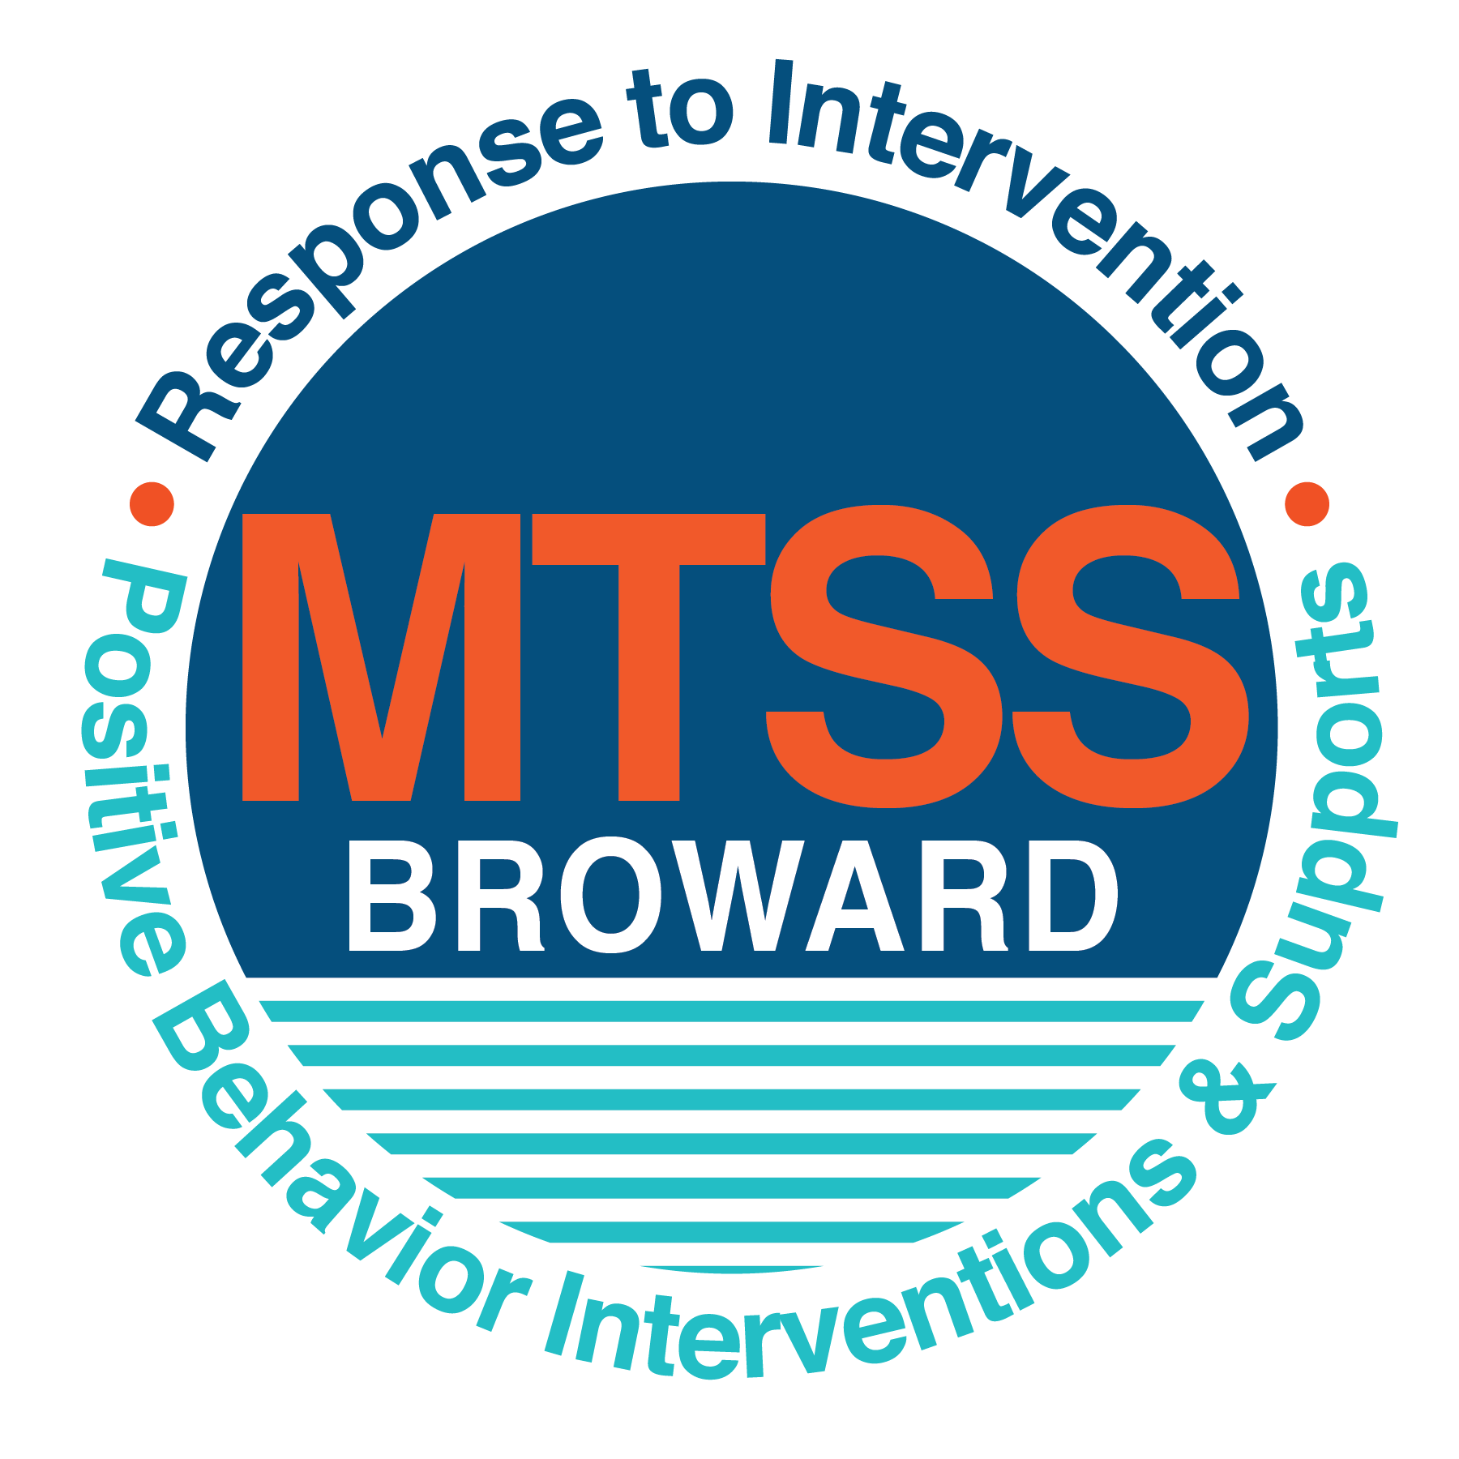
School-wide Positive Behavior Plan (SPBP)
Broward County Public Schools
To be implemented in SY 2019/20

School Name: | Westchester Elementary School
School Number: | 2681
SPBP Contact Name: | Craig Saban
Direct Phone Number: | 754-322-8900

CRITICAL ELEMENT # 1: Active Team with Administrative Participation

1A. Current (SY 2018/19) SPBP team members:
Full Name | Position
Avis Goodman | 1. Administration
Caralyn Daniello | 2. BTU Representative
Craig Saban | 3. SPBP Point of Contact
Mary Stafford | 4. Parent/Community Representation
Robin Hersh | 5. Teacher
Samantha Hirsch | 6. Teacher
Lisa Kaine | 7. Teacher
Jarrod Transue | 8. Teacher
Miriam Miniet | 9. Math Coach
Shilpa Parikh | 10. Clerical

1B. Schedule of quarterly SPBP Team Meeting dates for next 2019/20 school year:
Meeting Date | Meeting Time | Content of meetings:
8/8/2019 | 9:00am | 1. Progress of Action Steps indicated in Implementation Plan in #9  2. Collect & analyze fidelity of staff implementation data in #10A  3. Collect & analyze student outcome data in #10B
10/17/2019 | 1:00pm
1/6/2020 | 9:00am
3/17/2020 | 9:00am

CRITICAL ELEMENT # 2: Faculty & Stakeholder Commitment:

2A. Action Steps completed this year (SY 2018/19) that increased faculty and stakeholder knowledge of the new SPBP:

Action Steps: | Date  (Between Jan 15 and  April 30, 2019) | Details  (Sign-in sheets in SPBP Binder)
Presented the new SPBP (for SY 2019/20) to staff | 4/2/2019 | # of participants = 71
Held a faculty vote on the new SPBP  (for SY 2019/20) | 4/5/2019 | # of participants = 68  % approved = 100%
Presented the new SPBP (for SY 2019/20) to stakeholders (parents and community) | 4/9/2019 | # of participants = 23

2B. Action Steps to be completed next year (SY 2019/20) to increase faculty and stakeholder knowledge of the new SPBP:

Action Steps: | Date  (SY 2019-20) | Content  (Sign-in sheets in SPBP Binder)
Provide professional development on the 2019/20 SPBP for all staff | 8/8/2019 | The team will present the updates in the SPBP for the 19/20 school year. All stakeholders will be provided with access to the SPBP. Feedback will be collected for future team meetings.
Present the 2019/20 SPBP to stakeholders  (parents and community) | 9/10/2019
Present the behavior data to all staff quarterly | 1. 10/7/2019 | The team will present:  - the team’s progress in the Implementation Plan in # 9.  - the fidelity of staff implementation data in #10A.  - the student outcome data in #10B.
 | 2. 11/21/2019
 | 3. 1/21/2020
 | 4. 4/16/2020

CRITICAL ELEMENT # 3: School-wide Expectations

3A. Top five behavior incidents data YTD as listed in BASIS 3.0
Top 5 Behavior Incidents
1. Unruly Disruptive Behavior---36
2. Unsubstantiated Bullying--6
3. Disobedience/ Insubordination--5
4. Disruptive Unruly Play--2
5. Disruption on Campus/Minor--2

3B. School-wide expectations are 3 – 5 positive characteristics (not behaviors) that counteract the demonstration of the top school-wide misbehaviors above. ALL people on campus model these expectations.
School-wide Expectations
Be respectful to others and yourself- Respect themselves, their property, and school property. Model expected behaviors on morning announcements. Once the student feels valued and looked up to, the behavior will change.
Be responsible- Students will become more responsible for their classwork, homework, and possessions. This expectation will be communicated with the parents beginning at Meet and Greet and continuing throughout the year.
Keep hands, feet, and objects to yourselves- We would like the students to display tolerance and acceptance toward others that may be transitioning in the hallways from our classrooms. Students will be able to receive Spirit Sticks when they show this positive school-wide expectation.
Be accountable for your actions-. When a student doesn’t necessarily follow directions or is involved in inappropriate actions, we are going to promote them to stop breath, and think. The students will be able to own their behavior and select a more school appropriate reaction.

3C. At least one lesson plan for each school-wide expectation above is distributed to teachers during pre-planning SY 2019/20 and maintained in the SPBP Binder.
Dates the school-wide expectations lesson plans are taught:
 | Date(s) | Time: | Location(s):
August | 8/12/2019 | 1:00 PM | Cafeteria
January | 1/6/2020 | 1:00 PM | Cafeteria
After Spring Break | 3/25/2019 | 2:00 PM | Room 139

CRITICAL ELEMENT #4: Location-based Rules

4A. Top three school-wide locations for Behavior Events YTD.
Top 3 Locations, not including Classroom:
School Location | # Incidents
1. Cafeteria | 9
2.Hallways | 4
3.Recess | 3

4B. Expectations and Rules Chart for common areas of school campus: (next page)

Expectations and Rules Chart |  |  |  | To be completed by classroom teachers
School-wide EXPECTATIONS | Cafeteria Rules | Hallway Rules | Recess Rules | Classroom Rules
Be respectful to others property | Using appropriate language towards teachers and peers and valuing school and others personal property | Admire the walls and boards with your eyes only | Using recess equipment correctly | Stop and think before you act. Is it helpful or hurtful?
Be responsible | Follow posted rules and procedures in the lunchroom | Walk in a straight line and face forward | Follow recess rules and be responsible for the equipment that was brought out | Be prepared to have required materials and complete assignments to the best of your ability.
Keep hands, feet and objects to yourselves | Keep hands, feet and objects to yourself | Keep hands to your sides and a voice level “0” is indicated by CHAMPS posters posted throughout school | Respect the personal space of others during activities | Keep personal space from others and treat them the way you would like to be treated.
Be accountable for your actions | Except responsibility for your own behaviors | Demonstrate self control in the hallways | Students being forthright for their actions. | Be honest and truthful no matter what the circumstances are.

4C. At least one Rules lesson plan for each specific location is distributed to teachers during pre-planning SY 2019/20 and maintained in the SPBP Binder.

Dates the Locations’ Rules lesson plans are taught
 | Date(s) | Time: | Location(s):
August | 8-8-2019 | 9:00 | Cafeteria
January | 1-6-2020 | 9:00 | Cafeteria
After Spring Break | 4-9-2020 | 1:00 | Room 139

CRITICAL ELEMENT # 5: Reward and Recognition Programs

5. The reward system is focused on one School-wide Expectation OR specific location at a time.
Expectation or Location: Cafeteria

4 Step Problem Solving Process | Plan Details
1. Problem Identification: Use your behavior data to identify one school-wide problem.  What problem did you identify? (use numerical data) | Data used: Unruly Disruptive Behavior—36 occurrences  Problem Identification: Students are leaving their seats in the cafeteria and not staying in their assigned area.
2. Problem Analysis: Why do you think this problem is occurring?  What is your goal? (use a SMART goal statement with numerical data) | Hypothesis: It is believed that this problem is occurring due to the fact that the rules/expectations for proper cafeteria behavior are not clearly communicated.  Goal Statement: With clearly communicated cafeteria rules and expectations, 70% of the identified problem will be corrected by displaying the correct behaviors/expectations.
3. Intervention Design: Describe how you will implement a positive reward program to decrease this problem. | Type of System: Choose an item. PAWS System  Description of System: A reward system known as PAWS will be implemented. Each letter stands for a specific behavior/expectation while in the cafeteria. Specifically aligned to this problem will be the “S”, which stands for stay seated at all times. Classes are able to earn 5 points per day, each letter being a point. The classes with the highest points from each grade level will then be invited to have lunch with the Principal in her office.
4. Evaluation:  A. Implementation fidelity | - How will you monitor the fidelity (consistency and effectiveness) of the staff’s implementation? In order to monitor the fidelity of the staff’s implementation of this reward program is by the amount of points his/her class receives. If the teacher is reminding and modeling proper behaviors to the students in the classroom, they will project that expected behavior in the cafeteria
B. Student outcome monitoring | - How will you know if the reward program is positively impacting students? What measurable data will you use to determine “success”? When the proper behavior is being displayed and the behaviors are decreasing, that is how we know the reward program is positively impacting our students. The measurable data that will be used to determine success is our point management system. The points will be displayed in the cafeteria for the students to see and share with other classes to entice and promote expected behaviors.

CRITICAL ELEMENT #6: Effective Discipline Procedures

Student Behavior Discipline Flow Chart
Observe problem behavior behaviorBehavior
Intervene and redirect
Office Managed Misbehaviors
Staff Managed Misbehaviors
Yes
Call to notify office of a
crisis/safety issue
Implement an initial consequence
Is behavior Office Managed?
(if unsure, check below)

Specific Examples of  6 Staff Managed  Misbehaviors: | Specific Examples of  6 Office Managed  Misbehaviors:
Verbal Disruptions in class  Out of assigned area  Not being kind  Not following directions  Unprepared  Name Calling | Disobedience/Insubordination  Fighting  Threats  Major Disruptive Behavior  Bus Referral  Disruption on Campus

No
If occurrence is reoccurring a behavior management plan will be implemented
Follow crisis protocol/refer child to CPST. If an ODR is needed, it will be written at this time.

Reinforce/Reward Student for corrected behavior
Behavior is corrected/ Reward student for corrected behavior

Implement behavior management plan

By adhering the behavior plan, the behavior is corrected
CRITICAL ELEMENT # 7: Classroom Management Systems

7A. In SY 2019/20, ALL teachers implement an evidence-based Tier 1 classroom management system:
Evidence-based system: | Evidence of training:
☐ CHAMPS | 10% of teachers currently holding valid CHAMPS certificate:
☐ PBIS Classroom Management  http://www.fl-pda.org/independent/ | 3% of teachers currently holding completion certificate:
☐ Other: Click here to enter name of system. | Training evidence: Click here to enter evidence  % of teachers currently trained:

7B. The administration reviews and analyzes the fidelity of staff implementation of Tier 1 classroom management systems across teachers using:
☐ CHAMPs 7 Up Checklist
☐ Basic FIVE (Classroom Management Screening)
☐ PBIS Classroom Assistance Tool (CAT)
☐ Other (specify):
☐ Classroom management screening is not conducted across teachers to determine appropriate professional
development. (Next year, assessment of classroom management implementation fidelity will be scored).

7C. School year 2018/19 percentage of classroom referrals:
Total number of discipline referrals from classrooms: | 35
Total number of other school-wide discipline referrals: | 16
% of referrals in the classroom: | 68%
Do more than 40% of your referrals come from the classroom? | ☐ Yes
If >40% of discipline referrals come from the classroom, it suggests Tier 1 classroom management implementation may need to be strengthened school-wide.
If “Yes”, school-wide classroom management professional development will be conducted in 2019-20:
Click here to choose: PBIS online course If “Other”, indicated system here:

CRITICAL ELEMENT # 8: Data Collection and Analysis

8A. Core Effectiveness:
TOTAL Population: | 1128 | % of Total Population | Core Effectiveness
# Referrals: | 33
0 - 1 referrals |  | 99% | Are your 0 – 1 referrals > 80%? | yes
2 - 5 referrals  (at risk students) | 11 | 1% | Are your 2 - 5 referrals <15%? | Yes
> 5 referrals  (high risk students) | 2 | 0 | Are your >5 referrals <5%? | Yes

8B. Core Effectiveness Action Steps:
If all 3 are “Yes”, your core is effective. Is your core behavior curriculum effective? | yes
Answer either (a) or (b):
(a) If you answered “Yes”, although your core is effective, what steps does your school leadership team take for early identification of at risk and high-risk students?
(b) If you answered “NO”, indicate the supports and interventions your school leadership team will implement at the beginning of the next school year to improve core strength:
Core Effectiveness Action Steps: (3-4 steps)
1. Student Data
2. Student Referrals
3. Guidance Meetings
4.

8C. Disproportionality within racial subgroups:
Subgroups | (PctPop - Green)  % of students | (PctRef - Blue)  % of referrals | Difference in referral composition | Positive value suggests disproportionality  (Is the value positive?)
Black | 24 | 43 | 19 | Yes
Hispanic/Latin | 37 | 37 | 0 | No
White | 28 | 17 | -11 | No

8D. Disproportionality Action Steps:
If all three are “No”, disproportionality is not indicated. Are all 3 “No”? | No
Answer either (a) or (b):
(a) If you answered “Yes”, although your data indicates equity, what plan does your school leadership team implement for early identification of any disproportionality issues
(b) If you answered “No”, indicate the support plan and interventions your school leadership team will implement at the beginning of next year to improve sub group disproportionality
Disproportionality Action Steps: (3-4 steps)
Our school’s disproportionality plan is to plan proper interventions as needed with our students. We treat all students fairly and provide adequate support when needed. Our school counselor intervenes with socio-emotional issues that may trigger future behaviors in subgroups of concern

Critical Elements # 9: SPBP Implementation Planning
RED Font = Action Steps for all schools in Broward County
GREY Font = Best Practices for all schools in Broward County
TEAL Font = Resources available at https://browardcountyschools.sharepoint.com/sites/DPI6Strands/strand6/SitePages/SPBP.aspx
SPBP Team Implementation Action Plan 2019 - 2020
Month | Action Steps  ☒ check off Action Step when completed
Current | X Create a SPBP binder or portfolio to retain (for 2 years) hard copies of: your SPBPs, Action Plans, staff PBIS  professional development attendance, stakeholder training attendance, quarterly meeting agendas, quarterly staff  behavior presentations, voting attendance and outcome, Expectations lesson plans and Rules lesson plans
Pre-Planning  2019 | X Print up your SPBP Review and school score from OSPA  X Provide SPBP presentation to all staff during Pre-Planning  X Disseminate the current SPBP (hard copy or electronically) to all staff and stakeholders  ☒ Market and post school-wide Expectations and location-specific Rules  ☒ Identify your district RtI Instructional Facilitator  (Contact tyyne.hogan@browardschools.com for more information, if you are unsure)  ☒ Confirm 1st team meeting date and time
August  1st meeting | ☒ Ensure schedule of quarterly meeting dates for entire year as indicated in the SPBP  ☒ Review Implementation plan; check off completed Action Steps  ☐ Determine any needed team training, such as these Brainsharks: 4 Step Problem Solving Process series, PBIS 10  Critical Elements, Data Collection, Big 5 Data, PBIS 101, etc. (All found in Sharepoint site)  ☐ Review previous year’s behavior data. (Use ‘Agenda’ Form and ‘Data Collection Template’ in Sharepoint site)  ☐ Utilize the 4 Step Problem Solving Process to initiate a Reward System for all students  ☐ Review previous year’s SPBP and feedback form; make necessary modifications  ☐ Verify and implement teaching schedule for Expectations and Rules behavior lesson plans  ☐ Present implementation data, behavior data, team activities and SPBP progress to entire staff
September | ☐ Provide SPBP stakeholder presentation prior to October 1  ☐ Check for staff and teacher understanding of PBIS - provide “PBIS 101” Brainshark as a resource  Brainshark available at: http://www.brainshark.com/browardschools/PBIS101  ☐ Ensure the Discipline Flow Chart is distributed to all staff and is being used as written
October  2nd meeting | ☐ Review Implementation plan; check off completed Action Steps  ☐ Ensure instructional staff know how to (and are, as needed) enter Tier 1 Supplemental Strategies  for behavior in BASIS  ☐ Review previous quarter’s behavior data. (Use ‘Agenda’ and ‘Data Collection Template’ in Sharepoint site)  ☐ Present implementation data, behavior data, team activities, and SPBP progress to entire staff  ☐ Ensure all teachers are using an evidence-based classroom management plan, such as CHAMPS  ☐ Ensure Core Effectiveness Action Steps are being implemented as written
November | ☐ Team to develop new and/or improved lesson plans as indicated by behavior data.  ☐ Ensure that the Disproportionality Action Steps are being implemented as written
January  2020  3rd meeting  Prepare for SY 2020/21 SPBP | ☐ Review Implementation plan; check off completed Action Steps  ☐ Staff to re-teach Expectations and Rules after winter break  ☐ Principal signs in and watches the new “SPBP for Principals” Brainshark: Due January 30th  ☐ Present implementation data, behavior data, team activities, and SPBP progress to entire staff  ☐ Choose team members and dates to work on, complete, and submit the new SPBP  ☐ Teams watch the new “SPBP Team Overview” Brainshark and refers to district resources and supports  (Brainsharks and Additional items in Sharepoint site. Webinars and in-person lab information in Team Brainshark)
February | ☐ Ensure progress towards completion of SPBP  ☐ Check on recently hired staff for PBIS understanding - provide “PBIS 101” Brainshark resource  ☐ Provide the SPBP Surveymonkey link to all staff (optional)
March  4th meeting | ☐ Ensure progress towards completion and submission of SPBP  ☐ Review Implementation plan; check off completed Action Steps  ☐ Staff to re-teach Expectations and Rules after from spring break  ☐ Provide stakeholders/parent presentation on new SPBP for next year  ☐ Provide staff presentation and faculty vote on new SPBP for next year  ☐ Present implementation data, behavior data, team activities, and SPBP progress to entire staff
April | ☐ Submit your SPBP in OSPA by April 30th every year. Use this new SPBP in the next school year  ☐ Continue implementing your current SPBP through the end of the current school year

CRITICAL ELEMENT # 10: Evaluation

10A. Staff implement the School-wide Positive Behavior Plan effectively:
“Are staff implementing the SPBP with fidelity? How do you know?”
STAFF Implementation Monitoring
Action Step | Create an observable and measurable SMART goal to determine “successful”  staff implementation of action step
School-wide expectations and location-specific rules are posted across campus | 100% of staff and students will be aware of expectations and participate in behavior discussions
Expectations and Rules lesson plans are being taught as written and when indicated | 90% of teachers will have behavior lesson plans in teacher plan books
The Discipline flow chart is being used by all staff as written | 100% of teachers will practice proper behavior managing techniques as discussed in meetings
A reward system is being implemented for all students | 70% of targeted behaviors will improve by the end of the SPBP year.

10B. The SPBP is successful in positively impacting students:
“If staff are implementing the SPBP consistently and effectively, did it positively impact the students? How do you know?”
STUDENT Outcome Monitoring
Student Outcome Data | Create an observable and measurable SMART goal to determine  “successful” student outcomes
Behavior Incident data  (See critical element #3A) | 70% of students will have 1 or less referral by June 2020
Top 3 event locations data  (See critical element #4A) | 70% of behavior modification and management techniques with show positive behavior outcomes by June 2020
Core effectiveness data  (See critical element #8A) | More than 80% students will have 1 or less referrals by June 2020
Classroom referrals data  (See critical element #7C) | More than 70% students will have 1 or less referrals by June 2020

