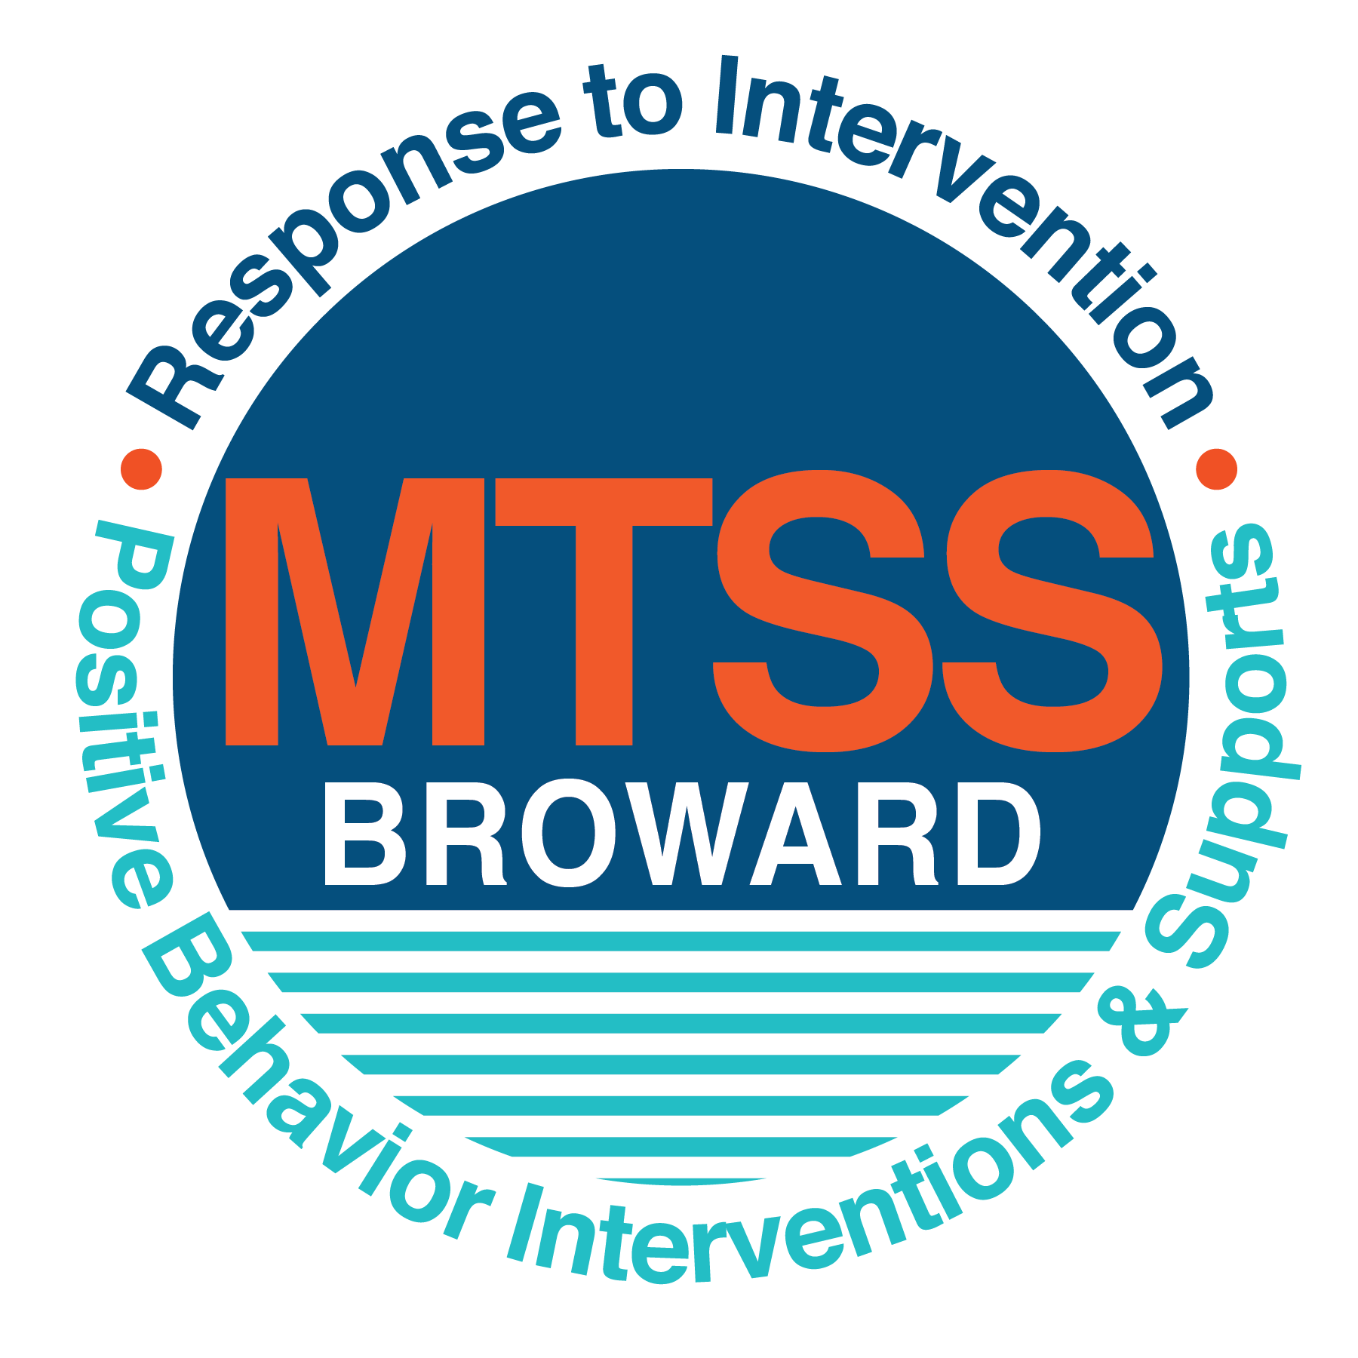

**School-wide Positive Behavior Plan (SPBP)**

Broward County Public Schools

To be implemented in SY 2018/19

**Elements have changed in the SPBP.**

Before completing, go to[**http://www.browardprevention.org/mtssrti/rtib/ →**](http://www.browardprevention.org/mtssrti/rtib/%20→)*School-wide Positive Behavior Plan* for:

* **A NEW Brainshark for Principals. ACTION: Log in with your p # and watch the Brainshark before Jan 30th.**
* **A NEW Overview Brainshark for Teams. ACTION: Log in with school name and watch the Brainshark.**
* A NEW mini Brainshark Series for teams. These Brainsharks are divided into the 10 Critical Elements of PBIS. They will

show you “how to” write a comprehensive SPBP (and receive a high score!)

* A Rating Rubric to ensure teams will correctly complete the SPBP and develop a meaningful plan.

To provide consistency across the District, *only plans entered on the current district template will be accepted*.

**ACTION: Download, complete and upload the SPBP into your School Improvement Plan before May 1, 2018:**

|  |  |
| --- | --- |
| **School Name:** | Westchester Elementary School |
| **School Number:** | 2681 |
| **SPBP Contact Name:** | Craig Saban |
| **Direct Phone Number:** | 754-322-8900 |

|  |
| --- |
| **CRITICAL ELEMENT # 1: Active Team with Administrative Participation** |

**1A.** List your current (SY 2017/18) team members (6 - 10 team members). **Must include an instructional representative from EACH grade/content area.** *Each name on this list verifies attendance in ongoing team meetings and participation in developing this SPBP. Each member is responsible for representing major stakeholders and sharing the SPBP content and updates with their respective group.*

|  |  |  |
| --- | --- | --- |
| **Full Name** | **Position** | **Who or what grade level does this member represent?** |
| Melissa Geraine | Principal | Administration |
| Craig Saban / Avis Goodman | SPBP Point of Contact | Assistant Principals |
| Alison Fox | Parent/Community Representation | SAC |
| Caralyn Daniello | BTU Representative | Kindergarten |
| Corrine Lamb | Teacher | 2nd Grade |
| Samantha Hirsch | Teacher | 4th Grade |
| Miriam Miniet | Math Coach | Whole School |
| Jarrod Transue | Teacher | 5th Grade |
| Victoria Bailen | Teacher | 1st Grade |
| Valeria Gonzalez | Teacher | 3rd Grade |

**1B**. Schedule and document your quarterly team meeting dates for *next* 2018/19 school year:

|  |  |  |  |
| --- | --- | --- | --- |
| **Meeting Date** | **Meeting Time** | **Name & title of person responsible to facilitate meeting** | **Content of meetings:** |
| 8/8/2018 | 10:00 | Craig Saban/ Assistant Principal | 1. Create and disseminate updated  Expectations and Rules lesson  plans (#3 and #4)  2. Review progress of  Implementation Action Plan (#9)  3. Collect & analyze implementation  data (#10A)  4. Collect & analyze student  outcome data (#10B) |
| 10/19/2018 | 9:00 | Miriam Miniet/ Math Coach |
| 1/7/2019 | 9:30 | Craig Saban/ Assistant Principal |
| 3/22/2019 | 9:00 | Miriam Miniet/ Math Coach |

|  |
| --- |
| **CRITICAL ELEMENT # 2: Faculty & Stakeholder Commitment:** |

**2A**. Action Steps completed **this year** (SY 2017/18) that increased faculty and stakeholder understanding and knowledge of your *new* (2018/19) SPBP:

|  |  |  |  |
| --- | --- | --- | --- |
| **Action Steps:** | **Date**  *(Between Jan 15 –*  *April 30, 2018)* | **Details**  *(retain attendance sheets at school)* | **Person responsible to collect and retain attendance sheets:** |
| Presented the *new* SPBP (for SY 2018/19) to staff | 2/22/2018 | # of participants = 68 | Craig Saban |
| Held a *faculty* vote on the new SPBP  (for SY 2018/19) | 3/5/2018 | % approved = 92 | Craig Saban |
| Presented the *new* SPBP (for SY 2018/19) to stakeholders (parents and community) | 3/13/2018 | # of participants = 18 | Craig Saban |

**2B.** Action Steps to be completed **next year** (SY 2018/19) to increase faculty and stakeholder understanding and knowledge of your SPBP:

|  |  |  |  |
| --- | --- | --- | --- |
| **Action Steps:** | **Date(s)**  *(NEXT YEAR)* | **Content**  *(retain attendance sheets at school)* | **Person responsible to collect and retain attendance sheets:** |
| Provide a professional development on the 2018/19SPBP for all staff | Prior to students’ 1st day:  8/8/2018 | The team will present the updates in the SPBP for the 18/19 school year. All stakeholders will be provided with access to the SPBP. Feedback will be collected for future team meetings. | Craig Saban |
| Present the 2018/19SPBP to stakeholders (parents and community) | Prior to Oct 1st, 2018  9/5/2018 |
| Present behavior data to staff  *Quarterly: minimum of 4 each year* | 1. 10/19/2018 | The team will present the implementation data in 10A. Include:  • the “marketing” (teaching and posting) of expectations and rules  • lesson plan implementation  • discipline procedures  • reward system implementation  The team will present the student outcome data in 10B. Include:  • top 3 event locations  • type of behavior incidents  • core effectiveness data  • classroom referral data, as well as analysis of this data. | Craig Saban |
| 2. 12/21/2018 |
| 3. 2/21/2019 |
| 4. 5/9/2019 |

|  |
| --- |
| **CRITICAL ELEMENT # 3: School-wide Expectations** |

**3A.** List the **top 10 behavior incidents** data YTD from BASIS 3.0 Behavior Dashboard:

|  |  |
| --- | --- |
| **Top 10 Behavior Incidents**  *(put N/A in any blank spaces)* | |
| 1. Unruly Disruptive Behavior---45 | 6. NA |
| 2. Disobedience/Insubordination---14 | 7. NA |
| 3. Bus Violations---3 | 8. NA |
| 4. NA | 9. NA |
| 5. NA | 10. NA |

**3B.** Based on the behavior incidents in 3A, develop 3 – 5 **positive characteristics** *(not behaviors)* that would counteract the demonstration of these misbehaviors. These positive characteristics become your school-wide expectations.

|  |
| --- |
| **School-wide Expectations** |
| Be respectful to others |
| Be responsible |
| Keep hands, feet, and objects to yourselves |
| Be accountable for your actions |
|  |

**3C.** Research indicates that discipline referrals increase after long holidays and during testing times. Plan to teach your expectations at least 3 times throughout the year (and anytime the expected behaviors are not being demonstrated).

**ACTION:** Create at least one lesson plan for **each** school-wide expectation above and distribute to teachers during pre-planning 2018-19. Develop additional lesson plans you will use throughout the year to re-teach and reinforce your school-wide expectations. *You do not need to submit your lesson plans with the SPBP. Retain all behavior lesson plans at the school; make sure these lesson plans are available for guests and stakeholders.*

|  |  |  |  |
| --- | --- | --- | --- |
| **When will school-wide expectations lesson plans be taught?** | | | |
|  | Date(s) | Time: | |
| August | 16th | 8:30 | |
| January | 9th | 8:30 | |
| 4th Quarter | May 9th | 12:30 | |
|  | | | |
| Who will be responsible for teaching the lesson plans? | | | Classroom Teachers |
| Where will the lesson plan instruction occur? | | | Classrooms |
| Who is responsible for retaining, organizing and distributing all lesson plans? | | | Craig Saban/Miriam Miniet |

|  |
| --- |
| **CRITICAL ELEMENT #4: Location-based Rules** |

**4A.** List the **top 3 locations** for behavior Events YTD from BASIS 3.0 Behavior Dashboard**.** ***Do not use “classroom”***

|  |  |
| --- | --- |
| **Top 3 Locations** | |
| School Location | # Incidents |
| 1. Cafeteria | 8 |
| 2. Hallways | 5 |
| 3. Recess | 3 |

**4B.** Create an Expectations/Rules Matrix from your 3-5 school-wide expectations and your top 3 event locations. Develop a positively stated, observable, and measurable rule that correlates with every expectation to create a maximum of 5 rules under each location**.**

|  |  |  |  |  |
| --- | --- | --- | --- | --- |
| **Expectations and Rules Matrix** | | | | |
| **School-wide EXPECTATIONS** | *Copy and paste expectations* | **IDENTIFIED LOCATIONS**  *Copy and paste locations from* ***4A.*** | | |
| Cafeteria | Recess | Hallways |
| **Rules** | **Rules** | **Rules** |
| Expectation #1:  Be respectful to others property | Using appropriate language towards teachers and peers and valuing school and others personal property | Using recess equipment correctly | Admire the walls and boards with your eyes only |
| Expectation #2:  Be responsible | Follow posted rules and procedures in the lunchroom | Follow recess rules and be responsible for the equipment that was brought out | Walk in a straight line and face forward |
| Expectation #3:  Keep hands, feet and objects to yourselves | Keep hands, feet and objects to yourself | Respect the personal space of others during activities | Keep hands to your sides and a voice level “0” is indicated by CHAMPS posters posted throughout school |
| Expectation #4:  Be accountable for your actions | Except responsibility for your own behaviors | Students being forthright for their actions. | Demonstrate self control in the hallways |
|

**4C**. Research indicates that discipline referrals increase after long holidays and during testing times. Plan to teach your location-specific rules at least 3 times throughout the year (and anytime the expected behaviors are not being demonstrated).

**ACTION:** Create at least one lesson plan for **each** location above and distribute to teachers during pre-planning 2018-19. Develop additional lesson plans you will use throughout the year to re-teach and reinforce your location-specific rules.

*You do not need to submit your lesson plans with the SPBP. Retain all behavior lesson plans at the school; make sure these lesson plans are available for guests and stakeholders.*

|  |  |  |  |
| --- | --- | --- | --- |
| **When will location-specific rules lesson plans be taught?** | | | |
|  | Date(s) | Time: | |
| August | 16th | 8:30 | |
| January | 9th | 8:30 | |
| 4th Quarter | May 9th | 12:30 | |
|  | | | |
| Who will be responsible for teaching the lesson plans? | | | Classroom Teachers |
| Where will the lesson plan instruction occur? | | | Classrooms |
| Who is responsible for retaining, organizing and distributing all lesson plans? | | | Craig Saban |

|  |
| --- |
| **CRITICAL ELEMENT # 5: Reward and Recognition Programs** |

Although you will post, teach, review, practice and reinforce all school-wide expectations and location-specific rules, **choose 1 expectation OR 1 event location** you will target for a specific reward program for students. Based on the data that led to this expectation or location, create a reward plan using the 4 Step Problem Solving Process:

Expectation or Location: Cafeteria

|  |  |
| --- | --- |
| **4 Step Problem Solving Process** | **Plan** |
| **1. Problem Identification:** Use your behavior data to identify a school-wide problem.  What problem did you identify? *(use numerical data)* | **Data used: Disruptive Unruly Behavior—45 occurrences**    **Problem Identification:** Students are leaving their seats in the cafeteria and not staying in their assigned area. |
| **2**. **Problem Analysis:** Why do you think this problem is occurring?  What is your goal? *(use a SMART goal statement with numerical data)* | **Hypothesis:** It is believed that this problem is occurring due to the fact that the rules/expectations for proper cafeteria behavior are not clearly communicated.  **Goal Statement:** With clearly communicated cafeteria rules and expectations, 70% of the identified problem will be corrected by displaying the correct behaviors/expectations. |
| **3. Intervention Design:**  Describehow you will implement a positive reward program to decrease this problem. | **Type of System: Point system**  **Description of System:** A reward system known as PAWS will be implemented. Each letter stands for a specific behavior/expectation while in the cafeteria. Specifically aligned to this problem will be the “S”, which stands for stay seated at all times. Classes are able to earn 5 points per day, each letter being a point. The classes with the highest points from each grade level will then be invited to have lunch with the Principal in her office. |
| **4. Evaluation:**  A. Implementation fidelity | How do you monitor the fidelity (consistency and effectiveness) of the **staff’s** implementation of the reward program? In order to monitor the fidelity of the staff’s implementation of this reward program is by the amount of points his/her class receives. If the teacher is reminding and modeling proper behaviors to the students in the classroom, they will project that expected behavior in the cafeteria. |
| B. Student outcome monitoring | How will you know if the reward program is positively impacting **students**? What measurable data will you use to determine “success”? When the proper behavior is being displayed and the behaviors are decreasing, that is how we know the reward program is positively impacting our students. The measurable data that will be used to determine success is our point management system. The points will be displayed in the cafeteria for the students to see and share with other classes to entice and promote expected behaviors. |

|  |
| --- |
| **CRITICAL ELEMENT #6 Effective Discipline Procedures** |

**6A. Staff Managed Misbehaviors:** List the top 6 *most common* school-wide misbehaviors **staff are expected to manage.**

Write a short, objective, and measurable definition for each.

|  |  |
| --- | --- |
| **Staff Managed Misbehaviors** | |
| Misbehavior | “Looks Like” - *provide a description with example(s)* |
| 1. Disruptive | Student talk excessively and disturbing the teacher and other students during instruction |
| 2. Work completion | Student repeatedly does not complete required assignments in class or at home |
| 3. Peer Relationships | Students do not listen to each other to work out conflicts in classrooms, lunch, recess, and hallways |
| 4. Defiant | Students do not comply with directions given by staff members in the school. |
| 5. Disrespectful | Students talk back to staff members in a rude manner |
| 6. Lack of Responsibility | Students do not take ownership of their actions |

**6B. Staff Managed Consequences**: Create a consequencemenu **OR** a consequence hierarchy for staff to use when students exhibit the above misbehaviors. Provide a minimum of **5** consequences.

|  |  |
| --- | --- |
| This is a menu. | Menu |
| Assign the student a specific seat in the cafeteria where they will not be tempted to misbehave. | |
| Create a classroom homework incentive where if the majority or all of the class receives points for the completion of homework assignments the class will be rewarded. | |
| Teacher will place student on a behavior monitoring system where their behavior (including recess) will be scored and signed by a parent. If the student receives excellent evaluations for a certain amount of time the student will be rewarded. | |
| The student will not be allowed to hold that classroom job position until they prove that they can handle such responsibility. | |
| The teacher will include the cafeteria as a part of the behavior modification report and track student behavior in the cafeteria. The cafeteria staff will report to the teacher each day whether the rules were followed by that individual. | |

**6C. Administration Managed Misbehaviors**:

(a) Define the first 3 behaviors by providing examples that clearly identify the point at which the misbehavior warrants an Office Discipline Referral (ODR).

(b) List two additional common school-wide misbehaviors that will result in an ODR. Provide concrete examples.

(c) Determine staff tolerance level for repetitive misbehaviors (the point at which the number of staff-managed misbehaviors becomes an ODR).

|  |  |
| --- | --- |
| **Office Discipline Referrals (ODRs)** | |
| Behavior | “Looks Like” - *provide a description with example(s)* |
| 1. Disobedience/Insubordination | Student continuing to act out in class after being asked to stop multiple times |
| 2. Disruptive/Unruly Play | Students playing and it turns physical when one of them intentionally hurts the other |
| 3. Defiance of authority | Telling the teacher “No” or refusing to leave the classroom with the other students when moving throughout the campus. |
| 6. Repetitive staff managed  misbehaviors | More than misbehaviors inwarrants an office referral.  day  one  3 |

**6D. School-wide Discipline Flow Chart:**

(a) Review the sample discipline flow charts in “Additional Items” located on browardprevention.org

(b) Copy or customize a flow chart to graphically represent the discipline process at **your** school.

(c) Paste the flow chart here**OR** complete the flow chart below.

**Student Behavior Discipline Flow Chart**

Observe Problem Behavior

Intervene and redirect

Is the behavior a crisis?

Is the behavior a referral?

Follow SPBP protocol

Reinforce/

reward student

Follow SPBP protocol

Reinforce/

Reward student

Behavior is not corrected

Behavior is corrected

Behavior is corrected

Behavior is not corrected

Implement minor consequence(s)

Is the behavior moderate?

Is the behavior considered staff managed?

Follow crisis protocol

Refer student to CPS by creating a behavior referral

Implement behavior plan

Is the behavior considered office managed?

|  |
| --- |
| **CRITICAL ELEMENT # 7 : Classroom Management Systems** |

**7A.** ALL teachers implement an effective Tier 1 classroom management system:

|  |  |
| --- | --- |
| Which **evidence-based** classroom management system is supported by your school’s administration and is expected to be implemented school-wide?  *(Class Dojo, LEAPs, HERO, Cloud 9, etc. are tools,* ***not*** *classroom systems)* | CHAMPs* |
| If other, name the **evidence-based classroom management system:** | Click here to enter name of system. |
| *CHAMPs is the district-supported, evidence-based universal classroom management system for all teachers. Would your Principal like to be contacted to learn about CHAMPs professional development? | Yes |

**7B.** Fidelity of **staff** implementation of school-wide classroom management systems

|  |
| --- |
| What data collection tool does your school leadership team use to monitor and evaluate your teacher’s classroom management skills? *(Measure* ***staff skills****, not student outcomes)* |
| CHAMPs 7 Up Checklist |
| CHAMPs Classroom Check Up (CCU) |
| Explain how this data is collected and analyzed by your school leadership team as a **universal screening** *across teachers* to determine the need for classroom management training: |
| Fidelity of Implementation Plan: |

**7C. Percentage of Classroom Referrals:**

(a) Review your classroom data YTD (“Events by Location”) in BASIS 3.0 Behavior Dashboard.

(b) Complete the yellow highlighted cells first.

(c) Auto-calculate the % of referrals in the classroom by clicking on “!Zero Divide” in the next cell and pressing “Fn + F9” together.

|  |  |
| --- | --- |
| Total number of discipline referrals **from classrooms**: | 46 |
| Total number of **school-wide** discipline referrals: | 74 |
| % of referrals in the classroom: | 62% |
| Do more than 40% of your referrals come from the classroom? | Yes |

***If >40% of discipline referrals come from the classroom, it suggests Tier 1 classroom management implementation may need to be strengthened school-wide.***

|  |
| --- |
| **CRITICAL ELEMENT # 8: Data Collection and Analysis** |

**8A. Determine your School-wide Core Effectiveness YTD** from the BASIS Behavior Dashboard in the “Referrals per Student” chart.

(a) Complete the yellow highlighted cells first.

(b) Auto-calculate the “% of Total Population” by clicking on each “!Zero Divide” in the cells and pressing “Fn + F9”.

(c) Determine if the core is effective in all three areas

|  |  |  |  |  |
| --- | --- | --- | --- | --- |
| TOTAL Population: | 1194 |  |  | |
| # Referrals | 80 | **% of Total Population** | Core Effectiveness | |
| 0 - 1 referral | 17 | 98% | Are your 0 – 1 referrals > 80%? | Yes |
| 2 - 5 referrals  (at risk students) | 16 | 1% | Are your 2 - 5 referrals <15%? | Yes |
| > 5 referrals  (high risk students) | 4 | 0% | Are your >5 referrals <5%? | Yes |

**8B. Core Effectiveness Plan:**

|  |  |
| --- | --- |
| If all 3 are “**Yes**”, your core is effective. Is your core behavior curriculum effective? | Yes |
| Answer **either** (a) or (b):  (a) If you answered “**Yes**”, although your core is effective, what plan does your school leadership team implement for early identification of at risk and high risk students?  (b) If you answered “**NO”**, indicate the supports and interventions your school leadership team will implement at the beginning of the next school year to improve core strength: | |
| Core Effectiveness Plan: Our school leadership team implemented our CPST to identify at risk and high risk students. We then implement behavior management tools. | |

**8C. Disproportionality: Determine if there are any issues within subgroups** from BASIS 3.0 Behavior Dashboard in the “Referrals by Demographics” chart.

(a) Complete the yellow highlighted cells first.

(b) Auto-calculate the difference by clicking on each “0” in the next cell and pressing “Fn + F9”.

|  |  |  |  |  |
| --- | --- | --- | --- | --- |
| Subgroups | (PctPop - Green)  % **of students** | (PctRef - Blue)  **% of referrals** | Difference in referral composition | Positive value suggests disproportionality  (Is the value positive?) |
| Black | 32% | 26% | 8% | No |
| Hispanic/Latin | 32% | 40% | 8% | No |
| White | 24% | 28% | 5% | No |

**8D. Disproportionality Plan:** If any values are positive, the percentage of referrals contributed to that subgroup is higher than expected, given that subgroups’ percentage in the student population.

|  |  |
| --- | --- |
| If all 3 are “**No**”, disproportionality is not indicated. Are all 3 “No”? | Yes |
| Answer **either** (a) or (b):  (a) If you answered “**Yes**”, although your data indicates equity, what plan does your school leadership team implement for early identification of any disproportionality issues  (b) If you answered “**No**”, indicate the support plan and interventions your school leadership team will implement at the beginning of next year to improve sub group disproportionality | |
| Disproportionality Plan: *(3-4 sentences)* Our school’s disproportionality plan is to plan proper interventions as needed. We treat all students fairly and provide adequate support when needed. Our school counselor intervenes with socio-emotional issues that may trigger future behaviors. | |

|  |
| --- |
| **Critical Elements # 9: SPBP Implementation Planning** |

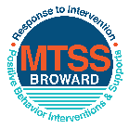This form provides a timeline to complete best practices and required actions. This timeline should drive team actions and accountability. As you implement your SPBP *NEXT* year, check off **completed items** and indicate the accountable person. (Complete only the yellow highlighted area at this time). Next year, you will upload this completed plan within your SPBP.

Required actions for all schools in Broward County

Best Practices for all schools in Broward County

**Resources**

|  |  |  |
| --- | --- | --- |
| **SPBP Team Implementation Action Plan 2018 - 2019** | | |
| **Month** | **Action Step**  *check when Action completed* | **Completed:**  Person Responsible  Name & Title |
| **Current** | **This Action Plan has been saved to use *next year* during quarterly meetings** | **Craig Saban Asst. Prin.** |
| **Current** | **X Create a SPBP binder or portfolio to retain (for 2 years) hard copies of: your SPBPs, Action Plans, staff PBIS professional development attendance, stakeholder training attendance, quarterly meeting agendas, quarterly staff behavior presentations, voting attendance and outcome, Expectation lesson plans and Rules lesson plans** | **Craig Saban Asst. Prin.** |
| **Pre Planning**  **2018** | Print up your SPBP Review and school score from OSPA  Provide SPBP presentation to all staff during Pre Planning  Disseminate the current SPBP (hard copy or electronically) to all staff and stakeholders  Market and post school-wide Expectations and location-specific Rules (posters, PSAs, etc.)  Identify your RtI Instructional Facilitator provided by the district  (Contact [tyyne.hogan@browardschools.com](mailto:tyyne.hogan@browardschools.com) for more information, if you are unsure)  Confirm 1st team meeting date and time | Click here to enter NAME & title. |
| **August**  **1st meeting** | Ensure schedule of quarterly meeting dates for entire year as indicated in the SPBP  Determine any needed team training, such as the 4 Step PSP Brainshark Series, 10 Critical  Elements Brainsharks, Data Collection, Effective CPST Teams, PBIS 101, etc.  Trainings available at: <http://www.browardprevention.org/mtssrti/training-modules/>  Review previous year’s behavior data. (Use ‘Agenda’ and ‘Data Collection Template’)  Forms available at: <http://www.browardprevention.org/mtssrti/rtib> in Tier 1, Teaming  Present implementation data, behavior data, team activities and progress to entire staff  Utilize the 4 Step Problem Solving Process to develop initial interventions  Review previous year’s SPBP and feedback form  Verify and implement teaching schedule for SPBP Expectations and Rules behavior lesson plans | Click here to enter NAME & title |
| **September** | Provide stakeholder presentation on SPBP prior to October 1  Check for staff and teacher understanding of PBIS - provide “PBIS 101” Brainshark as a resource  Brainshark available at: http://www.brainshark.com/browardschools/PBIS101 | Click here to enter NAME & title. |
| **October**  **2nd meeting** | Ensure instructional staff know how to (and are, as needed) enter Tier 1 Supplemental Strategies  for behavior in BASIS  Present implementation data, behavior data, team activities and progress to entire staff | Click here to enter NAME & title. |
| **November** | Staff to re-teach Expectations and Rules first day back from break.  Team to develop new and/or improved lesson plans as indicated by behavior data. | Click here to enter NAME & title |
| **January**  **2019**  **3rd meeting**  Prepare for *2019/20* SPBP | Staff to re-teach Expectations and Rules first day back from break  Ensure the Principal signs in and watches the *new* SPBP Brainshark: Due January 30th  Present implementation data, behavior data, team activities and progress to entire staff  Choose team members and dates to work on, complete, and submit the *new* SPBP  Teams watch the *new* SPBP Brainsharks and refers to *new* “Additional items”  Brainsharks and Additional items posted at: <http://www.browardprevention.org/mtssrti/rtib> | Click here to enter NAME & title. |
| **February** | Ensure progress towards completion of SPBP  Check on recently hired staff for PBIS understanding - provide “PBIS 101” Brainshark resource  Provide the SPBP Surveymonkey link to all staff (optional). Email [Tyyne.hogan@browardschools.com](mailto:Tyyne.hogan@browardschools.com) to request analysis. | Click here to enter NAME & title |
| **March**  **4th meeting** | Ensure progress towards completion of SPBP  Provide staff presentation and vote on new SPBP for next year  Provide stakeholders/parent presentation on new SPBP for next year  Present implementation data, behavior data, team activities and progress to entire staff | Click here to enter NAME & title |
| **April** | Submit your SPBP in OSPA by April 30th every year | Click here to enter NAME & title |

|  |
| --- |
| **CRITICAL ELEMENT # 10: Monitoring Plans** |

**10A.** How will you determine the success **of *staff* implementation** of the School-wide Positive Behavior Plan?

*“Are* ***staff*** *implementing the SPBP with fidelity? How do you know?”*

|  |  |  |  |
| --- | --- | --- | --- |
| **Fidelity of Implementation Monitoring Plan** | | | |
| Action Step | Create an **observable** and **measureable** SMART goal to determine “successful”  **staff implementation** of action step | When will data be collected, analyzed & presented? | Person responsible to collect and analyze data |
| School-wide **expectations** and location-specific **rules** are posted across campus | 100% of staff and students will be aware of expectations and participate in behavior discussions | Refer to **quarterly** presentation dates in 2B.  This is the data the team will be sharing during presentations. | Principal, Assistant Principal, and SPBP Committee |
| **Behavior lesson plans** are being taught as written and when indicated | 90% of teachers will have behavior lesson plans in teacher plan books | Principal and Assistant Principal |
| **Discipline consequences**  and **flow chart** are being used by all staff as written | 100% of teachers will practice proper behavior managing techniques as discussed in meetings | Assistant Principal |
| A **reward system** is being implemented for *all* students | 70% of targeted behaviors will improve by the end of the SPBP year. | Classroom Teachers and Administration will monitor as well |

**10B.** How will you determine whether the SPBP is successful in positively impacting **students?**

*“If staff are implementing the SPBP consistently and effectively, did it positively impact* ***the students****? How do you know?”*

|  |  |  |  |
| --- | --- | --- | --- |
| **Student Outcome Monitoring Plan** | | | |
| Student Outcome Data | Create an **observable** and **measureable** SMART goal to determine “successful”  **student outcomes** | When will data be collected, analyzed & presented? | Person responsible to collect and analyze data |
| See critical element 3A  • Type of **behavior incidents** data | 70% students will have 1 or less referral | Refer to **quarterly** presentation dates in 2B.  This is the data the team will be sharing during presentations. | Assistant Principal |
| See critical element 4A  • **Top 3 event locations** data | 70% of behavior modification and management techniques will show positive behavior outcomes | Assistant Principal and Classroom Teachers |
| See critical element 8  • **Core effectiveness** data | 80% students will have 1 or less referral | Administration |
| See critical element 7A  • **Grade Level/Classroom referrals** data | 70% students will have 1 or less referral | Principal, Assistant Principal, and classroom teachers |