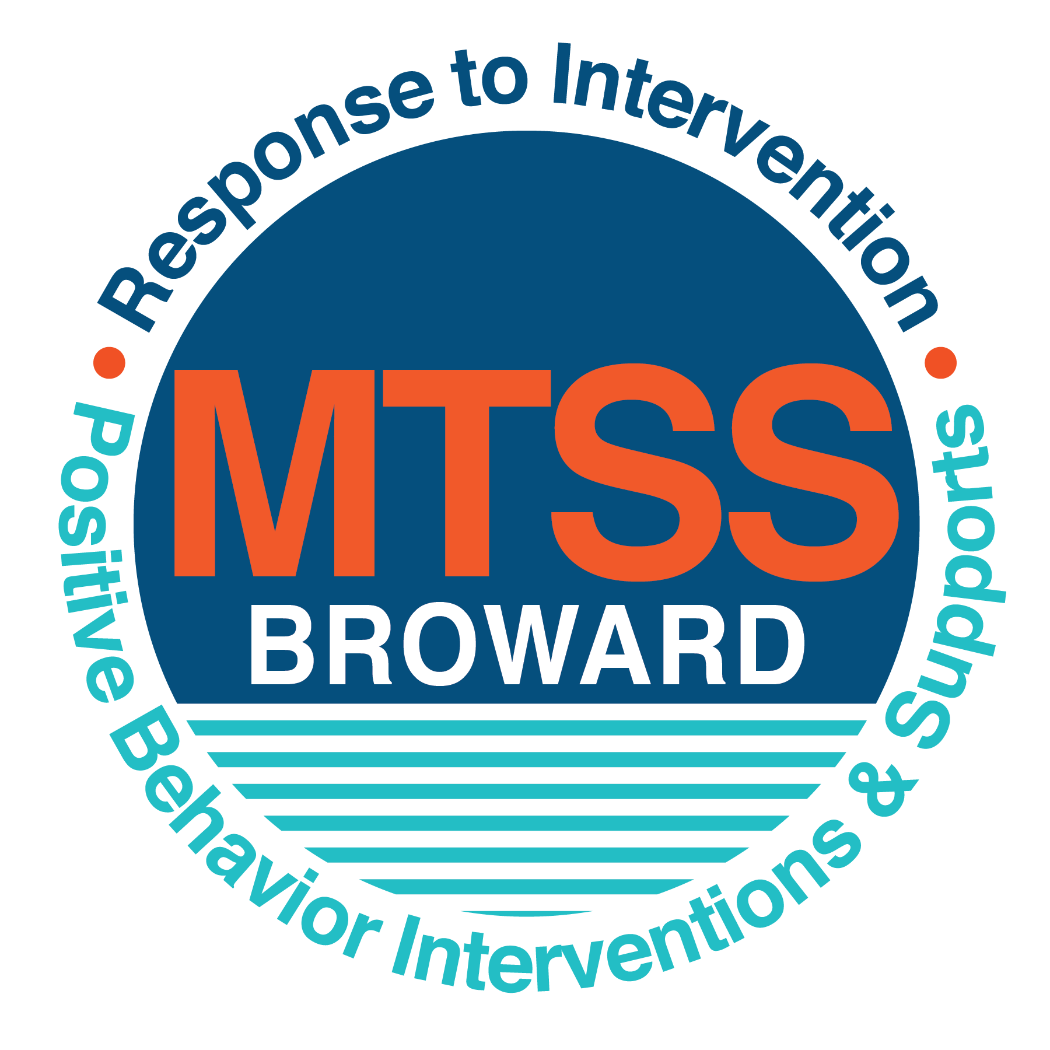

**School-wide Positive Behavior Plan (SPBP)**

Broward County Public Schools

To be implemented in SY 2018/19

**Elements have changed in the SPBP.**

Before completing, go to[**http://www.browardprevention.org/mtssrti/rtib/ →**](http://www.browardprevention.org/mtssrti/rtib/%20→)*School-wide Positive Behavior Plan* for:

* **A NEW Brainshark for Principals. ACTION: Log in with your p # and watch the Brainshark before Jan 30th.**
* **A NEW Overview Brainshark for Teams. ACTION: Log in with school name and watch the Brainshark.**
* A NEW mini Brainshark Series for teams. These Brainsharks are divided into the 10 Critical Elements of PBIS. They will

show you “how to” write a comprehensive SPBP (and receive a high score!)

* A Rating Rubric to ensure teams will correctly complete the SPBP and develop a meaningful plan.

To provide consistency across the District, *only plans entered on the current district template will be accepted*.

**ACTION: Download, complete and upload the SPBP into your School Improvement Plan before May 1, 2018:**

|  |  |
| --- | --- |
| **School Name:** | Nob Hill Elementary |
| **School Number:** | 2671 |
| **SPBP Contact Name:** | Arlene Kall |
| **Direct Phone Number:** | 754 322-7200 |

|  |
| --- |
| **CRITICAL ELEMENT # 1: Active Team with Administrative Participation** |

**1A.** List your current (SY 2017/18) team members (6 - 10 team members). **Must include an instructional representative from EACH grade/content area.** *Each name on this list verifies attendance in ongoing team meetings and participation in developing this SPBP. Each member is responsible for representing major stakeholders and sharing the SPBP content and updates with their respective group.*

|  |  |  |
| --- | --- | --- |
| **Full Name** | **Position** | **Who or what grade level does this member represent?** |
| David Suarez | Assistant Principal | Administration |
| Arlene Kall | SPBP Point of Contact | Guidance Counselor |
| Heather Most | Literacy Coach | K-5 |
| Chris Kuma | Parent/Community Representation | SAC |
| Ashi Aldayani | BTU Member | 1st Grade |
| Leslie Ross | Team leader | Kindergarten |
| Karlee Moshier | Team leader | 2nd Grade |
| Jennifer Gray | Team leader | 3rd Grade |
| Brittany Maher | Team leader | 4th Grade |
| Malecia Tardieu | Team leader | 5th Grade |
| Ellen Kaplan | Team leader | ESE |

**1B**. Schedule and document your quarterly team meeting dates for *next* 2018/19 school year:

|  |  |  |  |
| --- | --- | --- | --- |
| **Meeting Date** | **Meeting Time** | **Name & title of person responsible to facilitate meeting** | **Content of meetings:** |
| 8/10/2018 | 9:00a.m. | Arlene Kall/David suarez | 1. Create and disseminate updated  Expectations and Rules lesson  plans (#3 and #4)  2. Review progress of  Implementation Action Plan (#9)  3. Collect & analyze implementation  data (#10A)  4. Collect & analyze student  outcome data (#10B) |
| 10/19/1918 | 9:00a.m. | Arlene Kall/David suarez |
| 1/7/2019 | 9:00a.m. | Arlene Kall/ David Suarez |
| 3/22/2019 | 9:00a.m. | Arlene Kall/David Suarez |

|  |
| --- |
| **CRITICAL ELEMENT # 2: Faculty & Stakeholder Commitment:** |

**2A**. Action Steps completed **this year** (SY 2017/18) that increased faculty and stakeholder understanding and knowledge of your *new* (2018/19) SPBP:

|  |  |  |  |
| --- | --- | --- | --- |
| **Action Steps:** | **Date**  *(Between Jan 15 –*  *April 30, 2018)* | **Details**  *(retain attendance sheets at school)* | **Person responsible to collect and retain attendance sheets:** |
| Presented the *new* SWPBP (for SY 2018/19) to staff | 1/22/2018 | # of participants = 12 | David suarez Maritza Canizares |
| Held a *faculty* vote on the new SPBP  (for SY 2018/19) | 4/30/2018 | % approved =89% | David suarez Maritza Canizares |
| Presented the *new* SPBP (for SY 2018/19) to stakeholders (parents and community) | 5/8/2018 | # of participants = 15 | David suarez Maritza Canizares |

**2B.** Action Steps to be completed **next year** (SY 2018/19) to increase faculty and stakeholder understanding and knowledge of your SPBP:

|  |  |  |  |
| --- | --- | --- | --- |
| **Action Steps:** | **Date(s)**  *(NEXT YEAR)* | **Content**  *(retain attendance sheets at school)* | **Person responsible to collect and retain attendance sheets:** |
| Provide a professional development on the 2018/19SPBP for all staff | Prior to students’ 1st day:  8/10/2018 | The team will present the updates in the SPBP for the 18/19 school year. All stakeholders will be provided with access to the SPBP. Feedback will be collected for future team meetings. | Arlene Kall David Suarez |
| Present the 2018/19SPBP to stakeholders (parents and community) | Prior to Oct 1st, 2018  9/18/2018 |
| Present behavior data to staff  *Quarterly: minimum of 4 each year* | 1. 10/18/2018 | The team will present the implementation data in 10A. Include:  • the “marketing” (teaching and posting) of expectations and rules  • lesson plan implementation  • discipline procedures  • reward system implementation  The team will present the student outcome data in 10B. Include:  • top 3 event locations  • type of behavior incidents  • core effectiveness data  • classroom referral data, as well as analysis of this data. | Arlene Kall David Suarez |
| 2. 1/7/2019 |
| 3. 3/22/2019 |
| 4. 5/28/2019 |

|  |
| --- |
| **CRITICAL ELEMENT # 3: School-wide Expectations** |

**3A.** List the **top 10 behavior incidents** data YTD from BASIS 3.0 Behavior Dashboard:

|  |  |
| --- | --- |
| **Top 10 Behavior Incidents**  *(put N/A in any blank spaces)* | |
| 1.unsubstantiated bullying | 6.weapons class B |
| 2.unruly/disruptive behavior | 7.assault/threat medium |
| 3.disobedience/insubordination | 8.disruption on campus- minor |
| 4.disruptive/unruly play | 9.n/a |
| 5.assault/threat non criminal | 10.n/a |

**3B.** Based on the behavior incidents in 3A, develop 3 – 5 **positive characteristics** *(not behaviors)* that would counteract the demonstration of these misbehaviors. These positive characteristics become your school-wide expectations.

|  |
| --- |
| **School-wide Expectations** |
| 1.Being responsible |
| 2.Being respectful |
| 3.Being empathetic |
| 4. |
| 5. |

**3C.** Research indicates that discipline referrals increase after long holidays and during testing times. Plan to teach your expectations at least 3 times throughout the year (and anytime the expected behaviors are not being demonstrated).

**ACTION:** Create at least one lesson plan for **each** school-wide expectation above and distribute to teachers during pre-planning 2018-19. Develop additional lesson plans you will use throughout the year to re-teach and reinforce your school-wide expectations. *You do not need to submit your lesson plans with the SPBP. Retain all behavior lesson plans at the school; make sure these lesson plans are available for guests and stakeholders.*

|  |  |  |  |
| --- | --- | --- | --- |
| **When will school-wide expectations lesson plans be taught?** | | | |
|  | Date(s) | Time: | |
| August | 8/15/18 through 8/17/18 | 8:00a.m. | |
| January | 1/8/19 through 1/11/19 | 8:00a.m. | |
| 4th Quarter | 3/21/19 | 8:00a.m. | |
|  | | | |
| Who will be responsible for teaching the lesson plans? | | | teachers |
| Where will the lesson plan instruction occur? | | | classrooms |
| Who is responsible for retaining, organizing and distributing all lesson plans? | | | Heather Most |

|  |
| --- |
| **CRITICAL ELEMENT #4: Location-based Rules** |

**4A.** List the **top 3 locations** for behavior Events YTD from BASIS 3.0 Behavior Dashboard**.** ***Do not use “classroom”***

|  |  |
| --- | --- |
| **Top 3 Locations** | |
| School Location | # Incidents |
| 1.Hallway | 5 |
| 2.LIbrary | 3 |
| 3. Playground | 2 |

**4B.** Create an Expectations/Rules Matrix from your 3-5 school-wide expectations and your top 3 event locations. Develop a positively stated, observable, and measurable rule that correlates with every expectation to create a maximum of 5 rules under each location**.**

|  |  |  |  |  |
| --- | --- | --- | --- | --- |
| **Expectations and Rules Matrix** | | | | |
|  |  |  | | |
| Hallway | Library | Playground |
| **Rules** | **Rules** | **Rules** |
| Being Responsible | Students will keep hands and feet to self. | Students will be take accountability for their own actions. | Students will take accountability for their own actions |
|  | All students will walk at a level of 0 – 1. | Students will use strategies and statements learned in “Growth Mindset” lessons to engage in conversations and activities presented in media. | Students will adhere to playground rules and safety measures when on the playground. |
| Being Respectful | Students will leave one foot of space between themselves and the person in front of them. | Students will raise their hands when wanting to be recognized during media lessons. | Students will wait their turn when another student is on playground equipment (one student at a time on slide) |
|  | Students will walk in a single file on the second tile from the wall as to not impede other foot traffic in the hallway. | Students will use accountable talk when having discussions with others during media lessons |  |
| Being Emphathetic | Students will help push wheelchairs for IND students | Students will include and assist all IND students in grade level lessons and activities in the media center. | Students will include IND students in outdoor activities when appropriate |

**4C**. Research indicates that discipline referrals increase after long holidays and during testing times. Plan to teach your location-specific rules at least 3 times throughout the year (and anytime the expected behaviors are not being demonstrated).

**ACTION:** Create at least one lesson plan for **each** location above and distribute to teachers during pre-planning 2018-19. Develop additional lesson plans you will use throughout the year to re-teach and reinforce your location-specific rules.

*You do not need to submit your lesson plans with the SPBP. Retain all behavior lesson plans at the school; make sure these lesson plans are available for guests and stakeholders.*

|  |  |  |  |
| --- | --- | --- | --- |
| **When will location-specific rules lesson plans be taught?** | | | |
|  | Date(s) | Time: | |
| August | 8/15/18 through 8/17/18 | 9:00a.m. | |
| January | 1/8/19 through 1/11/19 | 9:00a.m. | |
| 4th Quarter | 3/21/19 | 9:00a.m. | |
|  | | | |
| Who will be responsible for teaching the lesson plans? | | | Classroom Teachers Guidance Counselor |
| Where will the lesson plan instruction occur? | | | classrooms |
| Who is responsible for retaining, organizing and distributing all lesson plans? | | | Heather Most |

|  |
| --- |
| **CRITICAL ELEMENT # 5: Reward and Recognition Programs** |

Although you will post, teach, review, practice and reinforce all school-wide expectations and location-specific rules, **choose 1 expectation OR 1 event location** you will target for a specific reward program for students. Based on the data that led to this expectation or location, create a reward plan using the 4 Step Problem Solving Process:

Expectation or Location: ___Being Respectful______________________________________________________________________

|  |  |
| --- | --- |
| **4 Step Problem Solving Process** | **Plan** |
| **1. Problem Identification:** Use your behavior data to identify a school-wide problem.  What problem did you identify? *(use numerical data)* | **Data used: Since the highest number of behavioral incidents where unsubstantiated bullying the 36 incidents were used as the data.**    **Problem Identification: Students are not always respectful of others as 36 incidents of unsubstantiated bullying were reported.** |
| **2**. **Problem Analysis:** Why do you think this problem is occurring?  What is your goal? *(use a SMART goal statement with numerical data)* | **Hypothesis: Students doing the unsubstantiated bullying are looking for power over others and use it as a measure to increase their own self-esteem.**  **Goal Statement:** By June, 2019 the number of unsubstantiated bullying incidents will decrease by 10% . This will be measured by the BASIS Behavior Dasboard. We will compare this number with the. 2018 BASIS recorded incidents. |
| **3. Intervention Design:**  Describehow you will implement a positive reward program to decrease this problem. | **Type of System: Token system**  **Description of System:** *(3-4 sentences*  Students, when observed by teacher or staff member, to be  exhibiting positive behaviors toward classmates ,will be given a “high five” hand cutout. The cutout will have the positive behavior observed and date listed on it. Teachers will display the high fives in a designated area of the classroom. |
| **4. Evaluation:**  A. Implementation fidelity | 1. How do you monitor the fidelity (consistency and effectiveness) of the **staff’s** implementation of the reward program? *(2-3 sentences)*   Teachers will keep track of the number of “high fives” handed out to students and received by students on display. When a student has earned 10 “high fives” a quarterly social will take place for those students earning the high fives. |
| B. Student outcome monitoring | 1. How will you know if the reward program is positively impacting **students**? What measurable data will you use to determine “success”? *(2-3 sentences)*   By June, 2019 the number of “high five” hand cut outs will have increased by 5% from August, 2018. The number of unsubstantiated bullying incidents will have decreased by 10% from 2017-18. |

|  |
| --- |
| **CRITICAL ELEMENT #6 Effective Discipline Procedures** |

**6A. Staff Managed Misbehaviors:** List the top 6 *most common* school-wide misbehaviors **staff are expected to manage.**

Write a short, objective, and measurable definition for each.

|  |  |
| --- | --- |
| **Staff Managed Misbehaviors** | |
| Misbehavior | “Looks Like” - *provide a description with example(s)* |
| 1.Not completing work | Definition: Student does not complete assigned work and or homework on an average of one assignment per three week period. (Example-looks like) Students will complete all assigned work and homework. |
| 2.Calling out | Definition: Answering a question without raising hand or being asked after being verbally reminded one time. (Example – looks like) Student will raise his/her hand when wished to be recognized or called on. |
| 3.Being tardy | Definition: Not arriving at school on time. Not being seated by the 8:00 bell. (Example – looks like). Students will be in their seats at the 8:00 bell. |
| 4.Name calling | Definitions:Calling another student names or making fun of them after being verbally reminded one time.( Example-looks like) Students will make positive statements to others. |
| 5.Physical contact | Definition: Accidently having physical contact with another student. (Example – looks like) Students will apologize when wrong. |
| 6.Excessive absences | Definition: Student missing more than 5 days per marking period. (Example – looks like) student will miss no more than 1 day per marking period. |

**6B. Staff Managed Consequences**: Create a consequencemenu **OR** a consequence hierarchy for staff to use when students exhibit the above misbehaviors. Provide a minimum of **5** consequences.

|  |  |
| --- | --- |
| Is this a menu or hierarchy system? | Menu Hierarchy |
| Re-teach appropriate behavior | |
| Verbal correction | |
| Non-verbal redirection | |
| Loss of points on a class behavior plan | |
| Call home when tardies or absences exceed the acceptable limit of 5 tardies/absences per marking period. | |

**6C. Administration Managed Misbehaviors**:

(a) Define the first 3 behaviors by providing examples that clearly identify the point at which the misbehavior warrants an Office Discipline Referral (ODR).

(b) List two additional common school-wide misbehaviors that will result in an ODR. Provide concrete examples.

(c) Determine staff tolerance level for repetitive misbehaviors (the point at which the number of staff-managed misbehaviors becomes an ODR).

|  |  |
| --- | --- |
| **Office Discipline Referrals (ODRs)** | |
| Behavior | “Looks Like” - *provide a description with example(s)* |
| 1. Disobedience/Insubordination | More than 3 moderate misbehaviors in 1 day requires a referral. |
| 2. Disruptive/Unruly Play | More than 3 moderate misbehaviors in 1 day requires a referral. |
| 3. Defiance of authority | More than 1 moderate misbehaviors in 1 day requires a referral |
| 4. Battery | An intentional act that is without consent and causes a minor injury. Immediate referral is required with Battery. |
| 5. Disruption on campus | An event that causes disruption effecting a classroom or localized area of the school. Immediate referral is required with disruption on campus. |
| 6. Repetitive staff managed  misbehaviors | More than misbehaviors inwarrants an office referral.  day  one  3    *e.g., 3 half hour*  *2 one period* |

o

**6D. School-wide Discipline Flow Chart:**

(a) Review the sample discipline flow charts in “Additional Items” located on browardprevention.org

(b) Copy or customize a flow chart to graphically represent the discipline process at **your** school.

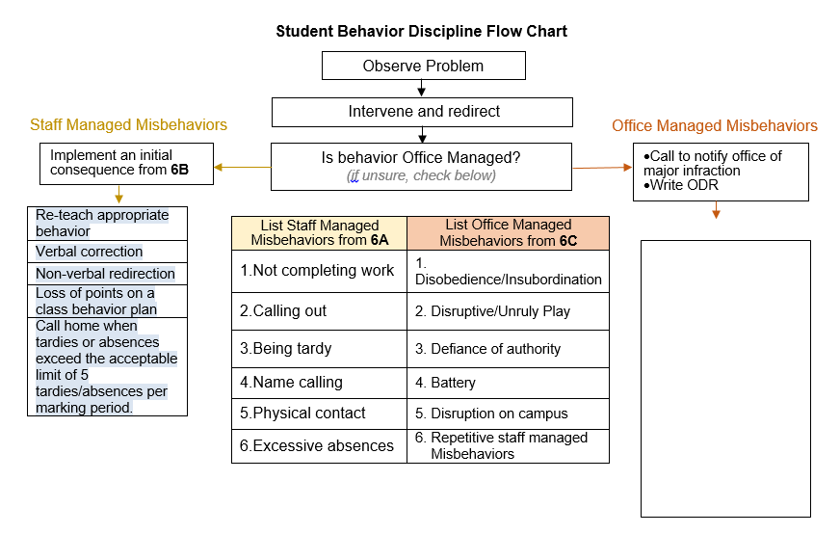(c) Paste the flow chart here**OR** complete the flow chart below

Enter administrative info here

Administration will follow the Broward County Matrix of consequences and if behavior is a crisis, will follow crisis protocol.

|  |
| --- |
| **CRITICAL ELEMENT # 7 : Classroom Management Systems** |

**7A.** ALL teachers implement an effective Tier 1 classroom management system:

|  |  |
| --- | --- |
| Which **evidence-based** classroom management system is supported by your school’s administration and is expected to be implemented school-wide?  *(Class Dojo, LEAPs, HERO, Cloud 9, etc. are tools,* ***not*** *classroom systems)* | CHAMPs*  PBIS Classroom Management  Administration does not expect an evidence-based classroom management system to be implemented by teachers this year  (*your school will need to adopt one next year)*  Other *(complete below)* |
| If other, name the **evidence-based classroom management system:** | Click here to enter name of system. |
| *CHAMPs is the district-supported, evidence-based universal classroom management system for all teachers. Would your Principal like to be contacted to learn about CHAMPs professional development? | Yes  No |

**7B.** Fidelity of **staff** implementation of school-wide classroom management systems

|  |
| --- |
| What data collection tool does your school leadership team use to monitor and evaluate your teacher’s classroom management skills? *(Measure* ***staff skills****, not student outcomes)* |
| CHAMPs 7 Up Checklist |
| CHAMPs Classroom Check Up (CCU) |
| PBIS Classroom Assistance Tool (CAT) |
| PBIS Walkthrough |
| Marzano’s Domain 1, Design Questions 5, 6, 7, 8, 9 |
| Fidelity of staff classroom management implementation is not monitored to determine training needs this year *(you will need to adopt a tool and plan next year)* |
| Other *(specify):* |
| Explain how this data is collected and analyzed by your school leadership team as a **universal screening** *across teachers* to determine the need for classroom management training: |
| Fidelity of Implementation Plan: *(3-4 sentences)Through teacher observation by trained administrators, teacher are observed to determine their use of Marzano’s Domain1. Design questions 5,6,7,8,9 which correlate with the CHAMPS modules of structure, signal, expectations, rules, corrective procedures, and engagement procedures. A teacher’s rating is then calculated and decision is made in regards to the teacher’s implementation of classroom management or the need for classroom management training.* |

**7C. Percentage of Classroom Referrals:**

(a) Review your classroom data YTD (“Events by Location”) in BASIS 3.0 Behavior Dashboard.

(b) Complete the yellow highlighted cells first.

(c) Auto-calculate the % of referrals in the classroom by clicking on “!Zero Divide” in the next cell and pressing “Fn + F9” together.

|  |  |
| --- | --- |
| Total number of discipline referrals **from classrooms**: | 36 |
| Total number of **school-wide** discipline referrals: | 111 |
| % of referrals in the classroom: | 24% |
| Do more than 40% of your referrals come from the classroom? | Yes  No |

***If >40% of discipline referrals come from the classroom, it suggests Tier 1 classroom management implementation may need to be strengthened school-wide.***

|  |
| --- |
| **CRITICAL ELEMENT # 8: Data Collection and Analysis** |

**8A. Determine your School-wide Core Effectiveness YTD** from the BASIS Behavior Dashboard in the “Referrals per Student” chart.

(a) Complete the yellow highlighted cells first.

(b) Auto-calculate the “% of Total Population” by clicking on each “!Zero Divide” in the cells and pressing “Fn + F9”.

(c) Determine if the core is effective in all three areas

|  |  |  |  |  |
| --- | --- | --- | --- | --- |
| TOTAL Population: | 660 |  |  | |
| # Referrals | 45 | **% of Total Population** | Core Effectiveness | |
| 0 - 1 referral |  | 98% | Are your 0 – 1 referrals > 80%? | Yes No |
| 2 - 5 referrals  (at risk students) | 9 | 1% | Are your 2 - 5 referrals <15%? | Yes No |
| > 5 referrals  (high risk students) | 5 | 1% | Are your >5 referrals <5%? | Yes No |

**8B. Core Effectiveness Plan:**

|  |  |
| --- | --- |
| If all 3 are “**Yes**”, your core is effective. Is your core behavior curriculum effective? | Yes No |
| Answer **either** (a) or (b):  (a) If you answered “**Yes**”, although your core is effective, what plan does your school leadership team implement for early identification of at risk and high risk students?  (b) If you answered “**NO”**, indicate the supports and interventions your school leadership team will implement at the beginning of the next school year to improve core strength: | |
| Core Effectiveness Plan: *(3-4 sentences)* | |

**8C. Disproportionality: Determine if there are any issues within subgroups** from BASIS 3.0 Behavior Dashboard in the “Referrals by Demographics” chart.

(a) Complete the yellow highlighted cells first.

(b) Auto-calculate the difference by clicking on each “0” in the next cell and pressing “Fn + F9”.

|  |  |  |  |  |
| --- | --- | --- | --- | --- |
| Subgroups | (PctPop - Green)  % **of students** | (PctRef - Blue)  **% of referrals** | Difference in referral composition | Positive value suggests disproportionality  (Is the value positive?) |
| Black | 42 | 35 | -7 | Yes No |
| Hispanic/Latin | 20 | 10 | -10 | Yes No |
| White | 23 | 22 | -1 | Yes No |

**8D. Disproportionality Plan:** If any values are positive, the percentage of referrals contributed to that subgroup is higher than expected, given that subgroups’ percentage in the student population.

|  |  |
| --- | --- |
| If all 3 are “**No**”, disproportionality is not indicated. Are all 3 “No”? | Yes No |
| Answer **either** (a) or (b):  (a) If you answered “**Yes**”, although your data indicates equity, what plan does your school leadership team implement for early identification of any disproportionality issues  (b) If you answered “**No**”, indicate the support plan and interventions your school leadership team will implement at the beginning of next year to improve sub group disproportionality | |
| Disproportionality Plan: *(3-4 sentences)*  School will monitor the referrals each quarter during the 2018-19 school year to assure any disproportionality issues are not occurring. If so, adjustments will be made accordingly. Additionally, we hope that our rules and expectations’ implementations will lower the overall number of referrals which should keep the disproportionality issues in check. | |

|  |
| --- |
| **Critical Elements # 9: SPBP Implementation Planning** |

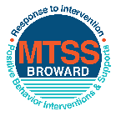This form provides a timeline to complete best practices and required actions. This timeline should drive team actions and accountability. As you implement your SPBP *NEXT* year, check off **completed items** and indicate the accountable person. (Complete only the yellow highlighted area at this time). Next year, you will upload this completed plan within your SPBP.

Required actions for all schools in Broward County

Best Practices for all schools in Broward County

**Resources**

|  |  |  |
| --- | --- | --- |
| **SPBP Team Implementation Action Plan 2018 - 2019** | | |
| **Month** | **Action Step**  *check when Action completed* | **Completed:**  Person Responsible  Name & Title |
| **Current** | **This Action Plan has been saved to use *next year* during quarterly meetings** | **Arlene Kall Guidance Counselor** |
| **Current** | **Create a SPBP binder or portfolio to retain (for 2 years) hard copies of: your SPBPs, Action Plans, staff PBIS professional development attendance, stakeholder training attendance, quarterly meeting agendas, quarterly staff behavior presentations, voting attendance and outcome, Expectation lesson plans and Rules lesson plans** | **Arlene Kall Guidance Counselor** |
| **Pre Planning**  **2018** | Print up your SPBP Review and school score from OSPA  Provide SPBP presentation to all staff during Pre Planning  Disseminate the current SPBP (hard copy or electronically) to all staff and stakeholders  Market and post school-wide Expectations and location-specific Rules (posters, PSAs, etc.)  Identify your RtI Instructional Facilitator provided by the district  (Contact [tyyne.hogan@browardschools.com](mailto:tyyne.hogan@browardschools.com) for more information, if you are unsure)  Confirm 1st team meeting date and time | Arlene Kall Guidance Counselor |
| **August**  **1st meeting** | Ensure schedule of quarterly meeting dates for entire year as indicated in the SPBP  Determine any needed team training, such as the 4 Step PSP Brainshark Series, 10 Critical  Elements Brainsharks, Data Collection, Effective CPST Teams, PBIS 101, etc.  Trainings available at: <http://www.browardprevention.org/mtssrti/training-modules/>  Review previous year’s behavior data. (Use ‘Agenda’ and ‘Data Collection Template’)  Forms available at: <http://www.browardprevention.org/mtssrti/rtib> in Tier 1, Teaming  Present implementation data, behavior data, team activities and progress to entire staff  Utilize the 4 Step Problem Solving Process to develop initial interventions  Review previous year’s SPBP and feedback form  Verify and implement teaching schedule for SPBP Expectations and Rules behavior lesson plans | David Suarez, AP Arlene Kall Guidance Counselor |
| **September** | Provide stakeholder presentation on SPBP prior to October 1  Check for staff and teacher understanding of PBIS - provide “PBIS 101” Brainshark as a resource  Brainshark available at: http://www.brainshark.com/browardschools/PBIS101 | **Arlene Kall Guidance Counselor** |
| **October**  **2nd meeting** | Ensure instructional staff know how to (and are, as needed) enter Tier 1 Supplemental Strategies  for behavior in BASIS  Present implementation data, behavior data, team activities and progress to entire staff | David Suarez, AP Arlene Kall Guidance Counselor |
| **November** | Staff to re-teach Expectations and Rules first day back from break.  Team to develop new and/or improved lesson plans as indicated by behavior data. | Arlene Kall Guidance Counselor |
| **January**  **2019**  **3rd meeting**  Prepare for *2019/20* SPBP | Staff to re-teach Expectations and Rules first day back from break  Ensure the Principal signs in and watches the *new* SPBP Brainshark: Due January 30th  Present implementation data, behavior data, team activities and progress to entire staff  Choose team members and dates to work on, complete, and submit the *new* SPBP  Teams watch the *new* SPBP Brainsharks and refers to *new* “Additional items”  Brainsharks and Additional items posted at: <http://www.browardprevention.org/mtssrti/rtib> | David Suarez, AP Arlene Kall Guidance Counselor |
| **February** | Ensure progress towards completion of SPBP  Check on recently hired staff for PBIS understanding - provide “PBIS 101” Brainshark resource  Provide the SPBP Surveymonkey link to all staff (optional). Email [Tyyne.hogan@browardschools.com](mailto:Tyyne.hogan@browardschools.com) to request analysis. | Arlene Kall Guidance Counselor |
| **March**  **4th meeting** | Ensure progress towards completion of SPBP  Provide staff presentation and vote on new SPBP for next year  Provide stakeholders/parent presentation on new SPBP for next year  Present implementation data, behavior data, team activities and progress to entire staff | David Suarez, AP Arlene Kall Guidance Counselor |
| **April** | Submit your SPBP in OSPA by April 30th every year | **Arlene Kall Guidance** |

|  |
| --- |
| **CRITICAL ELEMENT # 10: Monitoring Plans** |

**10A.** How will you determine the success **of *staff* implementation** of the School-wide Positive Behavior Plan?

*“Are* ***staff*** *implementing the SPBP with fidelity? How do you know?”*

|  |  |  |  |
| --- | --- | --- | --- |
| **Fidelity of Implementation Monitoring Plan** | | | |
| Action Step | Create an **observable** and **measureable** SMART goal to determine “successful”  **staff implementation** of action step | When will data be collected, analyzed & presented? | Person responsible to collect and analyze data |
| School-wide **expectations** and location-specific **rules** are posted across campus | By August, 2018 each school hallway will have a school-wide expectation poster posted as measured by a formal PBIS walk-through. | Refer to **quarterly** presentation dates in 2B.  This is the data the team will be sharing during presentations. | Team Leaders David Suarez, AP |
| **Behavior lesson plans** are being taught as written and when indicated | By October, 2018, 90% of the teachers will have taught all of the school wide expectations behavior lessons as measured by their inclusion of the lessons in their lesson plans. | Team Leaders David Suarez, AP |
| **Discipline consequences**  and **flow chart** are being used by all staff as written | By the end of the school year 2018-19 there will be a decrease of 10% in the number of Office Discipline Referrals that contain previously identified staff-managed misbehaviors as measured by a referral review by the PBIS team. | Team Leaders David Suarez, AP |
| A **reward system** is being implemented for *all* students | By the end of the reward system, 80% of the staff will have provided a reinforcement to at least 10 different students as measured by their master reinforcement list. | Team Leaders David Suarez, AP |

**10B.** How will you determine whether the SPBP is successful in positively impacting **students?**

*“If staff are implementing the SPBP consistently and effectively, did it positively impact* ***the students****? How do you know?”*

|  |  |  |  |
| --- | --- | --- | --- |
| **Student Outcome Monitoring Plan** | | | |
| Student Outcome Data | Create an **observable** and **measureable** SMART goal to determine “successful”  **student outcomes** | When will data be collected, analyzed & presented? | Person responsible to collect and analyze data |
| See critical element 3A  • Type of **behavior incidents** data | By March of 2019, the number of unsubstantiated bullying incidents will have decreased by 10% from this school year. | Refer to **quarterly** presentation dates in 2B.  This is the data the team will be sharing during presentations. | Team Leaders David Suarez, AP |
| See critical element 4A  • **Top 3 event locations** data | By March of 2019, the number of incidents occurring on campus will have decreased by 10% from this year. | Team Leaders David Suarez, AP |
| See critical element 8  • **Core effectiveness** data | By March of 2019 the core will be effect ivein all three areas measured. | Team Leaders David Suarez, AP |
| See critical element 7A  • **Grade Level/Classroom referrals** data | By March of 2019, the number of classroom referrals will fall below 40% | Team Leaders David Suarez, AP |