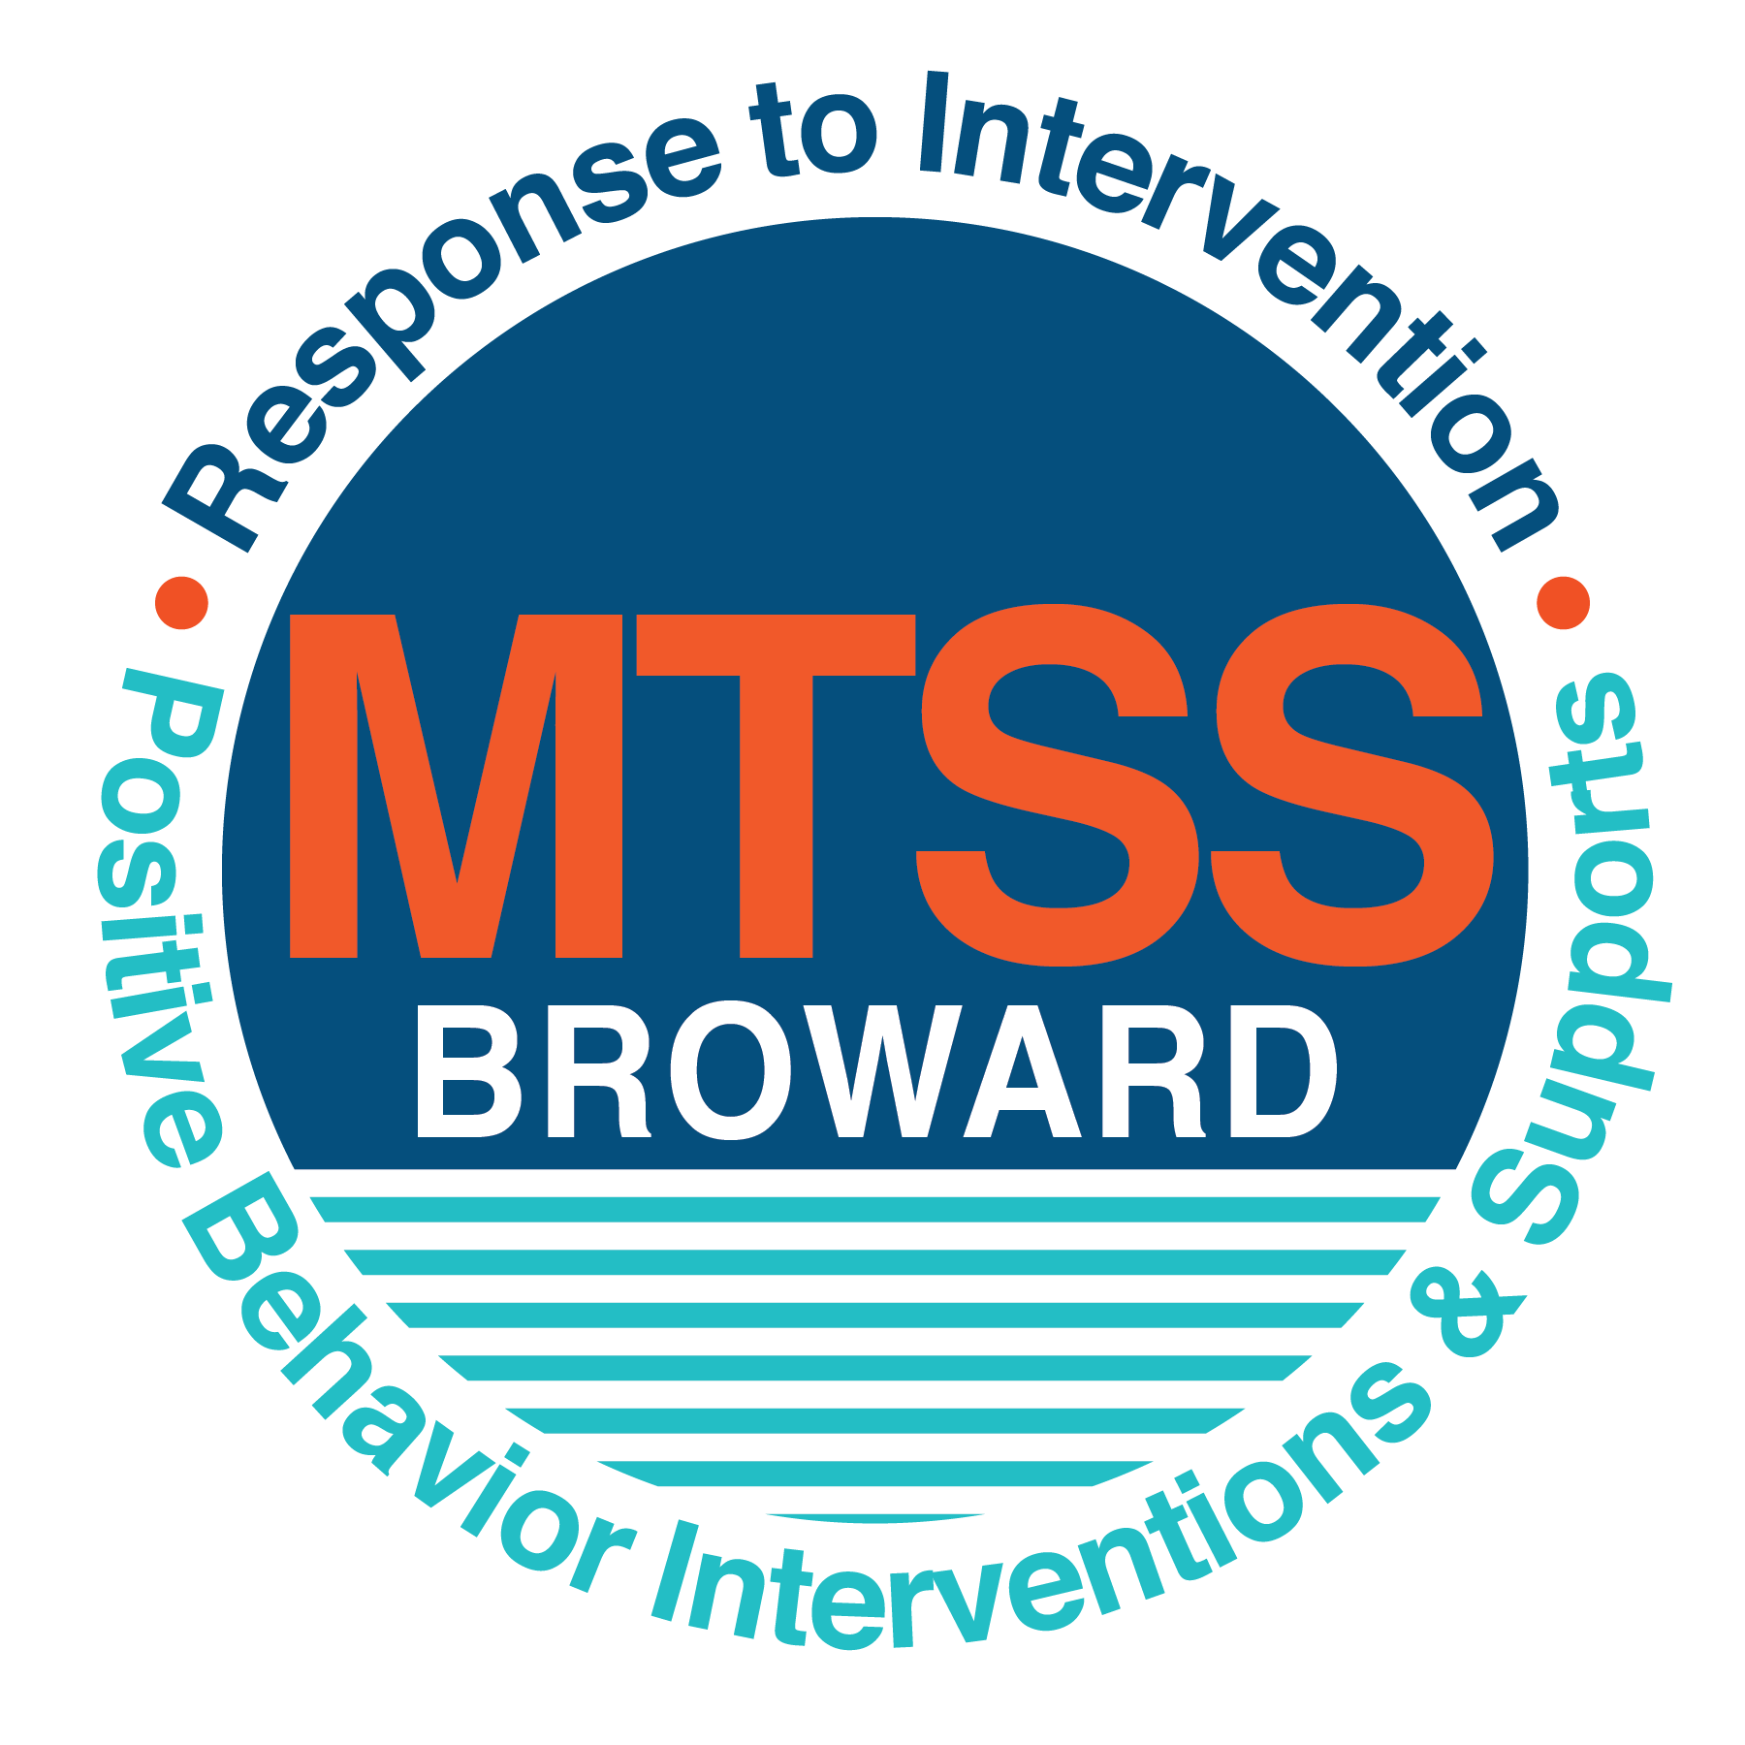
School-wide Positive Behavior Plan (SPBP)
Broward County Public Schools
To be implemented in SY 2019/20

School Name: | North Lauderdale Pre-K-8
School Number: | 2231
SPBP Contact Name: | Nicole Neunie
Direct Phone Number: | 754-322-7400

CRITICAL ELEMENT # 1: Active Team with Administrative Participation

1A. Current (SY 2018/19) SPBP team members:
Full Name | Position
Nichele Williams | 1. Administration
Tamela Williams | 2. BTU Representative
Nicole Nuenie | 3. SPBP Point of Contact
Jilan Samuels | 4. Parent/Community Representation
Carmen Conde | 5. ESE Representative
Beverly Whitely | 6. PreK Team Leader
Jeanne Pierre | 7. K Team Leader
Elizabeth Castillo | 8. 1st Grade Team Leader
Corey Brown | 9. 2nd Grade Team Leader
Maxine Nicholson | 10. 3rd Grade Team Leader
Jennifer Sobers-Gay | 11. 4th Grade Team Leader
Ronnie Frazier | 12. 5th Grade Team Leader
D’Andrea Brown | 13. 6th-8th Team Leader

1B. Schedule of quarterly SPBP Team Meeting dates for next 2019/20 school year:
Meeting Date | Meeting Time | Content of meetings:
9/24/2019 | 2:20 pm | 1. Progress of Action Steps indicated in Implementation Plan in #9  2. Collect & analyze fidelity of staff implementation data in #10A  3. Collect & analyze student outcome data in #10B
12/10/2019 | 2:20 pm
2/25/2020 | 2:20 pm
3/31/2020 | 2:20 pm

CRITICAL ELEMENT # 2: Faculty & Stakeholder Commitment:

2A. Action Steps completed this year (SY 2018/19) that increased faculty and stakeholder knowledge of the new SPBP:

Action Steps: | Date  (Between Jan 15 and  April 30, 2019) | Details  (Sign-in sheets in SPBP Binder)
Presented the new SPBP (for SY 2019/20) to staff | 3/22/2019 | # of participants = 65
Held a faculty vote on the new SPBP  (for SY 2019/20) | 4/22/2019 | # of participants =49  % approved =
Presented the new SPBP (for SY 2019/20) to stakeholders (parents and community) | 5/6/2019 | # of participants =

2B. Action Steps to be completed next year (SY 2019/20) to increase faculty and stakeholder knowledge of the new SPBP:

Action Steps: | Date  (SY 2019-20) | Content  (Sign-in sheets in SPBP Binder)
Provide professional development on the 2019/20 SPBP for all staff | Prior to students’ 1st day:  8/7/2019 | The team will present the updates in the SPBP for the 19/20 school year. All stakeholders will be provided with access to the SPBP. Feedback will be collected for future team meetings.
Present the 2019/20 SPBP to stakeholders  (parents and community) | Prior to Oct 1st, 2019  9/18/2019
Present the behavior data to all staff quarterly | 1. 10/15/2019 | The team will present:  - the team’s progress in the Implementation Plan in # 9.  - the fidelity of staff implementation data in #10A.  - the student outcome data in #10B.
 | 2. 12/17/2019
 | 3. 2/10/2020
 | 4. 4/7/2020

CRITICAL ELEMENT # 3: School-wide Expectations

3A. Top five behavior incidents data YTD as listed in BASIS 3.0
Top 5 Behavior Incidents
- SB: Unruly Disruptive Behavior
- Battery
- Disobedience/Insubordination
- Fight-Minor/ Altercation
- Disruption on campus (Minor)

3B. School-wide expectations are 3 – 5 positive characteristics (not behaviors) that counteract the demonstration of the top school-wide misbehaviors above. ALL people on campus model these expectations.
School-wide Expectations
- Be respectful
- Be responsible
- Be safe
4.
5.

3C. At least one lesson plan for each school-wide expectation above is distributed to teachers during pre-planning SY 2019/20 and maintained in the SPBP Binder.
Dates the school-wide expectations lesson plans are taught:
 | Date(s) | Time: | Location(s):
August | 8/14-8/28/2019 | 1:30-2:00 pm | Homeroom
January | 1/7-1/21/2020 | 1:30-2:00 pm | Homeroom
After Spring Break | 3/30-4/3/2020 | 1:30-2:00 pm | Homeroom

CRITICAL ELEMENT #4: Location-based Rules

4A. Top three school-wide locations for Behavior Events YTD.
Top 3 Locations, not including Classroom:
School Location | # Incidents
1. Cafeteria | 7
2. School ground | 5
3. Playground | 4

4B. Expectations and Rules Chart for common areas of school campus: (next page)

Expectatiofns and Rules Chart |  |  |  | To be completed by classroom teachers
School-wide EXPECTATIONS | Cafeteria Rules | Hallway Rules | Play Ground Rules | Classroom Rules
Be respectful | - Keep hands, feet and object to yourself  - Respect others property | - Keep hands, feet and object to yourself | - Keep hands, feet and object to yourself
Be responsible | - Stay in your seat  - Raise your hand for assistance | - Walk on the right side of the hallway | - No physical contact  - Play responsibly
Be safe | - Listen for instructions  - Voice level 1 | - Listen for instructions  - Voice level 0 | - Follow rules the first time  - Stay in assigned area

4C. At least one Rules lesson plan for each specific location is distributed to teachers during pre-planning SY 2019/20 and maintained in the SPBP Binder.

Dates the Locations’ Rules lesson plans are taught
 | Date(s) | Time: | Location(s):
August | 8/14-8/28/2019 | 8:00-8:30 am | Homeroom
January | 1/7-1/21/2020 | 8:00-8:30 am | Homeroom
After Spring Break | 3/30-4/32020 | 8:00-8:30 am | Homeroom

CRITICAL ELEMENT # 5: Reward and Recognition Programs

5. The reward system is focused on one School-wide Expectation OR specific location at a time.
Expectation or Location: ___________Cafeteria_______________________

4 Step Problem Solving Process | Plan Details
1. Problem Identification: Use your behavior data to identify one school-wide problem.  What problem did you identify? (use numerical data) | Data used: BASIS Behavior Dashboard  Problem Identification Statement: 7 of 10 referrals were cafeteria referrals which pertained to students not being respectful to their peers.
2. Problem Analysis: Why do you think this problem is occurring?  What is your goal? (use a SMART goal statement with numerical data) | Hypothesis: If students are taught quarterly lessons on self-monitoring and self-regulating behaviors in non-instructional settings a reduction of referrals in the cafeteria would occur in the 2019-2020 school year.  Goal Statement: Every quarter, the number of student Office Discipline Referrals in the Cafeteria will decrease by 2% as measured by the BASIS Behavior Dashboard
3. Intervention Design: Describe how you will implement a positive reward program to decrease this problem. | Type of System: Point system  Description of System:  - Classes (Students) will earn Lion Buck Tickets on a daily basis for adhering to cafeteria rules.  - Lion buck tickets will be collected by the teacher.  - Teachers will have to return their Lion Buck Tickets in at the end of the month.  - Administration/Support Staff will tally and identify the top 3 classes from each lunch shift.  - The top 3 classes per lunch shift will receive weekly & monthly recognition and rewards.
4. Evaluation:  A. Implementation fidelity | - How will you monitor the fidelity (consistency and effectiveness) of the staff’s implementation of the reward program?  - The Lion Buck System will be shared with staff (Paraprofessionals, Teachers & Support Staff)  - Class Points will be posted on the wall in the cafeteria. Classes will also be recognized for their good behavior in the cafeteria by receiving certificates and being recognized on the morning show.  - The top 3 classes per week will receive a certificate of recognition for adhering to cafeteria rules.
B. Student outcome monitoring | How will you know if the reward program is positively impacting students? What measurable data will you use to determine “success”?  - Students will adhere to the posted Cafeteria Rules of Remaining in their Seats and using inside voices while inside the cafeteria.  - Faculty & Staff Members will complete the Cafeteria Rules & Expectations Survey 2 times per quarter do determine overall Behavior Success within the Cafeteria.

CRITICAL ELEMENT #6: Effective Discipline Procedures

Student Behavior Discipline Flow Chart
Re-direct behavior.
Give verbal warning.
North Lauderdale P-8 Behavior Flow Chart
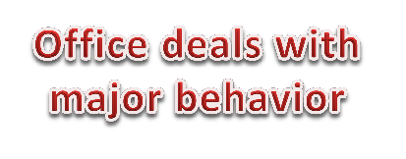
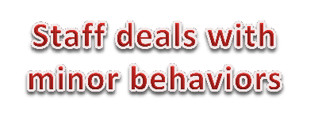
Observe Problem Behavior
Student conference
with administration.
Reflection/ re-teach/
rehearse behavior.
Is the behavior a
minor or major offense?

Minor Problem  Behaviors | Major Problem  Behaviors
Inappropriate  Language | Abusive Language
Physical Contact | Fighting/ Physical  Aggression
Disrespect | Disrespect
Defiance | Defiance
Failure to follow school rules | Failure to follow school rules
Disruptive | Weapons
Property Misuse | Lying/ Cheating
Dress Code Violation | Harassment/ Bullying
Stealing | Theft
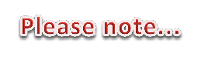
Re-teach appropriate
behavior to meet expectations.
Consequences will be
given with progressive discipline.
Use alternate redirect
options:
Pull aside and discuss behavior, review expectations, etc.
Communication with
teacher.
Parent contact is made.
If consequence is given,
document on referral form to be entered on Infinity.
- Everyday starts with a clean slate.
- Fill out discipline referral form when student doesn't respond to redirection, pre-correction, or verbal warning.
If behavior continues,
refer to major offense.
- Take concrete action to correct behavior (i.e. individual
practice, removal from activity, seat change, etc.)
- Behaviors are defined on back of this page.
Document incident on
referral form to be
entered on infinity.

CRITICAL ELEMENT # 7: Classroom Management Systems

7A. In SY 2019/20, ALL teachers implement an evidence-based Tier 1 classroom management system:
Evidence-based system: | Evidence of training:
☒ CHAMPS | 50% of teachers currently holding valid CHAMPS certificate:
☐ PBIS Classroom Management  http://www.fl-pda.org/independent/ | % of teachers currently holding completion certificate:
☐ Other: Click here to enter name of system. | Training evidence: Click here to enter evidence  % of teachers currently trained:

7B. The administration reviews and analyzes the fidelity of staff implementation of Tier 1 classroom management systems across teachers using:
☒ CHAMPs 7 Up Checklist
☐ Basic FIVE (Classroom Management Screening)
☐ PBIS Classroom Assistance Tool (CAT)
☐ Other (specify):
☐ Classroom management screening is not conducted across teachers to determine appropriate professional
development. (Next year, assessment of classroom management implementation fidelity will be scored).

7C. School year 2018/19 percentage of classroom referrals:
Total number of discipline referrals from classrooms: | 28
Total number of other school-wide discipline referrals: | 17
% of referrals in the classroom: | 62%
Do more than 40% of your referrals come from the classroom? | ☒ Yes ☐ No
If >40% of discipline referrals come from the classroom, it suggests Tier 1 classroom management implementation may need to be strengthened school-wide.
If “Yes”, school-wide classroom management professional development will be conducted in 2019-20:
CHAMPS Overview (80% teachers have certificate) If “Other”, indicated system here: Click here to enter text.

CRITICAL ELEMENT # 8: Data Collection and Analysis

8A. Core Effectiveness:
TOTAL Population: | 797 | % of Total Population | Core Effectiveness
# Referrals: | # of Students:
0 - 1 referrals |  | 97% | Are your 0 – 1 referrals > 80%? | ☒Yes ☐No
2 - 5 referrals  (at risk students) | 15 | 2% | Are your 2 - 5 referrals <15%? | ☒Yes ☐No
> 5 referrals  (high risk students) | 8 | 1% | Are your >5 referrals <5%? | ☒Yes ☐No

8B. Core Effectiveness Action Steps:
If all 3 are “Yes”, your core is effective. Is your core behavior curriculum effective? | ☒Yes ☐No
Answer either (a) or (b):
(a) If you answered “Yes”, although your core is effective, what steps does your school leadership team take for early identification of at risk and high-risk students?
(b) If you answered “NO”, indicate the supports and interventions your school leadership team will implement at the beginning of the next school year to improve core strength:
Core Effectiveness Action Steps: (3-4 steps)
1. At the beginning of the 2019/2020 school year, the AP will collect data on new and articulating students who may need extra assistance through Collaborative Problem Solving & RTI
2. Students needing immediate assistance will receive extra assistance through Response to Intervention.
3. The PBIS leader will collect monthly data on student through Office Discipline Referrals and Admin/Teacher discussions.

8C. Disproportionality within racial subgroups:
Subgroups | (PctPop - Green)  % of students | (PctRef - Blue)  % of referrals | Difference in referral composition | Positive value suggests disproportionality  (Is the value positive?)
Black | 79 | 94 | 15 | ☒Yes ☐No
Hispanic/Latin | 14 | 4 | -10 | ☐Yes ☒No
White | 3 | 2 | -1 | ☐Yes ☒No

8D. Disproportionality Action Steps:
If all three are “No”, disproportionality is not indicated. Are all 3 “No”? | ☒Yes ☐No
Answer either (a) or (b):
(a) If you answered “Yes”, although your data indicates equity, what plan does your school leadership team implement for early identification of any disproportionality issues
(b) If you answered “No”, indicate the support plan and interventions your school leadership team will implement at the beginning of next year to improve sub group disproportionality
Disproportionality Action Steps: (3-4 steps)
1. Our data indicates that our black students have disproportionality concerns.
2. To address the Disproportionality concern with black students, we will identify and provide extra support by incorporating cultural responsive strategies and proactive strategies from quarterly PBIS meetings.
3. The Discipline flow chart will be used to assist in modifying inappropriate behaviors interventions of black and other students.
4. Extra Training will be provided to assist teachers that may need extra assistance in Behavior Management.

Critical Elements # 9: SPBP Implementation Planning
RED Font = Action Steps for all schools in Broward County
GREY Font = Best Practices for all schools in Broward County
TEAL Font = Resources available at https://browardcountyschools.sharepoint.com/sites/DPI6Strands/strand6/SitePages/SPBP.aspx
SPBP Team Implementation Action Plan 2019 - 2020
Month | Action Steps  ☒ check off Action Step when completed
Current | ☒ Create a SPBP binder or portfolio to retain (for 2 years) hard copies of: your SPBPs, Action Plans, staff PBIS  professional development attendance, stakeholder training attendance, quarterly meeting agendas, quarterly staff  behavior presentations, voting attendance and outcome, Expectations lesson plans and Rules lesson plans
Pre-Planning  2019 | ☐ Print up your SPBP Review and school score from OSPA  ☐ Provide SPBP presentation to all staff during Pre-Planning  ☐ Disseminate the current SPBP (hard copy or electronically) to all staff and stakeholders  ☐ Market and post school-wide Expectations and location-specific Rules  ☐ Identify your district RtI Instructional Facilitator  (Contact tyyne.hogan@browardschools.com for more information, if you are unsure)  ☐ Confirm 1st team meeting date and time
August  1st meeting | ☐ Ensure schedule of quarterly meeting dates for entire year as indicated in the SPBP  ☐ Review Implementation plan; check off completed Action Steps  ☐ Determine any needed team training, such as these Brainsharks: 4 Step Problem Solving Process series, PBIS 10  Critical Elements, Data Collection, Big 5 Data, PBIS 101, etc. (All found in Sharepoint site)  ☐ Review previous year’s behavior data. (Use ‘Agenda’ Form and ‘Data Collection Template’ in Sharepoint site)  ☐ Utilize the 4 Step Problem Solving Process to initiate a Reward System for all students  ☐ Review previous year’s SPBP and feedback form; make necessary modifications  ☐ Verify and implement teaching schedule for Expectations and Rules behavior lesson plans  ☐ Present implementation data, behavior data, team activities and SPBP progress to entire staff
September | ☐ Provide SPBP stakeholder presentation prior to October 1  ☐ Check for staff and teacher understanding of PBIS - provide “PBIS 101” Brainshark as a resource  Brainshark available at: http://www.brainshark.com/browardschools/PBIS101  ☐ Ensure the Discipline Flow Chart is distributed to all staff and is being used as written
October  2nd meeting | ☐ Review Implementation plan; check off completed Action Steps  ☐ Ensure instructional staff know how to (and are, as needed) enter Tier 1 Supplemental Strategies  for behavior in BASIS  ☐ Review previous quarter’s behavior data. (Use ‘Agenda’ and ‘Data Collection Template’ in Sharepoint site)  ☐ Present implementation data, behavior data, team activities, and SPBP progress to entire staff  ☐ Ensure all teachers are using an evidence-based classroom management plan, such as CHAMPS  ☐ Ensure Core Effectiveness Action Steps are being implemented as written
November | ☐ Team to develop new and/or improved lesson plans as indicated by behavior data.  ☐ Ensure that the Disproportionality Action Steps are being implemented as written
January  2020  3rd meeting  Prepare for SY 2020/21 SPBP | ☐ Review Implementation plan; check off completed Action Steps  ☐ Staff to re-teach Expectations and Rules after winter break  ☐ Principal signs in and watches the new “SPBP for Principals” Brainshark: Due January 30th  ☐ Present implementation data, behavior data, team activities, and SPBP progress to entire staff  ☐ Choose team members and dates to work on, complete, and submit the new SPBP  ☐ Teams watch the new “SPBP Team Overview” Brainshark and refers to district resources and supports  (Brainsharks and Additional items in Sharepoint site. Webinars and in-person lab information in Team Brainshark)
February | ☐ Ensure progress towards completion of SPBP  ☐ Check on recently hired staff for PBIS understanding - provide “PBIS 101” Brainshark resource  ☐ Provide the SPBP Surveymonkey link to all staff (optional)
March  4th meeting | ☐ Ensure progress towards completion and submission of SPBP  ☐ Review Implementation plan; check off completed Action Steps  ☐ Staff to re-teach Expectations and Rules after from spring break  ☐ Provide stakeholders/parent presentation on new SPBP for next year  ☐ Provide staff presentation and faculty vote on new SPBP for next year  ☐ Present implementation data, behavior data, team activities, and SPBP progress to entire staff
April | ☐ Submit your SPBP in OSPA by April 30th every year. Use this new SPBP in the next school year  ☐ Continue implementing your current SPBP through the end of the current school year

CRITICAL ELEMENT # 10: Evaluation

10A. Staff implement the School-wide Positive Behavior Plan effectively:
“Are staff implementing the SPBP with fidelity? How do you know?”
STAFF Implementation Monitoring
Action Step | Create an observable and measurable SMART goal to determine “successful”  staff implementation of action step
School-wide expectations and location-specific rules are posted across campus | By the end of every quarter, there will be a 2% decrease in cafeteria behavior as measured by Cafeteria Rules & Expectations Survey in addition to Office Discipline Referrals (ODRs) from the Behavior dashboard.
Expectations and Rules lesson plans are being taught as written and when indicated | By the end of every quarter, the Assistant Principal will check to make sure that Expectations and Rules Lesson Plans are taught during the months of August, January, and April.
The Discipline flow chart is being used by all staff as written | At the beginning of every quarter, North Lauderdale P-8’s Discipline flow chart will be used to teach and model behavioral practices during the 2019-2020 school year.
A reward system is being implemented for all students | During the 2019 school year, Lion Bucks will be used to encourage the desired behavior of students as monitored by the cafeteria behavioral excel point tracking system.

10B. The SPBP is successful in positively impacting students:
“If staff are implementing the SPBP consistently and effectively, did it positively impact the students? How do you know?”
STUDENT Outcome Monitoring
Student Outcome Data | Create an observable and measurable SMART goal to determine  “successful” student outcomes
Behavior Incident data  (See critical element #3A) | By the end of every quarter, there will be a 2% decrease in cafeteria behavior as measured by Cafeteria Rules & Expectations Survey in addition to Office Discipline Referrals (ODRs) from the Behavior dashboard.
Top 3 event locations data  (See critical element #4A) | By the end of every quarter, staff will receive data pertaining to ODRs in the top 3 event locations. Staff will also complete the Cafeteria Rules & Expectations Survey to determine if there is improvement in cafeteria behavior.
Core effectiveness data  (See critical element #8A) | During each quarter, ODRs will be reviewed with Faculty & Staff Members, plus meetings will also be held with teachers who have select Targeted Students are receiving support through Collaborative Problem Solving and RTI.
Classroom referrals data  (See critical element #7C) | By the end of each quarter, North Lauderdale P-8’s goal is to decrease referrals by 2% each quarter as measured by ODRs and Cafeteria Rules & Expectations Survey.

