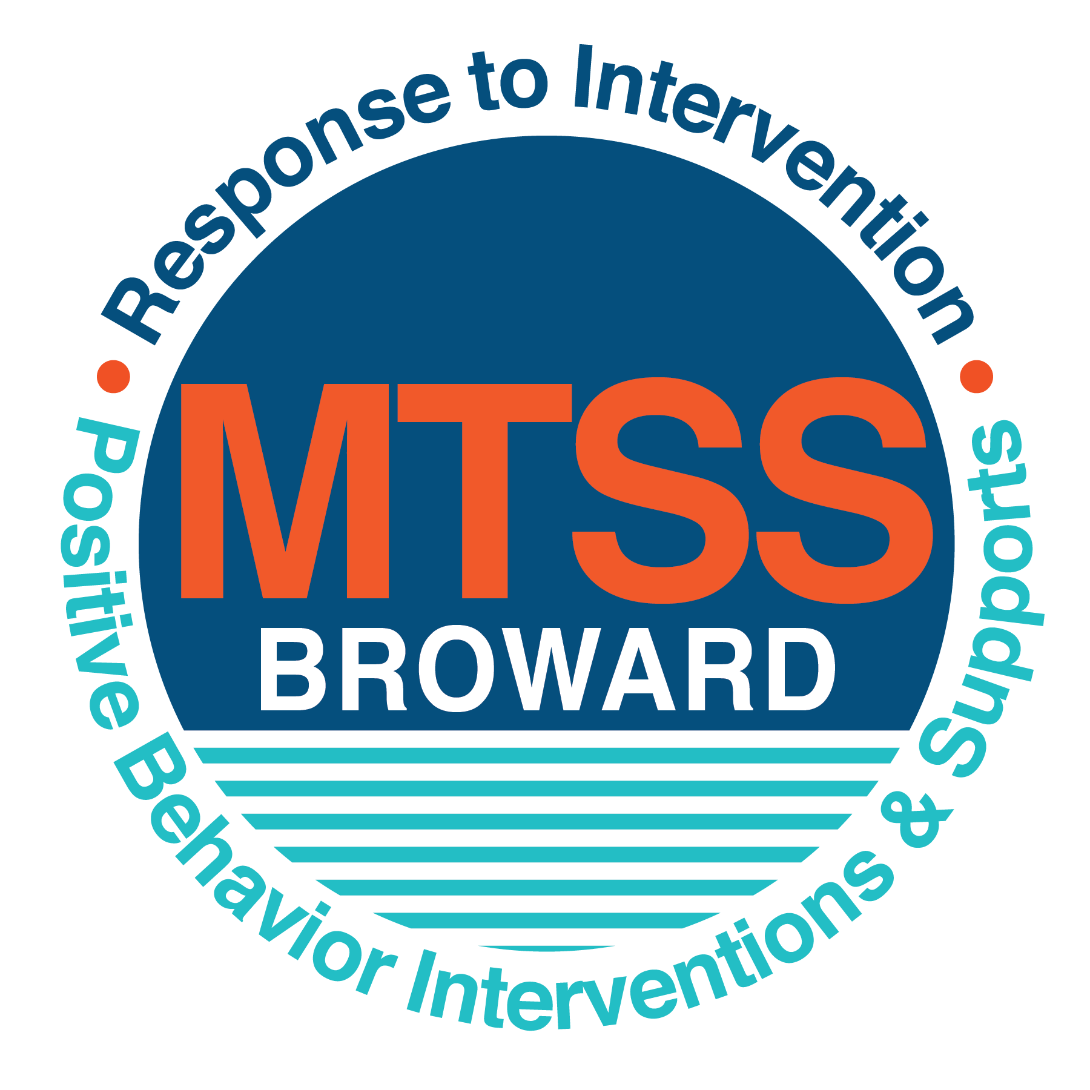
School-wide Positive Behavior Plan (SPBP)
Broward County Public Schools
To be implemented in SY 2019/20

School Name: | Banyan Elementary
School Number: | 2001
SPBP Contact Name: | Mrs. Lashawn Settles
Direct Phone Number: | 754-322-5365

CRITICAL ELEMENT # 1: Active Team with Administrative Participation

1A. Current (SY 2018/19) SPBP team members:
Full Name | Position
Dr. Eric Miller/Mrs. Mayra Hernandez | 1. Administration
Mrs. Betty Warren | 2. BTU Representative
Mrs. Lashawn Settles | 3. Guidance Counselor
Mrs. April Balzanti | 4. Parent/Community Representation (SAC)
Ms. Juanita Green | 5. K Teacher
Ms. Sara Holschauer | 6. 1st Grade Teacher
Mrs. Sondra Oliver | 7. 2nd Grade Teacher
Mrs. Diane Hutchinson | 8. 3rd Grade Teacher
Mrs. Farrah Kellingbeck | 9. 4th Grade Teacher
Mrs. Daughn White | 10. SAC Chair & 5th Grade Teacher

1B. Schedule of quarterly SPBP Team Meeting dates for next 2019/20 school year:
Meeting Date | Meeting Time | Content of meetings:
8/8/2019 | 2:15-2:50pm | - Create and disseminate updated Expectations and rules lesson plans (#3 and #4)  - Review progress of Implementation Action Plan (#9)  - Collect and analyze implementation of data (#10A)  - Collect and analyze student outcome data (#10B)
9/4/2019 | 2:15-2:50pm
1/8/2020 | 2:15-2:50pm
4/1/2020 | 2:15-2:50pm

CRITICAL ELEMENT # 2: Faculty & Stakeholder Commitment:

2A. Action Steps completed this year (SY 2018/19) that increased faculty and stakeholder knowledge of the new SPBP:

Action Steps: | Date  (Between Jan 15 and  April 30, 2019) | Details  (Sign-in sheets in SPBP Binder)
Presented the new SPBP (for SY 2019/20) to staff | 3/19/2019 | # of participants = 37
Held a faculty vote on the new SPBP  (for SY 2019/20) | 3/20/2019 | # of participants  % approved = 57%
Presented the new SPBP (for SY 2019/20) to stakeholders (parents and community) | 3/20/2019 | # of participants = 16

2B. Action Steps to be completed next year (SY 2019/20) to increase faculty and stakeholder knowledge of the new SPBP:

Action Steps: | Date  (SY 2019-20) | Content  (Sign-in sheets in SPBP Binder)
Provide professional development on the 2019/20 SPBP for all staff | Prior to students’ 1st day:  8/12/2019 | The team will present the updates in the SPBP for the 19/20 school year. All stakeholders will be provided with access to the SPBP. Feedback will be collected for future team meetings.
Present the 2019/20 SPBP to stakeholders  (parents and community) | Prior to Oct 1st, 2019  9/25/2019
Present the behavior data to all staff quarterly | 1. 9/25/2019 | The team will present the implementation data in 10A. This will include the:  - “marketing” which is the teaching and posting of expectations and rules  - Lesson plan implementation  - Discipline procedures  - Reward system implementation  The team will present the student outcome data in 10B: This includes:  - Top 3 event locations  - Type of behavior incidents  - Core effectiveness data  - Classroom referral data, as well as analysis of this data.
 | 2. 12/18/2019
 | 3. 2/19/2020
 | 4. 5/20/2020

CRITICAL ELEMENT # 3: School-wide Expectations

3A. Top five behavior incidents data YTD as listed in BASIS 3.0
Top 5 Behavior Incidents
- Unruly Disruptive Behavior
- Disobedient Subordinate
- Defiance of authority
- Petty Theft
- Battery

3B. School-wide expectations are 3 – 5 positive characteristics (not behaviors) that counteract the demonstration of the top school-wide misbehaviors above. ALL people on campus model these expectations.
School-wide Expectations
- Treat others with kindness and respect
- Be ready in preparation for learning
- Be responsible for your thoughts and actions
- Be safe and cautious
- Yes to Self Control

3C. At least one lesson plan for each school-wide expectation above is distributed to teachers during pre-planning SY 2019/20 and maintained in the SPBP Binder.
Dates the school-wide expectations lesson plans are taught:
 | Date(s) | Time: | Location(s):
August | 8/8/2019 | 9:30am | Creative Khan
January | 1/8/2020 | 9:30am | Classroom and Cafeteria
After Spring Break | 4/1/2020 | 8:30am | Cafeteria

CRITICAL ELEMENT #4: Location-based Rules

4A. Top three school-wide locations for Behavior Events YTD.
Top 3 Locations, not including Classroom:
School Location | # Incidents
1. Cafeteria | 11
2. Hallway | 9
3. Recess | 4

4B. Expectations and Rules Chart for common areas of school campus: (next page)

Expectations and Rules Chart |  |  |  | To be completed by classroom teachers
School-wide EXPECTATIONS | Cafeteria Rules | Hallway Rules | Playground Rules | Classroom Rules
Treat Others with Kindness | Responsible for keeping personal area clean. Use appropriate table manners. | Walking directionally on the right side of the hallway. Keep appropriate distance between you and fellow classmates (1 tile square between you and your classmate in front of you, both feet in the square). | Keep hands and feet to yourself. Use appropriate language while playing with classmates. | Always respect classmates, and teachers.
Be responsible for your thoughts before your actions. | Level 1 voices inside the cafeteria. Listen to cafeteria paraprofessionals and support staff. Keep seated at all times/raise your hand for assistance. | Level 0 voices in hallway during transitional times. Move quietly through the hallways. | Remember all safety rules while playing with peers. Playground rules are to be followed at all times. | Listen to directions the first time given. Raise your hands before speaking/leaving your seat.
Be Safe | Pick up all trash in personal space. Help keep table area tidy by picking up all trash on tables and seats. | Keep hands off walls while transitioning through hallways. Respect all decorations and bulletin boards in hallways. | Return all playground equipment to the PE teacher. Do not litter on the playground, if something is dropped, immediately pick up the trash and dispose of it in nearby garbage cans. Do not abuse any playground/PE equipment. | Keep, hands, feet and objects to yourself at all times.
Yes to Self-Control | Walk at all times maintaining personal space. Speak in a normal voice and only with people at your table. | Walk at all times maintaining personal space. | Keep hands and feet to self.  Follow classroom rules and be attentive and on task.

4C. At least one Rules lesson plan for each specific location is distributed to teachers during pre-planning SY 2019/20 and maintained in the SPBP Binder.

Dates the Locations’ Rules lesson plans are taught
 | Date(s) | Time: | Location(s):
August | 8/15/2019 | 8:30am | School Cafeteria
January | 1/9/2020 | 8:30am | School Cafeteria
After Spring Break | 4/2/2020 | 8:30am | School Cafeteria

CRITICAL ELEMENT # 5: Reward and Recognition Programs

5. The reward system is focused on one School-wide Expectation OR specific location at a time.
Expectation or Location: __Cafeteria________________________________

4 Step Problem Solving Process | Plan Details
1. Problem Identification: Use your behavior data to identify one school-wide problem.  What problem did you identify? (use numerical data) | Data used: Referrals  Problem Identification Statement: Noise level within the cafeteria and cleanliness of tables.
2. Problem Analysis: Why do you think this problem is occurring?  What is your goal? (use a SMART goal statement with numerical data) | Hypothesis: After being in a structured classroom, students are eager to talk to friends so their voice level increases, they play around and leave their tables messy.  Goal Statement: By October 2020, students’ behaviors will increase to promote respectful communication levels/proper behavior/cleanliness as evidenced by weekly Cafeteria Progress Monitoring sheets.
3. Intervention Design: Describe how you will implement a positive reward program to decrease this problem. | Type of System: Token system  Description of System: Cafeteria Plan Reward  - Enter quietly (no talking in line)  - Use level 1 voices  - Stay in designated area during eating of lunch, raise for assistance  - Clean designated lunch area  - Exit quietly when dismissed  There are 4 adults (paraprofessionals and support staff) continually monitoring their assigned area of the cafeteria. Each table has 3 cups (1 green, 1 yellow and 1 red). The class always starts on a green cup. When the majority of the class is following expectations, the cup will remain on green and the class will earn a point on the progress monitoring chart. When the majority of the class is not following expectations, the cup will change to yellow. If the class is continuously not following expectations, and sufficient efforts at redirection, the cup will than change to red. Each class is given the opportunity to earn 10 “points” to earn extra recess time, 20 “points” to earn extra recess time and fruit roll ups, 30 “points” to earn extra recess time and a popcorn party, and 50 “points” to earn extra recess time and a class pizza party. The “points” do not have to be earned consecutively.
4. Evaluation:  A. Implementation fidelity | - How will you monitor the fidelity (consistency and effectiveness) of the staff’s implementation of the reward program? (2-3 sentences)  The Cafeteria Progress Monitoring Charts will be monitored by support staff and administration on a monthly basis. Results will be presented and discussed at monthly Team Leader meetings. Those classes with major infractions, will have further discussions with designated support staff.
B. Student outcome monitoring | - How will you know if the reward program is positively impacting students? What measurable data will you use to determine “success”? (2-3 sentences)  Administration will utilize the Cafeteria Progress Monitoring Charts as a means of measuring the success of the reward system in the cafeteria. This will allow us to monitor data throughout the school year. In addition, data from the DMS on the number of cafeteria referrals, will be analyzed quarterly by Administration.

CRITICAL ELEMENT #6: Effective Discipline Procedures

Student Behavior Discipline Flow Chart
Observe problem behavior behaviorBehavior
Teacher Staff
Managed Misbehaviors
Intervene and redirect
Office Managed Misbehaviors
Call to notify office of major infraction, student to be picked up or sent to office
Re-direct student
No
Yes

Is behavior Office Managed?
(if unsure, check below)

Specific Examples of  6 Staff Managed  Misbehaviors: | Specific Examples of  6 Office Managed  Misbehaviors:
Inappropriate language  Profanity | Abusive language  Verbal Bullying
Physical Contact  Wrestling w/another student  Using hands, feet or objects against another student | Fighting/physical  Kicking, hitting, pushing, shoving, w/ intent to do harm
Defiance  Not completing class work  Not following directions/non compliance | Leaving School grounds/classroom without permission
Observable Behavior  running in the hallway,  throwing food | Threat or intimidation  Verbal threats of aggression against another person
Disruptive  Tattling  Distracting other students | Vandalism of personal property/school property
Theft  Theft with little or no value | Theft  Major theft items of high value

Student conference with administration. Reflection/re-teach/rehearse appropriate behavior
Implement an initial consequence. Reteach appropriate behavior to meet CHAMPS expectations

Reteach and Verbal Reflection Discuss behavior one to one, review CHAMPS expectations

Administration determines and assigns consequences according to policy

Written Behavior Reflection Sheet and Contact Parent/Guardian. Document contact

Parent Contact (phone/sheet) and administrator provides teacher with feedback

Call office/send student to office with Reflection Sheet

Incident entered in BASIS

If behavior continues and interventions are not modifying behaviors refer to watch team

CRITICAL ELEMENT # 7: Classroom Management Systems

7A. In SY 2019/20, ALL teachers implement an evidence-based Tier 1 classroom management system:
Evidence-based system: | Evidence of training:
☒ CHAMPS | 50% of teachers currently holding valid CHAMPS certificate:
☐ PBIS Classroom Management  http://www.fl-pda.org/independent/ | % of teachers currently holding completion certificate:
☐ Other: Click here to enter name of system. | Training evidence: Click here to enter evidence  % of teachers currently trained:

7B. The administration reviews and analyzes the fidelity of staff implementation of Tier 1 classroom management systems across teachers using:
☒ CHAMPs 7 Up Checklist
☐ Basic FIVE (Classroom Management Screening)
☐ PBIS Classroom Assistance Tool (CAT)
☒ Other Marzano’s Domain 1, Design Questions, 5, 6, 7, 8, 9
☐ Classroom management screening is not conducted across teachers to determine appropriate professional
development. (Next year, assessment of classroom management implementation fidelity will be scored).

7C. School year 2018/19 percentage of classroom referrals:
Total number of discipline referrals from classrooms: | 13
Total number of other school-wide discipline referrals: | 24
% of referrals in the classroom: | 2%
Do more than 40% of your referrals come from the classroom? | ☐ Yes ☒ No
If >40% of discipline referrals come from the classroom, it suggests Tier 1 classroom management implementation may need to be strengthened school-wide.
If “Yes”, school-wide classroom management professional development will be conducted in 2019-20:
Click here to choose: If “Other”, indicated system here: Click here to enter text.

CRITICAL ELEMENT # 8: Data Collection and Analysis

8A. Core Effectiveness:
TOTAL Population: | 604 | % of Total Population | Core Effectiveness
# Referrals: | # of Students:
0 - 1 referrals |  | 99% | Are your 0 – 1 referrals > 80%? | ☒Yes ☐No
2 - 5 referrals  (at risk students) | 7 | 1% | Are your 2 - 5 referrals <15%? | ☒Yes ☐No
> 5 referrals  (high risk students) | 1 | 0% | Are your >5 referrals <5%? | ☒Yes ☐No

8B. Core Effectiveness Action Steps:
If all 3 are “Yes”, your core is effective. Is your core behavior curriculum effective? | ☒Yes ☐No
Answer either (a) or (b):
(a) If you answered “Yes”, although your core is effective, what steps does your school leadership team take for early identification of at risk and high-risk students?
(b) If you answered “NO”, indicate the supports and interventions your school leadership team will implement at the beginning of the next school year to improve core strength:
Core Effectiveness Action Steps: (3-4 steps)
1. Review of School Wide Discipline Plan
2. Weekly Classroom Walkthroughs by Administration
3. Weekly RtI meetings
4. Quarterly monitoring of the DMS

8C. Disproportionality within racial subgroups:
Subgroups | (PctPop - Green)  % of students | (PctRef - Blue)  % of referrals | Difference in referral composition | Positive value suggests disproportionality  (Is the value positive?)
Black | 65% | 74% | 9 | ☒Yes ☐No
Hispanic/Latin | 23% | 18% | -6 | ☐Yes ☒No
White | 7% | 0% | 7 | ☒Yes ☐No

8D. Disproportionality Action Steps:
If all three are “No”, disproportionality is not indicated. Are all 3 “No”? | ☐Yes ☒No
Answer either (a) or (b):
(a) If you answered “Yes”, although your data indicates equity, what plan does your school leadership team implement for early identification of any disproportionality issues
(b) If you answered “No”, indicate the support plan and interventions your school leadership team will implement at the beginning of next year to improve sub group disproportionality
Disproportionality Action Steps: (3-4 steps)
1. Weekly Guidance Counselor sessions with students
2. Weekly mentoring sessions for identified students
3. Weekly RtI meetings
4. Quarterly monitoring of the DMS

Critical Elements # 9: SPBP Implementation Planning
RED Font = Action Steps for all schools in Broward County
GREY Font = Best Practices for all schools in Broward County
TEAL Font = Resources available at https://browardcountyschools.sharepoint.com/sites/DPI6Strands/strand6/SitePages/SPBP.aspx
SPBP Team Implementation Action Plan 2019 - 2020
Month | Action Steps  ☒ check off Action Step when completed
Current | ☐ Create a SPBP binder or portfolio to retain (for 2 years) hard copies of: your SPBPs, Action Plans, staff PBIS  professional development attendance, stakeholder training attendance, quarterly meeting agendas, quarterly staff  behavior presentations, voting attendance and outcome, Expectations lesson plans and Rules lesson plans
Pre-Planning  2019 | ☐ Print up your SPBP Review and school score from OSPA  ☐ Provide SPBP presentation to all staff during Pre-Planning  ☐ Disseminate the current SPBP (hard copy or electronically) to all staff and stakeholders  ☐ Market and post school-wide Expectations and location-specific Rules  ☐ Identify your district RtI Instructional Facilitator  (Contact tyyne.hogan@browardschools.com for more information, if you are unsure)  ☐ Confirm 1st team meeting date and time
August  8, 2019 | ☐ Ensure schedule of quarterly meeting dates for entire year as indicated in the SPBP  ☐ Review Implementation plan; check off completed Action Steps  ☐ Determine any needed team training, such as these Brainsharks: 4 Step Problem Solving Process series, PBIS 10  Critical Elements, Data Collection, Big 5 Data, PBIS 101, etc. (All found in Sharepoint site)  ☐ Review previous year’s behavior data. (Use ‘Agenda’ Form and ‘Data Collection Template’ in Sharepoint site)  ☐ Utilize the 4 Step Problem Solving Process to initiate a Reward System for all students  ☐ Review previous year’s SPBP and feedback form; make necessary modifications  ☐ Verify and implement teaching schedule for Expectations and Rules behavior lesson plans  ☐ Present implementation data, behavior data, team activities and SPBP progress to entire staff
September  4, 2019 | ☐ Provide SPBP stakeholder presentation prior to October 1  ☐ Check for staff and teacher understanding of PBIS - provide “PBIS 101” Brainshark as a resource  Brainshark available at: http://www.brainshark.com/browardschools/PBIS101  ☐ Ensure the Discipline Flow Chart is distributed to all staff and is being used as written
October  17, 2019 | ☐ Review Implementation plan; check off completed Action Steps  ☐ Ensure instructional staff know how to (and are, as needed) enter Tier 1 Supplemental Strategies  for behavior in BASIS  ☐ Review previous quarter’s behavior data. (Use ‘Agenda’ and ‘Data Collection Template’ in Sharepoint site)  ☐ Present implementation data, behavior data, team activities, and SPBP progress to entire staff  ☐ Ensure all teachers are using an evidence-based classroom management plan, such as CHAMPS  ☐ Ensure Core Effectiveness Action Steps are being implemented as written
November  20, 2019 | ☐ Team to develop new and/or improved lesson plans as indicated by behavior data.  ☐ Ensure that the Disproportionality Action Steps are being implemented as written
January 8,  2020  Prepare for SY 2020/21 SPBP | ☐ Review Implementation plan; check off completed Action Steps  ☐ Staff to re-teach Expectations and Rules after winter break  ☐ Principal signs in and watches the new “SPBP for Principals” Brainshark: Due January 30th  ☐ Present implementation data, behavior data, team activities, and SPBP progress to entire staff  ☐ Choose team members and dates to work on, complete, and submit the new SPBP  ☐ Teams watch the new “SPBP Team Overview” Brainshark and refers to district resources and supports  (Brainsharks and Additional items in Sharepoint site. Webinars and in-person lab information in Team Brainshark)
February  20, 2019 | ☐ Ensure progress towards completion of SPBP  ☐ Check on recently hired staff for PBIS understanding - provide “PBIS 101” Brainshark resource  ☐ Provide the SPBP Surveymonkey link to all staff (optional)
March  10, 2020 | ☐ Ensure progress towards completion and submission of SPBP  ☐ Review Implementation plan; check off completed Action Steps  ☐ Staff to re-teach Expectations and Rules after from spring break  ☐ Provide stakeholders/parent presentation on new SPBP for next year  ☐ Provide staff presentation and faculty vote on new SPBP for next year  ☐ Present implementation data, behavior data, team activities, and SPBP progress to entire staff
April  9, 2020 | ☐ Submit your SPBP in OSPA by April 30th every year. Use this new SPBP in the next school year  ☐ Continue implementing your current SPBP through the end of the current school year

CRITICAL ELEMENT # 10: Evaluation

10A. Staff implement the School-wide Positive Behavior Plan effectively:
“Are staff implementing the SPBP with fidelity? How do you know?”
STAFF Implementation Monitoring
Action Step | Create an observable and measurable SMART goal to determine “successful”  staff implementation of action step
School-wide expectations and location-specific rules are posted across campus | By the end of 1st quarter, School wide expectation and rules will be posted in hallways/cafeteria during preplanning week. These posters will be reviewed during the first week of school and in video presentations during behavior assembly.
Expectations and Rules lesson plans are being taught as written and when indicated | By the end of the 1st quarter, 100% of the teachers will have documented in their lesson plans that they reviewed the expectations and rules of the School-wide Positive Behavior plan with their students.
The Discipline flow chart is being used by all staff as written | By the end of the 1st quarter, 100% of the staff will be trained in utilizing the Discipline flow chart. When discipline issues occur, administration will ensure that staff is following the Discipline flow chart.
A reward system is being implemented for all students | By the end of the 1st quarter, 100% of the teachers will have a classroom reward system for positive behavior in place. Administration will conduct weekly walkthroughs to ensure that a reward system for positive behavior is being implemented in all classrooms.

10B. The SPBP is successful in positively impacting students:
“If staff are implementing the SPBP consistently and effectively, did it positively impact the students? How do you know?”
STUDENT Outcome Monitoring
Student Outcome Data | Create an observable and measurable SMART goal to determine  “successful” student outcomes
Behavior Incident  Unruly/disruptive behavior | By the end of the 1st quarter, the amount of behavior incidents will be less than 3 as evidenced by the DMS.
Top 3 event locations data | By the end of the 2nd quarter, the amount of incidents in the cafeteria, hallway and playground areas will decrease by 50%.
Core effectiveness data  (See critical element #8A) | By the end of the 3rd quarter, 100% of the students identified with at risk behavior, will be referred to the RtI team by the affected teachers, and action plans will be developed and monitored to correct the students’ inappropriate behaviors.
Classroom referrals data  (See critical element #7C) | By the end of the 2019-2020 school year, 100% of the teachers will have completed the Tier 1 Classroom Management Refresher course (CHAMPS), and the number of student referrals, will decrease by at least 25% as evident by the DMS.

