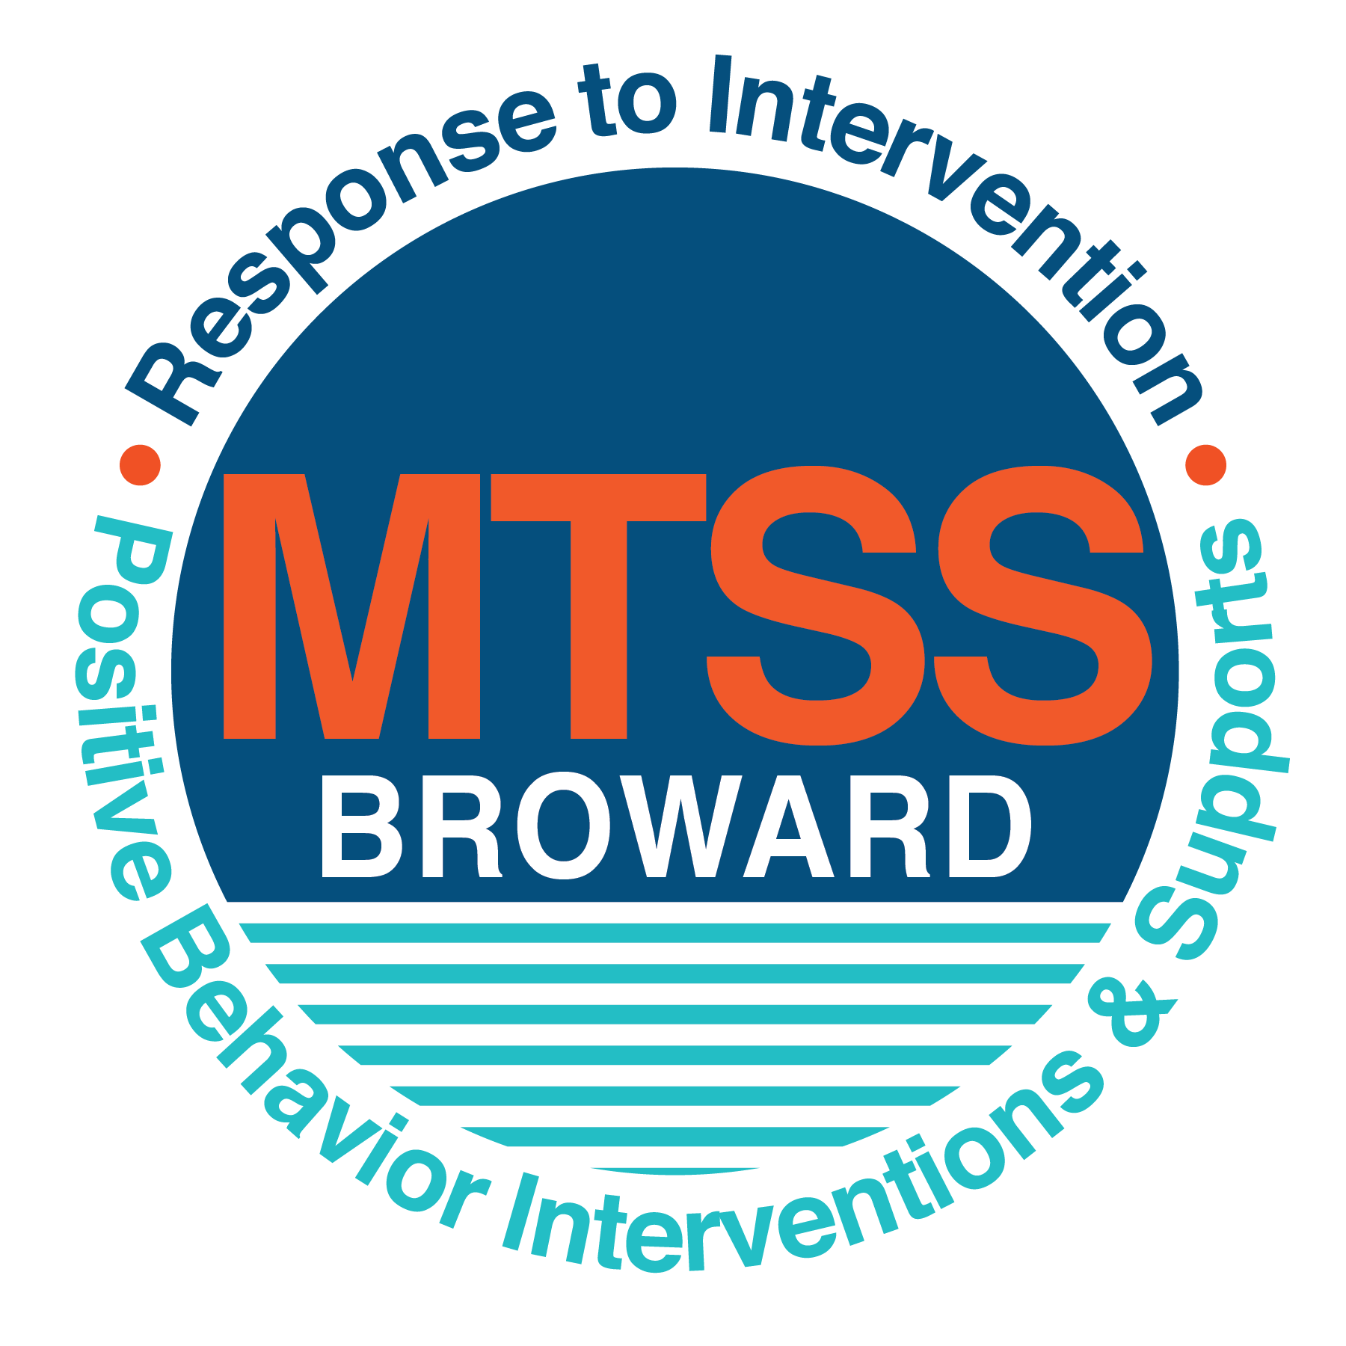
School-wide Positive Behavior Plan (SPBP)
Broward County Public Schools
To be implemented in SY 2019/20

School Name: | James S. Hunt Elementary
School Number: | 1971
SPBP Contact Name: | Emilia Espana
Direct Phone Number: | 754-322-6500

CRITICAL ELEMENT # 1: Active Team with Administrative Participation

1A. Current (SY 2018/19) SPBP team members:
Full Name | Position
Christina Monroe | 1. Administration
Latonya Coldros | 2. BTU Representative
Emilia Espana | 3. SPBP Point of Contact & Asst. Principal
Sandy Moise | 4. Classroom Teacher/PBIS Team Member
Kim Chamberlin | 5. Reading Coach & Parent
Kim JnBaptiste | 6. Paraprofessional
Jessica Frias | 7. ESE Specialist & Parent
Margarita Rivera | 8. Parent/Community Representation
 | 9.
 | 10.

1B. Schedule of quarterly SPBP Team Meeting dates for next 2019/20 school year:
Meeting Date | Meeting Time | Content of meetings:
8/7/2019 | 8:30 a.m. | 1. Progress of Action Steps indicated in Implementation Plan in #9  2. Collect & analyze fidelity of staff implementation data in #10A  3. Collect & analyze student outcome data in #10B
11/12/2019 | 2:15 p.m.
2/18/2019 | 2:15 p.m.
5/7/2019 | 2:15 p.m.

CRITICAL ELEMENT # 2: Faculty & Stakeholder Commitment:

2A. Action Steps completed this year (SY 2018/19) that increased faculty and stakeholder knowledge of the new SPBP:

Action Steps: | Date  (Between Jan 15 and  April 30, 2019) | Details  (Sign-in sheets in SPBP Binder)
Presented the new SPBP (for SY 2019/20) to staff | 4/17/2019 | # of participants = 40
Held a faculty vote on the new SPBP  (for SY 2019/20) | 4/22/2019 | # of participants = 45  % approved = 100%
Presented the new SPBP (for SY 2019/20) to stakeholders (parents and community) | 4/24/2019 | # of participants = 20

2B. Action Steps to be completed next year (SY 2019/20) to increase faculty and stakeholder knowledge of the new SPBP:

Action Steps: | Date  (SY 2019-20) | Content  (Sign-in sheets in SPBP Binder)
Provide professional development on the 2019/20 SPBP for all staff | Prior to students’ 1st day:  8/8/2019 | The team will present the updates in the SPBP for the 19/20 school year. All stakeholders will be provided with access to the SPBP. Feedback will be collected for future team meetings.
Present the 2019/20 SPBP to stakeholders  (parents and community) | Prior to Oct 1st, 2019  8/13/2019
Present the behavior data to all staff quarterly | 1. 10/24/2019 | The team will present:  - the team’s progress in the Implementation Plan in # 9.  - the fidelity of staff implementation data in #10A.  - the student outcome data in #10B.
 | 2. 12/16/2019
 | 3. 3/9/2020
 | 4. 5/18/2020

CRITICAL ELEMENT # 3: School-wide Expectations

3A. Top five behavior incidents data YTD as listed in BASIS 3.0
Top 5 Behavior Incidents
1. Disobedience/Insubordination (58)
2. Unruly/Disruptive (39)
3. Defiance of Auth./Hab. (17)
4. Campus Disruption/Minor (3)
5. Assault/Threat (2)

3B. School-wide expectations are 3 – 5 positive characteristics (not behaviors) that counteract the demonstration of the top school-wide misbehaviors above. ALL people on campus model these expectations.
School-wide Expectations
1. Be RESPECTFUL
2. Be ACCOUNTABLE
3. Be SAFE
4.
5.

3C. At least one lesson plan for each school-wide expectation above is distributed to teachers during pre-planning SY 2019/20 and maintained in the SPBP Binder.
Dates the school-wide expectations lesson plans are taught:
 | Date(s) | Time: | Location(s):
August | 08/08/2019 | 8:30 a.m. | Media Center
January | 01/06/2020 | 9:00 a.m. | Media Center
After Spring Break | 03/31/2020 | 2:20 p.m. | Media Center

CRITICAL ELEMENT #4: Location-based Rules

4A. Top three school-wide locations for Behavior Events YTD.
Top 3 Locations, not including Classroom:
School Location | # Incidents
1. School Grounds | 16
2. Cafeteria | 12
3. Hallway | 6

4B. Expectations and Rules Chart for common areas of school campus: (next page)

Expectations and Rules Chart |  |  |  | To be completed by classroom teachers
School-wide EXPECTATIONS | Cafeteria Rules | Hallway Rules | School Grounds Rules | Classroom Rules
Expectation #1:  Be SAFE | - Remain in your assigned line spot  - Remain in your assigned seat | - Report to your assigned area  - Keep your hands and feet to your self | - Choose a safe activity or game to play
Expectation #2:  Be ACCOUNTABLE | - Collect all items while you are in line.  - Keep your table and floor area clean | - Read while you wait  - Raise your hand for assistance  - Follow directions the first time asked | - Report unsafe behavior  - Avoid conflict—walk away
Expectation #3:  Be RESPECTFUL | - Enter the kitchen at voice level zero  - Use voice level 1 at your table  - Follow directions the first time asked | - Enter the building at voice level zero  - Use kind and respectful words | - Participate in respectful interaction  - Follow directions the first time asked

4C. At least one Rules lesson plan for each specific location is distributed to teachers during pre-planning SY 2019/20 and maintained in the SPBP Binder.

Dates the Locations’ Rules lesson plans are taught
 | Date(s) | Time: | Location(s):
August | 08/08/2019 | 8:30 a.m. | Media Center
January | 01/06/2020 | 9:00 a.m. | Media Center
After Spring Break | 03/31/2020 | 2:20 p.m. | Media Center

CRITICAL ELEMENT # 5: Reward and Recognition Programs

5. The reward system is focused on one School-wide Expectation OR specific location at a time.
Expectation or Location: _____Cafeteria_____________________________

4 Step Problem Solving Process | Plan Details
1. Problem Identification: Use your behavior data to identify one school-wide problem.  What problem did you identify? (use numerical data) | Data used: BASIS Behavior Incidents Data  Problem Identification Statement: We have had 12 incidents of defiance and noncompliance in the cafeteria this year.
2. Problem Analysis: Why do you think this problem is occurring?  What is your goal? (use a SMART goal statement with numerical data) | Hypothesis: We believe this problem is occurring because we need to review expectations more consistently, and we need to improve our cafeteria rewards for The Golden Spoon cafeteria behavior program.  Goal Statement: By April 2020, the number of behavior incidents in the cafeteria will be reduced by half based on a reduction of ODR as evidence by BASIS data from the Behavior Dashboard.
3. Intervention Design: Describe how you will implement a positive reward program to decrease this problem. | Type of System: Point system  Description of System: The Golden Spoon Award Program provides daily incentive for classes to follow expectations during lunch. Hunt Cafeteria Monitors evaluate the classes that enter the cafeteria each day for proper lunchroom conduct. The expected conduct will be posted and reviewed by each teacher daily within their classroom to develop consistency. Purple/Blue/Red/Yellow Plastic Cups: To help students self-monitor, we will also use colored cups to let each table/class know if their noise level is too high. At the end of each lunch period, the classes that exhibit appropriate behavior will receive a point toward earning the Golden Spoon. At the end of each month, three classes will win a Golden Spoon and treats.
4. Evaluation:  A. Implementation fidelity | - How will you monitor the fidelity (consistency and effectiveness) of the staff’s implementation of the reward program? During the 2019-2020 school year, 100% of teachers will teach and reteach the Cafeteria Behavior Lesson Plan in classrooms (on designated dates each quarter). 100% of Cafeteria Monitors will also participate in training and modeling at our monthly ESP meeting in order to ensure increased understanding and consistent implementation of our Golden Spoon Program.
B. Student outcome monitoring | How will you know if the reward program is positively impacting students? What measurable data will you use to determine “success”? We will know that the reward program is positively impacting students because the number of behavior incidents in the cafeteria will be reduced by half based on a reduction of ODR as evidence by BASIS data from the Behavior Dashboard.

CRITICAL ELEMENT #6: Effective Discipline Procedures

Student Behavior Discipline Flow Chart
Observe problem behavior behaviorBehavior
Intervene and redirect
Office Managed Misbehaviors
Staff Managed Misbehaviors
Call to notify office of a
crisis/safety issue
No
Yes

Implement an initial consequence
Is behavior Office Managed?
(if unsure, check below)

Specific Examples of  6 Staff Managed  Minor Misbehaviors: | Specific Examples of  6 Office Managed  Misbehaviors:
1. Getting out of seat | 1. Repetitive moderate misbehaviors
2. Calling out | 2. Tantrum
3. Delaying transition | 3. Yelling at teacher
4. Stepping out of line | 4. Refusing to transition or get on task
5. Being off task | 5. Elopement
6. Using unkind words | 6. Physical altercation
Response Menu for Minor Misbehaviors
(Staff’s choice of 5):
- Refer to Zones of Regulation element for self-regulation

- Deny Incentive Point with expectation to earn it

- Deduct partial time from special privilege

- Apologize to classmate

- Bring “folder” to neighbor teacher (diffuse strategy)

If the behavior requires a referral or is crisis related intervention
Intervention 1
Call to notify office of major infraction. Student to be removed by support team member. Write ODR and contact RTI Team as needed.

Intervention 2
Student conference with administration. Zones of Regulation Reflection/
re-teach/ rehearse behavior

Intervention 3
Administration determines and assigns consequences according to policy.

Moderate
Misbehavior
1. Repeated Minor Misbehaviors
2. Yelling loudly in class
3. Refusing to take out materials needed for transition
4. Refusing to get in line
5. Refusing to get on task
6. Repeating unkind words to classmates
Response Menu for Moderate Misbehaviors
(Staff’s choice):
- Implement Individual Tier 2 Behavior Plan – OR
- Request meeting with RTI Team to determine if Tier 2 Behavior Plan is needed.
- Send behavior note home
- Go to Thinking or Safe Place
- Complete SOAR Thinking Paper
- Deduct entire time from special privilege
- Write apology letter
- Enter Tier 1 Strategies onto BASIS

Intervention 4
Parent contact and administration follows up with email update to teacher and Support Team

All staff are encouraged to use preventive strategies to encourage students to seek alternative solutions to conflict. This includes reminding students to use skills learned as part of our schoolwide Zones of Regulation Program, and our Hunt SOAR (Safe, Obedient, Accountable, and Respectful) Plan.

Teachers use the Hunt Infraction Sheet with this flowchart to keep track of the positive Tier 1 Intervention Strategies used to respond to Minor and/or Moderate misbehaviors/infractions.

We are a PBIS (Positive Behavior Intervention School) school.

CRITICAL ELEMENT # 7: Classroom Management Systems

7A. In SY 2019/20, ALL teachers implement an evidence-based Tier 1 classroom management system:
Evidence-based system: | Evidence of training:
☐ CHAMPS | % of teachers currently holding valid CHAMPS certificate:
☐ PBIS Classroom Management  http://www.fl-pda.org/independent/ | % of teachers currently holding completion certificate:
☒ Other: Zones of Regulation | Training evidence: Sign-in sheet(s) 95% of teachers currently trained

7B. The administration reviews and analyzes the fidelity of staff implementation of Tier 1 classroom management systems across teachers using:
☐ CHAMPs 7 Up Checklist
☐ Basic FIVE (Classroom Management Screening)
☐ PBIS Classroom Assistance Tool (CAT)
☒ Other Daily classroom walkthroughs, and required, documented IObservation monitoring; and designated elements of Zones of Regulation Program
☐ Classroom management screening is not conducted across teachers to determine appropriate professional
development. (Next year, assessment of classroom management implementation fidelity will be scored).

7C. School year 2018/19 percentage of classroom referrals:
Total number of discipline referrals from classrooms: | 88
Total number of other school-wide discipline referrals: | 43
% of referrals in the classroom: | 88/131=67%
Do more than 40% of your referrals come from the classroom? | ☒ Yes ☐ No
If >40% of discipline referrals come from the classroom, it suggests Tier 1 classroom management implementation may need to be strengthened school-wide.
If “Yes”, school-wide classroom management professional development will be conducted in 2019-20:
Other: If “Other”, indicated system here: Zones of Regulation Training 2

CRITICAL ELEMENT # 8: Data Collection and Analysis

8A. Core Effectiveness:
TOTAL Population: | 638 | % of Total Population | Core Effectiveness
# Referrals (49 sts) | # of Students:
0 - 1 referrals | 25 | 96% | Are your 0 – 1 referrals > 80%? | ☒Yes ☐No
2 - 5 referrals  (at risk students) | 15 | 2% | Are your 2 - 5 referrals <15%? | ☒Yes ☐No
> 5 referrals  (high risk students) | 10 | 2% | Are your >5 referrals <5%? | ☒Yes ☐No

8B. Core Effectiveness Action Steps:
If all 3 are “Yes”, your core is effective. Is your core behavior curriculum effective? | ☒Yes ☐No
Answer either (a) or (b):
(a) If you answered “Yes”, although your core is effective, what steps does your school leadership team take for early identification of at risk and high-risk students?
(b) If you answered “NO”, indicate the supports and interventions your school leadership team will implement at the beginning of the next school year to improve core strength:
Core Effectiveness Action Steps: (3-4 steps)
1.Zones of Regulation Program for SEL success
2.Improved Golden Spoon Cafeteria Program for Good Behavior
3.Year 2 of PBIS Implementation (Quarterly meetings to share behavior data)
4. Continue school wide Praisin Raisin student reward program.

8C. Disproportionality within racial subgroups:
Subgroups | (PctPop - Green)  % of students | (PctRef - Blue)  % of referrals | Difference in referral composition | Positive value suggests disproportionality  (Is the value positive?)
Black | 53 | 86 | 33 | ☒Yes ☐No
Hispanic/Latin | 38 | 05 | -33 | ☐Yes ☒No
White | 06 | 07 | 01 | ☒Yes ☐No

8D. Disproportionality Action Steps:
If all three are “No”, disproportionality is not indicated. Are all 3 “No”? | ☐Yes ☒No
Answer either (a) or (b):
(a) If you answered “Yes”, although your data indicates equity, what plan does your school leadership team implement for early identification of any disproportionality issues
(b) If you answered “No”, indicate the support plan and interventions your school leadership team will implement at the beginning of next year to improve sub group disproportionality
Disproportionality Action Steps: (3-4 steps)
1.Plan Year 2 of MTL (Mentoring Tomorrow’s Leaders) participation to include goals and schedules for implementation
2.Plan Year 3 of LIA (Latinos in Action) with a focus on improving sub group disproportionality
3. The Zones of Regulation Program will be implemented school wide next year.
4. Plan to schedule training on Culturally Responsive Teaching in 2019-2020.

Critical Elements # 9: SPBP Implementation Planning
RED Font = Action Steps for all schools in Broward County
GREY Font = Best Practices for all schools in Broward County
TEAL Font = Resources available at https://browardcountyschools.sharepoint.com/sites/DPI6Strands/strand6/SitePages/SPBP.aspx
SPBP Team Implementation Action Plan 2019 - 2020
Month | Action Steps  ☒ check off Action Step when completed
Current | ☒ Create a SPBP binder or portfolio to retain (for 2 years) hard copies of: your SPBPs, Action Plans, staff PBIS  professional development attendance, stakeholder training attendance, quarterly meeting agendas, quarterly staff  behavior presentations, voting attendance and outcome, Expectations lesson plans and Rules lesson plans
Pre-Planning  2019 | ☐ Print up your SPBP Review and school score from OSPA  ☐ Provide SPBP presentation to all staff during Pre-Planning  ☐ Disseminate the current SPBP (hard copy or electronically) to all staff and stakeholders  ☐ Market and post school-wide Expectations and location-specific Rules  ☐ Identify your district RtI Instructional Facilitator  (Contact tyyne.hogan@browardschools.com for more information, if you are unsure)  ☐ Confirm 1st team meeting date and time
August  1st meeting | ☐ Ensure schedule of quarterly meeting dates for entire year as indicated in the SPBP  ☐ Review Implementation plan; check off completed Action Steps  ☐ Determine any needed team training, such as these Brainsharks: 4 Step Problem Solving Process series, PBIS 10  Critical Elements, Data Collection, Big 5 Data, PBIS 101, etc. (All found in Sharepoint site)  ☐ Review previous year’s behavior data. (Use ‘Agenda’ Form and ‘Data Collection Template’ in Sharepoint site)  ☐ Utilize the 4 Step Problem Solving Process to initiate a Reward System for all students  ☐ Review previous year’s SPBP and feedback form; make necessary modifications  ☐ Verify and implement teaching schedule for Expectations and Rules behavior lesson plans  ☐ Present implementation data, behavior data, team activities and SPBP progress to entire staff
September | ☐ Provide SPBP stakeholder presentation prior to October 1  ☐ Check for staff and teacher understanding of PBIS - provide “PBIS 101” Brainshark as a resource  Brainshark available at: http://www.brainshark.com/browardschools/PBIS101  ☐ Ensure the Discipline Flow Chart is distributed to all staff and is being used as written
October  2nd meeting | ☐ Review Implementation plan; check off completed Action Steps  ☐ Ensure instructional staff know how to (and are, as needed) enter Tier 1 Supplemental Strategies  for behavior in BASIS  ☐ Review previous quarter’s behavior data. (Use ‘Agenda’ and ‘Data Collection Template’ in Sharepoint site)  ☐ Present implementation data, behavior data, team activities, and SPBP progress to entire staff  ☐ Ensure all teachers are using an evidence-based classroom management plan, such as CHAMPS  ☐ Ensure Core Effectiveness Action Steps are being implemented as written
November | ☐ Team to develop new and/or improved lesson plans as indicated by behavior data.  ☐ Ensure that the Disproportionality Action Steps are being implemented as written
January  2020  3rd meeting  Prepare for SY 2020/21 SPBP | ☐ Review Implementation plan; check off completed Action Steps  ☐ Staff to re-teach Expectations and Rules after winter break  ☐ Principal signs in and watches the new “SPBP for Principals” Brainshark: Due January 30th  ☐ Present implementation data, behavior data, team activities, and SPBP progress to entire staff  ☐ Choose team members and dates to work on, complete, and submit the new SPBP  ☐ Teams watch the new “SPBP Team Overview” Brainshark and refers to district resources and supports  (Brainsharks and Additional items in Sharepoint site. Webinars and in-person lab information in Team Brainshark)
February | ☐ Ensure progress towards completion of SPBP  ☐ Check on recently hired staff for PBIS understanding - provide “PBIS 101” Brainshark resource  ☐ Provide the SPBP Surveymonkey link to all staff (optional)
March  4th meeting | ☐ Ensure progress towards completion and submission of SPBP  ☐ Review Implementation plan; check off completed Action Steps  ☐ Staff to re-teach Expectations and Rules after from spring break  ☐ Provide stakeholders/parent presentation on new SPBP for next year  ☐ Provide staff presentation and faculty vote on new SPBP for next year  ☐ Present implementation data, behavior data, team activities, and SPBP progress to entire staff
April | ☐ Submit your SPBP in OSPA by April 30th every year. Use this new SPBP in the next school year  ☐ Continue implementing your current SPBP through the end of the current school year

CRITICAL ELEMENT # 10: Evaluation

10A. Staff implement the School-wide Positive Behavior Plan effectively:
“Are staff implementing the SPBP with fidelity? How do you know?”
STAFF Implementation Monitoring
Action Step | Create an observable and measurable SMART goal to determine “successful”  staff implementation of action step
School-wide expectations and location-specific rules are posted across campus | By the first day of school 2019-2020, school-wide expectations and rules will be posted in 100% of classrooms and common areas including pictures for our non-readers – as measured by a formal PBIS walkthrough.
Expectations and Rules lesson plans are being taught as written and when indicated | By August 21st, 2019, 100% of teachers will have taught all of the school-wide expectations behavior lesson plans as measured by self-report to grade level team leaders.
The Discipline flow chart is being used by all staff as written | In the 2019-2020 school year, 100% of teachers will use the Discipline Flow Chart to record at least three infractions before a referral is made to Administration as measured by a referral review by the PBIS team.
A reward system is being implemented for all students | In the 2019-2020 school year, 100% of teachers will reward 2 students every week with a Praisin Raisin as measured by student participation at the weekly gathering to receive their rewards.

10B. The SPBP is successful in positively impacting students:
“If staff are implementing the SPBP consistently and effectively, did it positively impact the students? How do you know?”
STUDENT Outcome Monitoring
Student Outcome Data | Create an observable and measurable SMART goal to determine  “successful” student outcomes
Behavior Incident data  (See critical element #3A) | By June 2020, given the Zones of Regulation strategies, students will use three ZR strategies in order to reduce the number of office behavior referrals by 5%, as measured by the BASIS Behavior Dashboard.
Top 3 event locations data  (See critical element #4A) | By June 2020, the number of student office discipline referrals in the top three event locations will be reduced by 3%, as measured by the BASIS Behavior Dashboard.
Core effectiveness data  (See critical element #8A) | By June 2020, the percentage of students who have 0 to 1 referrals will increase by 2% as measured by the BASIS Behavior Dashboard.
Classroom referrals data  (See critical element #7C) | By June 2020, classroom Office Discipline Referrals will decrease by 10% as measured by the BASIS Behavior Dashboard.

