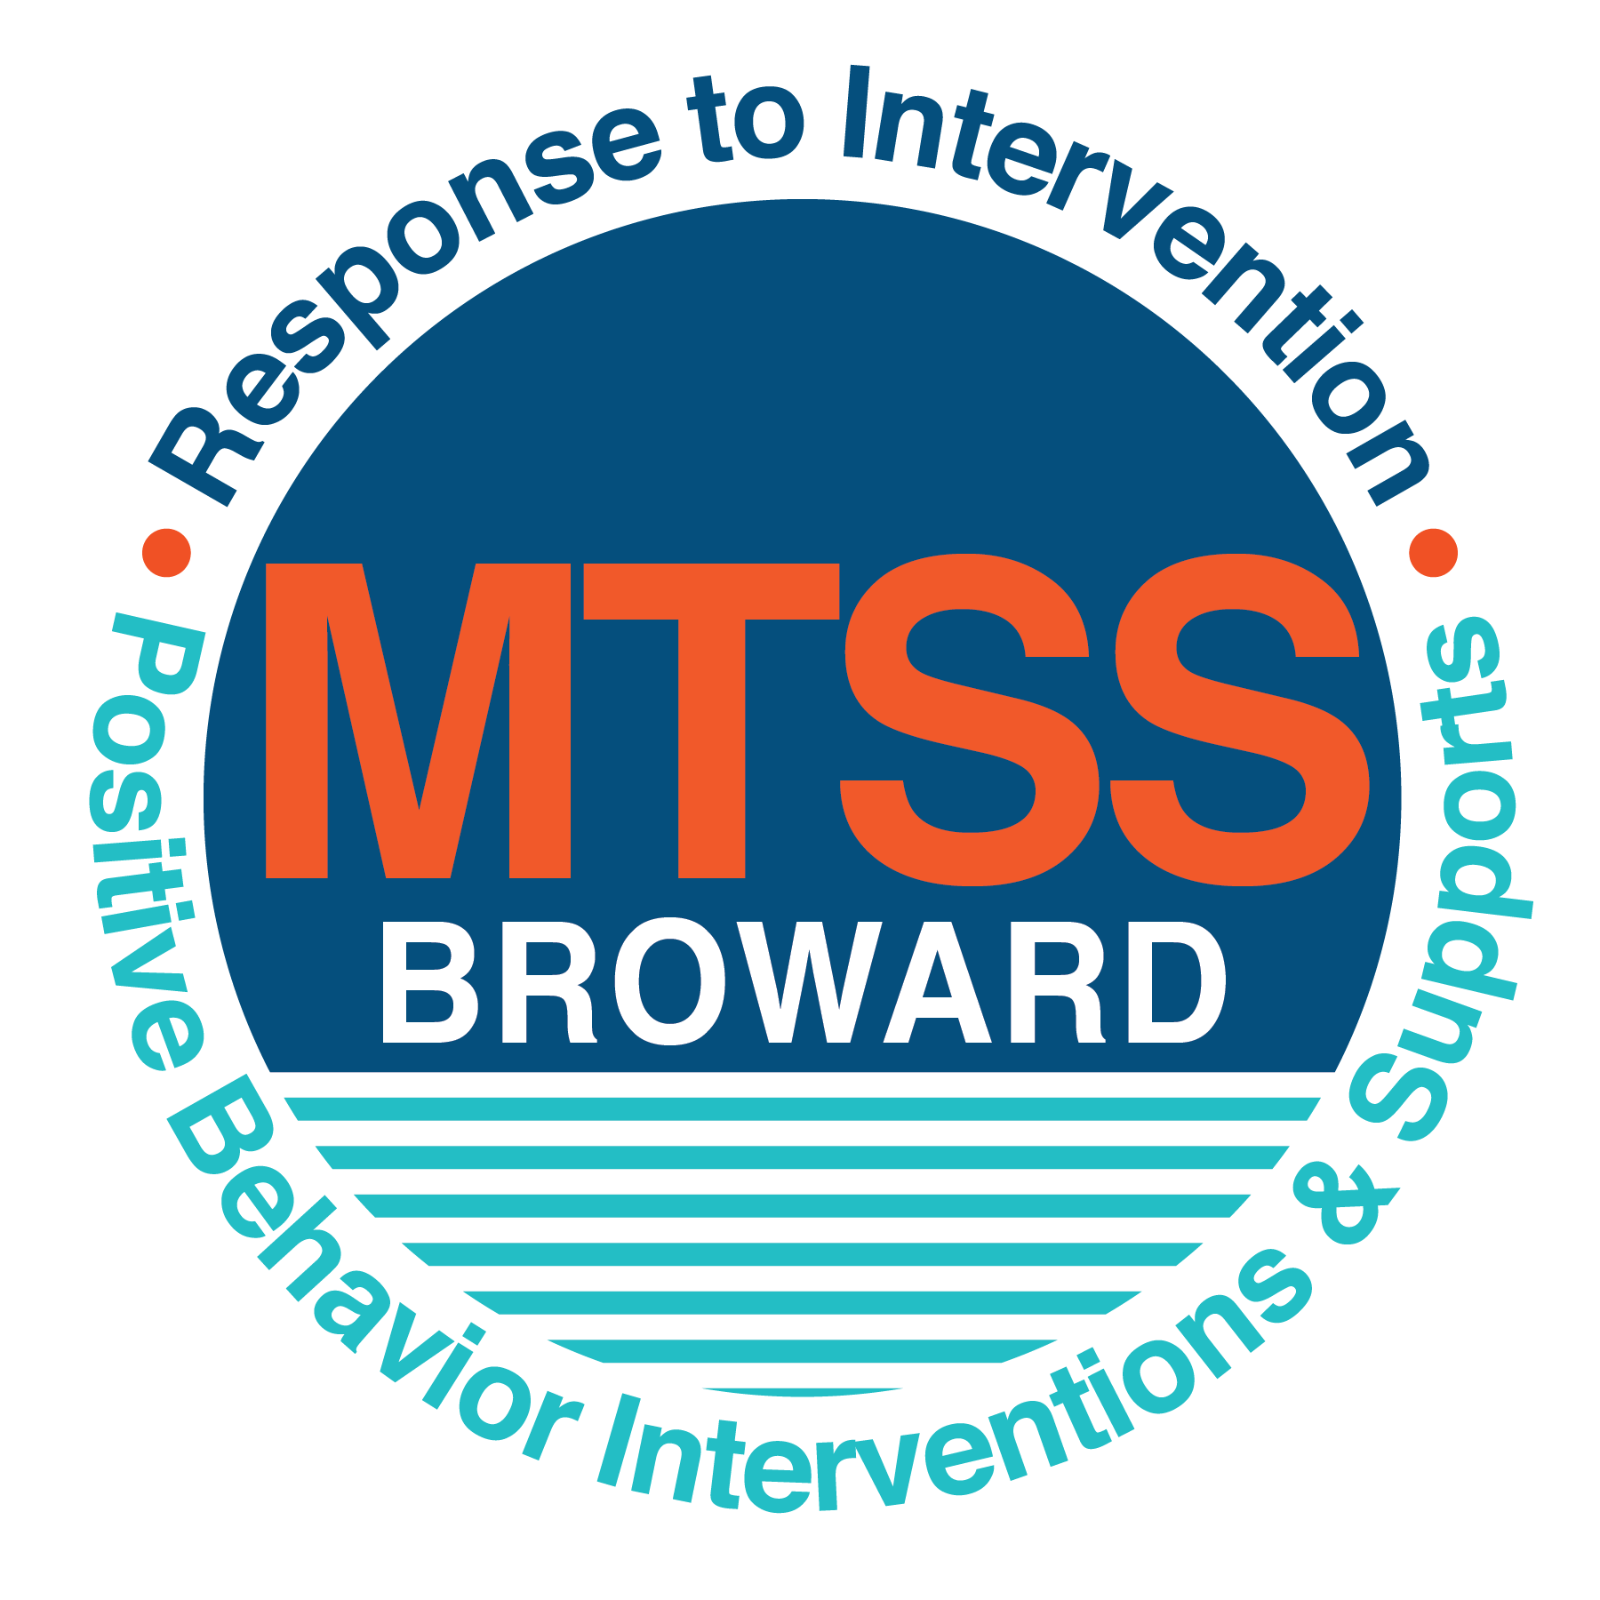

**School-wide Positive Behavior Plan (SPBP)**

Broward County Public Schools

To be implemented in SY 2018/19

**Elements have changed in the SPBP.**

Before completing, go to[**http://www.browardprevention.org/mtssrti/rtib/ →**](http://www.browardprevention.org/mtssrti/rtib/%20→)*School-wide Positive Behavior Plan* for:

* **A NEW Brainshark for Principals. ACTION: Log in with your p # and watch the Brainshark before Jan 30th.**
* **A NEW Overview Brainshark for Teams. ACTION: Log in with school name and watch the Brainshark.**
* A NEW mini Brainshark Series for teams. These Brainsharks are divided into the 10 Critical Elements of PBIS. They will

show you “how to” write a comprehensive SPBP (and receive a high score!)

* A Rating Rubric to ensure teams will correctly complete the SPBP and develop a meaningful plan.

To provide consistency across the District, *only plans entered on the current district template will be accepted*.

**ACTION: Download, complete and upload the SPBP into your School Improvement Plan before May 1, 2018:**

|  |  |
| --- | --- |
| **School Name:** | Piper High School |
| **School Number:** | 1901 |
| **SPBP Contact Name:** | Kenneth Walton |
| **Direct Phone Number:** | 754-322-1720 |

|  |
| --- |
| **CRITICAL ELEMENT # 1: Active Team with Administrative Participation** |

**1A.** List your current (SY 2017/18) team members (6 - 10 team members). **Must include an instructional representative from EACH grade/content area.** *Each name on this list verifies attendance in ongoing team meetings and participation in developing this SPBP. Each member is responsible for representing major stakeholders and sharing the SPBP content and updates with their respective group.*

|  |  |  |
| --- | --- | --- |
| **Full Name** | **Position** | **Who or what grade level does this member represent?** |
| Kenneth Walton | SPBP Point of Contact | Administration |
| Tara Rolle | Parent/Community Representation | Counseling |
| Jillian Gaygan | School Counseling Director | Educational Support Personnel |
| Kecia Pink | School Counselor | Educational Support Personnel |
| Micah Harrell | RTI Chair | Educational Support Personnel |
| Kim McHenry-Williams | School Counselor | Educational Support Personnel |
| Jaime Boyett | ESE Specialist | ESE |
| Jackie Schuck | Teacher | ESOL Teacher |
| Gryssel Cruz | Social Worker | Educational Support Personnel |
| Marcy Berger | School Psychologist | School Psychologist |

**1B**. Schedule and document your quarterly team meeting dates for *next* 2018/19 school year:

|  |  |  |  |
| --- | --- | --- | --- |
| **Meeting Date** | **Meeting Time** | **Name & title of person responsible to facilitate meeting** | **Content of meetings:** |
| 9/12/2018 | 9:20am-10:50am | Kenneth Walton | 1. Create and disseminate updated  Expectations and Rules lesson  plans (#3 and #4)  2. Review progress of  Implementation Action Plan (#9)  3. Collect & analyze implementation  data (#10A)  4. Collect & analyze student  outcome data (#10B) |
| 10/17/2018 | 9:20am-10:50am | Kenneth Walton |
| 12/12/2018 | 9:20am-10:50am | Kenneth Walton |
| 2/6/2019 | 9:20am-10:50am | Kenneth Walton |

|  |
| --- |
| **CRITICAL ELEMENT # 2: Faculty & Stakeholder Commitment:** |

**2A**. Action Steps completed **this year** (SY 2017/18) that increased faculty and stakeholder understanding and knowledge of your *new* (2018/19) SPBP:

|  |  |  |  |
| --- | --- | --- | --- |
| **Action Steps:** | **Date**  *(Between Jan 15 –*  *April 30, 2018)* | **Details**  *(retain attendance sheets at school)* | **Person responsible to collect and retain attendance sheets:** |
| Presented the *new* SPBP (for SY 2018/19) to staff | 03/22/2018 | # of participants ~ 150 | Kenneth Walton |
| Held a *faculty* vote on the new SPBP  (for SY 2018/19) | 04/05/2018 | % approved = 44/83= %53 | Kenneth Walton |
| Presented the *new* SPBP (for SY 2018/19) to stakeholders (parents and community) | 4/10/2018 | # of participants = 15 | Kenneth Walton |

**2B.** Action Steps to be completed **next year** (SY 2018/19) to increase faculty and stakeholder understanding and knowledge of your SPBP:

|  |  |  |  |
| --- | --- | --- | --- |
| **Action Steps:** | **Date(s)**  *(NEXT YEAR)* | **Content**  *(retain attendance sheets at school)* | **Person responsible to collect and retain attendance sheets:** |
| Provide a professional development on the 2018/19SPBP for all staff | Prior to students’ 1st day:  8/9/2018 | The team will present the updates in the SPBP for the 18/19 school year. All stakeholders will be provided with access to the SPBP. Feedback will be collected for future team meetings. | Kenneth Walton |
| Present the 2018/19SPBP to stakeholders (parents and community) | Prior to Oct 1st, 2018  9/11/2018 |
| Present behavior data to staff  *Quarterly: minimum of 4 each year* | 1. 10/18/2018 | The team will present the implementation data in 10A. Include:  • the “marketing” (teaching and posting) of expectations and rules  • lesson plan implementation  • discipline procedures  • reward system implementation  The team will present the student outcome data in 10B. Include:  • top 3 event locations  • type of behavior incidents  • core effectiveness data  • classroom referral data, as well as analysis of this data. | Kenneth Walton |
| 2. 12/6/2018 |
| 3. 2/21/2019 |
| 4. 5/9/2019 |

|  |
| --- |
| **CRITICAL ELEMENT # 3: School-wide Expectations** |

**3A.** List the **top 10 behavior incidents** data YTD from BASIS 3.0 Behavior Dashboard:

|  |  |
| --- | --- |
| **Top 10 Behavior Incidents**  *(put N/A in any blank spaces)* | |
| 1. Disobedience/Insubordination | 6. Truacy |
| 2. Class cuts | 7. Unruly/Disruptive Behavior |
| 3. Defiance of Authority | 8. Fighting- Medium |
| 4. Profanity | 9. Out of Assigned Area |
| 5. Tardiness Habitual | 10. Fight minor/Altercation/Conference |

**3B.** Based on the behavior incidents in 3A, develop 3 – 5 **positive characteristics** *(not behaviors)* that would counteract the demonstration of these misbehaviors. These positive characteristics become your school-wide expectations.

|  |
| --- |
| **School-wide Expectations** |
| 1.Be respectful to others |
| 2.Be on time |
| 3.Be responsible in your actions. |
| 4.Engages in safe practices. |
|  |

**3C.** Research indicates that discipline referrals increase after long holidays and during testing times. Plan to teach your expectations at least 3 times throughout the year (and anytime the expected behaviors are not being demonstrated).

**ACTION:** Create at least one lesson plan for **each** school-wide expectation above and distribute to teachers during pre-planning 2018-19. Develop additional lesson plans you will use throughout the year to re-teach and reinforce your school-wide expectations. *You do not need to submit your lesson plans with the SPBP. Retain all behavior lesson plans at the school; make sure these lesson plans are available for guests and stakeholders.*

|  |  |  |  |
| --- | --- | --- | --- |
| **When will school-wide expectations lesson plans be taught?** | | | |
|  | Date(s) | Time: | |
| August | 8/15/2018, 8/16/2018 | Assemblies | |
| January | 1/23/2019, 1/24/2019 | Assemblies | |
| 4th Quarter | 4/3/2019, 4/4/2019 | Assemblies | |
|  | | | |
| Who will be responsible for teaching the lesson plans? | | | Leadership team |
| Where will the lesson plan instruction occur? | | | Assemblies |
| Who is responsible for retaining, organizing and distributing all lesson plans? | | | Kenneth Walton |

|  |
| --- |
| **CRITICAL ELEMENT #4: Location-based Rules** |

**4A.** List the **top 3 locations** for behavior Events YTD from BASIS 3.0 Behavior Dashboard**.** ***Do not use “classroom”***

|  |  |
| --- | --- |
| **Top 3 Locations** | |
| School Location | # Incidents |
| 1.School Grounds | 79 |
| 2.Hallway | 36 |
| 3.Cafeteria | 13 |

**4B.** Create an Expectations/Rules Matrix from your 3-5 school-wide expectations and your top 3 event locations. Develop a positively stated, observable, and measurable rule that correlates with every expectation to create a maximum of 5 rules under each location**.**

|  |  |  |  |  |
| --- | --- | --- | --- | --- |
| **Expectations and Rules Matrix** | | | | |
| **School-wide EXPECTATIONS** | *Copy and paste expectations from* ***3C****.* | **IDENTIFIED LOCATIONS**  *Copy and paste locations from* ***4A.*** | | |
| Location #1: School Grounds | Location #2: Hallway | Location #3: Cafeteria |
| **Rules** | **Rules** | **Rules** |
| Expectation #1: Be respectful to others. | Use a quiet voice and keep hands to self. | Move with the flow of traffic, directly to class. | Wait your turn in line and use polite language. |
| Expectation #2: Be on time. | Move to assigned areas in a timely fashion. | Travel directly to intended destination. | Start to clean up and return to class at the first bell. |
| Expectation #3: Be responsible in your actions. | Politely follow staff and faculty directions. | Respect personal space while walking with purpose to your destination. | Report potential unsafe activity. |
| Expectation #4: Engages in safe practices. | Report unsafe behaviors to proper school authorities. | Travel with a pass during class times. | Throw garbage in the trash bins. |
| Click here to enter Expectation #5 | Click here to enter a Rule | Click here to enter a Rule | Click here to enter a Rule |

**4C**. Research indicates that discipline referrals increase after long holidays and during testing times. Plan to teach your location-specific rules at least 3 times throughout the year (and anytime the expected behaviors are not being demonstrated).

**ACTION:** Create at least one lesson plan for **each** location above and distribute to teachers during pre-planning 2018-19. Develop additional lesson plans you will use throughout the year to re-teach and reinforce your location-specific rules.

*You do not need to submit your lesson plans with the SPBP. Retain all behavior lesson plans at the school; make sure these lesson plans are available for guests and stakeholders.*

|  |  |  |  |
| --- | --- | --- | --- |
| **When will location-specific rules lesson plans be taught?** | | | |
|  | Date(s) | Time: | |
| August | 8/27/2018, 8/28/2018 | Study hall | |
| January | 1/28/2019, 1/29/2019 | Study hall | |
| 4th Quarter | 4/16/2019, 4/17/2019 | Study hall | |
|  | | | |
| Who will be responsible for teaching the lesson plans? | | | Leadership team |
| Where will the lesson plan instruction occur? | | | Assemblies |
| Who is responsible for retaining, organizing and distributing all lesson plans? | | | Kenneth Walton |

|  |
| --- |
| **CRITICAL ELEMENT # 5: Reward and Recognition Programs** |

Although you will post, teach, review, practice and reinforce all school-wide expectations and location-specific rules, **choose 1 expectation OR 1 event location** you will target for a specific reward program for students. Based on the data that led to this expectation or location, create a reward plan using the 4 Step Problem Solving Process:

Expectation or Location: School Grounds__________________________________________________________________

|  |  |
| --- | --- |
| **4 Step Problem Solving Process** | **Plan** |
| **1. Problem Identification:** Use your behavior data to identify a school-wide problem.  What problem did you identify? *(use numerical data)* | **Data used: BASIS Data**    **Problem Identification: Tardies** |
| **2**. **Problem Analysis:** Why do you think this problem is occurring?  What is your goal? *(use a SMART goal statement with numerical data)* | **Hypothesis: Lack of consequence for tardies**  **Goal Statement:** Students will be able to be on time for class 90% of the time. |
| **3. Intervention Design:**  Describehow you will implement a positive reward program to decrease this problem. | **Type of System: Lottery**  **Description of System: Students with no tardies will receive ice cream social quarterly.** |
| **4. Evaluation:**  A. Implementation fidelity | 1. How do you monitor the fidelity (consistency and effectiveness) of the **staff’s** implementation of the reward program? Teachers will be responsible for entering attendance accurately and in a timely fashion, as reflected in evaluations. Teachers are expected to follow tardy protocol being implemented schoolwide. |
| B. Student outcome monitoring | 1. How will you know if the reward program is positively impacting **students**? What measurable data will you use to determine “success”? Reduction in tardies should show an improvement in grades |

|  |
| --- |
| **CRITICAL ELEMENT #6 Effective Discipline Procedures** |

**6A. Staff Managed Misbehaviors:** List the top 6 *most common* school-wide misbehaviors **staff are expected to manage.**

Write a short, objective, and measurable definition for each.

|  |  |
| --- | --- |
| **Staff Managed Misbehaviors** | |
| Misbehavior | “Looks Like” - *provide a description with example(s)* |
| 1.Profanity | Using swear words |
| 2.Tardy | Showing up to class after the late bell has rang |
| 3.Cutting class | Being present in school, and not attending class |
| 4.Cell phone in class | Student using phone for non-school purposes during instruction |
| 5.Out of area | Being in an area where the student is not scheduled to be |
| 6.Defiance | Lack of respect for peers & adults |

**6B. Staff Managed Consequences**: Create a consequencemenu **OR** a consequence hierarchy for staff to use when students exhibit the above misbehaviors. Provide a minimum of **5** consequences.

|  |  |
| --- | --- |
| Is this a menu or hierarchy system? | Menu Hierarchy |
| Verbal warning | |
| Student conference with teacher | |
| Parent contact | |
| Referral | |
| RtI | |

**6C. Administration Managed Misbehaviors**:

(a) Define the first 3 behaviors by providing examples that clearly identify the point at which the misbehavior warrants an Office Discipline Referral (ODR).

(b) List two additional common school-wide misbehaviors that will result in an ODR. Provide concrete examples.

(c) Determine staff tolerance level for repetitive misbehaviors (the point at which the number of staff-managed misbehaviors becomes an ODR).

|  |  |
| --- | --- |
| **Office Discipline Referrals (ODRs)** | |
| Behavior | “Looks Like” - *provide a description with example(s)* |
| 1. Disobedience/Insubordination |  |
| 2. Disruptive/Unruly Play |  |
| 3. Defiance of authority |  |
| 4. Tardys |  |
| 5. Class cuts |  |
| 6. Repetitive staff managed  misbehaviors | More than misbehaviors inwarrants an office referral.  period  one  3    *e.g., 3 half hour*  *2 one period* |

**6D. School-wide Discipline Flow Chart:**

(a) Review the sample discipline flow charts in “Additional Items” located on browardprevention.org

(b) Copy or customize a flow chart to graphically represent the discipline process at **your** school.

(c) Paste the flow chart here**OR** complete the flow chart below.

**Student Behavior Discipline Flow Chart**

Observe Problem Behavior

Intervene and redirect

Office Managed Misbehaviors

Staff Managed Misbehaviors

•Call to notify office of major infraction

•Write ODR

Implement an initial consequence from **6B**

Is behavior Office Managed?

*(if unsure, check below)*

|  |  |
| --- | --- |
| List Staff Managed  Misbehaviors from **6A** | List Office Managed  Misbehaviors from **6C** |
| Profanity  Tardy  Class Cutting  Cell phone in class  Out of assigned area  Defiance | Disobediance/Insubordination  Disruptive/Unruly play  Defiance of Authority  Repetitive Staff Managed Misbehavior |

* Administrator uses discipline matrix to determine consequence
* Refer student to administration
* If all above are followed, and behavior continues, issue detention.
* Administrator follows-through on consequence
* Administrator contacts parent
* Administrator follows-up with teacher
* Plan created and put in place to increase positive behavior
* Referral to RtI if recommended

|  |
| --- |
| **CRITICAL ELEMENT # 7 : Classroom Management Systems** |

**7A.** ALL teachers implement an effective Tier 1 classroom management system:

|  |  |
| --- | --- |
| Which **evidence-based** classroom management system is supported by your school’s administration and is expected to be implemented school-wide?  *(Class Dojo, LEAPs, HERO, Cloud 9, etc. are tools,* ***not*** *classroom systems)* | CHAMPs*  PBIS Classroom Management  Administration does not expect an evidence-based classroom management system to be implemented by teachers this year  (*your school will need to adopt one next year)*  Other *(complete below)* |
| If other, name the **evidence-based classroom management system:** | Teachers use their own model |
| *CHAMPs is the district-supported, evidence-based universal classroom management system for all teachers. Would your Principal like to be contacted to learn about CHAMPs professional development? | Yes  No |

**7B.** Fidelity of **staff** implementation of school-wide classroom management systems

|  |
| --- |
| What data collection tool does your school leadership team use to monitor and evaluate your teacher’s classroom management skills? *(Measure* ***staff skills****, not student outcomes)* |
| CHAMPs 7 Up Checklist |
| CHAMPs Classroom Check Up (CCU) |
| PBIS Classroom Assistance Tool (CAT) |
| PBIS Walkthrough |
| Marzano’s Domain 1, Design Questions 5, 6, 7, 8, 9 |
| Fidelity of staff classroom management implementation is not monitored to determine training needs this year *(you will need to adopt a tool and plan next year)* |
| Other *(specify):* |
| Explain how this data is collected and analyzed by your school leadership team as a **universal screening** *across teachers* to determine the need for classroom management training: |
| Fidelity of Implementation Plan: *(3-4 sentences)* |

**7C. Percentage of Classroom Referrals:**

(a) Review your classroom data YTD (“Events by Location”) in BASIS 3.0 Behavior Dashboard.

(b) Complete the yellow highlighted cells first.

(c) Auto-calculate the % of referrals in the classroom by clicking on “!Zero Divide” in the next cell and pressing “Fn + F9” together.

|  |  |
| --- | --- |
| Total number of discipline referrals **from classrooms**: | 495 |
| Total number of **school-wide** discipline referrals: | 634 |
| % of referrals in the classroom: | 78% |
| Do more than 40% of your referrals come from the classroom? | Yes  No |

***If >40% of discipline referrals come from the classroom, it suggests Tier 1 classroom management implementation may need to be strengthened school-wide.***

|  |
| --- |
| **CRITICAL ELEMENT # 8: Data Collection and Analysis** |

**8A. Determine your School-wide Core Effectiveness YTD** from the BASIS Behavior Dashboard in the “Referrals per Student” chart.

(a) Complete the yellow highlighted cells first.

(b) Auto-calculate the “% of Total Population” by clicking on each “!Zero Divide” in the cells and pressing “Fn + F9”.

(c) Determine if the core is effective in all three areas

|  |  |  |  |  |
| --- | --- | --- | --- | --- |
| TOTAL Population: | 2,333 |  |  | |
| # Referrals | 634 | **% of Total Population** | Core Effectiveness | |
| 0 - 1 referral | 229 | 36% | Are your 0 – 1 referrals > 80%? | Yes No |
| 2 - 5 referrals  (at risk students) | 145 | 23% | Are your 2 - 5 referrals <15%? | Yes No |
| > 5 referrals  (high risk students) | 9 | 1% | Are your >5 referrals <5%? | Yes No |

**8B. Core Effectiveness Plan:**

|  |  |
| --- | --- |
| If all 3 are “**Yes**”, your core is effective. Is your core behavior curriculum effective? | Yes No |
| Answer **either** (a) or (b):  (a) If you answered “**Yes**”, although your core is effective, what plan does your school leadership team implement for early identification of at risk and high risk students?  (b) If you answered “**NO”**, indicate the supports and interventions your school leadership team will implement at the beginning of the next school year to improve core strength: | |
| Core Effectiveness Plan: *CHAMPs training for all staff to work on effective classroom management procedures.* | |

**8C. Disproportionality: Determine if there are any issues within subgroups** from BASIS 3.0 Behavior Dashboard in the “Referrals by Demographics” chart.

(a) Complete the yellow highlighted cells first.

(b) Auto-calculate the difference by clicking on each “0” in the next cell and pressing “Fn + F9”.

|  |  |  |  |  |
| --- | --- | --- | --- | --- |
| Subgroups | (PctPop - Green)  % **of students** | (PctRef - Blue)  **% of referrals** | Difference in referral composition | Positive value suggests disproportionality  (Is the value positive?) |
| Black | 69% | 84% | 15 | Yes No |
| Hispanic/Latin | 16% | 16% | 0 | Yes No |
| White | 24% | >1% | -23 | Yes No |

**8D. Disproportionality Plan:** If any values are positive, the percentage of referrals contributed to that subgroup is higher than expected, given that subgroups’ percentage in the student population.

|  |  |
| --- | --- |
| If all 3 are “**No**”, disproportionality is not indicated. Are all 3 “No”? | Yes No |
| Answer **either** (a) or (b):  (a) If you answered “**Yes**”, although your data indicates equity, what plan does your school leadership team implement for early identification of any disproportionality issues  (b) If you answered “**No**”, indicate the support plan and interventions your school leadership team will implement at the beginning of next year to improve sub group disproportionality | |
| Disproportionality Plan: CHAMPS program implemented for successful classroom behavior. | |

|  |
| --- |
| **Critical Elements # 9: SPBP Implementation Planning** |

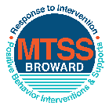This form provides a timeline to complete best practices and required actions. This timeline should drive team actions and accountability. As you implement your SPBP *NEXT* year, check off **completed items** and indicate the accountable person. (Complete only the yellow highlighted area at this time). Next year, you will upload this completed plan within your SPBP.

Required actions for all schools in Broward County

Best Practices for all schools in Broward County

**Resources**

|  |  |  |
| --- | --- | --- |
| **SPBP Team Implementation Action Plan 2018 - 2019** | | |
| **Month** | **Action Step**  *check when Action completed* | **Completed:**  Person Responsible  Name & Title |
| **Current** | **This Action Plan has been saved to use *next year* during quarterly meetings** | **Kenneth Walton Asst. Principal** |
| **Current** | **Create a SPBP binder or portfolio to retain (for 2 years) hard copies of: your SPBPs, Action Plans, staff PBIS professional development attendance, stakeholder training attendance, quarterly meeting agendas, quarterly staff behavior presentations, voting attendance and outcome, Expectation lesson plans and Rules lesson plans** | **Jillian Gaygan Guidance Director** |
| **Pre Planning**  **2018** | Print up your SPBP Review and school score from OSPA  Provide SPBP presentation to all staff during Pre Planning  Disseminate the current SPBP (hard copy or electronically) to all staff and stakeholders  Market and post school-wide Expectations and location-specific Rules (posters, PSAs, etc.)  Identify your RtI Instructional Facilitator provided by the district  (Contact [tyyne.hogan@browardschools.com](mailto:tyyne.hogan@browardschools.com) for more information, if you are unsure)  Confirm 1st team meeting date and time | Kenneth Walton Asst. Principal |
| **August**  **1st meeting** | Ensure schedule of quarterly meeting dates for entire year as indicated in the SPBP  Determine any needed team training, such as the 4 Step PSP Brainshark Series, 10 Critical  Elements Brainsharks, Data Collection, Effective CPST Teams, PBIS 101, etc.  Trainings available at: <http://www.browardprevention.org/mtssrti/training-modules/>  Review previous year’s behavior data. (Use ‘Agenda’ and ‘Data Collection Template’)  Forms available at: <http://www.browardprevention.org/mtssrti/rtib> in Tier 1, Teaming  Present implementation data, behavior data, team activities and progress to entire staff  Utilize the 4 Step Problem Solving Process to develop initial interventions  Review previous year’s SPBP and feedback form  Verify and implement teaching schedule for SPBP Expectations and Rules behavior lesson plans | Kenneth Walton, Asst. Principal |
| **September** | Provide stakeholder presentation on SPBP prior to October 1  Check for staff and teacher understanding of PBIS - provide “PBIS 101” Brainshark as a resource  Brainshark available at: http://www.brainshark.com/browardschools/PBIS101 | **Jillian Gaygan, Guidance Director** |
| **October**  **2nd meeting** | Ensure instructional staff know how to (and are, as needed) enter Tier 1 Supplemental Strategies  for behavior in BASIS  Present implementation data, behavior data, team activities and progress to entire staff | Kenneth Walton, Asst. Principal |
| **November** | Staff to re-teach Expectations and Rules first day back from break.  Team to develop new and/or improved lesson plans as indicated by behavior data. | Marie Hautigan, Asst. Principal |
| **January**  **2019**  **3rd meeting**  Prepare for *2019/20* SPBP | Staff to re-teach Expectations and Rules first day back from break  Ensure the Principal signs in and watches the *new* SPBP Brainshark: Due January 30th  Present implementation data, behavior data, team activities and progress to entire staff  Choose team members and dates to work on, complete, and submit the *new* SPBP  Teams watch the *new* SPBP Brainsharks and refers to *new* “Additional items”  Brainsharks and Additional items posted at: <http://www.browardprevention.org/mtssrti/rtib> | Kenneth Walton, Asst. Principal |
| **February** | Ensure progress towards completion of SPBP  Check on recently hired staff for PBIS understanding - provide “PBIS 101” Brainshark resource  Provide the SPBP Surveymonkey link to all staff (optional). Email [Tyyne.hogan@browardschools.com](mailto:Tyyne.hogan@browardschools.com) to request analysis. | Kenneth Walton, Asst. Principal |
| **March**  **4th meeting** | Ensure progress towards completion of SPBP  Provide staff presentation and vote on new SPBP for next year  Provide stakeholders/parent presentation on new SPBP for next year  Present implementation data, behavior data, team activities and progress to entire staff | Kenneth Walton, Asst. Principal |
| **April** | Submit your SPBP in OSPA by April 30th every year | **Kenneth Walton, Asst. Principal** |

|  |
| --- |
| **CRITICAL ELEMENT # 10: Monitoring Plans** |

**10A.** How will you determine the success **of *staff* implementation** of the School-wide Positive Behavior Plan?

*“Are* ***staff*** *implementing the SPBP with fidelity? How do you know?”*

|  |  |  |  |
| --- | --- | --- | --- |
| **Fidelity of Implementation Monitoring Plan** | | | |
| Action Step | Create an **observable** and **measureable** SMART goal to determine “successful”  **staff implementation** of action step | When will data be collected, analyzed & presented? | Person responsible to collect and analyze data |
| School-wide **expectations** and location-specific **rules** are posted across campus | All classrooms and buildings will display specific rules for area of building. | Refer to **quarterly** presentation dates in 2B.  This is the data the team will be sharing during presentations. | Kenneth Walton |
| **Behavior lesson plans** are being taught as written and when indicated | Teachers will sign-off with department chair when this has been completed on assigned days. | Kenneth Walton |
| **Discipline consequences**  and **flow chart** are being used by all staff as written | Teachers will sign-off that they have received and understand the flow chart, and will commit to following prior to writing a referral. | Kenneth Walton |
| A **reward system** is being implemented for *all* students | Continuation of events to recognize student success. | Kenneth Walton |

**10B.** How will you determine whether the SPBP is successful in positively impacting **students?**

*“If staff are implementing the SPBP consistently and effectively, did it positively impact* ***the students****? How do you know?”*

|  |  |  |  |
| --- | --- | --- | --- |
| **Student Outcome Monitoring Plan** | | | |
| Student Outcome Data | Create an **observable** and **measureable** SMART goal to determine “successful”  **student outcomes** | When will data be collected, analyzed & presented? | Person responsible to collect and analyze data |
| See critical element 3A  • Type of **behavior incidents** data | 90% of students will be on-time to class. | Refer to **quarterly** presentation dates in 2B.  This is the data the team will be sharing during presentations. | Kenneth Walton |
| See critical element 4A  • **Top 3 event locations** data | Staff will work to reduce incidents on school grounds, in the hallway, and cafeteria by assisting students in understanding and following school rules. | Kenneth Walton |
| See critical element 8  • **Core effectiveness** data | Staff will work with CHAMPs program to reduce referrals and work on classroom management/recognizing positive behavior. | Kenneth Walton |
| See critical element 7A  • **Grade Level/Classroom referrals** data | All staff will be training in the CHAMPs model for uniform classroom management, and uniform understanding of expectations for students. | Kenneth Walton |