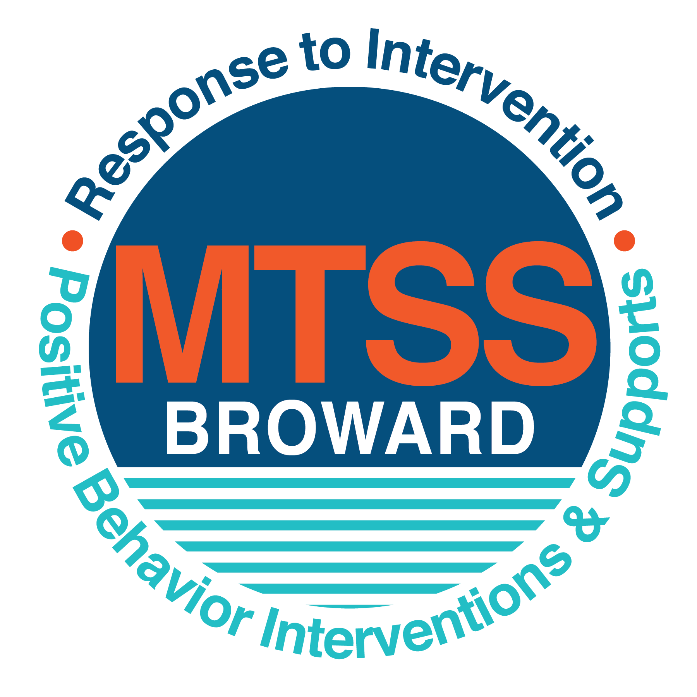
School-wide Positive Behavior Plan (SPBP)
Broward County Public Schools
To be implemented in SY 2019/20

School Name: | Pines Middle School
School Number: | 1881
SPBP Contact Name: | Ricardo Angus
Direct Phone Number: | 754-323-4041

CRITICAL ELEMENT # 1: Active Team with Administrative Participation

1A. Current (SY 2018/19) SPBP team members:
Full Name | Position
Carlton Campbell, Principal | 1. Administration
Anne Skurnick | 2. BTU Representative
Ricardo Angus | 3. SPBP Point of Contact
Shuntice McBurrows (SAC) | 4. Parent/Community Representation
Petre-Ann Williams | 5. Guidance Director
Cathy Spotts | 6. Literacy Coach
Aileen Zissen | 7. 8th Grade Teacher
Tameika Haynes | 8. 6th Grade Teacher
Krystal Romano | 9. Band Director
Simony Pereira | 10.Non-Instructional

1B. Schedule of quarterly SPBP Team Meeting dates for next 2019/20 school year:
Meeting Date | Meeting Time | Content of meetings:
8/28/2019 | 8:05 | 1. Progress of Action Steps indicated in Implementation Plan in #9  2. Collect & analyze fidelity of staff implementation data in #10A  3. Collect & analyze student outcome data in #10B
10/23/2019 | 8:05
1/22/2020 | 8;05
4/8/2020 | 8;05

CRITICAL ELEMENT # 2: Faculty & Stakeholder Commitment:

2A. Action Steps completed this year (SY 2018/19) that increased faculty and stakeholder knowledge of the new SPBP:

Action Steps: | Date  (Between Jan 15 and  April 30, 2019) | Details  (Sign-in sheets in SPBP Binder)
Presented the new SPBP (for SY 2019/20) to staff | 4/17/2019 | # of participants = 45
Held a faculty vote on the new SPBP  (for SY 2019/20) | 4/24/2019 | # of participants =47  % approved =87
Presented the new SPBP (for SY 2019/20) to stakeholders (parents and community) | 4/23/2019 | # of participants = 9

2B. Action Steps to be completed next year (SY 2019/20) to increase faculty and stakeholder knowledge of the new SPBP:

Action Steps: | Date  (SY 2019-20) | Content  (Sign-in sheets in SPBP Binder)
Provide professional development on the 2019/20 SPBP for all staff | Prior to students’ 1st day:  8/9/2019 | The team will present the updates in the SPBP for the 19/20 school year. All stakeholders will be provided with access to the SPBP. Feedback will be collected for future team meetings.
Present the 2019/20 SPBP to stakeholders  (parents and community) | Prior to Oct 1st, 2019  9/5/2019
Present the behavior data to all staff quarterly | 1. 9/4/2019 | The team will present:  - the team’s progress in the Implementation Plan in # 9.  - the fidelity of staff implementation data in #10A.  - the student outcome data in #10B.
 | 2. 10/30/2019
 | 3. 1/29/2020
 | 4. 4/15/2020

CRITICAL ELEMENT # 3: School-wide Expectations

3A. Top five behavior incidents data YTD as listed in BASIS 3.0
Top 5 Behavior Incidents
1.Disobedience/Insubordination - 88
2.Unruly disruptive behavior - 58
3.Fighting medium - 38
4.Class cut skipping - 28
5.Tardiness habitual - 21

3B. School-wide expectations are 3 – 5 positive characteristics (not behaviors) that counteract the demonstration of the top school-wide misbehaviors above. ALL people on campus model these expectations.
School-wide Expectations
1.Demonstrate Self-Control
2.Respect School Property
3.Respect Yourself and Others
4.Practice Honesty
5.Act in a Responsible and Safe Manner

3C. At least one lesson plan for each school-wide expectation above is distributed to teachers during pre-planning SY 2019/20 and maintained in the SPBP Binder.
Dates the school-wide expectations lesson plans are taught:
 | Date(s) | Time: | Location(s):
August | 8/29/2019 | 9:00-9:25 | First Block Class
January | 1/8/2020 | 3:00-3:25 | Last Block Class
After Spring Break | 4/1/2020 | 10:30-10:55 | Start of Second Block

CRITICAL ELEMENT #4: Location-based Rules

4A. Top three school-wide locations for Behavior Events YTD.
Top 3 Locations, not including Classroom:
School Location | # Incidents
1. Hallway | 55
2.Cafeteria | 22
3. Morning Outside Area | 11

4B. Expectations and Rules Chart for common areas of school campus: (next page)

Completed by each teacher | Classroom Rules
Key Expectations and Rules Chart | Morning Outside Area Rules | Keep your hands, body, and objects to yourself. | IDs and dress code must be worn at all times. | Follow adult directions the first time. |  | Report suspicious or dangerous behavior and threats.
 | Cafeteria Rules | Keep your hands, body, and objects to yourself. | Pick up trash on the table and floor. | Keep your food on your tray, and do not take another person’s food. | Only get out of your seat when recognized. | Follow the wall to discard your tray.
 | Hallway Rules | Keep your hands, body, and objects to yourself.  (HBO) | Keep hands off the Hallway walls and boards. | Be on time to class. | IDs must be worn at all times. | Walk on the right in the hallways.
 | School-wide EXPECTATIONS | Demonstrate Self-Control | Respect School Property | Respect Yourself and Others | Practice Honesty | Act in a Responsible and Safe Manner

4C. At least one Rules lesson plan for each specific location is distributed to teachers during pre-planning SY 2019/20 and maintained in the SPBP Binder.

Dates the Locations’ Rules lesson plans are taught
 | Date(s) | Time: | Location(s):
August | 8/9/2019 | 10:00 | Media Center
January | 1/6/2020 | 11:00 | Media Center
After Spring Break | 3/31/2020 | 11:00 | Media Center

CRITICAL ELEMENT # 5: Reward and Recognition Programs

5. The reward system is focused on one School-wide Expectation OR specific location at a time.
Expectation or Location: _______Hallways___________________________

4 Step Problem Solving Process | Plan Details
1. Problem Identification: Use your behavior data to identify one school-wide problem.  What problem did you identify? (use numerical data) | Data used:  BASIS Dashboard and ID Violations  Problem Identification Statement:  Students do not always wear their IDS and cannot always be identified in the hallways. Students with repeated violations end up with administrative referrals.
2. Problem Analysis: Why do you think this problem is occurring?  What is your goal? (use a SMART goal statement with numerical data) | Hypothesis:  If students know they will be rewarded, they will more often wear their IDs.  Goal Statement: Referrals for ID violations will decrease by 15% by December of 2019.
3. Intervention Design: Describe how you will implement a positive reward program to decrease this problem. | Type of System: Point system  Description of System: (≥ 5 sentences) The grade level with the fewest ID violations at the end of the first quarter will receive a rewards party for the students complying with this rule. A poster will track the violations earned in each grade level weekly.
4. Evaluation:  A. Implementation fidelity | - How will you monitor the fidelity (consistency and effectiveness) of the staff’s implementation of the reward program? (2-3 sentences) The grade level centers will keep a checklist of which teachers turn in ID violation forms. Administration will spot check classrooms of teachers who turn in few or no referrals.  A poster in the cafeteria will show students which grade is receiving the most violations. Violation data will be pulled biweekly as to which teachers/administrators are writing ID violations.
B. Student outcome monitoring | - How will you know if the reward program is positively impacting students? What measurable data will you use to determine “success”? (2-3 sentences)  We will utilize our Hero system to monitor the frequency of violations from reward period (quarter) to reward period and will measure the number of violations issued.

CRITICAL ELEMENT #6: Effective Discipline Procedures

Student Behavior Discipline Flow Chart
Observe problem behavior
Intervene and redirect
Office Managed Misbehaviors
Staff Managed Misbehaviors
Call to notify office of a
crisis/safety issue or write office discipline referral.
No
Yes

Implement an initial consequence
Is behavior Office Managed?
(if unsure, check below)

Specific Examples of  6 Staff Managed  Misbehaviors: | Specific Examples of  6 Office Managed  Misbehaviors:
Disruptive | Disobedience/Insubordination
Yelling Out | Disruptive/Unruly Play
Out of seat | Defiance of Authority
Tardy | Class cut/skip
Leaving class without permission | Leaving campus without permission
Inappropriate comments | Repetitive staff managed misbehaviors

1- Verbal warning and redirection

2- Phone call home

3-Corrective Assignment

4-Detention

5-Parent Conference
Administrator determines consequences based on Broward County Discipline Matrix and provides feedback to teacher.

CRITICAL ELEMENT # 7: Classroom Management Systems

7A. In SY 2019/20, ALL teachers implement an evidence-based Tier 1 classroom management system:
Evidence-based system: | Evidence of training:
☐ CHAMPS | % of teachers currently holding valid CHAMPS certificate:
☒ PBIS Classroom Management  http://www.fl-pda.org/independent/ | % of teachers currently holding completion certificate: 0
☐ Other: Click here to enter name of system. | Training evidence: Click here to enter evidence  % of teachers currently trained:

7B. The administration reviews and analyzes the fidelity of staff implementation of Tier 1 classroom management systems across teachers using:
☐ CHAMPs 7 Up Checklist
☐ Basic FIVE (Classroom Management Screening)
☒ PBIS Classroom Assistance Tool (CAT)
☐ Other (specify):
☐ Classroom management screening is not conducted across teachers to determine appropriate professional
development. (Next year, assessment of classroom management implementation fidelity will be scored).

7C. School year 2018/19 percentage of classroom referrals:
Total number of discipline referrals from classrooms: | 177
Total number of other school-wide discipline referrals: | 111
% of referrals in the classroom: | 63
Do more than 40% of your referrals come from the classroom? | ☒ Yes ☐ No
If >40% of discipline referrals come from the classroom, it suggests Tier 1 classroom management implementation may need to be strengthened school-wide.
If “Yes”, school-wide classroom management professional development will be conducted in 2019-20:
Click here to choose: PBIS Classroom Mgmt. If “Other”, indicated system here: Click here to enter text.

CRITICAL ELEMENT # 8: Data Collection and Analysis

8A. Core Effectiveness:
TOTAL Population: | 847 | % of Total Population | Core Effectiveness
# Referrals: | # of Students:
0 - 1 referrals | 78 | !Zero Divide | Are your 0 – 1 referrals > 80%? | ☒Yes ☐No
2 - 5 referrals  (at risk students) | 75 | !Zero Divide | Are your 2 - 5 referrals <15%? | ☒Yes ☐No
> 5 referrals  (high risk students) | 7 | !Zero Divide | Are your >5 referrals <5%? | ☒Yes ☐No

8B. Core Effectiveness Action Steps:
If all 3 are “Yes”, your core is effective. Is your core behavior curriculum effective? | ☒Yes ☐No
Answer either (a) or (b):
(a) If you answered “Yes”, although your core is effective, what steps does your school leadership team take for early identification of at risk and high-risk students?
(b) If you answered “NO”, indicate the supports and interventions your school leadership team will implement at the beginning of the next school year to improve core strength:
Core Effectiveness Action Steps: (3-4 steps)
1. Use BASIS for RTI team and guidance to identify at risk students (biweekly)
2. Recommend students for mentoring program
3. Grade Level Discipline Assemblies held quarterly
4. Weekly parent conferences as needed

8C. Disproportionality within racial subgroups:
Subgroups | (PctPop - Green)  % of students | (PctRef - Blue)  % of referrals | Difference in referral composition | Positive value suggests disproportionality  (Is the value positive?)
Black | 49 | 61 | -12 | ☒Yes ☐No
Hispanic/Latin | 37 | 27 | 10 | ☐Yes ☒No
White | 8 | 9 | -1 | ☐Yes ☒No

8D. Disproportionality Action Steps:
If all three are “No”, disproportionality is not indicated. Are all 3 “No”? | ☐Yes ☒No
Answer either (a) or (b):
(a) If you answered “Yes”, although your data indicates equity, what plan does your school leadership team implement for early identification of any disproportionality issues
(b) If you answered “No”, indicate the support plan and interventions your school leadership team will implement at the beginning of next year to improve sub group disproportionality
Disproportionality Action Steps: (3-4 steps)
1. Incorporate SEL and Equity training into preplanning and ongoing through the year.
2. Analysis of specific teachers submitting referrals and classroom management training.
3. Provide additional SEL Resources
4. Have Representatives attend District Diversity and Equity Conference.

Critical Elements # 9: SPBP Implementation Planning
RED Font = Action Steps for all schools in Broward County
GREY Font = Best Practices for all schools in Broward County
TEAL Font = Resources available at https://browardcountyschools.sharepoint.com/sites/DPI6Strands/strand6/SitePages/SPBP.aspx
SPBP Team Implementation Action Plan 2019 - 2020
Month | Action Steps  ☒ check when Action Step completed
Current | ☒ Create a SPBP binder or portfolio to retain (for 2 years) hard copies of: your SPBPs, Action Plans, staff PBIS  professional development attendance, stakeholder training attendance, quarterly meeting agendas, quarterly staff  behavior presentations, voting attendance and outcome, Expectations lesson plans and Rules lesson plans
Pre-Planning  2019 | ☐ Print up your SPBP Review and school score from OSPA  ☐ Provide SPBP presentation to all staff during Pre-Planning  ☐ Disseminate the current SPBP (hard copy or electronically) to all staff and stakeholders  ☐ Market and post school-wide Expectations and location-specific Rules  ☐ Identify your district RtI Instructional Facilitator  (Contact tyyne.hogan@browardschools.com for more information, if you are unsure)  ☐ Confirm 1st team meeting date and time
August  1st meeting | ☐ Ensure schedule of quarterly meeting dates for entire year as indicated in the SPBP  ☐ Review Implementation plan; check off completed Action Steps  ☐ Determine any needed team training, such as these Brainsharks: 4 Step Problem Solving Process series, PBIS 10  Critical Elements, Data Collection, Big 5 Data, PBIS 101, etc. (All found in Sharepoint site)  ☐ Review previous year’s behavior data. (Use ‘Agenda’ Form and ‘Data Collection Template’ in Sharepoint site)  ☐ Utilize the 4 Step Problem Solving Process to initiate a Reward System for all students  ☐ Review previous year’s SPBP and feedback form; make necessary modifications  ☐ Verify and implement teaching schedule for Expectations and Rules behavior lesson plans  ☐ Present implementation data, behavior data, team activities and SPBP progress to entire staff
September | ☐ Provide SPBP stakeholder presentation prior to October 1  ☐ Check for staff and teacher understanding of PBIS - provide “PBIS 101” Brainshark as a resource  Brainshark available at: http://www.brainshark.com/browardschools/PBIS101  ☐ Ensure the Discipline Flow Chart is distributed to all staff and is being used as written
October  2nd meeting | ☐ Review Implementation plan; check off completed Action Steps  ☐ Ensure instructional staff know how to (and are, as needed) enter Tier 1 Supplemental Strategies  for behavior in BASIS  ☐ Review previous quarter’s behavior data. (Use ‘Agenda’ and ‘Data Collection Template’ in Sharepoint site)  ☐ Present implementation data, behavior data, team activities, and SPBP progress to entire staff  ☐ Ensure all teachers are using an evidence-based classroom management plan, such as CHAMPS  ☐ Ensure Core Effectiveness Action Steps are being implemented as written
November | ☐ Team to develop new and/or improved lesson plans as indicated by behavior data.  ☐ Ensure that the Disproportionality Action Steps are being implemented as written
January  2020  3rd meeting  Prepare for SY 2020/21 SPBP | ☐ Review Implementation plan; check off completed Action Steps  ☐ Staff to re-teach Expectations and Rules after winter break  ☐ Principal signs in and watches the new “SPBP for Principals” Brainshark: Due January 30th  ☐ Present implementation data, behavior data, team activities, and SPBP progress to entire staff  ☐ Choose team members and dates to work on, complete, and submit the new SPBP  ☐ Teams watch the new “SPBP Team Overview” Brainshark and refers to district resources and supports  (Brainsharks and Additional items in Sharepoint site. Webinars and in-person lab information in Team Brainshark)
February | ☐ Ensure progress towards completion of SPBP  ☐ Check on recently hired staff for PBIS understanding - provide “PBIS 101” Brainshark resource  ☐ Provide the SPBP Surveymonkey link to all staff (optional)
March  4th meeting | ☐ Ensure progress towards completion and submission of SPBP  ☐ Review Implementation plan; check off completed Action Steps  ☐ Staff to re-teach Expectations and Rules after from spring break  ☐ Provide stakeholders/parent presentation on new SPBP for next year  ☐ Provide staff presentation and faculty vote on new SPBP for next year  ☐ Present implementation data, behavior data, team activities, and SPBP progress to entire staff
April | ☐ Submit your SPBP in OSPA by April 30th every year. Use this new SPBP in the next school year  ☐ Continue implementing your current SPBP through the end of the current school year

CRITICAL ELEMENT # 10: Evaluation

10A. Staff implement the School-wide Positive Behavior Plan effectively:
“Are staff implementing the SPBP with fidelity? How do you know?”
STAFF Implementation Monitoring
Action Step | Create an observable and measurable SMART goal to determine “successful”  staff implementation of action step
School-wide expectations and location-specific rules are posted across campus | Expectations posters will be posted in four conspicuous locations downstairs and three conspicuous locations upstairs. There we be two Cafeteria rules posted in the cafeteria, 10 hallways posters in various hallways, and 2 morning area posters outside where students congregate.
Expectations and Rules lesson plans are being taught as written and when indicated | Administrators and support will do walkthroughs of assigned areas at the times the lessons are to be taught with a checklist to insure 100% of the teachers are following the lesson plans.
The Discipline flow chart is being used by all staff as written | Administrators will refer to the flow chart in monthly grade level meetings and review individually the flow chart with teachers who send in referrals without following the chart.
A reward system is being implemented for all students | Results will be kept of ID violations issued, and the chart will be posted in the cafeteria. By the end of the first quarter students who have been complying with the rule to wear their IDs will receive their rewards. Teachers who are not turning in violations on offenders will be spoken to individually.

10B. The SPBP is successful in positively impacting students:
“If staff are implementing the SPBP consistently and effectively, did it positively impact the students? How do you know?”
STUDENT Outcome Monitoring
Student Outcome Data | Create an observable and measurable SMART goal to determine  “successful” student outcomes
Behavior Incident data
(See critical element #3A)
Top 3 event locations data
(See critical element #4A)
Core effectiveness data
(See critical element #8A)
Classroom referrals data
(See critical element #7C)

