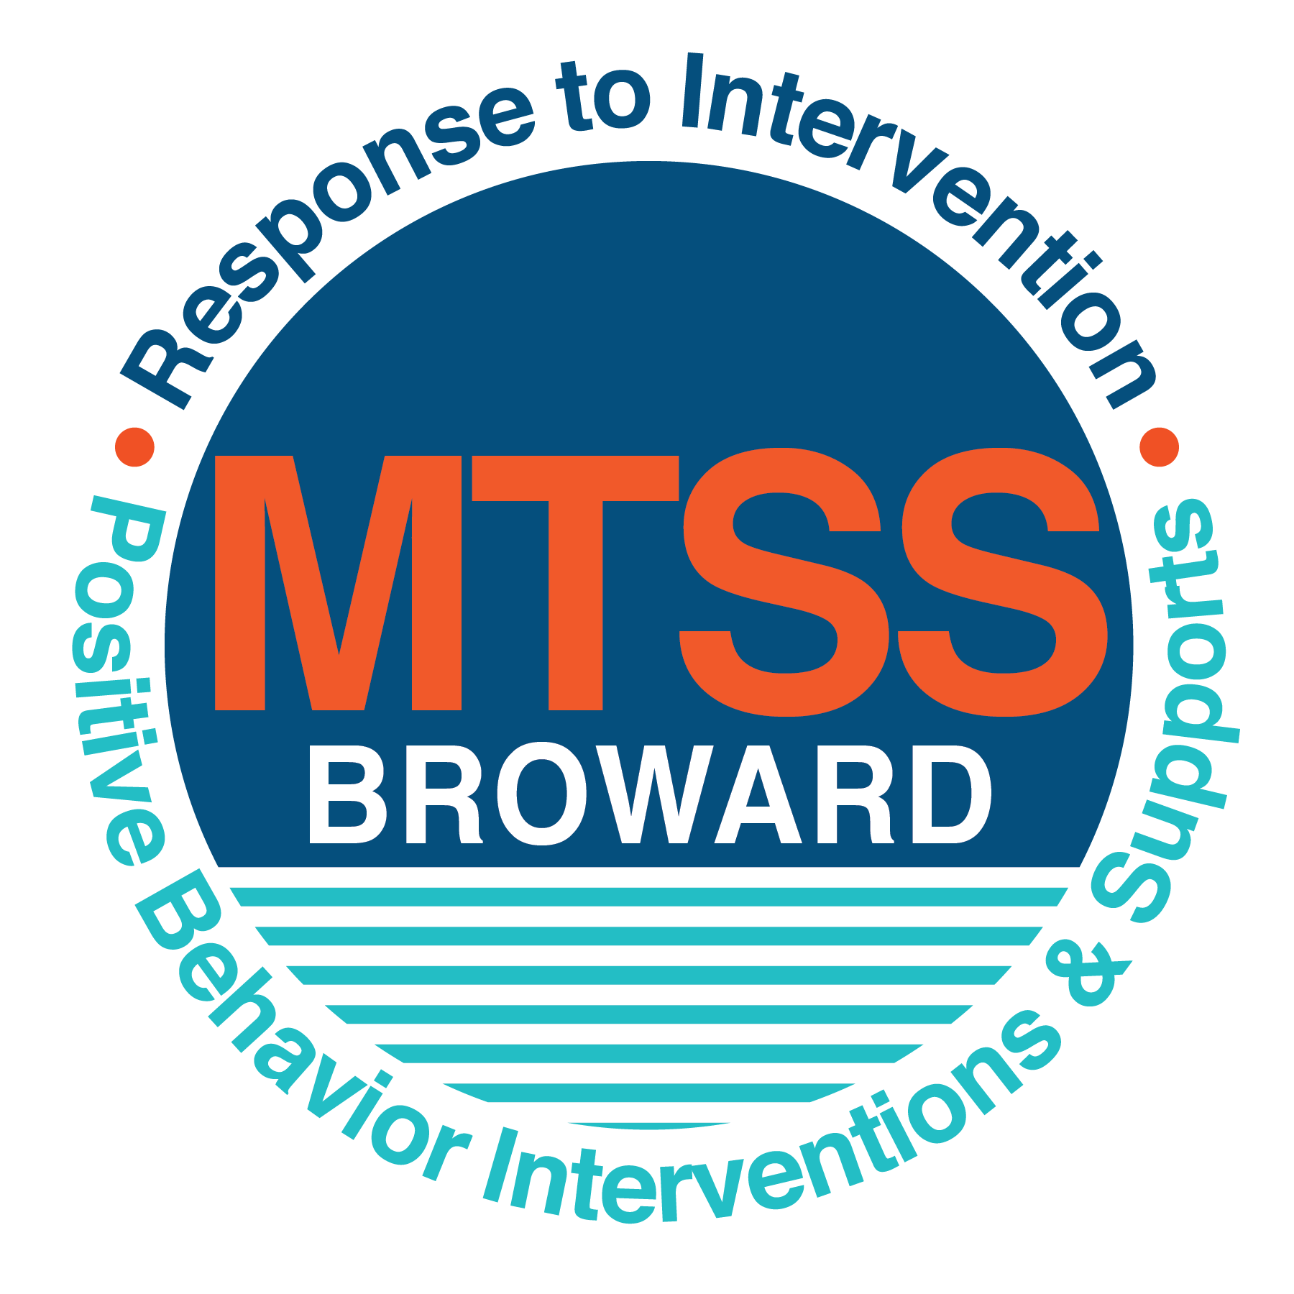
School-wide Positive Behavior Plan (SPBP)
Broward County Public Schools
To be implemented in SY 2019/20

School Name: | Apollo Middle School
School Number: | 1791
SPBP Contact Name: | Winston Symonette
Direct Phone Number: | 7543232900

CRITICAL ELEMENT # 1: Active Team with Administrative Participation

1A. Current (SY 2018/19) SPBP team members:
Full Name | Position
Damon Martin | 1. Administration
Marlon Thompson | 2. BTU Representative
Winston Symonette | 3. SPBP Point of Contact
Shazia Bajwa | 4. Parent/Community Representation
Ayanna Whitworth-Barner | 5. Curriculum Support
Stephen Rosen | 6. 8th Grade Counselor
Luis Morrina | 7. Internal Suspension Teacher
Maria Desmond | 8. Guidance Director
Melonie Jimenez | 9. ESE specialist
Marie Martin | 10. Teacher/ Site Coordinator 21st century

1B. Schedule of quarterly SPBP Team Meeting dates for next 2019/20 school year:
Meeting Date | Meeting Time | Content of meetings:
10/18/2019 | 11:00 am | 1. Progress of Action Steps indicated in Implementation Plan in #9  2. Collect & analyze fidelity of staff implementation data in #10A  3. Collect & analyze student outcome data in #10B
1/6/2020 | 11:00 am
3/17/2020 | 11:00 am
6/2/2020 | 11:00 am

CRITICAL ELEMENT # 2: Faculty & Stakeholder Commitment:

2A. Action Steps completed this year (SY 2018/19) that increased faculty and stakeholder knowledge of the new SPBP:

Action Steps: | Date  (Between Jan 15 and  April 30, 2019) | Details  (Sign-in sheets in SPBP Binder)
Presented the new SPBP (for SY 2019/20) to staff | 2/11/2019 | # of participants = 60
Held a faculty vote on the new SPBP  (for SY 2019/20) | 4/30/2019 | # of participants =71  % approved =70
Presented the new SPBP (for SY 2019/20) to stakeholders (parents and community) | Click here to enter a date. | # of participants =

2B. Action Steps to be completed next year (SY 2019/20) to increase faculty and stakeholder knowledge of the new SPBP:

Action Steps: | Date  (SY 2019-20) | Content  (Sign-in sheets in SPBP Binder)
Provide professional development on the 2019/20 SPBP for all staff | Prior to students’ 1st day:  8/12/2019 | The team will present the updates in the SPBP for the 19/20 school year. All stakeholders will be provided with access to the SPBP. Feedback will be collected for future team meetings.
Present the 2019/20 SPBP to stakeholders  (parents and community) | Prior to Oct 1st, 2019  9/18/2019
Present the behavior data to all staff quarterly | 1. 10/18/2019 | The team will present:  - the team’s progress in the Implementation Plan in # 9.  - the fidelity of staff implementation data in #10A.  - the student outcome data in #10B.
 | 2. 1/6/2019
 | 3. 3/17/2019
 | 4. 6/2/2019

CRITICAL ELEMENT # 3: School-wide Expectations

3A. Top five behavior incidents data YTD as listed in BASIS 3.0
Top 5 Behavior Incidents
1.Disobendience
2.Dress Code Violation
3.Unruly/Disruptive Behavior
4.Disrupitive/ Unruly Play
5.Unsubstantiated Bullying

3B. School-wide expectations are 3 – 5 positive characteristics (not behaviors) that counteract the demonstration of the top school-wide misbehaviors above. ALL people on campus model these expectations.
School-wide Expectations
1.Take Responsibility
2.Inspire Others
3.Make good choices
4.Expect Success
Apollo, the TIME is now…

3C. At least one lesson plan for each school-wide expectation above is distributed to teachers during pre-planning SY 2019/20 and maintained in the SPBP Binder.
Dates the school-wide expectations lesson plans are taught:
 | Date(s) | Time: | Location(s):
August | August 14-21 | 10:00 am | First Block/5th Block
January | January 7-13 | 10:00 am | First Block/5th Block
After Spring Break | March 30-April 3 | 10:00 am | First Block/5th Block

CRITICAL ELEMENT #4: Location-based Rules

4A. Top three school-wide locations for Behavior Events YTD.
Top 3 Locations, not including Classroom:
School Location | # Incidents
1. School Grounds | 107
2. Hallway | 89
3. Cafeteria | 70

4B. Expectations and Rules Chart for common areas of school campus: (next page)

Completed by each teacher | Classroom Rules
Expectations and Rules Chart | School Ground Rules | Stay in assigned area. | Keep hands and feet to self. | No running or speed walking. | No horseplay allowed.
 | Cafeteria Rules | Be silent when an adult is counting down using 4..3..2..2..1 | Remain seated until you have permission from an adult in cafeteria. | Keep hands and feet to self | Pick up all trash from the table and floor when dumping tray.
 | Hallway Rules | Allow 1 foot of personal space between yourself and other student. | No hanging around in hallway/ Go class immediately | Walk to the right of the hallway | Use bathroom or get water before class
 | School-wide EXPECTATIONS | Take Responsibility | Inspire Others | Make Good Choices | Expect Success

4C. At least one Rules lesson plan for each specific location is distributed to teachers during pre-planning SY 2019/20 and maintained in the SPBP Binder.

Dates the Locations’ Rules lesson plans are taught
 | Date(s) | Time: | Location(s):
August | August 7-13 | 10:00 am | 5th Block
January | January 7-13 | 10:00 am | 5th Block
After Spring Break | March 30-April 3 | 10:00 am | 5th Block

CRITICAL ELEMENT # 5: Reward and Recognition Programs

5. The reward system is focused on one School-wide Expectation OR specific location at a time.
Expectation or Location: ______Cafeteria____________________________

4 Step Problem Solving Process | Plan Details
1. Problem Identification: Use your behavior data to identify one school-wide problem.  What problem did you identify? (use numerical data) | Data used:  Office Discipline Referrals (ODR) from hallway  Problem Identification Statement: The number of Office discipline referrals from cafeteria has increased from 36 (2018) to 70 (2019).
2. Problem Analysis: Why do you think this problem is occurring?  What is your goal? (use a SMART goal statement with numerical data) | Hypothesis: An increase in our student body with a rotating lunch block has caused an increase in the need for structure.  Goal Statement: By the end of the next year, ODR’s from cafeteria will decrease from 70 to less 35. (50% decrease)
3. Intervention Design: Describe how you will implement a positive reward program to decrease this problem. | Type of System: Point system  Description of System: (≥ 5 sentences)  1. Classes will grouped based on their teacher/ table #.  2. Each day classes will be able to receive 1 point if there area is clean and no one at the table receive a consequence.  3. Tables can lose points if their table is not clean or someone receives consequence at their table.  4. At the end of the two weeks the classes will have the opportunity to turn their points for a reward.  5. A group reward will be provided to the students tables with the highest number of points.  6.. The reward will be giving on the first of every bi-weekly.
4. Evaluation:  A. Implementation fidelity | - How will you monitor the fidelity (consistency and effectiveness) of the staff’s implementation of the reward program? (2-3 sentences)  - Every day the AP in charge of lunch will check each table to make sure points are distributed correctly  - Points will be posted daily after each lunch in the cafeteria on poster.  - Posters will display the total amount of points so that each class and administrator can keep track of their points.
B. Student outcome monitoring | - How will you know if the reward program is positively impacting students? What measurable data will you use to determine “success”? (2-3 sentences)  - ODR will be checked by the Behavior Specialist on a monthly basis to determine the success on the incentive program.  - The behavior team will meet on a quarterly basis to to go over outcomes with faculty and staff about ODRs.  - Our program will be a success if the number ODRs in the cafeteria has decreased from last year.

CRITICAL ELEMENT #6: Effective Discipline Procedures

Student Behavior Discipline Flow Chart
Observe problem behavior behaviorBehavior
Intervene and redirect
Office Managed Misbehaviors
Staff Managed Misbehaviors
Call to notify office of a
crisis/safety issue

-Call/Notify Parent of infraction/misbehavior

-Enter Office Discipline Referral into basis for
infraction

-Administration follows up with teacher and student

-Administrator processes referral in basis

Administration enter data in terms (L27 panel)

-Student receive consequence for misbehavior/infraction committed based off the school discipline matrix.

Implement an initial consequence

Verbal Warning

Re-teach appropriate behavior to meet expectations

One on one consultation with student

Parent Phone Call

Lunch Detention

After- school Detention

Loss of privileges

Guidance Referral

No
Yes

Is behavior Office Managed?
(if unsure, check below)

Specific Examples of  6 Staff Managed  Misbehaviors: | Specific Examples of  6 Office Managed  Misbehaviors:
-Eating Candy/ Chewing Gum  -Tardy to class  - Profanity  -use of profanity in conversation with other students  -Minor Disruptions  -talking loud/distracting other students)  -Cell phone usage  -Using phone when not allowed  -Teasing/ Name Calling  -Horseplay  -pushing  - running  -shoving  (no intent to harm) | -Disrespectful tone/Profanity toward teacher  -Fighting  -kicking, punching, shoving with intent to harm  -Bullying/ Harassment  -Repeated  -Imbalance of power  - Purposeful  -Property destruction/Vandalism  -Major classroom disruption- ability to teach class  -Skipping/ Elopement form campus  -Leave campus

CRITICAL ELEMENT # 7: Classroom Management Systems

7A. In SY 2019/20, ALL teachers implement an evidence-based Tier 1 classroom management system:
Evidence-based system: | Evidence of training:
☐ CHAMPS | % of teachers currently holding valid CHAMPS certificate:
☐ PBIS Classroom Management  http://www.fl-pda.org/independent/ | % of teachers currently holding completion certificate:
☒ Other: School Wide Positive Behavior Plan | Training evidence: Sign-in sheet(s)  93% of teachers currently trained:

7B. The administration reviews and analyzes the fidelity of staff implementation of Tier 1 classroom management systems across teachers using:
☐ CHAMPs 7 Up Checklist
☐ Basic FIVE (Classroom Management Screening)
☐ PBIS Classroom Assistance Tool (CAT)
☐ Other (specify):
☒ Classroom management screening is not conducted across teachers to determine appropriate professional
development. (Next year, assessment of classroom management implementation fidelity will be scored).

7C. School year 2018/19 percentage of classroom referrals:
Total number of discipline referrals from classrooms: | 350
Total number of other school-wide discipline referrals: | 709
% of referrals in the classroom: | 33%
Do more than 40% of your referrals come from the classroom? | ☐ Yes ☒ No
If >40% of discipline referrals come from the classroom, it suggests Tier 1 classroom management implementation may need to be strengthened school-wide.
If “Yes”, school-wide classroom management professional development will be conducted in 2019-20:
Click here to choose: If “Other”, indicated system here: Click here to enter text.

CRITICAL ELEMENT # 8: Data Collection and Analysis

8A. Core Effectiveness:
TOTAL Population: | 1382 | % of Total Population | Core Effectiveness
# Referrals: | # of Students:
0 - 1 referrals | 180 | 87% | Are your 0 – 1 referrals > 80%? | ☒Yes ☐No
2 - 5 referrals  (at risk students) | 149 | 11% | Are your 2 - 5 referrals <15%? | ☒Yes ☐No
> 5 referrals  (high risk students) | 36 | 3% | Are your >5 referrals <5%? | ☒Yes ☐No

8B. Core Effectiveness Action Steps:
If all 3 are “Yes”, your core is effective. Is your core behavior curriculum effective? | ☐Yes ☒No
Answer either (a) or (b):
(a) If you answered “Yes”, although your core is effective, what steps does your school leadership team take for early identification of at risk and high-risk students?
(b) If you answered “NO”, indicate the supports and interventions your school leadership team will implement at the beginning of the next school year to improve core strength:
Core Effectiveness Action Steps: (3-4 steps)
1. Analyzing data available through basis
2. Counselors check mid-term grades and attendance
3. Teacher recommendations
4. Noticing negative interactions with other students and staff.

8C. Disproportionality within racial subgroups:
Subgroups | (PctPop - Green)  % of students | (PctRef - Blue)  % of referrals | Difference in referral composition | Positive value suggests disproportionality  (Is the value positive?)
Black | 34 | 50 | 16 | ☒Yes ☐No
Hispanic/Latin | 45 | 37 | -8 | ☐Yes ☒No
White | 14 | 10 | -4 | ☐Yes ☒No

8D. Disproportionality Action Steps:
If all three are “No”, disproportionality is not indicated. Are all 3 “No”? | ☐Yes ☒No
Answer either (a) or (b):
(a) If you answered “Yes”, although your data indicates equity, what plan does your school leadership team implement for early identification of any disproportionality issues
(b) If you answered “No”, indicate the support plan and interventions your school leadership team will implement at the beginning of next year to improve sub group disproportionality
Disproportionality Action Steps: (3-4 steps)
1.Offer mentoring and tutoring programs to those students
2. Increase parental involvement (directed at those students and their families)
3. Increase student engagement by offering extra-curricular activities such as sports, enrichment school programs and field trips.

Critical Elements # 9: SPBP Implementation Planning
RED Font = Action Steps for all schools in Broward County
GREY Font = Best Practices for all schools in Broward County
TEAL Font = Resources available at https://browardcountyschools.sharepoint.com/sites/DPI6Strands/strand6/SitePages/SPBP.aspx
SPBP Team Implementation Action Plan 2019 - 2020
Month | Action Steps  ☒ check when Action Step completed
Current | ☐ Create a SPBP binder or portfolio to retain (for 2 years) hard copies of: your SPBPs, Action Plans, staff PBIS  professional development attendance, stakeholder training attendance, quarterly meeting agendas, quarterly staff  behavior presentations, voting attendance and outcome, Expectations lesson plans and Rules lesson plans
Pre-Planning  2019 | ☐ Print up your SPBP Review and school score from OSPA  ☐ Provide SPBP presentation to all staff during Pre-Planning  ☐ Disseminate the current SPBP (hard copy or electronically) to all staff and stakeholders  ☐ Market and post school-wide Expectations and location-specific Rules  ☐ Identify your district RtI Instructional Facilitator  (Contact tyyne.hogan@browardschools.com for more information, if you are unsure)  ☐ Confirm 1st team meeting date and time
August  1st meeting | ☐ Ensure schedule of quarterly meeting dates for entire year as indicated in the SPBP  ☐ Review Implementation plan; check off completed Action Steps  ☐ Determine any needed team training, such as these Brainsharks: 4 Step Problem Solving Process series, PBIS 10  Critical Elements, Data Collection, Big 5 Data, PBIS 101, etc. (All found in Sharepoint site)  ☐ Review previous year’s behavior data. (Use ‘Agenda’ Form and ‘Data Collection Template’ in Sharepoint site)  ☐ Utilize the 4 Step Problem Solving Process to initiate a Reward System for all students  ☐ Review previous year’s SPBP and feedback form; make necessary modifications  ☐ Verify and implement teaching schedule for Expectations and Rules behavior lesson plans  ☐ Present implementation data, behavior data, team activities and SPBP progress to entire staff
September | ☐ Provide SPBP stakeholder presentation prior to October 1  ☐ Check for staff and teacher understanding of PBIS - provide “PBIS 101” Brainshark as a resource  Brainshark available at: http://www.brainshark.com/browardschools/PBIS101  ☐ Ensure the Discipline Flow Chart is distributed to all staff and is being used as written
October  2nd meeting | ☐ Review Implementation plan; check off completed Action Steps  ☐ Ensure instructional staff know how to (and are, as needed) enter Tier 1 Supplemental Strategies  for behavior in BASIS  ☐ Review previous quarter’s behavior data. (Use ‘Agenda’ and ‘Data Collection Template’ in Sharepoint site)  ☐ Present implementation data, behavior data, team activities, and SPBP progress to entire staff  ☐ Ensure all teachers are using an evidence-based classroom management plan, such as CHAMPS  ☐ Ensure Core Effectiveness Action Steps are being implemented as written
November | ☐ Team to develop new and/or improved lesson plans as indicated by behavior data.  ☐ Ensure that the Disproportionality Action Steps are being implemented as written
January  2020  3rd meeting  Prepare for SY 2020/21 SPBP | ☐ Review Implementation plan; check off completed Action Steps  ☐ Staff to re-teach Expectations and Rules after winter break  ☐ Principal signs in and watches the new “SPBP for Principals” Brainshark: Due January 30th  ☐ Present implementation data, behavior data, team activities, and SPBP progress to entire staff  ☐ Choose team members and dates to work on, complete, and submit the new SPBP  ☐ Teams watch the new “SPBP Team Overview” Brainshark and refers to district resources and supports  (Brainsharks and Additional items in Sharepoint site. Webinars and in-person lab information in Team Brainshark)
February | ☐ Ensure progress towards completion of SPBP  ☐ Check on recently hired staff for PBIS understanding - provide “PBIS 101” Brainshark resource  ☐ Provide the SPBP Surveymonkey link to all staff (optional)
March  4th meeting | ☐ Ensure progress towards completion and submission of SPBP  ☐ Review Implementation plan; check off completed Action Steps  ☐ Staff to re-teach Expectations and Rules after from spring break  ☐ Provide stakeholders/parent presentation on new SPBP for next year  ☐ Provide staff presentation and faculty vote on new SPBP for next year  ☐ Present implementation data, behavior data, team activities, and SPBP progress to entire staff
April | ☐ Submit your SPBP in OSPA by April 30th every year. Use this new SPBP in the next school year  ☐ Continue implementing your current SPBP through the end of the current school year

CRITICAL ELEMENT # 10: Evaluation

10A. Staff implement the School-wide Positive Behavior Plan effectively:
“Are staff implementing the SPBP with fidelity? How do you know?”
STAFF Implementation Monitoring
Action Step | Create an observable and measurable SMART goal to determine “successful”  staff implementation of action step
School-wide expectations and location-specific rules are posted across campus | By the end of 1st quarter, the 3 main hallways, the annex, kiva and cafeteria will have at least 2 posters of the expectations and rules posted in each area.
Expectations and Rules lesson plans are being taught as written and when indicated | By August 26, 2019, a 100% of 1st/ 5th block teachers will be provided behavior lesson plans and teaching the plans with fidelity.
The Discipline flow chart is being used by all staff as written | By August 19, 2019, 100% of teachers will be provided the discipline consequences and flow charts that will be utilized for all students.
A reward system is being implemented for all students | By the end of 1st quarter, 100% students will be on a point reward system based on behavior focus calendar that will be provided to all teachers during orientation week.

10B. The SPBP is successful in positively impacting students:
“If staff are implementing the SPBP consistently and effectively, did it positively impact the students? How do you know?”
STUDENT Outcome Monitoring
Student Outcome Data | Create an observable and measurable SMART goal to determine  “successful” student outcomes
Behavior Incident data  (See critical element #3A) | By the end of the 1st quarter, there will be 10% fewer referrals written for disobedience.
Top 3 event locations data  (See critical element #4A) | By the end of the 1st quarter, there will be a 5 % decrease in referrals written for location of school grounds.
Core effectiveness data  (See critical element #8A) | By the end of the 1st quarter, there will be a decrease in the number of students receiving more than one referral by 2%.
Classroom referrals data  (See critical element #7C) | By end of the year, the number of referrals in each grade level will decrease by 5%.

