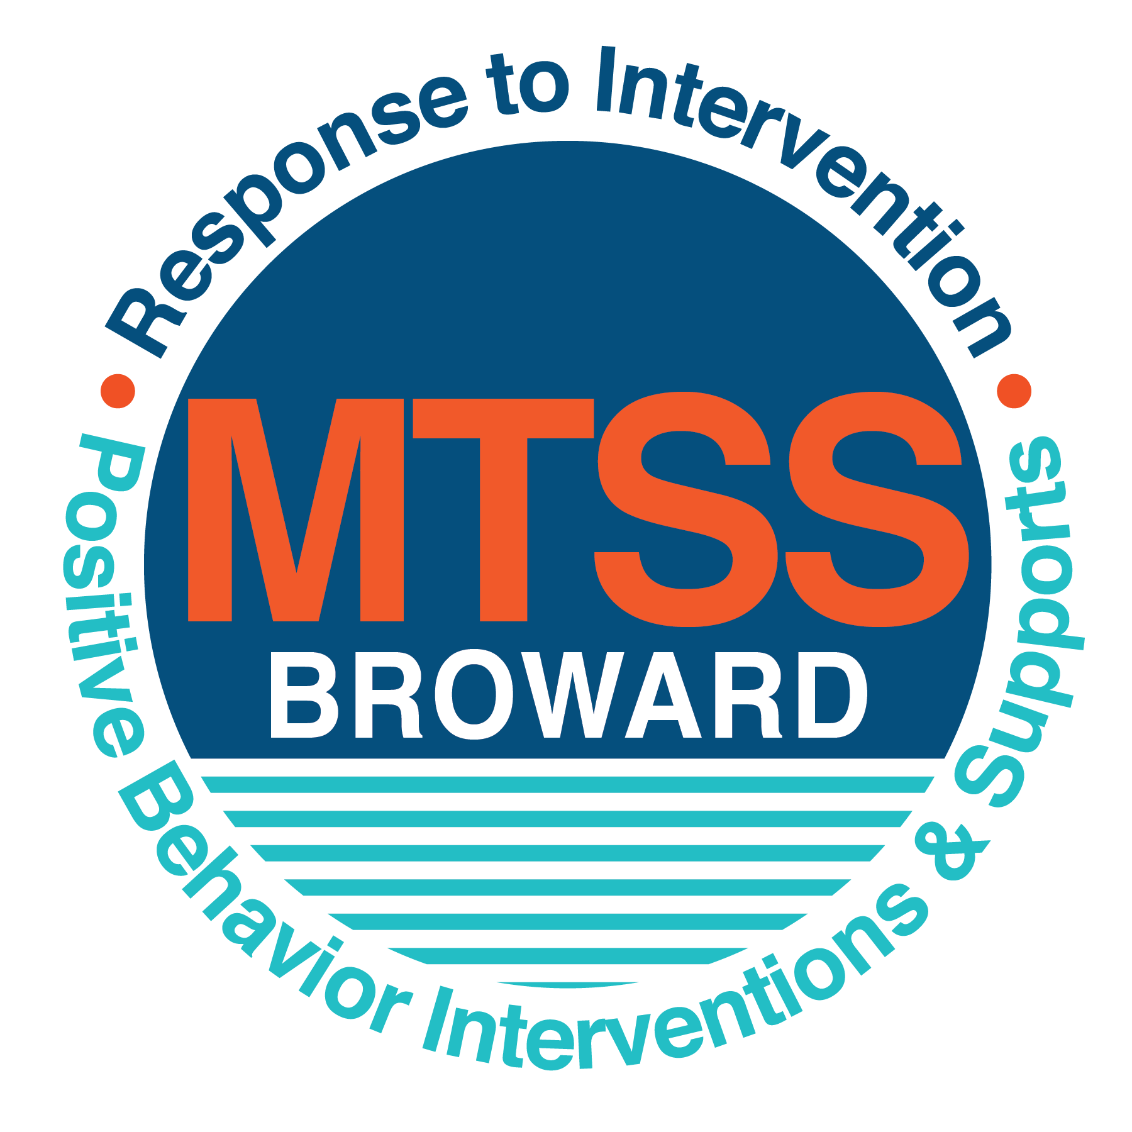
School-wide Positive Behavior Plan (SPBP)
Broward County Public Schools
To be implemented in SY 2019/20

School Name: | Coconut Creek High School
School Number: | 1681
SPBP Contact Name: | Edward Rodriguez
Direct Phone Number: | 754-322-0380

CRITICAL ELEMENT # 1: Active Team with Administrative Participation

1A. Current (SY 2018/19) SPBP team members:
Full Name | Position
Scott Fiske | 1. Administration
Marc Aronson | 2. BTU Representative
Edward Rodriguez | 3. SPBP Point of Contact
Wade Edmond | 4. Parent/Community Representation
Camille D. Edwards | 5. Support Facilitator
Jeffery Silverman | 6. Business Teacher
Doris Thomas | 7. Math Teacher
Adrian Fuller | 8. Science Teacher
Carol Johnson-Coote | 9. English Teacher
Carima Cave | 10. French Teacher

1B. Schedule of quarterly SPBP Team Meeting dates for next 2019/20 school year:
Meeting Date | Meeting Time | Content of meetings:
8/20/2019 | 1:45-2:15 | 1. Create and disseminate updated  Expectations and Rules lesson  plans  2. Review progress of  Implementation Action Plan  3. Collect & analyze implementation  data (#10A)  4. Collect & analyze student  outcome data (#10B)
10/29/2019 | 1:45-2:15
1/14/2020 | 1:45-2:15
4/14/2020 | 1:45-2:15

CRITICAL ELEMENT # 2: Faculty & Stakeholder Commitment:

2A. Action Steps completed this year (SY 2018/19) that increased faculty and stakeholder knowledge of the new SPBP:

Action Steps: | Date  (Between Jan 15 and  April 30, 2019) | Details  (Sign-in sheets in SPBP Binder)
Presented the new SPBP (for SY 2019/20) to staff | 3/19/2019 | # of participants = 43
Held a faculty vote on the new SPBP  (for SY 2019/20) | 3/19/2019 | # of participants =43  % approved =95%
Presented the new SPBP (for SY 2019/20) to stakeholders (parents and community) | 4/2/2019 | # of participants = 16

2B. Action Steps to be completed next year (SY 2019/20) to increase faculty and stakeholder knowledge of the new SPBP:

Action Steps: | Date  (SY 2019-20) | Content  (Sign-in sheets in SPBP Binder)
Provide professional development on the 2019/20 SPBP for all staff | Prior to students’ 1st day:  8/9/2019 | The team will present the updates in the SPBP for the 19/20 school year. All stakeholders will be provided with access to the SPBP. Feedback will be collected for future team meetings.
Present the 2019/20 SPBP to stakeholders  (parents and community) | Prior to Oct 1st, 2019  9/3/2019
Present the behavior data to all staff quarterly | 1. 10/17/2019 | The team will present:  - the team’s progress in the Implementation Plan in # 9.  - the fidelity of staff implementation data in #10A.  - the student outcome data in #10B.
 | 2. 12/20/2019
 | 3. 2/20/2020
 | 4. 4/9/2020

CRITICAL ELEMENT # 3: School-wide Expectations

3A. Top five behavior incidents data YTD as listed in BASIS 3.0
Top 5 Behavior Incidents
- Disobedience/ Insubordination
- Defiance of Authority
- Unruly/Disruptive
- Fighting- Medium
- Profanity to Staff

3B. School-wide expectations are 3 – 5 positive characteristics (not behaviors) that counteract the demonstration of the top school-wide misbehaviors above. ALL people on campus model these expectations.
School-wide Expectations
- Be Respectful
- Be Outstanding
- Be Accountable
- Be Responsible
5.

3C. At least one lesson plan for each school-wide expectation above is distributed to teachers during pre-planning SY 2019/20 and maintained in the SPBP Binder.
Dates the school-wide expectations lesson plans are taught:
 | Date(s) | Time: | Location(s):
August | 8/15/2019 | 7-8 AM | Classroom
January | 1/7/2020 | 7-8 AM | Classroom
After Spring Break | 4/7/2020 | 7-8 AM | Classroom

CRITICAL ELEMENT #4: Location-based Rules

4A. Top three school-wide locations for Behavior Events YTD.
Top 3 Locations, not including Classroom:
School Location | # Incidents
1. Hallway | 98
2. School Grounds | 34
3. Internal Suspension | 26

4B. Expectations and Rules Chart for common areas of school campus: (next page)

Completed by each teacher | Classroom Rules
Expectations and Rules Chart | Click here to enter location. Rules | Use proper etiquette | Interact positively with others | Ensure that area is clean before leaving | Discard all trash in appropriate trash bins
 | Cafeteria Rules | Appreciate differences Use appropriate language | Discard all trash in appropriate trash bins | Seek help if you notice something wrong | Stay to the right in hallway be mindful of voice level
 | Hallway Rules | Appreciate differences Use appropriate language | If you drop something, pick it up | Be prompt to class Keep hands and feet to yourself | Stay to the right in hallway be mindful of voice level
 | School-wide EXPECTATIONS | Be Respectful | Be Outstanding | Be Accountable | Be Responsible

4C. At least one Rules lesson plan for each specific location is distributed to teachers during pre-planning SY 2019/20 and maintained in the SPBP Binder.

Dates the Locations’ Rules lesson plans are taught
 | Date(s) | Time: | Location(s):
August | 8/14/2019 | 12:00 | Media Center
January | 1/6/2020 | 12:00 | Auditorium
After Spring Break | 4/6/2020 | 12:00 | Upstairs Media Center

CRITICAL ELEMENT # 5: Reward and Recognition Programs

5. The reward system is focused on one School-wide Expectation OR specific location at a time.
Expectation or Location: Cafeteria

4 Step Problem Solving Process | Plan Details
1. Problem Identification: Use your behavior data to identify one school-wide problem.  What problem did you identify? (use numerical data) | Data used: Office Discipline Referrals  Problem Identification Statement: Student skipping to unassigned lunch and fighting. In 2018, there were 22 referrals. As of April 2019, there are 25 referrals.
2. Problem Analysis: Why do you think this problem is occurring?  What is your goal? (use a SMART goal statement with numerical data) | Hypothesis: Students are skipping to unassigned lunch and participating in inappropriate behaviors such as fighting due to no incentive to stay in assigned area.  Goal Statement: By the end of 3rd quarter, office discipline referrals from the cafeteria will decrease from 25 to less than 15. (50% reduction)
3. Intervention Design: Describe how you will implement a positive reward program to decrease this problem. | Type of System: Point system  Description of System: (≥ 5 sentences)  The students will be awarded points for eating with peers nicely, picking up items and throwing them in the trash without prompting. Students will also be awarded points if they identify students who are skipping at a lunch they are not assigned to.
4. Evaluation:  A. Implementation fidelity | - How will you monitor the fidelity (consistency and effectiveness) of the staff’s implementation of the reward program? (2-3 sentences)  The supervising staff will award HERO points to all the students demonstrating the appropriate behavior. The students can use the points to make purchases at the HERO store. HERO points will be pulled monthly to review data.
B. Student outcome monitoring | - How will you know if the reward program is positively impacting students? What measurable data will you use to determine “success”? (2-3 sentences)  Office discipline referrals from cafeteria will be reviewed quarterly to see if there is a decrease.

CRITICAL ELEMENT #6: Effective Discipline Procedures

Student Behavior Discipline Flow Chart
Consistently Teach and Re-Teach
School-Wide Rules/Expectations

Notice and reward correct behaviors
Administration submits referral for data input
Administrative action
Teacher and guidance counselor work with student to re-teach behavior and propose strategies for success
Complete
Detention Slip and/or Contact Parent
Administration follows up teacher/staff member

Redirect student
Re-teach behavior

Teacher-managed

Office- managed
Is the behavior Teacher or Office managed?

Observe and identify problem behavior
Conference with student on inappropriate behavior in this situation and of potential + /- consequences
Referring Teacher/Staff Member completes discipline referral and contacts parent
YES
Did the behavior change?
Complete Discipline Referral and send student and referral to the discipline office
- Failure to be in one’s assigned place
- Inappropriate language
- Tardiness
- Calling out
- Teasing
- Inattentive Behavior
- Invading personal space
- Lying/giving false information
- Minor disruption
- Minor aggression-grabbing items
- Pushing past someone
- Unsafe or rough play
- Misusing property-throwing or damaging items
- Disrespectful tone
- Pattern of not completing homework

- Aggressive physical contact
- Bullying/Harassment
- Fighting
- Property destruction
- Weapons
- Leaving school property
- Pattern of aggressive/profane language
- Dress Code
- Credible threats
- Major/chronic destruction
- Major/chronic refusal to follow school rules
- Theft
- Racial/Ethnic discrimination
- Cheating
- Inappropriate use of internet
- Defiance of authority
NO
Teacher/Staff vs. Administration
Managed Managed

CRITICAL ELEMENT # 7: Classroom Management Systems

7A. In SY 2019/20, ALL teachers implement an evidence-based Tier 1 classroom management system:
Evidence-based system: | Evidence of training:
☐ CHAMPS | % of teachers currently holding valid CHAMPS certificate: 0
☐ PBIS Classroom Management  http://www.fl-pda.org/independent/ | % of teachers currently holding completion certificate: 0
☐ Other: Click here to enter name of system. | Training evidence: Click here to enter evidence  % of teachers currently trained: 0

7B. The administration reviews and analyzes the fidelity of staff implementation of Tier 1 classroom management systems across teachers using:
☐ CHAMPs 7 Up Checklist
☐ Basic FIVE (Classroom Management Screening)
☐ PBIS Classroom Assistance Tool (CAT)
☐ Other (specify):
☒ Classroom management screening is not conducted across teachers to determine appropriate professional
development. (Next year, assessment of classroom management implementation fidelity will be scored).

7C. School year 2018/19 percentage of classroom referrals:
Total number of discipline referrals from classrooms: | 392
Total number of other school-wide discipline referrals: | 210
% of referrals in the classroom: | 65%
Do more than 40% of your referrals come from the classroom? | ☒ Yes ☐ No
If >40% of discipline referrals come from the classroom, it suggests Tier 1 classroom management implementation may need to be strengthened school-wide.
If “Yes”, school-wide classroom management professional development will be conducted in 2019-20:
PBIS online course If “Other”, indicated system here: Click here to enter text.

CRITICAL ELEMENT # 8: Data Collection and Analysis

8A. Core Effectiveness:
TOTAL Population: | 1438 | % of Total Population | Core Effectiveness
# Referrals: | # of Students:
0 - 1 referrals |  | 93% | Are your 0 – 1 referrals > 80%? | ☒Yes ☐No
2 - 5 referrals  (at risk students) | 91 | 6% | Are your 2 - 5 referrals <15%? | ☒Yes ☐No
> 5 referrals  (high risk students) | 6 | 0% | Are your >5 referrals <5%? | ☒Yes ☐No

8B. Core Effectiveness Action Steps:
If all 3 are “Yes”, your core is effective. Is your core behavior curriculum effective? | ☒Yes ☐No
Answer either (a) or (b):
(a) If you answered “Yes”, although your core is effective, what steps does your school leadership team take for early identification of at risk and high-risk students?
(b) If you answered “NO”, indicate the supports and interventions your school leadership team will implement at the beginning of the next school year to improve core strength:
Core Effectiveness Action Steps: (3-4 steps)
1. At the beginning of the year, the AP will collect data on the new students to see their past referrals and suspensions.
2. Students who have a history of referrals and suspensions will be advised to join one of the various mentoring programs
offered at Coconut Creek High.
3. The PBIS leader will collect monthly data on student referrals and mentoring program attendance.

8C. Disproportionality within racial subgroups:
Subgroups | (PctPop - Green)  % of students | (PctRef - Blue)  % of referrals | Difference in referral composition | Positive value suggests disproportionality  (Is the value positive?)
Black | 74 | 82 | 8 | ☒Yes ☐No
Hispanic/Latin | 17 | 11 | -6 | ☐Yes ☒No
White | 5 | 4 | -1 | ☐Yes ☒No

8D. Disproportionality Action Steps:
If all three are “No”, disproportionality is not indicated. Are all 3 “No”? | ☐Yes ☒No
Answer either (a) or (b):
(a) If you answered “Yes”, although your data indicates equity, what plan does your school leadership team implement for early identification of any disproportionality issues
(b) If you answered “No”, indicate the support plan and interventions your school leadership team will implement at the beginning of next year to improve sub group disproportionality
Disproportionality Action Steps: (3-4 steps)
- Our data indicates there is disproportionality among the white subgroups. To address this, we will review the referrals that we obtained by this subgroup.
- The discipline flow chart will be disseminated to staff during pre-planning.
- Staff will attend Culturally Responsive training during the pre-planning week.
- Office Discipline Referrals will be monitored quarterly and presented during staff meetings for feedback.

Critical Elements # 9: SPBP Implementation Planning
RED Font = Action Steps for all schools in Broward County
GREY Font = Best Practices for all schools in Broward County
TEAL Font = Resources available at https://browardcountyschools.sharepoint.com/sites/DPI6Strands/strand6/SitePages/SPBP.aspx
SPBP Team Implementation Action Plan 2019 - 2020
Month | Action Steps  ☒ check when Action Step completed
Current | ☒ Create a SPBP binder or portfolio to retain (for 2 years) hard copies of: your SPBPs, Action Plans, staff PBIS  professional development attendance, stakeholder training attendance, quarterly meeting agendas, quarterly staff  behavior presentations, voting attendance and outcome, Expectations lesson plans and Rules lesson plans
Pre-Planning  2019 | ☐ Print up your SPBP Review and school score from OSPA  ☐ Provide SPBP presentation to all staff during Pre-Planning  ☐ Disseminate the current SPBP (hard copy or electronically) to all staff and stakeholders  ☐ Market and post school-wide Expectations and location-specific Rules  ☐ Identify your district RtI Instructional Facilitator  (Contact tyyne.hogan@browardschools.com for more information, if you are unsure)  ☐ Confirm 1st team meeting date and time
August  1st meeting | ☐ Ensure schedule of quarterly meeting dates for entire year as indicated in the SPBP  ☐ Review Implementation plan; check off completed Action Steps  ☐ Determine any needed team training, such as these Brainsharks: 4 Step Problem Solving Process series, PBIS 10  Critical Elements, Data Collection, Big 5 Data, PBIS 101, etc. (All found in Sharepoint site)  ☐ Review previous year’s behavior data. (Use ‘Agenda’ Form and ‘Data Collection Template’ in Sharepoint site)  ☐ Utilize the 4 Step Problem Solving Process to initiate a Reward System for all students  ☐ Review previous year’s SPBP and feedback form; make necessary modifications  ☐ Verify and implement teaching schedule for Expectations and Rules behavior lesson plans  ☐ Present implementation data, behavior data, team activities and SPBP progress to entire staff
September | ☐ Provide SPBP stakeholder presentation prior to October 1  ☐ Check for staff and teacher understanding of PBIS - provide “PBIS 101” Brainshark as a resource  Brainshark available at: http://www.brainshark.com/browardschools/PBIS101  ☐ Ensure the Discipline Flow Chart is distributed to all staff and is being used as written
October  2nd meeting | ☐ Review Implementation plan; check off completed Action Steps  ☐ Ensure instructional staff know how to (and are, as needed) enter Tier 1 Supplemental Strategies  for behavior in BASIS  ☐ Review previous quarter’s behavior data. (Use ‘Agenda’ and ‘Data Collection Template’ in Sharepoint site)  ☐ Present implementation data, behavior data, team activities, and SPBP progress to entire staff  ☐ Ensure all teachers are using an evidence-based classroom management plan, such as CHAMPS  ☐ Ensure Core Effectiveness Action Steps are being implemented as written
November | ☐ Team to develop new and/or improved lesson plans as indicated by behavior data.  ☐ Ensure that the Disproportionality Action Steps are being implemented as written
January  2020  3rd meeting  Prepare for SY 2020/21 SPBP | ☐ Review Implementation plan; check off completed Action Steps  ☐ Staff to re-teach Expectations and Rules after winter break  ☐ Principal signs in and watches the new “SPBP for Principals” Brainshark: Due January 30th  ☐ Present implementation data, behavior data, team activities, and SPBP progress to entire staff  ☐ Choose team members and dates to work on, complete, and submit the new SPBP  ☐ Teams watch the new “SPBP Team Overview” Brainshark and refers to district resources and supports  (Brainsharks and Additional items in Sharepoint site. Webinars and in-person lab information in Team Brainshark)
February | ☐ Ensure progress towards completion of SPBP  ☐ Check on recently hired staff for PBIS understanding - provide “PBIS 101” Brainshark resource  ☐ Provide the SPBP Surveymonkey link to all staff (optional)
March  4th meeting | ☐ Ensure progress towards completion and submission of SPBP  ☐ Review Implementation plan; check off completed Action Steps  ☐ Staff to re-teach Expectations and Rules after from spring break  ☐ Provide stakeholders/parent presentation on new SPBP for next year  ☐ Provide staff presentation and faculty vote on new SPBP for next year  ☐ Present implementation data, behavior data, team activities, and SPBP progress to entire staff
April | ☐ Submit your SPBP in OSPA by April 30th every year. Use this new SPBP in the next school year  ☐ Continue implementing your current SPBP through the end of the current school year

CRITICAL ELEMENT # 10: Evaluation

10A. Staff implement the School-wide Positive Behavior Plan effectively:
“Are staff implementing the SPBP with fidelity? How do you know?”
STAFF Implementation Monitoring
Action Step | Create an observable and measurable SMART goal to determine “successful”  staff implementation of action step
School-wide expectations and location-specific rules are posted across campus | By the end of Sept. 2019, 100% of hallways, cafeteria, and all classrooms will have at least 2 posters of expectations and rules posted.
Expectations and Rules lesson plans are being taught as written and when indicated | By October 22, 2019, 98% of teachers will have taught all of the school-wide expectations behavior lesson plans as measured by the submission of their teacher lesson plans to their assistant principal.
The Discipline flow chart is being used by all staff as written | By the end of every quarter of the 19-20 school year, there will be a 5% decrease in the number of Office Discipline Referrals that contain previously identified staff-managed misbehaviors as measured by a referral review by the PBIS team.
A reward system is being implemented for all students | By May 31, 2020, 85% of staff will have provided a reinforcement to at least 25 different students as measured by the HERO database.

10B. The SPBP is successful in positively impacting students:
“If staff are implementing the SPBP consistently and effectively, did it positively impact the students? How do you know?”
STUDENT Outcome Monitoring
Student Outcome Data | Create an observable and measurable SMART goal to determine  “successful” student outcomes
Behavior Incident data  (See critical element #3A) | By June 4, 2020, school-wide student Office Discipline Referrals will reduce 5% each quarter, as measured by BASIS Behavior Dashboard.
Top 3 event locations data  (See critical element #4A) | By the end of every quarter, the number of student Office Discipline Referrals in the Hallway will decrease by 5% as measured by the BASIS Behavior Dashboard
Core effectiveness data  (See critical element #8A) | By the end of every quarter, the percentage of students who have 0 to 1 referrals will increase by 2% as measured in the BASIS Behavior Dashboard.
Classroom referrals data  (See critical element #7C) | By the end of the first semester, the classroom Office Discipline Referrals from Grade 9 students will decrease by 10% as measured by the BASIS Behavior Dashboard.

