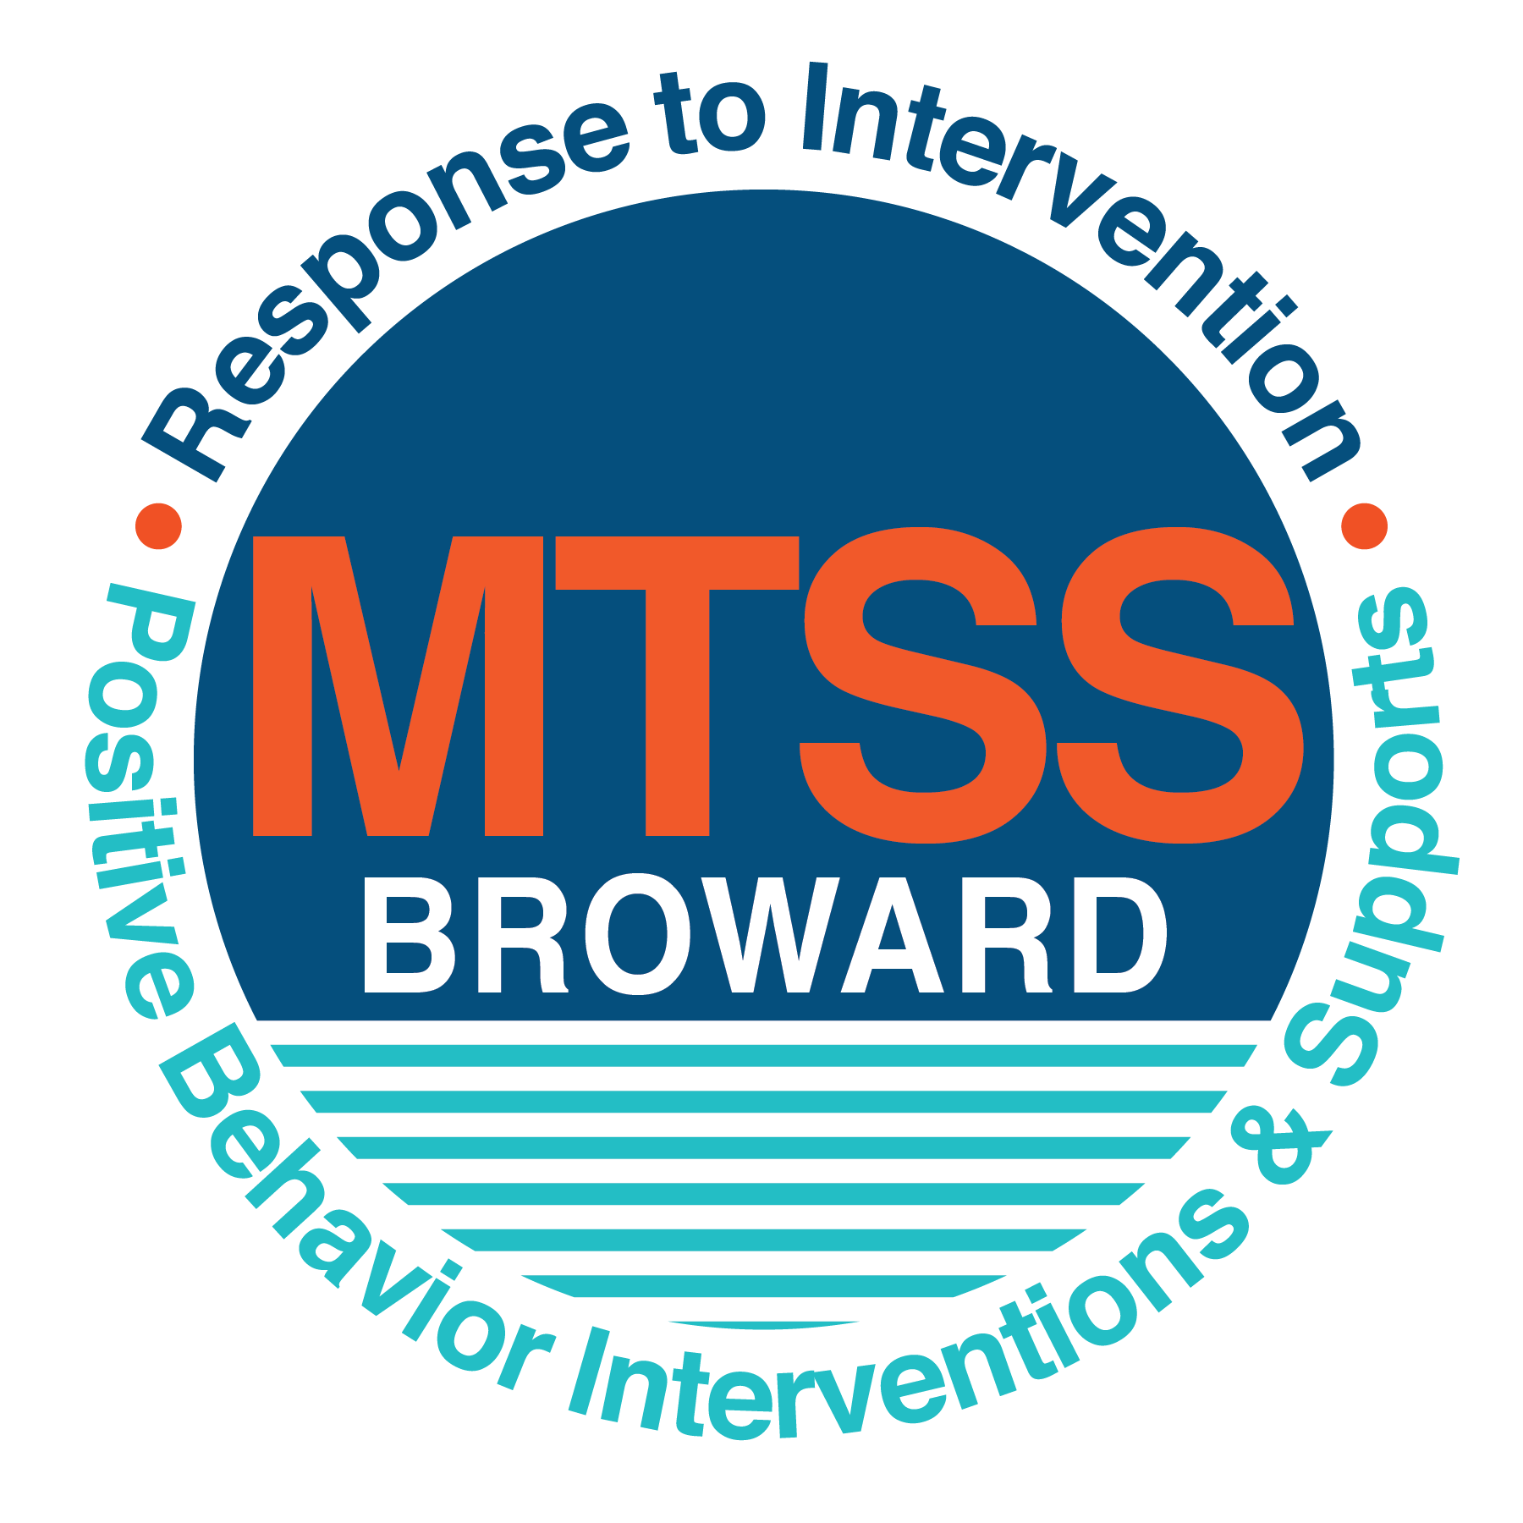

**School-wide Positive Behavior Plan (SPBP)**

Broward County Public Schools

To be implemented in SY 2018/19

**Elements have changed in the SPBP.**

Before completing, go to[**http://www.browardprevention.org/mtssrti/rtib/ →**](http://www.browardprevention.org/mtssrti/rtib/%20→)*School-wide Positive Behavior Plan* for:

* **A NEW Brainshark for Principals. ACTION: Log in with your p # and watch the Brainshark before Jan 30th.**
* **A NEW Overview Brainshark for Teams. ACTION: Log in with school name and watch the Brainshark.**
* A NEW mini Brainshark Series for teams. These Brainsharks are divided into the 10 Critical Elements of PBIS. They will

show you “how to” write a comprehensive SPBP (and receive a high score!)

* A Rating Rubric to ensure teams will correctly complete the SPBP and develop a meaningful plan.

To provide consistency across the District, *only plans entered on the current district template will be accepted*.

**ACTION: Download, complete and upload the SPBP into your School Improvement Plan before May 1, 2018:**

|  |  |
| --- | --- |
| **School Name:** | Nova Middle School |
| **School Number:** | 1311 |
| **SPBP Contact Name:** | Roxana Matthews / Darryl Baker / Melissa Johnkins |
| **Direct Phone Number:** | 754 323 3700 |

|  |
| --- |
| **CRITICAL ELEMENT # 1: Active Team with Administrative Participation** |

**1A.** List your current (SY 2017/18) team members (6 - 10 team members). **Must include an instructional representative from EACH grade/content area.** *Each name on this list verifies attendance in ongoing team meetings and participation in developing this SPBP. Each member is responsible for representing major stakeholders and sharing the SPBP content and updates with their respective group.*

|  |  |  |
| --- | --- | --- |
| **Full Name** | **Position** | **Who or what grade level does this member represent?** |
| Melissa Johnkins | Assistant Principal | Administration |
| Darryl Baker | SPBP Point of Contact/ Teacher/SAC Coordinator | 7th Grade |
| Hollie Kwak | Parent/Community Representation | SAC |
| Michael Brennan | BTU Representative | Union Members |
| Roxana Matthews | Teacher / SAC Coordinator | 8th Grade |
| Cassandra Joseph | Teacher | 6th Grade |
|  |  |  |
|  |  |  |
|  |  |  |
|  |  |  |

**1B**. Schedule and document your quarterly team meeting dates for *next* 2018/19 school year:

|  |  |  |  |
| --- | --- | --- | --- |
| **Meeting Date** | **Meeting Time** | **Name & title of person responsible to facilitate meeting** | **Content of meetings:** |
| 8/9/2018 | 9:00 | Melissa Johnkins | 1. Create and disseminate updated  Expectations and Rules lesson  plans (#3 and #4)  2. Review progress of  Implementation Action Plan (#9)  3. Collect & analyze implementation  data (#10A)  4. Collect & analyze student  outcome data (#10B) |
| 10/19/2018 | 9:00 | Melissa Johnkins |
| 1/7/2019 | 9:00 | Melissa Johnkins |
| 3/22/2019 | 9:00 | Melissa Johnkins |

|  |
| --- |
| **CRITICAL ELEMENT # 2: Faculty & Stakeholder Commitment:** |

**2A**. Action Steps completed **this year** (SY 2017/18) that increased faculty and stakeholder understanding and knowledge of your *new* (2018/19) SPBP:

|  |  |  |  |
| --- | --- | --- | --- |
| **Action Steps:** | **Date**  *(Between Jan 15 –*  *April 30, 2018)* | **Details**  *(retain attendance sheets at school)* | **Person responsible to collect and retain attendance sheets:** |
| Presented the *new* SPBP (for SY 2018/19) to staff | 4/24/2018 | # of participants = 72 | Darryl Baker / Melissa Johnkins |
| Held a *faculty* vote on the new SPBP  (for SY 2018/19) | 4/24/2018 | % approved = 56 | Darryl Baker / Melissa Johnkins |
| Presented the *new* SPBP (for SY 2018/19) to stakeholders (parents and community) | 4/25/2018 | # of participants = 14 | Darryl Baker / Melissa Johnkins |

**2B.** Action Steps to be completed **next year** (SY 2018/19) to increase faculty and stakeholder understanding and knowledge of your SPBP:

|  |  |  |  |
| --- | --- | --- | --- |
| **Action Steps:** | **Date(s)**  *(NEXT YEAR)* | **Content**  *(retain attendance sheets at school)* | **Person responsible to collect and retain attendance sheets:** |
| Provide a professional development on the 2018/19SPBP for all staff | Prior to students’ 1st day:  8/8/2018 | The team will present the updates in the SPBP for the 18/19 school year. All stakeholders will be provided with access to the SPBP. Feedback will be collected for future team meetings. | Roxana Matthews / Darryl Baker / Melissa Johnkins |
| Present the 2018/19SPBP to stakeholders (parents and community) | Prior to Oct 1st, 2018  9/11/2018 |
| Present behavior data to staff  *Quarterly: minimum of 4 each year* | 1. 10/19/2018 | The team will present the implementation data in 10A. Include:  • the “marketing” (teaching and posting) of expectations and rules  • lesson plan implementation  • discipline procedures  • reward system implementation  The team will present the student outcome data in 10B. Include:  • top 3 event locations  • type of behavior incidents  • core effectiveness data  • classroom referral data, as well as analysis of this data. | Roxana Matthews / Darryl Baker / Melissa Johnkins |
| 2. 1/7/2019 |
| 3. 3/22/2019 |
| 4. 5/9/2019 |

|  |
| --- |
| **CRITICAL ELEMENT # 3: School-wide Expectations** |

**3A.** List the **top 10 behavior incidents** data YTD from BASIS 3.0 Behavior Dashboard:

|  |  |
| --- | --- |
| **Top 10 Behavior Incidents**  *(put N/A in any blank spaces)* | |
| 1. Unruly / Disruptive Behavior | 6. Class Cut / Skipping |
| 2. Bus Violation – Level 2 | 7. Bus Violation |
| 3. Disruption / Unruly Play | 8. Fight / Medium Altercation |
| 4. Disobedience / Insubordination | 9. Battery |
| 5. Out of Assigned Area | 10. Fighting Minor |

**3B.** Based on the behavior incidents in 3A, develop 3 – 5 **positive characteristics** *(not behaviors)* that would counteract the demonstration of these misbehaviors. These positive characteristics become your school-wide expectations.

|  |
| --- |
| **School-wide Expectations**  **Taking Titans to The Top (4 T’s) If these expectations are followed it will take us to the top** |
| 1. Be Respectful |
| 1. Be Responsible |
| 1. Be Positive |
| 1. Be Cooperative |
|  |

**3C.** Research indicates that discipline referrals increase after long holidays and during testing times. Plan to teach your expectations at least 3 times throughout the year (and anytime the expected behaviors are not being demonstrated).

**ACTION:** Create at least one lesson plan for **each** school-wide expectation above and distribute to teachers during pre-planning 2018-19. Develop additional lesson plans you will use throughout the year to re-teach and reinforce your school-wide expectations. *You do not need to submit your lesson plans with the SPBP. Retain all behavior lesson plans at the school; make sure these lesson plans are available for guests and stakeholders.*

|  |  |  |  |
| --- | --- | --- | --- |
| **When will school-wide expectations lesson plans be taught?** | | | |
|  | Date(s) | Time: | |
| August | 20th and 21st | To be conducted during Social Studies | |
| January | 8th and 9th | To be conducted during Social Studies | |
| 4th Quarter | April 1st – 10th | To be conducted during Social Studies | |
|  | | | |
| Who will be responsible for teaching the lesson plans? | | | Social Studies Department |
| Where will the lesson plan instruction occur? | | | Social Studies Classroom |
| Who is responsible for retaining, organizing and distributing all lesson plans? | | | Melissa Johnkins |

|  |
| --- |
| **CRITICAL ELEMENT #4: Location-based Rules** |

**4A.** List the **top 3 locations** for behavior Events YTD from BASIS 3.0 Behavior Dashboard**.** ***Do not use “classroom”***

|  |  |
| --- | --- |
| **Top 3 Locations** | |
| School Location | # Incidents |
| 1. Bus Loop | 96 |
| 1. Hallway | 52 |
| 1. School Courtyard by “Pit” area | 44 |

**4B.** Create an Expectations/Rules Matrix from your 3-5 school-wide expectations and your top 3 event locations. Develop a positively stated, observable, and measurable rule that correlates with every expectation to create a maximum of 5 rules under each location**.**

|  |  |  |  |  |
| --- | --- | --- | --- | --- |
| **Expectations and Rules Matrix** | | | | |
| **School-wide EXPECTATIONS** | *Copy and paste expectations from* ***3C****.* | **IDENTIFIED LOCATIONS**  *Copy and paste locations from* ***4A.*** | | |
| Bus | Hallway | School Courtyard by Pit Area |
| **Rules** | **Rules** | **Rules** |
| 1. Be Respectful | Use appropriate conversation and kind words | Use your CHAMPS voice level in the hallway. Especially while class is in session | Use Appropriate conversation and kind words |
| 2. Be Responsible | Remain seated. Keep hands, feet and objects inside always. | Walk directly to your destination. Do your part to keep hallways clean. Dispose of trash in hallway | Walk to your actual destination without lingering. Do your part to keep school area clean. Dispose of trash in specified trash bins. |
| 3. Be Positive | Acknowledge bus driver | Do your part to keep hallways clean | N/A |
| 4. Be Cooperative | Report any issues or incidents to staff immediately | Report any issues or incidents to staff immediately | Report any issues or incidents to staff immediately. |
| Click here to enter Expectation #5 | Click here to enter a Rule | Click here to enter a Rule | Click here to enter a Rule |

**4C**. Research indicates that discipline referrals increase after long holidays and during testing times. Plan to teach your location-specific rules at least 3 times throughout the year (and anytime the expected behaviors are not being demonstrated).

**ACTION:** Create at least one lesson plan for **each** location above and distribute to teachers during pre-planning 2018-19. Develop additional lesson plans you will use throughout the year to re-teach and reinforce your location-specific rules.

*You do not need to submit your lesson plans with the SPBP. Retain all behavior lesson plans at the school; make sure these lesson plans are available for guests and stakeholders.*

|  |  |  |  |
| --- | --- | --- | --- |
| **When will location-specific rules lesson plans be taught?** | | | |
|  | Date(s) | Time: | |
| August | 20th and 21st | To be conducted by Social Studies (throughout day) | |
| January | 8th and 9th | To be conducted by Social Studies (throughout day) | |
| 4th Quarter | April 1st – 10th | To be conducted by Social Studies (throughout day) | |
|  | | | |
| Who will be responsible for teaching the lesson plans? | | | Social Studies Department |
| Where will the lesson plan instruction occur? | | | Social Studies Department |
| Who is responsible for retaining, organizing and distributing all lesson plans? | | | Melissa Johnkins |

|  |
| --- |
| **CRITICAL ELEMENT # 5: Reward and Recognition Programs** |

Although you will post, teach, review, practice and reinforce all school-wide expectations and location-specific rules, **choose 1 expectation OR 1 event location** you will target for a specific reward program for students. Based on the data that led to this expectation or location, create a reward plan using the 4 Step Problem Solving Process:

Expectation or Location: Hallway

|  |  |
| --- | --- |
| **4 Step Problem Solving Process** | **Plan** |
| **1. Problem Identification:** Use your behavior data to identify a school-wide problem.  What problem did you identify? *(use numerical data)* | **Data used: Referrals (499)**    **Problem Identification: We notice an increase in referrals as the year progresses (especially during 3rd quarter)** |
| **2**. **Problem Analysis:** Why do you think this problem is occurring?  What is your goal? *(use a SMART goal statement with numerical data)* | **Hypothesis: Not enough rewards are in place that promote positive behavior and the school wide expectations with focus on proper conduct in the hallway.**  **Goal Statement:** If we reward appropriate behavior which is adhering to classroom rules and school-wide expectations in the hallways, office discipline referrals will decrease by at least 15% percent. |
| **3. Intervention Design:**  Describehow you will implement a positive reward program to decrease this problem. | **Type of System: Token system**  **Description of System:** *(3-4* *• Titan Bucks reward and incentive program for students where they receive “bucks” that can be given out by any staff member. The goal is for staff to reward students when you catch them doing the right thing* |
| **4. Evaluation:**  A. Implementation fidelity | 1. How do you monitor the fidelity (consistency and effectiveness) of the **staff’s** implementation of the reward program? During Titan Buck redemption, students are called to redeem bucks earned by classroom. We can monitor how many students per class are being rewarded vs. how many bucks the teacher was given. (We will provide support to teachers who may need assistance with rolling out the system) |
| B. Student outcome monitoring | 1. How will you know if the reward program is positively impacting **students**?   Administration will analyze monthly if there is a reduction in discipline referrals and survey teachers monthly on the classroom climate.  What measurable data will you use to determine “success”?  We will look at the number of referrals written in basis 3.0, survey data from month to month to analyze if the incentive program is working from all teacher’s perspective. Finally, students will have the opportunity to voice their opinion on the successes and challenges of the incentive program.  We can monitor the referral data quarterly to see if the system is decreasing the amount of discipline infractions / referrals that are reported / written) |

|  |
| --- |
| **CRITICAL ELEMENT #6 Effective Discipline Procedures** |

**6A. Staff Managed Misbehaviors:** List the top 6 *most common* school-wide misbehaviors **staff are expected to manage.**

Write a short, objective, and measurable definition for each.

|  |  |
| --- | --- |
| **Staff Managed Misbehaviors** | |
| Misbehavior | “Looks Like” - *provide a description with example(s)* |
| 1. Profanity | Foul or obscene language. The use of curse words.  Please Note: Minors have First Amendment rights to express opinions, although they are diminished in a school setting, and while literally speaking profanity is part of the content of speech, it is often analyzed as a permissible "time, place or manner" restriction instead, especially when minors are present.  Profanity also covers a range of conduct.  Schools have the greatest authority to regulate speech when it is disruptive to the orderly operations of the school or threatening. Profanity used to provoke or threaten someone, such as the use of a racial slur or an offensive statement about someone's family, could potentially be punished severely based not simply on what was said but because it is part of a larger context of aggression. |
| 1. Tardiness | Arriving late to desired location. (on campus before the bell yet arrives to class late without a pass) |
| 1. Out of Assigned Area | Student leaving assigned area. Which disrupts the teaching and learning process for teachers and students, as well threatens the safety of the classroom environment and impedes student success. |
| 1. Excessive Talking / Interruption | Lack of self-control to prohibit excessive talking even after redirection which directly results in interruption of the learning process |
| 1. Disruptive/Unruly Behavior | Aggressive, disruptive, and defiant behavior that wastes teaching time, disrupts learning for all students, threatens safety, overwhelms teacher or ruins students chance for success. |
| 1. Insubordination | Defiance of authority; refusal to obey orders (Stay in your seat, follow classroom rules) |

**6B. Staff Managed Consequences**: Create a consequencemenu **OR** a consequence hierarchy for staff to use when students exhibit the above misbehaviors. Provide a minimum of **5** consequences.

|  |  |
| --- | --- |
| Is this a menu or hierarchy system? | Menu Hierarchy |
|  | |
| Redirection/Restate/reteach expectation or rule not being followed | |
| Seating Change within the classroom w/ re-statement of rules | |
| Removal from class with cool down time before they can return to class the same period | |
| Character Trait lesson w/ parental contact– Student must write a 250 reflection on how they will correct the behavior that needs to be addressed. Parents must sign document upon completion within the time frame specified by the issuer | |
| Referral w/ parental contact (stating reason for referral and the multiple opportunities given before this result. | |

**6C. Administration Managed Misbehaviors**:

(a) Define the first 3 behaviors by providing examples that clearly identify the point at which the misbehavior warrants an Office Discipline Referral (ODR).

(b) List two additional common school-wide misbehaviors that will result in an ODR. Provide concrete examples.

(c) Determine staff tolerance level for repetitive misbehaviors (the point at which the number of staff-managed misbehaviors becomes an ODR).

|  |  |
| --- | --- |
| **Office Discipline Referrals (ODRs)** | |
| Behavior | “Looks Like” - *provide a description with example(s)* |
| 1. Disobedience/Insubordination | Defiance of authority; habitually (repeatedly / more than once) refusing to obey orders (Stay in your seat, follow classroom rules) |
| 2. Disruptive/Unruly Play | Aggressive, disruptive, and defiant behavior that wastes teaching time, disrupts learning for all students, threatens safety, overwhelms teacher or ruins students chance for success. |
| 3. Defiance of authority | Challenging; non-compliant; confrontational; openly and boldly challenging and resisting. Defiance of authority is behavior resulting in 4 or more separate disobedience/insubordination infractions |
| 4. Out of assigned area | Student is not in proper area, does not have a pass or justified reason |
| 5. Fighting | Physical altercation on school grounds |
| 6. Repetitive Staff managed  Misbehaviors (6A) | More than misbehaviors inwarrants an office referral.  period  one  3    *e.g., 3 half* hour  *2 one period* |

**6D. School-wide Discipline Flow Chart:**

(a) Review the sample discipline flow charts in “Additional Items” located on browardprevention.org

(b) Copy or customize a flow chart to graphically represent the discipline process at **your** school.

(c) Paste the flow chart here**OR** complete the flow chart below.

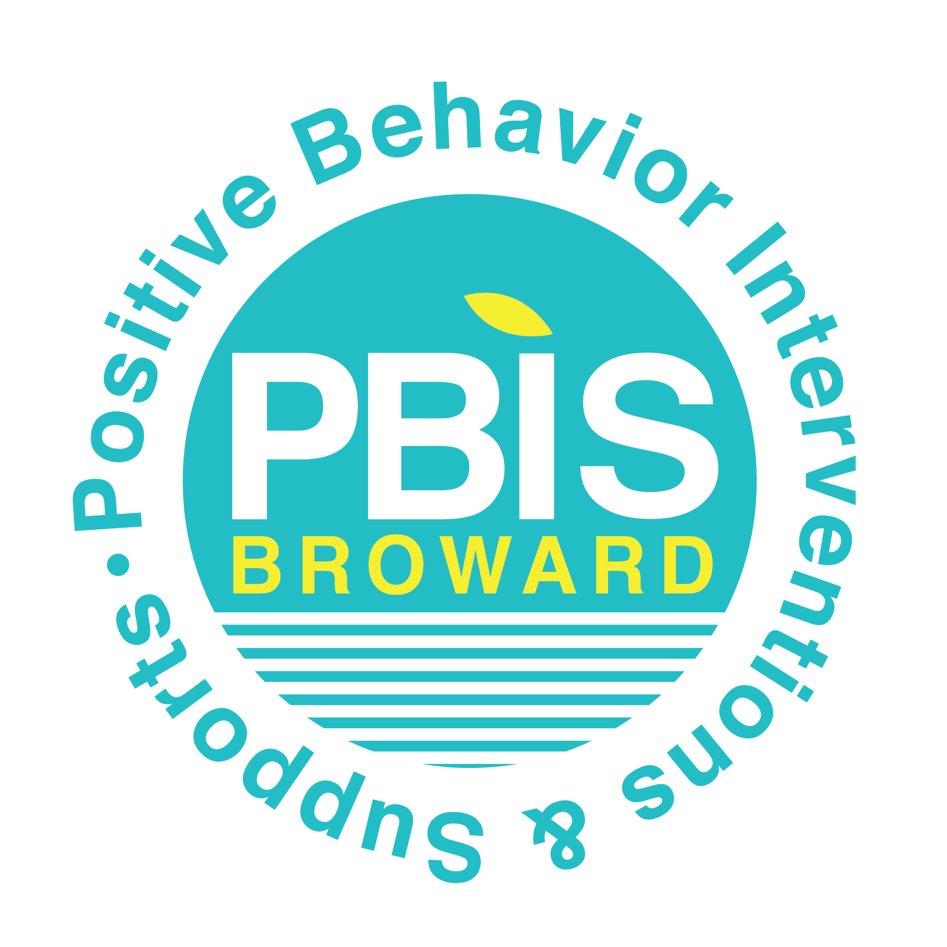

Observe and identify problem behavior

Teacher/Staff vs. Administration

Managed Managed

* Out of assigned area
* Inappropriate language
* Tardiness
* Calling/blurting out
* Teasing students
* Inattentive Behavior
* Invading personal space
* Lying/giving false information
* Minor disruption
* Minor aggression-grabbing items
* Pushing past another student
* Rough play
* Disrespectful tone
* Dress Code violation
* Cheating
* Profanity toward student
* Aggressive physical contact
* Bullying/Harassment
* Fighting
* Property destruction
* Weapons
* Leaving school property
* Pattern of aggressive/profane language
* Credible threats
* Major/chronic destruction
* Major/chronic refusal to follow school rules
* Theft
* Racial/Ethnic discrimination
* Inappropriate use of internet
* Direct refusal of authority
* Profanity toward staff

# Administration Managed

Menu

# Teacher Managed

Menu

Redirect student

Verbal Warning

2nd Step: Same Behavior Reteach Expectation/Rule / seating change

Use Tier 1 Behavior Strategies (proximity, positive specific praise, non-verbal gestures/cues

Reteach Expectations/Rules Use (CHAMPs), Provide Choices, Loss of Privilege, Character Trait (250 words reflecting on what positive choices should have been made. Trait must be signed by parent)

Submit Referral/Contact Parent/Contact Guidance/Administration for next action steps

Referring Teacher/Staff Member completes discipline referral and must have made (or attempted) parent contact

Administrative action/Administrative Consequence and information is given to student and parent

Contact Parent

Continue to Reteach Expectations/ Rules

Administration follows up teacher/staff member incidents by getting full details via Basis 3.0 of incident. Parent contact required

Student Behavior Management Process

Consistently Teach and Re-Teach

School-Wide Rules/Expectations

Is the behavior Teacher or Administration managed?

YES

Notice and reward correct behaviors (Verbal recognition) (Titan Bucks)

NO

Crisis Incident is when a student is in immediate danger of harming him/herself or others. Call office for removal of student. In many cases a guidance referral may be necessary

Did the behavior change?

Tier 1

Behavior Strategies must be entered into BASIS

|  |
| --- |
| **CRITICAL ELEMENT # 7: Classroom Management Systems** |

**7A.** ALL teachers implement an effective Tier 1 classroom management system:

|  |  |
| --- | --- |
| Which **evidence-based** classroom management system is supported by your school’s administration and is expected to be implemented school-wide?  *(Class Dojo, LEAPs, HERO, Cloud 9, etc. are tools,* ***not*** *classroom systems)* | CHAMPs*  PBIS Classroom Management  Administration does not expect an evidence-based classroom management system to be implemented by teachers this year  (*your school will need to adopt one next year)*  Other *(complete below)* |
| If other, name the **evidence-based classroom management system:** | Click here to enter name of system. |
| *CHAMPs is the district-supported, evidence-based universal classroom management system for all teachers. Would your Principal like to be contacted to learn about CHAMPs professional development? | Yes  No |

**7B.** Fidelity of **staff** implementation of school-wide classroom management systems

|  |
| --- |
| What data collection tool does your school leadership team use to monitor and evaluate your teacher’s classroom management skills? *(Measure* ***staff skills****, not student outcomes)* |
| CHAMPs 7 Up Checklist |
| CHAMPs Classroom Check Up (CCU) |
| PBIS Classroom Assistance Tool (CAT) |
| PBIS Walkthrough |
| Marzano’s Domain 1, Design Questions 1,2,3,4,5  **What will I do to establish and**  **Communicate learning goals,**  **track student progress, and**  **celebrate success?**  1. Providing Clear Learning Goals  And Scales (Rubrics)  2. Tracking Student Progress  3. Celebrating Success  **What will I do to establish or**  **maintain classroom rules and**  **procedures?**  4. Establishing Classroom Routines  5. Organizing the Physical Layout of  the Classroom |
| Fidelity of staff classroom management implementation is not monitored to determine training needs this year *(you will need to adopt a tool and plan next year)* |
| Other *(specify):* |
| Explain how this data is collected and analyzed by your school leadership team as a **universal screening** *across teachers* to determine the need for classroom management training: |
| Fidelity of Implementation Plan: *(3-4 sentences)* The leadership team will utilize Marzano’s Design Questions (5-9) from Domain 1 to identify teachers who need addition support with implementing CHAMPs in the classroom. The leadership team will develop a professional development plan for those specified teachers and provide on-going coaching support in CHAMPs. The leadership team will progress monitor fidelity of implementation once professional development has been completed and coaching has been initiated. |

**7C. Percentage of Classroom Referrals:**

(a) Review your classroom data YTD (“Events by Location”) in BASIS 3.0 Behavior Dashboard.

(b) Complete the yellow highlighted cells first.

(c) Auto-calculate the % of referrals in the classroom by clicking on “!Zero Divide” in the next cell and pressing “Fn + F9” together.

|  |  |
| --- | --- |
| Total number of discipline referrals **from classrooms**: | 220 |
| Total number of **school-wide** discipline referrals: | 499 |
| % of referrals in the classroom: | 31% |
| Do more than 40% of your referrals come from the classroom? | Yes  No |

***If >40% of discipline referrals come from the classroom, it suggests Tier 1 classroom management implementation may need to be strengthened school-wide.***

|  |
| --- |
| **CRITICAL ELEMENT # 8: Data Collection and Analysis** |

**8A. Determine your School-wide Core Effectiveness YTD** from the BASIS Behavior Dashboard in the “Referrals per Student” chart.

(a) Complete the yellow highlighted cells first.

(b) Auto-calculate the “% of Total Population” by clicking on each “!Zero Divide” in the cells and pressing “Fn + F9”.

(c) Determine if the core is effective in all three areas

|  |  |  |  |  |
| --- | --- | --- | --- | --- |
| TOTAL Population: | 1275 |  |  | |
| # Referrals |  | **% of Total Population** | Core Effectiveness | |
| 0 - 1 referral |  | 92% | Are your 0 – 1 referrals > 80%? | Yes No |
| 2 - 5 referrals  (at risk students) | 85 | 7% | Are your 2 - 5 referrals <15%? | Yes No |
| > 5 referrals  (high risk students) | 16 | 1% | Are your >5 referrals <5%? | Yes No |

**8B. Core Effectiveness Plan:**

|  |  |
| --- | --- |
| If all 3 are “**Yes**”, your core is effective. Is your core behavior curriculum effective? | Yes No |
| Answer **either** (a) or (b):  (a) If you answered “**Yes**”, although your core is effective, what plan does your school leadership team implement for early identification of at risk and high-risk students?  (b) If you answered “**NO”**, indicate the supports and interventions your school leadership team will implement at the beginning of the next school year to improve core strength: | |
| Core Effectiveness Plan: *(3-4 sentences)*  Behavior – If a student is continuously disruptive, student will be referred to administration for disciplinary and/or intervention assistance (first a parent conference). Attempting classroom intervention may escalate the off-task behavior and impede upon the learning process for other students.  Academically – We ask ourselves the question, what students have started out the quarter with low scores? For the students who score low in the beginning, having a conversation with them may remedy the situation. Many times, the student simply needed motivation, or they might need assistance with study skills, writing skills. Titan Tutoring and additional teacher support is given. | |

**8C. Disproportionality: Determine if there are any issues within subgroups** from BASIS 3.0 Behavior Dashboard in the “Referrals by Demographics” chart.

(a) Complete the yellow highlighted cells first.

(b) Auto-calculate the difference by clicking on each “0” in the next cell and pressing “Fn + F9”.

|  |  |  |  |  |
| --- | --- | --- | --- | --- |
| Subgroups | (Pct Pop - Green)  % **of students** | (Pct Ref - Blue)  **% of referrals** | Difference in referral composition | Positive value suggests disproportionality  (Is the value positive?) |
| Black | 80 | 86 | 6 | Yes No |
| Hispanic/Latin | 11 | 8 | -3 | Yes No |
| White | 6 | 4 | -2 | Yes No |

**8D. Disproportionality Plan:** If any values are positive, the percentage of referrals contributed to that subgroup is higher than expected, given that subgroups’ percentage in the student population.

|  |  |
| --- | --- |
| If all 3 are “**No**”, disproportionality is not indicated. Are all 3 “No”? | Yes No |
| Answer **either** (a) or (b):  (a) If you answered “**Yes**”, although your data indicates equity, what plan does your school leadership team implement for early identification of any disproportionality issues  (b) If you answered “**No**”, indicate the support plan and interventions your school leadership team will implement at the beginning of next year to improve sub group disproportionality | |
| **Disproportionality Plan:** There is disproportionality among the black subgroup. Data indicates that black students are a higher percentage of referrals compared to the percentage of the population. As a result, it is addressed by having professional development opportunities on culturally responsive teaching practices, etc. For students, guidance referrals allow us to address the social and emotional concerns our students have.  In addition, we have:  **Mentoring Tomorrow’s Leaders (MTL**). MTL is a peer-to-peer  mentoring and student leadership program that serves youth who are at-risk for not graduating and/or remaining  in school. The program aims to decrease dropout rates, particularly among minority males, to ensure successful school graduation.  **Diamonds and Pearls**. Diamonds & Pearls was birthed to bridge the gap between mature women and young ladies as they experience the everyday battle of being female in today’s society. Through this venue, women of all ages take part in mentoring young girls while sharing their own past and present life experiences. These sessions are like none other in which young ladies can candidly express themselves without feeling guilty, shameful, or embarrassed. The young ladies also take part in planned activities that groom them into productive young ladies. | |

|  |
| --- |
| **Critical Elements # 9: SPBP Implementation Planning** |

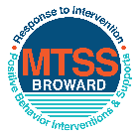This form provides a timeline to complete best practices and required actions. This timeline should drive team actions and accountability. As you implement your SPBP *NEXT* year, check off **completed items** and indicate the accountable person. (Complete only the yellow highlighted area currently). Next year, you will upload this completed plan within your SPBP.

Required actions for all schools in Broward County

Best Practices for all schools in Broward County

**Resources**

|  |  |  |
| --- | --- | --- |
| **SPBP Team Implementation Action Plan 2018 - 2019** | | |
| **Month** | **Action Step**  *check when Action completed* | **Completed:**  Person Responsible  Name & Title |
| **Current** | **This Action Plan has been saved to use *next year* during quarterly meetings** | **Darryl Baker SAC Chair/ Teacher** |
| **Current** | **Create a SPBP binder or portfolio to retain (for 2 years) hard copies of: your SPBPs, Action Plans, staff PBIS professional development attendance, stakeholder training attendance, quarterly meeting agendas, quarterly staff behavior presentations, voting attendance and outcome, Expectation lesson plans and Rules lesson plans** | **Darryl Baker SAC Chair/ Teacher** |
| **Pre Planning**  **2018** | Print up your SPBP Review and school score from OSPA  Provide SPBP presentation to all staff during Pre-Planning  Disseminate the current SPBP (hard copy or electronically) to all staff and stakeholders  Market and post school-wide Expectations and location-specific Rules (posters, PSAs, etc.)  Identify your RtI Instructional Facilitator provided by the district  (Contact [tyyne.hogan@browardschools.com](mailto:tyyne.hogan@browardschools.com) for more information, if you are unsure)  Confirm 1st team meeting date and time | Melissa Johnkins Assistant Principal |
| **August**  **1st meeting** | Ensure schedule of quarterly meeting dates for entire year as indicated in the SPBP  Determine any needed team training, such as the 4 Step PSP Brainshark Series, 10 Critical  Elements Brainshark’s, Data Collection, Effective CPST Teams, PBIS 101, etc.  Trainings available at: <http://www.browardprevention.org/mtssrti/training-modules/>  Review previous year’s behavior data. (Use ‘Agenda’ and ‘Data Collection Template’)  Forms available at: <http://www.browardprevention.org/mtssrti/rtib> in Tier 1, Teaming  Present implementation data, behavior data, team activities and progress to entire staff  Utilize the 4 Step Problem Solving Process to develop initial interventions  Review previous year’s SPBP and feedback form  Verify and implement teaching schedule for SPBP Expectations and Rules behavior lesson plans | Darryl Baker / Roxanna Matthews SAC Chairpersons - Teachers |
| **September** | Provide stakeholder presentation on SPBP prior to October 1  Check for staff and teacher understanding of PBIS - provide “PBIS 101” Brainshark as a resource  Brainshark available at: http://www.brainshark.com/browardschools/PBIS101 | **Darryl Baker / SAC Chair / Teacher** |
| **October**  **2nd meeting** | Ensure instructional staff know how to (and are, as needed) enter Tier 1 Supplemental Strategies  for behavior in BASIS  Present implementation data, behavior data, team activities and progress to entire staff | Melissa Johnkins Assistant Principal |
| **November** | Staff to re-teach Expectations and Rules first day back from break.  Team to develop new and/or improved lesson plans as indicated by behavior data. | Darryl Baker / Roxanna Matthews SAC Chair/Teachers |
| **January**  **2019**  **3rd meeting**  Prepare for *2019/20* SPBP | Staff to re-teach Expectations and Rules first day back from break  Ensure the Principal signs in and watches the *new* SPBP Brainshark: Due January 30th  Present implementation data, behavior data, team activities and progress to entire staff  Choose team members and dates to work on, complete, and submit the *new* SPBP  Teams watch the *new* SPBP Brainshark’s and refers to *new* “Additional items”  Brainshark’s and Additional items posted at: <http://www.browardprevention.org/mtssrti/rtib> | Darryl Baker / Roxanna Matthews SAC Chairs - Teachers |
| **February** | Ensure progress towards completion of SPBP  Check on recently hired staff for PBIS understanding - provide “PBIS 101” Brainshark resource  Provide the SPBP Survey Monkey link to all staff (optional). Email [Tyyne.hogan@browardschools.com](mailto:Tyyne.hogan@browardschools.com) to request analysis. | Darryl Baker / Roxanna Matthews / Cassandra Joseph - Teachers |
| **March**  **4th meeting** | Ensure progress towards completion of SPBP  Provide staff presentation and vote on new SPBP for next year  Provide stakeholders/parent presentation on new SPBP for next year  Present implementation data, behavior data, team activities and progress to entire staff | Cassandra Joseph - Teacher |
| **April** | Submit your SPBP in OSPA by April 30th every year | **Darryl Baker / Roxana Matthews - Teacher / Melissa Johnkins - Administrator** |

|  |
| --- |
| **CRITICAL ELEMENT # 10: Monitoring Plans** |

**10A.** How will you determine the success **of *staff* implementation** of the School-wide Positive Behavior Plan?

*“Are* ***staff*** *implementing the SPBP with fidelity? How do you know?”*

|  |  |  |  |
| --- | --- | --- | --- |
| **Fidelity of Implementation Monitoring Plan** | | | |
| Action Step | Create an **observable** and **measurable** SMART goal to determine “successful”  **staff implementation** of action step | When will data be collected, analyzed & presented? | Person responsible to collect and analyze data |
| School-wide **expectations** and location-specific **rules** are posted across campus | Expectation posters will be displayed in 100% of classrooms and rule posters will be displayed in the top three locations: hallway, bus and “pit” area of school grounds. | Refer to **quarterly** presentation dates in 2B.  This is the data the team will be sharing during presentations. | Darryl Baker / Roxanna Matthews |
| **Behavior lesson plans** are being taught as written and when indicated | Behavior lessons will be taught in 95% or more Social Studies classes on the scheduled days and times (see 3C and 4C) as indicated by administrative walkthroughs during those times. | Administrator over Social Studies department |
| **Discipline consequences** and **flow chart** are being used by all staff as written | Steps are following using SPBP Flowchart. 80% of staff utilize the discipline flow chart as measured by quarterly analysis of office discipline referral incidents). | Administration Team |
| A **reward system** is being implemented for *all* students | Students are given “Titan Bucks” to reward students for positive behavior. Titan bucks can be redeemed quarterly in our school store | Darryl Baker / Cassandra Joseph / Melissa Johnkins |

**10B.** How will you determine whether the SPBP is successful in positively impacting **students?**

*“If staff are implementing the SPBP consistently and effectively, did it positively impact* ***the students****? How do you know?”*

|  |  |  |  |
| --- | --- | --- | --- |
| **Student Outcome Monitoring Plan** | | | |
| Student Outcome Data | Create an **observable** and **measurable** SMART goal to determine “successful”  **student outcomes** | When will data be collected, analyzed & presented? | Person responsible to collect and analyze data |
| See critical element 3A  • Type of **behavior incidents** data | In 2018-19, behavior incidents will decrease by 10% each quarter as compared to the 2017-18 quarterly analysis data. | 1/7/2019  Refer to **quarterly** presentation dates in 2B.  This is the data the team will be sharing during presentations. | Darryl Baker / Roxanna Matthews / Melissa Johnkins |
| See critical element 4A  • **Top 3 event locations** data | In 2018-19, behavior incidents will decrease by 10% in each of the top 3 behavior event locations by quarter as compared to the 2017-18 quarterly analysis data. | Roxanna Matthews / Cassandra Joseph |
| See critical element 8  • **Core effectiveness** data | 1. Decrease the proficiency gap by 5% and achieve a 5% increase in the number of students scoring at the proficiency level based upon the 2018 FSA reading and Math.  2. Engage parents of students in the educational process and planning for students through increased school events. | Cassandra Joseph / Darryl Baker / Roxanna Matthews |
| See critical element 7A  • **Grade Level/Classroom referrals** data | By June 2019, the occurrence of discipline referrals for all students (6th, 7th, and 8th grades) will decrease by 20% with the effective implementation of RTI, the Titan Bucks Incentive Program, teacher classroom management training, and use of our SEL Coach. | Assistant Principals - Melissa Johnkins / Andre Jones / Cassandra Woehr |