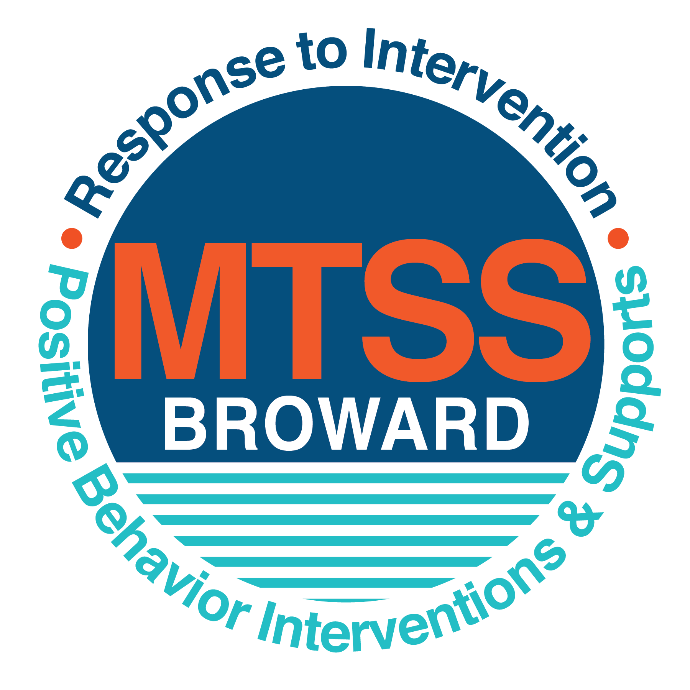

**School-wide Positive Behavior Plan (SPBP)**

Broward County Public Schools

To be implemented in SY 2018/19

**Elements have changed in the SPBP.**

Before completing, go to[**http://www.browardprevention.org/mtssrti/rtib/ →**](http://www.browardprevention.org/mtssrti/rtib/%20→)*School-wide Positive Behavior Plan* for:

* **A NEW Brainshark for Principals. ACTION: Log in with your p # and watch the Brainshark before Jan 30th.**
* **A NEW Overview Brainshark for Teams. ACTION: Log in with school name and watch the Brainshark.**
* A NEW mini Brainshark Series for teams. These Brainsharks are divided into the 10 Critical Elements of PBIS. They will

show you “how to” write a comprehensive SPBP (and receive a high score!)

* A Rating Rubric to ensure teams will correctly complete the SPBP and develop a meaningful plan.

To provide consistency across the District, *only plans entered on the current district template will be accepted*.

**ACTION: Download, complete and upload the SPBP into your School Improvement Plan before May 1, 2018:**

|  |  |
| --- | --- |
| **School Name:** | The Quest Center |
| **School Number:** | 1021 |
| **SPBP Contact Name:** | De Anna Nieves |
| **Direct Phone Number:** | 754-321-7509 |

|  |
| --- |
| **CRITICAL ELEMENT # 1: Active Team with Administrative Participation** |

**1A.** List your current (SY 2017/18) team members (6 - 10 team members). **Must include an instructional representative from EACH grade/content area.** *Each name on this list verifies attendance in ongoing team meetings and participation in developing this SPBP. Each member is responsible for representing major stakeholders and sharing the SPBP content and updates with their respective group.*

|  |  |  |
| --- | --- | --- |
| **Full Name** | **Position** | **Who or what grade level does this member represent?** |
| Michelle Laurent | Assistant Principal | Administration |
| De Anna Nieves | SPBP Point of Contact | Behavior Specialist/SAC Chair |
| Mrs. Beth Hoesch | Parent/Community Representation | SAC |
| Leigh Townley | BTU Representative | Teacher/SAC Secretary |
| Tracee Cheek | ASP Director | Community partner |
|  |  |  |
|  |  |  |
|  |  |  |
|  |  |  |
|  |  |  |

**1B**. Schedule and document your quarterly team meeting dates for *next* 2018/19 school year:

|  |  |  |  |
| --- | --- | --- | --- |
| **Meeting Date** | **Meeting Time** | **Name & title of person responsible to facilitate meeting** | **Content of meetings:** |
| 10/16/2018 | 10:30/6:30 | De Anna Nieves | 1. Create and disseminate updated  Expectations and Rules lesson  plans (#3 and #4)  2. Review progress of  Implementation Action Plan (#9)  3. Collect & analyze implementation  data (#10A)  4. Collect & analyze student  outcome data (#10B) |
| 12/18/2018 | 10:30/6:30 | De Anna Nieves |
| 2/19/2019 | 10:30/6:30 | De Anna Nieves |
| 4/16/2019 | 10:30/6:30 | De Anna Nieves |

|  |
| --- |
| **CRITICAL ELEMENT # 2: Faculty & Stakeholder Commitment:** |

**2A**. Action Steps completed **this year** (SY 2017/18) that increased faculty and stakeholder understanding and knowledge of your *new* (2018/19) SPBP:

|  |  |  |  |
| --- | --- | --- | --- |
| **Action Steps:** | **Date**  *(Between Jan 15 –*  *April 30, 2018)* | **Details**  *(retain attendance sheets at school)* | **Person responsible to collect and retain attendance sheets:** |
| Presented the *new* SPBP (for SY 2018/19) to staff | 3/15/2018 | # of participants = 8 | Michelle Laurent |
| Held a *faculty* vote on the new SPBP  (for SY 2018/19) | 4/12/2018 | % approved = 91 | Michelle Laurent |
| Presented the *new* SPBP (for SY 2018/19) to stakeholders (parents and community) | 4/17/2018 | # of participants = | Michelle Laurent |

**2B.** Action Steps to be completed **next year** (SY 2018/19) to increase faculty and stakeholder understanding and knowledge of your SPBP:

|  |  |  |  |
| --- | --- | --- | --- |
| **Action Steps:** | **Date(s)**  *(NEXT YEAR)* | **Content**  *(retain attendance sheets at school)* | **Person responsible to collect and retain attendance sheets:** |
| Provide a professional development on the 2018/19SPBP for all staff | Prior to students’ 1st day:  8/10/2018 | The team will present the updates in the SPBP for the 18/19 school year. All stakeholders will be provided with access to the SPBP. Feedback will be collected for future team meetings. | Michelle Laurent |
| Present the 2018/19SPBP to stakeholders (parents and community) | Prior to Oct 1st, 2018  9/18/2018 |
| Present behavior data to staff  *Quarterly: minimum of 4 each year* | 1. 10/11/2018 | The team will present the implementation data in 10A. Include:  • the “marketing” (teaching and posting) of expectations and rules  • lesson plan implementation  • discipline procedures  • reward system implementation  The team will present the student outcome data in 10B. Include:  • top 3 event locations  • type of behavior incidents  • core effectiveness data  • classroom referral data, as well as analysis of this data. | Michelle Laurent |
| 2. 12/20/2018 |
| 3. 2/7/2019 |
| 4. 4/4/2019 |

|  |
| --- |
| **CRITICAL ELEMENT # 3: School-wide Expectations** |

**3A.** List the **top 10 behavior incidents** data YTD from BASIS 3.0 Behavior Dashboard:

|  |  |
| --- | --- |
| **Top 10 Behavior Incidents**  *(put N/A in any blank spaces)* | |
| 1. Physical Aggression | 6. Non-compliance |
| 2. Self-Injurious Behavior (SIB) | 7. |
| 3. Elopement from classroom | 8. |
| 4. Property Destruction/Disruption | 9. |
| 5. Class disruption/tantrums | 10. |

**3B.** Based on the behavior incidents in 3A, develop 3 – 5 **positive characteristics** *(not behaviors)* that would counteract the demonstration of these misbehaviors. These positive characteristics become your school-wide expectations.

|  |
| --- |
| **School-wide Expectations** |
| 1. (S) Stay safe |
| 2. (P) Pay attention |
| 3. (A) Act respectfully |
| 4. (C) Communicate |
| 5. (E) Engage with your surroundings |

**3C.** Research indicates that discipline referrals increase after long holidays and during testing times. Plan to teach your expectations at least 3 times throughout the year (and anytime the expected behaviors are not being demonstrated).

**ACTION:** Create at least one lesson plan for **each** school-wide expectation above and distribute to teachers during pre-planning 2018-19. Develop additional lesson plans you will use throughout the year to re-teach and reinforce your school-wide expectations. *You do not need to submit your lesson plans with the SPBP. Retain all behavior lesson plans at the school; make sure these lesson plans are available for guests and stakeholders.*

|  |  |  |  |
| --- | --- | --- | --- |
| **When will school-wide expectations lesson plans be taught?** | | | |
|  | Date(s) | Time: | |
| August | 8/15/18-8/24/18 | 9:30-10:30 | |
| January | 1/8/19/ & 1/9/19 | 9:30-10:30 | |
| 4th Quarter | 4/1/19/ & 4/2/19 | 9:30-10:30 | |
|  | | | |
| Who will be responsible for teaching the lesson plans? | | | Teachers |
| Where will the lesson plan instruction occur? | | | Classroom |
| Who is responsible for retaining, organizing and distributing all lesson plans? | | | De Anna Nieves |

|  |
| --- |
| **CRITICAL ELEMENT #4: Location-based Rules** |

**4A.** List the **top 3 locations** for behavior Events YTD from BASIS 3.0 Behavior Dashboard**.** ***Do not use “classroom”***

|  |  |
| --- | --- |
| **Top 3 Locations** | |
| School Location | # Incidents |
| 1. Hallway | **NA – incidents not on BASIS** |
| 2. Cafeteria | **NA – incidents not on BASIS** |
| 3. Community | **NA – incidents not on BASIS** |

**4B.** Create an Expectations/Rules Matrix from your 3-5 school-wide expectations and your top 3 event locations. Develop a positively stated, observable, and measurable rule that correlates with every expectation to create a maximum of 5 rules under each location**.**

|  |  |  |  |  |
| --- | --- | --- | --- | --- |
| **Expectations and Rules Matrix** | | | | |
| **School-wide EXPECTATIONS** | *Copy and paste expectations from* ***3C****.* | **IDENTIFIED LOCATIONS**  *Copy and paste locations from* ***4A.*** | | |
| Hallway | Cafeteria | Community |
| **Rules** | **Rules** | **Rules** |
| Stay Safe | Stay with your teacher | Stay in your seat | Stay with your teacher |
| Pay Attention | Follow directions | Follow directions | Follow directions |
| Act Respectfully | Hands and feet to self | Clean up after yourself | Hands and feet to self |
| Communicate | Greet others | Ask for help/break | Greet others |
| Engage | Look in front of you | Eat your own food | Complete assigned tasks |

**4C**. Research indicates that discipline referrals increase after long holidays and during testing times. Plan to teach your location-specific rules at least 3 times throughout the year (and anytime the expected behaviors are not being demonstrated).

**ACTION:** Create at least one lesson plan for **each** location above and distribute to teachers during pre-planning 2018-19. Develop additional lesson plans you will use throughout the year to re-teach and reinforce your location-specific rules.

*You do not need to submit your lesson plans with the SPBP. Retain all behavior lesson plans at the school; make sure these lesson plans are available for guests and stakeholders.*

|  |  |  |  |
| --- | --- | --- | --- |
| **When will location-specific rules lesson plans be taught?** | | | |
|  | Date(s) | Time: | |
| August | 8/15/18-8/24/18 | 9:30-10:30 | |
| January | 1/8/19/ & 1/9/19 | 9:30-10:30 | |
| 4th Quarter | 4/1/19/ & 4/2/19 | 9:30-10:30 | |
|  | | | |
| Who will be responsible for teaching the lesson plans? | | | Teachers |
| Where will the lesson plan instruction occur? | | | Classroom |
| Who is responsible for retaining, organizing and distributing all lesson plans? | | | De Anna Nieves |

|  |
| --- |
| **CRITICAL ELEMENT # 5: Reward and Recognition Programs** |

Although you will post, teach, review, practice and reinforce all school-wide expectations and location-specific rules, **choose 1 expectation OR 1 event location** you will target for a specific reward program for students. Based on the data that led to this expectation or location, create a reward plan using the 4 Step Problem Solving Process:

Expectation or Location: _________________________________________________________________________

|  |  |
| --- | --- |
| **4 Step Problem Solving Process** | **Plan** |
| **1. Problem Identification:** Use your behavior data to identify a school-wide problem.  What problem did you identify? *(use numerical data)* | **Data used: Attendance/Time**    **Problem Identification:** 20% of our students are out of the classroom for 30% of their day. |
| **2**. **Problem Analysis:** Why do you think this problem is occurring?  What is your goal? *(use a SMART goal statement with numerical data)* | **Hypothesis:** Health concerns/Lack of motivation/Behavior Concerns  **Goal Statement:** By June 2019, there will be an increase of 15% of time that students will spend in the classroom. |
| **3. Intervention Design:**  Describehow you will implement a positive reward program to decrease this problem. | **Type of System: Token system**  **Description of System:** When students are present for 80% of the time, they will be recognized and will receive a pencil, pin and sticker and the monthly student awards ceremony. |
| **4. Evaluation:**  A. Implementation fidelity | 1. How do you monitor the fidelity (consistency and effectiveness) of the **staff’s** implementation of the reward program? On the 1st of the month, behavior technicians will submit in class data to the behavior specialist |
| B. Student outcome monitoring | 1. How will you know if the reward program is positively impacting **students**? What measurable data will you use to determine “success”? *Each quarter we will monitor the data and celebrate the improvements.* |

|  |
| --- |
| **CRITICAL ELEMENT #6 Effective Discipline Procedures** |

**6A. Staff Managed Misbehaviors:** List the top 6 *most common* school-wide misbehaviors **staff are expected to manage.**

Write a short, objective, and measurable definition for each.

|  |  |
| --- | --- |
| **Staff Managed Misbehaviors** | |
| Misbehavior | “Looks Like” - *provide a description with example(s)* |
| 1. **Noncompliance** | **Refusal to follow staff directions within 5 seconds** |
| 2. **Dropping to the floor** | **Laying on the ground and refusing to get up** |
| 3. **Grabbing** | **Grabbing staff to communicate** |
| 4. **Tantrums** | **Crying and whining** |
| 5. **Pushing others** | **Pushing others out of the way** |
| 6. **Taking items** | **Taking items without requesting them from another person** |

**6B. Staff Managed Consequences**: Create a consequencemenu **OR** a consequence hierarchy for staff to use when students exhibit the above misbehaviors. Provide a minimum of **5** consequences.

|  |  |
| --- | --- |
| Is this a menu or hierarchy system? | Menu Hierarchy |
| **Provide wait time** | |
| **Planned ignoring** | |
| **Use first-then language** | |
| **Visually and physically prompt specific replacement behaviors** | |
| **Call for Behavior Assist (additional behavior support)** | |

**6C. Administration Managed Misbehaviors**:

(a) Define the first 3 behaviors by providing examples that clearly identify the point at which the misbehavior warrants an Office Discipline Referral (ODR).

(b) List two additional common school-wide misbehaviors that will result in an ODR. Provide concrete examples.

(c) Determine staff tolerance level for repetitive misbehaviors (the point at which the number of staff-managed misbehaviors becomes an ODR).

|  |  |
| --- | --- |
| **Office Discipline Referrals (ODRs)** | |
| Behavior | “Looks Like” - *provide a description with example(s)* |
| 1. Disobedience/Insubordination |  |
| 2. Disruptive/Unruly Play |  |
| 3. Defiance of authority |  |
| 4. |  |
| 5. |  |
| 6. Repetitive staff managed  misbehaviors | More than misbehaviors inwarrants an office referral.    *e.g., 3 half hour*  *2 one period* |

**6D. School-wide Discipline Flow Chart:**

(a) Review the sample discipline flow charts in “Additional Items” located on browardprevention.org

(b) Copy or customize a flow chart to graphically represent the discipline process at **your** school.

(c) Paste the flow chart here**OR** complete the flow chart below.

**Student Behavior Discipline Flow Chart**

**Staff observes misbehavior**

**in the classroom or on campus**

Is the behavior considered office managed?

Is the behavior a crisis?

Call “Code B” (behavior support team)

Continue implementing consequence until student behavior stops/ call for behavior assist

Reinforce/

reward student

Continue implementing consequence until student behavior stops

Behavior continues

Behavior is corrected

Behavior continues

Implement moderate consequence

Is the behavior moderate?

Is the behavior considered staff managed?

Reinforce/

reward student

Implement minor consequence(s)

Behavior is corrected

Behavior continues

|  |
| --- |
| **CRITICAL ELEMENT # 7 : Classroom Management Systems** |

**7A.** ALL teachers implement an effective Tier 1 classroom management system:

|  |  |
| --- | --- |
| Which **evidence-based** classroom management system is supported by your school’s administration and is expected to be implemented school-wide?  *(Class Dojo, LEAPs, HERO, Cloud 9, etc. are tools,* ***not*** *classroom systems)* | CHAMPs*  PBIS Classroom Management  Administration does not expect an evidence-based classroom management system to be implemented by teachers this year  (*your school will need to adopt one next year)*  Other *(complete below)* |
| If other, name the **evidence-based classroom management system:** | Click here to enter name of system. |
| *CHAMPs is the district-supported, evidence-based universal classroom management system for all teachers. Would your Principal like to be contacted to learn about CHAMPs professional development? | Yes  No |

**7B.** Fidelity of **staff** implementation of school-wide classroom management systems

|  |
| --- |
| What data collection tool does your school leadership team use to monitor and evaluate your teacher’s classroom management skills? *(Measure* ***staff skills****, not student outcomes)* |
| CHAMPs 7 Up Checklist |
| CHAMPs Classroom Check Up (CCU) |
| PBIS Classroom Assistance Tool (CAT) |
| PBIS Walkthrough |
| Marzano’s Domain 1, Design Questions 5, 6, 7, 8, 9 |
| Fidelity of staff classroom management implementation is not monitored to determine training needs this year *(you will need to adopt a tool and plan next year)* |
| Other *(specify):* |
| Explain how this data is collected and analyzed by your school leadership team as a **universal screening** *across teachers* to determine the need for classroom management training: |
| Fidelity of Implementation Plan: *(3-4 sentences)* |

**7C. Percentage of Classroom Referrals:**

(a) Review your classroom data YTD (“Events by Location”) in BASIS 3.0 Behavior Dashboard.

(b) Complete the yellow highlighted cells first.

(c) Auto-calculate the % of referrals in the classroom by clicking on “!Zero Divide” in the next cell and pressing “Fn + F9” together.

|  |  |
| --- | --- |
| Total number of discipline referrals **from classrooms**: | N/A |
| Total number of **school-wide** discipline referrals: | N/A |
| % of referrals in the classroom: | **!Zero Divide** |
| Do more than 40% of your referrals come from the classroom? | Yes  No |

***If >40% of discipline referrals come from the classroom, it suggests Tier 1 classroom management implementation may need to be strengthened school-wide.***

|  |
| --- |
| **CRITICAL ELEMENT # 8: Data Collection and Analysis--No entry needed** |

|  |
| --- |
| **Critical Elements # 9: SPBP Implementation--No entry needed** |

|  |
| --- |
| **CRITICAL ELEMENT # 10: Monitoring Plans** |

**10A.** How will you determine the success **of *staff* implementation** of the School-wide Positive Behavior Plan?

*“Are* ***staff*** *implementing the SPBP with fidelity? How do you know?”*

|  |  |  |  |
| --- | --- | --- | --- |
| **Fidelity of Implementation Monitoring Plan** | | | |
| Action Step | Create an **observable** and **measureable** SMART goal to determine “successful”  **staff implementation** of action step | When will data be collected, analyzed & presented? | Person responsible to collect and analyze data |
| School-wide **expectations** and location-specific **rules** are posted across campus | Behavior expectations will be posted in 90% of common locations and classrooms. | Refer to **quarterly** presentation dates in 2B.  This is the data the team will be sharing during presentations. | Behavior Specialist & Team |
| **Behavior lesson plans** are being taught as written and when indicated | Reflected in teacher plan books 100% and on classroom walk through observations (90%) | Principal/AP/Coaches |
| **Discipline consequences** and **flow chart** are being used by all staff as written | Once a month, behavior technicians will submit in-class data to the behavior specialist. | Behavior Specialist & Team |
| A **reward system** is being implemented for *all* students | When students are present for 80% of the time, they will be recognized and will receive a pencil, pin and sticker and the monthly student awards ceremony. | Principal/AP/Coaches |

**10B.** How will you determine whether the SPBP is successful in positively impacting **students?**

*“If staff are implementing the SPBP consistently and effectively, did it positively impact* ***the students****? How do you know?”*

|  |  |  |  |
| --- | --- | --- | --- |
| **Student Outcome Monitoring Plan** | | | |
| Student Outcome Data | Create an **observable** and **measureable** SMART goal to determine “successful”  **student outcomes** | When will data be collected, analyzed & presented? | Person responsible to collect and analyze data |
| See critical element 3A  • Type of **behavior incidents** data | There will be an increase of 15% of time that students will spend in the classroom. | Refer to **quarterly** presentation dates in 2B.  This is the data the team will be sharing during presentations. | De Anna Nieves |
| See critical element 4A  • **Top 3 event locations** data | Reduction in incidents by 20% over baseline | De Anna Nieves |
| See critical element 8  • **Core effectiveness** data |  | N/A |
| See critical element 7A  • **Grade Level/Classroom referrals** data |  | N/A |