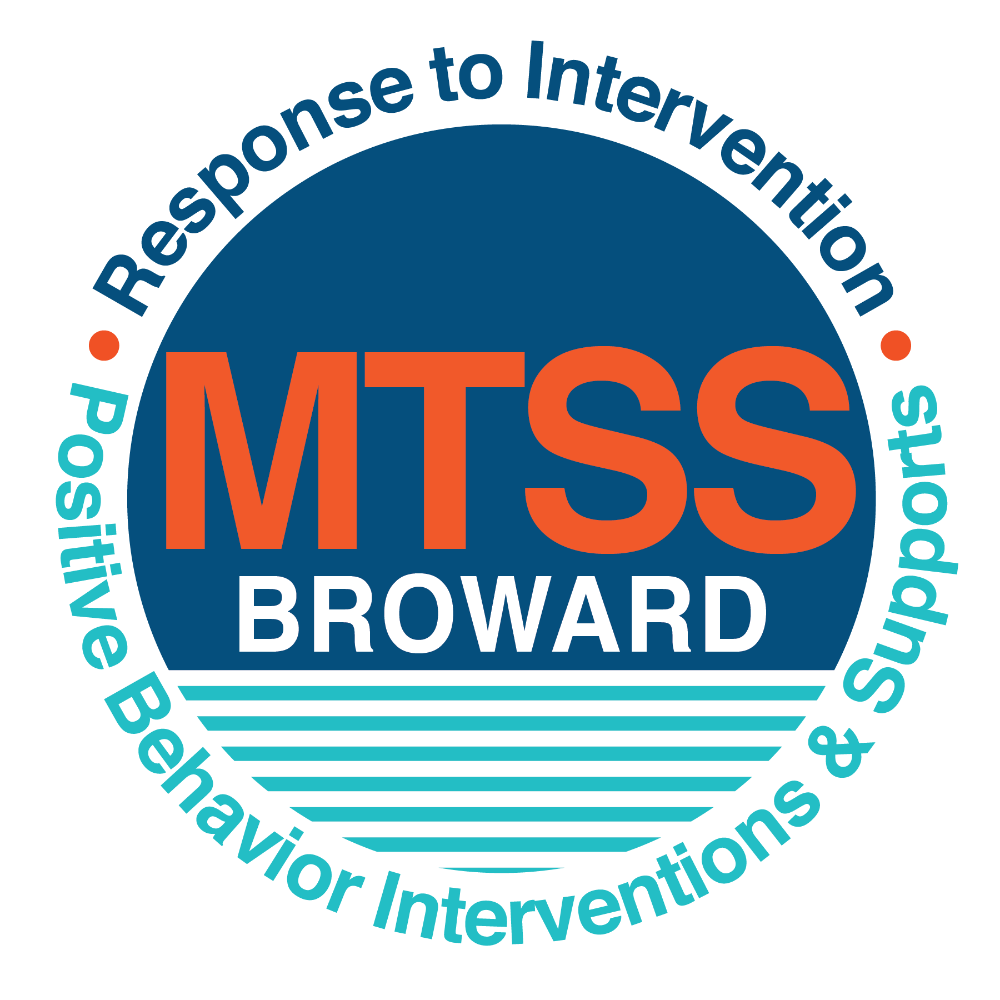
School-wide Positive Behavior Plan (SPBP)
Broward County Public Schools
To be implemented in SY 2019/20

School Name: | Wingate Oaks Center
School Number: | 0991
SPBP Contact Name: | TASHA RACHEL
Direct Phone Number: | 754-321-6857

CRITICAL ELEMENT # 1: Active Team with Administrative Participation

1A. Current (SY 2018/19) SPBP team members:
Full Name | Position
DONALD COTTRELL | 1. Administration
 | 2. BTU Representative
TASHA RACHEL | 3. SPBP Point of Contact
Lajoyce O’Neal | 4. Community Representation
LINDSEY WAY | 5. ESE Specialist
MARSHA STEELE | 6. ESE Pre-K Teacher
EWA DZIALOWSKI | 7. ESE K-12 Teacher
INES NEGRON | 8. District Behavior Support
 | 9.
 | 10.

1B. Schedule of quarterly SPBP Team Meeting dates for next 2019/20 school year:
Meeting Date | Meeting Time | Content of meetings:
8/13/2019 | 9 a.m. | 1. Review progress of Implementation Action Plan in #9  2. Collect & implementation data in #10A  3. Collect & analyze student outcome data in #10B  4. Create and disseminate updated Expectations and Rules lesson plans (#3 and #4)
10/18/2019 | 9 a.m.
1/6/2020 | 9 a.m.
3/20/2020 | 9 a.m.

CRITICAL ELEMENT # 2: Faculty & Stakeholder Commitment:

2A. Action Steps completed this year (SY 2018/19) that increased faculty and stakeholder knowledge of the new SPBP:

Action Steps: | Date  (Between Jan 15 and  April 30, 2019) | Details  (Sign-in sheets in SPBP Binder)
Presented the new SPBP (for SY 2019/20) to staff | 4/30/2019 | # of participants = 50
Held a faculty vote on the new SPBP  (for SY 2019/20) | 4/30/2019 | # of participants =  % approved =100
Presented the new SPBP (for SY 2019/20) to stakeholders (parents and community) | 4/30/2019 | # of participants = 10

2B. Action Steps to be completed next year (SY 2019/20) to increase faculty and stakeholder knowledge of the new SPBP:

Action Steps: | Date  (SY 2019-20) | Content  (Sign-in sheets in SPBP Binder)
Provide professional development on the 2019/20 SPBP for all staff | Prior to students’ 1st day:  8/9/2020 | The team will present the updates in the SPBP for the 19/20 school year. All stakeholders will be provided with access to the SPBP. Feedback will be collected for future team meetings.
Present the 2019/20 SPBP to stakeholders  (parents and community) | Prior to Oct 1st, 2019  9/19/2020
Present the behavior data to all staff quarterly | 1. 10/18/2019 | The team will present:  - the team’s progress in the Implementation Plan in # 9.  - the “marketing” (teaching and posting) of expectations and rules.  - lesson plan implementation  - discipline procedures  - reward system implementation  - the fidelity of staff implementation data in #10A.  - the student outcome data in #10B. Include:  - top 3 event locations  - type of behavior incidents  - core effectiveness data  - classroom referral data, as well as analysis of this data.
 | 2. 1/6/2020
 | 3. 3/20/2020
 | 4. 6/5/2020

CRITICAL ELEMENT # 3: School-wide Expectations

3A. Top five behavior incidents data YTD as listed in BASIS 3.0
Top 5 Behavior Incidents
1. NON-COMPLIANCE
2. AGGRESSION
3. ELOPEMENT
4. SELF-INJURY
5. OBSCENE/ PROFANE LANGUAGE

3B. School-wide expectations are 3 – 5 positive characteristics (not behaviors) that counteract the demonstration of the top school-wide misbehaviors above. ALL people on campus model these expectations.
School-wide Expectations
1. RESPECTFUL
2. RESPONSIBLE
3. POSITIVE ATTITUDE
4. SEE SOMETHING SAY SOMETHING
5.

3C. At least one lesson plan for each school-wide expectation above is distributed to teachers during pre-planning SY 2019/20 and maintained in the SPBP Binder.
Dates the school-wide expectations lesson plans are taught:
 | Date(s) | Time: | Location(s):
August | 9th | 8:30 am | Cafeteria
January | 7th | 8:30 am | Cafeteria
March | 20th | 8:30 am | Cafeteria

CRITICAL ELEMENT #4: Location-based Rules

4A. Top three school-wide locations for Behavior Events YTD.
Top 3 Locations, not including Classroom:
School Location | # Incidents
1. Playgrounds | 20
2. Cafeteria | 10
3.Learning Environment | 5

4B. Expectations and Rules Chart for common areas of school campus: (next page)

Expectations and Rules Chart |  |  |  | To be completed by classroom teachers
School-wide EXPECTATIONS | Cafeteria Rules | Hallway Rules | Playground Rules | Classroom Rules
Respectful | Use Appropriate language and voice volume | Respect personal space | Keep hands and feet to self
Responsible | Keep area clean and recycle/ throw away trash. | Stay with class | Maintain supplies and equipment
Positive Attitude | Comply with direction. | Stay calm and transition with appropriate pace and volume | Comply with directions
See Something Say Something | Inform others about new/different objects/people | Inform others about new/different objects/people | Inform others about new/different objects/people

4C. At least one Rules lesson plan for each specific location is distributed to teachers during pre-planning SY 2019/20 and maintained in the SPBP Binder.

Dates the Locations’ Rules lesson plans are taught
 | Date(s) | Time: | Location(s):
August | 9 | 8:30 am | Cafeteria
January | 6 | 8:30 am | Cafeteria
March | 20 | 8:30 am | Cafeteria

CRITICAL ELEMENT # 5: Reward and Recognition Programs

5. The reward system is focused on one School-wide Expectation OR specific location at a time.
Expectation or Location: _________Playground Be Respectful of others_________________________

4 Step Problem Solving Process | Plan Details
1. Problem Identification: Use your behavior data to identify one school-wide problem.  What problem did you identify? (use numerical data) | Data used: Frequency and ABC  Problem Identification Statement: Aggressive behavior towards staff and peers.
2. Problem Analysis: Why do you think this problem is occurring?  What is your goal? (use a SMART goal statement with numerical data) | Hypothesis: To communicate wants and needs  Goal Statement: Students will communicate his/her wants and needs appropriately, using total communication 95% of the time.
3. Intervention Design: Describe how you will implement a positive reward program to decrease this problem. | Type of System: Token system  Description of System: (≥ 5 sentences) A reinforcement system will be assessed for each student. The criteria for positive reinforcement will be individualized. Staff will be trained in the implementation of token reinforcement systems and primary reinforcement.
4. Evaluation:  A. Implementation fidelity | - How will you monitor the fidelity (consistency and effectiveness) of the staff’s implementation of the reward program? (2-3 sentences)  Behavior specialist will maintain behavior data. It will require quality assurance checks and model appropriate use system.
B. Student outcome monitoring | - How will you know if the reward program is positively impacting students? What measurable data will you use to determine “success”? (2-3 sentences)  Frequency data will be evaluated on a daily, weekly, and monthly basis. IEP progress reports will be reviewed.

CRITICAL ELEMENT #6: Effective Discipline Procedures

Student Behavior Discipline Flow Chart
Observe problem behavior behaviorBehavior
Staff Managed Misbehaviors
Intervene and redirect
Office Managed Misbehaviors
Yes

Call to notify office of a
crisis/safety issue
No

Implement an initial consequence
Is behavior Office Managed?
(if unsure, check below)

Specific Examples of  6 Staff Managed  Misbehaviors: | Specific Examples of  6 Office Managed  Misbehaviors:
Aggression  Self-Injury  Elopement  Disruption  Property Destruction  Throwing Objects | - Aggression with injury  - Self-injurious behavior with medical assistance  - Elopement  - Threating others  - Property destruction  - Behaviors that escalate to the point of needing help from outside agencies such as police or mental health

CRITICAL ELEMENT # 7: Classroom Management Systems

7A. In SY 2019/20, ALL teachers implement an evidence-based Tier 1 classroom management system:
Evidence-based system: | Evidence of training:
☐ CHAMPS | % of teachers currently holding valid CHAMPS certificate:
☒ PBIS Classroom Management  http://www.fl-pda.org/independent/ | % of teachers currently holding completion certificate:
☐ Other: Click here to enter name of system. | Training evidence: Click here to enter evidence  % of teachers currently trained:

7B. The administration reviews and analyzes the fidelity of staff implementation of Tier 1 classroom management systems across teachers using:
☐ CHAMPs 7 Up Checklist
☐ Basic FIVE (Classroom Management Screening)
☒ PBIS Classroom Assistance Tool (CAT)
☐ Other (specify):
☐ Classroom management screening is not conducted across teachers to determine appropriate professional
development. (Next year, assessment of classroom management implementation fidelity will be scored).

7C. School year 2018/19 percentage of classroom referrals:
Total number of discipline referrals from classrooms: | 1
Total number of other school-wide discipline referrals: | 1
% of referrals in the classroom: | !Zero Divide
Do more than 40% of your referrals come from the classroom? | ☐ Yes ☒ No
If >40% of discipline referrals come from the classroom, it suggests Tier 1 classroom management implementation may need to be strengthened school-wide.
If “Yes”, school-wide classroom management professional development will be conducted in 2019-20:
Click here to choose: If “Other”, indicated system here: Click here to enter text.

CRITICAL ELEMENT # 8: Data Collection and Analysis

8A. Core Effectiveness:
TOTAL Population: | 116 | % of Total Population | Core Effectiveness
# Referrals: | # of Students:
0 - 1 referrals | 0 | !Zero Divide | Are your 0 – 1 referrals > 80%? | ☐Yes ☒No
2 - 5 referrals  (at risk students) | 0 | !Zero Divide | Are your 2 - 5 referrals <15%? | ☒Yes ☐No
> 5 referrals  (high risk students) | 0 | !Zero Divide | Are your >5 referrals <5%? | ☒Yes ☒No

8B. Core Effectiveness Action Steps:
If all 3 are “Yes”, your core is effective. Is your core behavior curriculum effective? | ☒Yes ☐No
Answer either (a) or (b):
(a) If you answered “Yes”, although your core is effective, what steps does your school leadership team take for early identification of at risk and high-risk students?
(b) If you answered “NO”, indicate the supports and interventions your school leadership team will implement at the beginning of the next school year to improve core strength:
Core Effectiveness Action Steps: (3-4 steps)
1.
2.
3.
4.

8C. Disproportionality within racial subgroups:
Subgroups | (PctPop - Green)  % of students | (PctRef - Blue)  % of referrals | Difference in referral composition | Positive value suggests disproportionality  (Is the value positive?)
Black |  |  | 0 | ☐Yes ☐No
Hispanic/Latin |  |  | 0 | ☐Yes ☐No
White |  |  | 0 | ☐Yes ☐No

8D. Disproportionality Action Steps:
If all three are “No”, disproportionality is not indicated. Are all 3 “No”? | ☐Yes ☐No
Answer either (a) or (b):
(a) If you answered “Yes”, although your data indicates equity, what plan does your school leadership team implement for early identification of any disproportionality issues
(b) If you answered “No”, indicate the support plan and interventions your school leadership team will implement at the beginning of next year to improve sub group disproportionality
Disproportionality Action Steps: (3-4 steps)
1.
2.
3.
4.

Critical Elements # 9: SPBP Implementation Planning
RED Font = Action Steps for all schools in Broward County
GREY Font = Best Practices for all schools in Broward County
TEAL Font = Resources available at https://browardcountyschools.sharepoint.com/sites/DPI6Strands/strand6/SitePages/SPBP.aspx
SPBP Team Implementation Action Plan 2019 - 2020
Month | Action Steps  ☒ check off Action Step when completed
Current | ☒ Create a SPBP binder or portfolio to retain (for 2 years) hard copies of: your SPBPs, Action Plans, staff PBIS  professional development attendance, stakeholder training attendance, quarterly meeting agendas, quarterly staff  behavior presentations, voting attendance and outcome, Expectations lesson plans and Rules lesson plans
Pre-Planning  2019 | ☐ Print up your SPBP Review and school score from OSPA  ☒ Provide SPBP presentation to all staff during Pre-Planning  ☒ Disseminate the current SPBP (hard copy or electronically) to all staff and stakeholders  ☒ Market and post school-wide Expectations and location-specific Rules  ☐ Identify your district RtI Instructional Facilitator  (Contact tyyne.hogan@browardschools.com for more information, if you are unsure)  ☐ Confirm 1st team meeting date and time
August  1st meeting | ☐ Ensure schedule of quarterly meeting dates for entire year as indicated in the SPBP  ☐ Review Implementation plan; check off completed Action Steps  ☒ Determine any needed team training, such as these Brainsharks: 4 Step Problem Solving Process series, PBIS 10  Critical Elements, Data Collection, Big 5 Data, PBIS 101, etc. (All found in Sharepoint site)  ☒ Review previous year’s behavior data. (Use ‘Agenda’ Form and ‘Data Collection Template’ in Sharepoint site)  ☒ Utilize the 4 Step Problem Solving Process to initiate a Reward System for all students  ☒ Review previous year’s SPBP and feedback form; make necessary modifications  ☒ Verify and implement teaching schedule for Expectations and Rules behavior lesson plans  ☒ Present implementation data, behavior data, team activities and SPBP progress to entire staff
September | ☒ Provide SPBP stakeholder presentation prior to October 1  ☒ Check for staff and teacher understanding of PBIS - provide “PBIS 101” Brainshark as a resource  Brainshark available at: http://www.brainshark.com/browardschools/PBIS101  ☐ Ensure the Discipline Flow Chart is distributed to all staff and is being used as written
October  2nd meeting | ☐ Review Implementation plan; check off completed Action Steps  ☒ Ensure instructional staff know how to (and are, as needed) enter Tier 1 Supplemental Strategies  for behavior in BASIS  ☒ Review previous quarter’s behavior data. (Use ‘Agenda’ and ‘Data Collection Template’ in Sharepoint site)  ☒ Present implementation data, behavior data, team activities, and SPBP progress to entire staff  ☐ Ensure all teachers are using an evidence-based classroom management plan, such as CHAMPS  ☐ Ensure Core Effectiveness Action Steps are being implemented as written
November | ☒ Team to develop new and/or improved lesson plans as indicated by behavior data.  ☒ Ensure that the Disproportionality Action Steps are being implemented as written
January  2020  3rd meeting  Prepare for SY 2020/21 SPBP | ☒ Review Implementation plan; check off completed Action Steps  ☒ Staff to re-teach Expectations and Rules after winter break  ☒ Principal signs in and watches the new “SPBP for Principals” Brainshark: Due January 30th  ☒ Present implementation data, behavior data, team activities, and SPBP progress to entire staff  ☒ Choose team members and dates to work on, complete, and submit the new SPBP  ☒ Teams watch the new “SPBP Team Overview” Brainshark and refers to district resources and supports  (Brainsharks and Additional items in Sharepoint site. Webinars and in-person lab information in Team Brainshark)
February | ☒ Ensure progress towards completion of SPBP  ☒ Check on recently hired staff for PBIS understanding - provide “PBIS 101” Brainshark resource  ☒ Provide the SPBP Surveymonkey link to all staff (optional)
March  4th meeting | ☒ Ensure progress towards completion and submission of SPBP  ☐ Review Implementation plan; check off completed Action Steps  ☒ Staff to re-teach Expectations and Rules after from spring break  ☒ Provide stakeholders/parent presentation on new SPBP for next year  ☒ Provide staff presentation and faculty vote on new SPBP for next year  ☒ Present implementation data, behavior data, team activities, and SPBP progress to entire staff
April | ☒ Submit your SPBP in OSPA by April 30th every year. Use this new SPBP in the next school year  ☒ Continue implementing your current SPBP through the end of the current school year

CRITICAL ELEMENT # 10: Evaluation

10A. Staff implement the School-wide Positive Behavior Plan effectively:
“Are staff implementing the SPBP with fidelity? How do you know?”
STAFF Implementation Monitoring
Action Step | Create an observable and measurable SMART goal to determine “successful”  staff implementation of action step
School-wide expectations and location-specific rules are posted across campus | Frequency data on target behaviors will take place daily.
Expectations and Rules lesson plans are being taught as written and when indicated | Behavior specialist will do a minimum of two quality assurance checks per week.
The Discipline flow chart is being used by all staff as written | Behavior Specialist will observe and collect information
A reward system is being implemented for all students | All staff will implement the rewards system daily.

10B. The SPBP is successful in positively impacting students:
“If staff are implementing the SPBP consistently and effectively, did it positively impact the students? How do you know?”
STUDENT Outcome Monitoring
Student Outcome Data | Create an observable and measurable SMART goal to determine  “successful” student outcomes
Behavior Incident data  (See critical element #3A) | Students will maintain appropriate personal space, 80% of opportunities given gestural and verbal prompts.
Top 3 event locations data  (See critical element #4A) | Students will stay in their assigned area in 90% of opportunities given gestures, visual and verbal prompts.
Core effectiveness data
(See critical element #8A)
Classroom referrals data
(See critical element #7C)

