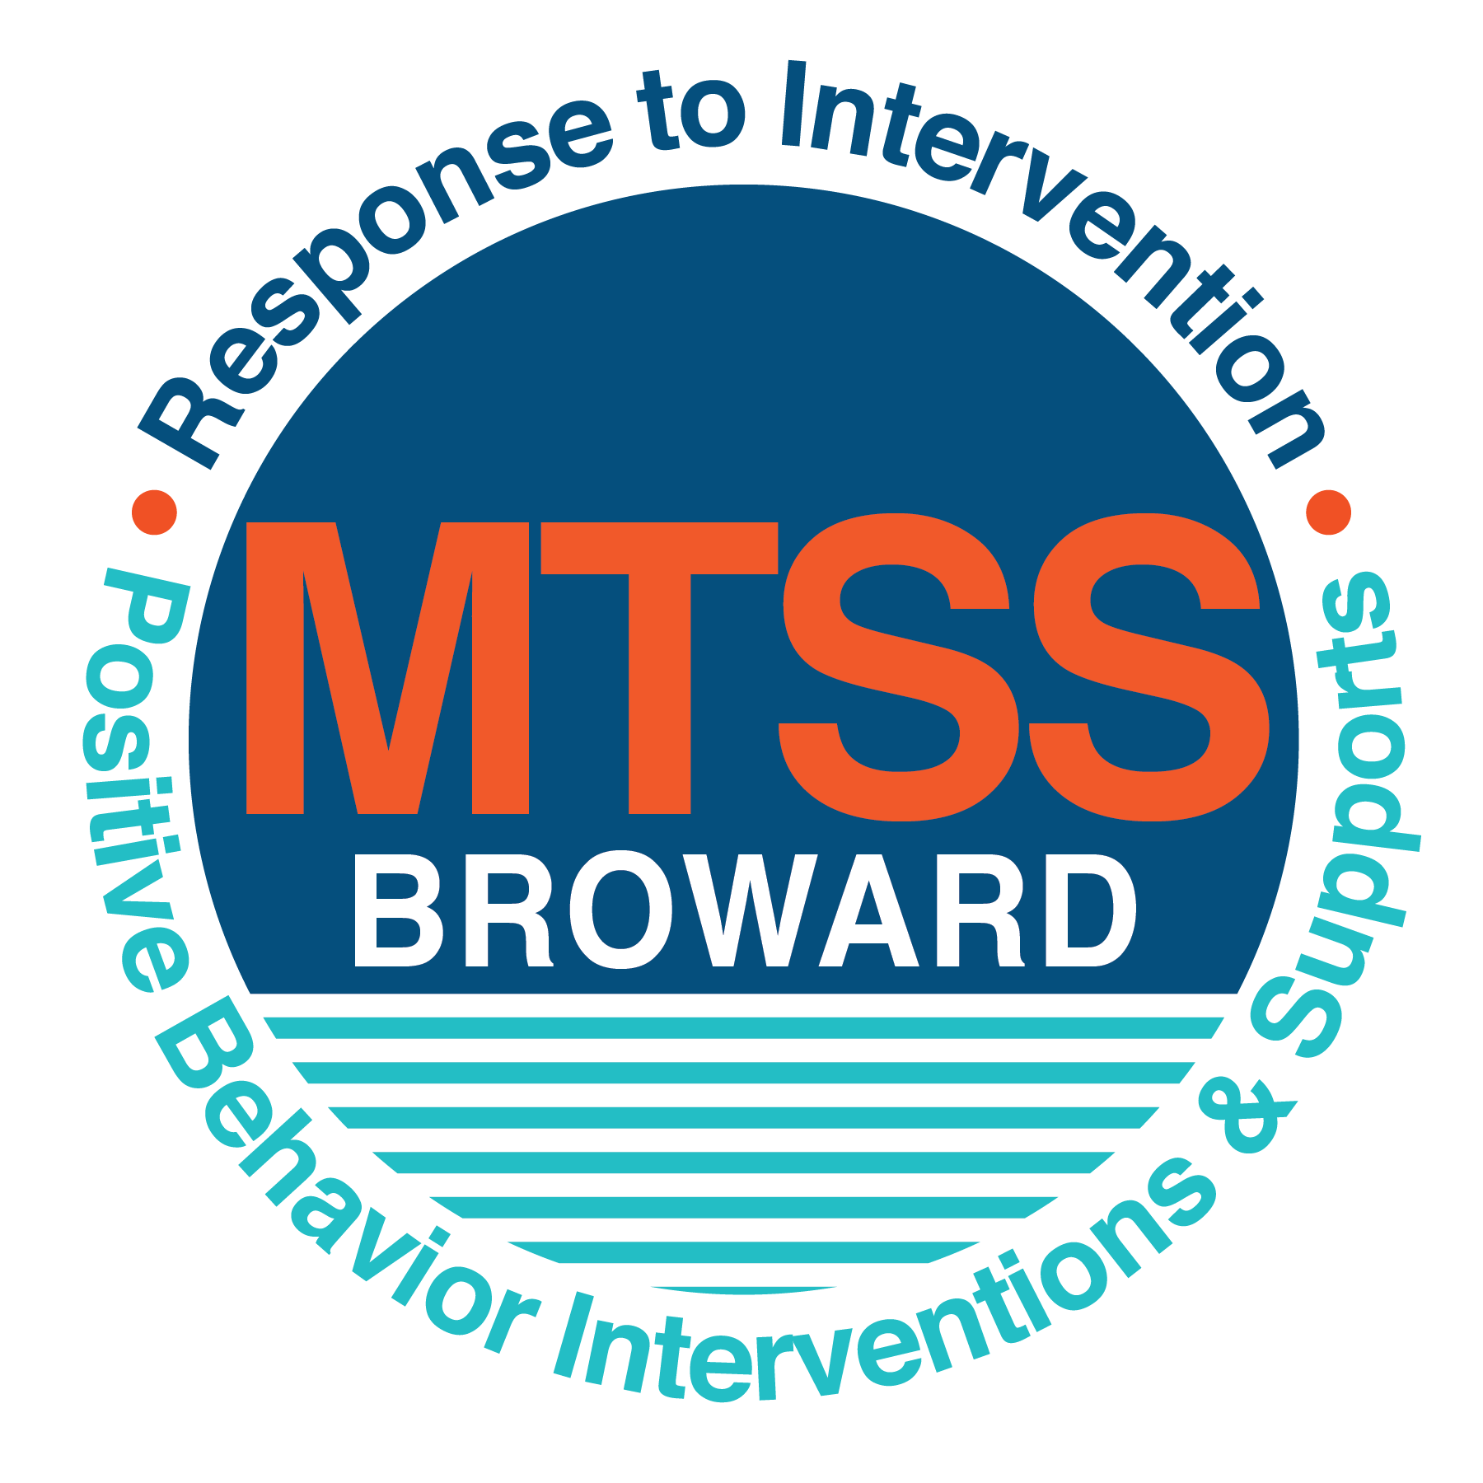

**School-wide Positive Behavior Plan (SPBP)**

Broward County Public Schools

To be implemented in SY 2018/19

**Elements have changed in the SPBP.**

Before completing, go to[**http://www.browardprevention.org/mtssrti/rtib/ →**](http://www.browardprevention.org/mtssrti/rtib/%20→)*School-wide Positive Behavior Plan* for:

* **A NEW Brainshark for Principals. ACTION: Log in with your p # and watch the Brainshark before Jan 30th.**
* **A NEW Overview Brainshark for Teams. ACTION: Log in with school name and watch the Brainshark.**
* A NEW mini Brainshark Series for teams. These Brainsharks are divided into the 10 Critical Elements of PBIS. They will

show you “how to” write a comprehensive SPBP (and receive a high score!)

* A Rating Rubric to ensure teams will correctly complete the SPBP and develop a meaningful plan.

To provide consistency across the District, *only plans entered on the current district template will be accepted*.

**ACTION: Download, complete and upload the SPBP into your School Improvement Plan before May 1, 2018:**

|  |  |
| --- | --- |
| **School Name:** | Stephen Foster Elementary |
| **School Number:** | 0921 |
| **SPBP Contact Name:** | Jacqui Arnaez |
| **Direct Phone Number:** | 754-323-5756 |

|  |
| --- |
| **CRITICAL ELEMENT # 1: Active Team with Administrative Participation** |

**1A.** List your current (SY 2017/18) team members (6 - 10 team members). **Must include an instructional representative from EACH grade/content area.** *Each name on this list verifies attendance in ongoing team meetings and participation in developing this SPBP. Each member is responsible for representing major stakeholders and sharing the SPBP content and updates with their respective group.*

|  |  |  |
| --- | --- | --- |
| **Full Name** | **Position** | **Who or what grade level does this member represent?** |
| Mrs. Arnaez | Assistant Principal | Administration |
| Ashley Nuttall | SPBP Point of Contact | 1st grade/ teacher |
| Ana Maria/ Jeffrey Allagood | Parent/Community Representation | Parent support/ SAC |
| Rebecca Albury | BTU Representative | BTU/ Pre K |
| Natalie Havens | Guidance Counselor | Support Staff |
| Keri Luna and Carolina Osorio | Teachers | Kindergarten |
| Lena Leon | Teacher | 1st Grade |
| Natalia Santiago and Mr. Franklin | Teachers | 2nd Grade |
| Stephanie Faria | Teacher | 3rd Grade |
| Belinda Coldwell and Ms. Perez  Ms. Heil and Mr. Flynn | Teachers | 4th Grade  5th Grade |

**1B**. Schedule and document your quarterly team meeting dates for *next* 2018/19 school year:

|  |  |  |  |
| --- | --- | --- | --- |
| **Meeting Date** | **Meeting Time** | **Name & title of person responsible to facilitate meeting** | **Content of meetings:** |
| 10/2/2017 | 2:30 | Mrs. Havens- Guidance Counselor | 1. Create and disseminate updated  Expectations and Rules lesson  plans (#3 and #4)  2. Review progress of  Implementation Action Plan (#9)  3. Collect & analyze implementation  data (#10A)  4. Collect & analyze student  outcome data (#10B) |
| 12/18/2017 | 2:30 | Mrs. Nuttall- team lead |
| 2/5/2018 | 2:30 | Mrs. Nuttall- team lead |
| 3/5/2018 | 2:30 | Mrs. Nuttall- team lead |

|  |
| --- |
| **CRITICAL ELEMENT # 2: Faculty & Stakeholder Commitment:** |

**2A**. Action Steps completed **this year** (SY 2017/18) that increased faculty and stakeholder understanding and knowledge of 2/your *new* (2018/19) SPBP:

|  |  |  |  |
| --- | --- | --- | --- |
| **Action Steps:** | **Date**  *(Between Jan 15 –*  *April 30, 2018)* | **Details**  *(retain attendance sheets at school)* | **Person responsible to collect and retain attendance sheets:** |
| Presented the *new* SPBP (for SY 2018/19) to staff | 4/16/2018 | # of participants = 41 | Ms. Havens |
| Held a *faculty* vote on the new SPBP  (for SY 2018/19) | 4/16/2018 | % approved =100 | Ms. Havens |
| Presented the *new* SPBP (for SY 2018/19) to stakeholders (parents and community) | 4/24/2018 | # of participants = 16 | Ms. Havens |

**2B.** Action Steps to be completed **next year** (SY 2018/19) to increase faculty and stakeholder understanding and knowledge of your SPBP:

|  |  |  |  |
| --- | --- | --- | --- |
| **Action Steps:** | **Date(s)**  *(NEXT YEAR)* | **Content**  *(retain attendance sheets at school)* | **Person responsible to collect and retain attendance sheets:** |
| Provide a professional development on the 2018/19SPBP for all staff | Prior to students’ 1st day:  8/10/2018 | The team will present the updates in the SPBP for the 18/19 school year. All stakeholders will be provided with access to the SPBP. Feedback will be collected for future team meetings. | Natalie Havens |
| Present the 2018/19SPBP to stakeholders (parents and community) | Prior to Oct 1st, 2018  9/11/2018 |
| Present behavior data to staff  *Quarterly: minimum of 4 each year* | 1. 10/1/2018 | The team will present the implementation data in 10A. Include:  • the “marketing” (teaching and posting) of expectations and rules  • lesson plan implementation  • discipline procedures  • reward system implementation  The team will present the student outcome data in 10B. Include:  • top 3 event locations  • type of behavior incidents  • core effectiveness data  • classroom referral data, as well as analysis of this data. | Natalie Havens |
| 2. 12/3/2018 |
| 3. 1/21/2019 |
| 4. 4/8/2019 |

|  |
| --- |
| **CRITICAL ELEMENT # 3: School-wide Expectations** |

**3A.** List the **top 10 behavior incidents** data YTD from BASIS 3.0 Behavior Dashboard:

|  |  |
| --- | --- |
| **Top 10 Behavior Incidents**  *(put N/A in any blank spaces)* | |
| 1. Unruly/ disruptive behavior | 6. Disruption on Campus |
| 2. Fight/ Minor altercation | 7. Assault-threat |
| 3. Disobedience/ Insubordination (minor) | 8. Defiance of authority- habitual |
| 4. Profanity to staff member | 9. Battery |
| 5. Leaving Campus without permission | 10. Out of assigned area |

**3B.** Based on the behavior incidents in 3A, develop 3 – 5 **positive characteristics** *(not behaviors)* that would counteract the demonstration of these misbehaviors. These positive characteristics become your school-wide expectations.

|  |
| --- |
| **School-wide Expectations** |
| 1. S- Self- Control |
| 1. T- Tolerant |
| 1. E- Educated Decisions |
| 1. A- Accountable |
| 1. M- Maintain positive behavior |

**3C.** Research indicates that discipline referrals increase after long holidays and during testing times. Plan to teach your expectations at least 3 times throughout the year (and anytime the expected behaviors are not being demonstrated).

**ACTION:** Create at least one lesson plan for **each** school-wide expectation above and distribute to teachers during pre-planning 2018-19. Develop additional lesson plans you will use throughout the year to re-teach and reinforce your school-wide expectations. *You do not need to submit your lesson plans with the SPBP. Retain all behavior lesson plans at the school; make sure these lesson plans are available for guests and stakeholders.*

|  |  |  |  |
| --- | --- | --- | --- |
| **When will school-wide expectations lesson plans be taught?** | | | |
|  | Date(s) | Time: | |
| August | 08/15/2018 | 8:00-10:00 | |
| January | 01/08/2019 | 8:00-10:00 | |
| 4th Quarter | 04/01/2019 | 8:00-10:00 | |
|  | | | |
| Who will be responsible for teaching the lesson plans? | | | Classroom Teachers |
| Where will the lesson plan instruction occur? | | | In each classroom |
| Who is responsible for retaining, organizing and distributing all lesson plans? | | | Natalie Havens |

|  |
| --- |
| **CRITICAL ELEMENT #4: Location-based Rules** |

**4A.** List the **top 3 locations** for behavior Events YTD from BASIS 3.0 Behavior Dashboard**.** ***Do not use “classroom”***

|  |  |
| --- | --- |
| **Top 3 Locations** | |
| School Location | # Incidents |
| 1. Hallway | 8 |
| 1. Cafeteria | 6 |
| 1. Athletic Field | 5 |

**4B.** Create an Expectations/Rules Matrix from your 3-5 school-wide expectations and your top 3 event locations. Develop a positively stated, observable, and measurable rule that correlates with every expectation to create a maximum of 5 rules under each location**.**

|  |  |  |  |  |
| --- | --- | --- | --- | --- |
| **Expectations and Rules Matrix** | | | | |
| **School-wide EXPECTATIONS** | *Copy and paste expectations from* ***3C****.* | **IDENTIFIED LOCATIONS**  *Copy and paste locations from* ***4A.*** | | |
| Hallway | Cafeteria | Athletic Field |
| **Rules** | **Rules** | **Rules** |
| Self-Control | When in line, walk single file along the painted line, facing forward. | Keep hands, feet and other object to yourself. | Keep, hands, feet, and other objects to yourself. |
| Tolerant | Use kind words and actions with your classmates. | Use kind words and actions with your classmates. | Use kind words and actions with your classmates. |
| Educated Decisions | Keep your hands and feet and other objects to yourself. | Clean up after yourself. | Make safe choices. |
| Accountable | Stay in your assigned area. | Use level 1 whisper voice. | Share equipment with others. |
| Maintain a positive behavior | When in line, maintain “Steamer Stride” | Keep hands, feet, and other objects to yourself. | Return equipment to proper locations. |

**4C**. Research indicates that discipline referrals increase after long holidays and during testing times. Plan to teach your location-specific rules at least 3 times throughout the year (and anytime the expected behaviors are not being demonstrated).

**ACTION:** Create at least one lesson plan for **each** location above and distribute to teachers during pre-planning 2018-19. Develop additional lesson plans you will use throughout the year to re-teach and reinforce your location-specific rules.

*You do not need to submit your lesson plans with the SPBP. Retain all behavior lesson plans at the school; make sure these lesson plans are available for guests and stakeholders.*

|  |  |  |  |
| --- | --- | --- | --- |
| **When will location-specific rules lesson plans be taught?** | | | |
|  | Date(s) | Time: | |
| August | 08/15/2018 | 8:00-10:00 | |
| January | 01/08/2019 | 8:00-10:00 | |
| 4th Quarter | 04/01/2019 | 8:00-10:00 | |
|  | | | |
| Who will be responsible for teaching the lesson plans? | | | Classroom teachers |
| Where will the lesson plan instruction occur? | | | In classrooms |
| Who is responsible for retaining, organizing and distributing all lesson plans? | | | Mrs. Havens |

|  |
| --- |
| **CRITICAL ELEMENT # 5: Reward and Recognition Programs** |

Although you will post, teach, review, practice and reinforce all school-wide expectations and location-specific rules, **choose 1 expectation OR 1 event location** you will target for a specific reward program for students. Based on the data that led to this expectation or location, create a reward plan using the 4 Step Problem Solving Process:

Expectation or Location: _______Cafeteria ______________________________________________________________

|  |  |
| --- | --- |
| **4 Step Problem Solving Process** | **Plan** |
| **1. Problem Identification:** Use your behavior data to identify a school-wide problem.  What problem did you identify? *(use numerical data)* | **Data used: number of incidences in cafeteria location (6) Office Discipline Referrals**    **Problem Identification: The number of ODR's in the first quarter is 50% higher than last year (2 last year, 4 this year).** |
| **2**. **Problem Analysis:** Why do you think this problem is occurring?  What is your goal? *(use a SMART goal statement with numerical data)* | **Hypothesis: Students**  **Students get riled up when they are with so many other classes and forget the rules and expectations in the cafeteria.**  **Goal Statement:** By the end of the second quarter, ODR's from the cafeteria will decrease from 4 to less than 2- a 50% reduction.) |
| **3. Intervention Design:**  Describehow you will implement a positive reward program to decrease this problem. | **Type of System: Point system**  **Description of System:** *(3-4 sentences)*  The classes will be given a numerical grade (1-5) at the end of the lunch, correlating to lunch rules. If a rule has been broken, the students receive a lower rating. The scores are counted each month and the highest scoring class at the end of the month for each grade will receive a popsicle party. Teachers also receive this score so they know how lunch went and can further reward in their own classrooms. |
| **4. Evaluation:**  A. Implementation fidelity | 1. How do you monitor the fidelity (consistency and effectiveness) of the **staff’s** implementation of the reward program?   1. The system will be taught to the cafeteria staff by Natalie Havens and support staff before school starts.  2. The system will be taught to the teachers by Ms. Arnaez before school starts.  3. Ms. Arnaez will observe in the cafeteria 3 random days week.   1. The monthly winners will be tallied by Ms. Havens, who will then let the teacher's know. 2. The teachers will share the news to all the classes. 3. Cafeteria Staff will ensure the popsicles are provided the last day of each month. |
| B. Student outcome monitoring | 1. How will you know if the reward program is positively impacting **students**? What measurable data will you use to determine “success”? *(2-3 sentences)*   We will look at the number of overall incidences within the cafeteria at the end of the month and will hopefully see the overall numbers decrease each month. |

|  |
| --- |
| **CRITICAL ELEMENT #6 Effective Discipline Procedures** |

**6A. Staff Managed Misbehaviors:** List the top 6 *most common* school-wide misbehaviors **staff are expected to manage.**

Write a short, objective, and measurable definition for each.

|  |  |
| --- | --- |
| **Staff Managed Misbehaviors** | |
| Misbehavior | “Looks Like” - *provide a description with example(s)* |
| 1. Inappropriate language | Cursing, using bad words |
| 1. Disobedience | Not following directions, questioning the teacher |
| 1. Disrespect of adults | Talking back to teacher and other adults |
| 1. Disrespect of classmates | Purposely picking on/bugging other students, making fun of others |
| 1. Not keeping hands and feet to self | Unwanted touching |
| 1. Out of assigned area | Out of seats or in wrong area during rotations |

**6B. Staff Managed Consequences**: Create a consequencemenu **OR** a consequence hierarchy for staff to use when students exhibit the above misbehaviors. Provide a minimum of **5** consequences.

|  |  |
| --- | --- |
| Is this a menu or hierarchy system? | Menu Hierarchy |
| Verbal warning/redirection | |
| Time out | |
| Parent contact | |
| Parent conference | |
| Referral | |

**6C. Administration Managed Misbehaviors**:

(a) Define the first 3 behaviors by providing examples that clearly identify the point at which the misbehavior warrants an Office Discipline Referral (ODR).

(b) List two additional common school-wide misbehaviors that will result in an ODR. Provide concrete examples.

(c) Determine staff tolerance level for repetitive misbehaviors (the point at which the number of staff-managed misbehaviors becomes an ODR).

|  |  |
| --- | --- |
| **Office Discipline Referrals (ODRs)** | |
| Behavior | “Looks Like” - *provide a description with example(s)* |
| 1. Unruly/ disruptive behaviors | After the teacher has exhausted all of the classroom based consequences and behaviors continue. |
| 1. Fight/ minor altercation | Teacher either has already has exhausted all of the classroom based consequences and behaviors continue OR if someone is injured OR if it becomes a classroom disruption. |
| 1. Disobedience/ insubordination | After the teacher has exhausted all of the classroom based consequences and behaviors continue. |
| 1. Profanity to staff members | Students use obscene or profane language and redirection/ consequences have not affected behavior. |
| 1. Leaving campus without permission | Student eloping classroom or assigned area. |
|  | More than misbehaviors inwarrants an office referral.  Hours  2  5    *e.g., 3 half hour*  *2 one period* |

**6D. School-wide Discipline Flow Chart:**

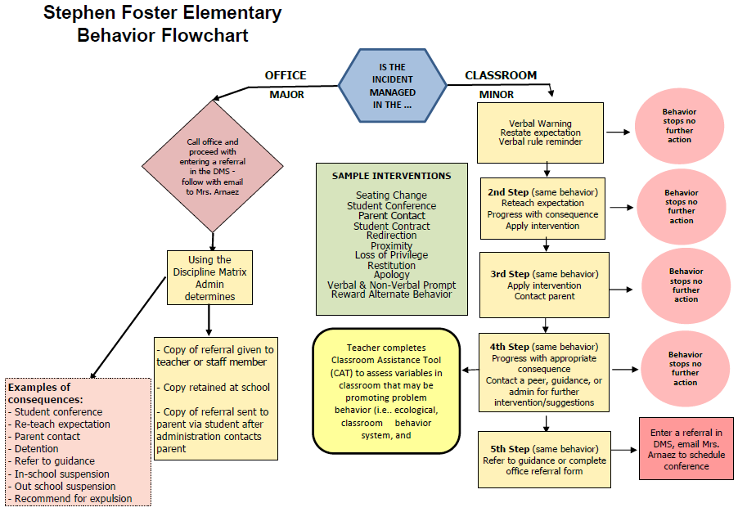

|  |
| --- |
| **CRITICAL ELEMENT # 7 : Classroom Management Systems** |

**7A.** ALL teachers implement an effective Tier 1 classroom management system:

|  |  |
| --- | --- |
| Which **evidence-based** classroom management system is supported by your school’s administration and is expected to be implemented school-wide?  *(Class Dojo, LEAPs, HERO, Cloud 9, etc. are tools,* ***not*** *classroom systems)* | CHAMPs*  PBIS Classroom Management  Administration does not expect an evidence-based classroom management system to be implemented by teachers this year  (*your school will need to adopt one next year)*  Other *(complete below)* |
| If other, name the **evidence-based classroom management system:** | Click here to enter name of system. |
| *CHAMPs is the district-supported, evidence-based universal classroom management system for all teachers. Would your Principal like to be contacted to learn about CHAMPs professional development? | Yes  No |

**7B.** Fidelity of **staff** implementation of school-wide classroom management systems

|  |
| --- |
| What data collection tool does your school leadership team use to monitor and evaluate your teacher’s classroom management skills? *(Measure* ***staff skills****, not student outcomes)* |
| CHAMPs 7 Up Checklist |
| CHAMPs Classroom Check Up (CCU) |
| PBIS Classroom Assistance Tool (CAT) |
| PBIS Walkthrough |
| Marzano’s Domain 1, Design Questions 5, 6, 7, 8, 9 |
| Fidelity of staff classroom management implementation is not monitored to determine training needs this year *(you will need to adopt a tool and plan next year)* |
| Other *(specify):* |
| Explain how this data is collected and analyzed by your school leadership team as a **universal screening** *across teachers* to determine the need for classroom management training: |
| Fidelity of Implementation Plan: *During class reviews, data from all areas is considered and reviewed. The reviews are quarterly and behavior management and things that have been noticed in each classroom is addressed. The teachers all have their formal observations which allow the leadership team to discuss individual needs.* |

**7C. Percentage of Classroom Referrals:**

(a) Review your classroom data YTD (“Events by Location”) in BASIS 3.0 Behavior Dashboard.

(b) Complete the yellow highlighted cells first.

(c) Auto-calculate the % of referrals in the classroom by clicking on “!Zero Divide” in the next cell and pressing “Fn + F9” together.

|  |  |
| --- | --- |
| Total number of discipline referrals **from classrooms**: | 21 |
| Total number of **school-wide** discipline referrals: | 40 |
| % of referrals in the classroom: | 34% |
| Do more than 40% of your referrals come from the classroom? | Yes  No |

***If >40% of discipline referrals come from the classroom, it suggests Tier 1 classroom management implementation may need to be strengthened school-wide.***

|  |
| --- |
| **CRITICAL ELEMENT # 8: Data Collection and Analysis** |

**8A. Determine your School-wide Core Effectiveness YTD** from the BASIS Behavior Dashboard in the “Referrals per Student” chart.

(a) Complete the yellow highlighted cells first.

(b) Auto-calculate the “% of Total Population” by clicking on each “!Zero Divide” in the cells and pressing “Fn + F9”.

(c) Determine if the core is effective in all three areas

|  |  |  |  |  |
| --- | --- | --- | --- | --- |
| TOTAL Population: | 677 |  |  | |
| # Referrals | 40 | **% of Total Population** | Core Effectiveness | |
| 0 - 1 referral |  | 98% | Are your 0 – 1 referrals > 80%? | Yes No |
| 2 - 5 referrals  (at risk students) | 12 | 2% | Are your 2 - 5 referrals <15%? | Yes No |
| > 5 referrals  (high risk students) | 0 | 0% | Are your >5 referrals <5%? | Yes No |

**8B. Core Effectiveness Plan:**

|  |  |
| --- | --- |
| If all 3 are “**Yes**”, your core is effective. Is your core behavior curriculum effective? | Yes No |
| Answer **either** (a) or (b):  (a) If you answered “**Yes**”, although your core is effective, what plan does your school leadership team implement for early identification of at risk and high risk students?  (b) If you answered “**NO”**, indicate the supports and interventions your school leadership team will implement at the beginning of the next school year to improve core strength: | |
| Core Effectiveness Plan: *During class reviews, we meet quarterly and discuss each student and their potential risks both academically and behaviorally.* | |

**8C. Disproportionality: Determine if there are any issues within subgroups** from BASIS 3.0 Behavior Dashboard in the “Referrals by Demographics” chart.

(a) Complete the yellow highlighted cells first.

(b) Auto-calculate the difference by clicking on each “0” in the next cell and pressing “Fn + F9”.

|  |  |  |  |  |
| --- | --- | --- | --- | --- |
| Subgroups | (PctPop - Green)  % **of students** | (PctRef - Blue)  **% of referrals** | Difference in referral composition | Positive value suggests disproportionality  (Is the value positive?) |
| Black | 20% | 28% | 8% | Yes No |
| Hispanic/Latin | 59% | 20% | -39% | Yes No |
| White | 19% | 10% | -9% | Yes No |

* + Due to some students who are entered into BASIS as mulit and native, our data reflects that.
  + **8D. Disproportionality Plan:** If any values are positive, the percentage of referrals contributed to that subgroup is higher than expected, given that subgroups’ percentage in the student population.

|  |  |
| --- | --- |
| If all 3 are “**No**”, disproportionality is not indicated. Are all 3 “No”? | Yes No |
| Answer **either** (a) or (b):  (a) If you answered “**Yes**”, although your data indicates equity, what plan does your school leadership team implement for early identification of any disproportionality issues  (b) If you answered “**No**”, indicate the support plan and interventions your school leadership team will implement at the beginning of next year to improve sub group disproportionality | |
| Disproportionality Plan: *During PLC’s for each grade, the school leadership will work with teachers in the specialized EBD classrooms in order to better support that population and its needs.* | |

|  |
| --- |
| **Critical Elements # 9: SPBP Implementation Planning** |

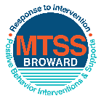This form provides a timeline to complete best practices and required actions. This timeline should drive team actions and accountability. As you implement your SPBP *NEXT* year, check off **completed items** and indicate the accountable person. (Complete only the yellow highlighted area at this time). Next year, you will upload this completed plan within your SPBP.

Required actions for all schools in Broward County

Best Practices for all schools in Broward County

**Resources**

|  |  |  |
| --- | --- | --- |
| **SPBP Team Implementation Action Plan 2018 – 2019** | | |
| **Month** | **Action Step**  *check when Action completed* | **Completed:**  Person Responsible  Name & Title |
| **Current** | **This Action Plan has been saved to use *next year* during quarterly meetings** | **Ashley Nuttall- team lead** |
| **Current** | **Create a SPBP binder or portfolio to retain (for 2 years) hard copies of: your SPBPs, Action Plans, staff PBIS professional development attendance, stakeholder training attendance, quarterly meeting agendas, quarterly staff behavior presentations, voting attendance and outcome, Expectation lesson plans and Rules lesson plans** | **Natalie Havens- Guidance counselor** |
| **Pre Planning**  **2018** | Print up your SPBP Review and school score from OSPA  Provide SPBP presentation to all staff during Pre Planning  Disseminate the current SPBP (hard copy or electronically) to all staff and stakeholders  Market and post school-wide Expectations and location-specific Rules (posters, PSAs, etc.)  Identify your RtI Instructional Facilitator provided by the district  (Contact [tyyne.hogan@browardschools.com](mailto:tyyne.hogan@browardschools.com) for more information, if you are unsure)  Confirm 1st team meeting date and time | Natalie Havens, Guidance Counselor |
| **August**  **1st meeting** | Ensure schedule of quarterly meeting dates for entire year as indicated in the SPBP  Determine any needed team training, such as the 4 Step PSP Brainshark Series, 10 Critical  Elements Brainsharks, Data Collection, Effective CPST Teams, PBIS 101, etc.  Trainings available at: <http://www.browardprevention.org/mtssrti/training-modules/>  Review previous year’s behavior data. (Use ‘Agenda’ and ‘Data Collection Template’)  Forms available at: <http://www.browardprevention.org/mtssrti/rtib> in Tier 1, Teaming  Present implementation data, behavior data, team activities and progress to entire staff  Utilize the 4 Step Problem Solving Process to develop initial interventions  Review previous year’s SPBP and feedback form  Verify and implement teaching schedule for SPBP Expectations and Rules behavior lesson plans | Natalie Havens, Guidance Counselor |
| **September** | Provide stakeholder presentation on SPBP prior to October 1  Check for staff and teacher understanding of PBIS - provide “PBIS 101” Brainshark as a resource  Brainshark available at: http://www.brainshark.com/browardschools/PBIS101 | **Mrs. Arnaez – Vice Principal** |
| **October**  **2nd meeting** | Ensure instructional staff know how to (and are, as needed) enter Tier 1 Supplemental Strategies  for behavior in BASIS  Present implementation data, behavior data, team activities and progress to entire staff | Lisa Leider- RTI coordinator |
| **November** | Staff to re-teach Expectations and Rules first day back from break.  Team to develop new and/or improved lesson plans as indicated by behavior data. | Natalie Havens, Guidance Counselor |
| **January**  **2019**  **3rd meeting**  Prepare for *2019/20* SPBP | Staff to re-teach Expectations and Rules first day back from break  Ensure the Principal signs in and watches the *new* SPBP Brainshark: Due January 30th  Present implementation data, behavior data, team activities and progress to entire staff  Choose team members and dates to work on, complete, and submit the *new* SPBP  Teams watch the *new* SPBP Brainsharks and refers to *new* “Additional items”  Brainsharks and Additional items posted at: <http://www.browardprevention.org/mtssrti/rtib> | Natalie Havens, Guidance Counselor |
| **February** | Ensure progress towards completion of SPBP  Check on recently hired staff for PBIS understanding - provide “PBIS 101” Brainshark resource  Provide the SPBP Surveymonkey link to all staff (optional). Email [Tyyne.hogan@browardschools.com](mailto:Tyyne.hogan@browardschools.com) to request analysis. | Chair of PBP for the 2018-19 school year |
| **March**  **4th meeting** | Ensure progress towards completion of SPBP  Provide staff presentation and vote on new SPBP for next year  Provide stakeholders/parent presentation on new SPBP for next year  Present implementation data, behavior data, team activities and progress to entire staff | Chair of PBP for the 2018-19 school year |
| **April** | Submit your SPBP in OSPA by April 30th every year | **Mrs. Arnaez- Vice Principal** |

|  |
| --- |
| **CRITICAL ELEMENT # 10: Monitoring Plans** |

**10A.** How will you determine the success **of *staff* implementation** of the School-wide Positive Behavior Plan?

*“Are* ***staff*** *implementing the SPBP with fidelity? How do you know?”*

|  |  |  |  |
| --- | --- | --- | --- |
| **Fidelity of Implementation Monitoring Plan** | | | |
| Action Step | Create an **observable** and **measureable** SMART goal to determine “successful”  **staff implementation** of action step | When will data be collected, analyzed & presented? | Person responsible to collect and analyze data |
| School-wide **expectations** and location-specific **rules** are posted across campus | By the end of each month, 100% of hallways, cafeteria, and all classrooms will have at least 2 posters of expectations and rules posted. | Refer to **quarterly** presentation dates in 2B.  This is the data the team will be sharing during presentations. | Natalie Havens, guidance counselor |
| **Behavior lesson plans** are being taught as written and when indicated | Three times per year (as previously specified) 100% of teachers will teach the provided lesson plans (or a lesson plan of their choosing) that teaches the rules and expectations. Teachers will sign off with the guidance counselor to show when it is completed. | Natalie Havens, guidance counselor |
| **Discipline consequences**  and **flow chart** are being used by all staff as written | Every quarter, there will be a 5% decrease in the number of Office Discipline Referrals that contain previously identified staff-managed misbehaviors as measured by a referral review by the PBIS team. | Ms. Arnaez, Assistant Principal |
| A **reward system** is being implemented for *all* students | At the end of each month, the top earning class for each grade level will be given a popsicle party. | Natalie Havens, guidance counselor |

**10B.** How will you determine whether the SPBP is successful in positively impacting **students?**

*“If staff are implementing the SPBP consistently and effectively, did it positively impact* ***the students****? How do you know?”*

|  |  |  |  |
| --- | --- | --- | --- |
| **Student Outcome Monitoring Plan** | | | |
| Student Outcome Data | Create an **observable** and **measureable** SMART goal to determine “successful”  **student outcomes** | When will data be collected, analyzed & presented? | Person responsible to collect and analyze data |
| See critical element 3A  • Type of **behavior incidents** data | By June 4, 2019, school-wide student Office Discipline Referrals will reduce 5% each quarter, as measured by BASIS Behavior Dashboard. | Refer to **quarterly** presentation dates in 2B.  This is the data the team will be sharing during presentations. | Natalie Havens, Guidance Counselor |
| See critical element 4A  • **Top 3 event locations** data | Every quarter, the number of student Office Discipline Referrals in the Cafeteria will decrease by 3% as measured by the BASIS Behavior Dashboard | Natalie Havens, Guidance Counselor |
| See critical element 8  • **Core effectiveness** data | Every quarter, the percentage of students who have 0 to 1 referrals will increase by 2% as measured in the BASIS Behavior Dashboard. | Natalie Havens, Guidance Counselor |
| See critical element 7A  • **Grade Level/Classroom referrals** data | By the end of the first quarter, the classroom Office Discipline Referrals will decrease by 5% as measured by the BASIS Behavior Dashboard. | Natalie Havens, Guidance Counselor |