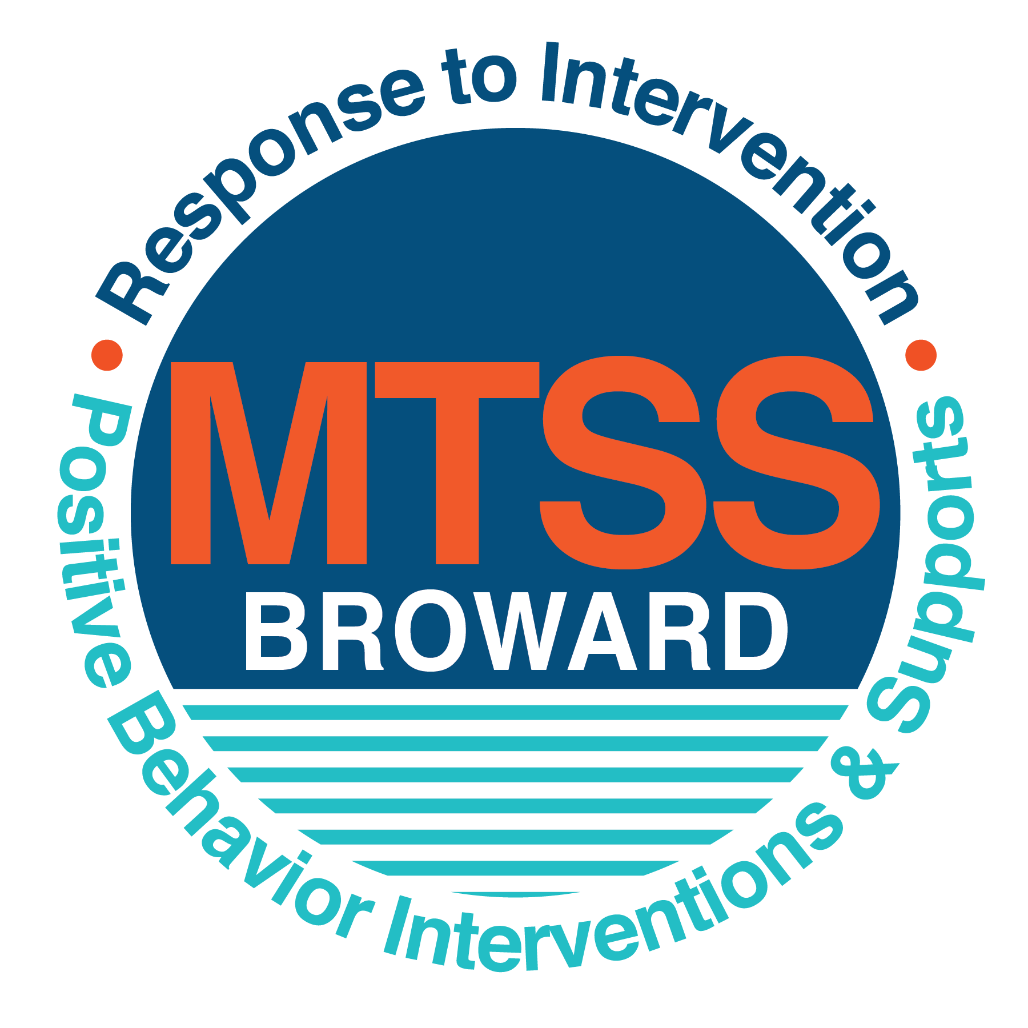
School-wide Positive Behavior Plan (SPBP)
Broward County Public Schools
To be implemented in SY 2019/20

School Name: | New River Middle School
School Number: | 0881
SPBP Contact Name: | Denise Duffus
Direct Phone Number: | 754-323-3600

CRITICAL ELEMENT # 1: Active Team with Administrative Participation

1A. Current (SY 2018/19) SPBP team members:
Full Name | Position
Lezondra Harris/ Cheryl Reep | 1. Administration
Melvin Figueroa | 2. BTU Representative
Denise Duffus | 3. SPBP Point of Contact
Brian Kelly | 4. Parent/Community Representation
Brooke Shelomith | 5. Peer Counseling Teacher
Cristine Chang | 6. Mathematics Teacher
Miroslava Rodriguez | 7. Language Arts Teacher
Mateo Garcia | 8. Science Teacher
Tony Murphy | 9. Broadcasting Teacher
Sabrine Taylor/Ivonne Hidalgo | 10. Guidance Counselor

1B. Schedule of quarterly SPBP Team Meeting dates for next 2019/20 school year:
Meeting Date | Meeting Time | Content of meetings:
8/9/2019 | 8:45 A.M. | 1. Progress of Action Steps indicated in Implementation Plan in #9  2. Collect & analyze fidelity of staff implementation data in #10A  3. Collect & analyze student outcome data in #10B
10/21/2019 | 8:45 A.M.
1/6/2020 | 8:45 A.M.
4/6/2020 | 8:45 A.M.

CRITICAL ELEMENT # 2: Faculty & Stakeholder Commitment:

2A. Action Steps completed this year (SY 2018/19) that increased faculty and stakeholder knowledge of the new SPBP:

Action Steps: | Date  (Between Jan 15 and  April 30, 2019) | Details  (Sign-in sheets in SPBP Binder)
Presented the new SPBP (for SY 2019/20) to staff | 3/22/2019 | # of participants = 80
Held a faculty vote on the new SPBP  (for SY 2019/20) | 3/22/2019 | # of participants =80  % approved =100
Presented the new SPBP (for SY 2019/20) to stakeholders (parents and community) | 4/4/2019 | # of participants = 15

2B. Action Steps to be completed next year (SY 2019/20) to increase faculty and stakeholder knowledge of the new SPBP:

Action Steps: | Date  (SY 2019-20) | Content  (Sign-in sheets in SPBP Binder)
Provide professional development on the 2019/20 SPBP for all staff | Prior to students’ 1st day:  8/12/2019 | The team will present the updates in the SPBP for the 19/20 school year. All stakeholders will be provided with access to the SPBP. Feedback will be collected for future team meetings.
Present the 2019/20 SPBP to stakeholders  (parents and community) | Prior to Oct 1st, 2019  9/5/2019
Present the behavior data to all staff quarterly | 1. 10/14/2019 | The team will present:  - the team’s progress in the Implementation Plan in # 9.  - the fidelity of staff implementation data in #10A.  - the student outcome data in #10B.
 | 2. 1/7/2020
 | 3. 3/20/2020
 | 4. 5/20/2020

CRITICAL ELEMENT # 3: School-wide Expectations

3A. Top five behavior incidents data YTD as listed in BASIS 3.0
Top 5 Behavior Incidents
1. Unruly/ Disruptive Behavior
2. Fighting Medium
3. Disobedience/ Insubordination
4. Insulting/ Obscene/ Profane Language
5. Defiance of Authority (Habitual)

3B. School-wide expectations are 3 – 5 positive characteristics (not behaviors) that counteract the demonstration of the top school-wide misbehaviors above. ALL people on campus model these expectations.
School-wide Expectations
1. Be respectful
2. Be responsible
3. Be ready to learn
4. Be reflective
5. Be resourceful

3C. At least one lesson plan for each school-wide expectation above is distributed to teachers during pre-planning SY 2019/20 and maintained in the SPBP Binder.
Dates the school-wide expectations lesson plans are taught:
 | Date(s) | Time: | Location(s):
August | 8/19/19 | 9:30 A.M. | 1st period classes
January | 1/8/20 | 9:30 A.M. | 1st period classes
After Spring Break | 4/1/20 | 9:30 A.M. | 1st period classes

CRITICAL ELEMENT #4: Location-based Rules

4A. Top three school-wide locations for Behavior Events YTD.
Top 3 Locations, not including Classroom:
School Location | # Incidents
1. Bus Loop | 77
2. Hallway | 67
3. Cafeteria | 54

4B. Expectations and Rules Chart for common areas of school campus: (next page)

Completed by each teacher | Classroom Rules
Expectations and Rules Chart | Click here to enter location. Rules | Follow the bus driver’s directions. | Keep hands and feet to yourself | Arrive on time to the bus stop or to the bus after school. | Think before you act. | Seek help from the bus driver, if needed.
 | Cafeteria Rules | Pick up trash from your table and surrounding area. | Refrain from using electronics in line, including earbuds. | Refrain from horse play. | Face one direction while seated. | Raise your hand to get the attention of an attendant.
 | Hallway Rules | Keep hands and feet to yourself. | Always walk. | Follow the arrows-Move in one direction. | Think before you act. | Seek help from the nearest adult, if needed.
 | School-wide EXPECTATIONS | Be Respectful | Be Responsible | Be Ready to Learn | Be Reflective | Be Resourceful

4C. At least one Rules lesson plan for each specific location is distributed to teachers during pre-planning SY 2019/20 and maintained in the SPBP Binder.

Dates the Locations’ Rules lesson plans are taught
 | Date(s) | Time: | Location(s):
August | 8/26/19 | 9:30 A.M. | 1st period classrooms
January | 1/13/20 | 9:30 A.M. | 1st period classrooms
After Spring Break | 4/7/20 | 9:30 A.M. | 1st period classrooms

CRITICAL ELEMENT # 5: Reward and Recognition Programs

5. The reward system is focused on one School-wide Expectation OR specific location at a time.
Expectation or Location: Being Respectful

4 Step Problem Solving Process | Plan Details
1. Problem Identification: Use your behavior data to identify one school-wide problem.  What problem did you identify? (use numerical data) | Data used: The number of incidents in the hallway totaled 67.  Problem Identification Statement: Students run and/or push to get to their next class, which causes arguments or minor altercations.
2. Problem Analysis: Why do you think this problem is occurring?  What is your goal? (use a SMART goal statement with numerical data) | Hypothesis: Students like to play in the hallway and like to be one of the first to beat the crowd trying to get down the hallway to their next class.  Goal Statement: By May of 2020, the amount of student hallway incidents will be decreased by 20%, as evidenced by the BASIS behavioral data
3. Intervention Design: Describe how you will implement a positive reward program to decrease this problem. | Type of System: Point system  Description of System: Students will receive ICU tickets when they are seen demonstrating the school-wide expectations to one another. These tickets can be exchanged weekly for various prizes. Each prize is worth a certain amount of ICU’s, so students will need to earn a certain amount to receive the prize of their choice.
4. Evaluation:  A. Implementation fidelity | - How will you monitor the fidelity (consistency and effectiveness) of the staff’s implementation of the reward program? (2-3 sentences)  Faculty must sign the ICU before giving it to students. As ICU’s are turned in, those who are collecting, can determine the amount being given and the specific faculty members dispersing them.
B. Student outcome monitoring | - How will you know if the reward program is positively impacting students? What measurable data will you use to determine “success”? (2-3 sentences)  BASIS data will be used to determine if there has been a decrease in the number of incidents in the hallway, cafeteria, and/or bus loop. The incidents in these areas, usually stem from students not being respectful towards one another.

CRITICAL ELEMENT #6: Effective Discipline Procedures

Student Behavior Discipline Flow Chart
Observe problem behavior behaviorBehavior
Intervene and redirect
Office Managed Misbehaviors
Staff Managed Misbehaviors
Call to notify office of a
crisis/safety issue
No
Yes

Implement an initial consequence
Is behavior Office Managed?
(if unsure, check below)

Specific Examples of  6 Staff Managed  Misbehaviors: | Specific Examples of  6 Office Managed  Misbehaviors:
1. Horse Playing Unruly play or behaviors that disrupt the learning environment. Includes, running, pushing, hitting, play fighting, throwing paper balls, etc.  2. Not following directions Failure to follow directives of faculty or staff. Includes, continual talking while instruction is occurring, and other continuous off task behaviors.  3. Walking around the classroom without permission. Disruption of the learning environment by being out of the assigned area of the classroom.  4. Being off task. Not doing the assigned work. Includes, talking to other students, doodling, trying to use the cell phone, etc.  5. Using the cell phone without permission. Using the cell phone without the teacher’s permission. Includes, texting, talking on the phone, playing video games, etc.  6. Eating food in class. Eating or drinking in class without permission. Includes, gum, chips, or any other food/drink items. | 1.Disobedience/Insubordination Failure to obey a reasonable or repeated instruction or request from a member of the school staff. Includes, refusing to change seats, stop playing in class, put the cell phone away, etc.  2. Disruptive/Unruly Play Unruly behavior or insubordinate conduct that interferes with or disrupts the learning environment. Includes, running, pushing, hitting, play fighting, throwing paper balls, etc.  3. Defiance of authority Refusal to go to internal suspension or leave the classroom at the request of security. Includes, having 5 instances of disobedience/insubordination during the school year.  4. Fight/Medium Mutual participation between two or more students in a physical encounter/altercation, resulting in minor injury. Includes, having to be separated by faculty/staff during the altercation.  5. Inciting a Disturbance The encouragement of confrontations or fights that cause a disruption on campus. Includes, use of electronic devices/social media to incite a disturbance, or use of racial slurs/epithets of any kind.  6. Repetitive staff managed misbehaviors More than 3 misbehaviors warrant an office referral.

CRITICAL ELEMENT # 7: Classroom Management Systems

7A. In SY 2019/20, ALL teachers implement an evidence-based Tier 1 classroom management system:
Evidence-based system: | Evidence of training:
☒ CHAMPS | 5% of teachers currently holding valid CHAMPS certificate:
☐ PBIS Classroom Management  http://www.fl-pda.org/independent/ | % of teachers currently holding completion certificate:
☐ Other: Click here to enter name of system. | Training evidence: Click here to enter evidence  % of teachers currently trained:

7B. The administration reviews and analyzes the fidelity of staff implementation of Tier 1 classroom management systems across teachers using:
☐ CHAMPs 7 Up Checklist
☐ Basic FIVE (Classroom Management Screening)
☒ PBIS Classroom Assistance Tool (CAT)
☒ Other (specify): Marzano Focus Model “Conditions for Learning”
☐ Classroom management screening is not conducted across teachers to determine appropriate professional
development. (Next year, assessment of classroom management implementation fidelity will be scored).

7C. School year 2018/19 percentage of classroom referrals:
Total number of discipline referrals from classrooms: | 465
Total number of other school-wide discipline referrals: | 304
% of referrals in the classroom: | 60%
Do more than 40% of your referrals come from the classroom? | ☒ Yes ☐ No
If >40% of discipline referrals come from the classroom, it suggests Tier 1 classroom management implementation may need to be strengthened school-wide.
If “Yes”, school-wide classroom management professional development will be conducted in 2019-20: August 2019
Other: If “Other”, indicated system here: District Offered

CRITICAL ELEMENT # 8: Data Collection and Analysis

8A. Core Effectiveness:
TOTAL Population: | 1592 | % of Total Population | Core Effectiveness
# Referrals: | # of Students:
0 - 1 referrals |  | 92% | Are your 0 – 1 referrals > 80%? | ☒Yes ☐No
2 - 5 referrals  (at risk students) | 90 | 6% | Are your 2 - 5 referrals <15%? | ☒Yes ☐No
> 5 referrals  (high risk students) | 33 | 2% | Are your >5 referrals <5%? | ☒Yes ☐No

8B. Core Effectiveness Action Steps:
If all 3 are “Yes”, your core is effective. Is your core behavior curriculum effective? | ☒Yes ☐No
Answer either (a) or (b):
(a) If you answered “Yes”, although your core is effective, what steps does your school leadership team take for early identification of at risk and high-risk students?
(b) If you answered “NO”, indicate the supports and interventions your school leadership team will implement at the beginning of the next school year to improve core strength:
Core Effectiveness Action Steps: (3-4 steps)
1. Monitor our number of referrals and specifically students who are at risk
2. Students will be discussed during our CPST meetings and follow up, throughout the year.
3. We will offer counseling by outside agencies and use behavior contracts, as needed, that are specific to individual students
4.

8C. Disproportionality within racial subgroups:
Subgroups | (PctPop - Green)  % of students | (PctRef - Blue)  % of referrals | Difference in referral composition | Positive value suggests disproportionality  (Is the value positive?)
Black | 27 | 54 | 27 | ☒Yes ☐No
Hispanic/Latin | 50 | 33 | -17 | ☐Yes ☒No
White | 19 | 10 | -9 | ☐Yes ☒No

8D. Disproportionality Action Steps:
If all three are “No”, disproportionality is not indicated. Are all 3 “No”? | ☐Yes ☒No
Answer either (a) or (b):
(a) If you answered “Yes”, although your data indicates equity, what plan does your school leadership team implement for early identification of any disproportionality issues
(b) If you answered “No”, indicate the support plan and interventions your school leadership team will implement at the beginning of next year to improve sub group disproportionality
Disproportionality Action Steps: (3-4 steps)
1. Our data indicate a disproportionality among Black students
2. To address this, teachers will have opportunism to share best practices to manage classrooms in a fair way.
3. We will provide training and resources to confront discipline in a way that is fair and unbiased. Data will be monitored monthly by PBIS facilitator.
4.

Critical Elements # 9: SPBP Implementation Planning
RED Font = Action Steps for all schools in Broward County
GREY Font = Best Practices for all schools in Broward County
TEAL Font = Resources available at https://browardcountyschools.sharepoint.com/sites/DPI6Strands/strand6/SitePages/SPBP.aspx
SPBP Team Implementation Action Plan 2019 - 2020
Month | Action Steps  ☒ check when Action Step completed
Current | ☒ Create a SPBP binder or portfolio to retain (for 2 years) hard copies of: your SPBPs, Action Plans, staff PBIS  professional development attendance, stakeholder training attendance, quarterly meeting agendas, quarterly staff  behavior presentations, voting attendance and outcome, Expectations lesson plans and Rules lesson plans
Pre-Planning  2019 | ☐ Print up your SPBP Review and school score from OSPA  ☐ Provide SPBP presentation to all staff during Pre-Planning  ☐ Disseminate the current SPBP (hard copy or electronically) to all staff and stakeholders  ☐ Market and post school-wide Expectations and location-specific Rules  ☐ Identify your district RtI Instructional Facilitator  (Contact tyyne.hogan@browardschools.com for more information, if you are unsure)  ☐ Confirm 1st team meeting date and time
August  1st meeting | ☐ Ensure schedule of quarterly meeting dates for entire year as indicated in the SPBP  ☐ Review Implementation plan; check off completed Action Steps  ☐ Determine any needed team training, such as these Brainsharks: 4 Step Problem Solving Process series, PBIS 10  Critical Elements, Data Collection, Big 5 Data, PBIS 101, etc. (All found in Sharepoint site)  ☐ Review previous year’s behavior data. (Use ‘Agenda’ Form and ‘Data Collection Template’ in Sharepoint site)  ☐ Utilize the 4 Step Problem Solving Process to initiate a Reward System for all students  ☐ Review previous year’s SPBP and feedback form; make necessary modifications  ☐ Verify and implement teaching schedule for Expectations and Rules behavior lesson plans  ☐ Present implementation data, behavior data, team activities and SPBP progress to entire staff
September | ☐ Provide SPBP stakeholder presentation prior to October 1  ☐ Check for staff and teacher understanding of PBIS - provide “PBIS 101” Brainshark as a resource  Brainshark available at: http://www.brainshark.com/browardschools/PBIS101  ☐ Ensure the Discipline Flow Chart is distributed to all staff and is being used as written
October  2nd meeting | ☐ Review Implementation plan; check off completed Action Steps  ☐ Ensure instructional staff know how to (and are, as needed) enter Tier 1 Supplemental Strategies  for behavior in BASIS  ☐ Review previous quarter’s behavior data. (Use ‘Agenda’ and ‘Data Collection Template’ in Sharepoint site)  ☐ Present implementation data, behavior data, team activities, and SPBP progress to entire staff  ☐ Ensure all teachers are using an evidence-based classroom management plan, such as CHAMPS  ☐ Ensure Core Effectiveness Action Steps are being implemented as written
November | ☐ Team to develop new and/or improved lesson plans as indicated by behavior data.  ☐ Ensure that the Disproportionality Action Steps are being implemented as written
January  2020  3rd meeting  Prepare for SY 2020/21 SPBP | ☐ Review Implementation plan; check off completed Action Steps  ☐ Staff to re-teach Expectations and Rules after winter break  ☐ Principal signs in and watches the new “SPBP for Principals” Brainshark: Due January 30th  ☐ Present implementation data, behavior data, team activities, and SPBP progress to entire staff  ☐ Choose team members and dates to work on, complete, and submit the new SPBP  ☐ Teams watch the new “SPBP Team Overview” Brainshark and refers to district resources and supports  (Brainsharks and Additional items in Sharepoint site. Webinars and in-person lab information in Team Brainshark)
February | ☐ Ensure progress towards completion of SPBP  ☐ Check on recently hired staff for PBIS understanding - provide “PBIS 101” Brainshark resource  ☐ Provide the SPBP Surveymonkey link to all staff (optional)
March  4th meeting | ☐ Ensure progress towards completion and submission of SPBP  ☐ Review Implementation plan; check off completed Action Steps  ☐ Staff to re-teach Expectations and Rules after from spring break  ☐ Provide stakeholders/parent presentation on new SPBP for next year  ☐ Provide staff presentation and faculty vote on new SPBP for next year  ☐ Present implementation data, behavior data, team activities, and SPBP progress to entire staff
April | ☐ Submit your SPBP in OSPA by April 30th every year. Use this new SPBP in the next school year  ☐ Continue implementing your current SPBP through the end of the current school year

CRITICAL ELEMENT # 10: Evaluation

10A. Staff implement the School-wide Positive Behavior Plan effectively:
“Are staff implementing the SPBP with fidelity? How do you know?”
STAFF Implementation Monitoring
Action Step | Create an observable and measurable SMART goal to determine “successful”  staff implementation of action step
School-wide expectations and location-specific rules are posted across campus | At least 10 school-wide expectations and location specific rules will be posted across campus each month, observed by Ms. Duffus
Expectations and Rules lesson plans are being taught as written and when indicated | By the end of each month, beginning in September 2019, 70% of New River Middle students would have completed a Sharks 360 lesson, as evidenced by the Sharks 360 reports, analyzed by Ms. Duffus
The Discipline flow chart is being used by all staff as written | By May of 2020, 100% of staff would have followed the school-wide discipline consequences as evidenced by use of the discipline matrix via referrals, monitored by Mrs. Reep and Mrs. Harris
A reward system is being implemented for all students | By May of 2020, 100% of staff would have used the school-wide reward system, ICU’s, to reward students, as evidenced by the amount of weekly trade-ins by students, monitored by Mrs. Shelomith.

10B. The SPBP is successful in positively impacting students:
“If staff are implementing the SPBP consistently and effectively, did it positively impact the students? How do you know?”
STUDENT Outcome Monitoring
Student Outcome Data | Create an observable and measurable SMART goal to determine  “successful” student outcomes
Behavior Incident data  (See critical element #3A) | By May 2020, there will be a 20% decrease in unruly disruptive behavior compared to the previous year, measured by ODR data collected by Ms. Duffus
Top 3 event locations data  (See critical element #4A) | By May 2020, there will be a 20% decrease in infractions in the hallway, compared to the previous year, measured by ODR data collected by Ms. Duffus.
Core effectiveness data  (See critical element #8A) | By May 2020, 5% or less students would have received 2-5 referrals, as evidenced by the behavior dashboard on BASIS, analyzed by Ms. Duffus.
Classroom referrals data  (See critical element #7C) | By May 2020, there will be a 10% decrease in classroom referrals, compared to the previous year, as evidenced by the behavior dashboard on BASIS, analyzed by Ms Duffus.

