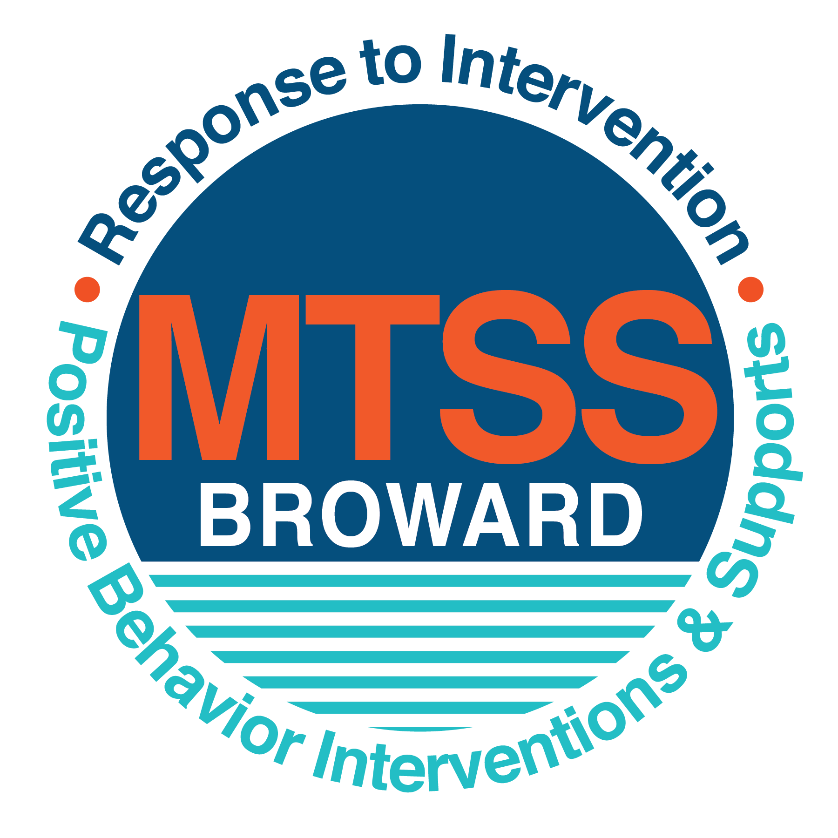

**School-wide Positive Behavior Plan (SPBP)**

Broward County Public Schools

To be implemented in SY 2018/19

**Elements have changed in the SPBP.**

Before completing, go to[**http://www.browardprevention.org/mtssrti/rtib/ →**](http://www.browardprevention.org/mtssrti/rtib/%20→)*School-wide Positive Behavior Plan* for:

* **A NEW Brainshark for Principals. ACTION: Log in with your p # and watch the Brainshark before Jan 30th.**
* **A NEW Overview Brainshark for Teams. ACTION: Log in with school name and watch the Brainshark.**
* A NEW mini Brainshark Series for teams. These Brainsharks are divided into the 10 Critical Elements of PBIS. They will

show you “how to” write a comprehensive SPBP (and receive a high score!)

* A Rating Rubric to ensure teams will correctly complete the SPBP and develop a meaningful plan.

To provide consistency across the District, *only plans entered on the current district template will be accepted*.

**ACTION: Download, complete and upload the SPBP into your School Improvement Plan before May 1, 2018:**

|  |  |
| --- | --- |
| **School Name:** | Floranada Elementary |
| **School Number:** | 0851 |
| **SPBP Contact Name:** | Josianne Valme |
| **Direct Phone Number:** | 754 322-6350 |

|  |
| --- |
| **CRITICAL ELEMENT # 1: Active Team with Administrative Participation** |

**1A.** List your current (SY 2017/18) team members (6 - 10 team members). **Must include an instructional representative from EACH grade/content area.** *Each name on this list verifies attendance in ongoing team meetings and participation in developing this SPBP. Each member is responsible for representing major stakeholders and sharing the SPBP content and updates with their respective group.*

|  |  |  |
| --- | --- | --- |
| **Full Name** | **Position** | **Who or what grade level does this member represent?** |
| John Vetter | Principal* | Administration |
| Josianne Valme | SPBP Point of Contact | Administration |
| Nate Cherson | Parent/Community Representation | SAC |
| Lauren Gordon | BTU Representative | BTU |
| Christine Chapparo | PTA president | Parents |
| Sandra Barry | Community Liaison | Community of Oakland Park/ FLL |
| Stacey Hernandez | Teacher | K-5 |
| Kristin Crunkleton | Teacher | K-5 |
| Patricia Lallande | Teacher | K-5 |
| Dena Jewett | Teacher | K-5 |
| Sergio Vuguin | Teacher | Specials |
| Ms. Prospere | Teacher | K-5 |

**1B**. Schedule and document your quarterly team meeting dates for *next* 2018/19 school year:

|  |  |  |  |
| --- | --- | --- | --- |
| **Meeting Date** | **Meeting Time** | **Name & title of person responsible to facilitate meeting** | **Content of meetings:** |
| 9/6/2018 | 5:15 pm – 6:15 pm | John Vetter, Principal | 1. Create and disseminate updated  Expectations and Rules lesson  plans (#3 and #4)  2. Review progress of  Implementation Action Plan (#9)  3. Collect & analyze implementation  data (#10A)  4. Collect & analyze student  outcome data (#10B) |
| 10/25/2018 | 8:00 am – 8:45 am | John Vetter, Principal |
| 1/7/2019 | 8:00 am – 8:45 am | John Vetter, Principal |
| 4/4/2019 | 8:00 am – 8:45 am | John Vetter, Principal |

8/14/2017

|  |
| --- |
| **CRITICAL ELEMENT # 2: Faculty & Stakeholder Commitment:** |

**2A**. Action Steps completed **this year** (SY 2017/18) that increased faculty and stakeholder understanding and knowledge of your *new* (2018/19) SPBP:

|  |  |  |  |
| --- | --- | --- | --- |
| **Action Steps:** | **Date**  *(Between Jan 15 –*  *April 30, 2018)* | **Details**  *(retain attendance sheets at school)* | **Person responsible to collect and retain attendance sheets:** |
| **Presented the 2018/19 SPBP to Staff** | 3/6/2018 | # 100 of participants = 45 | Dr. S. Lewis |
| **Held a faculty vote on the 2018/19 SPBP** | 3/23/2018 | 100% approved = 45 | Dr. S. Lewis |
| **Presented the 2018/19 SPBP to stakeholders (parents and community)** | 3/1/2018 | # of participants = 22 | Dr. S. Lewis;  A. Landley |

**2B.** Action Steps to be completed **next year** (SY 2018/19) to increase faculty and stakeholder understanding and knowledge of your SPBP:

|  |  |  |  |
| --- | --- | --- | --- |
| **Action Steps:** | **Date(s)**  *(NEXT YEAR)* | **Content**  *(retain attendance sheets at school)* | **Person responsible to collect and retain attendance sheets:** |
| Provide a professional development on the 2018/19SPBP for all staff | Prior to students’ 1st day:  8/9/2018 | The team will present the updates in the SPBP for the 18/19 school year. All stakeholders will be provided with access to the SPBP. Feedback will be collected for future team meetings. | John Vetter |
| Present the 2018/19SPBP to stakeholders (parents and community) | Prior to Oct 1st, 2018  9/6/2018 |
| Present behavior data to staff  *Quarterly: minimum of 4 each year* | 1. 8/28/2018 | The team will present the implementation data in 10A. Include:  • the “marketing” (teaching and posting) of expectations and rules  • lesson plan implementation  • discipline procedures  • reward system implementation  The team will present the student outcome data in 10B. Include:  • top 3 event locations  • type of behavior incidents  • core effectiveness data  • classroom referral data, and analysis of this data. | Josianne Valme |
| 2. 3/5/2019 |
| 3. 1/8/2019 |
| 4. 4/9/2019 |

|  |
| --- |
| **CRITICAL ELEMENT # 3: School-wide Expectations** |

**3A.** List the **top 10 behavior incidents** data YTD from BASIS 3.0 Behavior Dashboard:

|  |  |
| --- | --- |
| **Top 10 Behavior Incidents**  *(put N/A in any blank spaces)* | |
| 1.Unruly/Disruptive Behavior | 6.N/A |
| 2.Insulting/Profane/Obscene Language | 7.N/A |
| 3.Unsubstantiated Bullying | 8.N/A |
| 4.Disruptive Unruly Plan | 9.N/A |
| 5.Bullying | 10.N/A |

**3B.** Based on the behavior incidents in 3A, develop 3 – 5 **positive characteristics** *(not behaviors)* that would counteract the demonstration of these misbehaviors. These positive characteristics become your school-wide expectations.

|  |
| --- |
| **School-wide Expectations** |
| 1.Respect to self |
| 2 Respect to Others |
| 3.Respect the Environment |
| 4. |
| 5. |

**3C.** Research indicates that discipline referrals increase after long holidays and during testing times. Plan to teach your expectations at least 3 times throughout the year (and anytime the expected behaviors are not being demonstrated).

**ACTION:** Create at least one lesson plan for **each** school-wide expectation above and distribute to teachers during pre-planning 2018-19. Develop additional lesson plans you will use throughout the year to re-teach and reinforce your school-wide expectations. *You do not need to submit your lesson plans with the SPBP. Retain all behavior lesson plans at the school; make sure these lesson plans are available for guests and stakeholders.*

|  |  |  |  |
| --- | --- | --- | --- |
| **When will school-wide expectations lesson plans be taught?** | | | |
|  | Date(s) | Time: | |
| August | August 15-17, 2018 | All Day | |
| January | January 10, 2019 | 8-10:00 | |
| 4th Quarter | April 10, 2019 | 8-10:00 | |
|  | | | |
| Who will be responsible for teaching the lesson plans? | | | All staff |
| Where will the lesson plan instruction occur? | | | Classrooms |
| Who is responsible for retaining, organizing and distributing all lesson plans? | | | Classroom Teachers |

|  |
| --- |
| **CRITICAL ELEMENT #4: Location-based Rules** |

**4A.** List the **top 3 locations** for behavior Events YTD from BASIS 3.0 Behavior Dashboard**.** ***Do not use “classroom”***

|  |  |
| --- | --- |
| **Top 3 Locations** | |
| School Location | # Incidents |
| 1.Athletic field | 11 |
| 2.Cafeteria | 5 |
| 3.Hallway | 3 |

**4B.** Create an Expectations/Rules Matrix from your 3-5 school-wide expectations and your top 3 event locations. Develop a positively stated, observable, and measurable rule that correlates with every expectation to create a maximum of 5 rules under each location**.**

|  |  |  |  |  |
| --- | --- | --- | --- | --- |
| **Expectations and Rules Matrix** | | | | |
| **School-wide EXPECTATIONS** | *Copy and paste expectations from* ***3C****.* | **IDENTIFIED LOCATIONS**  *Copy and paste locations from* ***4A.*** | | |
| Athletic field | Hallway | Cafeteria |
| **Rules** | **Rules** | **Rules** |
| **Respect to Self** | Play fair game, follow rules | Help others when needed or asked. | Be complimentary and use kind words |
| **Respect to Others** | Take turns, include everyone | Work together, help each other, share | Share with others, using 6’ voice |
| **Respect the Environment** | Take care of equipment | Keep hands and backpacks of walls and bulletin boards | Keep your table, floor area clean |
|  |  |  |  |
|  |  |  |  |

**4C**. Research indicates that discipline referrals increase after long holidays and during testing times. Plan to teach your location-specific rules at least 3 times throughout the year (and anytime the expected behaviors are not being demonstrated).

**ACTION:** Create at least one lesson plan for **each** location above and distribute to teachers during pre-planning 2018-19. Develop additional lesson plans you will use throughout the year to re-teach and reinforce your location-specific rules.

*You do not need to submit your lesson plans with the SPBP. Retain all behavior lesson plans at the school; make sure these lesson plans are available for guests and stakeholders.*

|  |  |  |  |
| --- | --- | --- | --- |
| **When will location-specific rules lesson plans be taught?** | | | |
|  | Date(s) | Time: | |
| August | 8/15/2018-8/17/2018 | 8:30 a.m. | |
| January | 1/10/2019 | 8:30 a.m. | |
| 4th Quarter | 4/8/2019 | 8:30 a.m. | |
|  | | | |
| Who will be responsible for teaching the lesson plans? | | | Teachers |
| Where will the lesson plan instruction occur? | | | Classroom |
| Who is responsible for retaining, organizing and distributing all lesson plans? | | | Grade level Team Leaders |

|  |
| --- |
| **CRITICAL ELEMENT # 5: Reward and Recognition Programs** |

Although you will post, teach, review, practice and reinforce all school-wide expectations and location-specific rules, **choose 1 expectation OR 1 event location** you will target for a specific reward program for students. Based on the data that led to this expectation or location, create a reward plan using the 4 Step Problem Solving Process:

Expectation or Location: Athletic Field

|  |  |
| --- | --- |
| **4 Step Problem Solving Process** | **Plan** |
| **1. Problem Identification:** Use your behavior data to identify a school-wide problem.  What problem did you identify? *(use numerical data*  11 referrals during unstructured play | **Data used:** Location report, BASIS  **Problem Identification:**  Referrals indicate students are not following adult directions when playing on the athletic field. The misbehaviors persist after interventions such as parent contact or conference. Misbehaviors consist of hitting other students, failure to adhere to athletic field rules and displaying poor sportsmanship. |
| **2**. **Problem Analysis:** Why do you think this problem is occurring?  What is your goal? *(use a SMART goal statement with numerical data)* | **Hypothesis:**  The athletic field is less structured than a traditional classroom.  **Goal Statement:** By May 2019, the number of referrals will decrease by 20%. |
| **3. Intervention Design:**  Describehow you will implement a positive reward program to decrease this problem. | **Type of System: Positive reinforcement using “Falcon Feathers”.**  **Description of System:** *(3-4 sentences)*  Students will engage in activities to build coping skills and implement rules of fair play and sportsmanship. Students who display sportsmanship on the athletic field will be awarded and recognized with “Falcon Feathers”. Upon earning a “Falcon Feather”, the student will report to the front office where they will receive further verbal recognition by the office staff and during school wide announcements. All “Falcon Feathers” will be displayed in the front office discipline bulletin board. |
| **4. Evaluation:**  A. Implementation fidelity | 1. How do you monitor the fidelity (consistency and effectiveness) of the **staff’s** implementation of the reward program? *(2-3 sentences)*   We will monitor the fidelity of implementation by tracking the number of behavior incidents and discipline referrals entered on the Discipline Management System (DMS). We will also monitor the number of “Falcon Feathers” awarded and displayed on the office discipline bulletin board. |
| B. Student outcome monitoring | 1. How will you know if the reward program is positively impacting **students**? What measurable data will you use to determine “success”? *(2-3 sentences)*   The number of teacher referrals will decrease by at least 20% in the DMS. |

|  |
| --- |
| **CRITICAL ELEMENT #6 Effective Discipline Procedures** |

**6A. Staff Managed Misbehaviors:** List the top 6 *most common* school-wide misbehaviors **staff are expected to manage.**

Write a short, objective, and measurable definition for each.

|  |  |
| --- | --- |
| **Staff Managed Misbehaviors** | |
| Misbehavior | “Looks Like” - *provide a description with example(s)* |
| 1.Talking in class | Excessive talking without permission |
| 2.Off Task | Unfocused/off task behavior, classroom |
| 3.Disruptive type behaviors | Students not keeping their Hands, Body, and/or Objects (HBO) to themselves but causing no harm |
| 4.Cafeteria behaviors | Students not following directions, out of area, horseplay, not respecting others space etc. |
| 5.Inappropriate Language | Using words/profanity that are not acceptable at school but not directed at the teacher |
| 6.Arguing with adults, defiance | Talking back/not getting along, refusing to follow directions, move to another table |

**6B. Staff Managed Consequences**: Create a consequencemenu **OR** a consequence hierarchy for staff to use when students exhibit the above misbehaviors. Provide a minimum of **5** consequences.

|  |  |
| --- | --- |
| Is this a menu or hierarchy system? | Menu Hierarchy |
| Verbal Warning | |
| Think About it – Reflection, student conference | |
| Parent Contact | |
| In person Parent Conference, guidance referral | |
| Behavior Plan | |

**6C. Administration Managed Misbehaviors**:

(a) Define the first 3 behaviors by providing examples that clearly identify the point at which the misbehavior warrants an Office Discipline Referral (ODR).

(b) List two additional common school-wide misbehaviors that will result in an ODR. Provide concrete examples.

(c) Determine staff tolerance level for repetitive misbehaviors (the point at which the number of staff-managed misbehaviors becomes an ODR).

|  |  |
| --- | --- |
| **Office Discipline Referrals (ODRs)** | |
| Behavior | “Looks Like” - *provide a description with example(s)* |
| 1. Disobedience/Insubordination | Intentionally creating a disturbance that is stopping others from learning for more than 3 consecutive days. Refusing to follow teacher directions. |
| 2. Disruptive/unruly behavior | Forcing another to the ground and causing injury. |
| 3. Defiance of authority | Not following the directions of an adult and/or using inappropriate/defiant verbal or body language more than 3 times in one day. |
| 4. |  |
| 5. |  |
| 6. Repetitive staff managed  misbehaviors | More than **2** misbehaviors in a **WEEK** warrants an office referral. |

**6D. School-wide Discipline Flow Chart:**

(a) Review the sample discipline flow charts in “Additional Items” located on browardprevention.org

(b) Copy or customize a flow chart to graphically represent the discipline process at **your** school.

(c) Paste the flow chart here**OR** complete the flow chart below.

**Student Behavior Discipline Flow Chart**

Observe Problem Behavior

Intervene and redirect

Office Managed Misbehaviors

Staff Managed Misbehaviors

•Call to notify office of major infraction

•Write ODR

Implement an initial consequence from **6B**

Is behavior Office Managed?

*(if unsure, check below)*

|  |  |
| --- | --- |
| List Staff Managed  Misbehaviors from **6A** | List Office Managed  Misbehaviors from **6C** |
| 1.Talking excessive | 1. Disobedience/Insubordination |
| 2.Off Task behavior, classroom | 2. Disruptive/Unruly Play |
| 3.Disruptive behaviors | 3. Defiance of authority |
| 4.Playful Behavior |  |
| 5.Inappropriate Language |  |
| 6.Arguing with adults, defiance |  |

|  |
| --- |
| **CRITICAL ELEMENT # 7 : Classroom Management Systems** |

**7A.** ALL teachers implement an effective Tier 1 classroom management system:

|  |  |
| --- | --- |
| Which **evidence-based** classroom management system is supported by your school’s administration and is expected to be implemented school-wide?  *(Class Dojo, LEAPs, HERO, Cloud 9, etc. are tools,* ***not*** *classroom systems)* | CHAMPs*  PBIS Classroom Management  Administration does not expect an evidence-based classroom management system to be implemented by teachers this year  (*your school will need to adopt one next year)*  Other *(complete below)* |
| If other, name the **evidence-based classroom management system:** | CHAMPS |
| *CHAMPs is the district-supported, evidence-based universal classroom management system for all teachers. Would your Principal like to be contacted to learn about CHAMPs professional development? | Yes  No |

**7B.** Fidelity of **staff** implementation of school-wide classroom management systems

|  |
| --- |
| What data collection tool does your school leadership team use to monitor and evaluate your teacher’s classroom management skills? *(Measure* ***staff skills****, not student outcomes)* |
| CHAMPs 7 Up Checklist |
| CHAMPs Classroom Check Up (CCU) |
| PBIS Classroom Assistance Tool (CAT) |
| PBIS Walkthrough |
| Marzano’s Domain 1, Design Questions 5, 6, 7, 8, 9 |
| Fidelity of staff classroom management implementation is not monitored to determine training needs this year *(you will need to adopt a tool and plan next year)* |
| Other *(specify):* |
| Explain how this data is collected and analyzed by your school leadership team as a **universal screening** *across teachers* to determine the need for classroom management training: |
| Fidelity of Implementation Plan: *(3-4 sentences)*  Data is collected and analyzed by number of classroom referrals in BASIS and shared with individuals |

**7C. Percentage of Classroom Referrals:**

(a) Review your classroom data YTD (“Events by Location”) in BASIS 3.0 Behavior Dashboard.

(b) Complete the yellow highlighted cells first.

(c) Auto-calculate the % of referrals in the classroom by clicking on “!Zero Divide” in the next cell and pressing “Fn + F9” together.

|  |  |
| --- | --- |
| Total number of discipline referrals **from classrooms**: | 20 |
| Total number of **school-wide** discipline referrals: | 61 |
| % of referrals in the classroom: | 33% |
| Do more than 40% of your referrals come from the classroom? | Yes  No |

***If >40% of discipline referrals come from the classroom, it suggests Tier 1 classroom management implementation may need to be strengthened school-wide.***

|  |
| --- |
| **CRITICAL ELEMENT # 8: Data Collection and Analysis** |

**8A. Determine your School-wide Core Effectiveness YTD** from the BASIS Behavior Dashboard in the “Referrals per Student” chart.

(a) Complete the yellow highlighted cells first.

(b) Auto-calculate the “% of Total Population” by clicking on each “!Zero Divide” in the cells and pressing “Fn + F9”.

(c) Determine if the core is effective in all three areas

|  |  |  |  |  |
| --- | --- | --- | --- | --- |
| TOTAL Population: | 704 |  |  | |
| # Referrals |  | **% of Total Population** | Core Effectiveness | |
| 0 - 1 referral |  | 98% | Are your 0 – 1 referrals > 80%? | Yes No |
| 2 - 5 referrals  (at risk students) | 8 | 1% | Are your 2 - 5 referrals <15%? | Yes No |
| > 5 referrals  (high risk students) | 4 | 0% | Are your >5 referrals <5%? | Yes No |

**8B. Core Effectiveness Plan:**

|  |  |
| --- | --- |
| If all 3 are “**Yes**”, your core is effective. Is your core behavior curriculum effective? | Yes No |
| Answer **either** (a) or (b):  (a) If you answered “**Yes**”, although your core is effective, what plan does your school leadership team implement for early identification of at risk and high risk students?  (b) If you answered “**NO”**, indicate the supports and interventions your school leadership team will implement at the beginning of the next school year to improve core strength: | |
| Core Effectiveness Plan:  *To meet the behavioral needs of at-risk students, tier 1 teacher strategies and interventions will be implemented. Students receiving more than 2 discipline infractions and interventions will be referred to the CPST/RTI team for tier 2 intervention plan.* | |

**8C. Disproportionality: Determine if there are any issues within subgroups** from BASIS 3.0 Behavior Dashboard in the “Referrals by Demographics” chart.

(a) Complete the yellow highlighted cells first.

(b) Auto-calculate the difference by clicking on each “0” in the next cell and pressing “Fn + F9”.

|  |  |  |  |  |
| --- | --- | --- | --- | --- |
| Subgroups | (PctPop - Green)  % **of students** | (PctRef - Blue)  **% of referrals** | Difference in referral composition | Positive value suggests disproportionality  (Is the value positive?) |
| Black | 20% | 18% | 0 | Yes No |
| Hispanic/Latin | 50% | 53% | 0 | Yes No |
| White | 30% | 29% | 0 | Yes No |

**8D. Disproportionality Plan:** If any values are positive, the percentage of referrals contributed to that subgroup is higher than expected, given that subgroups’ percentage in the student population.

|  |  |
| --- | --- |
| If all 3 are “**No**”, disproportionality is not indicated. Are all 3 “No”? | Yes No |
| Answer **either** (a) or (b):  (a) If you answered “**Yes**”, although your data indicates equity, what plan does your school leadership team implement for early identification of any disproportionality issues  (b) If you answered “**No**”, indicate the support plan and interventions your school leadership team will implement at the beginning of next year to improve sub group disproportionality | |
| Disproportionality Plan: *(3-4 sentences)*  *Although our data indicates equity, students will receive early interventions and supports to build coping skills and develop positive behavior strategies.* | |

|  |
| --- |
| **Critical Elements # 9: SPBP Implementation Planning** |

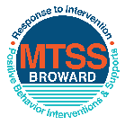This form provides a timeline to complete best practices and required actions. This timeline should drive team actions and accountability. As you implement your SPBP *NEXT* year, check off **completed items** and indicate the accountable person. (Complete only the yellow highlighted area at this time). Next year, you will upload this completed plan within your SPBP.

Required actions for all schools in Broward County

Best Practices for all schools in Broward County

**Resources**

|  |  |  |
| --- | --- | --- |
| **SPBP Team Implementation Action Plan 2018 - 2019** | | |
| **Month** | **Action Step**  *check when Action completed* | **Completed:**  Person Responsible  Name & Title |
| **Current** | **This Action Plan has been saved to use *next year* during quarterly meetings** | Dr. S. Lewis Asst. Principal |
| **Current** | **Create a SPBP binder or portfolio to retain (for 2 years) hard copies of: your SPBPs, Action Plans, staff PBIS professional development attendance, stakeholder training attendance, quarterly meeting agendas, quarterly staff behavior presentations, voting attendance and outcome, Expectation lesson plans and Rules lesson plans** | Dr. S. Lewis, A.P. |
| **Pre Planning**  **2018** | Print up your SPBP Review and school score from OSPA  Provide SPBP presentation to all staff during Pre Planning  Disseminate the current SPBP (hard copy or electronically) to all staff and stakeholders  Market and post school-wide Expectations and location-specific Rules (posters, PSAs, etc.)  Identify your RtI Instructional Facilitator provided by the district  (Contact [tyyne.hogan@browardschools.com](mailto:tyyne.hogan@browardschools.com) for more information, if you are unsure)  Confirm 1st team meeting date and time | John Vetter Principal |
| **August**  **1st meeting** | Ensure schedule of quarterly meeting dates for entire year as indicated in the SPBP  Determine any needed team training, such as the 4 Step PSP Brainshark Series, 10 Critical  Elements Brainsharks, Data Collection, Effective CPST Teams, PBIS 101, etc.  Trainings available at: <http://www.browardprevention.org/mtssrti/training-modules/>  Review previous year’s behavior data. (Use ‘Agenda’ and ‘Data Collection Template’)  Forms available at: <http://www.browardprevention.org/mtssrti/rtib> in Tier 1, Teaming  Present implementation data, behavior data, team activities and progress to entire staff  Utilize the 4 Step Problem Solving Process to develop initial interventions  Review previous year’s SPBP and feedback form  Verify and implement teaching schedule for SPBP Expectations and Rules behavior lesson plans | John Vetter, Principal |
| **September** | Provide stakeholder presentation on SPBP prior to October 1  Check for staff and teacher understanding of PBIS - provide “PBIS 101” Brainshark as a resource  Brainshark available at: http://www.brainshark.com/browardschools/PBIS101 | John Vetter, Principal |
| **October**  **2nd meeting** | Ensure instructional staff know how to (and are, as needed) enter Tier 1 Supplemental Strategies  for behavior in BASIS  Present implementation data, behavior data, team activities and progress to entire staff | John Vetter, Principal |
| **November** | Staff to re-teach Expectations and Rules first day back from break.  Team to develop new and/or improved lesson plans as indicated by behavior data. | Classroom teachers |
| **January**  **2019**  **3rd meeting**  Prepare for *2019/20* SPBP | Staff to re-teach Expectations and Rules first day back from break  Ensure the Principal signs in and watches the *new* SPBP Brainshark: Due January 30th  Present implementation data, behavior data, team activities and progress to entire staff  Choose team members and dates to work on, complete, and submit the *new* SPBP  Teams watch the *new* SPBP Brainsharks and refers to *new* “Additional items”  Brainsharks and Additional items posted at: <http://www.browardprevention.org/mtssrti/rtib> | John Vetter, Principal |
| **February** | Ensure progress towards completion of SPBP  Check on recently hired staff for PBIS understanding - provide “PBIS 101” Brainshark resource  Provide the SPBP Surveymonkey link to all staff (optional). Email [Tyyne.hogan@browardschools.com](mailto:Tyyne.hogan@browardschools.com) to request analysis. | Josianne Valme, AP |
| **March**  **4th meeting** | Ensure progress towards completion of SPBP  Provide staff presentation and vote on new SPBP for next year  Provide stakeholders/parent presentation on new SPBP for next year  Present implementation data, behavior data, team activities and progress to entire staff | Josianne Valme, AP |
| **April** | Submit your SPBP in OSPA by April 30th every year | Josianne Valme, AP |

|  |
| --- |
| **CRITICAL ELEMENT # 10: Monitoring Plans** |

**10A.** How will you determine the success **of *staff* implementation** of the School-wide Positive Behavior Plan?

*“Are* ***staff*** *implementing the SPBP with fidelity? How do you know?”*

|  |  |  |  |
| --- | --- | --- | --- |
| **Fidelity of Implementation Monitoring Plan** | | | |
| Action Step | Create an **observable** and **measureable** SMART goal to determine “successful”  **staff implementation** of action step | When will data be collected, analyzed & presented? | Person responsible to collect and analyze data |
| School-wide **expectations** and location-specific **rules** are posted across campus | 100% of the rules and expectations are posted on campus throughout the year. | Refer to **quarterly** presentation dates in 2B.  This is the data the team will be sharing during presentations. | Josianne Valme |
| **Behavior lesson plans** are being taught as written and when indicated | 100% lesson plans are being taught as being written | Classroom Teachers |
| **Discipline consequences**  and **flow chart** are being used by all staff as written | 100% of discipline consequences are being used by all staff as written | Classroom Teachers |
| A **reward system** is being implemented for *all* students | 100% a reward system is being implemented for all students | Classroom Teachers |

**10B.** How will you determine whether the SPBP is successful in positively impacting **students?**

*“If staff are implementing the SPBP consistently and effectively, did it positively impact* ***the students****? How do you know?”*

|  |  |  |  |
| --- | --- | --- | --- |
| **Student Outcome Monitoring Plan** | | | |
| Student Outcome Data | Create an **observable** and **measureable** SMART goal to determine “successful”  **student outcomes** | When will data be collected, analyzed & presented? | Person responsible to collect and analyze data |
| See critical element 3A  • Type of **behavior incidents** data | Decrease Athletic Field Level 2 Referrals by 20% every quarter. | Refer to **quarterly** presentation dates in 2B.  This is the data the team will be sharing during presentations. | Josianne Valme, AP |
| See critical element 4A  • **Top 3 event locations** data | 20% fewer referrals in the cafeteria every quarter | Josianne Valme, AP |
| See critical element 8  • **Core effectiveness** data | Decrease the number of students receiving 2-5 referrals by 20%. | Josianne Valme, AP |
| See critical element 7A  • **Grade Level/Classroom referrals** data | 20% fewer referrals in the classroom every quarter. | Josianne Valme, AP |