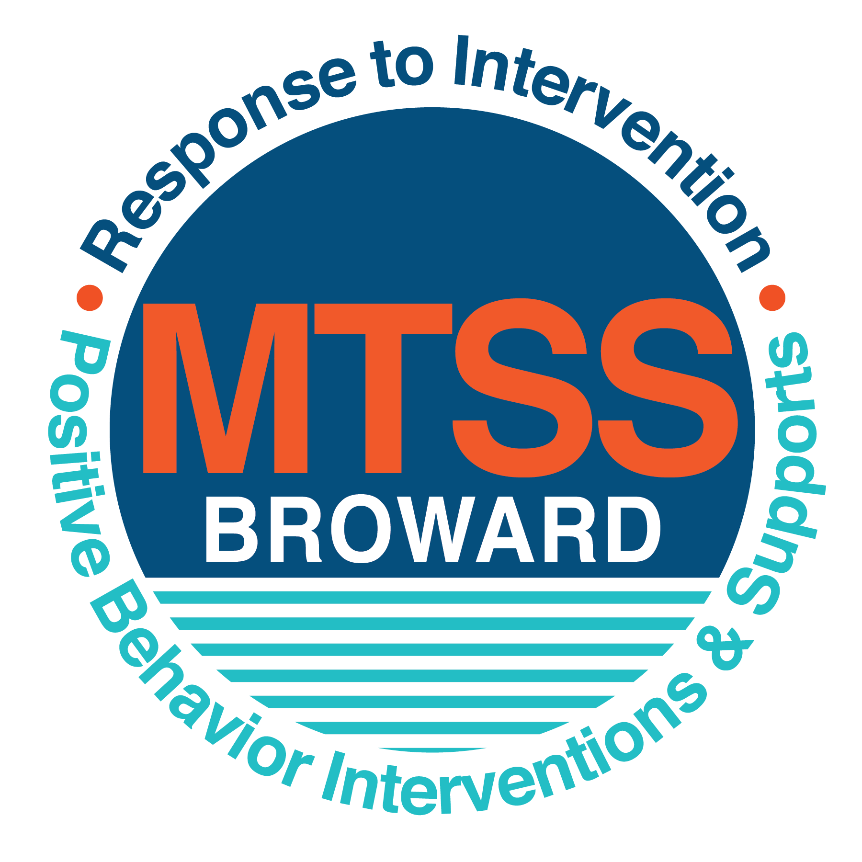
School-wide Positive Behavior Plan (SPBP)
Broward County Public Schools
To be implemented in SY 2019/20

School Name: | Floranada Elementary School
School Number: | 0851
SPBP Contact Name: | Lisa Leider
Direct Phone Number: | 754-322-6350

CRITICAL ELEMENT # 1: Active Team with Administrative Participation

1A. Current (SY 2018/19) SPBP team members:
Full Name | Position
Lisa Leider, John Vetter | 1. Administration
Dawn Whittenberg | 2. BTU Representative
Lisa Leider, AP | 3. SPBP Point of Contact
Stacey Hernandez, parent | 4. Parent/Community Representation
Maria Schwartz, Kelly Marrero | 5. PreK/Kindergarten
Dawn Whittenberg | 6. First Grade
Gina LaBarbera | 7. Second Grade
Allison Chadwick, Toni Holtel | 8. Third Grade
Vicki Curtis | 9. Fourth Grade
Danielle Murphy, Robin McGrew | 10. Fifth Grade
Sergio Vuguin | 11. Specials
Lauren Gordon | 12. Support Staff

1B. Schedule of quarterly SPBP Team Meeting dates for next 2019/20 school year:
Meeting Date | Meeting Time | Content of meetings:
9/4/2019 | 2:25 pm | 1. Progress of Action Steps indicated in Implementation Plan in #9  2. Collect & analyze fidelity of staff implementation data in #10A  3. Collect & analyze student outcome data in #10B
10/18/2019 | 10:00 am
1/6/2020 | 10:00 am
4/9/2020 | 1:00 pm

CRITICAL ELEMENT # 2: Faculty & Stakeholder Commitment:

2A. Action Steps completed this year (SY 2018/19) that increased faculty and stakeholder knowledge of the new SPBP:

Action Steps: | Date  (Between Jan 15 and  April 30, 2019) | Details  (Sign-in sheets in SPBP Binder)
Presented the new SPBP (for SY 2019/20) to staff | 4/1/2019 | # of participants = 48
Held a faculty vote on the new SPBP  (for SY 2019/20) | 4/1/2019 | # of participants = 46  % approved = 100
Presented the new SPBP (for SY 2019/20) to stakeholders (parents and community) | 4/4/2019 | # of participants = 14

2B. Action Steps to be completed next year (SY 2019/20) to increase faculty and stakeholder knowledge of the new SPBP:

Action Steps: | Date  (SY 2019-20) | Content  (Sign-in sheets in SPBP Binder)
Provide professional development on the 2019/20 SPBP for all staff | Prior to students’ 1st day:  8/7/2019 | The team will present the updates in the SPBP for the 19/20 school year. All stakeholders will be provided with access to the SPBP. Feedback will be collected for future team meetings.
Present the 2019/20 SPBP to stakeholders  (parents and community) | Prior to Oct 1st, 2019  9/5/2019
Present the behavior data to all staff quarterly | 1. 8/8/2019 | The team will present:  - the team’s progress in the Implementation Plan in # 9.  - the fidelity of staff implementation data in #10A.  - the student outcome data in #10B.
 | 2. 10/22/2019
 | 3. 1/7/2020
 | 4. 4/9/2020

CRITICAL ELEMENT # 3: School-wide Expectations

3A. Top five behavior incidents data YTD as listed in BASIS 3.0
Top 5 Behavior Incidents
- Unruly/disruptive behavior
- Disruptive campus/ minor
- Disruptive and unruly play
- Battery
- Profanity to staff

3B. School-wide expectations are 3 – 5 positive characteristics (not behaviors) that counteract the demonstration of the top school-wide misbehaviors above. ALL people on campus model these expectations.
School-wide Expectations
- Respect Yourself
- Respect Others
- Respect the Environment
4.
5.

3C. At least one lesson plan for each school-wide expectation above is distributed to teachers during pre-planning SY 2019/20 and maintained in the SPBP Binder.
Dates the school-wide expectations lesson plans are taught:
 | Date(s) | Time: | Location(s):
August | 8/14/2019 – 8/16/2019 | 9:00 am | Classrooms
January | 1/7/2020-1/10/2020 | 9:00 am | Classrooms
After Spring Break | 3/30/2020- 4/1/2020 | 9:00 am | Classrooms

CRITICAL ELEMENT #4: Location-based Rules

4A. Top three school-wide locations for Behavior Events YTD.
Top 3 Locations, not including Classroom:
School Location | # Incidents
1. Athletic field / playground | 11
2. Cafeteria | 4
3. Hallway | 4

4B. Expectations and Rules Chart for common areas of school campus: (next page)

Completed by each teacher | Classroom Rules
Expectations and Rules Chart | Athletic Field / Playground | Have a positive attitude | Keep your hands, feet and objects to yourself | Take care of equipment and be respectful to nature
 | Dining room Rules | Use table manners | Use please and thank you and consume only your food | Clean up after yourself and use walking feet
 | Hallway Rules | Use walking feet | Walk in a straight, quiet silently | Keep your hands and backpack off the wall
 | School-wide EXPECTATIONS | Respect Yourself | Respect Others | Respect the Environment

4C. At least one Rules lesson plan for each specific location is distributed to teachers during pre-planning SY 2019/20 and maintained in the SPBP Binder.

Dates the Locations’ Rules lesson plans are taught
 | Date(s) | Time: | Location(s):
August | 8/14/2019 – 8/16/2019 | 9:00 am | Classrooms
January | 1/7/2020-1/10/2020 | 9:00 am | Classrooms
After Spring Break | 3/30/2020- 4/1/2020 | 9:00 am | Classrooms

CRITICAL ELEMENT # 5: Reward and Recognition Programs

5. The reward system is focused on one School-wide Expectation OR specific location at a time.
Expectation or Location: Athletic Field

4 Step Problem Solving Process | Plan Details
1. Problem Identification: Use your behavior data to identify one school-wide problem.  What problem did you identify? (use numerical data) | Data used: Location report on DMS, BASIS  Problem Identification:  During the 2018-2019, 11 incidences occurred on the athletic field/ playground. Referrals indicate students are not following adult directions when playing on the athletic field. The misbehaviors persist after interventions and reteaching of the rules. Misbehaviors consist of inappropriate play and disruptive and unruly behavior.
2. Problem Analysis: Why do you think this problem is occurring?  What is your goal? (use a SMART goal statement with numerical data) | Hypothesis: The athletic field is less structured than a traditional classroom.  Goal Statement: By May 2020, athletic field behavior referrals will decrease by 20% from 11 incidences to less than 9 incidences.
3. Intervention Design: Describe how you will implement a positive reward program to decrease this problem. | Type of System: Positive reinforcement using “Falcon Feathers”.  Description of System: (3-4 sentences)  - Teachers will teach our positive school wide behavior plan lessons for athletic field and playground area.  - Students will engage in activities to build coping skills and implement rules of fair play and sportsmanship.  - Students who display sportsmanship on the athletic field will be awarded and recognized with “Falcon Feathers.”  - A “Falcon Feather” is a paper that looks like a feather that details the student’s name and the positive behavior they demonstrated.  - Upon earning a “Falcon Feather”, the teacher will submit the student’s “Falcon Feather” to the office.  - The next day during morning announcements, the principal will announce the name(s) of the student(s) and reason(s) for earning the “Falcon Feather.”  - Students will receive a recognition sticker to highlight their positive behavior in their teacher’s mailbox that day.  - The principal will display the “Falcon Feathers” on the “Falcon Feather” bulletin board.
4. Evaluation:  A. Implementation fidelity | - How do you monitor the fidelity (consistency and effectiveness) of the staff’s implementation of the reward program? (2-3 sentences)  - Administration will monitor the fidelity of implementation by tracking the number of behavior incidents and discipline referrals entered on the Discipline Management System (DMS).  - The SWPB Team will also monitor the number of “Falcon Feathers” awarded and displayed on the office discipline bulletin board.  - The school-wide expectation is to award a minimum of three “Falcon Feathers” per quarter.
B. Student outcome monitoring | - How will you know if the reward program is positively impacting students? What measurable data will you use to determine “success”? (2-3 sentences)  - The number of teacher referrals on the athletic field will decrease by 20%.  - The number of “Falcon Feathers” earned by students will increase by 30%.

CRITICAL ELEMENT #6: Effective Discipline Procedures

Student Behavior Discipline Flow Chart

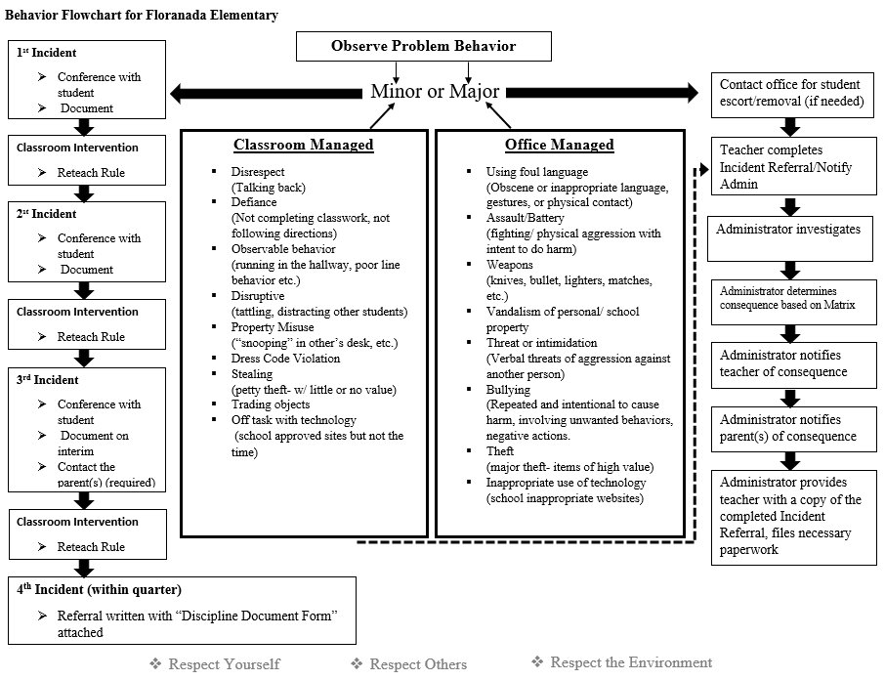

CRITICAL ELEMENT # 7: Classroom Management Systems

7A. In SY 2019/20, ALL teachers implement an evidence-based Tier 1 classroom management system:
Evidence-based system: | Evidence of training:
☐ CHAMPS | % of teachers currently holding valid CHAMPS certificate:
☐ PBIS Classroom Management  http://www.fl-pda.org/independent/ | % of teachers currently holding completion certificate:
☒ Other: 3 Rule System developed and implemented by Floranada Teachers and Staff | Training evidence: Sign-in sheet(s)  % of teachers currently trained: 100%

7B. The administration reviews and analyzes the fidelity of staff implementation of Tier 1 classroom management systems across teachers using:
☐ CHAMPs 7 Up Checklist
☐ Basic FIVE (Classroom Management Screening)
☐ PBIS Classroom Assistance Tool (CAT)
☒ Other (specify): Monthly faculty meetings, iObservation data, data chats
☐ Classroom management screening is not conducted across teachers to determine appropriate professional
development. (Next year, assessment of classroom management implementation fidelity will be scored).

7C. School year 2018/19 percentage of classroom referrals:
Total number of discipline referrals from classrooms: | 69
Total number of other school-wide discipline referrals: | 17
% of referrals in the classroom: | 25%
Do more than 40% of your referrals come from the classroom? | ☐ Yes ☒ No
If >40% of discipline referrals come from the classroom, it suggests Tier 1 classroom management implementation may need to be strengthened school-wide.
If “Yes”, school-wide classroom management professional development will be conducted in 2019-20:
Click here to choose: If “Other”, indicated system here: Click here to enter text.

CRITICAL ELEMENT # 8: Data Collection and Analysis

8A. Core Effectiveness:
TOTAL Population: | 735 | % of Total Population | Core Effectiveness
# Referrals: | # of Students:
0-1 referral | 717 | .975% | Are your 0-1 referral > 80%? | ☒Yes ☐No
2 - 5 referrals  (at risk students) | 14 | .01% | Are your 2 - 5 referrals <15%? | ☒Yes ☐No
> 5 referrals  (high risk students) | 4 | .005% | Are your >5 referrals <5%? | ☒Yes ☐No

8B. Core Effectiveness Action Steps:
If all 3 are “Yes”, your core is effective. Is your core behavior curriculum effective? | ☒Yes ☐No
Answer either (a) or (b):
(a) If you answered “Yes”, although your core is effective, what steps does your school leadership team take for early identification of at risk and high-risk students?
(b) If you answered “NO”, indicate the supports and interventions your school leadership team will implement at the beginning of the next school year to improve core strength:
Core Effectiveness Action Steps: (3-4 steps)
1. To meet the behavioral needs of at-risk students, Tier 1 teacher strategies and interventions will be implemented.
2. Student receiving 2 or more discipline referrals will be referred to the RTI team for a tier 2 intervention plan.
3. Students who are unsuccessful with their tier 2 intervention plan will be referred for a tier 3 intervention plan

8C. Disproportionality within racial subgroups:
Subgroups | (PctPop - Green)  % of students | (PctRef - Blue)  % of referrals | Difference in referral composition | Positive value suggests disproportionality  (Is the value positive?)
Black | 8% | 12% | 4% | ☐Yes ☒No
Hispanic/Latin | 35% | 28% | 7% | ☐Yes ☒No
White | 49% | 45% | 4% | ☐Yes ☒No

8D. Disproportionality Action Steps:
If all three are “No”, disproportionality is not indicated. Are all 3 “No”? | ☒Yes ☐No
Answer either (a) or (b):
(a) If you answered “Yes”, although your data indicates equity, what plan does your school leadership team implement for early identification of any disproportionality issues
(b) If you answered “No”, indicate the support plan and interventions your school leadership team will implement at the beginning of next year to improve sub group disproportionality
Disproportionality Action Steps: (3-4 steps)
1. Although our data indicates equity, students will receive early interventions and supports to build coping skills and develop positive behavior strategies.
2. By the end of quarter 1, support staff and teachers will identify at risk students and implement early interventions and support.
3. By the end of quarter 1, any students with 1 or more behavioral referrals, teachers will enter the tier 1 strategies on BASIS for behavior.
4. By the end of quarter 2, any students with 2 or more behavioral referrals will create a RTI behavior referral for the student.

Critical Elements # 9: SPBP Implementation Planning
RED Font = Action Steps for all schools in Broward County
GREY Font = Best Practices for all schools in Broward County
TEAL Font = Resources available at https://browardcountyschools.sharepoint.com/sites/DPI6Strands/strand6/SitePages/SPBP.aspx
SPBP Team Implementation Action Plan 2019 - 2020
Month | Action Steps  ☒ check when Action Step completed
Current | ☒ Create a SPBP binder or portfolio to retain (for 2 years) hard copies of: your SPBPs, Action Plans, staff PBIS  professional development attendance, stakeholder training attendance, quarterly meeting agendas, quarterly staff  behavior presentations, voting attendance and outcome, Expectations lesson plans and Rules lesson plans
Pre-Planning  2019 | ☐ Print up your SPBP Review and school score from OSPA  ☐ Provide SPBP presentation to all staff during Pre-Planning  ☐ Disseminate the current SPBP (hard copy or electronically) to all staff and stakeholders  ☐ Market and post school-wide Expectations and location-specific Rules  ☐ Identify your district RtI Instructional Facilitator  (Contact tyyne.hogan@browardschools.com for more information, if you are unsure)  ☐ Confirm 1st team meeting date and time
August  1st meeting | ☐ Ensure schedule of quarterly meeting dates for entire year as indicated in the SPBP  ☐ Review Implementation plan; check off completed Action Steps  ☐ Determine any needed team training, such as these Brainsharks: 4 Step Problem Solving Process series, PBIS 10  Critical Elements, Data Collection, Big 5 Data, PBIS 101, etc. (All found in Sharepoint site)  ☐ Review previous year’s behavior data. (Use ‘Agenda’ Form and ‘Data Collection Template’ in Sharepoint site)  ☐ Utilize the 4 Step Problem Solving Process to initiate a Reward System for all students  ☐ Review previous year’s SPBP and feedback form; make necessary modifications  ☐ Verify and implement teaching schedule for Expectations and Rules behavior lesson plans  ☐ Present implementation data, behavior data, team activities and SPBP progress to entire staff
September | ☐ Provide SPBP stakeholder presentation prior to October 1  ☐ Check for staff and teacher understanding of PBIS - provide “PBIS 101” Brainshark as a resource  Brainshark available at: http://www.brainshark.com/browardschools/PBIS101  ☐ Ensure the Discipline Flow Chart is distributed to all staff and is being used as written
October  2nd meeting | ☐ Review Implementation plan; check off completed Action Steps  ☐ Ensure instructional staff know how to (and are, as needed) enter Tier 1 Supplemental Strategies  for behavior in BASIS  ☐ Review previous quarter’s behavior data. (Use ‘Agenda’ and ‘Data Collection Template’ in Sharepoint site)  ☐ Present implementation data, behavior data, team activities, and SPBP progress to entire staff  ☐ Ensure all teachers are using an evidence-based classroom management plan, such as CHAMPS  ☐ Ensure Core Effectiveness Action Steps are being implemented as written
November | ☐ Team to develop new and/or improved lesson plans as indicated by behavior data.  ☐ Ensure that the Disproportionality Action Steps are being implemented as written
January  2020  3rd meeting  Prepare for SY 2020/21 SPBP | ☐ Review Implementation plan; check off completed Action Steps  ☐ Staff to re-teach Expectations and Rules after winter break  ☐ Principal signs in and watches the new “SPBP for Principals” Brainshark: Due January 30th  ☐ Present implementation data, behavior data, team activities, and SPBP progress to entire staff  ☐ Choose team members and dates to work on, complete, and submit the new SPBP  ☐ Teams watch the new “SPBP Team Overview” Brainshark and refers to district resources and supports  (Brainsharks and Additional items in Sharepoint site. Webinars and in-person lab information in Team Brainshark)
February | ☐ Ensure progress towards completion of SPBP  ☐ Check on recently hired staff for PBIS understanding - provide “PBIS 101” Brainshark resource  ☐ Provide the SPBP Surveymonkey link to all staff (optional)
March  4th meeting | ☐ Ensure progress towards completion and submission of SPBP  ☐ Review Implementation plan; check off completed Action Steps  ☐ Staff to re-teach Expectations and Rules after from spring break  ☐ Provide stakeholders/parent presentation on new SPBP for next year  ☐ Provide staff presentation and faculty vote on new SPBP for next year  ☐ Present implementation data, behavior data, team activities, and SPBP progress to entire staff
April | ☐ Submit your SPBP in OSPA by April 30th every year. Use this new SPBP in the next school year  ☐ Continue implementing your current SPBP through the end of the current school year

CRITICAL ELEMENT # 10: Evaluation

10A. Staff implement the School-wide Positive Behavior Plan effectively:
“Are staff implementing the SPBP with fidelity? How do you know?”
STAFF Implementation Monitoring
Action Step | Create an observable and measurable SMART goal to determine “successful”  staff implementation of action step
School-wide expectations and location-specific rules are posted across campus | By August 2019, 100% of the rules and expectations are posted throughout the campus.
Expectations and Rules lesson plans are being taught as written and when indicated | By September 2019, 100% of the lesson plans will be taught as written. These expectations will be reviewed at targeted times throughout the year.
The Discipline flow chart is being used by all staff as written | By September 2019, 100% of teachers will utilize the discipline flow chart as written.
A reward system is being implemented for all students | By September 2019, 100% of teachers will implement the school wide reward systems as written.

10B. The SPBP is successful in positively impacting students:
“If staff are implementing the SPBP consistently and effectively, did it positively impact the students? How do you know?”
STUDENT Outcome Monitoring
Student Outcome Data | Create an observable and measurable SMART goal to determine  “successful” student outcomes
Behavior Incident data  (See critical element #3A) | By May 2020, disruptive and unruly behavior incidents will decrease by 20%.
Top 3 event locations data  (See critical element #4A) | By May 2020, playground and athletic field behavior referrals will decrease by 20%.
Core effectiveness data  (See critical element #8A) | By May 2020, the number of students receiving between 2-5 referrals will decrease by 20%.
Classroom referrals data  (See critical element #7C) | By May 2020, the number of classroom referrals will decrease by 20%.

