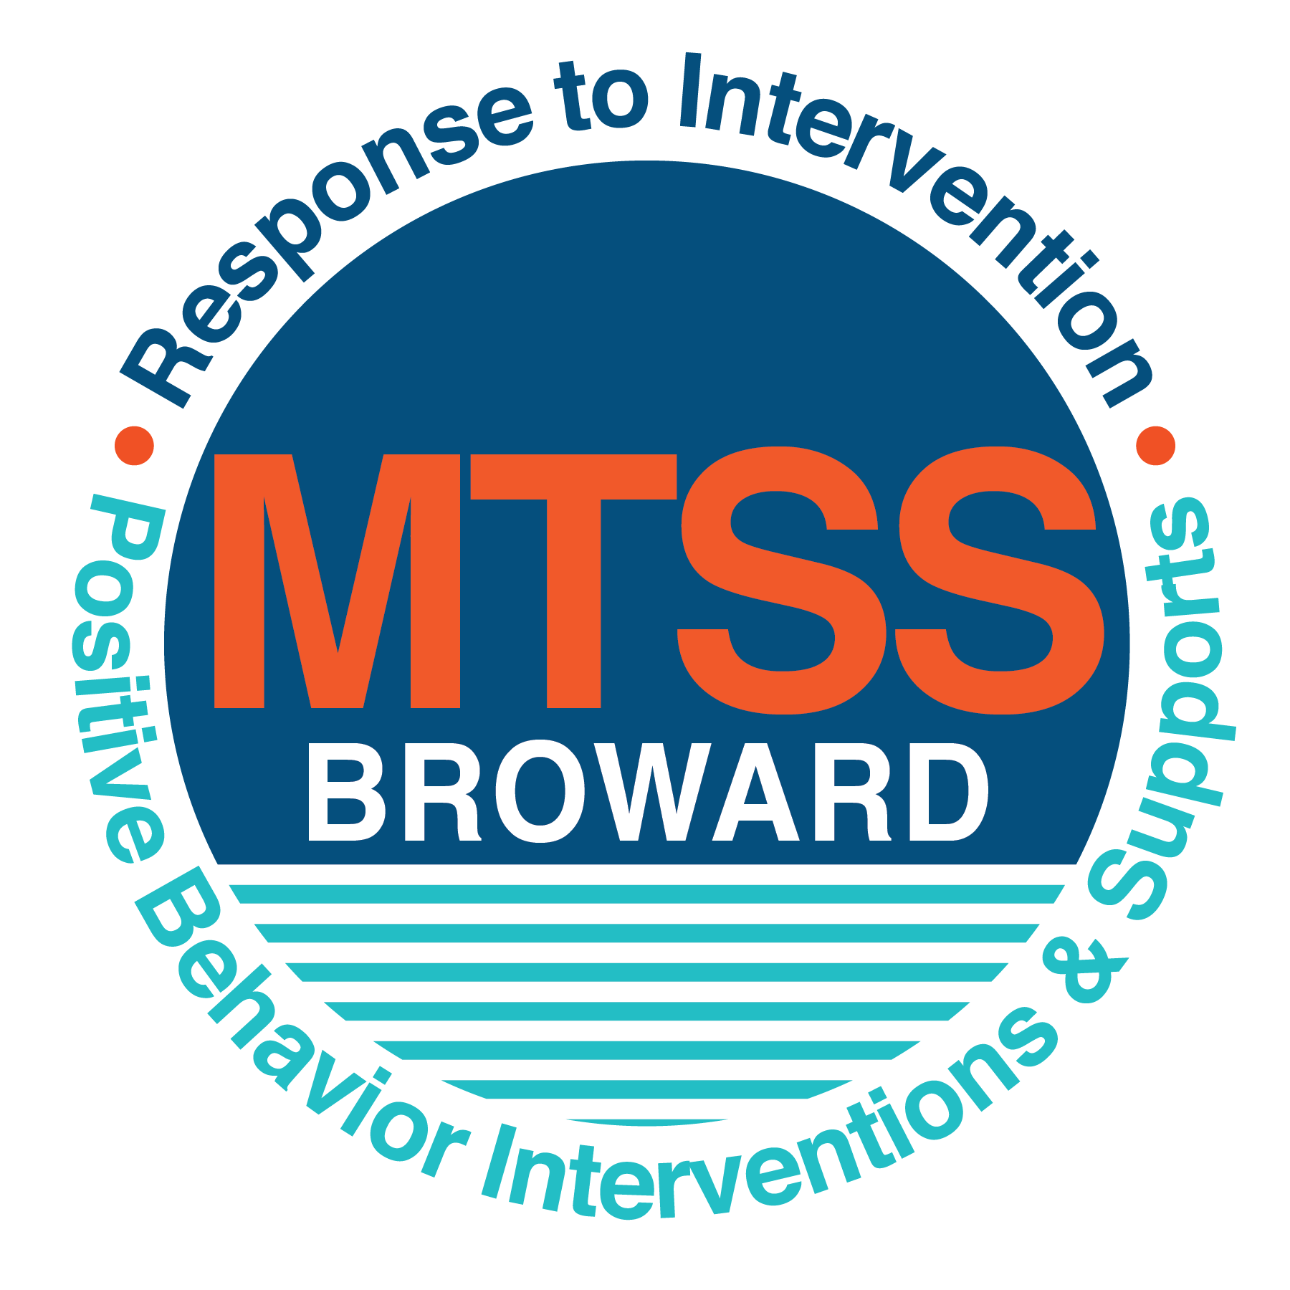

**School-wide Positive Behavior Plan (SPBP)**

Broward County Public Schools

To be implemented in SY 2018/19

**Elements have changed in the SPBP.**

Before completing, go to[**http://www.browardprevention.org/mtssrti/rtib/ →**](http://www.browardprevention.org/mtssrti/rtib/%20→)*School-wide Positive Behavior Plan* for:

* **A NEW Brainshark for Principals. ACTION: Log in with your p # and watch the Brainshark before Jan 30th.**
* **A NEW Overview Brainshark for Teams. ACTION: Log in with school name and watch the Brainshark.**
* A NEW mini Brainshark Series for teams. These Brainsharks are divided into the 10 Critical Elements of PBIS. They will

show you “how to” write a comprehensive SPBP (and receive a high score!)

* A Rating Rubric to ensure teams will correctly complete the SPBP and develop a meaningful plan.

To provide consistency across the District, *only plans entered on the current district template will be accepted*.

**ACTION: Download, complete and upload the SPBP into your School Improvement Plan before May 1, 2018:**

|  |  |
| --- | --- |
| **School Name:** | Westwood Heights Elementary |
| **School Number:** | 0631 |
| **SPBP Contact Name:** | Rohan Hanslip |
| **Direct Phone Number:** | 754-323-7900 |

|  |
| --- |
| **CRITICAL ELEMENT # 1: Active Team with Administrative Participation** |

**1A.** List your current (SY 2017/18) team members (6 - 10 team members). **Must include an instructional representative from EACH grade/content area.** *Each name on this list verifies attendance in ongoing team meetings and participation in developing this SPBP. Each member is responsible for representing major stakeholders and sharing the SPBP content and updates with their respective group.*

|  |  |  |
| --- | --- | --- |
| **Full Name** | **Position** | **Who or what grade level does this member represent?** |
| Lavina Robinson | Assistant Principal | Administration |
| Rohan Hanslip | SPBP Point of Contact/BTU Steward | Math Coach K-2/Behavior Support  Faculty |
| Jovania William | Parent/Community Representation | SAC |
| Corey Pendleton | Teacher | Grade 2 |
| Jessica Childers | ESE Specialist | K-5 |
| Freda Anderson | Social Worker | K-5 |
| Shakuanda Holt | School Psychologist | K-5 |
| Nicholas Mennecke | Instructional Coach/SAC Chair | SAC Chair/Science/Math 3-5 |
| Jennel Mayers | Instructional Coach | Reading K-5 |
| Jacquelyn Fernandez | Guidance Counselor | K-5 |
| Kay McKenzie | Para Professional | Pre-K/ BTU Steward |

**1B**. Schedule and document your quarterly team meeting dates for *next* 2018/19 school year:

|  |  |  |  |
| --- | --- | --- | --- |
| **Meeting Date** | **Meeting Time** | **Name & title of person responsible to facilitate meeting** | **Content of meetings:** |
| 10/17/2018 | 3:00pm | Rohan Hanslip – Behavior Specialist | 1. Create and disseminate updated  Expectations and Rules lesson  plans (#3 and #4)  2. Review progress of  Implementation Action Plan (#9)  3. Collect & analyze implementation  data (#10A)  4. Collect & analyze student  outcome data (#10B) |
| 12/19/2018 | 3:00pm | Lavina Robinson – Assistant Principal |
| 3/18/2019 | 3:00pm | Rohan Hanslip – Behavior Specialist |
| 5/15/2019 | 3:00pm | Lavina Robinson – Assistant Principal |

|  |
| --- |
| **CRITICAL ELEMENT # 2: Faculty & Stakeholder Commitment:** |

**2A**. Action Steps completed **this year** (SY 2017/18) that increased faculty and stakeholder understanding and knowledge of your *new* (2018/19) SPBP:

|  |  |  |  |
| --- | --- | --- | --- |
| **Action Steps:** | **Date**  *(Between Jan 15 –*  *April 30, 2018)* | **Details**  *(retain attendance sheets at school)* | **Person responsible to collect and retain attendance sheets:** |
| Presented the *new* SPBP (for SY 2018/19) to staff | 4/9/3018 | # of participants = 72 | Rohan Hanslip |
| Held a *faculty* vote on the new SPBP  (for SY 2018/19) | 4/23/2108 | % approved = 80% | Rohan Hanslip |
| Presented the *new* SPBP (for SY 2018/19) to stakeholders (parents and community) | 3/6/2018 | # of participants = 24 | Rohan Hanslip |

**2B.** Action Steps to be completed **next year** (SY 2018/19) to increase faculty and stakeholder understanding and knowledge of your SPBP:

|  |  |  |  |
| --- | --- | --- | --- |
| **Action Steps:** | **Date(s)**  *(NEXT YEAR)* | **Content**  *(retain attendance sheets at school)* | **Person responsible to collect and retain attendance sheets:** |
| Provide a professional development on the 2018/19SPBP for all staff | Prior to students’ 1st day:  8/9/2018 | The team will present the updates in the SPBP for the 18/19 school year. All stakeholders will be provided with access to the SPBP. Feedback will be collected for future team meetings. | Rohan Hanslip |
| Present the 2018/19SPBP to stakeholders (parents and community) | Prior to Oct 1st, 2018  9/11/2018 |
| Present behavior data to staff  *Quarterly: minimum of 4 each year* | 1. 10/19/2018 | The team will present the implementation data in 10A. Include:  • the “marketing” (teaching and posting) of expectations and rules  • lesson plan implementation  • discipline procedures  • reward system implementation  The team will present the student outcome data in 10B. Include:  • top 3 event locations  • type of behavior incidents  • core effectiveness data  • classroom referral data, as well as analysis of this data. | Rohan Hanslip |
| 2. 12/20/2018 |
| 3. 3/20/2019 |
| 4. 5/31/2019 |

|  |
| --- |
| **CRITICAL ELEMENT # 3: School-wide Expectations** |

**3A.** List the **top 10 behavior incidents** data YTD from BASIS 3.0 Behavior Dashboard:

|  |  |
| --- | --- |
| **Top 10 Behavior Incidents**  *(put N/A in any blank spaces)* | |
| 1. Unruly/ Disruptive Behavior | 6. Fight - Medium |
| 2. Disobedience/Insubordination | 7. Disruptive/Unruly Play |
| 3. Fight - Minor Altercation | 8. Leaving Campus |
| 4. Out of Assigned Area | 9. Weapon-Class B |
| 5. Battery | 10. Fire – Starting a Fire |

**3B.** Based on the behavior incidents in 3A, develop 3 – 5 **positive characteristics** *(not behaviors)* that would counteract the demonstration of these misbehaviors. These positive characteristics become your school-wide expectations.

|  |
| --- |
| **School-wide Expectations** |
| 1. **Respect** |
| 2. **Cooperation** |
| 3. **Safety** |
| 4. **Responsibility** |
| 5. |

**3C.** Research indicates that discipline referrals increase after long holidays and during testing times. Plan to teach your expectations at least 3 times throughout the year (and anytime the expected behaviors are not being demonstrated).

**ACTION:** Create at least one lesson plan for **each** school-wide expectation above and distribute to teachers during pre-planning 2018-19. Develop additional lesson plans you will use throughout the year to re-teach and reinforce your school-wide expectations. *You do not need to submit your lesson plans with the SPBP. Retain all behavior lesson plans at the school; make sure these lesson plans are available for guests and stakeholders.*

|  |  |  |  |
| --- | --- | --- | --- |
| **When will school-wide expectations lesson plans be taught?** | | | |
|  | Date(s) | Time: | |
| August | 15-17, 2018 | 8:00 - 9:00 | |
| January | 8-11, 20019 | 8:00 - 9:00 | |
| 4th Quarter | April 1-5, 2019 | 8:00 - 9:00 | |
|  | | | |
| Who will be responsible for teaching the lesson plans? | | | Teachers/Behavior Specialist |
| Where will the lesson plan instruction occur? | | | Classroom |
| Who is responsible for retaining, organizing and distributing all lesson plans? | | | Behavior Specialist |

|  |
| --- |
| **CRITICAL ELEMENT #4: Location-based Rules** |

**4A.** List the **top 3 locations** for behavior Events YTD from BASIS 3.0 Behavior Dashboard**.** ***Do not use “classroom”***

|  |  |
| --- | --- |
| **Top 3 Locations** | |
| School Location | # Incidents |
| 1. Athletic Field | 47 |
| 2. Hallway | 8 |
| 3.Cafeteria | 3 |

**4B.** Create an Expectations/Rules Matrix from your 3-5 school-wide expectations and your top 3 event locations. Develop a positively stated, observable, and measurable rule that correlates with every expectation to create a maximum of 5 rules under each location**.**

|  |  |  |  |  |
| --- | --- | --- | --- | --- |
| **Expectations and Rules Matrix** | | | | |
| **School-wide EXPECTATIONS** | *Copy and paste expectations from* ***3C****.* | **IDENTIFIED LOCATIONS**  *Copy and paste locations from* ***4A.*** | | |
| Athletic Field | Hallway | Cafeteria |
| **Rules** | **Rules** | **Rules** |
| Be Respectful | Wait turn to speak or use equipment | Use a level zero voice level, when walking to and from class | Clean up after yourself and place trash in the correct place |
| Be Cooperative | Work cooperatively with others | Follow directions the first time given | Follow directions the first time given |
| Be Safe | Keep hands, feet and other body parts to self | Walk in a single file on the right side always | Walk in a single file line in and out the cafeteria |
| Demonstrate Self-Control | Follow directions the first time given | Use a level zero voice level, when walking to and from class | Stay in assigned area at the table |
|  |  |  |  |

**4C**. Research indicates that discipline referrals increase after long holidays and during testing times. Plan to teach your location-specific rules at least 3 times throughout the year (and anytime the expected behaviors are not being demonstrated).

**ACTION:** Create at least one lesson plan for **each** location above and distribute to teachers during pre-planning 2018-19. Develop additional lesson plans you will use throughout the year to re-teach and reinforce your location-specific rules.

*You do not need to submit your lesson plans with the SPBP. Retain all behavior lesson plans at the school; make sure these lesson plans are available for guests and stakeholders.*

|  |  |  |  |
| --- | --- | --- | --- |
| **When will location-specific rules lesson plans be taught?** | | | |
|  | Date(s) | Time: | |
| August | 15-17, 2018 |  | |
| January | 8-11, 2019 |  | |
| 4th Quarter | April 1-5, 2019 |  | |
|  | | | |
| Who will be responsible for teaching the lesson plans? | | | Teachers |
| Where will the lesson plan instruction occur? | | | Classrooms |
| Who is responsible for retaining, organizing and distributing all lesson plans? | | | Rohan Hanslip |

|  |
| --- |
| **CRITICAL ELEMENT # 5: Reward and Recognition Programs** |

Although you will post, teach, review, practice and reinforce all school-wide expectations and location-specific rules, **choose 1 expectation OR 1 event location** you will target for a specific reward program for students. Based on the data that led to this expectation or location, create a reward plan using the 4 Step Problem Solving Process:

Expectation or Location: Athletic Field

|  |  |
| --- | --- |
| **4 Step Problem Solving Process** | **Plan** |
| **1. Problem Identification:** Use your behavior data to identify a school-wide problem.  What problem did you identify? *(use numerical data)* | Data used: (BASIS, ODRs). Number of Referrals    Problem Identification: 72 referrals were issued for unruly/disruptive behavior and 44 referrals for disobedient/insubordination. |
| **2**. **Problem Analysis:** Why do you think this problem is occurring?  What is your goal? *(use a SMART goal statement with numerical data)* | Hypothesis: The behavior is occurring because the positive behaviors are not taught and reinforced consistently.  Goal Statement: By June 2019 the number of referrals for unruly/disruptive and disobedient/insubordination behaviors will decreased by at least 10%. |
| **3. Intervention Design:**  Describehow you will implement a positive reward program to decrease this problem. | Type of System: Token system  Description of System: A ticket system will be implemented. The tickets will be called WWE Rock tickets. Tickets will be given to students who model adherence to the schoolwide expectations and rules in all locations across the campus. Students will exchange the tickets for different items from the school store (Eagle Mart). |
| **4. Evaluation:**  A. Implementation fidelity | 1. How do you monitor the fidelity (consistency and effectiveness) of the **staff’s** implementation of the reward program?   On a bi-weekly basis the behavior specialist will track the number of tickets issued by staff by recording the number of tickets redeemed each by each staff member. |
| B. Student outcome monitoring | 1. How will you know if the reward program is positively impacting **students**? What measurable data will you use to determine “success”?   A decrease in the number of referrals for the identified behaviors will indicate the effectiveness of the reward program. Data from BASIS, office directed referrals (ODRs). |

|  |
| --- |
| **CRITICAL ELEMENT #6 Effective Discipline Procedures** |

**6A. Staff Managed Misbehaviors:** List the top 6 *most common* school-wide misbehaviors **staff are expected to manage.**

Write a short, objective, and measurable definition for each.

|  |  |
| --- | --- |
| **Staff Managed Misbehaviors** | |
| Misbehavior | “Looks Like” - *provide a description with example(s)* |
| 1. Calling Out | Loud outburst/Talking out of turn  Student talks out loud without permission to speak |
| 2. Disobedience | Refuse to follow instructions or direction given by the teacher  Student continues to stand after being told to sit by the teacher. |
| 3. Hitting/Horseplay | Rough playing with another peer  Students are chasing, hitting or shoving each other |
| 4. Talking Back | When spoken to by an adult a student responds in a rude manner.  Teacher tells student to stop talking and student responds saying I’m not talking |
| 5. Out of Seat | Leaving assigned seat/area to go to another area in the classroom, on the playground and athletic field. |
| 6. Off Task | Doing something other the activity assigned by the teacher  Teacher assigns Iready but the student listens to music |

**6B. Staff Managed Consequences**: Create a consequencemenu **OR** a consequence hierarchy for staff to use when students exhibit the above misbehaviors. Provide a minimum of **5** consequences.

|  |  |
| --- | --- |
| Is this a menu or hierarchy system? | Menu Hierarchy |
| Verbal Warning | |
| Teacher/Student Conference | |
| Seat/Group Change | |
| In Class Timeout/ Reset | |
| Loss of Privileges | |
| Parent conference | |
| Reteach expectations and rules | |

**6C. Administration Managed Misbehaviors**:

(a) Define the first 3 behaviors by providing examples that clearly identify the point at which the misbehavior warrants an Office Discipline Referral (ODR).

(b) List two additional common school-wide misbehaviors that will result in an ODR. Provide concrete examples.

(c) Determine staff tolerance level for repetitive misbehaviors (the point at which the number of staff-managed misbehaviors becomes an ODR).

|  |  |
| --- | --- |
| **Office Discipline Referrals (ODRs)** | |
| Behavior | “Looks Like” - *provide a description with example(s)* |
| 1. Battery | Unwanted physical contact that results in injury needing medical attention. |
| 2. Elopement | Student runs away.  Student leaves the safe area |
| 3. Inappropriate language directed at a staff member | Student directs profane language at a staff member |
| 4. Bullying | Physical, verbal or emotional threat or abuse directed another student.  e.g. Student constantly picks on another student for no reason |
| 5. Fighting | Mutual combat |
| 6. Repetitive staff managed  misbehaviors | More than misbehaviors inwarrants an office referral.  day  one  3    *e.g., 3 half hour*  *2 one period* |

**6D. School-wide Discipline Flow Chart:**

(a) Review the sample discipline flow charts in “Additional Items” located on browardprevention.org

(b) Copy or customize a flow chart to graphically represent the discipline process at **your** school.

(c) Paste the flow chart here**OR** complete the flow chart below.

**Student Behavior Discipline Flow Chart**

Observe Problem Behavior

Intervene and redirect

Office Managed Misbehaviors

Staff Managed Misbehaviors

Implement an initial consequence from **6B**

•Call to notify office of major infraction

•Write ODR

Is behavior Office Managed?

*(if unsure, check below)*

|  |  |
| --- | --- |
| List Staff Managed  Misbehaviors from **6A** | List Office Managed  Misbehaviors from **6C** |
| Calling Out  Disobedience  Hitting/Horseplay  Talking Back  Out of Seat  Off Task | Disobedience/Insubordination  Disruptive/Unruly Play  Defiance of authority  Bullying  Fighting  Repetitive staff managed  misbehaviors |



Behavior continues

Behavior is corrected

Write referral

Contact parent

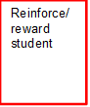

Reinforce behavior/ reward student

Reteach expectations and rules

Reteach expectations and rules

Behavior change

Behavior continues

Intervention

Additional support

Refer to counselor,

School social worker

Behavior continues-

Implement tier 2 strategies

Behavior

change

|  |
| --- |
| **CRITICAL ELEMENT # 7 : Classroom Management Systems** |

**7A.** ALL teachers implement an effective Tier 1 classroom management system:

|  |  |
| --- | --- |
| Which **evidence-based** classroom management system is supported by your school’s administration and is expected to be implemented school-wide? | CHAMPs*  PBIS Classroom Management  Administration does not expect an evidence-based classroom management system to be implemented by teachers this year  Other *(complete below)* |
| If other, name the **evidence-based classroom management system:** | Cloud9 |
| *CHAMPs is the district-supported, evidence-based universal classroom management system for all teachers. Would your Principal like to be contacted to learn about CHAMPs professional development? | Yes  No |

**7B.** Fidelity of **staff** implementation of school-wide classroom management systems

|  |
| --- |
| What data collection tool does your school leadership team use to monitor and evaluate your teacher’s classroom management skills? *(Measure* ***staff skills****, not student outcomes)* |
| CHAMPs 7 Up Checklist |
| CHAMPs Classroom Check Up (CCU) |
| PBIS Classroom Assistance Tool (CAT) |
| PBIS Walkthrough |
| Marzano’s Domain 1, Design Questions 5, 6, 7, 8, 9 |
| Fidelity of staff classroom management implementation is not monitored to determine training needs this year *(you will need to adopt a tool and plan next year)* |
| Other *(specify):* |
| Explain how this data is collected and analyzed by your school leadership team as a **universal screening** *across teachers* to determine the need for classroom management training: |
| Fidelity of Implementation Plan: Look at the number of referrals done by teacher.  Conduct walk-throughs using Marzano’s Domain 1 Element 5-9 |

**7C. Percentage of Classroom Referrals:**

(a) Review your classroom data YTD (“Events by Location”) in BASIS 3.0 Behavior Dashboard.

(b) Complete the yellow highlighted cells first.

(c) Auto-calculate the % of referrals in the classroom by clicking on “!Zero Divide” in the next cell and pressing “Fn + F9” together.

|  |  |
| --- | --- |
| Total number of discipline referrals **from classrooms**: | 76 |
| Total number of **school-wide** discipline referrals: | 183 |
| % of referrals in the classroom: | 29% |
| Do more than 40% of your referrals come from the classroom? | Yes  No |

***If >40% of discipline referrals come from the classroom, it suggests Tier 1 classroom management implementation may need to be strengthened school-wide.***

|  |
| --- |
| **CRITICAL ELEMENT # 8: Data Collection and Analysis** |

**8A. Determine your School-wide Core Effectiveness YTD** from the BASIS Behavior Dashboard in the “Referrals per Student” chart.

(a) Complete the yellow highlighted cells first.

(b) Auto-calculate the “% of Total Population” by clicking on each “!Zero Divide” in the cells and pressing “Fn + F9”.

(c) Determine if the core is effective in all three areas

|  |  |  |  |  |
| --- | --- | --- | --- | --- |
| TOTAL Population: | 687 |  |  | |
| # Referrals | 183 | **% of Total Population** | Core Effectiveness | |
| 0 - 1 referral |  | 92% | Are your 0 – 1 referrals > 80%? | Yes No |
| 2 - 5 referrals  (at risk students) | 40 | 6% | Are your 2 - 5 referrals <15%? | Yes No |
| > 5 referrals  (high risk students) | 12 | 2% | Are your >5 referrals <5%? | Yes No |

**8B. Core Effectiveness Plan:**

|  |  |
| --- | --- |
| If all 3 are “**Yes**”, your core is effective. Is your core behavior curriculum effective? | Yes No |
| Answer **either** (a) or (b):  (a) If you answered “**Yes**”, although your core is effective, what plan does your school leadership team implement for early identification of at risk and high risk students?  (b) If you answered “**NO”**, indicate the supports and interventions your school leadership team will implement at the beginning of the next school year to improve core strength: | |
| Core Effectiveness Plan: Monitoring BASIS for tier 1 strategies and the number office discipline referrals written per teacher. | |

**8C. Disproportionality: Determine if there are any issues within subgroups** from BASIS 3.0 Behavior Dashboard in the “Referrals by Demographics” chart.

(a) Complete the yellow highlighted cells first.

(b) Auto-calculate the difference by clicking on each “0” in the next cell and pressing “Fn + F9”.

|  |  |  |  |  |
| --- | --- | --- | --- | --- |
| Subgroups | (PctPop - Green)  % **of students** | (PctRef - Blue)  **% of referrals** | Difference in referral composition | Positive value suggests disproportionality  (Is the value positive?) |
| Black | 99% | 99% | 0 | Yes No |
| Hispanic/Latin | 1% | 1% | 0 | Yes No |
| White |  |  | 0 | Yes No |

**8D. Disproportionality Plan:** If any values are positive, the percentage of referrals contributed to that subgroup is higher than expected, given that subgroups’ percentage in the student population.

|  |  |
| --- | --- |
| If all 3 are “**No**”, disproportionality is not indicated. Are all 3 “No”? | Yes No |
| Answer **either** (a) or (b):  (a) If you answered “**Yes**”, although your data indicates equity, what plan does your school leadership team implement for early identification of any disproportionality issues  (b) If you answered “**No**”, indicate the support plan and interventions your school leadership team will implement at the beginning of next year to improve sub group disproportionality | |
| Disproportionality Plan: At monthly leadership team meetings review demographic data and analyze the difference in composition. | |

|  |
| --- |
| **Critical Elements # 9: SPBP Implementation Planning** |

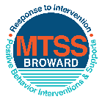This form provides a timeline to complete best practices and required actions. This timeline should drive team actions and accountability. As you implement your SPBP *NEXT* year, check off **completed items** and indicate the accountable person. (Complete only the yellow highlighted area at this time). Next year, you will upload this completed plan within your SPBP.

Required actions for all schools in Broward County

Best Practices for all schools in Broward County

**Resources**

|  |  |  |
| --- | --- | --- |
| **SPBP Team Implementation Action Plan 2018 - 2019** | | |
| **Month** | **Action Step**  *check when Action completed* | **Completed:**  Person Responsible  Name & Title |
| **Current** | **This Action Plan has been saved to use *next year* during quarterly meetings** | **Rohan Hanslip Behavior Support** |
| **Current** | **Create a SPBP binder or portfolio to retain (for 2 years) hard copies of: your SPBPs, Action Plans, staff PBIS professional development attendance, stakeholder training attendance, quarterly meeting agendas, quarterly staff behavior presentations, voting attendance and outcome, Expectation lesson plans and Rules lesson plans** | **Rohan Hanslip Behavior Support** |
| **Pre Planning**  **2018** | Print up your SPBP Review and school score from OSPA  Provide SPBP presentation to all staff during Pre Planning  Disseminate the current SPBP (hard copy or electronically) to all staff and stakeholders  Market and post school-wide Expectations and location-specific Rules (posters, PSAs, etc.)  Identify your RtI Instructional Facilitator provided by the district  (Contact [tyyne.hogan@browardschools.com](mailto:tyyne.hogan@browardschools.com) for more information, if you are unsure)  Confirm 1st team meeting date and time | Click here to enter NAME & title. |
| **August**  **1st meeting** | Ensure schedule of quarterly meeting dates for entire year as indicated in the SPBP  Determine any needed team training, such as the 4 Step PSP Brainshark Series, 10 Critical  Elements Brainsharks, Data Collection, Effective CPST Teams, PBIS 101, etc.  Trainings available at: <http://www.browardprevention.org/mtssrti/training-modules/>  Review previous year’s behavior data. (Use ‘Agenda’ and ‘Data Collection Template’)  Forms available at: <http://www.browardprevention.org/mtssrti/rtib> in Tier 1, Teaming  Present implementation data, behavior data, team activities and progress to entire staff  Utilize the 4 Step Problem Solving Process to develop initial interventions  Review previous year’s SPBP and feedback form  Verify and implement teaching schedule for SPBP Expectations and Rules behavior lesson plans | Click here to enter NAME & title |
| **September** | Provide stakeholder presentation on SPBP prior to October 1  Check for staff and teacher understanding of PBIS - provide “PBIS 101” Brainshark as a resource  Brainshark available at: http://www.brainshark.com/browardschools/PBIS101 | Click here to enter NAME & title. |
| **October**  **2nd meeting** | Ensure instructional staff know how to (and are, as needed) enter Tier 1 Supplemental Strategies  for behavior in BASIS  Present implementation data, behavior data, team activities and progress to entire staff | Click here to enter NAME & title. |
| **November** | Staff to re-teach Expectations and Rules first day back from break.  Team to develop new and/or improved lesson plans as indicated by behavior data. | Click here to enter NAME & title |
| **January**  **2019**  **3rd meeting**  Prepare for *2019/20* SPBP | Staff to re-teach Expectations and Rules first day back from break  Ensure the Principal signs in and watches the *new* SPBP Brainshark: Due January 30th  Present implementation data, behavior data, team activities and progress to entire staff  Choose team members and dates to work on, complete, and submit the *new* SPBP  Teams watch the *new* SPBP Brainsharks and refers to *new* “Additional items”  Brainsharks and Additional items posted at: <http://www.browardprevention.org/mtssrti/rtib> | Click here to enter NAME & title. |
| **February** | Ensure progress towards completion of SPBP  Check on recently hired staff for PBIS understanding - provide “PBIS 101” Brainshark resource  Provide the SPBP SurveyMonkey link to all staff (optional). Email [Tyyne.hogan@browardschools.com](mailto:Tyyne.hogan@browardschools.com) to request analysis. | Click here to enter NAME & title |
| **March**  **4th meeting** | Ensure progress towards completion of SPBP  Provide staff presentation and vote on new SPBP for next year  Provide stakeholders/parent presentation on new SPBP for next year  Present implementation data, behavior data, team activities and progress to entire staff | Click here to enter NAME & title |
| **April** | Submit your SPBP in OSPA by April 30th every year | Click here to enter NAME & title |

|  |
| --- |
| **CRITICAL ELEMENT # 10: Monitoring Plans** |

**10A.** How will you determine the success **of *staff* implementation** of the School-wide Positive Behavior Plan?

*“Are* ***staff*** *implementing the SPBP with fidelity? How do you know?”*

|  |  |  |  |
| --- | --- | --- | --- |
| **Fidelity of Implementation Monitoring Plan** | | | |
| Action Step | Create an **observable** and **measurable** SMART goal to determine “successful”  **staff implementation** of action step | When will data be collected, analyzed & presented? | Person responsible to collect and analyze data |
| School-wide **expectations** and location-specific **rules** are posted across campus | At least 80% posting of school-wide expectations and location specific rules across campus | Refer to **quarterly** presentation dates in 2B.  This is the data the team will be sharing during presentations. | Rohan Hanslip |
| **Behavior lesson plans** are being taught as written and when indicated | At least 80% of the staff are teaching the lesson plans as written and when indicated. | Rohan Hanslip |
| **Discipline consequences** and **flow chart** are being used by all staff as written | At least 80% of staff are using the discipline consequences and flow chart to consequence students for lack of adherence and adherence to school-wide expectations and rules | Rohan Hanslip |
| A **reward system** is being implemented for *all* students | At 80% of the staff are implementing the reward systems schoolwide. | Rohan Hanslip |

**10B.** How will you determine whether the SPBP is successful in positively impacting **students?**

*“If staff are implementing the SPBP consistently and effectively, did it positively impact* ***the students****? How do you know?”*

|  |  |  |  |
| --- | --- | --- | --- |
| **Student Outcome Monitoring Plan** | | | |
| Student Outcome Data | Create an **observable** and **measurable** SMART goal to determine “successful”  **student outcomes** | When will data be collected, analyzed & presented? | Person responsible to collect and analyze data |
| See critical element 3A  • Type of **behavior incidents** data | At least a 10% decrease in school-wide behavior incidents (Data to be used: BASIS) | Refer to **quarterly** presentation dates in 2B.  This is the data the team will be sharing during presentations. | Rohan Hanslip |
| See critical element 4A  • **Top 3 event locations** data | At least 10% reduction in the number of behavior incidences in all 3 event locations (Data to be used: BASIS, ODRs) | Rohan Hanslip |
| See critical element 8  • **Core effectiveness** data | Decrease in the number of referrals in all groups by at least 10% (students with 1 referral only, students with 2-5 referrals and students with greater than 5 referrals; Data to be used: BASIS, ODRs) | Rohan Hanslip |
| See critical element 7A  • **Grade Level/Classroom referrals** data | At least 80% of classroom teachers are implementing CHAMPS, PBIS Classroom Management and Cloud9 which will decrease grade level/classroom referrals by at least 10% | Rohan Hanslip |