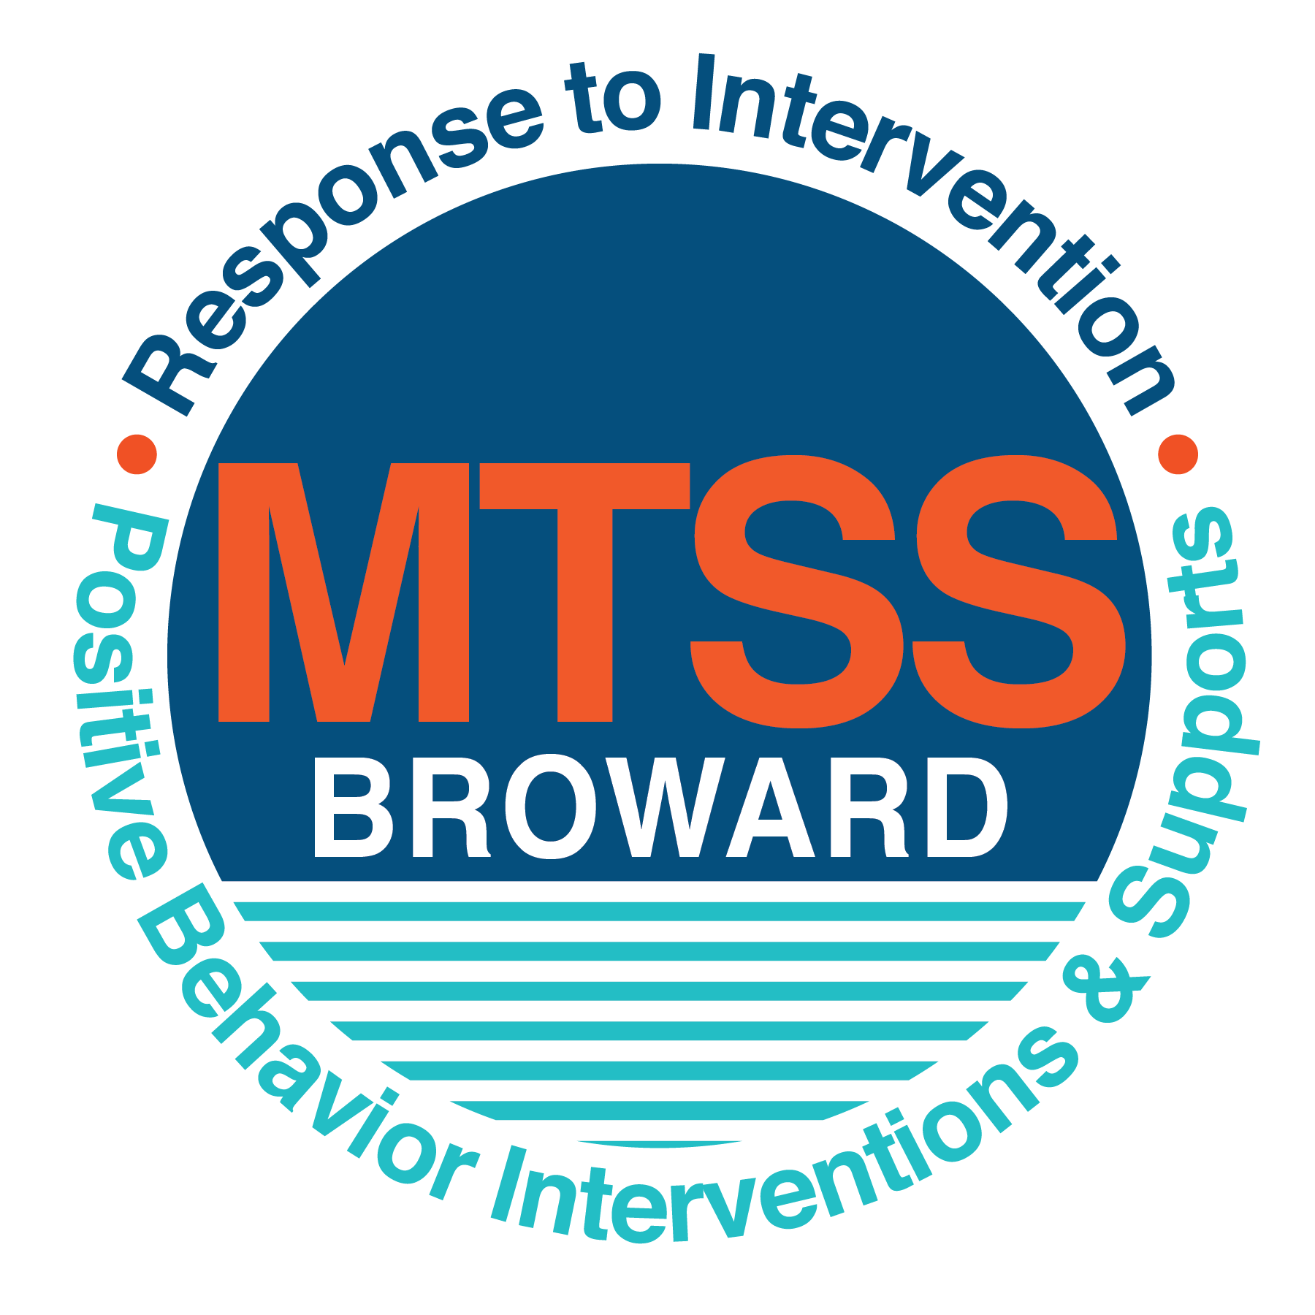
School-wide Positive Behavior Plan (SPBP)
Broward County Public Schools
To be implemented in SY 2019/20

School Name: | Sunland Park Academy
School Number: | 0611
SPBP Contact Name: | Nikia Ragin
Direct Phone Number: | 954-330-1300

CRITICAL ELEMENT # 1: Active Team with Administrative Participation

1A. Current (SY 2018/19) SPBP team members:
Full Name | Position
Sharonda Bailey | 1. Administration
Helen Kassim | 2. BTU Representative
Nikia Ragin | 3. SPBP Point of Contact
Maxine Brivitte | 4. Parent/Community Representation
Angelica Curry | 5. Guidance Counselor
Nicole Davis | 6. Literacy Coach
Latandra Carr | 7. ESE Specialist
 | 8.
 | 9.
 | 10.

1B. Schedule of quarterly SPBP Team Meeting dates for next 2019/20 school year:
Meeting Date | Meeting Time | Content of meetings:
10/17/2019 | 1:15 pm | 1. Progress of Action Steps indicated in Implementation Plan in #9  2. Collect & analyze fidelity of staff implementation data in #10A  3. Collect & analyze student outcome data in #10B
1/6/2020 | 10:00 am
3/19/2020 | 1:15 pm
5/26/2020 | 2:20 pm

CRITICAL ELEMENT # 2: Faculty & Stakeholder Commitment:

2A. Action Steps completed this year (SY 2018/19) that increased faculty and stakeholder knowledge of the new SPBP:

Action Steps: | Date  (Between Jan 15 and  April 30, 2019) | Details  (Sign-in sheets in SPBP Binder)
Presented the new SPBP (for SY 2019/20) to staff | 4/15/2019 | # of participants = 23
Held a faculty vote on the new SPBP  (for SY 2019/20) | 4/16/2019 | # of participants =48  % approved =87%
Presented the new SPBP (for SY 2019/20) to stakeholders (parents and community) | 4/23/2019 | # of participants = 15

2B. Action Steps to be completed next year (SY 2019/20) to increase faculty and stakeholder knowledge of the new SPBP:

Action Steps: | Date  (SY 2019-20) | Content  (Sign-in sheets in SPBP Binder)
Provide professional development on the 2019/20 SPBP for all staff | Prior to students’ 1st day:  8/8/2019 | The team will present the updates in the SPBP for the 19/20 school year. All stakeholders will be provided with access to the SPBP. Feedback will be collected for future team meetings.
Present the 2019/20 SPBP to stakeholders  (parents and community) | Prior to Oct 1st, 2019  9/26/2019
Present the behavior data to all staff quarterly | 1. 10/17/2019 | The team will present:  - the team’s progress in the Implementation Plan in # 9.  - the fidelity of staff implementation data in #10A.  - the student outcome data in #10B.
 | 2. 1/6/2020
 | 3. 3/19/2020
 | 4. 5/26/2020

CRITICAL ELEMENT # 3: School-wide Expectations

3A. Top five behavior incidents data YTD as listed in BASIS 3.0
Top 5 Behavior Incidents
- Unruly/Disruptive Behavior
- Disobedience/Insubordination
- Fight/Minor Altercation
- Defiance of Authority Habitual
- Disruption of Campus (Major)

3B. School-wide expectations are 3 – 5 positive characteristics (not behaviors) that counteract the demonstration of the top school-wide misbehaviors above. ALL people on campus model these expectations.
School-wide Expectations
- Be respectful to yourself and others.
- Be safe in all environments.
- Be kind to others.
- Be compliant to authority figures.
5.

3C. At least one lesson plan for each school-wide expectation above is distributed to teachers during pre-planning SY 2019/20 and maintained in the SPBP Binder.
Dates the school-wide expectations lesson plans are taught:
 | Date(s) | Time: | Location(s):
August | 8/14/2019 | 8:30 am | Classroom, with teacher
January | 1/7/2020 | 8:30 am | Classroom, with teacher
After Spring Break | 3/30/2020 | 8:30 am | Classroom, with teacher

CRITICAL ELEMENT #4: Location-based Rules

4A. Top three school-wide locations for Behavior Events YTD.
Top 3 Locations, not including Classroom:
School Location | # Incidents
1. Hallway | 12
2. Cafeteria | 5
3. Front Office | 3

4B. Expectations and Rules Chart for common areas of school campus: (next page)

Expectations and Rules Chart |  |  |  | To be completed by classroom teachers
School-wide EXPECTATIONS | Hallway Rules | Cafeteria Rules | Front Office Rules | Classroom Rules
Be respectful to others | Walk on the right side of the hallway at all times | Always pick up your trash from the table and floor | Use quiet voices (level 1) when entering the office
Be safe in all environments | Always keep your hands and feet to yourself while walking | Listen when someone makes an announcement on the microphone | Remain at back office seats, away from the front door
Be kind to others | Give appropriate space (one square) while walking in a line behind someone | Eat only what is on your tray | Greet others as they enter the office
Be compliant to all authority figures | Follow staff directives the first time given | Always wait for your teacher’s name to be called before leaving your seat | Follow staff directives the first time given

4C. At least one Rules lesson plan for each specific location is distributed to teachers during pre-planning SY 2019/20 and maintained in the SPBP Binder.

Dates the Locations’ Rules lesson plans are taught
 | Date(s) | Time: | Location(s):
August | 8/14/2019 | 8:30 am | Classroom and cafeteria
January | 1/7/2020 | 8:30 am | Classroom and cafeteria
After Spring Break | 3/30/2020 | 8:30 am | Classroom and cafeteria

CRITICAL ELEMENT # 5: Reward and Recognition Programs

5. The reward system is focused on one School-wide Expectation OR specific location at a time.
Expectation or Location: __Be respectful to yourself and others_______________________________

4 Step Problem Solving Process | Plan Details
1. Problem Identification: Use your behavior data to identify one school-wide problem.  What problem did you identify? (use numerical data) | Data used: DMS (Behavior Dashboard)  Problem Identification Statement: Of the 12 incidents occurring in the hallway, 8 of those incidents were for unruly/disruptive (our top behavior incident).
2. Problem Analysis: Why do you think this problem is occurring?  What is your goal? (use a SMART goal statement with numerical data) | Hypothesis: When students are transitioning in the hallway, behaviors tend to become disruptive.  Goal Statement: By June 2020, Sunland Park Academy students will have less than 5 incidents of unruly/disruptive behavior while transitioning in the hallway.
3. Intervention Design: Describe how you will implement a positive reward program to decrease this problem. | Type of System: Point system  Description of System: (≥ 5 sentences)  As students transition in the hallway, they will receive points from staff. If they are displaying proper hallway expectations, an observing staff member will actively compliment the class. Each compliment the class receives as they transition will equate to one point earned. Classes transition 5-7 times daily. Classes who earn 3 points daily will be recognized weekly on the announcements. Biweekly celebrations will be awarded to classes who have earned at least 50 points during that time period. Students running errands on the buddy system can also earn points for their class if they receive compliments while in the hallway.
4. Evaluation:  A. Implementation fidelity | - How will you monitor the fidelity (consistency and effectiveness) of the staff’s implementation of the reward program? (2-3 sentences)  Staff members must send AP a weekly list of the compliments. Effectiveness and consistency is monitored based on teacher participation and submission of points/hallway compliments.
B. Student outcome monitoring | - How will you know if the reward program is positively impacting students? What measurable data will you use to determine “success”? (2-3 sentences)  The reward program will be considered effective once 80% of classes consistently receive weekly acknowledgement on the morning announcements, meaning they have met their daily goal for appropriate behavior while in the hallway.

CRITICAL ELEMENT #6: Effective Discipline Procedures

Student Behavior Discipline Flow Chart
Observe problem behavior behaviorBehavior
Intervene and redirect
Office Managed Misbehaviors
Staff Managed Misbehaviors
Call to notify office of a
crisis/safety issue
No
Yes

Implement an initial consequence
Is behavior Office Managed?
(if unsure, check below)

Specific Examples of  6 Staff Managed  Misbehaviors: | Specific Examples of  6 Office Managed  Misbehaviors:
-Excessive Talking  -Calling out  -Refusal of Work  -Not following directions  -Back Talk | -Extreme horseplay  -Refusal of staff consequence  -Fighting/hitting
Warning
Warning/ Courtesy Call to parent

Administrator processes referral based on DMS
Courtesy parent call before consequence
Classroom timeout
Out of classroom timeout
Lunch detention/ Loss of privilege
CRITICAL ELEMENT # 7: Classroom Management Systems

7A. In SY 2019/20, ALL teachers implement an evidence-based Tier 1 classroom management system:
Evidence-based system: | Evidence of training:
☐ CHAMPS | % of teachers currently holding valid CHAMPS certificate:
☐ PBIS Classroom Management  http://www.fl-pda.org/independent/ | % of teachers currently holding completion certificate:
☒ Other: Sanford Harmony | Training evidence: Individual Certificate  % of teachers currently trained: 100%

7B. The administration reviews and analyzes the fidelity of staff implementation of Tier 1 classroom management systems across teachers using:
☐ CHAMPs 7 Up Checklist
☐ Basic FIVE (Classroom Management Screening)
☐ PBIS Classroom Assistance Tool (CAT)
☒ Other (specify):Quarterly DMS data is differentiated by teacher and grade levels and reviewed with teacher at data chat.
☐ Classroom management screening is not conducted across teachers to determine appropriate professional
development. (Next year, assessment of classroom management implementation fidelity will be scored).

7C. School year 2018/19 percentage of classroom referrals:
Total number of discipline referrals from classrooms: | 46
Total number of other school-wide discipline referrals: | 27
% of referrals in the classroom: | 63%
Do more than 40% of your referrals come from the classroom? | ☒ Yes ☐ No
If >40% of discipline referrals come from the classroom, it suggests Tier 1 classroom management implementation may need to be strengthened school-wide.
If “Yes”, school-wide classroom management professional development will be conducted in 2019-20:
CHAMPS Overview (80% teachers have certificate) If “Other”, indicated system here: Click here to enter text.

CRITICAL ELEMENT # 8: Data Collection and Analysis

8A. Core Effectiveness:
TOTAL Population: | 322 | % of Total Population | Core Effectiveness
# Referrals: | # of Students:
0 - 1 referrals |  | 94% | Are your 0 – 1 referrals > 80%? | ☒Yes ☐No
2 - 5 referrals  (at risk students) | 11 | .03% | Are your 2 - 5 referrals <15%? | ☒Yes ☐No
> 5 referrals  (high risk students) | 2 | .006% | Are your >5 referrals <5%? | ☒Yes ☐No

8B. Core Effectiveness Action Steps:
If all 3 are “Yes”, your core is effective. Is your core behavior curriculum effective? | ☒Yes ☐No
Answer either (a) or (b):
(a) If you answered “Yes”, although your core is effective, what steps does your school leadership team take for early identification of at risk and high-risk students?
(b) If you answered “NO”, indicate the supports and interventions your school leadership team will implement at the beginning of the next school year to improve core strength:
Core Effectiveness Action Steps: (3-4 steps)
1. Team minutes are submitted in which teachers identify at risk and high-risk students.
2. Administration, guidance, and support team members serve on lunch duty to identify potential at-risk students.
3. RtI team meets weekly to discuss potential at-risk students.
4. Social worker pulls groups of students who have been identified as emotional and/or disruptive.

8C. Disproportionality within racial subgroups:
Subgroups | (PctPop - Green)  % of students | (PctRef - Blue)  % of referrals | Difference in referral composition | Positive value suggests disproportionality  (Is the value positive?)
Black | 95 | 96 | +1% | ☒Yes ☐No
Hispanic/Latin | 5 | 5 | 0 | ☒Yes ☐No
White | 0 | 0 | 0 | ☒Yes ☐No

8D. Disproportionality Action Steps:
If all three are “No”, disproportionality is not indicated. Are all 3 “No”? | ☐Yes ☒No
Answer either (a) or (b):
(a) If you answered “Yes”, although your data indicates equity, what plan does your school leadership team implement for early identification of any disproportionality issues
(b) If you answered “No”, indicate the support plan and interventions your school leadership team will implement at the beginning of next year to improve sub group disproportionality
Disproportionality Action Steps: (3-4 steps)
1. Hold additional behavior data meetings.
2. Present more behavior data to parent representatives at SAC meetings.
3. Seek mentors for students.
4.

Critical Elements # 9: SPBP Implementation Planning
RED Font = Action Steps for all schools in Broward County
GREY Font = Best Practices for all schools in Broward County
TEAL Font = Resources available at https://browardcountyschools.sharepoint.com/sites/DPI6Strands/strand6/SitePages/SPBP.aspx
SPBP Team Implementation Action Plan 2019 - 2020
Month | Action Steps  ☒ check off Action Step when completed
Current | ☐ Create a SPBP binder or portfolio to retain (for 2 years) hard copies of: your SPBPs, Action Plans, staff PBIS  professional development attendance, stakeholder training attendance, quarterly meeting agendas, quarterly staff  behavior presentations, voting attendance and outcome, Expectations lesson plans and Rules lesson plans
Pre-Planning  2019 | ☐ Print up your SPBP Review and school score from OSPA  ☐ Provide SPBP presentation to all staff during Pre-Planning  ☐ Disseminate the current SPBP (hard copy or electronically) to all staff and stakeholders  ☐ Market and post school-wide Expectations and location-specific Rules  ☐ Identify your district RtI Instructional Facilitator  (Contact tyyne.hogan@browardschools.com for more information, if you are unsure)  ☐ Confirm 1st team meeting date and time
August  1st meeting | ☐ Ensure schedule of quarterly meeting dates for entire year as indicated in the SPBP  ☐ Review Implementation plan; check off completed Action Steps  ☐ Determine any needed team training, such as these Brainsharks: 4 Step Problem Solving Process series, PBIS 10  Critical Elements, Data Collection, Big 5 Data, PBIS 101, etc. (All found in Sharepoint site)  ☐ Review previous year’s behavior data. (Use ‘Agenda’ Form and ‘Data Collection Template’ in Sharepoint site)  ☐ Utilize the 4 Step Problem Solving Process to initiate a Reward System for all students  ☐ Review previous year’s SPBP and feedback form; make necessary modifications  ☐ Verify and implement teaching schedule for Expectations and Rules behavior lesson plans  ☐ Present implementation data, behavior data, team activities and SPBP progress to entire staff
September | ☐ Provide SPBP stakeholder presentation prior to October 1  ☐ Check for staff and teacher understanding of PBIS - provide “PBIS 101” Brainshark as a resource  Brainshark available at: http://www.brainshark.com/browardschools/PBIS101  ☐ Ensure the Discipline Flow Chart is distributed to all staff and is being used as written
October  2nd meeting | ☐ Review Implementation plan; check off completed Action Steps  ☐ Ensure instructional staff know how to (and are, as needed) enter Tier 1 Supplemental Strategies  for behavior in BASIS  ☐ Review previous quarter’s behavior data. (Use ‘Agenda’ and ‘Data Collection Template’ in Sharepoint site)  ☐ Present implementation data, behavior data, team activities, and SPBP progress to entire staff  ☐ Ensure all teachers are using an evidence-based classroom management plan, such as CHAMPS  ☐ Ensure Core Effectiveness Action Steps are being implemented as written
November | ☐ Team to develop new and/or improved lesson plans as indicated by behavior data.  ☐ Ensure that the Disproportionality Action Steps are being implemented as written
January  2020  3rd meeting  Prepare for SY 2020/21 SPBP | ☐ Review Implementation plan; check off completed Action Steps  ☐ Staff to re-teach Expectations and Rules after winter break  ☐ Principal signs in and watches the new “SPBP for Principals” Brainshark: Due January 30th  ☐ Present implementation data, behavior data, team activities, and SPBP progress to entire staff  ☐ Choose team members and dates to work on, complete, and submit the new SPBP  ☐ Teams watch the new “SPBP Team Overview” Brainshark and refers to district resources and supports  (Brainsharks and Additional items in Sharepoint site. Webinars and in-person lab information in Team Brainshark)
February | ☐ Ensure progress towards completion of SPBP  ☐ Check on recently hired staff for PBIS understanding - provide “PBIS 101” Brainshark resource  ☐ Provide the SPBP Surveymonkey link to all staff (optional)
March  4th meeting | ☐ Ensure progress towards completion and submission of SPBP  ☐ Review Implementation plan; check off completed Action Steps  ☐ Staff to re-teach Expectations and Rules after from spring break  ☐ Provide stakeholders/parent presentation on new SPBP for next year  ☐ Provide staff presentation and faculty vote on new SPBP for next year  ☐ Present implementation data, behavior data, team activities, and SPBP progress to entire staff
April | ☐ Submit your SPBP in OSPA by April 30th every year. Use this new SPBP in the next school year  ☐ Continue implementing your current SPBP through the end of the current school year

CRITICAL ELEMENT # 10: Evaluation

10A. Staff implement the School-wide Positive Behavior Plan effectively:
“Are staff implementing the SPBP with fidelity? How do you know?”
STAFF Implementation Monitoring
Action Step | Create an observable and measurable SMART goal to determine “successful”  staff implementation of action step
School-wide expectations and location-specific rules are posted across campus | By August 2019, expectations and goals will be posted in 100% of common areas (hallways, specials classes, cafeteria, media center, front office).
Expectations and Rules lesson plans are being taught as written and when indicated | At each quarterly lesson plan check, 95% of staff will have evidence of behavior lessons being taught and reviewed. Quarterly walkthrough data will show that 95% of teachers have taught behavior lessons.
The Discipline flow chart is being used by all staff as written | 100% of office referrals will be processed only after teachers have evidence of using all hierarchy of consequences from the discipline flow chart.
A reward system is being implemented for all students | By December 2019, 100% of classes would have received incentives from being acknowledged by staff members.

10B. The SPBP is successful in positively impacting students:
“If staff are implementing the SPBP consistently and effectively, did it positively impact the students? How do you know?”
STUDENT Outcome Monitoring
Student Outcome Data | Create an observable and measurable SMART goal to determine  “successful” student outcomes
Behavior Incident data  (See critical element #3A) | By June 2020, Unruly/Disruptive referrals will decrease by 25%, from 36 to 27 incidents occurring.
Top 3 event locations data  (See critical element #4A) | By June 2020, Hallway referrals will decrease from 12 to less than 5.
Core effectiveness data  (See critical element #8A) | At each quarterly behavior meeting, our core data will be greater than 80%.
Classroom referrals data  (See critical element #7C) | At each quarterly meeting, data will show that classroom referrals will decrease by 10% from the previous quarter.

