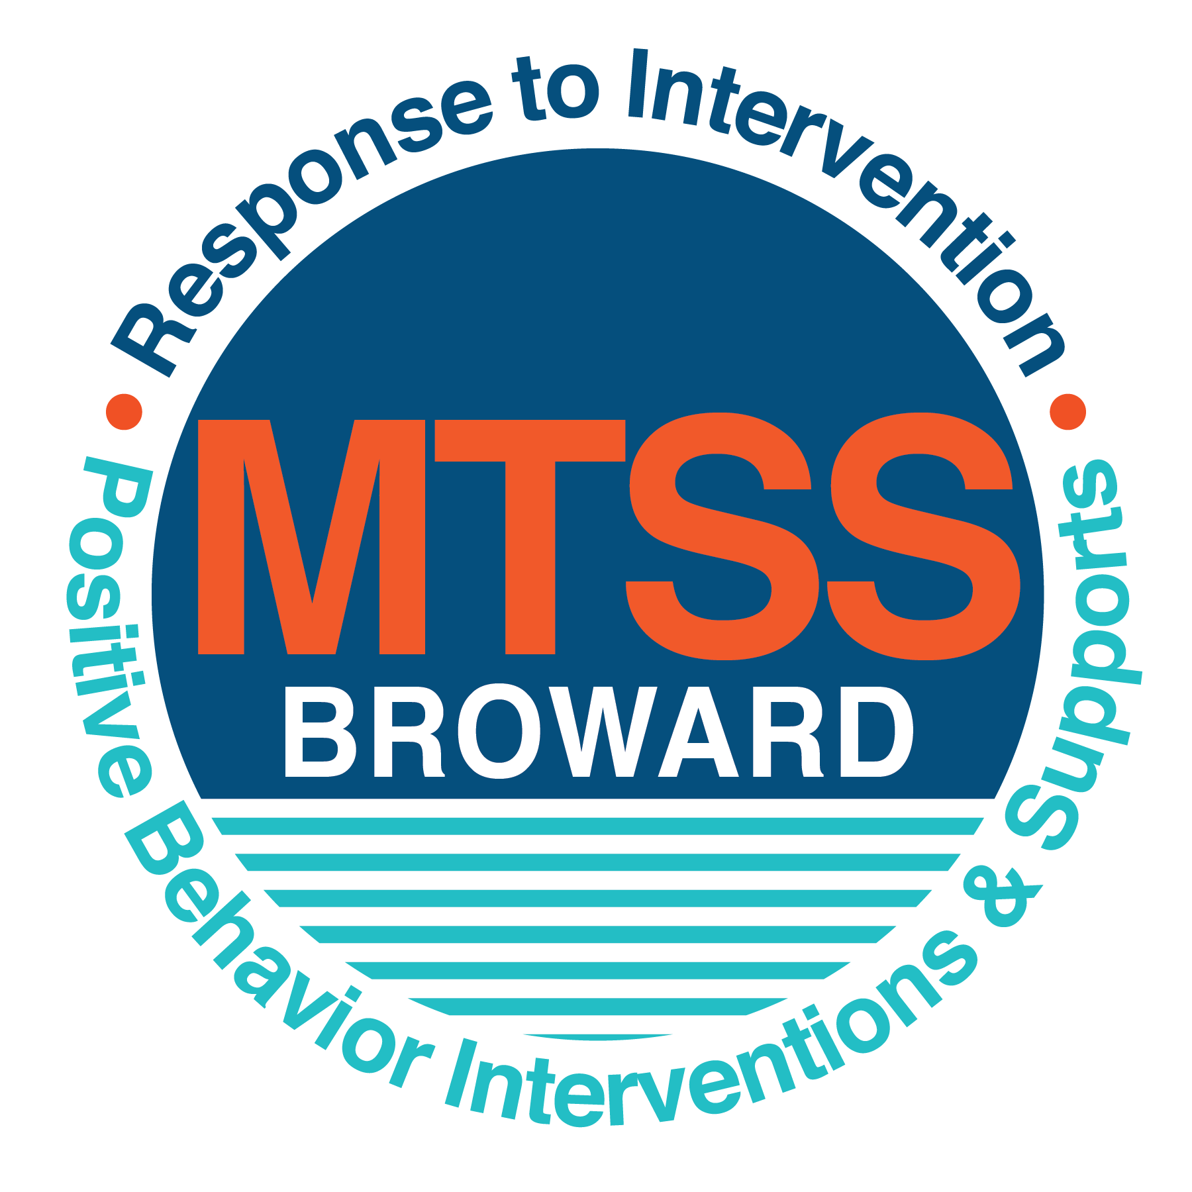
School-wide Positive Behavior Plan (SPBP)
Broward County Public Schools
To be implemented in SY 2018/19

Elements have changed in the SPBP.
Before completing, go to http://www.browardprevention.org/mtssrti/rtib/ → School-wide Positive Behavior Plan for:

- A NEW Brainshark for Principals. ACTION: Log in with your p # and watch the Brainshark before Jan 30th.
- A NEW Overview Brainshark for Teams. ACTION: Log in with school name and watch the Brainshark.
- A NEW mini Brainshark Series for teams. These Brainsharks are divided into the 10 Critical Elements of PBIS. They will
show you “how to” write a comprehensive SPBP (and receive a high score!)
- A Rating Rubric to ensure teams will correctly complete the SPBP and develop a meaningful plan.

To provide consistency across the District, only plans entered on the current district template will be accepted.
ACTION: Download, complete and upload the SPBP into your School Improvement Plan before May 1, 2018:

School Name: | Watkins Elementary
School Number: | 0511
SPBP Contact Name: | Shereen R. Reynolds & Michelle Patrovani
Direct Phone Number: | 754 323 7800

CRITICAL ELEMENT # 1: Active Team with Administrative Participation

1A. List your current (SY 2017/18) team members (6 - 10 team members). Must include an instructional representative from EACH grade/content area. Each name on this list verifies attendance in ongoing team meetings and participation in developing this SPBP. Each member is responsible for representing major stakeholders and sharing the SPBP content and updates with their respective group.
Full Name | Position | Who or what grade level does this member represent?
Shereen R. Reynolds | Assistant Principal | Administration
Shereen R. Reynolds  Michelle Patrovani | SPBP Point of Contact | Administration & ESE
Keosha Barry | Parent/Community Representation | SAC
Donna Ford | BTU Representative | Grade 4
Lurleen McCogg | Teacher | Kindergarten
Tanya Cherasard | Teacher | Grade 1
Shawony Russell | Teacher | Grade 2
Amanda Schenberger | Teacher | Grade 3
Ebony Harden | Teacher | Grade 5
Michelle Patrovani | Teacher | ESE

1B. Schedule and document your quarterly team meeting dates for next 2018/19 school year:
Meeting Date | Meeting Time | Name & title of person responsible to facilitate meeting | Content of meetings:
September 13, 2018 | 8:00 am to 2:30 p.m. | Shereen R. Reynolds,  Assistant Principal | 1. Create and disseminate updated  Expectations and Rules lesson  plans (#3 and #4)  2. Review progress of  Implementation Action Plan (#9)  3. Collect & analyze implementation  data (#10A)  4. Collect & analyze student  outcome data (#10B)
November 15, 2018. | 8:00 am to 2:30 p.m. | Michelle Patrovani  Teacher
February 7, 2019 | 8:00 am to 2:30 p.m. | Michelle Patrovani  Teacher
May 22, 2019 | 8:00 am to 2:30 p.m. | Michelle Patrovani  Teacher

CRITICAL ELEMENT # 2: Faculty & Stakeholder Commitment:

2A. Action Steps completed this year (SY 2017/18) that increased faculty and stakeholder understanding and knowledge of your new (2018/19) SPBP:
Action Steps: | Date  (Between Jan 15 –  April 30, 2018) | Details  (retain attendance sheets at school) | Person responsible to collect and retain attendance sheets:
Presented the new SPBP (for SY 2018/19) to staff | April 24, 2018 | # of participants = 40 | Shereen Reynolds
Held a faculty vote on the new SPBP  (for SY 2018/19) | April 26, 2018 | % approved = 86% | Shereen Reynolds
Presented the new SPBP (for SY 2018/19) to stakeholders (parents and community) | April 26, 2018 | # of participants = 10 | Shereen Reynolds

2B. Action Steps to be completed next year (SY 2018/19) to increase faculty and stakeholder understanding and knowledge of your SPBP:
Action Steps: | Date(s)  (NEXT YEAR) | Content  (retain attendance sheets at school) | Person responsible to collect and retain attendance sheets:
Provide a professional development on the 2018/19 SPBP for all staff | Prior to students’ 1st day:  August 8, 2018. | The team will present the updates in the SPBP for the 18/19 school year. All stakeholders will be provided with access to the SPBP. Feedback will be collected for future team meetings. | S. Reynolds &  M. Patrovani
Present the 2018/19 SPBP to stakeholders (parents and community) | Prior to Oct 1st, 2018  September 26, 2018 |  | S. Reynolds &  M. Patrovani
Present behavior data to staff  Quarterly: minimum of 4 each year | 1. August 8, 2018 | The team will present the implementation data in 10A. Include:  • the “marketing” (teaching and posting) of expectations and rules  • lesson plan implementation  • discipline procedures  • reward system implementation  The team will present the student outcome data in 10B. Include:  • top 3 event locations  • type of behavior incidents  • core effectiveness data  • classroom referral data, as well as analysis of this data. | S. Reynolds &  M. Patrovani
 | 2. October 25, 2018 |  | S. Reynolds &  M. Patrovani
 | 3. December 20, 2018 |  | S. Reynolds &  M. Patrovani
 | 4. April 11, 2019 |  | S. Reynolds &  M. Patrovani

CRITICAL ELEMENT # 3: School-wide Expectations

3A. List the top 10 behavior incidents data YTD from BASIS 3.0 Behavior Dashboard:
Top 10 Behavior Incidents
(put N/A in any blank spaces)
1. Unruly, disruptive behavior. | 6. Battery.
2. Fight, minor. | 7. Vandalism, damage to property < $1000.00.
3. Disobedience/Insubordination. | 8. Disruptive, unruly play.
4. Defiance of Authority, habitual | 9. Petty theft, < $100.00.
5. Disruption on campus, minor. | 10. Bus violations.

3B. Based on the behavior incidents in 3A, develop 3 – 5 positive characteristics (not behaviors) that would counteract the demonstration of these misbehaviors. These positive characteristics become your school-wide expectations.
School-wide Expectations
1. Respect for yourself and others, show kindness.
2. Own your choices.
3. A positive attitude.
4. Responsibility.
5.

3C. Research indicates that discipline referrals increase after long holidays and during testing times. Plan to teach your expectations at least 3 times throughout the year (and anytime the expected behaviors are not being demonstrated).
ACTION: Create at least one lesson plan for each school-wide expectation above and distribute to teachers during pre-planning 2018-19. Develop additional lesson plans you will use throughout the year to re-teach and reinforce your school-wide expectations. You do not need to submit your lesson plans with the SPBP. Retain all behavior lesson plans at the school; make sure these lesson plans are available for guests and stakeholders.
When will school-wide expectations lesson plans be taught?
 | Date(s) | Time:
August | Friday, August 17, 2018 | 8:30 a.m.
January | Wednesday, January 9, 2019 | 8:30 a.m.
4th Quarter | Wednesday, April 3, 2019 | 8:30 a.m.
Who will be responsible for teaching the lesson plans? |  |  | Classroom Teachers & Specials Teachers
Where will the lesson plan instruction occur? |  |  | Classrooms & Common Areas
Who is responsible for retaining, organizing and distributing all lesson plans? |  |  | S. Reynolds & M. Patrovani

CRITICAL ELEMENT #4: Location-based Rules

4A. List the top 3 locations for behavior Events YTD from BASIS 3.0 Behavior Dashboard. Do not use “classroom”
Top 3 Locations
School Location | # Incidents
1.Cafeteria | 14
2.Hallway | 14
3.Playground | 7

4B. Create an Expectations/Rules Matrix from your 3-5 school-wide expectations and your top 3 event locations. Develop a positively stated, observable, and measurable rule that correlates with every expectation to create a maximum of 5 rules under each location.
Expectations and Rules Matrix
School-wide EXPECTATIONS | Copy and paste expectations from 3C. | IDENTIFIED LOCATIONS  Copy and paste locations from 4A.
School-wide EXPECTATIONS | Copy and paste expectations from 3C. | Location #1: Hallway | Location #2: Cafeteria | Location #3: School Grounds
School-wide EXPECTATIONS | Copy and paste expectations from 3C. | Rules | Rules | Rules
School-wide EXPECTATIONS | Expectation #1  Be Respectful | Keep hands, feet and objects to yourself. Listen to safety patrols & adults. | Follow directions given by adults. | Keep hands, feet and objects to yourself.
School-wide EXPECTATIONS | Expectation #2  Ownership | Accept consequences for your actions calmly. | Demonstrate  self-control | Demonstrate self-control.  Accept consequences for your actions calmly.
School-wide EXPECTATIONS | Expectation #3  Positive Attitude | Stand tall and smile when approached by adults or peers. | Use a level 1 voice and kind and respectful words. | Play cooperatively.  Use kind words.
School-wide EXPECTATIONS | Expectation #4  Be Responsible | Face forward, walking with hands clasped behind your back. | Stay in assigned seat. | Be safe.  Share equipment.
4C. Research indicates that discipline referrals increase after long holidays and during testing times. Plan to teach your location-specific rules at least 3 times throughout the year (and anytime the expected behaviors are not being demonstrated).
ACTION: Create at least one lesson plan for each location above and distribute to teachers during pre-planning 2018-19. Develop additional lesson plans you will use throughout the year to re-teach and reinforce your location-specific rules.
You do not need to submit your lesson plans with the SPBP. Retain all behavior lesson plans at the school; make sure these lesson plans are available for guests and stakeholders.
When will location-specific rules lesson plans be taught?
 | Date(s) | Time:
August | Friday, August 17, 2018 | 8:30 a.m.
January | Wednesday, January 9, 2019 | 8:30 a.m.
4th Quarter | Wednesday, April 3, 2019 | 8:30 a.m.
Who will be responsible for teaching the lesson plans? |  |  | Classroom Teachers & Specials Teachers
Where will the lesson plan instruction occur? |  |  | Classrooms & Common Areas
Who is responsible for retaining, organizing and distributing all lesson plans? |  |  | Reynolds & Patrovani

CRITICAL ELEMENT # 5: Reward and Recognition Programs

Although you will post, teach, review, practice and reinforce all school-wide expectations and location-specific rules, choose 1 expectation OR 1 event location you will target for a specific reward program for students. Based on the data that led to this expectation or location, create a reward plan using the 4 Step Problem Solving Process:

Expectation or Location: Cafeteria

4 Step Problem Solving Process | Plan
1. Problem Identification: Use your behavior data to identify a school-wide problem.  What problem did you identify? (use numerical data) | Data used: 97 incidents of unruly and disruptive behavior  Problem Identification: Students are disrespectful to adults and peers.
2. Problem Analysis: Why do you think this problem is occurring?  What is your goal? (use a SMART goal statement with numerical data) | Hypothesis: Students lack social and emotional skills to navigate conflict in a positive manner.  Goal Statement: Unruly and disruptive incidents will decrease by 50% by March 2019.
3. Intervention Design: Describe how you will implement a positive reward program to decrease this problem. | Type of System: HERO,  Description of System: ROAR points are issued when students demonstrate respectful behavior. HERO data collection system will be used to track students and accumulated points.
4. Evaluation:  A. Implementation fidelity | - Administration utilizes monthly usage reports from HERO.
B. Student outcome monitoring | - Administration will monitor the number and frequency of points issued to students. A reduction in ODR’s for unruly / disruptive behavior, disobedience, insubordination and defiance.

CRITICAL ELEMENT #6 Effective Discipline Procedures

6A. Staff Managed Misbehaviors: List the top 6 most common school-wide misbehaviors staff are expected to manage.
Write a short, objective, and measurable definition for each.
Staff Managed Misbehaviors
Misbehavior | “Looks Like” - provide a description with example(s)
1. Verbal Outbursts | Student had an unprovoked verbal outburst lasting less than 90 seconds.
2.Throwing Objects | Student throws an object across the room, no contact with another individual.
3.Causing unwanted distractions | Student engaging in behavior resulting in a minor distraction for other students.
4.Failure to be in assigned location. | Student required one verbal prompt in order to move to assigned location.
5. Use of inappropriate language | Student used profanity/sexual innuendo in at least one instance.
6. Failure to follow instructions by faculty or staff. | Students failed to follow instructions, given in at least two instances.

6B. Staff Managed Consequences: Create a consequence menu OR a consequence hierarchy for staff to use when students exhibit the above misbehaviors. Provide a minimum of 5 consequences.
Is this a menu or hierarchy system? | X Menu ☐Hierarchy
Verbal Warning
Change color / clip down
Home note
Phone call home
Lunch detention to be served in the cafeteria or with administrator.

6C. Administration Managed Misbehaviors:
(a) Define the first 3 behaviors by providing examples that clearly identify the point at which the misbehavior warrants an Office Discipline Referral (ODR).
(b) List two additional common school-wide misbehaviors that will result in an ODR. Provide concrete examples.
(c) Determine staff tolerance level for repetitive misbehaviors (the point at which the number of staff-managed misbehaviors becomes an ODR).
Office Discipline Referrals (ODRs)
Behavior | “Looks Like” - provide a description with example(s)
1. Disobedience/Insubordination | Leaving the classroom without permission and refusing to follow staff directives.
2. Disruptive/Unruly Play | Hitting / pushing peers without harmful intent and escalating from play to conflict.
3. Defiance of authority | Student refuses to follow staff directives, the first time given.
4. Fighting - minor | Unwanted physical contact resulting in none to minor injury.
5. Battery | An unprovoked physical attack resulting in injury requiring first aid by the school nurse or medical professional.
6. Repetitive staff managed  misbehaviors | More than misbehaviors in warrants an office referral.  2  one  4 hour period

6D. School-wide Discipline Flow Chart:
(a) Review the sample discipline flow charts in “Additional Items” located on browardprevention.org
(b) Copy or customize a flow chart to graphically represent the discipline process at your school.
(c) Paste the flow chart here OR complete the flow chart below.

Is the behavior considered office managed?
Is the behavior a crisis?
Is the behavior a referral?
Staff observes misbehavior
in the classroom or on campus
Is the behavior considered staff managed?
Is the behavior moderate?
Immediately contact Administration.
Implement minor consequence(s)
Implement moderate consequence(s)

Behavior is corrected
Observe behaviors for positive outcomes
Reinforce/
reward student
Complete referral and send to the office with a messenger.
Behavior is not corrected
Begin tracking behaviors to determine if Office Referral needed.
Consult Elementary Discipline Matrix or appropriate district resource to determine consequence / outcome.
Process referral
Is the behavior minor?
Reteach rules and expectations
Begin tracking behaviors to determine if moderate consequences are needed

CRITICAL ELEMENT # 7 : Classroom Management Systems

7A. ALL teachers implement an effective Tier 1 classroom management system:
Which evidence-based classroom management system is supported by your school’s administration and is expected to be implemented school-wide?  (Class Dojo, LEAPs, HERO, Cloud 9, etc. are tools, not classroom systems) | X CHAMPs*  X PBIS Classroom Management  ☐ Administration does not expect an evidence-based classroom management system to be implemented by teachers this year  (your school will need to adopt one next year)  ☐ Other (complete below)
If other, name the evidence-based classroom management system: | Click here to enter name of system.
*CHAMPs is the district-supported, evidence-based universal classroom management system for all teachers. Would your Principal like to be contacted to learn about CHAMPs professional development? | ☐ Yes X No

7B. Fidelity of staff implementation of school-wide classroom management systems
What data collection tool does your school leadership team use to monitor and evaluate your teacher’s classroom management skills? (Measure staff skills, not student outcomes)
☐ CHAMPs 7 Up Checklist
☐ CHAMPs Classroom Check Up (CCU)
☐ PBIS Classroom Assistance Tool (CAT)
☐ PBIS Walkthrough
X Marzano’s Domain 1, Design Questions 5, 6, 7, 8, 9
☐ Fidelity of staff classroom management implementation is not monitored to determine training needs this year (you will need to adopt a tool and plan next year)
X Other: Data from PBIS Coach walk through, analysis of Office discipline Referrals
Explain how this data is collected and analyzed by your school leadership team as a universal screening across teachers to determine the need for classroom management training: Data is dis-aggregated and analyzed to determine professional development needs.
Fidelity of Implementation Plan: Data will be collected and analyzed by Administration for adherence to the plan. Lack of fidelity will result in teacher conversation and may lead to further action.

7C. Percentage of Classroom Referrals:
(a) Review your classroom data YTD (“Events by Location”) in BASIS 3.0 Behavior Dashboard.
(b) Complete the yellow highlighted cells first.
(c) Auto-calculate the % of referrals in the classroom by clicking on “!Zero Divide” in the next cell and pressing “Fn + F9” together.
Total number of discipline referrals from classrooms: | 51
Total number of school-wide discipline referrals: | 102
% of referrals in the classroom: | 33%
Do more than 40% of your referrals come from the classroom? | ☐ Yes X No
If >40% of discipline referrals come from the classroom, it suggests Tier 1 classroom management implementation may need to be strengthened school-wide.

CRITICAL ELEMENT # 8: Data Collection and Analysis

8A. Determine your School-wide Core Effectiveness YTD from the BASIS Behavior Dashboard in the “Referrals per Student” chart.
(a) Complete the yellow highlighted cells first.
(b) Auto-calculate the “% of Total Population” by clicking on each “!Zero Divide” in the cells and pressing “Fn + F9”.
(c) Determine if the core is effective in all three areas
TOTAL Population: | 560
# Referrals |  | % of Total Population | Core Effectiveness
0 - 1 referral |  | 96% | Are your 0 – 1 referrals > 80%? | X Yes ☐No
2 - 5 referrals  (at risk students) | 17 | 3% | Are your 2 - 5 referrals <15%? | X Yes ☐No
> 5 referrals  (high risk students) | 4 | 1% | Are your >5 referrals <5%? | X Yes ☐No

8B. Core Effectiveness Plan:
If all 3 are “Yes”, your core is effective. Is your core behavior curriculum effective? | X Yes ☐No
Answer either (a) or (b):
(a) If you answered “Yes”, although your core is effective, what plan does your school leadership team implement for early identification of at risk and high risk students?
(b) If you answered “NO”, indicate the supports and interventions your school leadership team will implement at the beginning of the next school year to improve core strength:
Core Effectiveness Plan: ODR’s are monitored for frequency, students with multiple ODR’s are observed by the Leadership Team and teachers. These students are then referred to CPST

8C. Disproportionality: Determine if there are any issues within subgroups from BASIS 3.0 Behavior Dashboard in the “Referrals by Demographics” chart.
(a) Complete the yellow highlighted cells first.
(b) Auto-calculate the difference by clicking on each “0” in the next cell and pressing “Fn + F9”.
Subgroups | (PctPop - Green)  % of students | (PctRef - Blue)  % of referrals | Difference in referral composition | Positive value suggests disproportionality  (Is the value positive?)
Black | 83 | 89 | 6 | X Yes ☐No
Hispanic/Latin | 9 | 6 | -3 | Yes X No
White | 4 | 4 | 0 | X Yes ☐No

8D. Disproportionality Plan: If any values are positive, the percentage of referrals contributed to that subgroup is higher than expected, given that subgroups’ percentage in the student population.
If all 3 are “No”, disproportionality is not indicated. Are all 3 “No”? | ☐Yes X No
Answer either (a) or (b):
(a) If you answered “Yes”, although your data indicates equity, what plan does your school leadership team implement for early identification of any disproportionality issues
(b) If you answered “No”, indicate the support plan and interventions your school leadership team will implement at the beginning of next year to improve sub group disproportionality
Disproportionality Plan: Black males are involved in the 5000 Role Model Program partnering them with positive community members. SEL curriculum is also utilized school wide and Cloud 9 for home school connections.

Critical Elements # 9: SPBP Implementation Planning

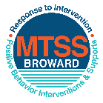
This form provides a timeline to complete best practices and required actions. This timeline should drive team actions and accountability. As you implement your SPBP NEXT year, check off completed items and indicate the accountable person. (Complete only the yellow highlighted area at this time). Next year, you will upload this completed plan within your SPBP.

Required actions for all schools in Broward County
Best Practices for all schools in Broward County
Resources
SPBP Team Implementation Action Plan 2018 - 2019
Month | Action Step  ☒ check when Action completed | Completed:  Person Responsible  Name & Title
Current | X This Action Plan has been saved to use next year during quarterly meetings | Shereen R. Reynolds – A.P.
Current | X Create a SPBP binder or portfolio to retain (for 2 years) hard copies of: your SPBPs, Action Plans, staff PBIS professional development attendance, stakeholder training attendance, quarterly meeting agendas, quarterly staff behavior presentations, voting attendance and outcome, Expectation lesson plans and Rules lesson plans | Shereen R. Reynolds – A.P.
Pre Planning  2018 | ☐ Print up your SPBP Review and school score from OSPA  ☐ Provide SPBP presentation to all staff during Pre Planning  ☐ Disseminate the current SPBP (hard copy or electronically) to all staff and stakeholders  ☐ Market and post school-wide Expectations and location-specific Rules (posters, PSAs, etc.)  ☐ Identify your RtI Instructional Facilitator provided by the district  (Contact tyyne.hogan@browardschools.com for more information, if you are unsure)  ☐ Confirm 1st team meeting date and time | Click here to enter NAME & title.
August  1st meeting | ☐ Ensure schedule of quarterly meeting dates for entire year as indicated in the SPBP  ☐ Determine any needed team training, such as the 4 Step PSP Brainshark Series, 10 Critical  Elements Brainsharks, Data Collection, Effective CPST Teams, PBIS 101, etc.  Trainings available at: http://www.browardprevention.org/mtssrti/training-modules/  ☐ Review previous year’s behavior data. (Use ‘Agenda’ and ‘Data Collection Template’)  Forms available at: http://www.browardprevention.org/mtssrti/rtib in Tier 1, Teaming  ☐ Present implementation data, behavior data, team activities and progress to entire staff  ☐ Utilize the 4 Step Problem Solving Process to develop initial interventions  ☐ Review previous year’s SPBP and feedback form  ☐ Verify and implement teaching schedule for SPBP Expectations and Rules behavior lesson plans | Click here to enter NAME & title
September | ☐ Provide stakeholder presentation on SPBP prior to October 1  ☐ Check for staff and teacher understanding of PBIS - provide “PBIS 101” Brainshark as a resource  Brainshark available at: http://www.brainshark.com/browardschools/PBIS101 | Click here to enter NAME & title.
October  2nd meeting | ☐ Ensure instructional staff know how to (and are, as needed) enter Tier 1 Supplemental Strategies  for behavior in BASIS  ☐ Present implementation data, behavior data, team activities and progress to entire staff | Click here to enter NAME & title.
November | ☐ Staff to re-teach Expectations and Rules first day back from break.  ☐ Team to develop new and/or improved lesson plans as indicated by behavior data. | Click here to enter NAME & title
January  2019  3rd meeting  Prepare for 2019/20 SPBP | ☐ Staff to re-teach Expectations and Rules first day back from break  ☐ Ensure the Principal signs in and watches the new SPBP Brainshark: Due January 30th  ☐ Present implementation data, behavior data, team activities and progress to entire staff  ☐ Choose team members and dates to work on, complete, and submit the new SPBP  ☐ Teams watch the new SPBP Brainsharks and refers to new “Additional items”  Brainsharks and Additional items posted at: http://www.browardprevention.org/mtssrti/rtib | Click here to enter NAME & title.
February | ☐ Ensure progress towards completion of SPBP  ☐ Check on recently hired staff for PBIS understanding - provide “PBIS 101” Brainshark resource  ☐ Provide the SPBP Surveymonkey link to all staff (optional). Email Tyyne.hogan@browardschools.com to request analysis. | Click here to enter NAME & title
March  4th meeting | ☐ Ensure progress towards completion of SPBP  ☐ Provide staff presentation and vote on new SPBP for next year  ☐ Provide stakeholders/parent presentation on new SPBP for next year  ☐ Present implementation data, behavior data, team activities and progress to entire staff | Click here to enter NAME & title
April | ☐ Submit your SPBP in OSPA by April 30th every year | Click here to enter NAME & title

CRITICAL ELEMENT # 10: Monitoring Plans

10A. How will you determine the success of staff implementation of the School-wide Positive Behavior Plan?
“Are staff implementing the SPBP with fidelity? How do you know?”
Fidelity of Implementation Monitoring Plan
Action Step | Create an observable and measureable SMART goal to determine “successful”  staff implementation of action step | When will data be collected, analyzed & presented? | Person responsible to collect and analyze data
School-wide expectations and location-specific rules are posted across campus | Expectations and rules are visible. Students are able to articulate both when asked. | August 15, 2018  October 25, 2018  December 20, 2018.  April 11, 2019 | Shereen Reynolds
Behavior lesson plans are being taught as written and when indicated | Monitoring lesson plan books for documented social skills lessons and the date taught. |  | Shereen Reynolds
Discipline consequences and flow chart are being used by all staff as written | Data review of referrals written by staff and for what infractions. |  | Shereen Reynolds
A reward system is being implemented for all students | Usage of the HERO system and points entered for students are monitored monthly. |  | Shereen Reynolds

10B. How will you determine whether the SPBP is successful in positively impacting students?
“If staff are implementing the SPBP consistently and effectively, did it positively impact the students? How do you know?”
Student Outcome Monitoring Plan
Student Outcome Data | Create an observable and measureable SMART goal to determine “successful”  student outcomes | When will data be collected, analyzed & presented? | Person responsible to collect and analyze data
See critical element 3A  • Type of behavior incidents data | By March 2019, behavioral infractions for unruly, disruptive behavior will decrease by 30%. | April 2019  April 2019  April 2019  October 2018 | Shereen Reynolds
See critical element 4A  • Top 3 event locations data | By March 2019, there will be a 50% reduction of incidents in the cafeteria and hallway. | April 2019  April 2019  April 2019  October 2018 | Shereen Reynolds
See critical element 8  • Core effectiveness data | By March 2019, there will be a 30% reduction of students referred to MTSS team for further interventions. | April 2019  April 2019  April 2019  October 2018 | Shereen Reynolds
See critical element 7A  • Grade Level/Classroom referrals data | 100% of teachers will utilize CHAMPS as their evidenced based classroom management system in SY 2018-2019. | April 2019  April 2019  April 2019  October 2018 | Shereen Reynolds

