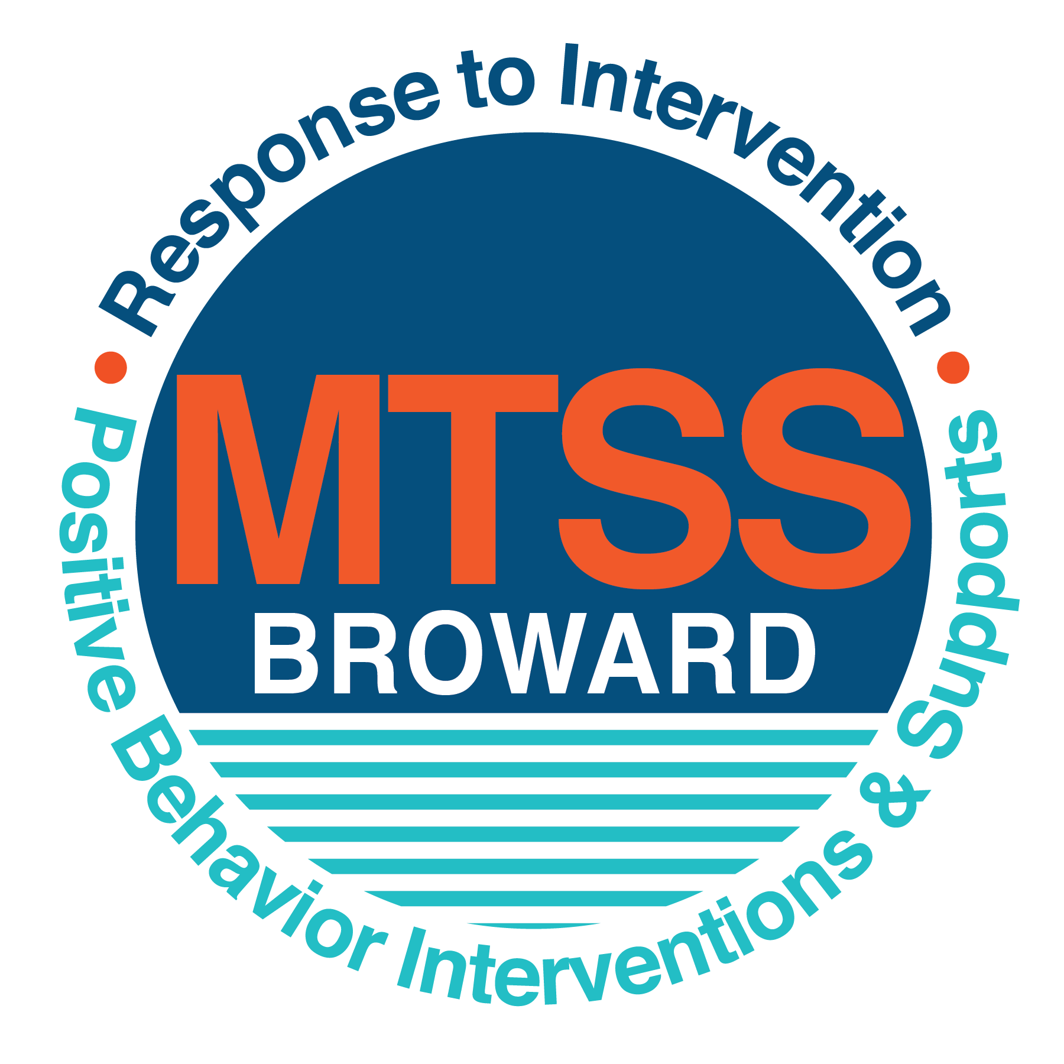
School-wide Positive Behavior Plan (SPBP)
Broward County Public Schools
To be implemented in SY 2019/20

School Name: | Boward Estates Elementary School
School Number: | 0501
SPBP Contact Name: | Dr. Tamara Florence
Direct Phone Number: | 754-322-5551

CRITICAL ELEMENT # 1: Active Team with Administrative Participation

1A. Current (SY 2018/19) SPBP team members:
Full Name | Position
Dr. Tamara Florence | 1. Administration
Janiece Brown | 2. BTU Representative
Tanya Fenton | 3. SPBP Point of Contact
Santonio Jones | 4. Parent/Community Representation
 | 5.
 | 6.
 | 7.
 | 8.
 | 9.
 | 10.

1B. Schedule of quarterly SPBP Team Meeting dates for next 2019/20 school year:
Meeting Date | Meeting Time | Content of meetings:
Oct. 16, 2018 | 3:15 p.m. | 1. Progress of Action Steps indicated in Implementation Plan in #9  2. Collect & analyze fidelity of staff implementation data in #10A  3. Collect & analyze student outcome data in #10B
Jan. 8, 2019 | 3:15 p.m.
Feb. 19, 2019 | 3:15 p.m.
April 18, 2019 | 3:15 p.m.

CRITICAL ELEMENT # 2: Faculty & Stakeholder Commitment:

2A. Action Steps completed this year (SY 2018/19) that increased faculty and stakeholder knowledge of the new SPBP:

Action Steps: | Date  (Between Jan 15 and  April 30, 2019) | Details  (Sign-in sheets in SPBP Binder)
Presented the new SPBP (for SY 2019/20) to staff | March 21, 2019 | # of participants = 15
Held a faculty vote on the new SPBP  (for SY 2019/20) | March 21, 2019 | # of participants =15  % approved =100%
Presented the new SPBP (for SY 2019/20) to stakeholders (parents and community) | March 21, 2019 | # of participants = 15

2B. Action Steps to be completed next year (SY 2019/20) to increase faculty and stakeholder knowledge of the new SPBP:

Action Steps: | Date  (SY 2019-20) | Content  (Sign-in sheets in SPBP Binder)
Provide professional development on the 2019/20 SPBP for all staff | Prior to students’ 1st day:  August 7, 2019. | The team will present the updates in the SPBP for the 19/20 school year. All stakeholders will be provided with access to the SPBP. Feedback will be collected for future team meetings.
Present the 2019/20 SPBP to stakeholders  (parents and community) | Prior to Oct 1st, 2019  September 3, 2019
Present the behavior data to all staff quarterly | 1. Oct. 2, 2019 | The team will present:  - the team’s progress in the Implementation Plan in # 9.  - the fidelity of staff implementation data in #10A.  - the student outcome data in #10B.
Present the behavior data to all staff quarterly | 2. Jan. 14, 2020
Present the behavior data to all staff quarterly | 3. Feb. 18, 2020
Present the behavior data to all staff quarterly | 4. April 14, 2020

CRITICAL ELEMENT # 3: School-wide Expectations

3A. Top five behavior incidents data YTD as listed in BASIS 3.0
Top 5 Behavior Incidents
1.Unruly Disruptive Behavior
2.Fighting (minor altercations)
3.Fighting (medium)
4.Disruptive Unruly Play
5. Technology (inappropriate use)

3B. School-wide expectations are 3 – 5 positive characteristics (not behaviors) that counteract the demonstration of the top school-wide misbehaviors above. ALL people on campus model these expectations.
School-wide Expectations
1.Be responsible, adhere to rules and procedures.
2.Be safe, keep hands and feet to self.
3. Be respectful, use kind words.
4.
5.

3C. At least one lesson plan for each school-wide expectation above is distributed to teachers during pre-planning SY 2019/20 and maintained in the SPBP Binder.
Dates the school-wide expectations lesson plans are taught:
 | Date(s) | Time: | Location(s):
August | Aug. 14, 2019 | 8:00 a.m. | Teachers’ Classrooms
January | Jan. 6, 2020 | 8:00 a.m. | Teachers’ Classrooms
After Spring Break | March 30, 2020 | 8:00 a.m. | Teachers’ Classrooms

CRITICAL ELEMENT #4: Location-based Rules

4A. Top three school-wide locations for Behavior Events YTD.
Top 3 Locations, not including Classroom:
School Location | # Incidents
1. Classroom | 99
2. Hallway | 22
3. Cafeteria | 11

4B. Expectations and Rules Chart for common areas of school campus: (next page)

Expectations and Rules Chart |  |  |  | To be completed by classroom teachers
School-wide EXPECTATIONS | Cafeteria Rules | Hallway Rules | Rules | Classroom Rules
Being responsible means you do the things you are expected to do at school. Following the rules and accepting the consequences (results) of your actions. Being dependable and making good choices including the wearing of your school ID badges at all times. | Use level 1 “inside voice”. | Walk on the white or red line (dependent on the direction the scholar is headed) |  | *Teachers have their individual Classroom Rules; however, the streamlined rules include…  Making Good Decisions
Be safe, keep hands and feet to self and by walking in an orderly manner throughout the school. | Keep hands, feet and objects to yourself. | Use your inside voice |  | Waiting to be acknowledged for speaking and movement
Show respect to others and make decisions that show respect. | Raise your hands for help  and ask permission to leave your assigned seat. | Always walk in pairs (scholars are always escorted) |  | Adhering to the classroom routines and procedures

4C. At least one Rules lesson plan for each specific location is distributed to teachers during pre-planning SY 2019/20 and maintained in the SPBP Binder.

Dates the Locations’ Rules lesson plans are taught
 | Date(s) | Time: | Location(s):
August | Aug 14-16 (first week of school) | 8:00 a.m. | Classroom Teachers (including Specials Teachers)
January | Jan 6-10 (reminder week) | 8:00 a.m. | Classroom Teachers (including Specials Teachers)
After Spring Break | March 30-April 3 (reminder week) | 8:00 a.m. | Classroom Teachers (including Specials Teachers)

CRITICAL ELEMENT # 5: Reward and Recognition Programs

5. The reward system is focused on one School-wide Expectation OR specific location at a time.
Expectation or Location: School-Wide Expectation

4 Step Problem Solving Process | Plan Details
1. Problem Identification: Use your behavior data to identify one school-wide problem.  What problem did you identify? (use numerical data) | Data used: BASIS  Problem Identification Statement: 99 out of a total of 141 referrals are for fighting (minor) this equals to 70% of our schools incidents stemming from scholars becoming physical (exchange of blows or punches) with one another.
2. Problem Analysis: Why do you think this problem is occurring?  What is your goal? (use a SMART goal statement with numerical data) | Hypothesis: If scholars are provided consistent modeling of conflict resolution techniques including the opportunity to speak with support staff then the number of fighting infractions will decrease.  Goal Statement: By the end of the 2019-2020 school year the number of infractions for fighting (minor) will decrease by 5%.
3. Intervention Design: Describe how you will implement a positive reward program to decrease this problem. | Type of System:  Description of System: The Positive Behavior System Broward Estates Elementary use is called “Bravo” Students earn “Bravo Cards” which are displayed in common areas for performing their job of being a good scholars.  - Positive Behavior is recognized and celebrated!  - Scholars have multiple opportunities to be celebrated including behavior change.
4. Evaluation:  A. Implementation fidelity | - How will you monitor the fidelity (consistency and effectiveness) of the staff’s implementation of the reward program?  The person responsible for organizing and analyzing this will be the school’s Guidance Counselor as there are tracking sheets for each teacher in their grade level.
B. Student outcome monitoring | - How will you know if the reward program is positively impacting students? What measurable data will you use to determine “success”?  The school’s Guidance Counselor will collect the individual teacher tally sheets which will be part of collaborative conversations with Administration and Team Leaders to discuss the impact on our scholars.

CRITICAL ELEMENT #6: Effective Discipline Procedures

Student Behavior Discipline Flow Chart
Observe problem behavior behaviorBehavior
Is the behavior considered staff managed?
Is the behavior moderate?
Follow crisis protocol
Implement minor consequence(s)
Verbal warning

Behavior is corrected
Verbal warning
Reinforce/
reward student
Re-teach Expectations
Begin classroom individualized behavior plan

Behavior is corrected
Reinforce/
reward student
Behavior is corrected
Reinforce/
reward student
Apply intervention contact parent

Continue classroom behavior plan. Contact a peer, guidance, or admin for further intervention/suggestion.

Complete office referral.

Write a referral & and submit in BASIS.

Write a referral & submit in BASIS.

Admin determines consequence using progressive discipline matrix.

Student conference
Re-teach expectation
Parent contact
Detention
Refer to guidance
In-school suspension
Out school suspension
Recommend for expulsion

Copy of referral given to teacher/staff
Copy retained at school
Copy of referral sent to parent via student

CRITICAL ELEMENT # 7: Classroom Management Systems

7A. In SY 2019/20, ALL teachers implement an evidence-based Tier 1 classroom management system:
Evidence-based system: | Evidence of training:
☐ CHAMPS | % of teachers currently holding valid CHAMPS certificate:
X PBIS Classroom Management  http://www.fl-pda.org/independent/ | % of teachers currently holding completion certificate: 0
☐ Other: Click here to enter name of system. | Training evidence: Click here to enter evidence  % of teachers currently trained:

7B. The administration reviews and analyzes the fidelity of staff implementation of Tier 1 classroom management systems across teachers using:
☐ CHAMPs 7 Up Checklist
☐ Basic FIVE (Classroom Management Screening)
X PBIS Classroom Assistance Tool (CAT)
☐ Other (specify):
☐ Classroom management screening is not conducted across teachers to determine appropriate professional
development. (Next year, assessment of classroom management implementation fidelity will be scored).

7C. School year 2018/19 percentage of classroom referrals:
Total number of discipline referrals from classrooms: | 99
Total number of other school-wide discipline referrals: | 141
% of referrals in the classroom: | 70%
Do more than 40% of your referrals come from the classroom? | X Yes ☐ No
If >40% of discipline referrals come from the classroom, it suggests Tier 1 classroom management implementation may need to be strengthened school-wide.
If “Yes”, school-wide classroom management professional development will be conducted in 2019-20:
PBIS Classroom Assistance Tool If “Other”, indicated system here: Click here

CRITICAL ELEMENT # 8: Data Collection and Analysis

8A. Core Effectiveness:
TOTAL Population: | 373 | % of Total Population | Core Effectiveness
# Referrals: | # of Students: | % of Total Population
0 - 1 referrals | 1 | !Zero Divide | Are your 0 – 1 referrals > 80%? | ☐Yes X No
2 - 5 referrals  (at risk students) | 37 | !Zero Divide | Are your 2 - 5 referrals <15%? | X Yes ☐No
> 5 referrals  (high risk students) | 3 | !Zero Divide | Are your >5 referrals <5%? | X Yes ☐No

8B. Core Effectiveness Action Steps:
If all 3 are “Yes”, your core is effective. Is your core behavior curriculum effective? | ☐Yes X No
Answer either (a) or (b):
(a) If you answered “Yes”, although your core is effective, what steps does your school leadership team take for early identification of at risk and high-risk students?
(b) If you answered “NO”, indicate the supports and interventions your school leadership team will implement at the beginning of the next school year to improve core strength:
Core Effectiveness Action Steps: (3-4 steps)
1. PBIS Training for Teachers
2.Follow-Up of PBIS Training including monitoring for fidelity and effectiveness
3. SPBT Meetings
4.

8C. Disproportionality within racial subgroups:
Subgroups | (PctPop - Green)  % of students | (PctRef - Blue)  % of referrals | Difference in referral composition | Positive value suggests disproportionality  (Is the value positive?)
Black | 96% | 92% | 0 | X Yes No
Hispanic/Latin | 2% | 3% | 0 | X Yes No
White | 2% | 2% | 0 | X Yes No

8D. Disproportionality Action Steps:
If all three are “No”, disproportionality is not indicated. Are all 3 “No”? | ☐Yes ☐No
Answer either (a) or (b):
(a) If you answered “Yes”, although your data indicates equity, what plan does your school leadership team implement for early identification of any disproportionality issues
(b) If you answered “No”, indicate the support plan and interventions your school leadership team will implement at the beginning of next year to improve sub group disproportionality
Disproportionality Action Steps: (3-4 steps)
1. All scholars are provided an opportunity to implement positive behavior changes
2. All scholars are provided modeling of good decision-making techniques
3. All scholars are provided an opportunity to be rewarded/celebrated
4.

Critical Elements # 9: SPBP Implementation Planning
RED Font = Action Steps for all schools in Broward County
GREY Font = Best Practices for all schools in Broward County
TEAL Font = Resources available at https://browardcountyschools.sharepoint.com/sites/DPI6Strands/strand6/SitePages/SPBP.aspx
SPBP Team Implementation Action Plan 2019 – 2020
Month | Action Steps  ☒ check off Action Step when completed
Current | ☐ Create a SPBP binder or portfolio to retain (for 2 years) hard copies of: your SPBPs, Action Plans, staff PBIS  professional development attendance, stakeholder training attendance, quarterly meeting agendas, quarterly staff  behavior presentations, voting attendance and outcome, Expectations lesson plans and Rules lesson plans
Pre-Planning  2019 | ☐ Print up your SPBP Review and school score from OSPA  ☐ Provide SPBP presentation to all staff during Pre-Planning  ☐ Disseminate the current SPBP (hard copy or electronically) to all staff and stakeholders  ☐ Market and post school-wide Expectations and location-specific Rules  ☐ Identify your district RtI Instructional Facilitator  (Contact tyyne.hogan@browardschools.com for more information, if you are unsure)  ☐ Confirm 1st team meeting date and time
August  1st meeting | ☐ Ensure schedule of quarterly meeting dates for entire year as indicated in the SPBP  ☐ Review Implementation plan; check off completed Action Steps  ☐ Determine any needed team training, such as these Brainsharks: 4 Step Problem Solving Process series, PBIS 10  Critical Elements, Data Collection, Big 5 Data, PBIS 101, etc. (All found in Sharepoint site)  ☐ Review previous year’s behavior data. (Use ‘Agenda’ Form and ‘Data Collection Template’ in Sharepoint site)  ☐ Utilize the 4 Step Problem Solving Process to initiate a Reward System for all students  ☐ Review previous year’s SPBP and feedback form; make necessary modifications  ☐ Verify and implement teaching schedule for Expectations and Rules behavior lesson plans  ☐ Present implementation data, behavior data, team activities and SPBP progress to entire staff
September | ☐ Provide SPBP stakeholder presentation prior to October 1  ☐ Check for staff and teacher understanding of PBIS - provide “PBIS 101” Brainshark as a resource  Brainshark available at: http://www.brainshark.com/browardschools/PBIS101  ☐ Ensure the Discipline Flow Chart is distributed to all staff and is being used as written
October  2nd meeting | ☐ Review Implementation plan; check off completed Action Steps  ☐ Ensure instructional staff know how to (and are, as needed) enter Tier 1 Supplemental Strategies  for behavior in BASIS  ☐ Review previous quarter’s behavior data. (Use ‘Agenda’ and ‘Data Collection Template’ in Sharepoint site)  ☐ Present implementation data, behavior data, team activities, and SPBP progress to entire staff  ☐ Ensure all teachers are using an evidence-based classroom management plan, such as CHAMPS  ☐ Ensure Core Effectiveness Action Steps are being implemented as written
November | ☐ Team to develop new and/or improved lesson plans as indicated by behavior data.  ☐ Ensure that the Disproportionality Action Steps are being implemented as written
January  2020  3rd meeting  Prepare for SY 2020/21 SPBP | ☐ Review Implementation plan; check off completed Action Steps  ☐ Staff to re-teach Expectations and Rules after winter break  ☐ Principal signs in and watches the new “SPBP for Principals” Brainshark: Due January 30th  ☐ Present implementation data, behavior data, team activities, and SPBP progress to entire staff  ☐ Choose team members and dates to work on, complete, and submit the new SPBP  ☐ Teams watch the new “SPBP Team Overview” Brainshark and refers to district resources and supports  (Brainsharks and Additional items in Sharepoint site. Webinars and in-person lab information in Team Brainshark)
February | ☐ Ensure progress towards completion of SPBP  ☐ Check on recently hired staff for PBIS understanding - provide “PBIS 101” Brainshark resource  ☐ Provide the SPBP Surveymonkey link to all staff (optional)
March  4th meeting | ☐ Ensure progress towards completion and submission of SPBP  ☐ Review Implementation plan; check off completed Action Steps  ☐ Staff to re-teach Expectations and Rules after from spring break  ☐ Provide stakeholders/parent presentation on new SPBP for next year  ☐ Provide staff presentation and faculty vote on new SPBP for next year  ☐ Present implementation data, behavior data, team activities, and SPBP progress to entire staff
April | ☐ Submit your SPBP in OSPA by April 30th every year. Use this new SPBP in the next school year  ☐ Continue implementing your current SPBP through the end of the current school year

CRITICAL ELEMENT # 10: Evaluation

10A. Staff implement the School-wide Positive Behavior Plan effectively:
“Are staff implementing the SPBP with fidelity? How do you know?”
STAFF Implementation Monitoring
Action Step | Create an observable and measurable SMART goal to determine “successful”  staff implementation of action step
School-wide expectations and location-specific rules are posted across campus | By August 23, 2019 of the new 2019/2020 school year all school-wide expectations and location-specific rules are posted on the campus in the common areas.
Expectations and Rules lesson plans are being taught as written and when indicated | During the weeks of August 14, 2019 – August 16, 2019 and August 19, 2019 – August 23, 2019 all expectations and rules lesson plans would have been taught in grades K-5 including Specials Teachers.
The Discipline flow chart is being used by all staff as written | By August 14, 2019 the discipline flow chart is being used.
A reward system is being implemented for all students | By August 14, 2019 the reward system is being implemented for all scholars in grades K-5.

10B. The SPBP is successful in positively impacting students:
“If staff are implementing the SPBP consistently and effectively, did it positively impact the students? How do you know?”
STUDENT Outcome Monitoring
Student Outcome Data | Create an observable and measurable SMART goal to determine  “successful” student outcomes
Behavior Incident data  (See critical element #3A) | By the end of the 2019/2020 school year the percent of unruly disruptive behavior incidents will decrease by 3%.
Top 3 event locations data  (See critical element #4A) | By the end of the 2019/2020 school year through the effective implementation of PBIS, the percent of classroom incidents will decrease by 5%.
Core effectiveness data  (See critical element #8A) | By the end of the 2019/2020 school year the number of 2-5 (at -risk students) will continue to be <15%.
Classroom referrals data  (See critical element #7C) | By the end of the 2019/2020 school year the percent of overall referrals (141) will decrease by 3%.

