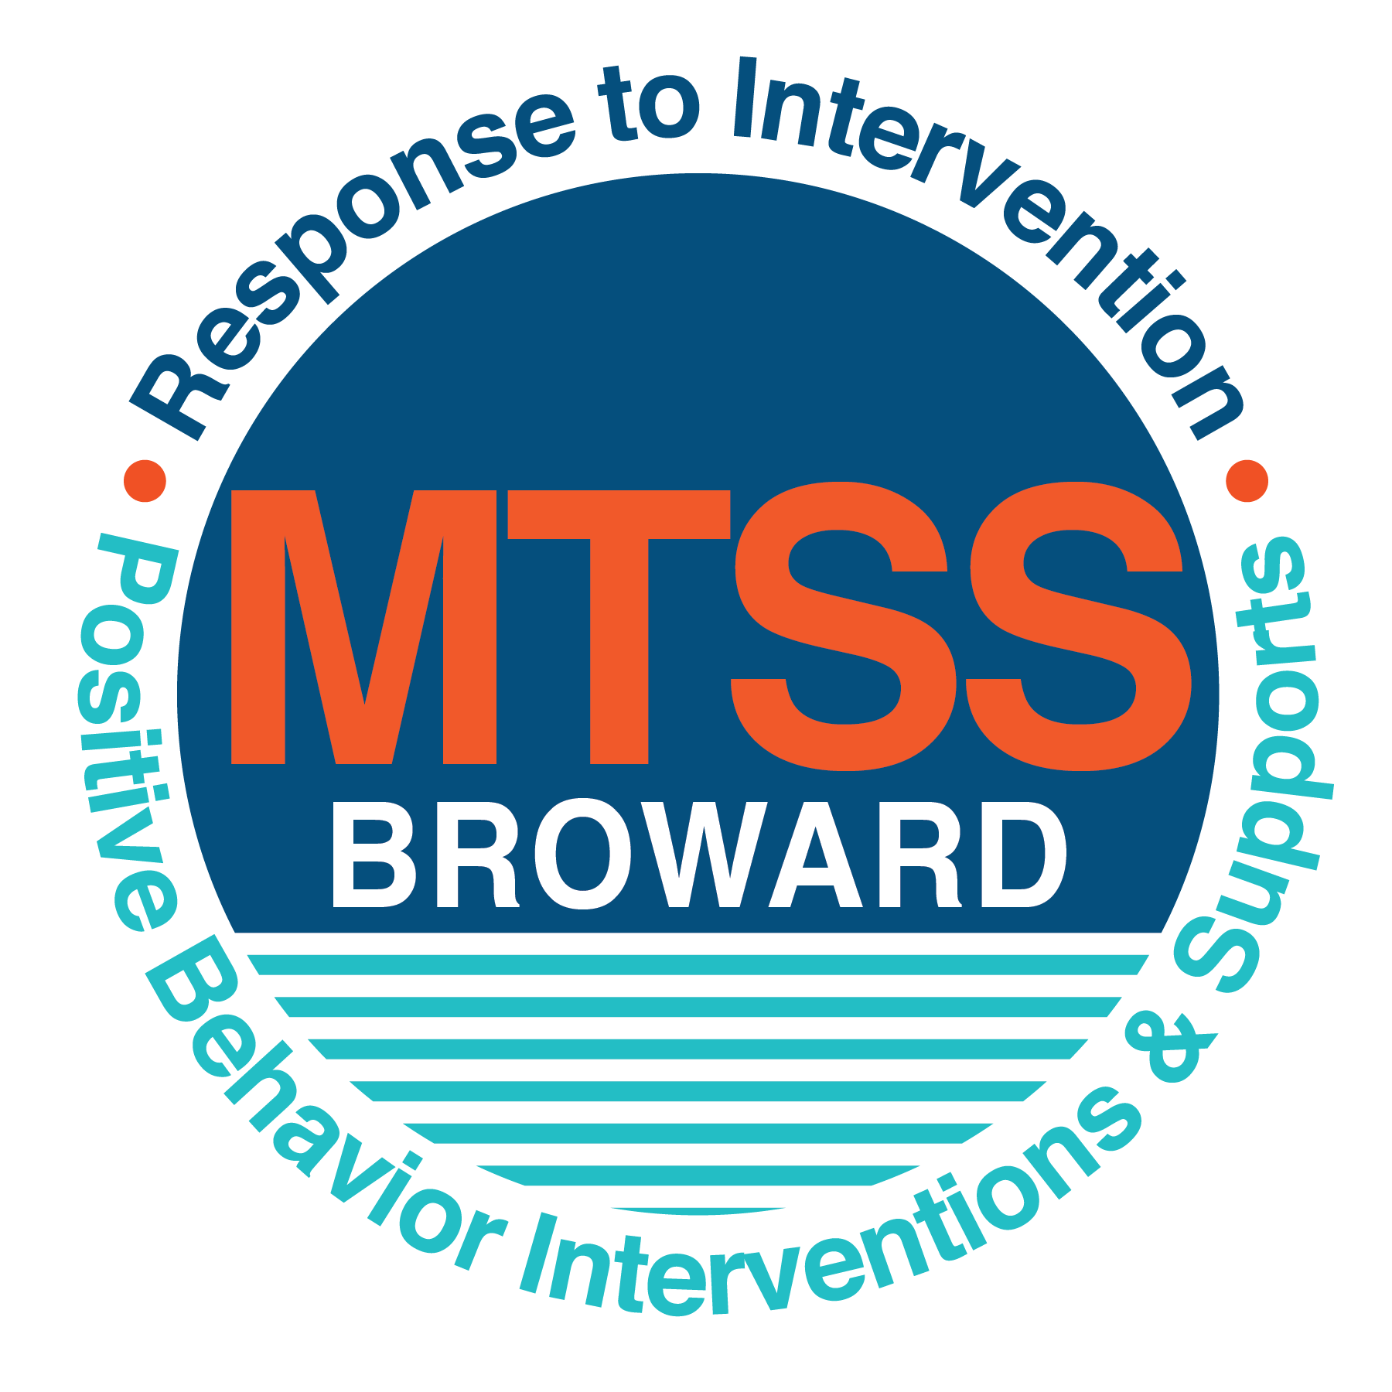

**School-wide Positive Behavior Plan (SPBP)**

Broward County Public Schools

To be implemented in SY 2018/19

**Elements have changed in the SPBP.**

Before completing, go to[**http://www.browardprevention.org/mtssrti/rtib/ →**](http://www.browardprevention.org/mtssrti/rtib/%20→)*School-wide Positive Behavior Plan* for:

* **A NEW Brainshark for Principals. ACTION: Log in with your p # and watch the Brainshark before Jan 30th.**
* **A NEW Overview Brainshark for Teams. ACTION: Log in with school name and watch the Brainshark.**
* A NEW mini Brainshark Series for teams. These Brainsharks are divided into the 10 Critical Elements of PBIS. They will

show you “how to” write a comprehensive SPBP (and receive a high score!)

* A Rating Rubric to ensure teams will correctly complete the SPBP and develop a meaningful plan.

To provide consistency across the District, *only plans entered on the current district template will be accepted*.

**ACTION: Download, complete and upload the SPBP into your School Improvement Plan before May 1, 2018:**

|  |  |
| --- | --- |
| **School Name:** | Harbordale Elementary |
| **School Number:** | 0491 |
| **SPBP Contact Name:** | Lauren Kirik |
| **Direct Phone Number:** | 754-323-6050 |

|  |
| --- |
| **CRITICAL ELEMENT # 1: Active Team with Administrative Participation** |

**1A.** List your current (SY 2017/18) team members (6 - 10 team members). **Must include an instructional representative from EACH grade/content area.** *Each name on this list verifies attendance in ongoing team meetings and participation in developing this SPBP. Each member is responsible for representing major stakeholders and sharing the SPBP content and updates with their respective group.*

|  |  |  |
| --- | --- | --- |
| **Full Name** | **Position** | **Who or what grade level does this member represent?** |
| Theresa Bucolo | Principal | Administration |
| Jennifer Kashdin | Intern Principal | Administration |
| Lauren Kirik | SPBP Point of Contact | Instructional – 4th grade |
| Kathy Diaz | Parent/Community Representation | SAC |
| Erin Curran | BTU Representative | Instructional – 2nd grade |
| Kelly Hardison | Art/ PE Teacher | Instructional - Specials |
| Gilda Kupferman | Spanish Teacher | Instructional - ESOL |
| Octavious Freeman | Educational Support | Non-Instructional |
| Katy Quackenbush | Speech Pathologist | ESE – Speech & Language |
| Megan Hanley | ESE Teacher/ ESE Specialist | ESE |
| Vicky Bureau | Guidance Counselor | Guidance |

**1B**. Schedule and document your quarterly team meeting dates for *next* 2018/19 school year:

|  |  |  |  |
| --- | --- | --- | --- |
| **Meeting Date** | **Meeting Time** | **Name & title of person responsible to facilitate meeting** | **Content of meetings:** |
| 8/9/2018 | 8:00 | Lauren Kirik RTI-b Contact | 1. Create and disseminate updated  Expectations and Rules lesson  plans (#3 and #4)  2. Review progress of  Implementation Action Plan (#9)  3. Collect & analyze implementation  data (#10A)  4. Collect & analyze student  outcome data (#10B) |
| 10/18/2018 | 1:00 | Lauren Kirik RTI-b Contact |
| 2/21/2019 | 1:00 | Lauren Kirik RTI-b Contact |
| 5/9/2019 | 1:00 | Lauren Kirik RTI-b Contact |

|  |
| --- |
| **CRITICAL ELEMENT # 2: Faculty & Stakeholder Commitment:** |

**2A**. Action Steps completed **this year** (SY 2017/18) that increased faculty and stakeholder understanding and knowledge of your *new* (2018/19) SPBP:

|  |  |  |  |
| --- | --- | --- | --- |
| **Action Steps:** | **Date**  *(Between Jan 15 –*  *April 30, 2018)* | **Details**  *(retain attendance sheets at school)* | **Person responsible to collect and retain attendance sheets:** |
| Presented the *new* SPBP (for SY 2018/19) to staff | 3/22/2018 | # of participants = 35 | Jennifer Kashdin |
| Held a *faculty* vote on the new SPBP  (for SY 2018/19) | 4/10/2018 | % approved = 100% | Jennifer Kashdin |
| Presented the *new* SPBP (for SY 2018/19) to stakeholders (parents and community) | 4/17/2018 | # of participants = 15 | Jennifer Kashdin |

**2B.** Action Steps to be completed **next year** (SY 2018/19) to increase faculty and stakeholder understanding and knowledge of your SPBP:

|  |  |  |  |
| --- | --- | --- | --- |
| **Action Steps:** | **Date(s)**  *(NEXT YEAR)* | **Content**  *(retain attendance sheets at school)* | **Person responsible to collect and retain attendance sheets:** |
| Provide a professional development on the 2018/19SPBP for all staff | Prior to students’ 1st day:  8/9/2018 | The team will present the updates in the SPBP for the 18/19 school year. All stakeholders will be provided with access to the SPBP. Feedback will be collected for future team meetings. | Jennifer Kashdin |
| Present the 2018/19SPBP to stakeholders (parents and community) | Prior to Oct 1st, 2018  8/30/2018 |
| Present behavior data to staff  *Quarterly: minimum of 4 each year* | 1. 10/18/2018 | The team will present the implementation data in 10A. Include:  • the “marketing” (teaching and posting) of expectations and rules  • lesson plan implementation  • discipline procedures  • reward system implementation  The team will present the student outcome data in 10B. Include:  • top 3 event locations  • type of behavior incidents  • core effectiveness data  • classroom referral data, as well as analysis of this data. | Lauren Kirik |
| 2. 12/21/2018 |
| 3. 2/21/2019 |
| 4. 3/21/2019 |

|  |
| --- |
| **CRITICAL ELEMENT # 3: School-wide Expectations** |

**3A.** List the **top 10 behavior incidents** data YTD from BASIS 3.0 Behavior Dashboard:

|  |  |
| --- | --- |
| **Top 10 Behavior Incidents**  *(put N/A in any blank spaces)* | |
| 1.Unruly Disruptive Behaviors | 6.NA |
| 2.Disruptive/Unruly Play | 7.NA |
| 3.Disobedience/Insubordination | 8.NA |
| 4.NA | 9.NA |
| 5.NA | 10.NA |

**3B.** Based on the behavior incidents in 3A, develop 3 – 5 **positive characteristics** *(not behaviors)* that would counteract the demonstration of these misbehaviors. These positive characteristics become your school-wide expectations.

|  |
| --- |
| **School-wide Expectations** |
| 1. Be responsible for self and actions. **Responsibility.** |
| 1. Be respectful to self and others. **Respect.** |
| 1. Be kind to self and others. **Kindness.** |
|  |
|  |

**3C.** Research indicates that discipline referrals increase after long holidays and during testing times. Plan to teach your expectations at least 3 times throughout the year (and anytime the expected behaviors are not being demonstrated).

**ACTION:** Create at least one lesson plan for **each** school-wide expectation above and distribute to teachers during pre-planning 2018-19. Develop additional lesson plans you will use throughout the year to re-teach and reinforce your school-wide expectations. *You do not need to submit your lesson plans with the SPBP. Retain all behavior lesson plans at the school; make sure these lesson plans are available for guests and stakeholders.*

|  |  |  |  |
| --- | --- | --- | --- |
| **When will school-wide expectations lesson plans be taught?** | | | |
|  | Date(s) | Time: | |
| August | 15-17 | 8:30-9:30 | |
| January | 8-11 | 8:30-9:30 | |
| 4th Quarter | May 13-17 | 8:30-9:30 | |
|  | | | |
| Who will be responsible for teaching the lesson plans? | | | classroom teachers |
| Where will the lesson plan instruction occur? | | | General Ed classrooms |
| Who is responsible for retaining, organizing and distributing all lesson plans? | | | Jennifer Kashdin |

|  |
| --- |
| **CRITICAL ELEMENT #4: Location-based Rules** |

**4A.** List the **top 3 locations** for behavior Events YTD from BASIS 3.0 Behavior Dashboard**.** ***Do not use “classroom”***

|  |  |
| --- | --- |
| **Top 3 Locations** | |
| School Location | # Incidents |
| 1. Cafeteria | 10 |
| 1. Hallway | 4 |
| 1. Playground | 2 |

**4B.** Create an Expectations/Rules Matrix from your 3-5 school-wide expectations and your top 3 event locations. Develop a positively stated, observable, and measurable rule that correlates with every expectation to create a maximum of 5 rules under each location**.**

|  |  |  |  |  |
| --- | --- | --- | --- | --- |
| **Expectations and Rules Matrix** | | | | |
| **School-wide EXPECTATIONS** | *Copy and paste expectations from* ***3C****.* | **IDENTIFIED LOCATIONS**  *Copy and paste locations from* ***4A.*** | | |
| Cafeteria | Hallway | Playground |
| **Rules** | **Rules** | **Rules** |
| Be respectful. | Raise your hand if you need something. | Raise your hand if you need something. | Line up when the teacher gives the signal. |
| Be responsible. | Clean up your area – table and floor. | Stay in the line on the directed line. | Go down the slides feet first, and up all climbing surfaces with both hands and feet. |
| Be kind. | Include other students at your table in quiet conversations. | Keep an arm distance between you and the person in front of you. | Include all students in games. |
| N/A | N/A | N/A | N/A |
| N/A | N/A | N/A | N/A |

**4C**. Research indicates that discipline referrals increase after long holidays and during testing times. Plan to teach your location-specific rules at least 3 times throughout the year (and anytime the expected behaviors are not being demonstrated).

**ACTION:** Create at least one lesson plan for **each** location above and distribute to teachers during pre-planning 2018-19. Develop additional lesson plans you will use throughout the year to re-teach and reinforce your location-specific rules.

*You do not need to submit your lesson plans with the SPBP. Retain all behavior lesson plans at the school; make sure these lesson plans are available for guests and stakeholders.*

|  |  |  |  |
| --- | --- | --- | --- |
| **When will location-specific rules lesson plans be taught?** | | | |
|  | Date(s) | Time: | |
| August | 15-17 | 8:30-9:30 | |
| January | 8-11 | 8:30-9:30 | |
| 4th Quarter | May 13-17 | 8:30-9:30 | |
|  | | | |
| Who will be responsible for teaching the lesson plans? | | | Classroom teachers |
| Where will the lesson plan instruction occur? | | | General Ed classrooms |
| Who is responsible for retaining, organizing and distributing all lesson plans? | | | Jennifer Kashdin |

|  |
| --- |
| **CRITICAL ELEMENT # 5: Reward and Recognition Programs** |

Although you will post, teach, review, practice and reinforce all school-wide expectations and location-specific rules, **choose 1 expectation OR 1 event location** you will target for a specific reward program for students. Based on the data that led to this expectation or location, create a reward plan using the 4 Step Problem Solving Process:

Expectation or Location: ____________Expectation: Be kind._________________________________________

|  |  |
| --- | --- |
| **4 Step Problem Solving Process** | **Plan** |
| **1. Problem Identification:** Use your behavior data to identify a school-wide problem.  What problem did you identify? *(use numerical data)* | **Data used: 12 behavioral referrals indicate disruptive behaviors as a result of students using unkind words or actions towards peers.**    **Problem Identification: Students use unkind words and/or actions when interacting with one another.** |
| **2**. **Problem Analysis:** Why do you think this problem is occurring?  What is your goal? *(use a SMART goal statement with numerical data)* | **Hypothesis: Students are unaware of positive alternatives during conflict resolution, and lack necessary words to solve problems leading to physical altercations.**  **Goal Statement:** By May, 2019 the number of behavior referrals that are linked to unkind words or actions are entered into BASIS will decrease by at least 30%. |
| **3. Intervention Design:**  Describehow you will implement a positive reward program to decrease this problem. | **Type of System: Token system**  **Description of System:** *(3-4 sentences)*  Students will receive ‘kindness coins’ for demonstrating exemplary acts of kindness toward other students. They can receive them from any faculty member when a desired behavior occurs. Students will be given a tangible reward of their choice (candy, toy, sticker, pencil etc). Select students will be recognized weekly on morning announcements to exemplify model behavior in regard to acts of kindness. |
| **4. Evaluation:**  A. Implementation fidelity | 1. How do you monitor the fidelity (consistency and effectiveness) of the **staff’s** implementation of the reward program? *(2-3 sentences)*   Staff feedback and input will be requested during RTI-b faculty meetings. Staff members will be given shout-outs via morning announcements for participating in kindness coin activities. Teachers with the most kindness coin recipients will be awarded ‘kindest class awards’ to hang on their classroom doors (monthly). |
| B. Student outcome monitoring | 1. How will you know if the reward program is positively impacting **students**?   What measurable data will you use to determine “success”? *(2-3 sentences)*  When the number of behavior referrals that directly tie to lack of kindness shows an overall decrease, then the kindness coin program will be considered a success. The program will continue until it is no longer deemed necessary. |

|  |
| --- |
| **CRITICAL ELEMENT #6 Effective Discipline Procedures** |

**6A. Staff Managed Misbehaviors:** List the top 6 *most common* school-wide misbehaviors **staff are expected to manage.**

Write a short, objective, and measurable definition for each.

|  |  |
| --- | --- |
| **Staff Managed Misbehaviors** | |
| Misbehavior | “Looks Like” - *provide a description with example(s)* |
| 1. Inappropriate language | Student chooses not to meet desired behavioral outcomes by engaging in the following behaviors: name calling, or inappropriate verbal remark, tattling |
| 1. Physical contact | Student chooses not to meet desired behavioral outcomes by engaging in the following behaviors: wrestling, pushing, shoving |
| 1. Disrespect | Student chooses not to meet desired behavioral outcomes by engaging in the following behaviors: talking back |
| 1. Defiance | Student chooses not to meet desired behavioral outcomes by engaging in the following behaviors: non-compliance with directions, refusal to complete assignment |
| 1. Uncooperative behavior | Student chooses not to meet desired behavioral outcomes by engaging in the following behaviors: running in hall, throwing food, dress code violation |
| 1. Destruction of property (minor) | Student chooses not to meet desired behavioral outcomes by engaging in the following behaviors: damage to classroom materials but material is still useable or fixable and or snooping through/ stealing another students’ materials. |

**6B. Staff Managed Consequences**: Create a consequencemenu **OR** a consequence hierarchy for staff to use when students exhibit the above misbehaviors. Provide a minimum of **5** consequences.

|  |  |
| --- | --- |
| Is this a menu or hierarchy system? | Menu Hierarchy |
| warning followed by a redirection | |
| behavior mark (change clip, change color, loss of dojo point, etc), appropriate behavior is retaught | |
| written behavior reflection sheet and contact home | |
| loss of privileges (in classroom or at recess) | |
| office contact | |
|  | |
|  | |

**6C. Administration Managed Misbehaviors**:

(a) Define the first 3 behaviors by providing examples that clearly identify the point at which the misbehavior warrants an Office Discipline Referral (ODR).

(b) List two additional common school-wide misbehaviors that will result in an ODR. Provide concrete examples.

(c) Determine staff tolerance level for repetitive misbehaviors (the point at which the number of staff-managed misbehaviors becomes an ODR).

|  |  |
| --- | --- |
| **Office Discipline Referrals (ODRs)** | |
| Behavior | “Looks Like” - *provide a description with example(s)* |
| 1. Abusive language | Student chooses not to meet desired behavioral outcomes by engaging in the following behaviors Racial taunting, cursing |
| 2. Fighting/ physical aggression | Student chooses not to meet desired behavioral outcomes by engaging in the following behaviors: hitting, punching, kicking, throwing sand or other objects, etc. |
| 3. Eloping | Student chooses not to meet desired behavioral outcomes by leaving the school grounds without permission |
| 3. Defiance of authority/ threat | Student chooses not to meet desired behavioral outcomes by engaging in the following behaviors: making a threat or using profanity toward a staff member or peer, refusing to adhere to safety procedures (code procedures, fire drill etc). |
| 4. Dangerous items | Student chooses not to meet desired behavioral outcomes by engaging in the following behaviors: bringing unsafe items on campus: knives, bullets, lighters etc |
| 6. Repetitive staff managed  misbehaviors | More than misbehaviors inwarrants an office referral.  hour  one  3    *e.g., 3 half hour*  *2 one period* |

**6D. School-wide Discipline Flow Chart:**

(a) Review the sample discipline flow charts in “Additional Items” located on browardprevention.org

(b) Copy or customize a flow chart to graphically represent the discipline process at **your** school.

(c) Paste the flow chart here**OR** complete the flow chart below.

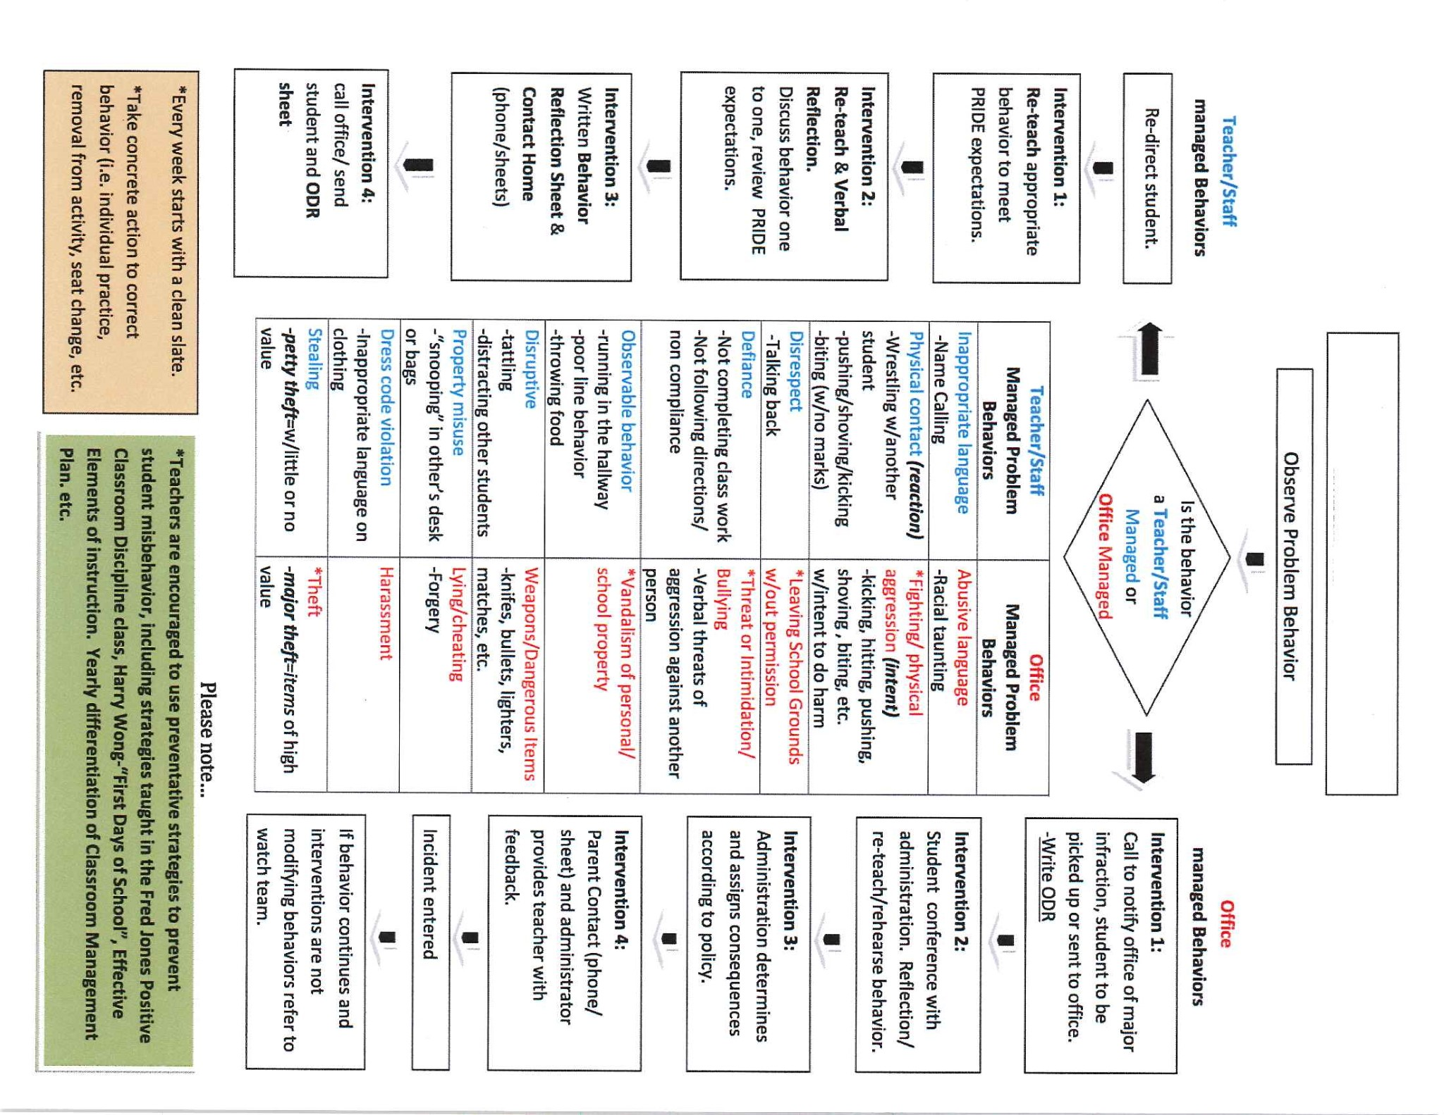

Reteach appropriate behavior using LEAPS lessons.

Discuss behavior one-on-one and review expectations

Harbordale’s Discipline Flow Chart

|  |
| --- |
| **CRITICAL ELEMENT # 7 : Classroom Management Systems** |

**7A.** ALL teachers implement an effective Tier 1 classroom management system:

|  |  |
| --- | --- |
| Which **evidence-based** classroom management system is supported by your school’s administration and is expected to be implemented school-wide?  *(Class Dojo, LEAPs, HERO, Cloud 9, etc. are tools,* ***not*** *classroom systems)* | CHAMPs*  PBIS Classroom Management  Administration does not expect an evidence-based classroom management system to be implemented by teachers this year  (*your school will need to adopt one next year)*  Other *(complete below)* |
| If other, name the **evidence-based classroom management system:** | Click here to enter name of system. |
| *CHAMPs is the district-supported, evidence-based universal classroom management system for all teachers. Would your Principal like to be contacted to learn about CHAMPs professional development? | Yes  No |

**7B.** Fidelity of **staff** implementation of school-wide classroom management systems

|  |
| --- |
| What data collection tool does your school leadership team use to monitor and evaluate your teacher’s classroom management skills? *(Measure* ***staff skills****, not student outcomes)* |
| CHAMPs 7 Up Checklist |
| CHAMPs Classroom Check Up (CCU) |
| PBIS Classroom Assistance Tool (CAT) |
| PBIS Walkthrough |
| Marzano’s Domain 1, Design Questions 5, 6, 7, 8, 9 |
| Fidelity of staff classroom management implementation is not monitored to determine training needs this year *(you will need to adopt a tool and plan next year)* |
| Other *(specify):* |
| Explain how this data is collected and analyzed by your school leadership team as a **universal screening** *across teachers* to determine the need for classroom management training: Data from CHAMPS checklists and Marzano observations for design questions 5 - 9, by teacher, are collected and analyzed by the discipline committee on a quarterly basis. Each quarter, this information is reviewed and disaggregated to identify any patterns, trends or staff development needs. This data is examined for individual teacher staff development as well as school-wide areas of weakness or concerns. |
| 1. Fidelity of Implementation Plan: *(3-4 sentences)* The discipline committee works collaboratively with administration and the RTI team to gather behavioral data, develop plans and provide behavioral resources necessary to promote effective classroom management system. When identification of a need is determined, the teacher is mentored by a resident expert to support the development of the identified weak area. Classroom management training is provided for those teachers in need of additional support. At each discipline committee meeting, progress is discussed, best practices shared and data is monitored. |

**7C. Percentage of Classroom Referrals:**

(a) Review your classroom data YTD (“Events by Location”) in BASIS 3.0 Behavior Dashboard.

(b) Complete the yellow highlighted cells first.

(c) Auto-calculate the % of referrals in the classroom by clicking on “!Zero Divide” in the next cell and pressing “Fn + F9” together.

|  |  |
| --- | --- |
| Total number of discipline referrals **from classrooms**: | 6 |
| Total number of **school-wide** discipline referrals: | 16 |
| % of referrals in the classroom: | 27% |
| Do more than 40% of your referrals come from the classroom? | Yes  No |

***If >40% of discipline referrals come from the classroom, it suggests Tier 1 classroom management implementation may need to be strengthened school-wide.***

|  |
| --- |
| **CRITICAL ELEMENT # 8: Data Collection and Analysis** |

**8A. Determine your School-wide Core Effectiveness YTD** from the BASIS Behavior Dashboard in the “Referrals per Student” chart.

(a) Complete the yellow highlighted cells first.

(b) Auto-calculate the “% of Total Population” by clicking on each “!Zero Divide” in the cells and pressing “Fn + F9”.

(c) Determine if the core is effective in all three areas

|  |  |  |  |  |
| --- | --- | --- | --- | --- |
| TOTAL Population: | 461 |  |  | |
| # Referrals |  | **% of Total Population** | Core Effectiveness | |
| 0 - 1 referral |  | 100% | Are your 0 – 1 referrals > 80%? | Yes No |
| 2 - 5 referrals  (at risk students) | 0 | 0% | Are your 2 - 5 referrals <15%? | Yes No |
| > 5 referrals  (high risk students) | 0 | 0% | Are your >5 referrals <5%? | Yes No |

**8B. Core Effectiveness Plan:**

|  |  |
| --- | --- |
| If all 3 are “**Yes**”, your core is effective. Is your core behavior curriculum effective? | Yes No |
| Answer **either** (a) or (b):  (a) If you answered “**Yes**”, although your core is effective, what plan does your school leadership team implement for early identification of at risk and high risk students? At the beginning of the school year, the discipline committee will review previous years data to identify potential student behavioral concerns. This will include collecting and gathering information on the new students to the school. The use of BASIS “at risk” data markers will be incorporated to identify students who potentially might need some support systems to promote student success. The discipline committee will work collaboratively with RTI team and support teachers who have students in RTI-B in an effort to extinguish behaviors at the earliest possible stage.  (b) If you answered “**NO”**, indicate the supports and interventions your school leadership team will implement at the beginning of the next school year to improve core strength: | |
| Core Effectiveness Plan: *(3-4 sentences)* A school-wide proactive discipline plan is implemented from the first day of school. All teachers spend the first two weeks of school and many times throughout the school year. Our CHAMPS and “Steps to Social Success” programs focus on three core values: responsibility, respect and kindness. Each classroom instills these expectations in their classroom each and every day. | |

**8C. Disproportionality: Determine if there are any issues within subgroups** from BASIS 3.0 Behavior Dashboard in the “Referrals by Demographics” chart.

(a) Complete the yellow highlighted cells first.

(b) Auto-calculate the difference by clicking on each “0” in the next cell and pressing “Fn + F9”.

|  |  |  |  |  |
| --- | --- | --- | --- | --- |
| Subgroups | (PctPop - Green)  % **of students** | (PctRef - Blue)  **% of referrals** | Difference in referral composition | Positive value suggests disproportionality  (Is the value positive?) |
| Black | 15 | 25 | 10 | Yes No |
| Hispanic/Latin | NA | NA | 0 | Yes No |
| White | 77 | 69 | -8 | Yes No |

**8D. Disproportionality Plan:** If any values are positive, the percentage of referrals contributed to that subgroup is higher than expected, given that subgroups’ percentage in the student population.

|  |  |
| --- | --- |
| If all 3 are “**No**”, disproportionality is not indicated. Are all 3 “No”? | Yes No |
| Answer **either** (a) or (b):  (a) If you answered “**Yes**”, although your data indicates equity, what plan does your school leadership team implement for early identification of any disproportionality issues   1. (b) If you answered “**No**”, indicate the support plan and interventions your school leadership team will implement at the beginning of next year to improve sub group disproportionality. Our data indicates that our white subgroup is disproportionaly represented with referrals by demographics. To address this issue, the discipline committee will present this information to the faculty and provide staff development training on The Zones of Regulation curriculum. This curriculum is designed to help students gain skills in the area of self-regulation. At the monthly faculty meetings, best practices will be shared by our resident experts to foster continue growth and development in this area. | |
| Disproportionality Plan: *(3-4 sentences)*  In addition to our school-wide proactive discipline plan, teachers will be provided training on The Zones of Regulation program. This curriculum will foster the development of self-regulation skills necessary to promote student success. This curriculum will help students recognize their own emotions and use appropriate problem solving skills for a successful outcome. | |

|  |
| --- |
| **Critical Elements # 9: SPBP Implementation Planning** |

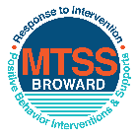This form provides a timeline to complete best practices and required actions. This timeline should drive team actions and accountability. As you implement your SPBP *NEXT* year, check off **completed items** and indicate the accountable person. (Complete only the yellow highlighted area at this time). Next year, you will upload this completed plan within your SPBP.

Required actions for all schools in Broward County

Best Practices for all schools in Broward County

**Resources**

|  |  |  |
| --- | --- | --- |
| **SPBP Team Implementation Action Plan 2018 - 2019** | | |
| **Month** | **Action Step**  *check when Action completed* | **Completed:**  Person Responsible  Name & Title |
| **Current** | **This Action Plan has been saved to use *next year* during quarterly meetings** | **Lauren Kirik-SPBP Chairperson** |
| **Current** | **Create a SPBP binder or portfolio to retain (for 2 years) hard copies of: your SPBPs, Action Plans, staff PBIS professional development attendance, stakeholder training attendance, quarterly meeting agendas, quarterly staff behavior presentations, voting attendance and outcome, Expectation lesson plans and Rules lesson plans** | **Lauren Kirik-SPBP Chairperson** |
| **Pre Planning**  **2018** | Print up your SPBP Review and school score from OSPA  Provide SPBP presentation to all staff during Pre Planning  Disseminate the current SPBP (hard copy or electronically) to all staff and stakeholders  Market and post school-wide Expectations and location-specific Rules (posters, PSAs, etc.)  Identify your RtI Instructional Facilitator provided by the district  (Contact [tyyne.hogan@browardschools.com](mailto:tyyne.hogan@browardschools.com) for more information, if you are unsure)  Confirm 1st team meeting date and time | Jennifer Kashdin-Assistant Principal |
| **August**  **1st meeting** | Ensure schedule of quarterly meeting dates for entire year as indicated in the SPBP  Determine any needed team training, such as the 4 Step PSP Brainshark Series, 10 Critical  Elements Brainsharks, Data Collection, Effective CPST Teams, PBIS 101, etc.  Trainings available at: <http://www.browardprevention.org/mtssrti/training-modules/>  Review previous year’s behavior data. (Use ‘Agenda’ and ‘Data Collection Template’)  Forms available at: <http://www.browardprevention.org/mtssrti/rtib> in Tier 1, Teaming  Present implementation data, behavior data, team activities and progress to entire staff  Utilize the 4 Step Problem Solving Process to develop initial interventions  Review previous year’s SPBP and feedback form  Verify and implement teaching schedule for SPBP Expectations and Rules behavior lesson plans | Jennifer Kashdin-Assistant Principal |
| **September** | Provide stakeholder presentation on SPBP prior to October 1  Check for staff and teacher understanding of PBIS - provide “PBIS 101” Brainshark as a resource  Brainshark available at: http://www.brainshark.com/browardschools/PBIS101 | **Lauren Kirik-SPBP Chairperson** |
| **October**  **2nd meeting** | Ensure instructional staff know how to (and are, as needed) enter Tier 1 Supplemental Strategies  for behavior in BASIS  Present implementation data, behavior data, team activities and progress to entire staff | Lauren Kirik-SPBP Chairperson |
| **November** | Staff to re-teach Expectations and Rules first day back from break.  Team to develop new and/or improved lesson plans as indicated by behavior data. | Jennifer Kashdin-Assistant Principal |
| **January**  **2019**  **3rd meeting**  Prepare for *2019/20* SPBP | Staff to re-teach Expectations and Rules first day back from break  Ensure the Principal signs in and watches the *new* SPBP Brainshark: Due January 30th  Present implementation data, behavior data, team activities and progress to entire staff  Choose team members and dates to work on, complete, and submit the *new* SPBP  Teams watch the *new* SPBP Brainsharks and refers to *new* “Additional items”  Brainsharks and Additional items posted at: <http://www.browardprevention.org/mtssrti/rtib> | Lauren Kirik-SPBP Chairperson |
| **February** | Ensure progress towards completion of SPBP  Check on recently hired staff for PBIS understanding - provide “PBIS 101” Brainshark resource  Provide the SPBP Surveymonkey link to all staff (optional). Email [Tyyne.hogan@browardschools.com](mailto:Tyyne.hogan@browardschools.com) to request analysis. | Jennifer Kashdin-Assistant Principal |
| **March**  **4th meeting** | Ensure progress towards completion of SPBP  Provide staff presentation and vote on new SPBP for next year  Provide stakeholders/parent presentation on new SPBP for next year  Present implementation data, behavior data, team activities and progress to entire staff | Lauren Kirik-SPBP Chairperson |
| **April** | Submit your SPBP in OSPA by April 30th every year | **Lauren Kirik-SPBP Chairperson** |

|  |
| --- |
| **CRITICAL ELEMENT # 10: Monitoring Plans** |

**10A.** How will you determine the success **of *staff* implementation** of the School-wide Positive Behavior Plan?

*“Are* ***staff*** *implementing the SPBP with fidelity? How do you know?”*

|  |  |  |  |
| --- | --- | --- | --- |
| **Fidelity of Implementation Monitoring Plan** | | | |
| Action Step | Create an **observable** and **measureable** SMART goal to determine “successful”  **staff implementation** of action step | When will data be collected, analyzed & presented? | Person responsible to collect and analyze data |
| School-wide **expectations** and location-specific **rules** are posted across campus | By August 24, 2018 100% of classrooms will post location specific rules and expectations. 100% of non-classroom areas (ie: cafeteria, hallways, office) will also post rules and expectations. | Refer to **quarterly** presentation dates in 2B.  This is the data the team will be sharing during presentations. | Jennifer Kashdin |
| **Behavior lesson plans** are being taught as written and when indicated | By August 24, 2018 100% of classroom teachers, including specials area teachers, will teach all behavior lesson plans as they are written. | Jennifer Kashdin |
| **Discipline consequences**  and **flow chart** are being used by all staff as written | By August 15, 2018 all teachers will receive discipline consequences and flow charts to reference when managing classroom behaviors. | Jennifer Kashdin |
| A **reward system** is being implemented for *all* students | By August 24, 2018 the kindness coin system will be fully implemented by all classroom teachers including specials, throughout the school with students from every class receiving rewards and recognition throughout the year. | Vicky Bureau |

**10B.** How will you determine whether the SPBP is successful in positively impacting **students?**

*“If staff are implementing the SPBP consistently and effectively, did it positively impact* ***the students****? How do you know?”*

|  |  |  |  |
| --- | --- | --- | --- |
| **Student Outcome Monitoring Plan** | | | |
| Student Outcome Data | Create an **observable** and **measureable** SMART goal to determine “successful”  **student outcomes** | When will data be collected, analyzed & presented? | Person responsible to collect and analyze data |
| See critical element 3A  • Type of **behavior incidents** data | By May 2019, the number of referrals for unruly and insubordinate behaviors including unruly play will decrease by at least 30%. | Refer to **quarterly** presentation dates in 2B.  This is the data the team will be sharing during presentations. | Lauren Kirik |
| See critical element 4A  • **Top 3 event locations** data | By May 2019, the number of referrals for these 3 locations (cafeteria, hallway and playground) will decrease by at least 30%. | Jennifer Kashdin |
| See critical element 8  • **Core effectiveness** data | By May 2019, the core effectiveness plan will reduce referral by 3%. | Jennifer Kashdin |
| See critical element 7A  • **Grade Level/Classroom referrals** data | By May 2019, grade level referrals will decrease by 3%. | Jennifer Kashdin |