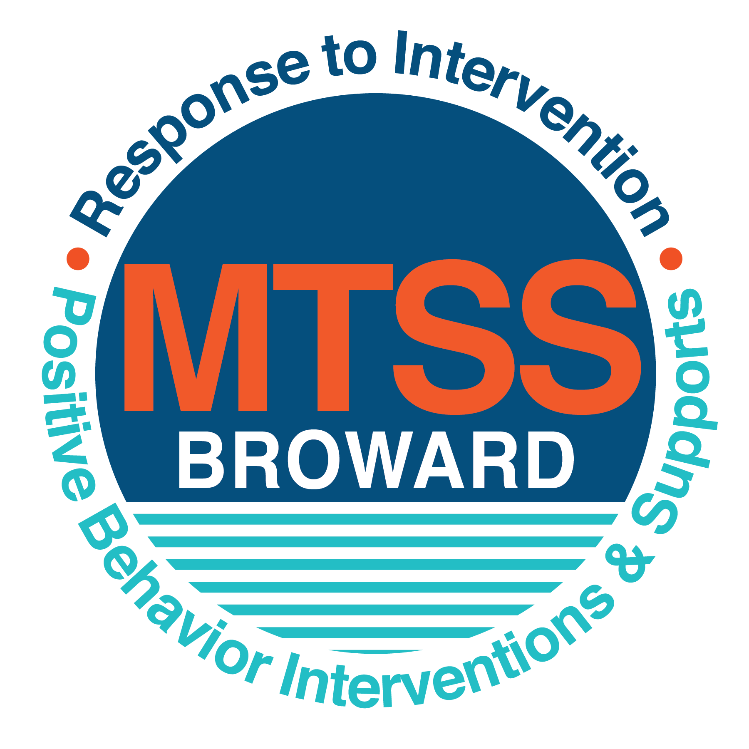

**School-wide Positive Behavior Plan (SPBP)**

Broward County Public Schools

To be implemented in SY 2018/19

**Elements have changed in the SPBP.**

Before completing, go to[**http://www.browardprevention.org/mtssrti/rtib/ →**](http://www.browardprevention.org/mtssrti/rtib/%20→)*School-wide Positive Behavior Plan* for:

* **A NEW Brainshark for Principals. ACTION: Log in with your p # and watch the Brainshark before Jan 30th.**
* **A NEW Overview Brainshark for Teams. ACTION: Log in with school name and watch the Brainshark.**
* A NEW mini Brainshark Series for teams. These Brainsharks are divided into the 10 Critical Elements of PBIS. They will

show you “how to” write a comprehensive SPBP (and receive a high score!)

* A Rating Rubric to ensure teams will correctly complete the SPBP and develop a meaningful plan.

To provide consistency across the District, *only plans entered on the current district template will be accepted*.

**ACTION: Download, complete and upload the SPBP into your School Improvement Plan before May 1, 2018:**

|  |  |
| --- | --- |
| **School Name:** | **McNicol Middle School** |
| **School Number:** | **0481** |
| **SPBP Contact Name:** | **Sophia Brown** |
| **Direct Phone Number:** | **754-323-3400** |

|  |
| --- |
| **CRITICAL ELEMENT # 1: Active Team with Administrative Participation** |

**1A.** List your current (SY 2017/18) team members (6 - 10 team members). **Must include an instructional representative from EACH grade/content area.** *Each name on this list verifies attendance in ongoing team meetings and participation in developing this SPBP. Each member is responsible for representing major stakeholders and sharing the SPBP content and updates with their respective group.*

|  |  |  |
| --- | --- | --- |
| **Full Name** | **Position** | **Who or what grade level does this member represent?** |
| **Melissa Gurreonero** | **Principal** | **Administration** |
| **Sophia Brown** | **SPBP Point of Contact** | **Behavior Specialist** |
| **Latonya Gardener** | **Parent/Community Representation** | **SAC** |
| **Charles Montalto** | **BTU Representative** | **Teacher** |
| **Chandra Lee** | **Guidance Director** | **Guidance** |
| **Brisco Decembert** | **Assistant Principal** | **Administration 7th Grade** |
| **Stephen Williams** | **Security Specialist** | **Security** |
| **Lara Ruddy** | **Literacy Coach** | **Teacher** |
| **Dacyany Ibarrondo** | **Administration** | **Administration 6th Grade** |
| **Deirdre-Benka- Coker** | **Administration** | **Administration 8th Grade** |

**1B**. Schedule and document your quarterly team meeting dates for *next* 2018/19 school year:

|  |  |  |  |
| --- | --- | --- | --- |
| **Meeting Date** | **Meeting Time** | **Name & title of person responsible to facilitate meeting** | **Content of meetings:** |
| **8/20/2018** | **8:00am** | **Linda Lopez /Behavior Specialist** | 1. Create and disseminate updated  Expectations and Rules lesson  plans (#3 and #4)  2. Review progress of  Implementation Action Plan (#9)  3. Collect & analyze implementation  data (#10A)  4. Collect & analyze student  outcome data (#10B) |
| **10/17/2018** | **8:15am** | **Linda Lopez / Behavior Specialist** |
| **1/24/2018** | **8:15am** | **Linda Lopez / Behavior Specialist** |
| **4/2/2018** | **8:15am** | **Linda Lopez / Behavior Specialist** |

|  |
| --- |
| **CRITICAL ELEMENT # 2: Faculty & Stakeholder Commitment:** |

**2A**. Action Steps completed **this year** (SY 2017/18) that increased faculty and stakeholder understanding and knowledge of your *new* (2018/19) SPBP:

|  |  |  |  |
| --- | --- | --- | --- |
| **Action Steps:** | **Date**  *(Between Jan 15 –*  *April 30, 2018)* | **Details**  *(retain attendance sheets at school)* | **Person responsible to collect and retain attendance sheets:** |
| Presented the *new* SPBP (for SY 2018/19) to staff | **4/2/2018** | **40 Faculty members** | **Sophia A. Brown** |
| Held a *faculty* vote on the new SPBP  (for SY 2018/19) | **4/16/2018** | **95%** | **Sophia A. Brown** |
| Presented the *new* SPBP (for SY 2018/19) to stakeholders (parents and community) | **4/19/2018** | **# of participants = 18** | **Sophia A. Brown** |

**2B.** Action Steps to be completed **next year** (SY 2018/19) to increase faculty and stakeholder understanding and knowledge of your SPBP:

|  |  |  |  |
| --- | --- | --- | --- |
| **Action Steps:** | **Date(s)**  *(NEXT YEAR)* | **Content**  *(retain attendance sheets at school)* | **Person responsible to collect and retain attendance sheets:** |
| Provide a professional development on the 2018/19SPBP for all staff | **Prior to students’ 1st day:**  **8/10/2018** | The team will present the updates in the SPBP for the 18/19 school year. All stakeholders will be provided with access to the SPBP. Feedback will be collected for future team meetings. | **Linda Lopez** |
| Present the 2018/19SPBP to stakeholders (parents and community) | **Prior to Oct 1st, 2018**  **9/20/2018** |
| Present behavior data to staff  *Quarterly: minimum of 4 each year* | **1. 10/1/2018** | The team will present the implementation data in 10A. Include:  • the “marketing” (teaching and posting) of expectations and rules  • lesson plan implementation  • discipline procedures  • reward system implementation  The team will present the student outcome data in 10B. Include:  • top 3 event locations  • type of behavior incidents  • core effectiveness data  • classroom referral data, as well as analysis of this data. | **Linda Lopez** |
| **2. 12/3/2018** |
| **3. 2/4/2019** |
| **4. 4/1/2018** |

|  |
| --- |
| **CRITICAL ELEMENT # 3: School-wide Expectations** |

**3A.** List the **top 10 behavior incidents** data YTD from BASIS 3.0 Behavior Dashboard:

|  |  |
| --- | --- |
| **Top 10 Behavior Incidents**  *(put N/A in any blank spaces)* | |
| **1. Unruly Disruptive** | **6. Level 3 Bus Violations** |
| **2. Disobedience /Insubordination** | **7. Level 2 Bus Violations** |
| **3. Fight- Minor Altercations** | **8. Profanity to staff** |
| **4. Disruptive Unruly Horse Play** | **9. Insulting, profane /obscene language** |
| **5. Fighting Medium** | **10. Defiance of Authority** |

**3B.** Based on the behavior incidents in 3A, develop 3 – 5 **positive characteristics** *(not behaviors)* that would counteract the demonstration of these misbehaviors. These positive characteristics become your school-wide expectations.

|  |
| --- |
| **School-wide Expectations** |
| **1.Be Responsible** |
| **2.Be Respectful** |
| **3.Be Safe** |
| **4.Be A Learner** |
|  |

**3C.** Research indicates that discipline referrals increase after long holidays and during testing times. Plan to teach your expectations at least 3 times throughout the year (and anytime the expected behaviors are not being demonstrated).

**ACTION:** Create at least one lesson plan for **each** school-wide expectation above and distribute to teachers during pre-planning 2018-19. Develop additional lesson plans you will use throughout the year to re-teach and reinforce your school-wide expectations. *You do not need to submit your lesson plans with the SPBP. Retain all behavior lesson plans at the school; make sure these lesson plans are available for guests and stakeholders.*

|  |  |  |  |
| --- | --- | --- | --- |
| **When will school-wide expectations lesson plans be taught?** | | | |
|  | Date(s) | Time: | |
| August | **08/20/2018** | **8:20 am- 9:00am** | |
| January | **01/17/2019** | **8:00 am-9:00am** | |
| 4th Quarter | **04/01/ 2019** | **8:00 am- 9:00am** | |
|  | | | |
| Who will be responsible for teaching the lesson plans? | | | **Behavior Specialist- Linda Lopez** |
| Where will the lesson plan instruction occur? | | | **Broadcast/ telecast through our morning show schoolwide, grade level discipline assemblies and reinforced by teachers in the classroom.** |
| Who is responsible for retaining, organizing and distributing all lesson plans? | | | **Behavior Specialist- Linda Lopez** |

|  |
| --- |
| **CRITICAL ELEMENT #4: Location-based Rules** |

**4A.** List the **top 3 locations** for behavior Events YTD from BASIS 3.0 Behavior Dashboard**.** ***Do not use “classroom”***

|  |  |
| --- | --- |
| **Top 3 Locations** | |
| School Location | # Incidents |
| 1. **Bus Loop** | **42** |
| 1. **Hallway** | **43** |
| 1. **Cafeteria** | **26** |

**4B.** Create an Expectations/Rules Matrix from your 3-5 school-wide expectations and your top 3 event locations. Develop a positively stated, observable, and measurable rule that correlates with every expectation to create a maximum of 5 rules under each location**.**

|  |  |  |  |  |
| --- | --- | --- | --- | --- |
| **Expectations and Rules Matrix** | | | | |
| **School-wide EXPECTATIONS** | *Copy and paste expectations from* ***3C****.* | **IDENTIFIED LOCATIONS**  *Copy and paste locations from* ***4A.*** | | |
| **Hallway** | **Cafeteria** | **Bus Loop** |
| **Rules** | **Rules** | **Rules** |
| **Be Respectful** | **Use appropriate language while communicating** | **Clean your area, before leaving the Cafeteria** | **Board your bus when directed** |
| **Be Responsible** | **Proceed directly to your assigned classes on time** | **Adhere to Level 3 announcements for dismissal procedures** | **Board your assigned bus** |
| **Be Safe** | **Walk on the right of the hallway, and keep hands and objects to yourself** | **Remain seated at your assigned tables; sitting up straight, with both feet on the ground** | **Stand inside the boundary fence** |
| **Be A Learner** | **Transition quickly to your assigned location** | **Adhere to level three during dismissal procedures** | **Use voice level II when in the bus loop** |
| Click here to enter Expectation #5 | Click here to enter a Rule | Click here to enter a Rule | Click here to enter a Rule |

**4C**. Research indicates that discipline referrals increase after long holidays and during testing times. Plan to teach your location-specific rules at least 3 times throughout the year (and anytime the expected behaviors are not being demonstrated).

**ACTION:** Create at least one lesson plan for **each** location above and distribute to teachers during pre-planning 2018-19. Develop additional lesson plans you will use throughout the year to re-teach and reinforce your location-specific rules.

*You do not need to submit your lesson plans with the SPBP. Retain all behavior lesson plans at the school; make sure these lesson plans are available for guests and stakeholders.*

|  |  |  |  |
| --- | --- | --- | --- |
| **When will location-specific rules lesson plans be taught?** | | | |
|  | Date(s) | Time: | |
| August | **08/20/2018** | **8:30am- 9:05am** | |
| January | **01/017/2019** | **8:00am -9:45am** | |
| 4th Quarter | **04/01/2019** | **8:00am- 8:45am** | |
|  | | | |
| Who will be responsible for teaching the lesson plans? | | | **Behavior Specialist** |
| Where will the lesson plan instruction occur? | | | **Within the classroom, and reinforced in behavior assembly** |
| Who is responsible for retaining, organizing and distributing all lesson plans? | | | **Linda Lopez** |

|  |
| --- |
| **CRITICAL ELEMENT # 5: Reward and Recognition Programs** |

Although you will post, teach, review, practice and reinforce all school-wide expectations and location-specific rules, **choose 1 expectation OR 1 event location** you will target for a specific reward program for students. Based on the data that led to this expectation or location, create a reward plan using the 4 Step Problem Solving Process:

Expectation or Location: **_______________Being Respectful__________________________**

|  |  |
| --- | --- |
| **4 Step Problem Solving Process** | **Plan** |
| **1. Problem Identification:** Use your behavior data to identify a school-wide problem.  What problem did you identify? *(use numerical data)* | **Data used:** The number of Office Discipline Referrals for minor fights and altercations/ confrontations.    **Problem Identification:** The number of office discipline referrals for minor fights altercations /confrontations; currently stands at (60), a 15% increase over last year’s number of (52). |
| **2**. **Problem Analysis:** Why do you think this problem is occurring?  What is your goal? *(use a SMART goal statement with numerical data)* | **Hypothesis:** Students lack maturity and social tolerance which often results in conflict, leading to minor fights, confrontations and altercations.  An expectation specific reward system, is needed to reinforce “**respect”** as one of core B 4s.  **Goal Statement:** By the end of the 2018-2019 school year, office discipline referrals for minor fights and altercations will decrease from 60 to 40 referrals; a 33% reduction. |
| **3. Intervention Design:**  Describehow you will implement a positive reward program to decrease this problem. | **Type of System:** Lottery  **Description of System:** The top 36 students who display attitudes which exemplify and embody respect and social tolerance around our campus, will be given a **Caught You Excelling** ticket, (*6th grade pink, 7th grade blue and 8th grade white tickets, to distinguish participants by grade level*) which they will deposit into a designated receptacle in the Cafeteria.  There will be a drawing on our televised morning show every Monday morning, where the 3 lucky winners across each grade level, will receive a $5 McDonald’s gift card. As a consolation prize/reward; a monthly **HAWK HONOR CODE** ice cream social will be hosted for all lottery ticket recipients, on the last Friday of each month during 6th period. |
| **4. Evaluation:**  A. Implementation fidelity | 1. **How do you monitor the fidelity (consistency and effectiveness) of the staff’s implementation of the reward program?**   The Behavior Specialist will generate and distribute lottery tickets in teacher’s mailboxes. She will track the number of entries which must meet a minimum of 36 eligible students weekly. Both staff and students will be tracked and documented, using the **Hawk Honor Code** tab within the **HERO Plasco-Trac System**. Teachers who issue tickets to student participants, will also be entered in a monthly drawing for a chance to win a gift card. |
| B. Student outcome monitoring | 1. **How will you know if the reward program is positively impacting students?** Minor fight referral data will be collected from BASIS every Friday to determine the effectiveness of this **RESPECT** expectation specific reward program. The team will meet on 10/01/2018, to determine our goal of reducing the number of office discipline referrals by 33% is being actualized. |

|  |
| --- |
| **CRITICAL ELEMENT #6 Effective Discipline Procedures** |

**6A. Staff Managed Misbehaviors:** List the top 6 *most common* school-wide misbehaviors **staff are expected to manage.**

Write a short, objective, and measurable definition for each.

|  |  |
| --- | --- |
| **Staff Managed Misbehaviors** | |
| Misbehavior | “Looks Like” - *provide a description with example(s)* |
| 1.Unruly horse- play | Roughhousing or physical boisterous play |
| 2. Tardy to class | Arriving to class after the tardy bell, without a pass |
| 3. Inappropriate language | Using inappropriate language while on campus |
| 4.Use of cell phone in class | The act of text messaging, playing video games or any other use of a cellphone during class, without the expressed permission from the teacher |
| 5.Out of seat without permission | Student fails to remain seated for the duration of class |
| 6.Name Calling and teasing | Verbal statements made to intentionally harm or belittle a student |

**6B. Staff Managed Consequences**: Create a consequencemenu **OR** a consequence hierarchy for staff to use when students exhibit the above misbehaviors. Provide a minimum of **5** consequences.

|  |  |
| --- | --- |
| Is this a menu or hierarchy system? | **Menu** Hierarchy |
| * **Warning** | |
| * **In class intervention- (time out -15 minutes, seat change)** | |
| * **Parent Contact** | |
| * **Teacher detention** | |
| * **Guidance or Administrative Referral** | |

**6C. Administration Managed Misbehaviors**:

(a) Define the first 3 behaviors by providing examples that clearly identify the point at which the misbehavior warrants an Office Discipline Referral (ODR).

(b) List two additional common school-wide misbehaviors that will result in an ODR. Provide concrete examples.

(c) Determine staff tolerance level for repetitive misbehaviors (the point at which the number of staff-managed misbehaviors becomes an ODR).

|  |  |
| --- | --- |
| **Office Discipline Referrals (ODRs)** | |
| Behavior | “Looks Like” - *provide a description with example(s)* |
| 1.Disobedience/Insubordination | The deliberate refusal to obey a reasonable request. |
| 2. Fighting | Two or more individuals engaged in a physical altercation, exchanging physical contact rendering strikes with the intent to injure. |
| 3. Defiance of authority | A daring and bold resistance, disregard and contempt to staff or authority figure. |
| 4. Use of profanity | The use of language that is offensive, condescending and or degrading. |
| 5. Disruptive/Unruly Play | Roughhousing, physical boisterous play, capable of escalating into a physical alteration. |
| 6. Repetitive staff managed  misbehaviors | More than misbehaviors inwarrants an office referral.  one  period  2 |

**6D. School-wide Discipline Flow Chart:**

(a) Review the sample discipline flow charts in “Additional Items” located on browardprevention.org

(b) Copy or customize a flow chart to graphically represent the discipline process at **your** school.

(c) Paste the flow chart here**OR** complete the flow chart below.

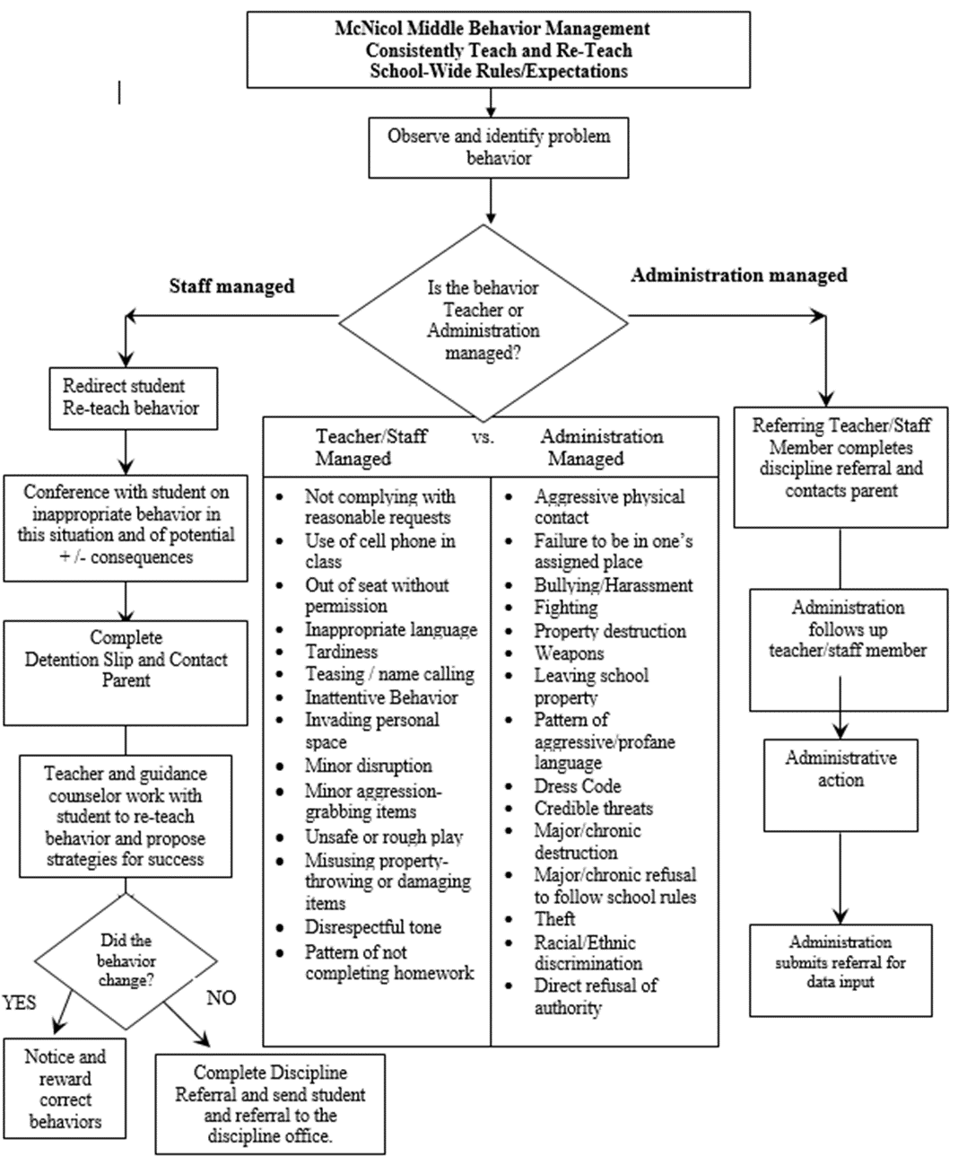

|  |
| --- |
| **CRITICAL ELEMENT # 7: Classroom Management Systems** |

**7A.** ALL teachers implement an effective Tier 1 classroom management system:

|  |  |
| --- | --- |
| Which **evidence-based** classroom management system is supported by your school’s administration and is expected to be implemented school-wide?  *(Class Dojo, LEAPs, HERO, Cloud 9, etc. are tools,* ***not*** *classroom systems)* | **CHAMPs\***  **PBIS Classroom Management**  **Administration does not expect an evidence-based classroom management system to be implemented by teachers this year**  **(*your school will need to adopt one next year)***  **Other *(complete below)*** |
| If other, name the **evidence-based classroom management system:** |  |
| *CHAMPs is the district-supported, evidence-based universal classroom management system for all teachers. Would your Principal like to be contacted to learn about CHAMPs professional development? | **Yes  No** |

**7B.** Fidelity of **staff** implementation of school-wide classroom management systems

|  |
| --- |
| What data collection tool does your school leadership team use to monitor and evaluate your teacher’s classroom management skills? *(Measure* ***staff skills****, not student outcomes)* |
| CHAMPs 7 Up Checklist |
| CHAMPs Classroom Check Up (CCU) |
| PBIS Classroom Assistance Tool (CAT) |
| **PBIS Walkthrough** |
| **Marzano’s Domain 1, Design Questions 5, 6, 7, 8, 9** |
| Fidelity of staff classroom management implementation is not monitored to determine training needs this year *(you will need to adopt a tool and plan next year)* |
| Other *(specify):* |
| Explain how this data is collected and analyzed by your school leadership team as a **universal screening** *across teachers* to determine the need for classroom management training: |
| **Fidelity of Implementation Plan***:* Marzano’s Design questions 5-9 is used by the administrative team to determine staff needs, for classroom management support. Referral data within BASIS is used as a supplemental indicator of staff who would benefit from classroom management strategies. Regular PBIS walkthroughs are conducted by Behavior Specialist in a quest to provide direct support in the form of team teaching and or modelling. Classroom management trainings will be conducted, with a focus on student engagement strategies, classroom management tools and adherence to the flowchart hierarchy. Teachers are compensated for attending these best practice trainings, which are scheduled after school. |

**7C. Percentage of Classroom Referrals:**

(a) Review your classroom data YTD (“Events by Location”) in BASIS 3.0 Behavior Dashboard.

(b) Complete the yellow highlighted cells first.

(c) Auto-calculate the % of referrals in the classroom by clicking on “!Zero Divide” in the next cell and pressing “Fn + F9” together.

|  |  |
| --- | --- |
| Total number of discipline referrals **from classrooms**: | **306** |
| Total number of **school-wide** discipline referrals: | **159** |
| % of referrals in the classroom: | **66%** |
| Do more than 40% of your referrals come from the classroom? | **Yes  No** |

***If >40% of discipline referrals come from the classroom, it suggests Tier 1 classroom management implementation may need to be strengthened school-wide.***

|  |
| --- |
| **CRITICAL ELEMENT # 8: Data Collection and Analysis** |

**8A. Determine your School-wide Core Effectiveness YTD** from the BASIS Behavior Dashboard in the “Referrals per Student” chart.

(a) Complete the yellow highlighted cells first.

(b) Auto-calculate the “% of Total Population” by clicking on each “!Zero Divide” in the cells and pressing “Fn + F9”.

(c) Determine if the core is effective in all three areas

|  |  |  |  |  |
| --- | --- | --- | --- | --- |
| TOTAL Population: | 775 |  |  | |
| # Referrals |  | **% of Total Population** | Core Effectiveness | |
| 0 - 1 referral |  | 88% | Are your 0 – 1 referrals > 80%? | Yes No |
| 2 - 5 referrals  (at risk students) | 74 | 10% | Are your 2 - 5 referrals <15%? | Yes No |
| > 5 referrals  (high risk students) | 18 | 2% | Are your >5 referrals <5%? | Yes No |

**8B. Core Effectiveness Plan:**

|  |  |
| --- | --- |
| If all 3 are “**Yes**”, your core is effective. Is your core behavior curriculum effective? | Yes No |
| Answer **either** (a) or (b):  (a) If you answered “**Yes**”, although your core is effective, what plan does your school leadership team implement for early identification of at risk and high risk students?  (b) If you answered “**NO”**, indicate the supports and interventions your school leadership team will implement at the beginning of the next school year to improve core strength: | |
| **Core Effectiveness Plan:** At the start of the school year, the Behavior Specialist and Administrative team will source behavior data to identify our- risk student cohort by grade level, as indicated in BASIS. Students who received 3 referrals or greater during the academic year, will be strategically scheduled for a social- emotional elective, as part of a TIER 2 plan. A daily behavior feedback / progress monitoring sheet, will be used over the course of the quarter to determine the degree of effectiveness of this TIER two support strategy. | |

**8C. Disproportionality: Determine if there are any issues within subgroups** from BASIS 3.0 Behavior Dashboard in the “Referrals by Demographics” chart.

(a) Complete the yellow highlighted cells first.

(b) Auto-calculate the difference by clicking on each “0” in the next cell and pressing “Fn + F9”.

|  |  |  |  |  |
| --- | --- | --- | --- | --- |
| Subgroups | (PctPop - Green)  % **of students** | (PctRef - Blue)  **% of referrals** | Difference in referral composition | Positive value suggests disproportionality  (Is the value positive?) |
| Black | 85% | 88% | 3 | Yes No |
| Hispanic/Latin | 14% | 11% | -3 | Yes No |
| White | 2% | 1% | -1 | Yes No |

**8D. Disproportionality Plan:** If any values are positive, the percentage of referrals contributed to that subgroup is higher than expected, given that subgroups’ percentage in the student population.

|  |  |
| --- | --- |
| If all 3 are “**No**”, disproportionality is not indicated. Are all 3 “No”? | Yes No |
| Answer **either** (a) or (b):  (a) If you answered “**Yes**”, although your data indicates equity, what plan does your school leadership team implement for early identification of any disproportionality issues  (b) If you answered “**No**”, indicate the support plan and interventions your school leadership team will implement at the beginning of next year to improve sub group disproportionality | |
| **Disproportionality Plan:** Our data indicates 3% disproportionality within the African American subgroup. To address this disproportionality, the behavior specialist and leadership team will implement social- emotional training and support initiatives, geared towards cultural sensitivity and social tolerance to improve school climate. Trainings will focus on student/student connectedness, and teacher/student connectedness, with reinforcement of the consequence and flowchart discipline hierarchy. Data will have collected monthly, following trainings to determine the impact of the plan, and the support needs of faculty. The requisite adjustments will be made based on data, to provide support for both staff and students. | |

|  |
| --- |
| **Critical Elements # 9: SPBP Implementation Planning** |

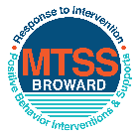This form provides a timeline to complete best practices and required actions. This timeline should drive team actions and accountability. As you implement your SPBP *NEXT* year, check off **completed items** and indicate the accountable person. (Complete only the yellow highlighted area at this time). Next year, you will upload this completed plan within your SPBP.

Required actions for all schools in Broward County

Best Practices for all schools in Broward County

**Resources**

|  |  |  |
| --- | --- | --- |
| **SPBP Team Implementation Action Plan 2018 - 2019** | | |
| **Month** | **Action Step**  *check when Action completed* | **Completed:**  Person Responsible  Name & Title |
| **Current** | **This Action Plan has been saved to use *next year* during quarterly meetings** | **Behavior Specialist Linda Lopez** |
| **Current** | **Create a SPBP binder or portfolio to retain (for 2 years) hard copies of: your SPBPs, Action Plans, staff PBIS professional development attendance, stakeholder training attendance, quarterly meeting agendas, quarterly staff behavior presentations, voting attendance and outcome, Expectation lesson plans and Rules lesson plans** | **Behavior Specialist Linda Lopez** |
| **Pre Planning**  **2018** | Print up your SPBP Review and school score from OSPA  Provide SPBP presentation to all staff during Pre Planning  Disseminate the current SPBP (hard copy or electronically) to all staff and stakeholders  Market and post school-wide Expectations and location-specific Rules (posters, PSAs, etc.)  Identify your RtI Instructional Facilitator provided by the district  (Contact [tyyne.hogan@browardschools.com](mailto:tyyne.hogan@browardschools.com) for more information, if you are unsure)  Confirm 1st team meeting date and time |  |
| **August**  **1st meeting** | Ensure schedule of quarterly meeting dates for entire year as indicated in the SPBP  Determine any needed team training, such as the 4 Step PSP Brainshark Series, 10 Critical  Elements Brainsharks, Data Collection, Effective CPST Teams, PBIS 101, etc.  Trainings available at: <http://www.browardprevention.org/mtssrti/training-modules/>  Review previous year’s behavior data. (Use ‘Agenda’ and ‘Data Collection Template’)  Forms available at: <http://www.browardprevention.org/mtssrti/rtib> in Tier 1, Teaming  Present implementation data, behavior data, team activities and progress to entire staff  Utilize the 4 Step Problem Solving Process to develop initial interventions  Review previous year’s SPBP and feedback form  Verify and implement teaching schedule for SPBP Expectations and Rules behavior lesson plans | Click here to enter NAME & title |
| **September** | Provide stakeholder presentation on SPBP prior to October 1  Check for staff and teacher understanding of PBIS - provide “PBIS 101” Brainshark as a resource  Brainshark available at: http://www.brainshark.com/browardschools/PBIS101 | Click here to enter NAME & title |
| **October**  **2nd meeting** | Ensure instructional staff know how to (and are, as needed) enter Tier 1 Supplemental Strategies  for behavior in BASIS  Present implementation data, behavior data, team activities and progress to entire staff | Click here to enter NAME & title. |
| **November** | Staff to re-teach Expectations and Rules first day back from break.  Team to develop new and/or improved lesson plans as indicated by behavior data. | Click here to enter NAME & title |
| **January**  **2019**  **3rd meeting**  Prepare for *2019/20* SPBP | Staff to re-teach Expectations and Rules first day back from break  Ensure the Principal signs in and watches the *new* SPBP Brainshark: Due January 30th  Present implementation data, behavior data, team activities and progress to entire staff  Choose team members and dates to work on, complete, and submit the *new* SPBP  Teams watch the *new* SPBP Brainsharks and refers to *new* “Additional items”  Brainsharks and Additional items posted at: <http://www.browardprevention.org/mtssrti/rtib> | Click here to enter NAME & title |
| **February** | Ensure progress towards completion of SPBP  Check on recently hired staff for PBIS understanding - provide “PBIS 101” Brainshark resource  Provide the SPBP Surveymonkey link to all staff (optional). Email [Tyyne.hogan@browardschools.com](mailto:Tyyne.hogan@browardschools.com) to request analysis. | Click here to enter NAME & title |
| **March**  **4th meeting** | Ensure progress towards completion of SPBP  Provide staff presentation and vote on new SPBP for next year  Provide stakeholders/parent presentation on new SPBP for next year  Present implementation data, behavior data, team activities and progress to entire staff |  |
| **April** | Submit your SPBP in OSPA by April 30th every year | Click here to enter NAME & title |

|  |
| --- |
| **CRITICAL ELEMENT # 10: Monitoring Plans** |

**10A.** How will you determine the success **of *staff* implementation** of the School-wide Positive Behavior Plan?

*“Are* ***staff*** *implementing the SPBP with fidelity? How do you know?”*

|  |  |  |  |
| --- | --- | --- | --- |
| **Fidelity of Implementation Monitoring Plan** | | | |
| Action Step | Create an **observable** and **measureable** SMART goal to determine “successful”  **staff implementation** of action step | When will data be collected, analyzed & presented? | Person responsible to collect and analyze data |
| School-wide **expectations** and location-specific **rules** are posted across campus | By August 15, 2018, 100% of our school hallways will have a minimum of 2 school-wide expectation and location specific expectations posters posted as measured by a formal PBIS walk-though. | Refer to **quarterly** presentation dates in 2B.  This is the data the team will be sharing during presentations. | **Linda Lopez** |
| **Behavior lesson plans** are being taught as written and when indicated | By September 12, 2018, 94% of teachers will have taught school-wide expectations, and behavior lesson plans as measured by the submission of their teacher lesson plans to the Principal. | **Linda Lopez** |
| **Discipline consequences**  and **flow chart** are being used by all staff as written | Every quarter, there will be a 5% decrease in the number of Office Discipline Referrals that contain previously identified staff-managed misbehaviors to include; **unruly horse- play, tardy to class, Inappropriate language, use of cell phone in class,**  **out of seat without permission, name calling** as measured by a referral review by the PBIS team. | **Linda Lopez** |
| A **reward system** is being implemented for *all* students | By the end of the reward system timeline, 85% of staff will have provided a reinforcement to at least 25 different students as measured by the HERO database. | **Linda Lopez** |

**10B.** How will you determine whether the SPBP is successful in positively impacting **students?**

*“If staff are implementing the SPBP consistently and effectively, did it positively impact* ***the students****? How do you know?”*

|  |  |  |  |
| --- | --- | --- | --- |
| **Student Outcome Monitoring Plan** | | | |
| Student Outcome Data | Create an **observable** and **measureable** SMART goal to determine “successful”  **student outcomes** | When will data be collected, analyzed & presented? | Person responsible to collect and analyze data |
| See critical element 3A  • Type of **behavior incidents** data | By June 4, 2019, school-wide student Referrals incidents in u**nruly disruptive, disobedience /insubordination, fight- minor altercations and disruptive unruly horse play** will be reduced 5% each quarter, as measured by BASIS Behavior Dashboard. | Refer to **quarterly** presentation dates in 2B.  This is the data the team will be sharing during presentations. | **Linda Lopez** |
| See critical element 4A  • **Top 3 event locations** data | Every quarter, the number of student Office Discipline Referrals in the **Hallway, Cafeteria**, and **Bus Loop**, will decrease by 3% as measured by the BASIS Behavior Dashboard. | **Linda Lopez** |
| See critical element 8  • **Core effectiveness** data | Every quarter, the percentage of students who have 0 to 1 referrals will increase by 2% as measured in the BASIS Behavior Dashboard. | **Linda Lopez** |
| See critical element 7A  • **Grade Level/Classroom referrals** data | By the end of the first semester, the classroom Office Discipline Referrals from the incoming 7th Grade students,  will decrease by 10% as measured by the BASIS Behavior Dashboard. | **Linda Lopez** |