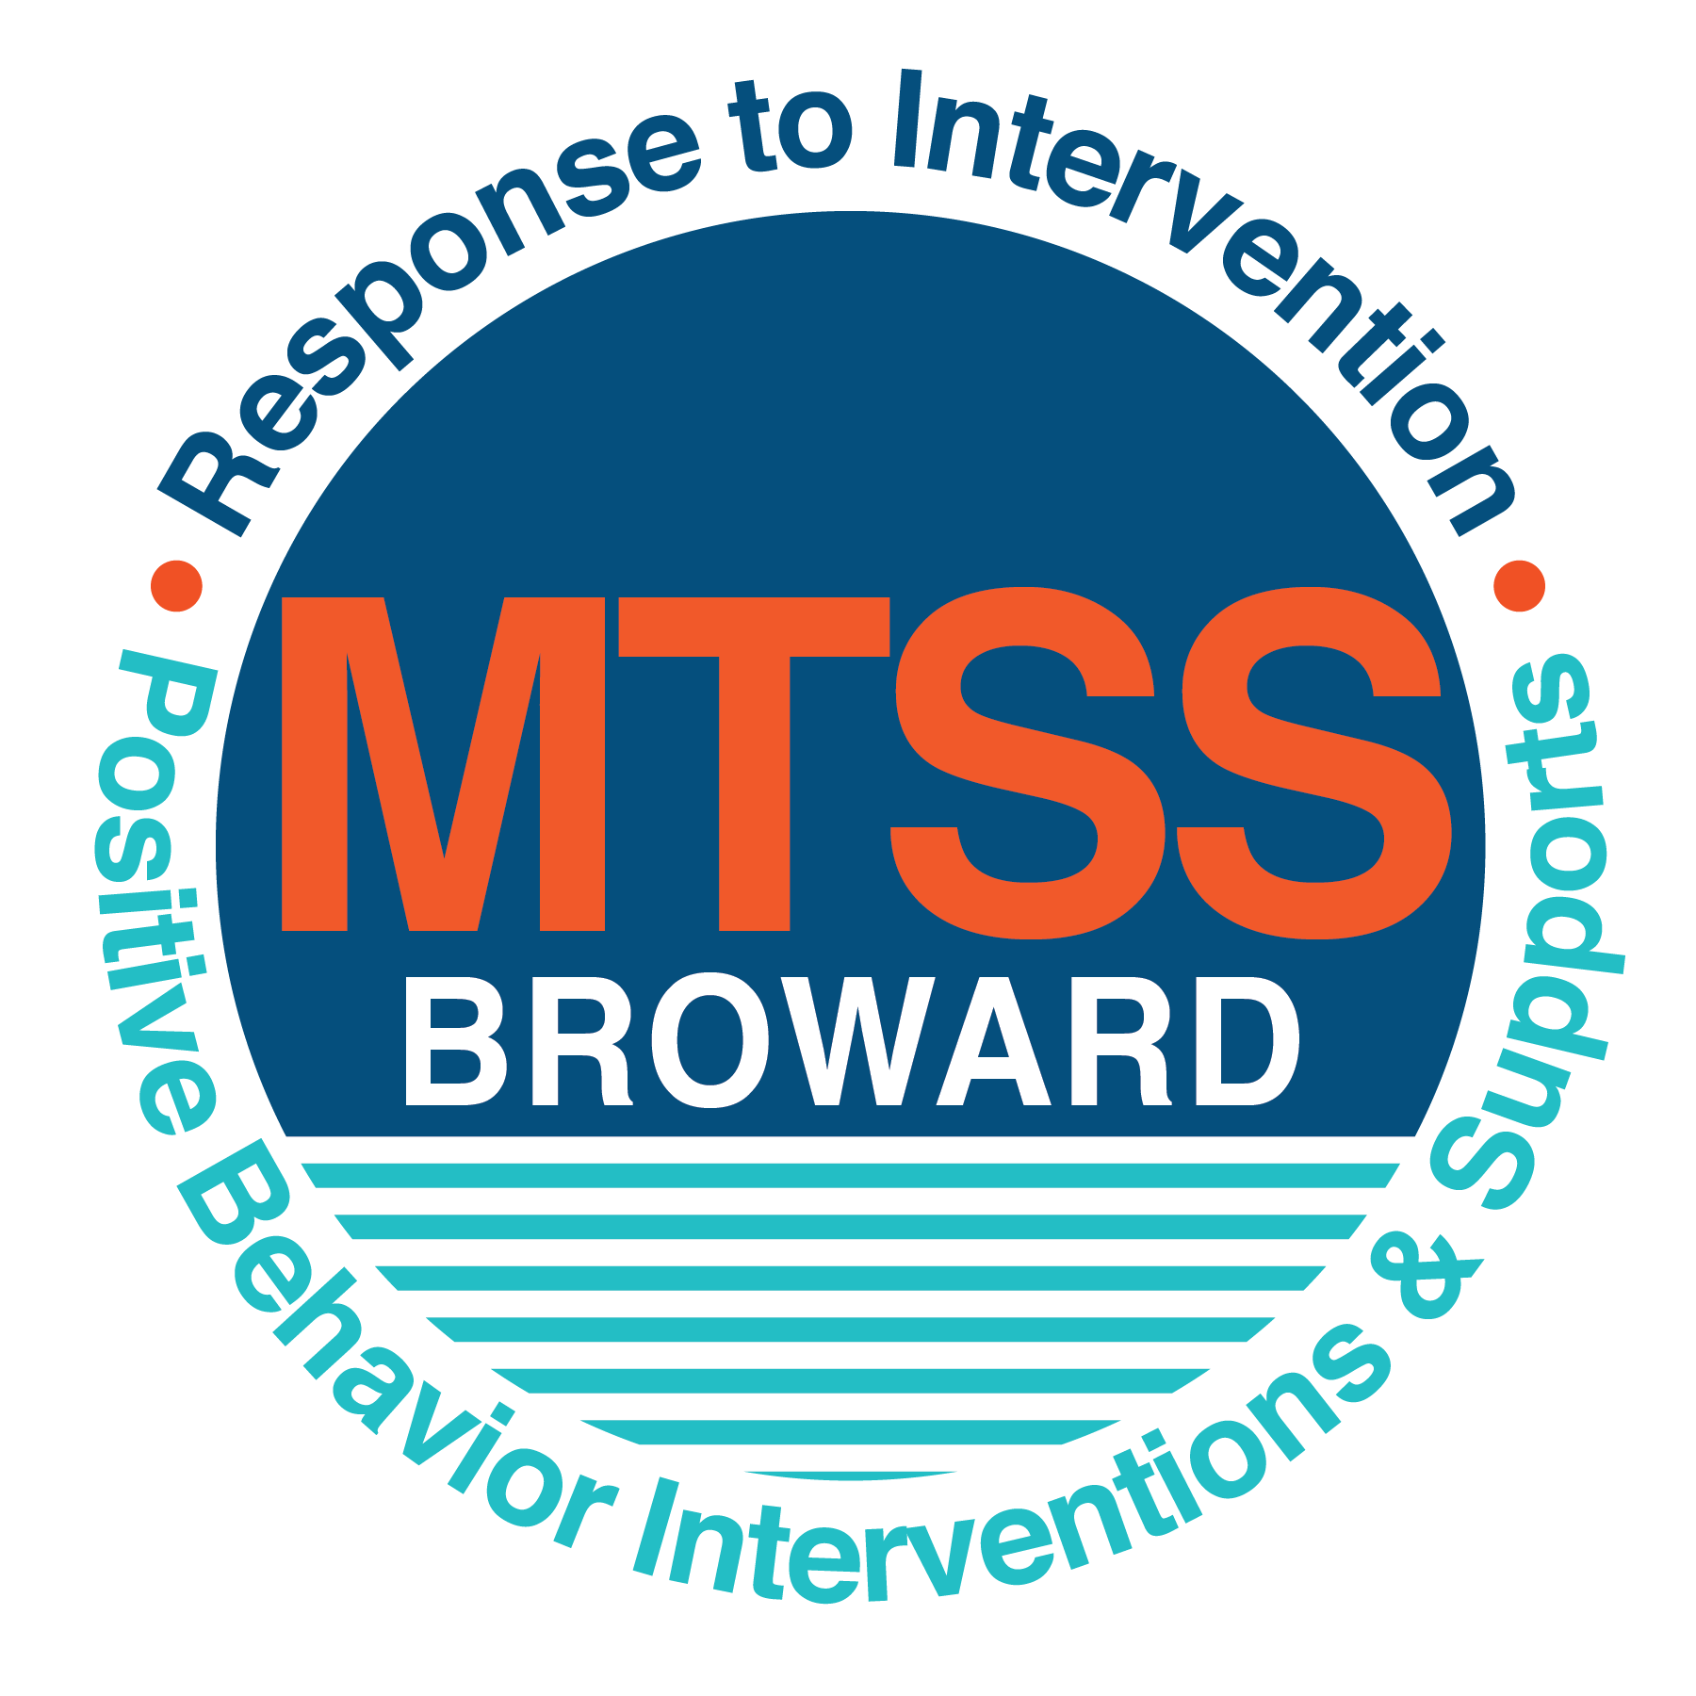
School-wide Positive Behavior Plan (SPBP)
Broward County Public Schools
To be implemented in SY 2019/20

School Name: | McNicol Middle
School Number: | 0841
SPBP Contact Name: | Jerelle Robinson
Direct Phone Number: | 754-323-3440

CRITICAL ELEMENT # 1: Active Team with Administrative Participation

1A. Current (SY 2018/19) SPBP team members:
Full Name | Position
Melissa Gurreonero | 1. Administration
Charles Montalto | 2. BTU Representative
Jerelle Robinson | 3. SPBP Point of Contact
Latonya Gardener | 4. Parent/Community Representation
Stephen Williams | 5. Security Specialist
Chandra Lee | 6. Guidance Director
Lara Ruddy | 7. Literacy Coach
Markis Facyson | 8. Math Teacher
Dacyany Ibarrondo | 9. Administrator
Brisco December | 10. Administrator
Deirdre Benka-Coker | 11. Administrator

1B. Schedule of quarterly SPBP Team Meeting dates for next 2019/20 school year:
Meeting Date | Meeting Time | Content of meetings:
8/13/2019 | 8:00 a.m. | 1. Progress of Action Steps indicated in Implementation Plan in #9  2. Collect & analyze fidelity of staff implementation data in #10A  3. Collect & analyze student outcome data in #10B
10/24/2019 | 8:00 a.m.
1/9/2020 | 8:00 a.m.
4/16/2020 | 8:00 a.m.

CRITICAL ELEMENT # 2: Faculty & Stakeholder Commitment:

2A. Action Steps completed this year (SY 2018/19) that increased faculty and stakeholder knowledge of the new SPBP:

Action Steps: | Date  (Between Jan 15 and  April 30, 2019) | Details  (Sign-in sheets in SPBP Binder)
Presented the new SPBP (for SY 2019/20) to staff | 3/18/2019 | # of participants = 38
Held a faculty vote on the new SPBP  (for SY 2019/20) | 3/18/2019 | # of participants =38  % approved =100%
Presented the new SPBP (for SY 2019/20) to stakeholders (parents and community) | 4/18/2019 | # of participants = 12

2B. Action Steps to be completed next year (SY 2019/20) to increase faculty and stakeholder knowledge of the new SPBP:

Action Steps: | Date  (SY 2019-20) | Content  (Sign-in sheets in SPBP Binder)
Provide professional development on the 2019/20 SPBP for all staff | Prior to students’ 1st day:  8/12/2019 | The team will present the updates in the SPBP for the 19/20 school year. All stakeholders will be provided with access to the SPBP. Feedback will be collected for future team meetings.
Present the 2019/20 SPBP to stakeholders  (parents and community) | Prior to Oct 1st, 2019  9/19/2019
Present the behavior data to all staff quarterly | 1. 10/21/2019 | The team will present:  - the team’s progress in the Implementation Plan in # 9.  - the fidelity of staff implementation data in #10A.  - the student outcome data in #10B.
 | 2. 1/13/2020
 | 3. 3/30/2020
 | 4. 5/26/2020

CRITICAL ELEMENT # 3: School-wide Expectations

3A. Top five behavior incidents data YTD as listed in BASIS 3.0
Top 5 Behavior Incidents
- Unruly/disruptive behavior
- Disobedience/insubordination
- Fight-Minor/altercation
- Disruptive/unruly play
- Fighting-Medium

3B. School-wide expectations are 3 – 5 positive characteristics (not behaviors) that counteract the demonstration of the top school-wide misbehaviors above. ALL people on campus model these expectations.
School-wide Expectations
- Be Responsible
- Be Respectful
- Be Safe
- Be a Learner

3C. At least one lesson plan for each school-wide expectation above is distributed to teachers during pre-planning SY 2019/20 and maintained in the SPBP Binder.
Dates the school-wide expectations lesson plans are taught:
 | Date(s) | Time: | Location(s):
August | 8/19/2019 | 8:30am | Auditorium, & Homeroom classrooms
January | 1/7/2020 | 8:30am | Auditorium & Homeroom classrooms
After Spring Break | 3/30/2020 | 8:30am | Auditorium & Homeroom classrooms

CRITICAL ELEMENT #4: Location-based Rules

4A. Top three school-wide locations for Behavior Events YTD.
Top 3 Locations, not including Classroom:
School Location | # Incidents
1. Hallway | 59
2.Bus | 35
3.Cafeteria | 21

4B. Expectations and Rules Chart for common areas of school campus: (next page)

Completed by each teacher | Classroom Rules
Expectations and Rules Chart | Bus Rules | Keep the aisle of the bus clear at all times | Take your seat promptly and sit facing forward at all times | Keep your head, hands, arms and objects inside the bus | Talk quietly so the driver can concentrate on driving safely
 | Cafeteria Rules | Adhere to Level 3 announcements for dismissal procedures | Clean your area before leaving the cafeteria | Remain seated at your assigned tables; sitting up straight with both feet on the ground | Adhere to level three during dismissal procedures
 | Hallway Rules | Proceed directly to your assigned classes on time | Use appropriate language while communicating | Walk on the right side of the hallway and keep hands and objects to yourself | Transition quickly to your assigned location
 | School-wide EXPECTATIONS | Be Responsible | Be Respectful | Be Safe | Be a Learner

4C. At least one Rules lesson plan for each specific location is distributed to teachers during pre-planning SY 2019/20 and maintained in the SPBP Binder.

Dates the Locations’ Rules lesson plans are taught
 | Date(s) | Time: | Location(s):
August | 8/19/2019 | 8:30am | Auditorium, Morning Show, and follow up with lesson plans in classrooms.
January | 1/7/2020 | 8:30am | Auditorium, Morning Show, and follow up with lesson plans in classrooms.
After Spring Break | 3/30/2020 | 8:30am | Auditorium, Morning Show, and follow up with lesson plans in classrooms.

CRITICAL ELEMENT # 5: Reward and Recognition Programs

5. The reward system is focused on one School-wide Expectation OR specific location at a time.
Expectation or Location: Hallway

4 Step Problem Solving Process | Plan Details
1. Problem Identification: Use your behavior data to identify one school-wide problem.  What problem did you identify? (use numerical data) | Data used: the number of Office Discipline Referrals (ODRs) from the hallway  Problem Identification Statement: The number of ODRs in the hallways for the 2018-2019 school year is 13% higher than last year (55)
2. Problem Analysis: Why do you think this problem is occurring?  What is your goal? (use a SMART goal statement with numerical data) | Hypothesis: Students are horse-playing and are not going directly to class.  Goal Statement: By the end of the second quarter, ODRs from the hallway will decrease from 62 to less than 30. This is a reduction of 52%.
3. Intervention Design: Describe how you will implement a positive reward program to decrease this problem. | Type of System: Lottery  Description of System: Students who display attitudes that exemplify and embody our 4B’s Expectations (Be Safe, Be Respectful, Be Responsible, Be a Learner) in the hallway, will be given a Caught You Excelling ticket (6th grade pink, 7th grade blue, 8th grade white tickets). In addition, students have the opportunity to nominate a staff member who they feel has gone above and beyond the 4B’s. Students will then deposit into a designated receptacle in the Café. There will be a drawing every other Wednesday on the school’s morning show where three winners (one per grade level) will be rewarded with lunch from Wing Stop (“Wing Stop Wednesday”). As a consolation prize/reward; a monthly Hawk Honor Code ice cream social will be hosted for all lottery ticket recipients on the last Friday of the month during 6th period.
4. Evaluation:  A. Implementation fidelity | - How will you monitor the fidelity (consistency and effectiveness) of the staff’s implementation of the reward program? (2-3 sentences)  The Behavior Specialist will generate and distribute lottery tickets in teacher mailboxes. The Behavior Specialist will track the number of entries which must meet a minimum of 30 eligible students weekly. Both staff and students will be tracked and documented, using the Hawk Honor Code tab within the HERO Plasco-Trac System. Teachers who issue tickets to student participants, will also be entered in a monthly drawing for a chance to win a gift card.
B. Student outcome monitoring | - How will you know if the reward program is positively impacting students? What measurable data will you use to determine “success”? (2-3 sentences)  Minor disruptive/unruly horseplay referral data for the hallways will be collected from BASIS every other Friday to determine the effectiveness of this specific reward program. In addition, the Behavior Specialist will monitor HERO points on a weekly basis. The team will meet on 12/18/19 to determine our goal of reducing the number of office discipline referrals by 52% is being actualized. If the number of ODR

CRITICAL ELEMENT #6: Effective Discipline Procedures

McNicol Middle Behavior Management Process
Consistently Teach and Re-Teach
School-Wide Rules/Expectations

Teacher/Staff Managed Problem Behaviors | Office  Managed Problem Behaviors
Inappropriate language  -Name calling  -profanity | Abusive language  -racial taunting  -profanity directed towards staff
Physical contact  -wrestling with another student  -pushing/shoving/ kicking  -roughhousing  -boisterous play | Fighting/physical aggression (intent)  -kicking, hitting, pushing, shoving w/intent to do harm
Disrespect  -talking back  -using cellphone in class (texting, playing games)  -out of seat w/o permission | Lying/cheating  -forgery
Defiance  -not following directions  -not completing classwork | Defiance  -Major/chronic refusal to follow school rules/expectations
Disruptive  -talking in class w/o permission  -distracting other students | Disruptive  -performing a distractive repetitive act (talking w/o permission, banging on the wall)  -yelling or use of aggressive body gestures/movement

Administration/office managed behaviors

Teacher/staff

managed behaviors

Is the behavior Teacher/staff or Administration/ office managed?

Observe and identify problem behavior

Administration submits referral for data input
Administrative action

Administration follows up teacher/staff member

Referring Teacher/Staff Member completes discipline referral and contacts parent

Did the behavior change?

YES
Notice and reward correct behaviors

NO

Complete Discipline Referral and send student and referral to the discipline office
Teacher and counselor work with student to re-teach behavior and propose strategies for success

Complete
Detention Slip and Contact Parent

Conference with student on inappropriate behavior in this situation and of potential + /- consequences

Redirect student
Re-teach behavior

CRITICAL ELEMENT # 7: Classroom Management Systems

7A. In SY 2019/20, ALL teachers implement an evidence-based Tier 1 classroom management system:
Evidence-based system: | Evidence of training:
☒ CHAMPS | 40% of teachers currently holding valid CHAMPS certificate:
☐ PBIS Classroom Management  http://www.fl-pda.org/independent/ | % of teachers currently holding completion certificate:
☐ Other: Click here to enter name of system. | Training evidence: Click here to enter evidence  % of teachers currently trained:

7B. The administration reviews and analyzes the fidelity of staff implementation of Tier 1 classroom management systems across teachers using:
☐ CHAMPs 7 Up Checklist
☐ Basic FIVE (Classroom Management Screening)
☐ PBIS Classroom Assistance Tool (CAT)
☐ Other (specify):
☒ Classroom management screening is not conducted across teachers to determine appropriate professional
development. (Next year, assessment of classroom management implementation fidelity will be scored).

7C. School year 2018/19 percentage of classroom referrals:
Total number of discipline referrals from classrooms: | 199
Total number of other school-wide discipline referrals: | 232
% of referrals in the classroom: | 46%
Do more than 40% of your referrals come from the classroom? | ☒ Yes ☐ No
If >40% of discipline referrals come from the classroom, it suggests Tier 1 classroom management implementation may need to be strengthened school-wide.
If “Yes”, school-wide classroom management professional development will be conducted in 2019-20:
CHAMPS Brainsharks - Individual If “Other”, indicated system here:
Click here to enter text.
CRITICAL ELEMENT # 8: Data Collection and Analysis

8A. Core Effectiveness:
TOTAL Population: | 751 | % of Total Population | Core Effectiveness
# Referrals: | # of Students:
0 - 1 referrals |  | 89% | Are your 0 – 1 referrals > 80%? | ☒Yes ☐No
2 - 5 referrals  (at risk students) | 72 | 10% | Are your 2 - 5 referrals <15%? | ☒Yes ☐No
> 5 referrals  (high risk students) | 14 | 2% | Are your >5 referrals <5%? | ☒Yes ☐No

8B. Core Effectiveness Action Steps:
If all 3 are “Yes”, your core is effective. Is your core behavior curriculum effective? | ☒Yes ☐No
Answer either (a) or (b):
(a) If you answered “Yes”, although your core is effective, what steps does your school leadership team take for early identification of at risk and high-risk students?
(b) If you answered “NO”, indicate the supports and interventions your school leadership team will implement at the beginning of the next school year to improve core strength:
Core Effectiveness Action Steps: (3-4 steps)
- At the beginning of the school year, the Behavior Specialist and Administrative team will disaggregate behavior data to identify our risk student cohort by grade level as indicated in BASIS.
- Students who have received 3 referrals or greater during the academic year, will be strategically scheduled for a social emotional elective as a part of a TIER 2 intervention.
- A daily behavior monitoring/progress monitoring sheet will be used over the course of the quarter to determine the degree of effectiveness of this TIER two support strategy.

8C. Disproportionality within racial subgroups:
Subgroups | (PctPop - Green)  % of students | (PctRef - Blue)  % of referrals | Difference in referral composition | Positive value suggests disproportionality  (Is the value positive?)
Black | 71 | 86 | 15 | ☒Yes ☐No
Hispanic/Latin | 22 | 10 | -12 | ☐Yes ☒No
White | 4 | 3 | -1 | ☐Yes ☒No

8D. Disproportionality Action Steps:
If all three are “No”, disproportionality is not indicated. Are all 3 “No”? | ☐Yes ☒No
Answer either (a) or (b):
(a) If you answered “Yes”, although your data indicates equity, what plan does your school leadership team implement for early identification of any disproportionality issues
(b) If you answered “No”, indicate the support plan and interventions your school leadership team will implement at the beginning of next year to improve sub group disproportionality
Disproportionality Action Steps: (3-4 steps)
- Our data indicates 15% disproportionality within the African American subgroup. To address this disproportionality, the Behavior Specialist and leadership team will implement social-emotional training and support initiatives, geared towards cultural sensitivity and social tolerance to improve school climate. Trainings will focus on student to student connectedness, and student to teacher connectedness with reinforcement of the consequence and flowchart discipline hierarchy.
- Data will be collected on a monthly basis following trainings to determine the impact of the plan and the support needs of faculty. The adjustments will be made based on data to provide support for both staff and students.
- In addition, there will be staff trainings on culturally responsive teaching. These trainings will be offered as a part of our school’s “Lunch & Learn” professional development offered on Wednesdays.

Critical Elements # 9: SPBP Implementation Planning
RED Font = Action Steps for all schools in Broward County
GREY Font = Best Practices for all schools in Broward County
TEAL Font = Resources available at https://browardcountyschools.sharepoint.com/sites/DPI6Strands/strand6/SitePages/SPBP.aspx
SPBP Team Implementation Action Plan 2019 - 2020
Month | Action Steps  ☒ check when Action Step completed
Current | ☒ Create a SPBP binder or portfolio to retain (for 2 years) hard copies of: your SPBPs, Action Plans, staff PBIS  professional development attendance, stakeholder training attendance, quarterly meeting agendas, quarterly staff  behavior presentations, voting attendance and outcome, Expectations lesson plans and Rules lesson plans
Pre-Planning  2019 | ☐ Print up your SPBP Review and school score from OSPA  ☐ Provide SPBP presentation to all staff during Pre-Planning  ☐ Disseminate the current SPBP (hard copy or electronically) to all staff and stakeholders  ☐ Market and post school-wide Expectations and location-specific Rules  ☐ Identify your district RtI Instructional Facilitator  (Contact tyyne.hogan@browardschools.com for more information, if you are unsure)  ☐ Confirm 1st team meeting date and time
August  1st meeting | ☐ Ensure schedule of quarterly meeting dates for entire year as indicated in the SPBP  ☐ Review Implementation plan; check off completed Action Steps  ☐ Determine any needed team training, such as these Brainsharks: 4 Step Problem Solving Process series, PBIS 10  Critical Elements, Data Collection, Big 5 Data, PBIS 101, etc. (All found in Sharepoint site)  ☐ Review previous year’s behavior data. (Use ‘Agenda’ Form and ‘Data Collection Template’ in Sharepoint site)  ☐ Utilize the 4 Step Problem Solving Process to initiate a Reward System for all students  ☐ Review previous year’s SPBP and feedback form; make necessary modifications  ☐ Verify and implement teaching schedule for Expectations and Rules behavior lesson plans  ☐ Present implementation data, behavior data, team activities and SPBP progress to entire staff
September | ☐ Provide SPBP stakeholder presentation prior to October 1  ☐ Check for staff and teacher understanding of PBIS - provide “PBIS 101” Brainshark as a resource  Brainshark available at: http://www.brainshark.com/browardschools/PBIS101  ☐ Ensure the Discipline Flow Chart is distributed to all staff and is being used as written
October  2nd meeting | ☐ Review Implementation plan; check off completed Action Steps  ☐ Ensure instructional staff know how to (and are, as needed) enter Tier 1 Supplemental Strategies  for behavior in BASIS  ☐ Review previous quarter’s behavior data. (Use ‘Agenda’ and ‘Data Collection Template’ in Sharepoint site)  ☐ Present implementation data, behavior data, team activities, and SPBP progress to entire staff  ☐ Ensure all teachers are using an evidence-based classroom management plan, such as CHAMPS  ☐ Ensure Core Effectiveness Action Steps are being implemented as written
November | ☐ Team to develop new and/or improved lesson plans as indicated by behavior data.  ☐ Ensure that the Disproportionality Action Steps are being implemented as written
January  2020  3rd meeting  Prepare for SY 2020/21 SPBP | ☐ Review Implementation plan; check off completed Action Steps  ☐ Staff to re-teach Expectations and Rules after winter break  ☐ Principal signs in and watches the new “SPBP for Principals” Brainshark: Due January 30th  ☐ Present implementation data, behavior data, team activities, and SPBP progress to entire staff  ☐ Choose team members and dates to work on, complete, and submit the new SPBP  ☐ Teams watch the new “SPBP Team Overview” Brainshark and refers to district resources and supports  (Brainsharks and Additional items in Sharepoint site. Webinars and in-person lab information in Team Brainshark)
February | ☐ Ensure progress towards completion of SPBP  ☐ Check on recently hired staff for PBIS understanding - provide “PBIS 101” Brainshark resource  ☐ Provide the SPBP Surveymonkey link to all staff (optional)
March  4th meeting | ☐ Ensure progress towards completion and submission of SPBP  ☐ Review Implementation plan; check off completed Action Steps  ☐ Staff to re-teach Expectations and Rules after from spring break  ☐ Provide stakeholders/parent presentation on new SPBP for next year  ☐ Provide staff presentation and faculty vote on new SPBP for next year  ☐ Present implementation data, behavior data, team activities, and SPBP progress to entire staff
April | ☐ Submit your SPBP in OSPA by April 30th every year. Use this new SPBP in the next school year  ☐ Continue implementing your current SPBP through the end of the current school year

CRITICAL ELEMENT # 10: Evaluation

10A. Staff implement the School-wide Positive Behavior Plan effectively:
“Are staff implementing the SPBP with fidelity? How do you know?”
STAFF Implementation Monitoring
Action Step | Create an observable and measurable SMART goal to determine “successful”  staff implementation of action step
School-wide expectations and location-specific rules are posted across campus | By August 14, 2019, 100% of our school hallways will have a minimum of 2 school-wide expectations posters posted as measured by a formal PBIS walkthrough.
Expectations and Rules lesson plans are being taught as written and when indicated | By September 30, 2019, 94% of teachers will have taught school-wide expectations behavior lesson plans as measured by the submission of their teacher lesson plans to the Principal.
The Discipline flow chart is being used by all staff as written | Every quarter, there will be a 5% decrease in the number of Office Discipline Referrals that contain previously identified staff-managed misbehaviors as measured by a referral review by the PBIS team.
A reward system is being implemented for all students | By the end of the reward system timeline, 85% of staff will have provided a reinforcement to at least 25 different students as measured by the HERO database.

10B. The SPBP is successful in positively impacting students:
“If staff are implementing the SPBP consistently and effectively, did it positively impact the students? How do you know?”
STUDENT Outcome Monitoring
Student Outcome Data | Create an observable and measurable SMART goal to determine  “successful” student outcomes
Behavior Incident data  (See critical element #3A) | By June 2020, school-wide student incident referrals in unruly disruptive behavior, disobedience/insubordination, fight minor, disruptive unruly play, bus violations will be reduced by 5% each quarter as measured by the BASIS Behavior Dashboard.
Top 3 event locations data  (See critical element #4A) | Every quarter, the number of student discipline referrals in the hallway, cafeteria, and on the school bus will decrease by 3% as measured by the BASIS Behavior Dashboard.
Core effectiveness data  (See critical element #8A) | Every quarter, the percentage of students who have 0 to 1 referral will increase to 3% as measured by the BASIS Behavior Dashboard.
Classroom referrals data  (See critical element #7C) | By the end of quarter 1, the classroom discipline referrals from the incoming 7th graders will decrease by 10% as measured by the BASIS Behavior Dashboard.

