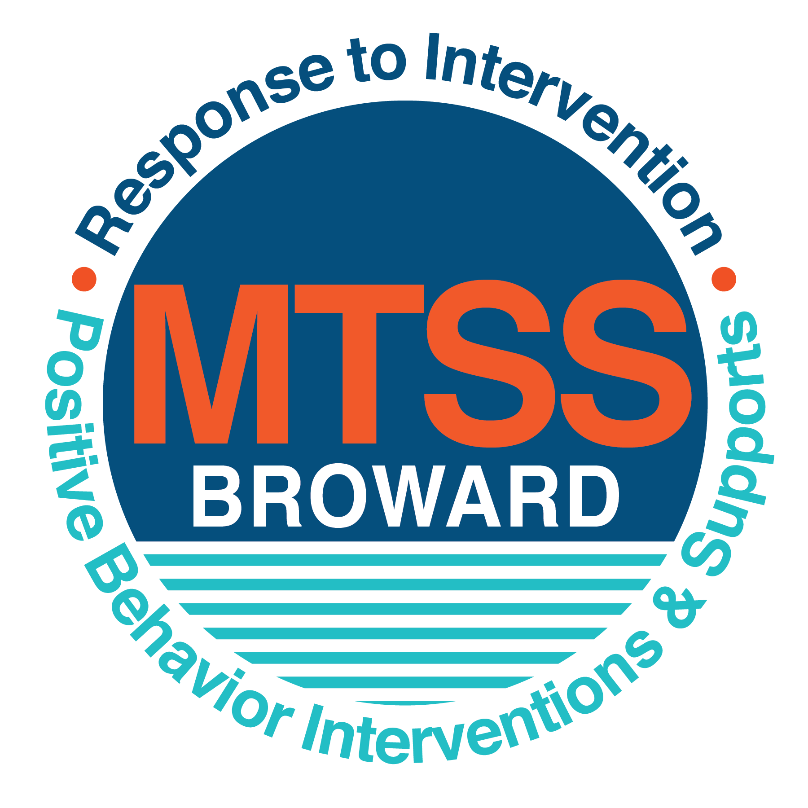
School-wide Positive Behavior Plan (SPBP)
Broward County Public Schools
To be implemented in SY 2018/19

Elements have changed in the SPBP.
Before completing, go to http://www.browardprevention.org/mtssrti/rtib/ → School-wide Positive Behavior Plan for:

- A NEW Brainshark for Principals. ACTION: Log in with your p # and watch the Brainshark before Jan 30th.
- A NEW Overview Brainshark for Teams. ACTION: Log in with school name and watch the Brainshark.
- A NEW mini Brainshark Series for teams. These Brainsharks are divided into the 10 Critical Elements of PBIS. They will
show you “how to” write a comprehensive SPBP (and receive a high score!)
- A Rating Rubric to ensure teams will correctly complete the SPBP and develop a meaningful plan.

To provide consistency across the District, only plans entered on the current district template will be accepted.
ACTION: Download, complete and upload the SPBP into your School Improvement Plan before May 1, 2018:

School Name: | Deerfield Park Elementary
School Number: | 0391
SPBP Contact Name: | Donna Rucker
Direct Phone Number: | 754-322-6171

CRITICAL ELEMENT # 1: Active Team with Administrative Participation

1A. List your current (SY 2017/18) team members (6 - 10 team members). Must include an instructional representative from EACH grade/content area. Each name on this list verifies attendance in ongoing team meetings and participation in developing this SPBP. Each member is responsible for representing major stakeholders and sharing the SPBP content and updates with their respective group.
Full Name | Position | Who or what grade level does this member represent?
Donna Rucker | Assistant Principal | Administration
Donna Rucker/Penny Skalis | SPBP Point of Contact | Administration/ESE Specialist
Bonita Mason | Parent/Community Representation | SAC
Janiece Davis | BTU Representative | Teachers
Machard Desire | Literacy Coach | Educational Support Personnel
Driana Hughes Mithchell-Philpart | Counselor | Support Staff/Special Teachers
Penny Skalis | ESE Specialist | ESE Personnel/Staff Members
Rosilande Desamour | Teacher | First Grade
Storm McCullough | Teacher | Fifth Grade
Leon Boyd | Head Facilities Person | Facilities

1B. Schedule and document your quarterly team meeting dates for next 2018/19 school year:
Meeting Date | Meeting Time | Name & title of person responsible to facilitate meeting | Content of meetings:
8/10/2018 | 7:40 am | Donna Rucker/Assistant Principal | 1. Create and disseminate updated  Expectations and Rules lesson  plans (#3 and #4)  2. Review progress of  Implementation Action Plan (#9)  3. Collect & analyze implementation  data (#10A)  4. Collect & analyze student  outcome data (#10B)
10/17/2018 | 7:40 am | Donna Rucker/Assistant Principal
1/9/2019 | 7:40 am | Donna Rucker/Assistant Principal
3/20/2019 | 7:40 am | Donna Rucker/Assistant Principal

CRITICAL ELEMENT # 2: Faculty & Stakeholder Commitment:

2A. Action Steps completed this year (SY 2017/18) that increased faculty and stakeholder understanding and knowledge of your new (2018/19) SPBP:
Action Steps: | Date  (Between Jan 15 –  April 30, 2018) | Details  (retain attendance sheets at school) | Person responsible to collect and retain attendance sheets:
Presented the new SPBP (for SY 2018/19) to staff | 4/17/2018 | # of participants = 34 | Donna Rucker
Held a faculty vote on the new SPBP  (for SY 2018/19) | 4/19/2018 | % approved =100 | Donna Rucker
Presented the new SPBP (for SY 2018/19) to stakeholders (parents and community) | 4/19/2018 | # of participants = 10 | Donna Rucker

2B. Action Steps to be completed next year (SY 2018/19) to increase faculty and stakeholder understanding and knowledge of your SPBP:
Action Steps: | Date(s)  (NEXT YEAR) | Content  (retain attendance sheets at school) | Person responsible to collect and retain attendance sheets:
Provide a professional development on the 2018/19 SPBP for all staff | Prior to students’ 1st day:  8/10/2018 | The team will present the updates in the SPBP for the 18/19 school year. All stakeholders will be provided with access to the SPBP. Feedback will be collected for future team meetings. | Janiece Davis
Present the 2018/19 SPBP to stakeholders (parents and community) | Prior to Oct 1st, 2018  9/20/2018
Present behavior data to staff  Quarterly: minimum of 4 each year | 1. 10/18/2018 | The team will present the implementation data in 10A. Include:  • the “marketing” (teaching and posting) of expectations and rules  • lesson plan implementation  • discipline procedures  • reward system implementation  The team will present the student outcome data in 10B. Include:  • top 3 event locations  • type of behavior incidents  • core effectiveness data  • classroom referral data, as well as analysis of this data. | Janiece Davis
 | 2. 12/20/2018
 | 3. 3/21/2019
 | 4. 4/11/2019

CRITICAL ELEMENT # 3: School-wide Expectations

3A. List the top 10 behavior incidents data YTD from BASIS 3.0 Behavior Dashboard:
Top 10 Behavior Incidents
(put N/A in any blank spaces)
1. Unruly Disruptive Behavior | 6. Insulting/Profane/Obscene
2. Disobedience and Insubordination | 7. Disruptive Unruly Play
3. Fight/Minor Altercation/Confrontation | 8. Cut Class
4. Out of Assigned Area | 9.
5. Profanity to Staff Member | 10.

3B. Based on the behavior incidents in 3A, develop 3 – 5 positive characteristics (not behaviors) that would counteract the demonstration of these misbehaviors. These positive characteristics become your school-wide expectations.
School-wide Expectations
1. Keep your hands, feet, objects, and unkind words and actions to yourself
2.Use respectful language and actions at all times
3.Stay in your assigned area
4.
5.

3C. Research indicates that discipline referrals increase after long holidays and during testing times. Plan to teach your expectations at least 3 times throughout the year (and anytime the expected behaviors are not being demonstrated).
ACTION: Create at least one lesson plan for each school-wide expectation above and distribute to teachers during pre-planning 2018-19. Develop additional lesson plans you will use throughout the year to re-teach and reinforce your school-wide expectations. You do not need to submit your lesson plans with the SPBP. Retain all behavior lesson plans at the school; make sure these lesson plans are available for guests and stakeholders.
When will school-wide expectations lesson plans be taught?
 | Date(s) | Time:
August | August 14, 2018 | 3:00 pm
January | January 10, 2019 | 3:00 pm
4th Quarter | April 4, 2019 | 3:00 pm
Who will be responsible for teaching the lesson plans? |  |  | Teachers
Where will the lesson plan instruction occur? |  |  | Classroom
Who is responsible for retaining, organizing and distributing all lesson plans? |  |  | Counselor

CRITICAL ELEMENT #4: Location-based Rules

4A. List the top 3 locations for behavior Events YTD from BASIS 3.0 Behavior Dashboard. Do not use “classroom”
Top 3 Locations
School Location | # Incidents
1.School Grounds | 3
2.Hallway | 2
3.Cafeteria | 2

4B. Create an Expectations/Rules Matrix from your 3-5 school-wide expectations and your top 3 event locations. Develop a positively stated, observable, and measurable rule that correlates with every expectation to create a maximum of 5 rules under each location.
Expectations and Rules Matrix
School-wide EXPECTATIONS | Copy and paste expectations from 3C. | IDENTIFIED LOCATIONS  Copy and paste locations from 4A.
 |  | School Grounds | Hallway | Cafeteria
 |  | Rules | Rules | Rules
 | Be in Control | Make choices that are respectful, kind, and healthy | Maintain safe and orderly behavior | Enter cafeteria quietly
 | Be Respectful | Use kind words and follow the rules | Use quiet voices when walking through hallways | Use respectful language and inside voice
 | Be Safe | Stay in assigned area | Walk with a partner at all times | Keep hands, feet, and objects to yourself
 | Click here to enter Expectation #4 | Click here to enter a Rule | Click here to enter a Rule | Click here to enter a Rule
 | Click here to enter Expectation #5 | Click here to enter a Rule | Click here to enter a Rule | Click here to enter a Rule

4C. Research indicates that discipline referrals increase after long holidays and during testing times. Plan to teach your location-specific rules at least 3 times throughout the year (and anytime the expected behaviors are not being demonstrated).
ACTION: Create at least one lesson plan for each location above and distribute to teachers during pre-planning 2018-19. Develop additional lesson plans you will use throughout the year to re-teach and reinforce your location-specific rules.
You do not need to submit your lesson plans with the SPBP. Retain all behavior lesson plans at the school; make sure these lesson plans are available for guests and stakeholders.
When will location-specific rules lesson plans be taught?
 | Date(s) | Time:
August | August 17, 2018 | 3:00 pm
January | January 10, 2019 | 3:00 pm
4th Quarter | April 4, 2019 | 3:00 pm
Who will be responsible for teaching the lesson plans? |  |  | Teachers
Where will the lesson plan instruction occur? |  |  | Classroom
Who is responsible for retaining, organizing and distributing all lesson plans? |  |  | Counselor

CRITICAL ELEMENT # 5: Reward and Recognition Programs

Although you will post, teach, review, practice and reinforce all school-wide expectations and location-specific rules, choose 1 expectation OR 1 event location you will target for a specific reward program for students. Based on the data that led to this expectation or location, create a reward plan using the 4 Step Problem Solving Process:

Expectation or Location: ____Cafeteria___________________________________________________________

4 Step Problem Solving Process | Plan
1. Problem Identification: Use your behavior data to identify a school-wide problem.  What problem did you identify? (use numerical data) | Data used: Discipline Data (BASIS)  Problem Identification: Unruly Disruptive Behavior
2. Problem Analysis: Why do you think this problem is occurring?  What is your goal? (use a SMART goal statement with numerical data) | Hypothesis: This problem is occurring due to a low amount of parental involvement.  Goal Statement: By April 2019 we plan to increase parent involvement by 2%.
3. Intervention Design: Describe how you will implement a positive reward program to decrease this problem. | Type of System: Point system  Students earn fawn bucks (worth 5 points) each day that rules are followed in school grounds  Description of System: Reward is given to each child when seated and removed if child violates the rule after verbal warning and/or discussion with supervising personnel. On departure student is allowed to take the buck with them. If the majority of the students earn the buck the class also receives a sticker on their Cafeteria Challenge Calendar for each day. (3-4 sentences)
4. Evaluation:  A. Implementation fidelity | - How do you monitor the fidelity (consistency and effectiveness) of the staff’s implementation of the reward program? (2-3 sentences)  The fidelity of the staff’s implementation is monitored via observation and by the requested and redeemed bucks.
B. Student outcome monitoring | - How will you know if the reward program is positively impacting students? What measurable data will you use to determine “success”? (2-3 sentences)  The measurable data that will be used is the monitoring of the decrease in referrals, the amount of bucks being distributed, and the inventory of items being purchase to redeem the buck.

CRITICAL ELEMENT #6 Effective Discipline Procedures

6A. Staff Managed Misbehaviors: List the top 6 most common school-wide misbehaviors staff are expected to manage.
Write a short, objective, and measurable definition for each.
Staff Managed Misbehaviors
Misbehavior | “Looks Like” - provide a description with example(s)
1. Lying | Giving false information
2. Physical Contact  (“Serve”) | Incidental/Accidental play, unwarranted horseplay  (Pulling the back of the neck playfully)
3. Unkind words (“Shade”) | Offensive words
4. Pushing | Intent to hurt or cause harm
5. Disrespect | Talking back to an adult and not obeying
6. Out of Assigned area | Not in the assigned location

6B. Staff Managed Consequences: Create a consequence menu OR a consequence hierarchy for staff to use when students exhibit the above misbehaviors. Provide a minimum of 5 consequences.
Is this a menu or hierarchy system? | ☐ Menu ☐Hierarchy
- Verbal Warning
- Time Out
- Student/Teacher Conference
- Loss of Privilege
- Phone Call Home

6C. Administration Managed Misbehaviors:
(a) Define the first 3 behaviors by providing examples that clearly identify the point at which the misbehavior warrants an Office Discipline Referral (ODR).
(b) List two additional common school-wide misbehaviors that will result in an ODR. Provide concrete examples.
(c) Determine staff tolerance level for repetitive misbehaviors (the point at which the number of staff-managed misbehaviors becomes an ODR).
Office Discipline Referrals (ODRs)
Behavior | “Looks Like” - provide a description with example(s)
1. Disobedience/Insubordination | Failure to obey a reasonable or repeated instruction or request from a member of the school staff
2. Disruptive/Unruly Play | Unruly disruptive behavior or play that disrupts the learning environment
3. Defiance of authority | Repetitive (4 or more) Disobedience/Insubordination referrals
4. Profanity | Cursing when speaking with peers or toward and adult
5. Out of assigned area | Not in assigned area and/or roaming the campus
6. Repetitive staff managed  misbehaviors | More than misbehaviors in warrants an office referral.  day  2  3  e.g., 3 half hour  2 one period

6D. School-wide Discipline Flow Chart:
(a) Review the sample discipline flow charts in “Additional Items” located on browardprevention.org
(b) Copy or customize a flow chart to graphically represent the discipline process at your school.
(c) Paste the flow chart here OR complete the flow chart below.

Staff observes misbehavior
in the classroom or on campus
Is the behavior considered office managed?

Is the behavior considered staff managed?

Institute Counseling
Alternative Setting
Reinforce/
Reward student
Behavior is corrected
Time Out w/Admin
Verbal Warning
Reinforce/
reward student
Behavior is corrected
Loss of Privilege
School Specific
Submit referral to Counselor or Admin
Implement consequence(s)
Detention
Modify Behavior Contract
Implement Behavior Contract
Follow crisis protocol
Is the behavior a crisis?
Suspension
Is the behavior a referral?
Phone call
Detention
Time Out in another class
Removal
Reinforce/
Reward student
Behavior is corrected
Loss of privilege
Is the behavior moderate?
Time Out
Conference
Phone call home
Loss of Privilege
Verbal Warning
Reinforce/
Reward student
Behavior is corrected
Implement minor consequence(s)

CRITICAL ELEMENT # 7 : Classroom Management Systems

7A. ALL teachers implement an effective Tier 1 classroom management system:
Which evidence-based classroom management system is supported by your school’s administration and is expected to be implemented school-wide? Cloud 9 and Class Dojo are used to supplement the system  (Class Dojo, LEAPs, HERO, Cloud 9, etc. are tools, not classroom systems) | ☐☐ CHAMPs*  ☒PBIS Classroom Management  Administration does not expect an evidence-based classroom management system to be implemented by teachers this year  (your school will need to adopt one next year)  ☐ Other (complete below)
If other, name the evidence-based classroom management system: | Click here to enter name of system.
*CHAMPs is the district-supported, evidence-based universal classroom management system for all teachers. Would your Principal like to be contacted to learn about CHAMPs professional development? | ☒ Yes ☐ No

7B. Fidelity of staff implementation of school-wide classroom management systems
What data collection tool does your school leadership team use to monitor and evaluate your teacher’s classroom management skills? (Measure staff skills, not student outcomes)
☐ CHAMPs 7 Up Checklist
☐ CHAMPs Classroom Check Up (CCU)
☐ PBIS Classroom Assistance Tool (CAT)
☐ PBIS Walkthrough
☒ Marzano’s Domain 1, Design Questions 5, 6, 7, 8, 9
☐ Fidelity of staff classroom management implementation is not monitored to determine training needs this year (you will need to adopt a tool and plan next year)
☐ Other (specify):
Explain how this data is collected and analyzed by your school leadership team as a universal screening across teachers to determine the need for classroom management training:
Data is screened by administration via Marzano’s reports weekly. Data is then drilled down to specific teachers and/or specific areas in order to implement assistance to the teachers in need.
Fidelity of Implementation Plan: (3-4 sentences)
The implementation planned is monitored monthly to determine the overall month’s needs and to make adjustments where needed. Analyzed data will be shared with team leaders during team leader meetings to ensure that all leadership members are abreast of the data and needs of specific students and teachers.

7C. Percentage of Classroom Referrals:
(a) Review your classroom data YTD (“Events by Location”) in BASIS 3.0 Behavior Dashboard.
(b) Complete the yellow highlighted cells first.
(c) Auto-calculate the % of referrals in the classroom by clicking on “!Zero Divide” in the next cell and pressing “Fn + F9” together.
Total number of discipline referrals from classrooms: | 22
Total number of school-wide discipline referrals: | 31
% of referrals in the classroom: | 42%
Do more than 40% of your referrals come from the classroom? | ☒ Yes ☐ No
If >40% of discipline referrals come from the classroom, it suggests Tier 1 classroom management implementation may need to be strengthened school-wide.

CRITICAL ELEMENT # 8: Data Collection and Analysis

8A. Determine your School-wide Core Effectiveness YTD from the BASIS Behavior Dashboard in the “Referrals per Student” chart.
(a) Complete the yellow highlighted cells first.
(b) Auto-calculate the “% of Total Population” by clicking on each “!Zero Divide” in the cells and pressing “Fn + F9”.
(c) Determine if the core is effective in all three areas
TOTAL Population: | 4
# Referrals |  | % of Total Population | Core Effectiveness
0 - 1 referral | 1 | 25% | Are your 0 – 1 referrals > 80%? | ☐Yes ☒No
2 - 5 referrals  (at risk students) | 3 | 75% | Are your 2 - 5 referrals <15%? | ☐Yes ☒No
> 5 referrals  (high risk students) | 0 | 0% | Are your >5 referrals <5%? | ☒Yes ☐No

8B. Core Effectiveness Plan:
If all 3 are “Yes”, your core is effective. Is your core behavior curriculum effective? | ☐Yes ☒No
Answer either (a) or (b):
(a) If you answered “Yes”, although your core is effective, what plan does your school leadership team implement for early identification of at risk and high risk students?
(b) If you answered “NO”, indicate the supports and interventions your school leadership team will implement at the beginning of the next school year to improve core strength:
Any at-risk and high risk students will begin the year with a behavior contract instituted within the first five days of the school year.
Core Effectiveness Plan: (3-4 sentences)
The school leadership team will implement CHAMPS review training and new trainings for all staff members. The students will be given an overview and complete training on student rules and expectations during the first week of school with follow-up presentation in classrooms that are experiencing challenges with adhering to rules and expectations.

8C. Disproportionality: Determine if there are any issues within subgroups from BASIS 3.0 Behavior Dashboard in the “Referrals by Demographics” chart.
(a) Complete the yellow highlighted cells first.
(b) Auto-calculate the difference by clicking on each “0” in the next cell and pressing “Fn + F9”.
Subgroups | (PctPop - Green)  % of students | (PctRef - Blue)  % of referrals | Difference in referral composition | Positive value suggests disproportionality  (Is the value positive?)
Black | 100 | 100 | 90 | ☒Yes ☐No
Hispanic/Latin | 0 | 0 | 90 | ☒Yes ☐No
White | 0 | 0 | 90 | ☒Yes ☐No

8D. Disproportionality Plan: If any values are positive, the percentage of referrals contributed to that subgroup is higher than expected, given that subgroups’ percentage in the student population.
If all 3 are “No”, disproportionality is not indicated. Are all 3 “No”? | ☐Yes ☒No
Answer either (a) or (b):
(a) If you answered “Yes”, although your data indicates equity, what plan does your school leadership team implement for early identification of any disproportionality issues
(b) If you answered “No”, indicate the support plan and interventions your school leadership team will implement at the beginning of next year to improve sub group disproportionality
Disproportionality Plan: (3-4 sentences)
Our data indicates that the student population is majority black, therefore we will implement the planned intervention of using CHAMPS and Cloud 9 schoolwide, which is also sufficient for all students. The data flow chart will be used to a resource for teachers. Training will be provided in Cloud 9 and suggested to new teachers in CHAMPS. Data will be monitored weekly by the referrals submitted and RTI behavior data.

Critical Elements # 9: SPBP Implementation Planning

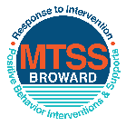
This form provides a timeline to complete best practices and required actions. This timeline should drive team actions and accountability. As you implement your SPBP NEXT year, check off completed items and indicate the accountable person. (Complete only the yellow highlighted area at this time). Next year, you will upload this completed plan within your SPBP.

Required actions for all schools in Broward County
Best Practices for all schools in Broward County
Resources
SPBP Team Implementation Action Plan 2018 - 2019
Month | Action Step  ☒ check when Action completed | Completed:  Person Responsible  Name & Title
Current | ☒ This Action Plan has been saved to use next year during quarterly meetings | Donna Rucker, Assistant Principal
Current | ☒ Create a SPBP binder or portfolio to retain (for 2 years) hard copies of: your SPBPs, Action Plans, staff PBIS professional development attendance, stakeholder training attendance, quarterly meeting agendas, quarterly staff behavior presentations, voting attendance and outcome, Expectation lesson plans and Rules lesson plans | Donna Rucker, Assistant Principal
Pre Planning  2018 | ☒ Print up your SPBP Review and school score from OSPA  ☒ Provide SPBP presentation to all staff during Pre Planning  ☒ Disseminate the current SPBP (hard copy or electronically) to all staff and stakeholders  ☐ Market and post school-wide Expectations and location-specific Rules (posters, PSAs, etc.)  ☒ Identify your RtI Instructional Facilitator provided by the district  (Contact tyyne.hogan@browardschools.com for more information, if you are unsure)  ☒ Confirm 1st team meeting date and time | Donna Rucker, Assistant Principal
August  1st meeting | ☒ Ensure schedule of quarterly meeting dates for entire year as indicated in the SPBP  ☒ Determine any needed team training, such as the 4 Step PSP Brainshark Series, 10 Critical  Elements Brainsharks, Data Collection, Effective CPST Teams, PBIS 101, etc.  Trainings available at: http://www.browardprevention.org/mtssrti/training-modules/  ☒ Review previous year’s behavior data. (Use ‘Agenda’ and ‘Data Collection Template’)  Forms available at: http://www.browardprevention.org/mtssrti/rtib in Tier 1, Teaming  ☒ Present implementation data, behavior data, team activities and progress to entire staff  ☒ Utilize the 4 Step Problem Solving Process to develop initial interventions  ☒ Review previous year’s SPBP and feedback form  ☐ Verify and implement teaching schedule for SPBP Expectations and Rules behavior lesson plans | Donna Rucker, Assistant Principal
September | ☒ Provide stakeholder presentation on SPBP prior to October 1  ☒ Check for staff and teacher understanding of PBIS - provide “PBIS 101” Brainshark as a resource  Brainshark available at: http://www.brainshark.com/browardschools/PBIS101 | Donna Rucker, Assistant Principal & Janiece Davis BTU Representative
October  2nd meeting | ☒ Ensure instructional staff know how to (and are, as needed) enter Tier 1 Supplemental Strategies  for behavior in BASIS  ☒ Present implementation data, behavior data, team activities and progress to entire staff | Donna Rucker, Assistant Principal, School Counselor & Penny Skalis, ESE Specialist
November | ☐ Staff to re-teach Expectations and Rules first day back from break.  ☐ Team to develop new and/or improved lesson plans as indicated by behavior data. | Donna Rucker, Assistant Principal
January  2019  3rd meeting  Prepare for 2019/20 SPBP | ☐ Staff to re-teach Expectations and Rules first day back from break  ☐ Ensure the Principal signs in and watches the new SPBP Brainshark: Due January 30th  ☐ Present implementation data, behavior data, team activities and progress to entire staff  ☐ Choose team members and dates to work on, complete, and submit the new SPBP  ☐ Teams watch the new SPBP Brainsharks and refers to new “Additional items”  Brainsharks and Additional items posted at: http://www.browardprevention.org/mtssrti/rtib | Jocelyn Reid, Principal
February | ☐ Ensure progress towards completion of SPBP  ☐ Check on recently hired staff for PBIS understanding - provide “PBIS 101” Brainshark resource  ☐ Provide the SPBP Surveymonkey link to all staff (optional). Email Tyyne.hogan@browardschools.com to request analysis. | Donna Rucker, Assistant Principal
March  4th meeting | ☐ Ensure progress towards completion of SPBP  ☐ Provide staff presentation and vote on new SPBP for next year  ☐ Provide stakeholders/parent presentation on new SPBP for next year  ☐ Present implementation data, behavior data, team activities and progress to entire staff | Donna Rucker, Assistant Principal
April | ☐ Submit your SPBP in OSPA by April 30th every year | Donna Rucker, Assistant Principal

CRITICAL ELEMENT # 10: Monitoring Plans

10A. How will you determine the success of staff implementation of the School-wide Positive Behavior Plan?
“Are staff implementing the SPBP with fidelity? How do you know?”
Fidelity of Implementation Monitoring Plan
Action Step | Create an observable and measureable SMART goal to determine “successful”  staff implementation of action step | When will data be collected, analyzed & presented? | Person responsible to collect and analyze data
School-wide expectations and location-specific rules are posted across campus | 100% of Hallways. Classrooms and the cafeteria will have rules posted in two areas | Refer to quarterly presentation dates in 2B.  This is the data the team will be sharing during presentations. | Donna Rucker, AP
Behavior lesson plans are being taught as written and when indicated | 100% teachers will have behavior lesson plans |  | Jocelyn Reid, Principal Donna Rucker, AP & Counselor
Discipline consequences and flow chart are being used by all staff as written | Monitor 100% staff usage of flow chart via survey of behavior |  | Jocelyn Reid, Principal Donna Rucker, AP & Counselor
A reward system is being implemented for all students | 100% of staff will use reward system for all students |  | Donna Rucker, AP

10B. How will you determine whether the SPBP is successful in positively impacting students?
“If staff are implementing the SPBP consistently and effectively, did it positively impact the students? How do you know?”
Student Outcome Monitoring Plan
Student Outcome Data | Create an observable and measureable SMART goal to determine “successful”  student outcomes | When will data be collected, analyzed & presented? | Person responsible to collect and analyze data
See critical element 3A  • Type of behavior incidents data | 80% students will have 1 or less ODR. | Refer to quarterly presentation dates in 2B.  This is the data the team will be sharing during presentations. | Donna Rucker, AP
See critical element 4A  • Top 3 event locations data | 80% students will have 1 or less ODR. |  | Donna Rucker, AP
See critical element 8  • Core effectiveness data | 80% students will have 1 or less ODR. |  | Donna Rucker, AP
See critical element 7A  • Grade Level/Classroom referrals data | 80% students will have 1 or less ODR. |  | Donna Rucker, AP

