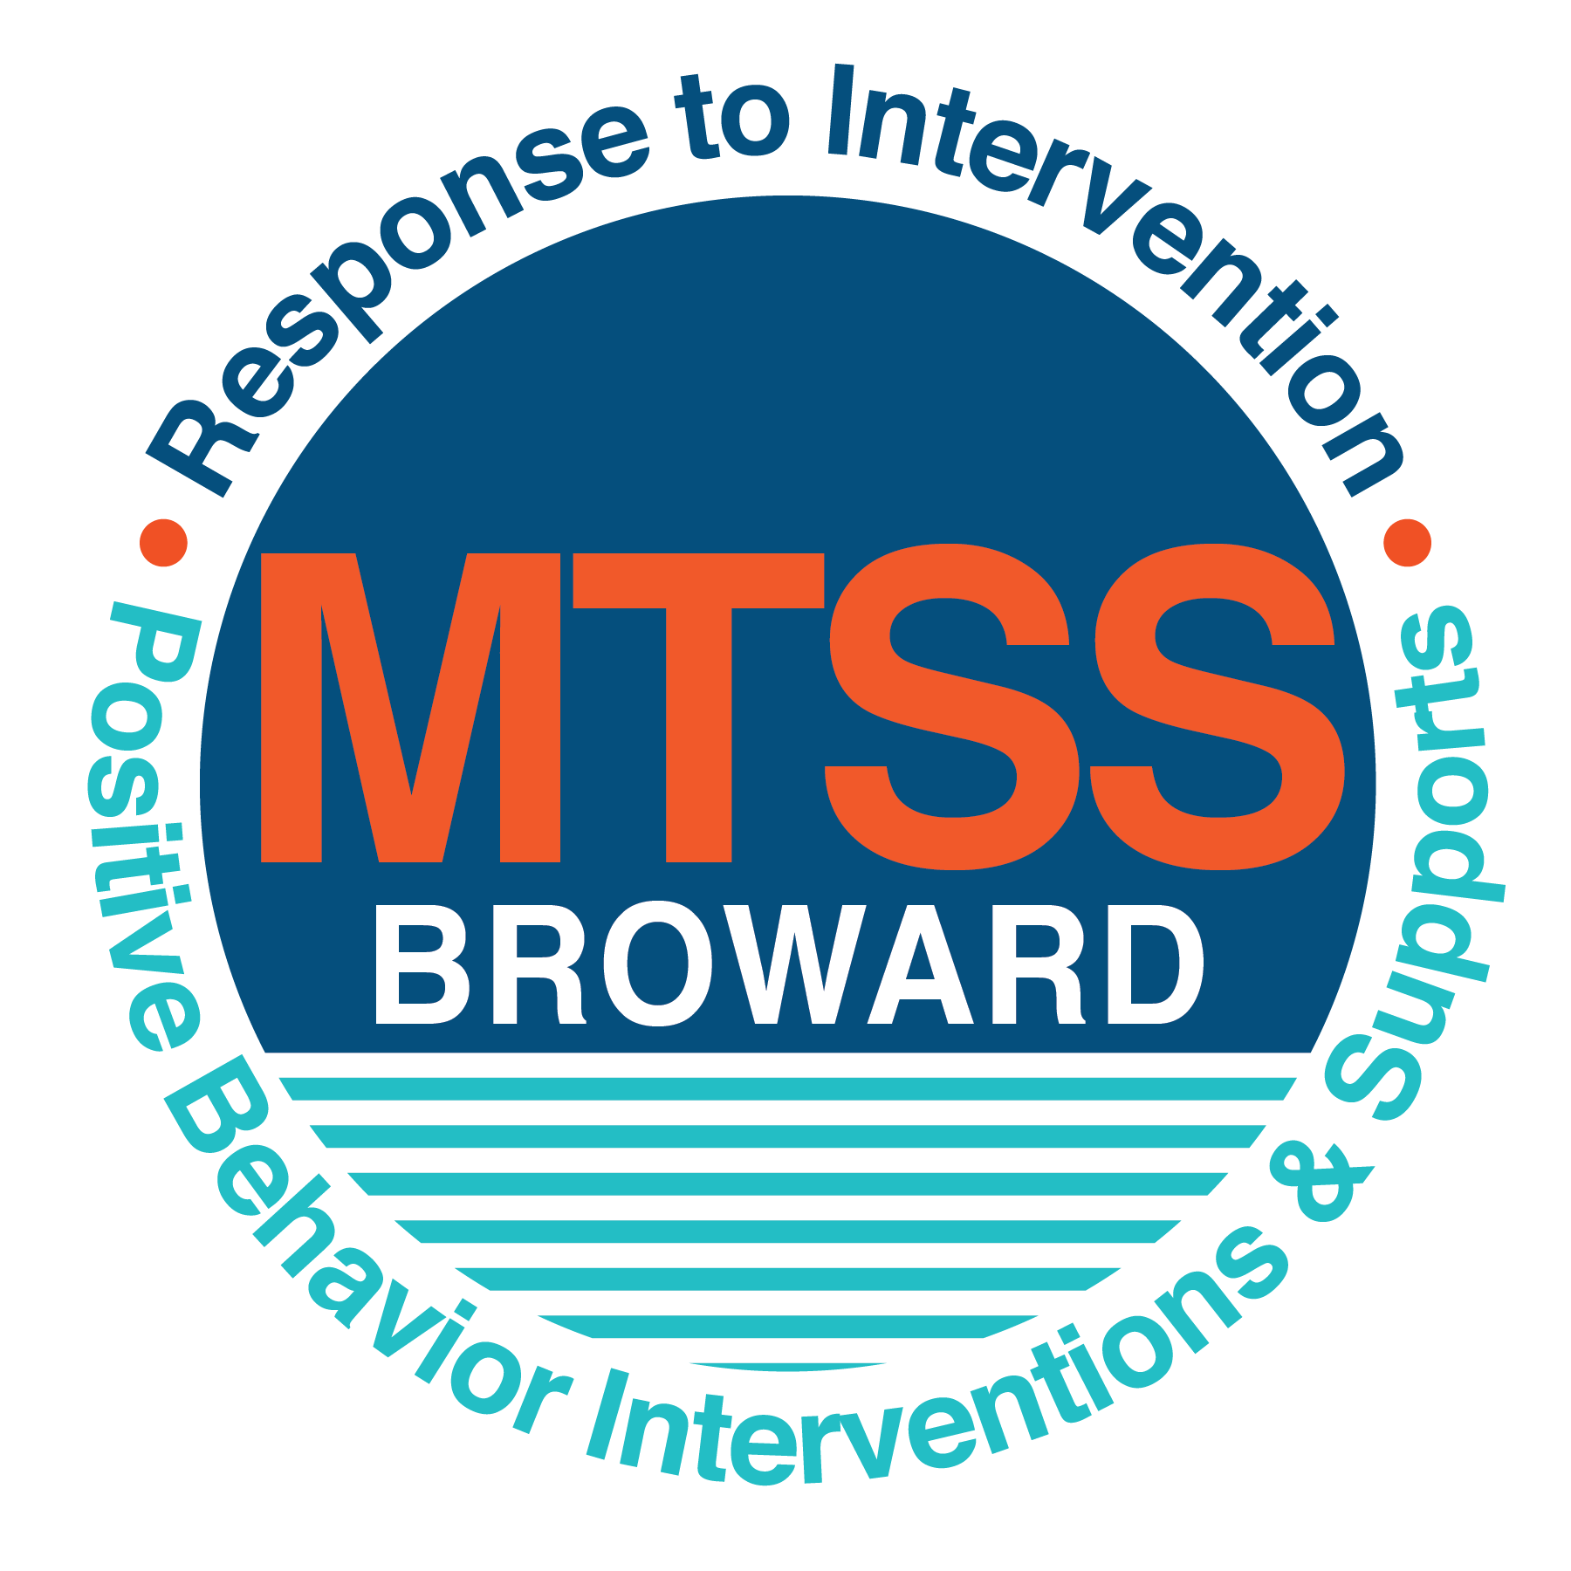
School-wide Positive Behavior Plan (SPBP)
Broward County Public Schools
To be implemented in SY 2019/20

School Name: | Bennett Elementary
School Number: | 0201
SPBP Contact Name: | Amy Rubin
Direct Phone Number: | 754-322-5462

CRITICAL ELEMENT # 1: Active Team with Administrative Participation

1A. Current (SY 2018/19) SPBP team members:
Full Name | Position
Danielle Smith | 1. Administration
Danielle Wesley | 2. BTU Representative
Amy Rubin | 3. SPBP Point of Contact
Monique Walters | 4. Parent/Community Representation
Lesle Bragunier | 5. Teacher
Rebecca Morgado | 6. Resource Teacher/Title 1 Liaison
 | 7.
 | 8.
 | 9.
 | 10.

1B. Schedule of quarterly SPBP Team Meeting dates for next 2019/20 school year:
Meeting Date | Meeting Time | Content of meetings:
9/25/2019 | 2:00 | - Create and disseminate updated Expectation and Rules lesson plans  - Review progress of Implementation Action Plan  - Collect and analyze implementation data  - Collect and analyze student outcome data
11/26/2019 | 2:00
1/29/2020 | 2:00
4/30/2020 | 2:00

CRITICAL ELEMENT # 2: Faculty & Stakeholder Commitment:

2A. Action Steps completed this year (SY 2018/19) that increased faculty and stakeholder knowledge of the new SPBP:

Action Steps: | Date  (Between Jan 15 and  April 30, 2019) | Details  (Sign-in sheets in SPBP Binder)
Presented the new SPBP (for SY 2019/20) to staff | 2/5/2019 | # of participants = 44
Held a faculty vote on the new SPBP  (for SY 2019/20) | 2/19/2019 | # of participants =44  % approved =100
Presented the new SPBP (for SY 2019/20) to stakeholders (parents and community) | 4/24/2019 | # of participants = 15

2B. Action Steps to be completed next year (SY 2019/20) to increase faculty and stakeholder knowledge of the new SPBP:

Action Steps: | Date  (SY 2019-20) | Content  (Sign-in sheets in SPBP Binder)
Provide professional development on the 2019/20 SPBP for all staff | Prior to students’ 1st day:  8/7/2019 | The team will present the updates in the SPBP for the 19/20 school year. All stakeholders will be provided with access to the SPBP. Feedback will be collected for future team meetings.
Present the 2019/20 SPBP to stakeholders  (parents and community) | Prior to Oct 1st, 2019  9/18/2019
Present the behavior data to all staff quarterly | 1. 11/5/2019 | The team will present:  - the team’s progress in the Implementation Plan in # 9.  - the fidelity of staff implementation data in #10A.  - the student outcome data in #10B.
 | 2. 1/7/2020
 | 3. 3/4/2020
 | 4. 5/6/2019

CRITICAL ELEMENT # 3: School-wide Expectations

3A. Top five behavior incidents data YTD as listed in BASIS 3.0
Top 5 Behavior Incidents
1.Disobedience/Insubordination
2.Battery on District Employee
3.Unruly/Disruptive Behavior
4.Distruption on Campus Minor
5.Technology-Inapproprate Use

3B. School-wide expectations are 3 – 5 positive characteristics (not behaviors) that counteract the demonstration of the top school-wide misbehaviors above. ALL people on campus model these expectations.
School-wide Expectations
1.Be Responsible
2. Be Respectful
3. Be Kind
4. Be Safe
5. Be Positive

3C. At least one lesson plan for each school-wide expectation above is distributed to teachers during pre-planning SY 2019/20 and maintained in the SPBP Binder.
Dates the school-wide expectations lesson plans are taught:
 | Date(s) | Time: | Location(s):
August | 08/14/2019 | As appropriate for each classroom | Classroom
January | 01/07/2020 | As appropriate for each classroom | Classroom
After Spring Break | 03/30/2020 | As appropriate for each classroom | Classroom

CRITICAL ELEMENT #4: Location-based Rules

4A. Top three school-wide locations for Behavior Events YTD.
Top 3 Locations, not including Classroom:
School Location | # Incidents
1. Playground | 2
2. Cafeteria | 2
3. Restroom | 1

4B. Expectations and Rules Chart for common areas of school campus: (next page)

Expectations and Rules Chart |  |  |  | To be completed by classroom teachers
School-wide EXPECTATIONS | Cafeteria Rules | Hallway Rules | Playground | Classroom Rules
Be Responsible | Eat your own food. Clean up your area. | Walk in a line on the right side of the hallway. | Follow adult directions. Line up when the adult calls.
Be respectful | Soft voices. Use table manners. Listen to monitors | Keep your hands to yourself and no talking. | Follow the game rules during play. Share equipment.
Be Kind | Say kind things. No gossiping. | Leave personal space between yourself and the person in front and in back of you. | Invite others to play. Use kind words.
Be Safe | Sit at your table. Stay in your seat. Raise your hand if you need assistance. Walk. | Keep your hands by your side. Keep personal space. | Use equipment appropriately. Demonstrate self-control.
Be Positive | Say kind things. No gossiping. | Smile at people walking by. | Promote good sportsmanship. Encourage others.

4C. At least one Rules lesson plan for each specific location is distributed to teachers during pre-planning SY 2019/20 and maintained in the SPBP Binder.

Dates the Locations’ Rules lesson plans are taught
 | Date(s) | Time: | Location(s):
August | 08/14/2019 | As appropriate for each classroom | Classroom
January | 01/07/2020 | As appropriate for each classroom | Classroom
After Spring Break | 03/30/20 | As appropriate for each classroom | Classroom

CRITICAL ELEMENT # 5: Reward and Recognition Programs

5. The reward system is focused on one School-wide Expectation OR specific location at a time.
Expectation or Location: Be Respectful

4 Step Problem Solving Process | Plan Details
1. Problem Identification: Use your behavior data to identify one school-wide problem.  What problem did you identify? (use numerical data) | Data used: According to BASIS data, 2 incidences of disobedience /insubordination during the 2018/2019 academic year, resulting in a referral: behavior most often referred.  Problem Identification Statement: 2 incidences of disobedience/insubordination during the 2018/2019 resulting in a referral: behavior most often referred.
2. Problem Analysis: Why do you think this problem is occurring?  What is your goal? (use a SMART goal statement with numerical data) | Hypothesis: Students may not understand that following the rules is expected throughout the school.  Goal Statement: Students will display respectful behavior throughout the school day in all locations, therefore behavior referrals will decrease.
3. Intervention Design: Describe how you will implement a positive reward program to decrease this problem. | Type of System: Token system  Description of System: The school will implement the Passport to Peace which includes the lifeskill language to foster a positive school environment. Praise and positive reinforcement of target reinforcement of target behavior will aid in decreasing disobedience/insubordination.
4. Evaluation:  A. Implementation fidelity | - How will you monitor the fidelity (consistency and effectiveness) of the staff’s implementation of the reward program? Students will wear lanyards displaying the target behavior or attitude for each area. Staff will be required to identify students demonstrating specific lifeskills. The school counselor will guide the staff with implementation of the program.
B. Student outcome monitoring | - How will you know if the reward program is positively impacting students? What measurable data will you use to determine “success”. The leadership team will monitor referable offenses and the reason for each offense using BASIS.

CRITICAL ELEMENT #6: Effective Discipline Procedures

Student Behavior Discipline Flow Chart
Observe problem behavior behaviorBehavior
Intervene and redirect
Office Managed Misbehaviors
Staff Managed Misbehaviors
Call to notify office of a
crisis/safety issue
No
Yes

Implement an initial consequence
Is behavior Office Managed?
(if unsure, check below)

Specific Examples of  6 Staff Managed  Misbehaviors: | Specific Examples of  6 Office Managed  Misbehaviors:
- Refusal to obey rules.  - Interacting with others without self-control.  - Fail to complete work.  - Distracting others from academic time.  - Students making inappropriate remarks.  - Students talking back to teacher. | - Failure to obey rule that result in endangering others.  - Students harassing another student repeatedly.  - Students threatening another student, teacher or themselves.  - Students that physically harm another student or faculty member.  - Student breaks or takes item without permission. Student is out of assigned area.

Contact parent
Loss of privilege
Active resolution
Parent/teacher
Conference with admin

CRITICAL ELEMENT # 7: Classroom Management Systems

7A. In SY 2019/20, ALL teachers implement an evidence-based Tier 1 classroom management system:
Evidence-based system: | Evidence of training:
☐ CHAMPS | % of teachers currently holding valid CHAMPS certificate:
☐ PBIS Classroom Management  http://www.fl-pda.org/independent/ | % of teachers currently holding completion certificate:
☒ Other: Passport to Peace/Lifeskills | Training evidence: Sign-in sheet(s)  100% of teachers currently trained:

7B. The administration reviews and analyzes the fidelity of staff implementation of Tier 1 classroom management systems across teachers using:
☐ CHAMPs 7 Up Checklist
☐ Basic FIVE (Classroom Management Screening)
☐ PBIS Classroom Assistance Tool (CAT)
☒ Passport to Peace/Lifeskills
☐ Classroom management screening is not conducted across teachers to determine appropriate professional
development. (Next year, assessment of classroom management implementation fidelity will be scored).

7C. School year 2018/19 percentage of classroom referrals:
Total number of discipline referrals from classrooms: | 7
Total number of other school-wide discipline referrals: | 5
% of referrals in the classroom: | 53.8
Do more than 40% of your referrals come from the classroom? | ☒ Yes ☐ No
If >40% of discipline referrals come from the classroom, it suggests Tier 1 classroom management implementation may need to be strengthened school-wide.
If “Yes”, school-wide classroom management professional development will be conducted in 2019-20:
Other: If “Other”, indicated system here: Passport to Peace/Lifeskills

CRITICAL ELEMENT # 8: Data Collection and Analysis

8A. Core Effectiveness:
TOTAL Population: | 387 | % of Total Population | Core Effectiveness
# Referrals: 13 | # of Students:
0 - 1 referrals | 11 | 99% | Are your 0 – 1 referrals > 80%? | ☒Yes ☐No
2 - 5 referrals  (at risk students) | 2 | 1% | Are your 2 - 5 referrals <15%? | ☒Yes ☒No
> 5 referrals  (high risk students) | 0 | 0% | Are your >5 referrals <5%? | ☒Yes ☒No

8B. Core Effectiveness Action Steps:
If all 3 are “Yes”, your core is effective. Is your core behavior curriculum effective? | ☒Yes ☐No
Answer either (a) or (b):
(a) If you answered “Yes”, although your core is effective, what steps does your school leadership team take for early identification of at risk and high-risk students?
(b) If you answered “NO”, indicate the supports and interventions your school leadership team will implement at the beginning of the next school year to improve core strength:
Core Effectiveness Action Steps: (3-4 steps)
1. Staff Development Training on implementation of the Passport to Peace Program
2. Mentoring for struggling teachers
3. Data Collection
4.Continued Support

8C. Disproportionality within racial subgroups:
Subgroups | (PctPop - Green)  % of students | (PctRef - Blue)  % of referrals | Difference in referral composition | Positive value suggests disproportionality  (Is the value positive?)
Black | 10 | 76 | 66 | ☒Yes ☐No
Hispanic/Latin | 3 | 23 | 20 | ☒Yes ☒No
White | 0 | 0 | 0 | ☐Yes ☒No

8D. Disproportionality Action Steps:
If all three are “No”, disproportionality is not indicated. Are all 3 “No”? | ☐Yes ☒No
Answer either (a) or (b):
(a) If you answered “Yes”, although your data indicates equity, what plan does your school leadership team implement for early identification of any disproportionality issues
(b) If you answered “No”, indicate the support plan and interventions your school leadership team will implement at the beginning of next year to improve sub group disproportionality
Disproportionality Action Steps: (3-4 steps)
1. Leadership team will address the specific areas of disproportionality.
2. The leadership team will assist the faculty/staff with understanding the need for change
3. The leadership team will identify areas for improvement and determine appropriate action.
4. The leadership team will guide necessary adjustments using Professional Development.

Critical Elements # 9: SPBP Implementation Planning
RED Font = Action Steps for all schools in Broward County
GREY Font = Best Practices for all schools in Broward County
TEAL Font = Resources available at https://browardcountyschools.sharepoint.com/sites/DPI6Strands/strand6/SitePages/SPBP.aspx
SPBP Team Implementation Action Plan 2019 - 2020
Month | Action Steps  ☒ check off Action Step when completed
Current | ☒ Create a SPBP binder or portfolio to retain (for 2 years) hard copies of: your SPBPs, Action Plans, staff PBIS  professional development attendance, stakeholder training attendance, quarterly meeting agendas, quarterly staff  behavior presentations, voting attendance and outcome, Expectations lesson plans and Rules lesson plans
Pre-Planning  2019 | ☐ Print up your SPBP Review and school score from OSPA  ☐ Provide SPBP presentation to all staff during Pre-Planning  ☐ Disseminate the current SPBP (hard copy or electronically) to all staff and stakeholders  ☐ Market and post school-wide Expectations and location-specific Rules  ☐ Identify your district RtI Instructional Facilitator  (Contact tyyne.hogan@browardschools.com for more information, if you are unsure)  ☐ Confirm 1st team meeting date and time
August  1st meeting | ☐ Ensure schedule of quarterly meeting dates for entire year as indicated in the SPBP  ☐ Review Implementation plan; check off completed Action Steps  ☐ Determine any needed team training, such as these Brainsharks: 4 Step Problem Solving Process series, PBIS 10  Critical Elements, Data Collection, Big 5 Data, PBIS 101, etc. (All found in Sharepoint site)  ☐ Review previous year’s behavior data. (Use ‘Agenda’ Form and ‘Data Collection Template’ in Sharepoint site)  ☐ Utilize the 4 Step Problem Solving Process to initiate a Reward System for all students  ☐ Review previous year’s SPBP and feedback form; make necessary modifications  ☐ Verify and implement teaching schedule for Expectations and Rules behavior lesson plans  ☐ Present implementation data, behavior data, team activities and SPBP progress to entire staff
September | ☐ Provide SPBP stakeholder presentation prior to October 1  ☐ Check for staff and teacher understanding of PBIS - provide “PBIS 101” Brainshark as a resource  Brainshark available at: http://www.brainshark.com/browardschools/PBIS101  ☐ Ensure the Discipline Flow Chart is distributed to all staff and is being used as written
October  2nd meeting | ☐ Review Implementation plan; check off completed Action Steps  ☐ Ensure instructional staff know how to (and are, as needed) enter Tier 1 Supplemental Strategies  for behavior in BASIS  ☐ Review previous quarter’s behavior data. (Use ‘Agenda’ and ‘Data Collection Template’ in Sharepoint site)  ☐ Present implementation data, behavior data, team activities, and SPBP progress to entire staff  ☐ Ensure all teachers are using an evidence-based classroom management plan, such as CHAMPS  ☐ Ensure Core Effectiveness Action Steps are being implemented as written
November | ☐ Team to develop new and/or improved lesson plans as indicated by behavior data.  ☐ Ensure that the Disproportionality Action Steps are being implemented as written
January  2020  3rd meeting  Prepare for SY 2020/21 SPBP | ☐ Review Implementation plan; check off completed Action Steps  ☐ Staff to re-teach Expectations and Rules after winter break  ☐ Principal signs in and watches the new “SPBP for Principals” Brainshark: Due January 30th  ☐ Present implementation data, behavior data, team activities, and SPBP progress to entire staff  ☐ Choose team members and dates to work on, complete, and submit the new SPBP  ☐ Teams watch the new “SPBP Team Overview” Brainshark and refers to district resources and supports  (Brainsharks and Additional items in Sharepoint site. Webinars and in-person lab information in Team Brainshark)
February | ☐ Ensure progress towards completion of SPBP  ☐ Check on recently hired staff for PBIS understanding - provide “PBIS 101” Brainshark resource  ☐ Provide the SPBP Surveymonkey link to all staff (optional)
March  4th meeting | ☐ Ensure progress towards completion and submission of SPBP  ☐ Review Implementation plan; check off completed Action Steps  ☐ Staff to re-teach Expectations and Rules after from spring break  ☐ Provide stakeholders/parent presentation on new SPBP for next year  ☐ Provide staff presentation and faculty vote on new SPBP for next year  ☐ Present implementation data, behavior data, team activities, and SPBP progress to entire staff
April | ☐ Submit your SPBP in OSPA by April 30th every year. Use this new SPBP in the next school year  ☐ Continue implementing your current SPBP through the end of the current school year

CRITICAL ELEMENT # 10: Evaluation

10A. Staff implement the School-wide Positive Behavior Plan effectively:
“Are staff implementing the SPBP with fidelity? How do you know?”
STAFF Implementation Monitoring
Action Step | Create an observable and measurable SMART goal to determine “successful”  staff implementation of action step
School-wide expectations and location-specific rules are posted across campus
Expectations and Rules lesson plans are being taught as written and when indicated
The Discipline flow chart is being used by all staff as written
A reward system is being implemented for all students

10B. The SPBP is successful in positively impacting students:
“If staff are implementing the SPBP consistently and effectively, did it positively impact the students? How do you know?”
STUDENT Outcome Monitoring
Student Outcome Data | Create an observable and measurable SMART goal to determine  “successful” student outcomes
Behavior Incident data
(See critical element #3A)
Top 3 event locations data
(See critical element #4A)
Core effectiveness data
(See critical element #8A)
Classroom referrals data
(See critical element #7C)

