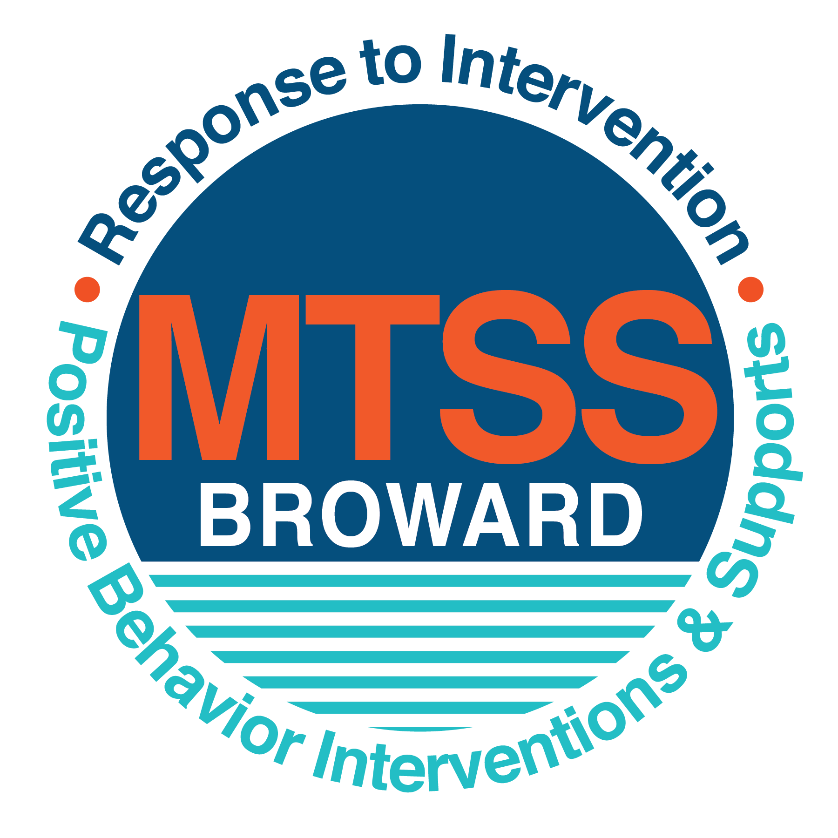

**School-wide Positive Behavior Plan (SPBP)**

Broward County Public Schools

To be implemented in SY 2018/19

|  |  |
| --- | --- |
| **School Name:** | Pompano Beach Middle |
| **School Number:** | 0021 |
| **SPBP Contact Name:** | Ms. Frazier |
| **Direct Phone Number:** | 754 322-4223 |

|  |
| --- |
| **CRITICAL ELEMENT # 1: Active Team with Administrative Participation** |

**1A.** List your current (SY 2017/18) team members (6 - 10 team members). **Must include an instructional representative from EACH grade/content area.** *Each name on this list verifies attendance in ongoing team meetings and participation in developing this SPBP. Each member is responsible for representing major stakeholders and sharing the SPBP content and updates with their respective group.*

|  |  |  |
| --- | --- | --- |
| **Full Name** | **Position** | **Who or what grade level does this member represent?** |
| Sonja Braziel |  | Administration |
| Joniece M. Frazier | SPBP Point of Contact |  |
| Jannette Irwin-Thompson | Parent/Community Representation | SAC |
| Laura Clark | BTU Representative |  |
| Charles Zimmerman | Assistant Principal | Administration=8th |
| Patrick Sauer | Assistant Principal | Administration=7th |
| Karen Karras | Assistant Principal | Administration=6th |
| Novelette Pitt | ESE Specialist | ESE=6th -8th |
|  |  |  |
|  |  |  |

**1B**. Schedule and document your quarterly team meeting dates for *next* 2018/19 school year:

|  |  |  |  |
| --- | --- | --- | --- |
| **Meeting Date** | **Meeting Time** | **Name & title of person responsible to facilitate meeting** | **Content of meetings:** |
| 9/10/2018 | 8:30 AM | Ms. Frazier: Behavior Specialist | 1. Create and disseminate updated  Expectations and Rules lesson  plans (#3 and #4)  2. Review progress of  Implementation Action Plan (#9)  3. Collect & analyze implementation  data (#10A)  4. Collect & analyze student  outcome data (#10B) |
| 10/19/2018 | 8:30 AM | Ms. Frazier: Behavior Specialist |
| 1/7/2019 | 8:30 AM | Ms. Frazier: Behavior Specialist |
| 3/22/2019 | 8:30 AM | Ms. Frazier: Behavior Specialist |

|  |
| --- |
| **CRITICAL ELEMENT # 2: Faculty & Stakeholder Commitment:** |

**2A**. Action Steps completed **this year** (SY 2017/18) that increased faculty and stakeholder understanding and knowledge of your *new* (2018/19) SPBP:

|  |  |  |  |
| --- | --- | --- | --- |
| **Action Steps:** | **Date**  *(Between Jan 15 –*  *April 30, 2018)* | **Details**  *(retain attendance sheets at school)* | **Person responsible to collect and retain attendance sheets:** |
| Presented the *new* SPBP (for SY 2018/19) to staff | 2/15/2018 | # of participants = | Ms Palumbo |
| Held a *faculty* vote on the new SPBP  (for SY 2018/19) | 3/19/2018 | % approved =95% | Ms. Frazier |
| Presented the *new* SPBP (for SY 2018/19) to stakeholders (parents and community) | 4/11/2018 | # of participants = 15 | Ms. Thompson |

**2B.** Action Steps to be completed **next year** (SY 2018/19) to increase faculty and stakeholder understanding and knowledge of your SPBP:

|  |  |  |  |
| --- | --- | --- | --- |
| **Action Steps:** | **Date(s)**  *(NEXT YEAR)* | **Content**  *(retain attendance sheets at school)* | **Person responsible to collect and retain attendance sheets:** |
| Provide a professional development on the 2018/19SPBP for all staff | 8/10/2018 | The team will present the updates in the SPBP for the 18/19 school year. All stakeholders will be provided with access to the SPBP. Feedback will be collected for future team meetings. | Ms. Frazier |
| Present the 2018/19SPBP to stakeholders (parents and community)00 | 9/12/2018 |
| Present behavior data to staff  *Quarterly: minimum of 4 each year* | 1. 9/13/2018 | The team will present the implementation data in 10A. Include:  • the “marketing” (teaching and posting) of expectations and rules  • lesson plan implementation  • discipline procedures  • reward system implementation  The team will present the student outcome data in 10B. Include:  • top 3 event locations  • type of behavior incidents  • core effectiveness data  • classroom referral data, as well as analysis of this data. | Ms. Frazier |
| 2. 12/14/2018 |
| 3. 2/20/2019 |
| 4. 4/17/2019 |

|  |
| --- |
| **CRITICAL ELEMENT # 3: School-wide Expectations** |

**3A.** List the **top 10 behavior incidents** data YTD from BASIS 3.0 Behavior Dashboard:

|  |
| --- |
|  |
| 1.Disobedience Insubordination |
| 2.Unruly Disruptive Behavior |
| 3.Defiance of Authority |
| 4.Fighting Medium |
| 5.Profanity to Staff Member |
| 6.Fighting Mutual Combat |
| 7.Class Cut/ Skipping |
| 8. Disruptive Unruly Play |
| 9.Insulting Profane Obs. Language |
| 10.Fight Minor Altercation Conference |

**3B.** Based on the behavior incidents in 3A, develop 3 – 5 **positive characteristics** *(not behaviors)* that would counteract the demonstration of these misbehaviors. These positive characteristics become your school-wide expectations.

|  |
| --- |
| **School-wide Expectations** |
| Demonstrate respect by following directions and rules. |
| Students will walk while keeping hands and feet to self in hallways. |
| Students will use positive, non-offensive vocabulary and gestures. |

**3C.** Research indicates that discipline referrals increase after long holidays and during testing times. Plan to teach your expectations at least 3 times throughout the year (and anytime the expected behaviors are not being demonstrated).

**ACTION:** Create at least one lesson plan for **each** school-wide expectation above and distribute to teachers during pre-planning 2018-19. Develop additional lesson plans you will use throughout the year to re-teach and reinforce your school-wide expectations. *You do not need to submit your lesson plans with the SPBP. Retain all behavior lesson plans at the school; make sure these lesson plans are available for guests and stakeholders.*

|  |  |  |  |
| --- | --- | --- | --- |
| **When will school-wide expectations lesson plans be taught?** | | | |
|  | Date(s) | Time: | |
| August | August 8, 2018  August 9, 2018  August 10, 2018  August 13, 2018  August 14, 2018 | 10:00AM on all dates | |
|  | | | |
| Who will be responsible for teaching the lesson plans? | | | Homeroom/Tiger-Tune-Up Teacher |
| Where will the lesson plan instruction occur? | | | Homeroom Teacher Classroom |
| Who is responsible for retaining, organizing and distributing all lesson plans? | | | Classroom Teacher |

|  |
| --- |
| **CRITICAL ELEMENT #4: Location-based Rules** |

**4A.** List the **top 3 locations** for behavior Events YTD from BASIS 3.0 Behavior Dashboard**.** ***Do not use “classroom”***

|  |  |
| --- | --- |
| **Top 3 Locations** | |
| School Location | # Incidents |
| 1.Classroom | 344 |
| 2.Cafeteria | 40 |
| 3. Schools Grounds | 45 |

**4B.** Create an Expectations/Rules Matrix from your 3-5 school-wide expectations and your top 3 event locations. Develop a positively stated, observable, and measurable rule that correlates with every expectation to create a maximum of 5 rules under each location**.**

|  |  |  |  |  |
| --- | --- | --- | --- | --- |
| **Expectations and Rules Matrix** | | | | |
| **Schoolwide**  **EXPECTATIONS** | *Copy and paste expectations from* ***3C****.* | **IDENTIFIED LOCATIONS**  *Copy and paste locations from* ***4A.*** | | |
| Location#1 Classroom | Location#2 Cafeteria | Location#3 School Grounds |
| **Rules** | **Rules** | **Rules** |
| Classroom | Keep hand off other student’s book bags | Be responsible:  Say Please and Thank you using soft voices | Demonstrate respect by using appropriate language on school campus |
| Cafeteria | Demonstrate respect by following directions from security monitors in hallways. | Demonstrate respect by following directions from lunch monitors | Keep hands off adults or students’ belongings |
| Schools Grounds | Walk quietly in halls keeping voice at indoor level | Be Safe: Raise hand to respectfully ask permission to leave assigned table. | Maintain a conversation level voice in all school offices. |

**4C**. Research indicates that discipline referrals increase after long holidays and during testing times. Plan to teach your location-specific rules at least 3 times throughout the year (and anytime the expected behaviors are not being demonstrated).

**ACTION:** Create at least one lesson plan for **each** location above and distribute to teachers during pre-planning 2018-19. Develop additional lesson plans you will use throughout the year to re-teach and reinforce your location-specific rules.

*You do not need to submit your lesson plans with the SPBP. Retain all behavior lesson plans at the school; make sure these lesson plans are available for guests and stakeholders.*

|  |  |  |
| --- | --- | --- |
| **When will location-specific rules lesson plans be taught?** | | |
|  | Date(s) | Time: |
| August | August 8, 2018 |  |
| January | January 7, 2019 |  |
| 4th Quarter | March 22, 2019 |  |
|  | | |
| Who will be responsible for teaching the lesson plans? | | Homeroom/ Tiger-Tune-Up Teacher |
| Where will the lesson plan instruction occur? | | Tiger-Tune-Up Classroom |
| Who is responsible for retaining, organizing and distributing all lesson plans? | | Ms. Frazier |

|  |
| --- |
| **CRITICAL ELEMENT # 5: Reward and Recognition Programs** |

Although you will post, teach, review, practice and reinforce all school-wide expectations and location-specific rules, **choose 1 expectation OR 1 event location** you will target for a specific reward program for students. Based on the data that led to this expectation or location, create a reward plan using the 4 Step Problem Solving Process:

Expectation or Location: _________________________________________________________________________

|  |  |
| --- | --- |
| **4 Step Problem Solving Process** | **Plan** |
| **1. Problem Identification:** Use your behavior data to identify a school-wide problem.  What problem did you identify? *(use numerical data)* | **Data used: BASIS**    **Problem Identification: Disrespect in the classroom.** |
| **2**. **Problem Analysis:** Why do you think this problem is occurring?  What is your goal? *(use a SMART goal statement with numerical data)* | **Student will show an Act of Kindness towards another student. Student will use kind words and show respect when interacting with fellow students during the school day. 0-1 referrals per quarter (9 weeks)** |
| **3. Intervention Design:**  Describehow you will implement a positive reward program to decrease this problem. | **Type of System: Point system**  **Description of System: Students can earn**  **Student gift card**  **Homework forgiveness**  **Media Center pass**  **Free Gym pass**  **Dress Down Day**  **Student & Staff Basketball.**  **The rewards and recognition program will be implemented by the Administrative staff.** |
| **4. Evaluation:**  A. Implementation fidelity | **Data will be collected through BASIS, Teacher and Administrative input to Determine who is eligible for the reward.** |
| B. Student outcome monitoring | 1. How will you know if the reward program is positively impacting **students**? What measurable data will you use to determine “success”? Student data will be collected from BASIS discipline records, Administrative and teacher input |

|  |
| --- |
| **CRITICAL ELEMENT #6 Effective Discipline Procedures** |

**6A. Staff Managed Misbehaviors:** List the top 6 *most common* school-wide misbehaviors **staff are expected to manage.**

Write a short, objective, and measurable definition for each.

|  |  |
| --- | --- |
| **Staff Managed Misbehaviors** | |
| Misbehavior | “Looks Like” - *provide a description with example(s)* |
| 1. Disobedience | Wondering around the classroom during instruction. |
| 2. Offensive Language | Student using obscene and profane towards peers. |
| 3. Disruptive –Unruly Playfulness | Play fighting in class. |
| 4.Classroom Disruption | Talking out during instruction |
| 5.Inappropriate Touching | Touching other Students |
| 6.Verbal Confrontation | Profanity towards Teacher |

**6B. Staff Managed Consequences**: Create a consequencemenu **OR** a consequence hierarchy for staff to use when students exhibit the above misbehaviors. Provide a minimum of **5** consequences.

|  |  |
| --- | --- |
| Is this a menu or hierarchy system? | Menu Hierarchy |
| Parent contact ( call) | |
| Lunch detention | |
| Peer Teacher timeout | |
| Parent Conference | |
| Referral | |

**6C. Administration Managed Misbehaviors**:

(a) Define the first 3 behaviors by providing examples that clearly identify the point at which the misbehavior warrants an Office Discipline Referral (ODR).

(b) List two additional common school-wide misbehaviors that will result in an ODR. Provide concrete examples.

(c) Determine staff tolerance level for repetitive misbehaviors (the point at which the number of staff-managed misbehaviors becomes an ODR).

|  |  |
| --- | --- |
| **Office Discipline Referrals (ODRs)** | |
| Behavior | “Looks Like” - *provide a description with example(s)* |
| 1. Disobedience/Insubordination | Talking out during instruction after being redirected 4 or times. |
| 2. Disruptive/Unruly Play | Play fighting in the class, student is injured |
| 3. Defiance of authority | Refusing to put away the cell phone, after caught filming other students |
| 4. Arguing | Yelling and using profane language in the classroom. |
| 5. Inappropriate touching | Touch others students personal parts. |
| 6. Repetitive staff managed  Misbehaviors | More than misbehaviors inwarrants an office referral.  8  4  2    *e.g., 3 half hour*  *2 one period* |

**6D. School-wide Discipline Flow Chart:**

(a) Review the sample discipline flow charts in “Additional Items” located on browardprevention.org

(b) Copy or customize a flow chart to graphically represent the discipline process at **your** school.

(c) Paste the flow chart here**OR** complete the flow chart below.

**Staff observes and identify behavior**

Administration submits referral for data input

Administrative action

Administrative follow up

Teacher/ Staff

Completes referral contact parent

Administration managed

Out of assigned area

Inappropriate language

Tardiness

Calling Out

Teasing

Inattentive Behavior

Lying/ giving false information

Minor aggression

Misuse of property

Unsafe-Rough Play

Disrespect

Aggressive Physical Contact

* Bullying/ Harassment
* Fight
* Property destruction
* Weapons
* Leaving School property
* Aggressive/ profane language
* Dress Code
* Credible threats
* Major/chronic destruction
* Defiance of Authority
* Theft
* Inappropriate use of school technology

Administrative

Managed

Teacher/Staff

Managed

Complete Discipline Referral and notify Administrator of referral for disciplinary actions.

Reinforce/

Reward correct student behavior

Did Behavior

Change?

Yes NO

Implement minor consequence

Is the behavior minor?

Staff Managed

|  |
| --- |
| **CRITICAL ELEMENT # 7 : Classroom Management Systems** |

**7A.** ALL teachers implement an effective Tier 1 classroom management system:

|  |  |
| --- | --- |
| Which **evidence-based** classroom management system is supported by your school’s administration and is expected to be implemented school-wide?  *(Class Dojo, LEAPs, HERO, Cloud 9, etc. are tools,* ***not*** *classroom systems)* | CHAMPs*  PBIS Classroom Management  Administration does not expect an evidence-based classroom management system to be implemented by teachers this year  (*your school will need to adopt one next year)*  Other *(complete below)* |
| If other, name the **evidence-based classroom management system:** | Click here to enter name of system. |
| *CHAMPs is the district-supported, evidence-based universal classroom management system for all teachers. Would your Principal like to be contacted to learn about CHAMPs professional development? | Yes  No |

**7B.** Fidelity of **staff** implementation of school-wide classroom management systems

|  |
| --- |
| What data collection tool does your school leadership team use to monitor and evaluate your teacher’s classroom management skills? *(Measure* ***staff skills****, not student outcomes)* |
| CHAMPs 7 Up Checklist |
| CHAMPs Classroom Check Up (CCU) |
| PBIS Classroom Assistance Tool (CAT) |
| PBIS Walkthrough |
| Marzano’s Domain 1, Design Questions 5, 6, 7, 8, 9 |
| Fidelity of staff classroom management implementation is not monitored to determine training needs this year *(you will need to adopt a tool and plan next year)* |
| Other *(specify):* |
| Explain how this data is collected and analyzed by your school leadership team as a **universal screening** *across teachers* to determine the need for classroom management training: |
| Fidelity of Implementation Plan: Teacher referral data will be monitored through the RTI, BASIS Dashboard to determine the need for classroom management Training. |

**7C. Percentage of Classroom Referrals:**

(a) Review your classroom data YTD (“Events by Location”) in BASIS 3.0 Behavior Dashboard.

(b) Complete the yellow highlighted cells first.

(c) Auto-calculate the % of referrals in the classroom by clicking on “!Zero Divide” in the next cell and pressing “Fn + F9” together.

|  |  |
| --- | --- |
| Total number of discipline referrals **from classrooms**: | 428 |
| Total number of **school-wide** discipline referrals: | 527 |
| % of referrals in the classroom: | 45% |
| Do more than 40% of your referrals come from the classroom? | Yes  No |

***If >40% of discipline referrals come from the classroom, it suggests Tier 1 classroom management implementation may need to be strengthened school-wide.***

|  |
| --- |
| **CRITICAL ELEMENT # 8: Data Collection and Analysis** |

**8A. Determine your School-wide Core Effectiveness YTD** from the BASIS Behavior Dashboard in the “Referrals per Student” chart.

(a) Complete the yellow highlighted cells first.

(b) Auto-calculate the “% of Total Population” by clicking on each “!Zero Divide” in the cells and pressing “Fn + F9”.

(c) Determine if the core is effective in all three areas

|  |  |  |  |  |
| --- | --- | --- | --- | --- |
| TOTAL Population: | 1,083 |  |  | |
| # Referrals |  | **% of Total Population** | Core Effectiveness | |
| 0 - 1 referral |  | **!Zero Divide** | Are your 0 – 1 referrals > 80%? | Yes No |
| 2 - 5 referrals  (at risk students) | 85 | 9.2 | Are your 2 - 5 referrals <15%? | Yes No |
| > 5 referrals  (high risk students) | 20 | 2.1 | Are your >5 referrals <5%? | Yes No |

**8B. Core Effectiveness Plan:**

|  |  |
| --- | --- |
| If all 3 are “**Yes**”, your core is effective. Is your core behavior curriculum effective? | Yes No |
| Answer **either** (a) or (b):  (a) If you answered “**Yes**”, although your core is effective, what plan does your school leadership team implement for early identification of at risk and high risk students?  (b) If you answered “**NO”**, indicate the supports and interventions your school leadership team will implement at the beginning of the next school year to improve core strength: | |
| Core Effectiveness Plan: At-Risk and High Risk will be targeted through the RTI process and closely monitored by the Behavioral Specialist and Family Counselor. | |

**8C. Disproportionality: Determine if there are any issues within subgroups** from BASIS 3.0 Behavior Dashboard in the “Referrals by Demographics” chart.

(a) Complete the yellow highlighted cells first.

(b) Auto-calculate the difference by clicking on each “0” in the next cell and pressing “Fn + F9”.

|  |  |  |  |  |
| --- | --- | --- | --- | --- |
| Subgroups | (PctPop - Green)  % **of students** | (PctRef - Blue)  **% of referrals** | Difference in referral composition | Positive value suggests disproportionality  (Is the value positive?) |
| Black | 77 | 83 | 6 | Yes No |
| Hispanic/Latin | 15 | 13 | -2 | Yes No |
| White | 7 | 4 | -3 | Yes No |

**8D. Disproportionality Plan:** If any values are positive, the percentage of referrals contributed to that subgroup is higher than expected, given that subgroups’ percentage in the student population.

|  |  |
| --- | --- |
| If all 3 are “**No**”, disproportionality is not indicated. Are all 3 “No”? | Yes No |
| Answer **either** (a) or (b):  (a) If you answered “**Yes**”, although your data indicates equity, what plan does your school leadership team implement for early identification of any disproportionality issues  (b) If you answered “**No**”, indicate the support plan and interventions your school leadership team will implement at the beginning of next year to improve sub group disproportionality | |
| Disproportionality Plan: The disproportionality will be addressed through the Social Emotional Learning domain on going staff development. | |

|  |
| --- |
| **Critical Elements # 9: SPBP Implementation Planning** |

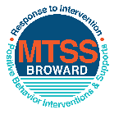This form provides a timeline to complete best practices and required actions. This timeline should drive team actions and accountability. As you implement your SPBP *NEXT* year, check off **completed items** and indicate the accountable person. (Complete only the yellow highlighted area at this time). Next year, you will upload this completed plan within your SPBP.

Required actions for all schools in Broward County

Best Practices for all schools in Broward County

**Resources**

|  |  |  |
| --- | --- | --- |
| **SPBP Team Implementation Action Plan 2018 - 2019** | | |
| **Month** | **Action Step**  *check when Action completed* | **Completed:**  Person Responsible  Name & Title |
| **Current** | **This Action Plan has been saved to use *next year* during quarterly meetings** | **J. Frazier Behavior Specialist** |
| **Current** | **Create a SPBP binder or portfolio to retain (for 2 years) hard copies of: your SPBPs, Action Plans, staff PBIS professional development attendance, stakeholder training attendance, quarterly meeting agendas, quarterly staff behavior presentations, voting attendance and outcome, Expectation lesson plans and Rules lesson plans** | **J. Frazier Behavior Specialist** |
| **Pre Planning**  **2018** | Print up your SPBP Review and school score from OSPA  Provide SPBP presentation to all staff during Pre Planning  Disseminate the current SPBP (hard copy or electronically) to all staff and stakeholders  Market and post school-wide Expectations and location-specific Rules (posters, PSAs, etc.)  Identify your RtI Instructional Facilitator provided by the district  (Contact [tyyne.hogan@browardschools.com](mailto:tyyne.hogan@browardschools.com) for more information, if you are unsure)  Confirm 1st team meeting date and time | Click here to enter NAME & title. |
| **August**  **1st meeting** | Ensure schedule of quarterly meeting dates for entire year as indicated in the SPBP  Determine any needed team training, such as the 4 Step PSP Brainshark Series, 10 Critical  Elements Brainsharks, Data Collection, Effective CPST Teams, PBIS 101, etc.  Trainings available at: <http://www.browardprevention.org/mtssrti/training-modules/>  Review previous year’s behavior data. (Use ‘Agenda’ and ‘Data Collection Template’)  Forms available at: <http://www.browardprevention.org/mtssrti/rtib> in Tier 1, Teaming  Present implementation data, behavior data, team activities and progress to entire staff  Utilize the 4 Step Problem Solving Process to develop initial interventions  Review previous year’s SPBP and feedback form  Verify and implement teaching schedule for SPBP Expectations and Rules behavior lesson plans | Click here to enter NAME & title |
| **September** | Provide stakeholder presentation on SPBP prior to October 1  Check for staff and teacher understanding of PBIS - provide “PBIS 101” Brainshark as a resource  Brainshark available at: http://www.brainshark.com/browardschools/PBIS101 | Click here to enter NAME & title. |
| **October**  **2nd meeting** | Ensure instructional staff know how to (and are, as needed) enter Tier 1 Supplemental Strategies  for behavior in BASIS  Present implementation data, behavior data, team activities and progress to entire staff | Click here to enter NAME & title. |
| **November** | Staff to re-teach Expectations and Rules first day back from break.  Team to develop new and/or improved lesson plans as indicated by behavior data. | Click here to enter NAME & title |
| **January**  **2019**  **3rd meeting**  Prepare for *2019/20* SPBP | Staff to re-teach Expectations and Rules first day back from break  Ensure the Principal signs in and watches the *new* SPBP Brainshark: Due January 30th  Present implementation data, behavior data, team activities and progress to entire staff  Choose team members and dates to work on, complete, and submit the *new* SPBP  Teams watch the *new* SPBP Brainsharks and refers to *new* “Additional items”  Brainsharks and Additional items posted at: <http://www.browardprevention.org/mtssrti/rtib> | Click here to enter NAME & title. |
| **February** | Ensure progress towards completion of SPBP  Check on recently hired staff for PBIS understanding - provide “PBIS 101” Brainshark resource  Provide the SPBP Surveymonkey link to all staff (optional). Email [Tyyne.hogan@browardschools.com](mailto:Tyyne.hogan@browardschools.com) to request analysis. | Click here to enter NAME & title |
| **March**  **4th meeting** | Ensure progress towards completion of SPBP  Provide staff presentation and vote on new SPBP for next year  Provide stakeholders/parent presentation on new SPBP for next year  Present implementation data, behavior data, team activities and progress to entire staff | Click here to enter NAME & title |
| **April** | Submit your SPBP in OSPA by April 30th every year | Click here to enter NAME & title |

|  |
| --- |
| **CRITICAL ELEMENT # 10: Monitoring Plans** |

**10A.** How will you determine the success **of *staff* implementation** of the School-wide Positive Behavior Plan?

*“Are* ***staff*** *implementing the SPBP with fidelity? How do you know?”*

|  |  |  |  |
| --- | --- | --- | --- |
| **Fidelity of Implementation Monitoring Plan** | | | |
| Action Step | Create an **observable** and **measureable** SMART goal to determine “successful”  **staff implementation** of action step | When will data be collected, analyzed & presented? | Person responsible to collect and analyze data |
| School-wide **expectations** and location-specific **rules** are posted across campus | Students will demonstrate respect by following the directions and rules. | 1. 9/13/2018  2. 12/14/2018  3. 2/20/2019  4. 4/17/2019 | Administrator |
| **Behavior lesson plans** are being taught as written and when indicated | Behavior lesson plans will be reviewed to staff on or by the dates indicated. | Administrator |
| **Discipline consequences**  and **flow chart** are being used by all staff as written | Discipline consequence and flow chart will be distributed used by the date indicated. | Administrator |
| A **reward system** is being implemented for *all* students | The reward system will be implemented with all students by all staff. | Administrator |

**10B.** How will you determine whether the SPBP is successful in positively impacting **students?**

*“If staff are implementing the SPBP consistently and effectively, did it positively impact* ***the students****? How do you know?”*

|  |  |  |  |
| --- | --- | --- | --- |
| **Student Outcome Monitoring Plan** | | | |
| Student Outcome Data | Create an **observable** and **measureable** SMART goal to determine “successful”  **student outcomes** | When will data be collected, analyzed & presented? | Person responsible to collect and analyze data |
| See critical element 3A  • Type of **behavior incidents** data | The SPBP will monitor BASIS Quarterly to monitor student behavior incidents to determine student success outcome. | 1. 9/13/2018  2. 12/14/2018  3. 2/20/2019  4. 4/17/2019 | RTI Coordinator |
| See critical element 4A  • **Top 3 event locations** data | The SPBP Team will compare the to 3 event locations through BASIS for student incidents | RTI Coordinator |
| See critical element 8  • **Core effectiveness** data | At-Risk and High Risk will be targeted through the RTI process and closely monitored by the Behavioral Specialist and Family Counselor. | RTI Coordinator |
| See critical element 7A  • **Grade Level/Classroom referrals** data | SPBP Team will monitor grade level classroom referral data through BASIS to determine the student success outcome. | RTI Coordinator |