SCHOOL IMPROVEMENT
Standard Operating Procedural Manual

Broward County Public Schools

Professional Learning Communities: Monica Bianchi, Supervisor, Professional Development Support Department, Email or 754-321-5054 X2872
Title I Plan: Paula Canady, Title I Program Specialist, Title I, Migrant and Special Programs Department, Email or 754-321-1407
Schoolwide Positive Behavior Plan: Tyyne Hogan, Prevention Specialist, Prevention Program,
Email or 754-321‐1642

For Technical/Computer Support with the Broward School Improvement Plan, Title I Plan and the Schoolwide Positive Behavior Plan Templates contact: Yaco Zaragoza, Senior Programmer,
Office of Service Quality Email or 754-321-3850

IMPORTANT MESSAGE TO ALL PRINCIPALS:
SAC Chairs who are SBBC employees or the SAC designee
need to be able to log on to OSPA Central to input school improvement information.

Steps to Add SAC Chair(s) to OSPA Central 2.0 as designated users:

• Log on to OSPA Central V2.0 (http://www.broward.k12.fl.us/ospa/ospa-central2/)

• Click on Manage Users

• Click on New User

• Fill Out the User Information Form
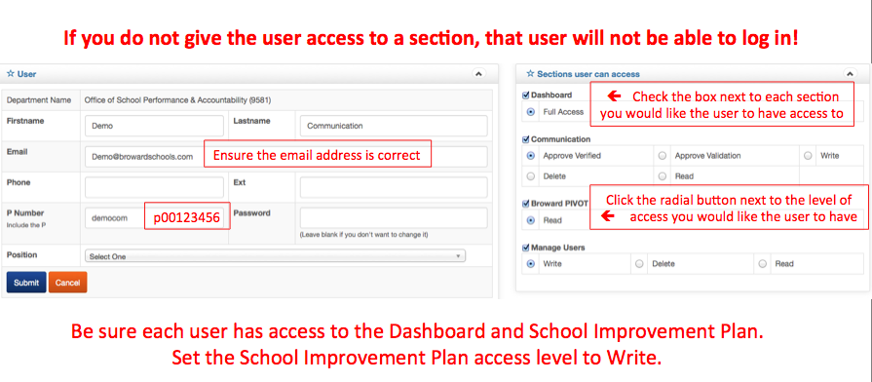
SBBC SCHOOL IMPROVEMENT TEMPLATE GUIDE

- Log on to the OSPA website:

http://www.browardschools.com/departments/office-of-school-performance-and accountability

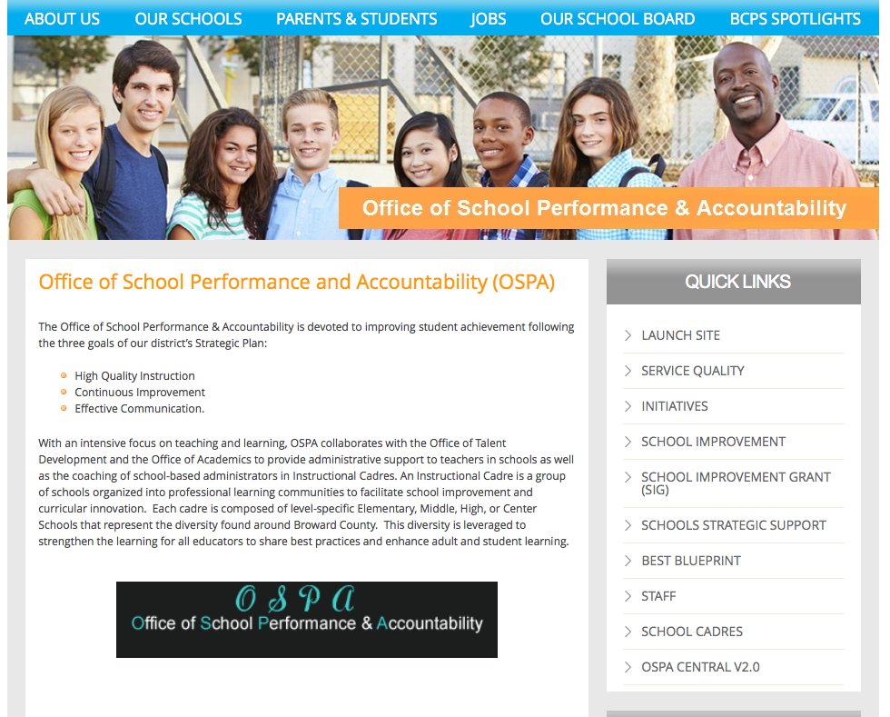
3. Click on OSPA Central V2.0  ⬆

This is what you will see:
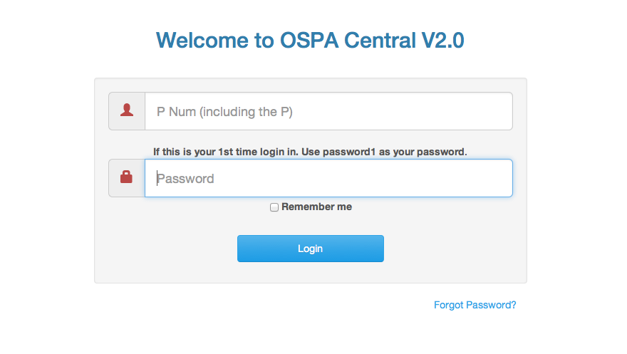

4. Log on to OSPA Central 2.0
(Your Principal should have added you as a designated user. See page #2.)

This is what you will see:

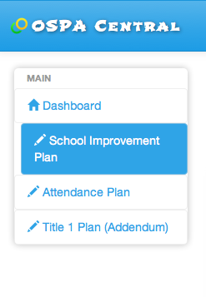
5. Click on School Improvement Plan.
6. The name of your school will appear. Click on View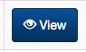.
This is what you will see.
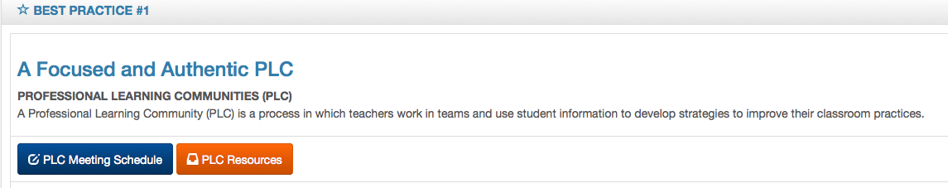
7. BEST Practice #1: Click on PLC Meeting Schedule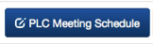.
This is what you will see.
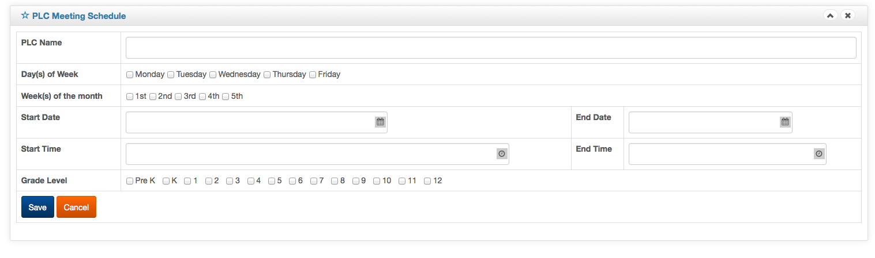
Complete the form and click on Save.
Special Note: This form will need to be completed and saved for each PLC at a school.
The PLC Meeting Schedule can be updated as needed throughout the school year.

8. Scroll down to BEST Practice #2.
This is what you will see. Early Warning indicators will be updated periodically.
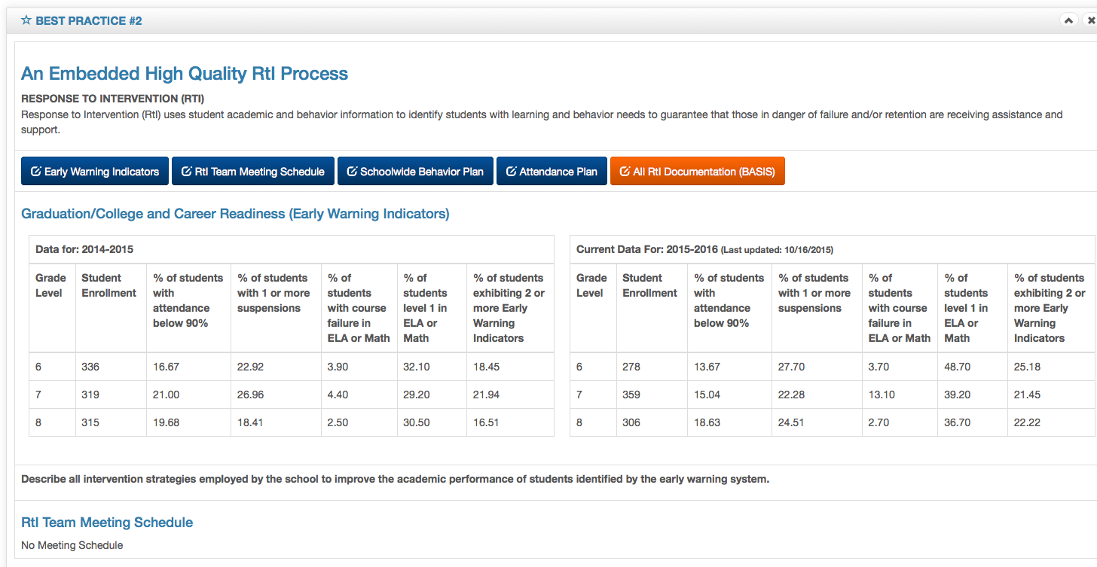
- Click on Early Warning Indicators respond to the question, and click Submit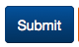.
- Click on the RtI schedule, input the requested information and click Save.
- Click on Schoolwide Behavior Plan, input requested information, and click Save.
- Click on the Attendance Plan, input requested information, and click Save.

Special Note: Refer questions about the Behavior Plan or Attendance Plan to:

Schoolwide Positive Behavior Plan: Tyyne Hogan, Prevention Specialist, Prevention Program, Email or 754-321‐1642

Attendance Plan: Laurel Thompson, Director, Student Services Department, Program, Email or 754-321‐1550

9. Scroll down to BEST Practice #3.

This is what you will see:
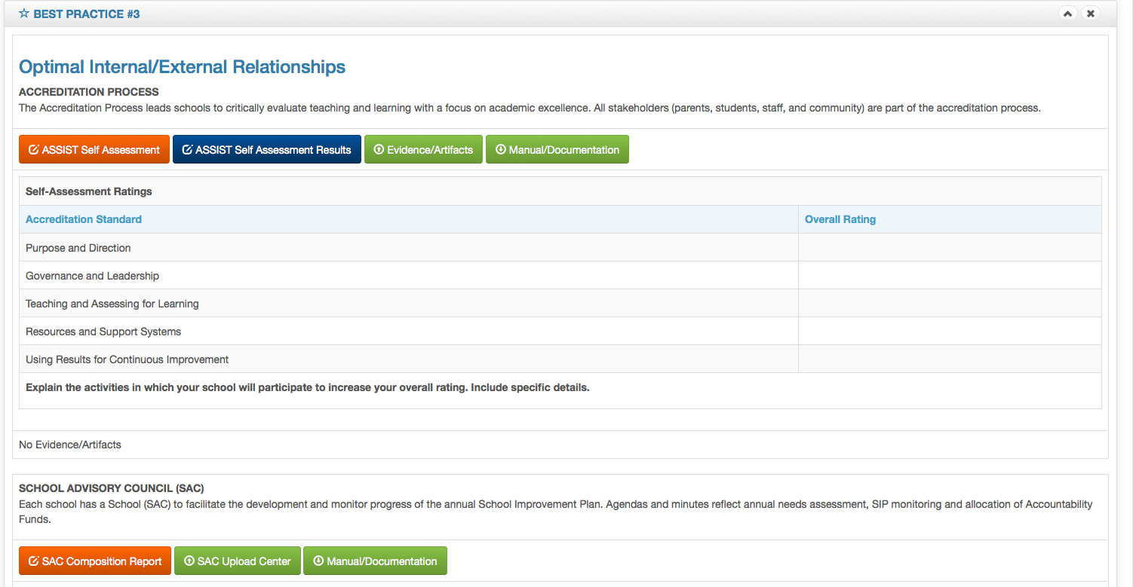
- Click on Assist Self-Assessment 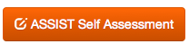 which will connect to the AdvancED website for the completion and viewing of the school’s annual Self-Assessment.
- Click on Assist Self Assessment Results 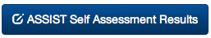, input the information requested and click Submit .
- Click on Evidence/Artifacts 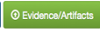, click , then click on Upload File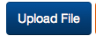 to upload all Accreditation artifacts and documents. Refer to the Accreditation Standard Operating Procedure Manual for naming protocols.
- Manual/Documentation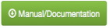 is the Accreditation Standard Operating Procedure Manual with specific directions needed for formatting and completion of all Accreditation documents.
- Click on 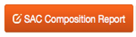 and input the information requested. Be sure to click update button after enrolling each SAC Team member.
- Click on Evidence/Artifacts , click , then click on Upload File
to upload all SAC documents: SAC Composition, SAC Bylaws, SAC Agendas,
Minutes, Sign-In Sheets, etc. Follow naming protocols for all documents: School
Location#_Name of Document _Date.doc
- Manual/Documentation is the School Improvement
Standard Operating Procedure Manual with specific directions needed for completion
of all School Improvement documents.

10. Scroll down to BEST Practice #4
You will see the sections that apply to your school.
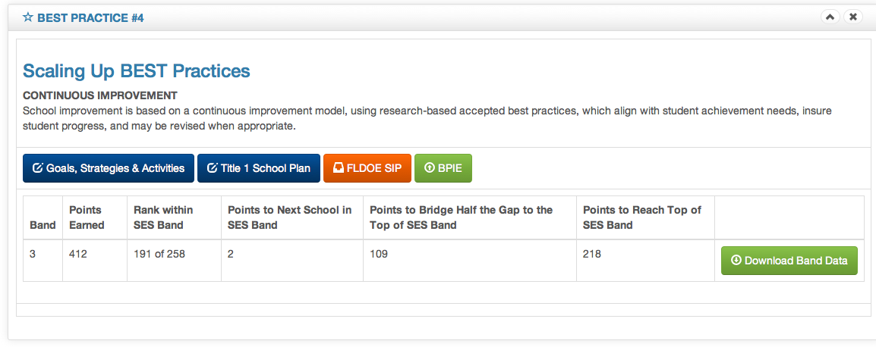
- Click on Goals, Strategies and Activities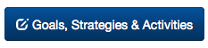 if the school is an FLDOE A, B, or C rated school. Input all requested information and click on the Submit button.
Be very specific and include clear, concise details. Use of Accountability Funds must be outlined in the Budget section.
- Title I School Plan button will appear for all designated Title I schools with a FLDOE A, B, or C rating. Input all required information and click on Save
- FLDOE SIP button will appear for all DA designated schools. Click on this button to link to FL CIMS for completion and viewing of the FLDOE SIP.
- Click on BPIE button and upload the PDF version of the school BPIE (Best Practices for Inclusive Education).

Resources that may be used to provide information and/or guidelines for completion any section of the SBBC School Improvement Plan are available by just clicking on the title:

