Veda Hudge, Director
Donna Boruch, School Improvement Coordinator

NEW WAIVER
Standard Operating Procedural Manual

Broward County Public Schools

SECTION 2: WAIVER PROCESS TIMELINE
October Schools notified of process & directions

School Principals and School Advisory Council (SAC) Chairs currently implementing final year of prior school board approved waiver reminded to follow process for New Waivers in order to renew Waiver

November 14 Schools submits New Waiver Intent Form to Instructional
Facilitator assigned to their Cadre Director

December Schools notified of support/non-­‐support to proceed with New Waiver Process
- New Waiver Power Point can be viewed by Principal, SAC Chair, SAC Committee and other stakeholders at: http://www.broward.k12.fl.us/ospa/initiatives.asp? initiative_id=5

December – February New Waiver Applications Developed
- SAC Develops New Waiver Request
- Conduct Community Meeting(s)
- SAC approves Waiver Request
- Faculty Votes on Waiver Request
- Online Waiver Request Forms Completed

February 9 New Waiver Applications submitted to SAC Documentation
Upload Center (where SAC Agenda/Minutes are submitted)

- School-­‐based signatures
- Completed Waiver Checklist
- SAC Waiver Documentation Form
- All other required documentation
February 16-24 Office of Service Quality reviews Waiver Application &
Documentation

March Schools with pre-approved Waivers not expiring the current year begin the Continuation Waiver process documentation due submitted to the SAC Documentation Upload Center (where SAC Agenda/Minutes are submitted)

Continuation Waiver Powerpoint (http://www.broward.k12.fl.us/ospa/initiatives.asp
?initiative_id=5) can be viewed for schools with prior school board approved waivers currently
or 4 of implementation and that do not expire this school year
- Schools with Continuation Waivers: Review annual data for current waivers
- Conduct faculty vote to continue or discontinue existing waiver(s)

- Prepare Continuation Waiver Form with Continuation Waiver Checklist for submission to SAC Documentation Upload Center

March New Waiver Applications reviewed by District Committee

New Waiver Applications reviewed by respective Principal level Cabinet Committees
New Waiver Applications reviewed by Chief Officer of School Performance and Accountability

April Board Item for New Waiver Applications prepared and presented to District’s Agenda Preparation Group (APG) for discussion prior to School Board Meeting

May New Waiver Applications submitted to School Board for approval

May Schools are notified of School Board Action

May 14 Renewal of Continuation Waivers Due:
- Schools review annual data for current waivers
- Conduct faculty vote to continue or discontinue existing waiver(s)
- Submit Continuation Waiver Form with Continuation Waiver Checklist to Donna Boruch, Coordinator of School od School Improvement

May Schools finalize plans to implement new and continuing waivers for 2015-2016 school year

SECTION 3: NEW WAIVER PROCESS FLOWCHART
School SAC and/or faculty identify a barrier to school improvement (policy or contract

School SAC and faculty investigate alternatives to
Can the barrier
only be removed via a waiver to
policy or contract?
No
Waiver does not go forward
No
Submit New Waiver Intent Form
Yes

New Waiver proposed by SAC
Yes
New Waiver Podcast viewed
Public meetings for community input
SAC votes to approve wavier
Community input
is favorable?
No
SAC votes to revise waiver per
community input
Yes

SAC votes to approve waiver
SAC votes not to pursue wavier
as is, but notes community input in board item
School Faculty votes on waiver as prescribed in
Article 15 of the BTU contract-2/3 in favor of the
Faculty vote is
favorable?
No
Waiver application
does not go forward
School implements new waiver
Reviewed by Office of Service Quality
School
Reviewed by District Waiver committee (includes BTU) and
the appropriate principal executive committee
No
Yes
Reviewed by the Chief Officer of School Performance
and Accountability
School Board takes
action on New Waiver
Superintendent makes recommendations to School Board for

SECTION 4: WAIVERS PROCESS & FORMS
Florida Statute 1001.42 and School Board Policy #1403 provides opportunities for schools to waive District policy or contract items that may impede progress of the School Improvement Plan activities. The waiver process has two components: (1) new waivers and (2) continuation waivers. All waivers must support the accomplishment of improved performance outcomes. Policy #1403 also outlines the requirements for developing a waiver.
Waivers may be approved for up to five years. Schools must follow the voting procedures outlined in the Broward Teacher’s Union contract, Article 15.

New Waiver Podcast
A podcast is available for the Principal, SAC Chair, SAC Committee and other stakeholders to view online at http://www.broward.k12.fl.us/ospa/initiatives.asp?initiative_id=5. The podcast is approximately 10 minutes and provides general discussion and guidelines about waivers and the waivers process.

Viewing of the New Waiver Podcast is most appropriate before the submission of the New Waiver Intent Form.

New Waiver Intent Form
The School Advisory Council Chairperson and the Principal may complete, sign, scan and submit a New Waiver Intent to Apply Form by the deadline noted in the timeline. Submissions are to be by email to the Instructional Facilitator assigned to your Cadre Director.
District support of a New Waiver Intent Form permits the school to begin and/or continue conversations with the SAC about applying for a waiver.
Signatures are required on the New Waiver Intent Form. Typed signatures will not be accepted.
See Waiver Intent Form Template on the next Page.

NEW WAIVER INTENT TO APPLY FORM

School: _____________________________ Date: _____________________

Policy or Contract Article to be waived: _________________________________

Brief description of Waiver Request: ___________________________________________________________________

___________________________________________________________________

Rationale for Waiver:

Submitted by:

Principal’s Name: __________________ Signature: ________________________

SAC Chairperson: _________________ Signature: _________________________

--------------------------Information Below Completed by District----------------------------

Proposal supported to continue with process: ______________________________

Proposal not supported to move forward: __________________________________

Date: _____________________________________________________________

If the New Waiver Intent Form is returned and supported to continue with the process, the school can move forward with the New Waiver Process.

New Waiver Application for All Waivers

(Except Professional Study Days)

(See next section for Professional Study Days Waiver Application)
- Log on to to http://www.broward.k12.fl.us/ospa/ospa-central2/
- Click on School Improvement Plan
- Go to Best Practice # 4 and Click Waivers
- Click School Waivers Login
- Click: Click here for new Waiver Application2013 and After
- Enter your username and password as directed on screen

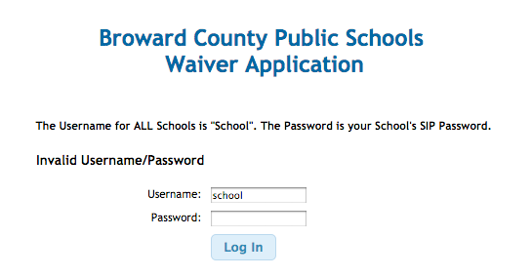
- Click Create Waiver
Note:

  - If your school is applying for a Professional Study Days waiver proceed directly to the next section. The remaining steps in this section are for all waivers except that for Professional Study Days.

- Waiver application opens, complete the sections as appropriate and required.

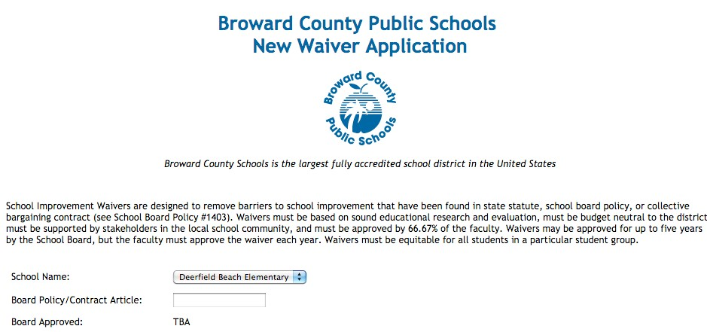

Note
  - The Board Approved part says TBA, this will be completed by the District upon approval by the School Board.

- Complete the sections I -­‐ V.

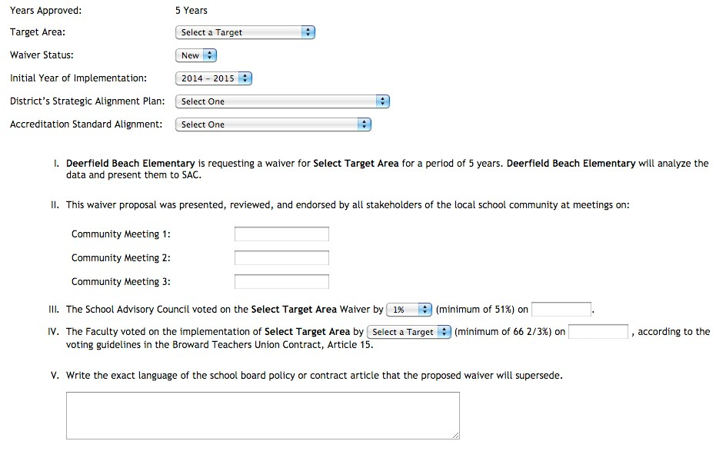

Notes:
  - The Years approved is defaulted to 5 years, the maximum amount permitted by school board policy. If your school desires that a waiver application be for less then 5 years, contact the Instructional Facilitator assigned to your Cadre Director.
  - For additional information on the District’s Strategic Plan to select the appropriate response for the District’s Strategic Plan Alignment visit the Strategic Plan Goal 1 (High-­‐Quality Instruction) at www.browardschools.com/About-­‐Us/Strategic-­‐ Plan/Goals.
  - For additional information on Accreditation to select the appropriate Accreditation Standard Alignment response go to:
www.broward.k12.fl.us/schoolimprove Click Accreditation
Click the link next to ‘Visit our Accreditation website at’

Click the each link under Standard Links

  - Section II
    - Community Meetings 1 and 3 are SAC Meetings
    - Community Meeting 2 is a general community meeting for additional input.
    - Community Meeting 2 may occur before the Community Meeting 3 SAC Meeting on the same night
    - See the New Waiver Process Flowchart and Waiver Checklist for additional information

  - Section IV
    - The faculty vote asks the BTU instructional collective bargaining unit members if they support the waiver for the school.
      - Yes/No are the options
      - 66 2/3 must respond yes to pass
      - BTU instructional collective bargaining unit members includes anyone that is on a teacher’s contract
    - The faculty must pass the waiver with a 66 2/3 vote
    - SBBC Policy calls for all faculty to vote, if a faculty member does not vote it counts as a ‘no vote’
    - See School Board Policy 1403 (http://www.broward.k12.fl.us/sbbcpolicies/docs/P1403.0 00.pdf), School Board Policy 1403 Guidelines (http://www.broward.k12.fl.us/sbbcpolicies/docs/P1403-­‐ A.pdf) and Broward Teachers Union Contract Article 15 (http://www.broward.k12.fl.us/employeerelations/BTU_P DFs_for_Website/ARTICLE15_BTU.pdf) for procedural and additional information on faculty voting for waivers

- Complete sections VI – X.

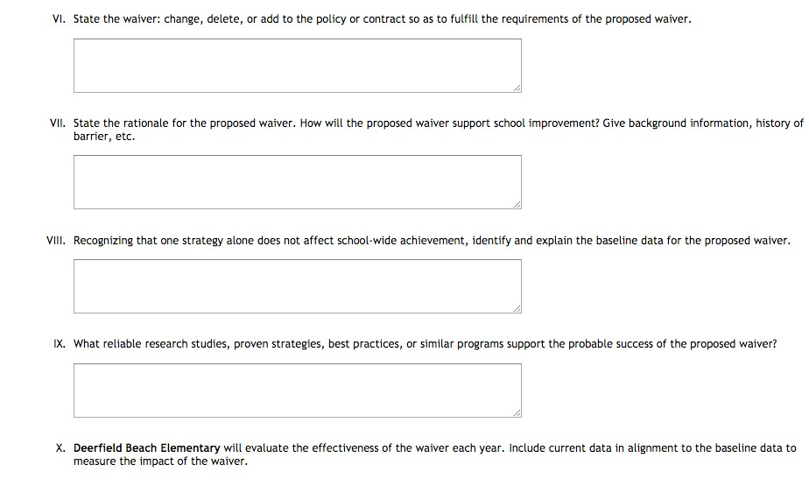
- Complete sections 11 – 12.

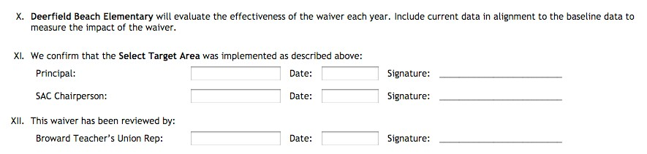

- Click Save or Save and Submit
  - Click Save to save application and return to it to continuing working in the future.
  - Click Save and Submit to submit application to District for review

    - As noted once Save and Submit is selected the Waiver will be locked from further editing.

Notes:
  - This waiver application, with original signature, is to be kept on file at the school and made available to District personnel upon request.
  - A scanned version of the completed waiver application, with signature, and all other required documents are to be uploaded to the SAC Documentation Upload Center (see SAC Documentation Upload Center section) by the deadline noted in the timeline.
    - Filename formula is to be: SchoolName_GradeLevel_PSD_WaiverNumber_Date.pdf, ex. Abc_ES_PSD_1_02082013.pdf

New Waiver Application Professional Study Days

- Go to www.broward.k12.fl.us/schoolimprove
- Click Waivers
- Click School Waivers Login
- Click: Click here for new Waiver Application2013 and After
- Enter your username and password as directed on screen

- Click Create Waiver for all new Waivers except for Professional Study Days

- Waiver application opens, complete all sections as appropriate and required

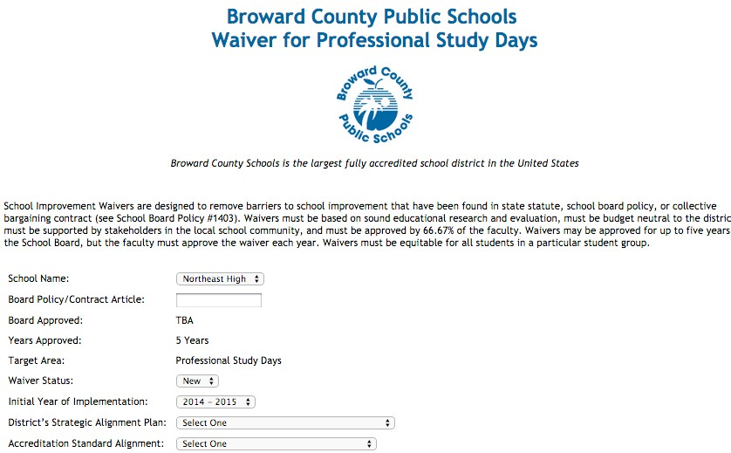

Note:
  - The Board Approved part says TBA, this will be completed by the District upon approval by the School Board.
  - The Years approved is defaulted to 5 years, the maximum amount permitted by school board policy. If your school desires that a waiver application be for less then 5 years, contact the Instructional Facilitator assigned to your Cadre Director.
  - For additional information on the District’s Strategic Plan to select the appropriate response for the District’s Strategic Plan Alignment visit the Strategic Plan Goal 1 (High-­‐Quality Instruction) at www.browardschools.com/About-­‐Us/Strategic-­‐ Plan/Goals.

  - For additional information on Accreditation to select the appropriate Accreditation Standard Alignment response go to:
www.broward.k12.fl.us/schoolimprove Click Accreditation
Click the link next to ‘Visit our Accreditation website at’ Click the each link under Standard Links

- Complete sections I -­‐ VIII

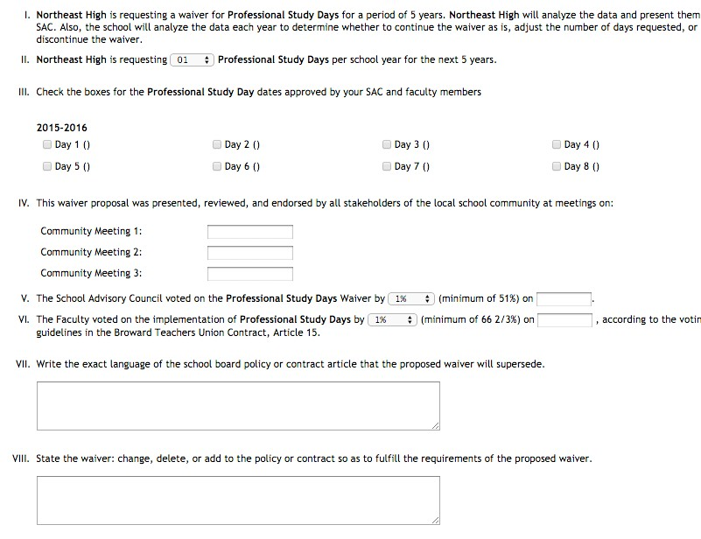

Notes:
  - Section III
    - SAC can offer the faculty options for the number of Professional Study Days.
    - It is recommended that no more than 2 options of number of Professional Study Days be presented to the faculty to assure that one of the dates received a 51% majority vote
    - This section can be completed after the faculty vote determines the number of days
      - The actual dates will be determined as approved by the School Board; this traditionally occurs after the school-­‐based part of the waiver process has concluded so the schools are simply identifying Day 1 through Day 8 not to exceed the number of days approved by the SAC and faculty
        - Day 1 – Day 8 are the 8 days approved by the School Board. A school with 4 professional study days does not need to document days 1-­‐4, they could document days 1, 3, 5 and 7 or any other combination as recommended by SAC and approved by the Principal
      - Once the number of days are selected the SAC can recommend to the Principal the actual days for Professional Study Days
  - Section IV
    - Community Meetings 1 and 3 are SAC Meetings
    - Community Meeting 2 is a general community meeting for additional input.
    - Community Meeting 2 may occur before the Community Meeting 3 SAC Meeting on the same night
    - See the New Waiver Process Flowchart and Waiver Checklist for additional information

  - Section VI
    - For Professional Study Days the faculty vote ballot has 2 parts asking BTU instructional collective bargaining unit

members
      - Part I: Does the faculty want professional study days?
        - Yes/No are the options
        - 66 2/3 must say yes to pass (see below for more information)
        - BTU instructional collective bargaining unit members includes anyone that is on a teacher’s contract
      - Part II: If Part I passes, how many Professional Study Days does the school want?
        - See notes for Section III above for information on options
        - 51% of votes cast required to pass Part II (this is different from the 66 2/3 votes of all collective bargaining unit members required to pass (see below for more information on 66 2/3 vote to pass)
      - It is appropriate for a faculty member that votes ‘No’ for section 1 to cast a vote in section 2. The faculty member is thus saying they do not support the school have Professional Study Days, but if it does pass they want X number of days.
    - The faculty must pass the waiver with a 66 2/3 vote
      - SBBC Policy calls for all faculty to vote, if a faculty member does not vote it counts as a ‘no vote’
    - See School Board Policy 1403 (http://www.broward.k12.fl.us/sbbcpolicies/docs/P1403.0 00.pdf), School Board Policy 1403 Guidelines (http://www.broward.k12.fl.us/sbbcpolicies/docs/P1403-­‐ A.pdf) and Broward Teachers Union Contract Article 15 (http://www.broward.k12.fl.us/employeerelations/BTU_P DFs_for_Website/ARTICLE15_BTU.pdf) for procedural and additional information on faculty voting for waivers

- Complete sections IX – XV

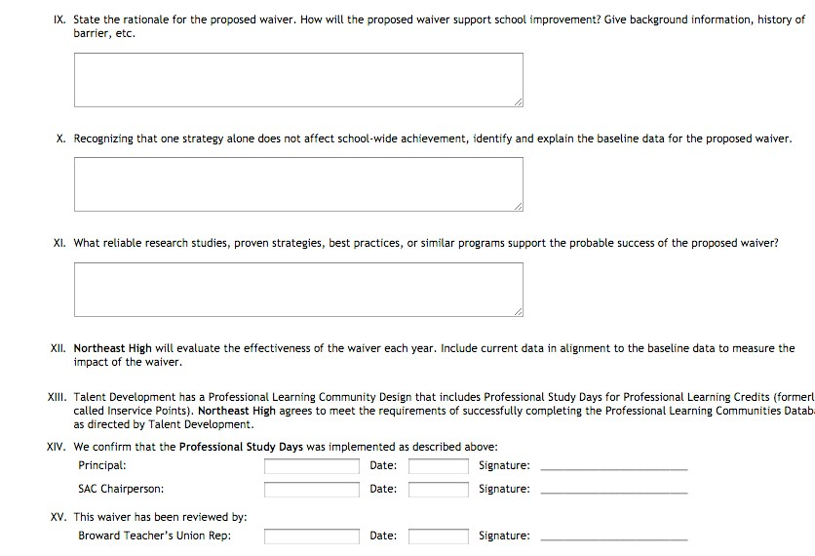

- Click Save or Save and Submit
  - Click Save to save application and return to it to continuing working in the future.
  - Click Save and Submit to submit application to District for review
o As noted once Save and Submit is selected the Waiver will be locked from further editing.

Notes:

    - This waiver application, with original signature, is to be kept on file at the school and made available to District personnel upon request.
    - A scanned version of the completed waiver application, with signature, and all other required documents are to be uploaded to the SAC Documentation Upload Center (see SAC Documentation Upload Center section) by the deadline noted in the timeline.
o Filename formula is to be: SchoolName_GradeLevel_PSD_WaiverNumber_Date.pdf, ex. Abc_ES_PSD_1_02082013.pdf

New Waiver Request Checklist

Action | Action Required by Statute, Policy or Contract | Documentation | Documentation Submitted
 |  |  | Yes | No
Identify barrier that will be overcome through waiver process.  View New Waiver Process Podcast  Submit Waiver Intent Form  Review similar waivers on School Improvement | No  Follow steps on waiver flowchart and timeline | record of viewers verified

Action | Action Required by Statute, Policy or Contract | Documentation | Documentation Submitted
 |  |  | Yes | No
Website at: www.broward.k12.fl. us/schoolimprove
SAC discusses need for waiver and develops waiver request using online waiver template.  Contact Research Services Dept. to review rationale and evaluation plan. | No | SAC members sign-in Sheet (use sign-in sheet provided with online SAC Composition Form)
 |  | Sign-in sheet for guests at meeting (use sign-in sheet provided with online SAC Composition Form)
 |  | Document date, time and location of SAC meeting
 |  | SAC Meeting minutes

Action | Action Required by Statute, Policy or Contract | Documentation | Documentation Submitted
 |  |  | Yes | No
Schedule and advertise open community meeting to review waiver | Yes | Copy of flyer(s) or other methods of advertising meeting(s)-- include date of notice

Action  request (This is not a SAC or SAF  meeting.) Policy requires at least one community meeting, which should be scheduled at a time and place to encourage parent/community attendance. | Action Required by Statute, Policy or Contract | Documentation | Documentation Submitted
 |  |  | Yes | No
 |  | Document date, time and location of community meeting(s)
 |  | Community members sign- in Sheet(s) indicating the role of each person (i.e., parent, teacher, community member)
 |  | SAC sign-in sheet, documenting attendance of Principal and SAC Chair or designee at the community meeting(s)
 |  | Minutes from community meeting(s) documenting discussion and community recommendations

Action | Action Required by Statute, Policy or Contract | Documentation | Documentation Submitted
 |  |  | Yes | No
SAC advertises SAC meeting with item on agenda to vote on waiver request. | Yes | Copy of flyer or other method of advertising meeting (include date of notice)

Action  SAC must vote to endorse waiver as presented to community, revise waiver per community input, or to not pursue the waiver.  (See new waiver flowchart on School Improvement website) | Action Required by Statute, Policy or Contract | Documentation | Documentation Submitted
 |  |  | Yes | No
 |  | Copy of SAC meeting agenda
 |  | Document date, time and location of SAC meeting
 |  | SAC members sign-in Sheet (use official SAC Composition Form sign-in sheet)
 |  | Sign-in sheet for guests at meeting
 |  | SAC Meeting minutes
Present waiver in writing to faculty at least 3 days prior to faculty vote.  Announce date for faculty vote not less than 24 hours prior to election day | Yes | Document date, time and location of faculty meeting.

Action | Action Required by Statute, Policy or Contract | Documentation | Documentation Submitted
 |  |  | Yes | No
Conduct Faculty Vote through a secret ballot conducted by a bargaining unit representative who shall be responsible for securing ballots during voting.  Principal and BTU representative shall be official observers of election and ballot counting | Yes  (Article 15 BTU Contract) | Sign-in sheet showing faculty members that voted-- use list of eligible voters and have faculty initial by name  Document results of vote, showing percent of faculty voting for and against waiver (to pass 66 2/3 % of eligible voters must vote “yes” to approve waiver request)
Submit completed Waiver Request (http://www.broward. k12.fl.us/schoolimpro ve/school_staff_login  .asp) by deadline noted in timeline | Yes | Copy of Waiver Request with school based signatures.
 | No | Copy of completed SAC documentation form
 |  | Copy of all required back- up documentation

School Advisory Council (SAC) Documentation for Waiver Requests
Submit this form with the Waiver Request to document SAC and community involvement in the development of the SIP.
School Name:

1) State the waiver being requested:

- This waiver proposal was presented to the community stakeholders of the local school community at meetings on:

How and when was meeting advertised? |  | Date, time and location of Community Meeting(s)
How was each meeting advertised? | Date of notice | Date | Time | Location
- Attach a copy of the sign-in sheet showing the Principal and SAC Chair (or designee) in attendance for each of the public/community meetings.

- Attach a copy of the sign-in sheet showing Community members in attendance at the public/community meetings.

- Attach the minutes for each of the public/community meetings as well as the SAC meetings when the waiver was discussed.

Submitting Waiver Documents to the SAC Documentation Upload Program

This program will be used to upload documentation for Waiver applications. Submitted documentation is on scanned file to include:
  - Waiver application
  - All documentation noted in the New Waiver Checklist
  - SAC Documentation for Waiver Requests Form

Uploading Required Waiver Documentation

- Go to: http://www.broward.k12.fl.us/ospa/ospa-central2/

- Click on to School Improvement Plan

- Go to Best Practice #3 and click on SAC Upload Center

- Click link SAC Documentation Upload

- Click Waiver Application Documentation and upload File

