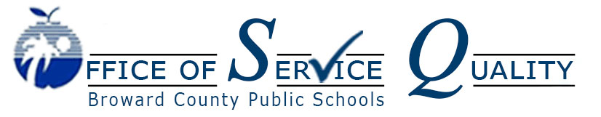
Veda Hudge, Director
Donna R. Boruch, Coordinator of School Improvement

AdvancED Accreditation Standards

Standard 1: Purpose and Direction
The school maintains and communicates a purpose and direction that commit to high
expectations for learning as well as shared values and beliefs about teaching and learning.

Standard 2: Governance and Leadership
The school operates under governance and leadership that promote and support student performance and school effectiveness.

Standard 3: Teaching and Assessing for Learning
The school’s curriculum, instructional design, and assessment practices guide and ensure teacher effectiveness and student learning.

Standard 4: Resources and Support Systems
The school has resources and provides services that support its purpose and direction to ensure success for all students.

Standard 5: Using Results for Continuous Improvement
The school implements a comprehensive assessment system that generates a range of data about student learning and school effectiveness and uses the results to guide continuous improvement.

AdvancED Accreditation Standards & BEST Blueprint

1. Purpose and Direction: The BEST Blueprint maintains and communicates at all levels of the organization a purpose and direction for continuous improvement that commits to high expectations for learning as well as shared values and beliefs about teaching and learning.

2. Governance and Leadership: The BEST Blueprint is a part of a system of governance and leadership that promotes and supports student performance and system effectiveness.

3. Teaching and Assessing for Learning: The BEST Blueprint supports the district’s practices for curriculum, instructional design, and assessment, ensuring teacher effectiveness and student learning across all grades and courses.

4. Resources and Support Systems: The BEST Blueprint leverages BCPS resources and provides services in all schools to support its purpose and direction to ensure success for all students.

5. Using Results for Continuous Improvement: The BEST Blueprint supports the district’s comprehensive assessment process that generates a wide range of data about
student learning and system effectiveness and uses the results to guide continuous improvement

