Typing Test Instructions

- PLEASE NOTE – Keyboarding Quiz 1 (KQ1), you must have a minimum NET SPEED of 10 words per minute. KQ2 is 15 WPM, and KQ3 is 20 WPM, and so on, increasing by 5 WPM. If you do not achieve this speed, you must retake the test, until you do. Remember, Name, Date and Class Period!
- Go to http://www.typingtest.com
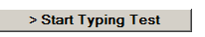
- Click Start Typing Test -
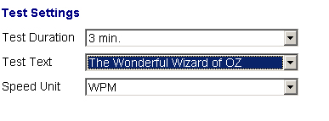

- Click Begin - 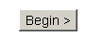
- The clock doesn’t start until you type the Capital D for Dorothy. The word you are typing is blue and underlined. You can make changes to a word as long as you are still inside the word. Once you hit space, you cannot make changes to the previous word. You must begin typing the next word. When the clock runs out, your results will pop up. DO NOT CLICK NEXT. Press and hold both the CTRL key and the PRINT SCREEN key located on your keyboard. This will make a “screen capture”, a picture of your screen. You will not SEE the computer take the picture
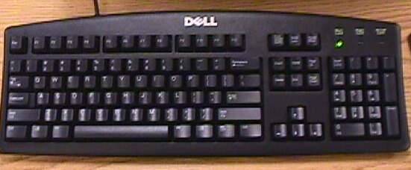

- Press the windows key, then choose programs, Microsoft Office, Microsoft Word
- Type in your name, class period, keyboarding quiz number, i.e., KQ1, KQ2, KQ8, etc and then choose the insert menu and choose date and time
- 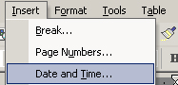
- Choose the format you want and click ok
- Then choose Edit and Paste. This will paste in your screen capture of your keyboarding quiz results.
- 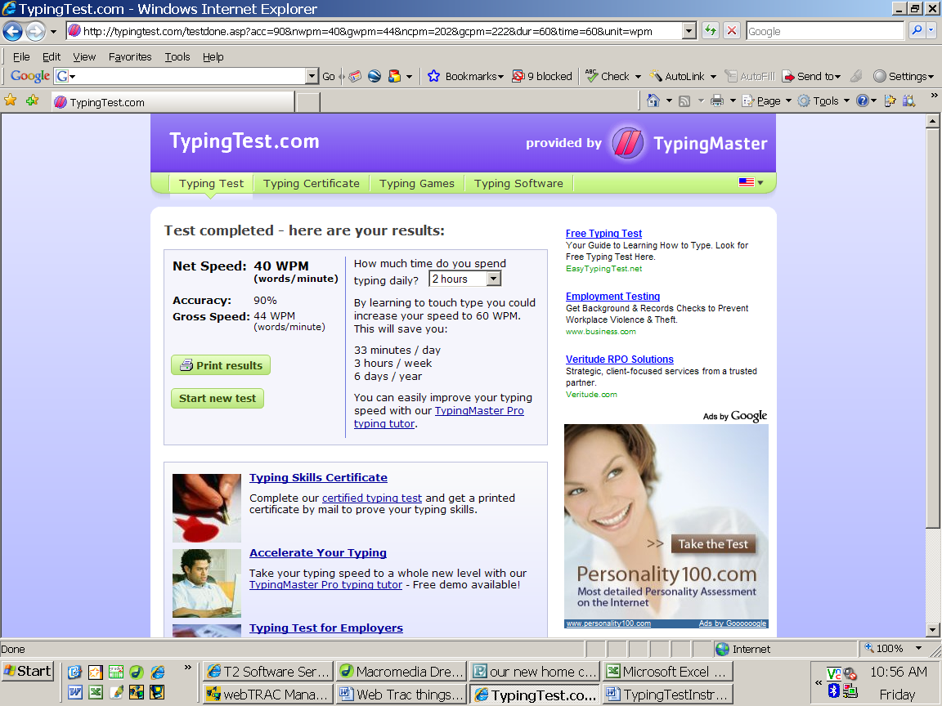
- Print a copy to the P1 printer, write the corresponding page number from the TOC, show me for a grade, 3 hole punch it, and put it in your business folder.

