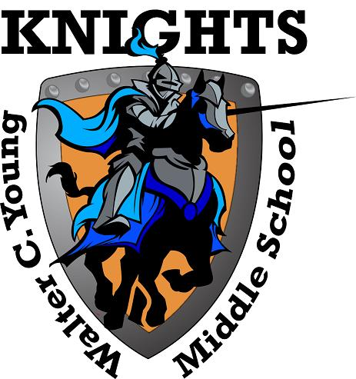
Walter C. Young Middle School
“Home of the Young Knights”
2018-2019

School Advisory Council
Agenda
Tuesday, October 9th, 2018

- Welcome
- Roll Call to Establish Quorum
- Approval of September Minutes
- SAC By Laws
- SAC Membership Voting
- A+ Recognition Funds Results

- Tutoring Science Materials (Ms. Bernard-Mark)

- Nearpod (Mr. Yetter)

- Explore Learning (Mrs. Spector)

- Ms. Helen Boyle (Update on SMART Program)

- Principal’s Report
- For the Good of the Group
.

SAC Meeting dates for 2018-2019 School year are as follows:
12/11, 1/8, 2/12, 3/12, 4/9, 5/14.

