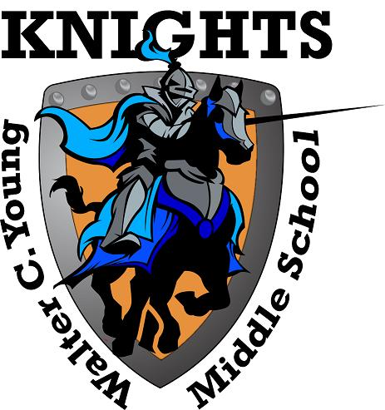
Walter C. Young Middle School
“Home of the Young Knights”

SAF Meeting Dates
2018- 2019

- September 11th

- October 9th

- November – No SAF Meeting

- December 11th

- January 8th

- February 12th

- March 12th

- April 9th

- May 14th

